KAZAKH-BRITISH TECHNICAL UNIVERSITY
School of Information Technology
Project name: KBTU University Intranet
Discipline: Object-Oriented Programming

Team members:
Ussibaliyev Yergali Ganiyevich
Serikbayuly Serzhan (team lead)
Zhutanov Farkhat Zhasulanovich

The main goal of the project
Create a project university system INTRANET. The university management system is a form of distribution, coordination and implementation of management activities within the structure of an educational institution. The relationship between employees and students of the university should be facilitated and of high quality. To achieve this, our goal was to make a convenient console Java application that supports the simplest basic queries for students and university staff using the knowledge gained in object-oriented programming courses.

Project description
- Create an architecture using Use Case and UML Class Diagrams.
- Working with IntelliJ IDEA.
- Report, documentation, presentation.

1. Diagrams
We have created diagrams using the StarUML tool. The UML model is divided into two parts:
- Use-case diagram
- Class diagram

Use-Case diagram
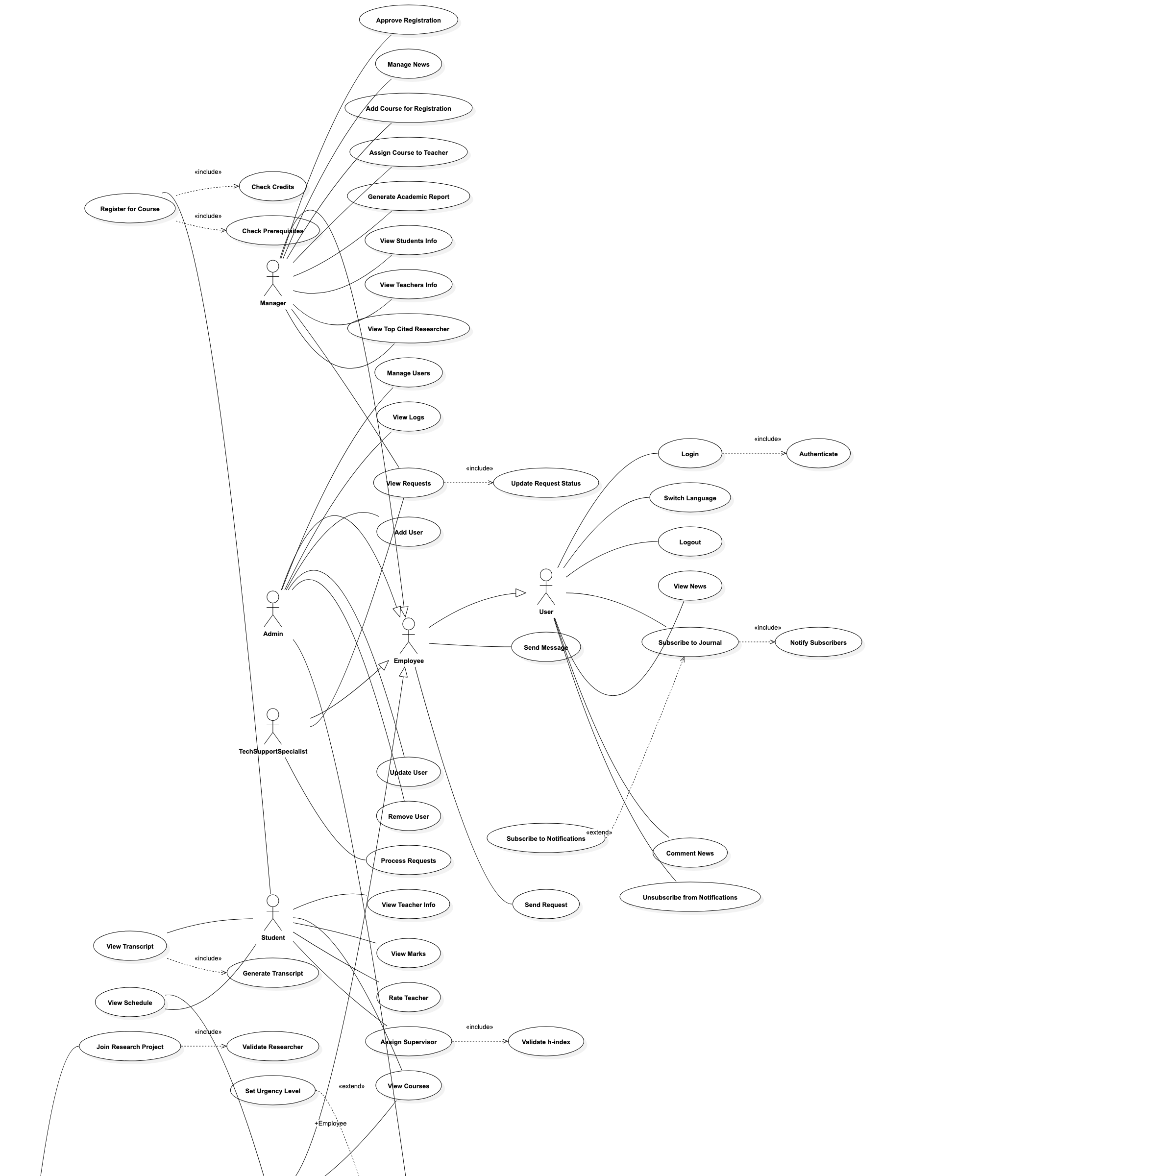
Use Case diagram
The system supports five primary actors:
- Admin — manages the user lifecycle (add / remove / update) and audits the log.
- Manager — opens courses for registration, assigns teachers, approves student registrations, generates reports.
- Teacher — views courses and students, records marks, publishes research, writes recommendation letters.
- Student — registers for courses, views the transcript and GPA, rates teachers, views attendance.
- Research Employee — publishes papers, joins research projects, computes h-index.
Each role is a subclass of Employee (which extends User) except Student, which extends User directly.

Class diagram
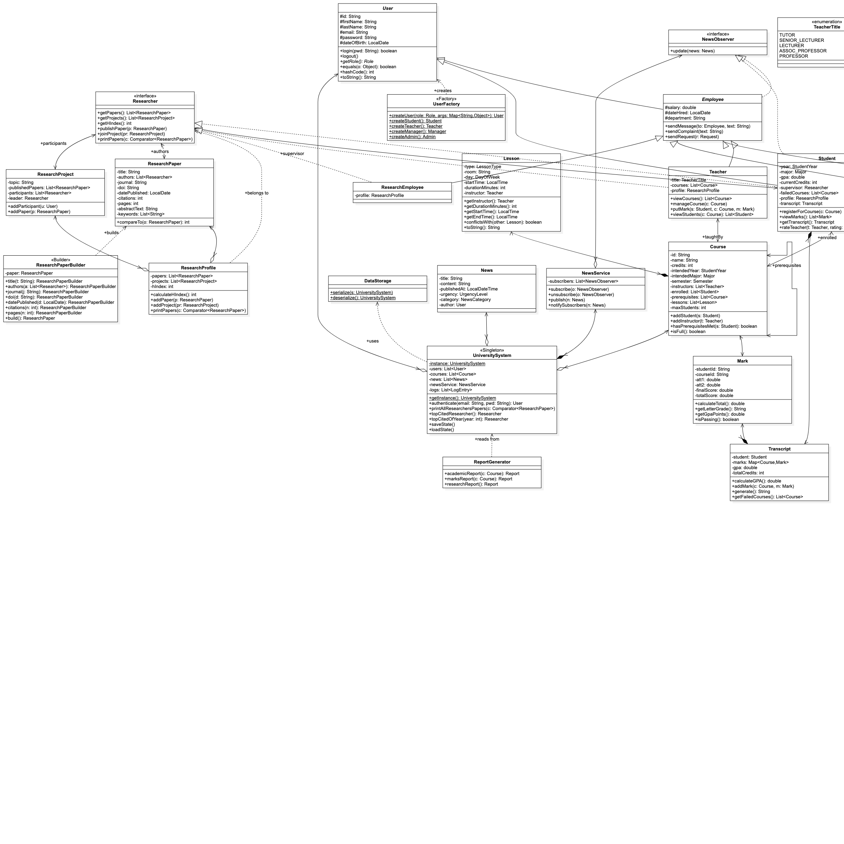
Class diagram
The class diagram shows the complete hierarchy:
- User → Employee → Teacher / Manager / Admin / ResearchEmployee
- User → Student
The Researcher interface is a mix-in that lets Teacher, Student, and ResearchEmployee participate in research activities through a ResearchProfile composition rather than multiple inheritance.

2. Working with IntelliJ IDEA

Packages
The code is organised into eight packages under edu.kbtu.university:
- users — User, Employee, Student, Teacher, Manager, Admin, ResearchEmployee, Researcher (interface), NewsObserver (interface), UserFactory.
- academics — Course, Lesson, Mark, Transcript, AttendanceRecord.
- research — ResearchPaper, ResearchPaperBuilder, ResearchProfile, ResearchProject, three comparators (ByCitationsComparator, ByDateComparator, ByPagesComparator).
- news — News, NewsService (subject of the Observer pattern).
- system — UniversitySystem (singleton), DataStorage (serialization), LogEntry, Request, Report, ReportGenerator, RecommendationLetter, ScheduleGenerator.
- enums — Role, Major, Semester, StudentYear, LessonType, RoomType, TeacherTitle, ManagerType, NewsCategory, UrgencyLevel, RequestStatus, AttestationType.
- exceptions — AuthenticationException, LowHIndexException, NotAResearcherException, CourseRegistrationException, CreditLimitExceededException, MaxFailuresException, PrerequisiteNotMetException.
- Top-level — Main (CLI dispatcher) and ConsoleApp (interactive REPL).

User class — the base of the hierarchy
User is an abstract base class. Student and every employee subtype extend it. It implements Serializable so the whole system graph can be saved through DataStorage, and stores the SHA-256 hash of the user’s password.
public abstract class User implements Serializable {
private static final long serialVersionUID = 1L;
protected String id;
protected String firstName;
protected String lastName;
protected String email;
protected String passwordHash;
protected LocalDate dateOfBirth;
public boolean login(String pwd) throws AuthenticationException {
if (!verifyPassword(pwd)) {
throw new AuthenticationException(
"Invalid credentials for user " + id);
}
return true;
}
@Override
public boolean equals(Object o) {
if (this == o) return true;
if (!(o instanceof User)) return false;
return Objects.equals(id, ((User) o).id);
}
@Override
public int hashCode() { return Objects.hash(id); }
public abstract Role getRole();
}

Student class
Student is a direct subclass of User. It carries the academic year, declared major, GPA, currently enrolled credits, a transcript, a list of failed courses, a research profile, and an optional research supervisor.
public class Student extends User implements Researcher, NewsObserver {
private StudentYear year;
private Major major;
private double gpa;
private int currentCredits;
private Researcher supervisor;
private List<Course> failedCourses;
private ResearchProfile profile;
private Transcript transcript;
// ...
}
registerForCourse() is the most important business operation in the project. It enforces the four academic constraints from the spec — prerequisites, the 21-credit cap, the 3-failure cap, and course capacity:
public void registerForCourse(Course c) {
if (c == null) {
throw new CourseRegistrationException("Course is not specified");
}
if (!c.hasPrerequisitesMet(this)) {
throw new PrerequisiteNotMetException("Prerequisites are not met");
}
if (currentCredits + c.getCredits() > 21) {
throw new CreditLimitExceededException("Credit limit of 21 exceeded");
}
if (failedCourses.size() >= 3) {
throw new MaxFailuresException("Maximum number of failed courses exceeded");
}
if (c.isFull()) {
throw new CourseRegistrationException("Course has no free seats");
}
c.addStudent(this);
currentCredits += c.getCredits();
}
setSupervisor() implements the supervisor h-index rule for fourth-year students:
public void setSupervisor(Researcher supervisor) {
if (year != StudentYear.FOURTH) {
throw new IllegalStateException(
"Only 4th-year students may be assigned a research supervisor");
}
if (supervisor.getHIndex() < 3) {
throw new LowHIndexException(
"Supervisor h-index must be >= 3 (was " + supervisor.getHIndex() + ")");
}
this.supervisor = supervisor;
}
Other student methods: viewMarks(), getTranscript(), rateTeacher(Teacher, int), getAttendanceRate(Course), and the full Researcher interface (publishPaper, joinProject, printPapers, getHIndex).

Teacher class
Teacher extends Employee and implements Researcher. Per the spec, a teacher with the rank PROFESSOR must have a non-null research profile — setTitle() guarantees the invariant. The teacher’s main operations are managing the courses they teach, putting marks, and (for bonus features) generating marks reports, writing recommendation letters, and recording attendance.
public void putMark(Student s, Course c, Mark m) {
if (s == null || c == null || m == null) {
throw new IllegalArgumentException("Student, course and mark must not be null");
}
boolean teachesCourse = courses.contains(c)
|| c.getInstructors().contains(this);
if (!teachesCourse) {
throw new IllegalArgumentException("Teacher does not teach this course");
}
s.getTranscript().addMark(c, m);
}

Mark class
Mark carries the three KBTU attestations — att1, att2, and finalScore — and computes the total via att1 + att2 + finalScore. The letter grade is mapped from the total according to the standard KBTU scale (A ≥ 95, A− ≥ 90, B+ ≥ 85, …, F < 50).
public class Mark implements Serializable {
private double att1;
private double att2;
private double finalScore;
private double totalScore;
public void calculateTotal() {
this.totalScore = att1 + att2 + finalScore;
}
public String getLetterGrade() { /* KBTU grade rules */ }
public double getGpaPoints() { /* 0..4 from letter */ }
public boolean isPassing() { return totalScore >= 50; }
}
Transcript aggregates all marks of a student into a Map<Course, Mark> and computes a credit-weighted GPA in calculateGPA().

ResearchPaper class
ResearchPaper stores nine IEEE-style bibliographic fields (title, authors, journal, DOI, publication date, citation count, page count, abstract, keywords). Construction goes through ResearchPaperBuilder (the Builder design pattern, see below). The class is Comparable and can also be ordered by any of the three Comparator strategies in the research package.

Researcher interface and h-index calculation
Researcher is an interface, allowing Teacher, Student, and ResearchEmployee to implement it via a ResearchProfile composition. This design lets any user type become a researcher without multiple inheritance.
public interface Researcher extends Serializable {
List<ResearchPaper> getPapers();
List<ResearchProject> getProjects();
int getHIndex();
void publishPaper(ResearchPaper p);
void joinProject(ResearchProject pr);
void printPapers(Comparator<ResearchPaper> c);
}
The h-index is the maximum h such that the researcher has at least h papers with ≥ h citations:
public int calculateHIndex() {
if (papers == null || papers.isEmpty()) {
hIndex = 0;
return hIndex;
}
List<Integer> citations = new ArrayList<>();
for (ResearchPaper paper : papers) {
citations.add(paper == null ? 0 : paper.getCitations());
}
citations.sort(Collections.reverseOrder());
int h = 0;
for (int i = 0; i < citations.size(); i++) {
int candidate = i + 1;
if (citations.get(i) >= candidate) {
h = candidate;
} else {
break;
}
}
hIndex = h;
return hIndex;
}

Design Patterns
We used five design patterns throughout the project — one more than the required minimum of four.

1. Singleton — UniversitySystem
The UniversitySystem class is the global container of state (users, courses, news, logs, requests, attendance, teacher ratings). A private constructor plus getInstance() guarantees a single instance shared across all services.
public class UniversitySystem implements Serializable {
private static UniversitySystem instance;
private UniversitySystem() {
}
public static synchronized UniversitySystem getInstance() {
if (instance == null) {
instance = new UniversitySystem();
}
return instance;
}
}

2. Factory — UserFactory
UserFactory creates concrete User subclasses with prefix-tagged IDs (BD#### for bachelor students, MP#### for masters, PHD#### for PhD, EMP#### for every employee subtype). A generic createUser(Role, Map<String,Object>) method dispatches by role.
public static Student createStudent(String firstName, String lastName, String email,
String password, LocalDate dob,
StudentYear year, Major major) {
return new Student(studentId(year), firstName, lastName, email,
password, dob, year, major);
}
public static Teacher createTeacher(String firstName, String lastName, String email,
String password, LocalDate dob,
double salary, LocalDate dateHired, String department,
TeacherTitle title) {
return new Teacher(employeeId(), firstName, lastName, email, password, dob,
salary, dateHired, department, title);
}

3. Strategy — paper comparators
The Researcher.printPapers(Comparator<ResearchPaper>) API accepts any sort strategy. We provide three concrete strategies in the research package:
public class ByCitationsComparator implements Comparator<ResearchPaper> {
public int compare(ResearchPaper a, ResearchPaper b) {
return Integer.compare(
b == null ? 0 : b.getCitations(),
a == null ? 0 : a.getCitations());
}
}
ByDateComparator orders papers by publication date (newest first) and ByPagesComparator orders them by page count (longest first). All three are stateless and Serializable, so they round-trip through saveState().

4. Observer — NewsService ↔ NewsObserver
NewsService is the subject. It holds a list of NewsObserver subscribers and pushes every published News item to all of them. Every User subtype implements NewsObserver and stores received news in a per-instance inbox.
public class NewsService implements Serializable {
private List<NewsObserver> subscribers = new ArrayList<>();
public void subscribe(NewsObserver o) {
if (o != null && !subscribers.contains(o)) subscribers.add(o);
}
public void publish(News n) {
for (NewsObserver subscriber : new ArrayList<>(subscribers)) {
subscriber.update(n);
}
}
}

5. Builder — ResearchPaperBuilder
ResearchPaperBuilder provides a fluent API for the nine IEEE fields of a ResearchPaper. Each setter returns this; build() returns the assembled paper and resets the internal state so the same builder instance can be reused.
ResearchPaper paper = new ResearchPaperBuilder()
.title("OOP Design Patterns in Education")
.authors(List.of(teacher))
.journal("IEEE Software Education")
.doi("10.1109/SE.2026.0001")
.datePublished(LocalDate.of(2026, 3, 1))
.citations(42)
.pages(12)
.abstractText("Empirical study of teaching OOP via real-world projects.")
.keywords(List.of("OOP", "education", "patterns"))
.build();

Authentication and Console Demo
Every user must log in before accessing the system. User.login(String) verifies the SHA-256 hash of the supplied password and throws AuthenticationException on mismatch.
public User authenticate(String email, String pwd) throws AuthenticationException {
User u = findUserByEmail(email);
if (u == null) {
throw new AuthenticationException("No user with email " + email);
}
u.login(pwd);
addLog(u, "LOGIN", "User authenticated");
return u;
}
The interactive ConsoleApp reached by java edu.kbtu.university.Main console loads any saved state from university-system.ser, seeds a default admin (admin@kbtu.kz / admin) if no users exist, then exposes a per-role menu after login:
- Admin — add / remove / update user, list users, view logs, save state, regex search.
- Manager — open course, assign teacher, approve registration, view requests, generate report, generate weekly schedule.
- Teacher — view courses / students, put mark, publish paper, print sorted papers, marks report, write recommendation letter, mark attendance.
- Student — view marks, transcript / GPA, register for a course, rate teacher, view supervisor, view attendance rate.
- Research Employee — view papers, publish, sort by strategy, view h-index.
The non-interactive Main (the default mode without arguments) runs an end-to-end 18-step demo that exercises every critical operation and every custom exception path, then proves serialization round-trips through saveState() / loadState().

Course Registration with business rules
The course registration flow is the showcase of the project. It demonstrates four mutually exclusive failure modes, each represented by a dedicated runtime exception, plus the happy path that mutates Course.enrolled and updates Student.currentCredits atomically.
public void registerForCourse(Course c) {
if (c == null) {
throw new CourseRegistrationException("Course is not specified");
}
if (!c.hasPrerequisitesMet(this)) {
throw new PrerequisiteNotMetException("Prerequisites are not met");
}
if (currentCredits + c.getCredits() > 21) {
throw new CreditLimitExceededException("Credit limit of 21 exceeded");
}
if (failedCourses.size() >= 3) {
throw new MaxFailuresException("Maximum number of failed courses exceeded");
}
if (c.isFull()) {
throw new CourseRegistrationException("Course has no free seats");
}
c.addStudent(this);
currentCredits += c.getCredits();
}
The Manager mirrors this with approveRegistration(Student, Course) that delegates to the student’s own method, wrapping success in an audit log entry written through UniversitySystem.addLog().

Bonus features
We implemented five of the six bonus features listed in the project spec:

Marks report for the teacher
Teacher.generateMarksReport(Course) aggregates marks for a course: enrolled / graded counts, average total, pass rate, best / worst student, and an A → F letter-grade histogram pulled from each enrollee’s transcript. Implemented in ReportGenerator.marksReport(Course).

Advanced search by regex
UniversitySystem.findUsersByRegex(String) and findCoursesByRegex(String) accept any Java regular expression (case-insensitive Matcher.find) and return matching users / courses. Invalid patterns surface PatternSyntaxException. Reachable from the Admin menu.

Recommendation letters
Teacher.writeRecommendationLetter(Student) returns a RecommendationLetter whose body is rendered from the student’s transcript: a GPA-based qualifier (outstanding / strong / satisfactory / below expectations), the credit count, and the failed-course list — followed by the author’s signature.

Attendance
AttendanceRecord(student, course, date, present) stored on UniversitySystem. Teacher.markAttendance(Student, Course, LocalDate, boolean) enforces course ownership; Student.getAttendanceRate(Course) returns the present-to-total ratio.

Schedule generation
ScheduleGenerator.generate(List<Lesson>, Map<String, RoomType>) greedy-places each lesson into a (room, day, startTime) slot. Compatibility rules: LECTURE → LECTURE_HALL, PRACTICE → LAB or SEMINAR_ROOM. Avoids both room conflicts (via Lesson.conflictsWith) and instructor conflicts. Search space is Mon–Fri × 09:00–17:00 in 90-minute slots. Throws ScheduleConflictException when no slot can be found.
The 18-step Main demo finishes by running through all five bonuses end-to-end — the marks report prints a real histogram, the recommendation letter renders, attendance computes to 67% on a 2-of-3 sample, the regex search finds the seeded users and seven CS10X courses, and the schedule generator places 4 lessons on Monday in A301 / B101 without conflicts.

Project Management
Our team coordinated work through a shared Telegram group.
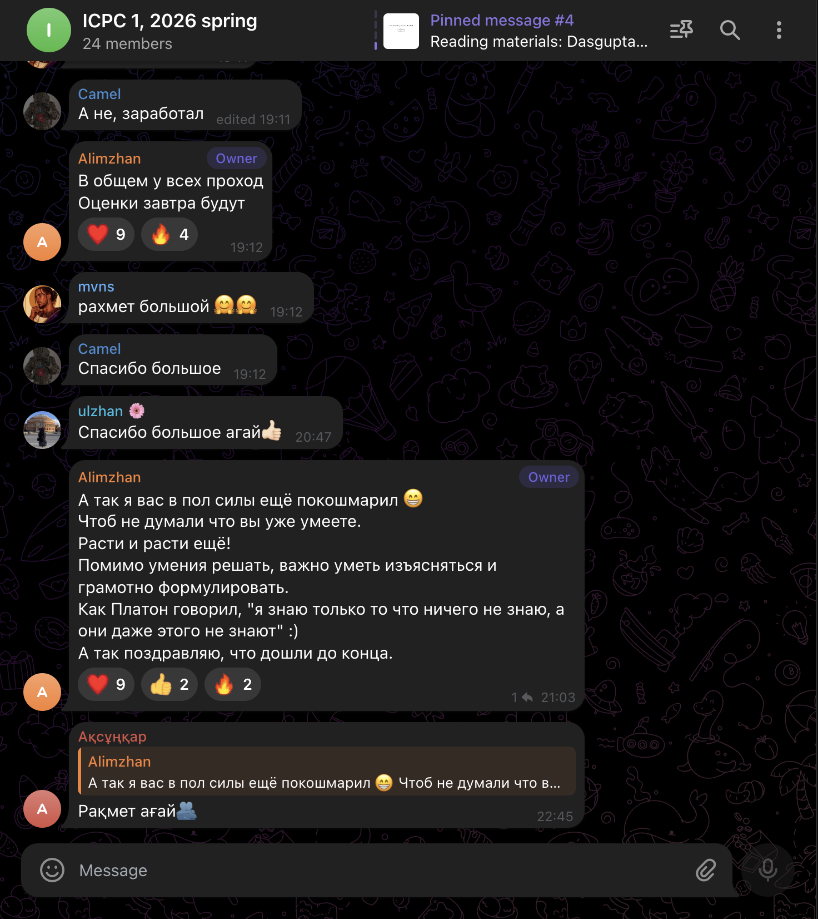
Telegram group overview
After the original four-person team lost one member to academic non-admission on the 18th of May, the work was redistributed: the team-lead absorbed the research and management modules; the academic module stayed with its original owner; the user / authentication module stayed with its original owner. The redistribution was tracked publicly in the chat and in the project’s git history.
Pull requests are reviewed in the Telegram chat and on GitHub before merging into main. Low-risk single-module additions (tests, JavaDoc) are self-merged; cross-module behaviour changes wait for the team-lead’s review. Every merged PR is squash-merged so main reads as a clean linear history.

Conclusion
Building the KBTU University Intranet has been a hands-on exercise in object-oriented design at full scale: an abstract base class, two parallel sub-hierarchies, an interface used as a mix-in, five named design patterns, custom exceptions for every business rule, full serialization, an interactive role-based console, an end-to-end demo, and five extra-credit features.
The most important lessons:
- Frozen public APIs after sprint 1 let four people work in parallel without stepping on each other. The only files with merge conflicts were the ones touched by more than one person — and those were resolved through PR review rather than ad-hoc.
- Exceptions are the contract. Surfacing every business-rule violation as a typed exception (CreditLimitExceededException, LowHIndexException, NotAResearcherException, …) made the registration flow self-documenting and the demo trivially expressive.
- Composition over inheritance for Researcher — keeping it as an interface backed by a ResearchProfile field let us mix research capability into Teacher, Student, and ResearchEmployee without multiple inheritance.
- Reproducibility through serialization. DataStorage round-trips the entire singleton in one call. The demo proves the property at every run.
Final deliverables in the project ZIP:
- src/ — Java source (51+ files)
- target/reports/apidocs/ — generated JavaDoc HTML
- pom.xml — Maven build
- README.md, report.pdf, presentation.pdf
mvn clean compile passes cleanly; mvn javadoc:javadoc reports zero warnings under the users package; the 18-step Main demo finishes with === Demo finished successfully ===.

End of report.

