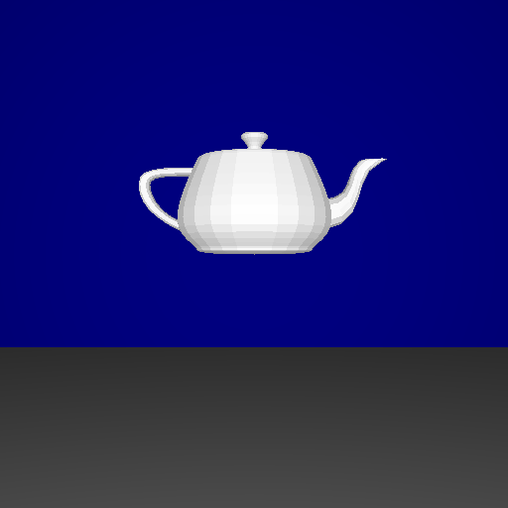

512x512, 8 threads, no partitioning of model, 24491ms

512x512, 8 threads, octree partitioning, 5037ms

512x512, 4 threads, octree partitioning, 4687ms

512x512, 2 threads, octree partitioning, 5846ms

512x512, 1 thread, octree partitioning, 9647ms

512x512, no threading overhead, octree partitioning, 9564ms

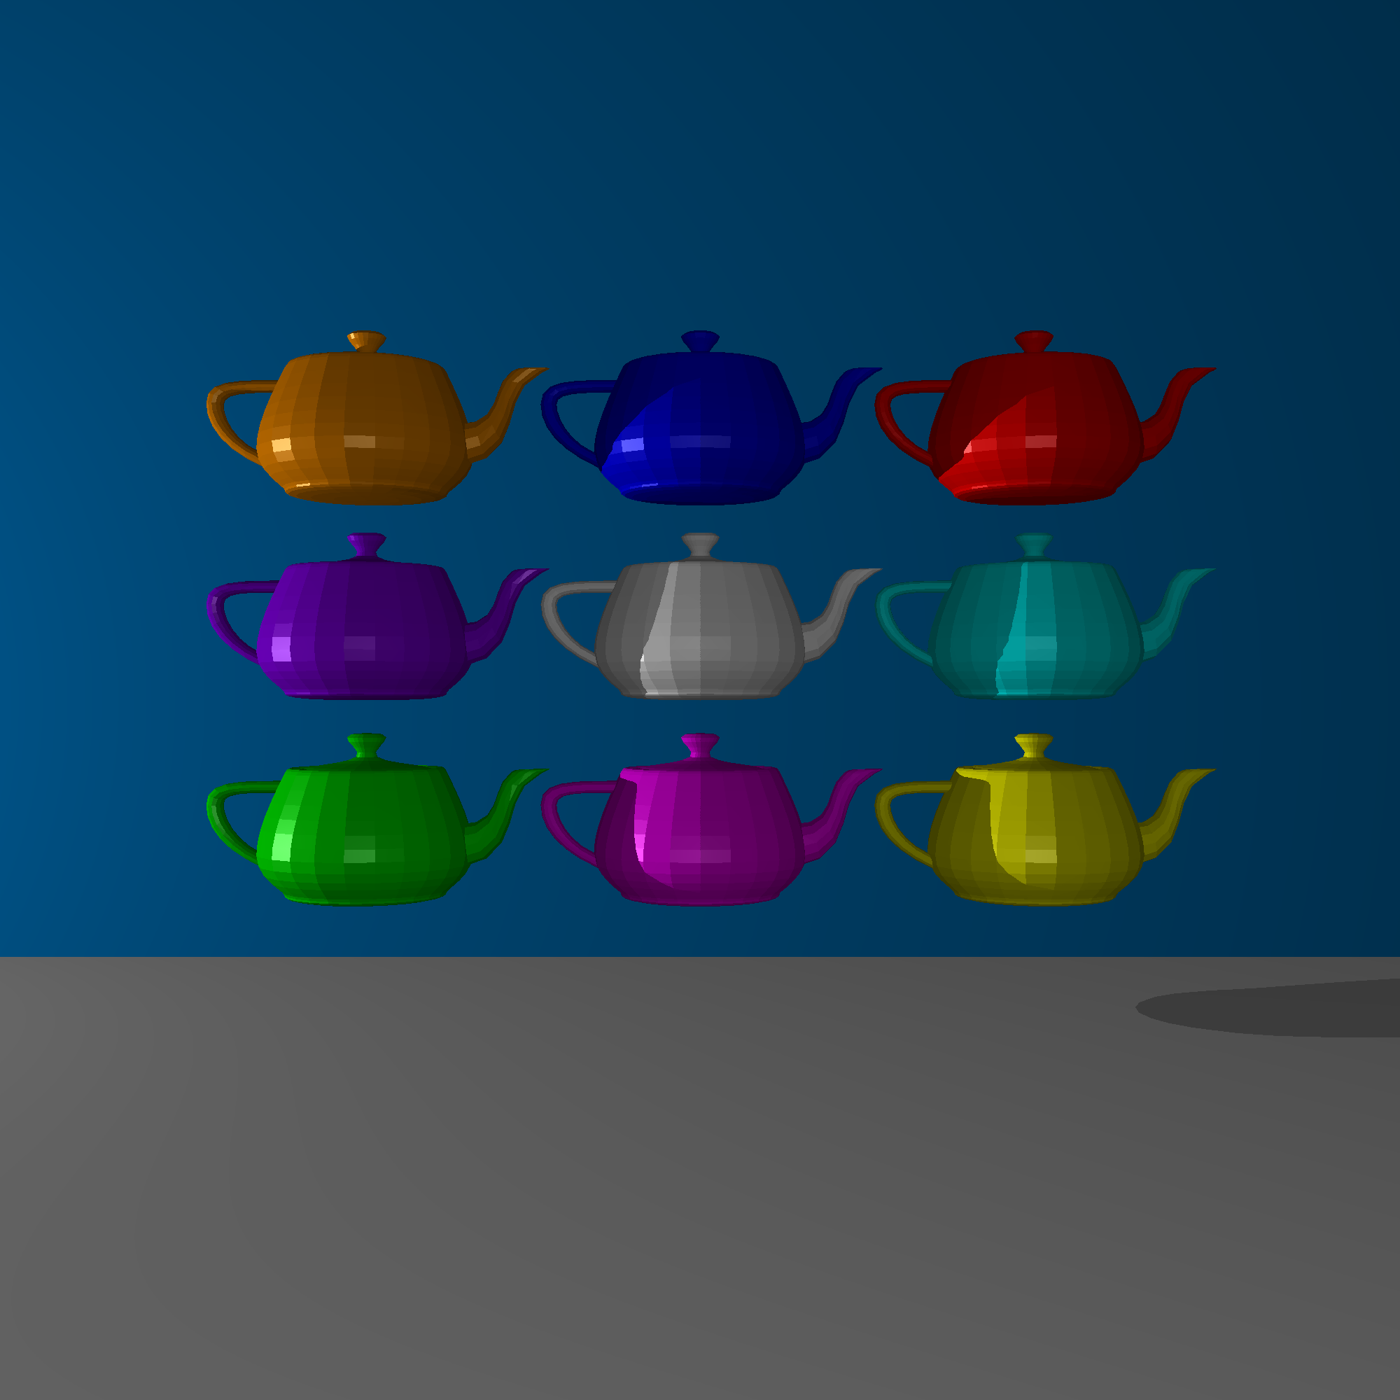

2000x2000, 8 threads, octrees, 178.094s