AVL TREES FOR FAST SEARCHING
CAPSTONE PROJECT / RESEARCH EXPLORATION REPORT
Presented by
Yericharla Spurthi
Roll No.: CH.EN.U4CCE25037
B.Tech CCE – 2nd Year
Amrita Vishwa Vidyapeetham

Table of Contents
1. Abstract
2. Introduction
3. Problem Statement
4. Need for AVL Trees
5. Objectives
6. Background: Binary Search Tree
7. AVL Tree
8. Balance Factor
9. AVL Rotations
10. AVL Insertion Process
11. Searching in AVL
12. Time Complexity
13. Research Methodology
14. Experimental Setup
15. Experimental Results
16. Discussion of Results
17. BST vs AVL vs Hash Table
18. Industry Relevance
19. Limitations
20. AVL and Modern Alternatives
21. Future Scope
22. Conclusion
23. References
24. Appendix: Implementation and Experiment

1. Abstract
Binary Search Trees can provide efficient searching when they remain balanced, but their shape depends on insertion order. An unfavorable order can make a conventional BST highly skewed and degrade search performance from O(log n) to O(n). This project explores AVL trees as a self-balancing alternative. An AVL tree maintains a balance factor of -1, 0, or +1 at every node and uses rotations to restore balance after updates. A C implementation was developed in Google Colab and evaluated using synthetically generated datasets of 100, 500, 1,000, 5,000, 10,000 and 20,000 elements under ascending, descending and random insertion orders. The experiments compare BST and AVL tree height and insertion time, with search-comparison analysis also performed in the project. For 20,000 ascending elements, the conventional BST reached height 20,000 while AVL maintained height 15, demonstrating the importance of self-balancing for predictable tree-based searching.

2. Introduction
Searching is a fundamental operation in computer science and is used in databases, indexing, dictionaries, symbol tables and many software systems. Binary Search Trees organize keys so that smaller values are placed in the left subtree and larger values in the right subtree. When a BST is balanced, its search path can be short. However, the basic BST does not automatically control its height. The project therefore investigates how self-balancing changes the behavior of a search tree.

3. Problem Statement
The central problem is that the performance of a conventional Binary Search Tree depends on the order in which elements are inserted. Ascending or descending insertion can produce a chain-like tree. In such a case, searching may require visiting a large fraction of the nodes, giving worst-case O(n) behavior.

4. Need for AVL Trees
A search structure is needed that can automatically maintain balance as data changes. AVL trees address this by monitoring the balance factor of nodes and performing rotations whenever an insertion or deletion makes the tree unbalanced. The goal is not to make every operation faster in every dataset, but to maintain a controlled tree height and consequently predictable search performance.

5. Objectives
- Understand why a conventional BST can become skewed.
- Study the structure and balancing rule of an AVL tree.
- Implement BST and AVL operations in C.
- Generate controlled synthetic datasets with different insertion orders.
- Compare tree height and insertion performance across dataset sizes.
- Analyze search behavior using comparison counts.
- Discuss practical relevance, limitations and future extensions.

6. Background: Binary Search Tree
A Binary Search Tree follows the ordering property that keys smaller than a node are placed in its left subtree and keys larger than the node are placed in its right subtree. For a balanced BST, search can be O(log n) on average. However, in the worst case a BST may become skewed and have O(n) search and insertion behavior.

7. AVL Tree
An AVL tree is a self-balancing Binary Search Tree. It automatically maintains its height by checking the balance of nodes. If an update causes an imbalance, one of four rotation patterns—LL, RR, LR or RL—is applied to restore the balance condition.

8. Balance Factor
Balance Factor = Height(Left Subtree) − Height(Right Subtree)
For a valid AVL tree, every node must have a balance factor of -1, 0 or +1. A balance factor below -1 or above +1 indicates that rebalancing is required.

9. AVL Rotations
Case | Condition | Correction
LL | Insertion in left subtree of left child | Single right rotation
RR | Insertion in right subtree of right child | Single left rotation
LR | Insertion in right subtree of left child | Left rotation, then right rotation
RL | Insertion in left subtree of right child | Right rotation, then left rotation
Rotations change the local structure while preserving the binary-search ordering of the keys.

10. AVL Insertion Process
- Perform normal BST insertion.
- Move back toward the root and update node heights.
- Calculate the balance factor of affected nodes.
- If a node becomes unbalanced, identify the LL, RR, LR or RL case.
- Apply the corresponding rotation(s).
- Continue until the tree is balanced.

11. Searching in AVL
Searching in an AVL tree follows the same comparison process as searching in a BST: compare the target with the current node, then move left or right according to the ordering property. The difference is that AVL maintains logarithmic height, so the worst-case search time is O(log n).

12. Time Complexity
Structure | Search | Insertion | Deletion
BST – average | O(log n) | O(log n) | O(log n)
BST – worst case | O(n) | O(n) | O(n)
AVL – worst case | O(log n) | O(log n) | O(log n)
The AVL guarantees come from maintaining a logarithmic tree height.

13. Research Methodology
The research question guiding the experiment was: How does AVL balancing affect searching performance compared with a conventional Binary Search Tree under different insertion orders?
The implementation was written in C and executed in Google Colab using GCC. Synthetic data was used so that dataset size and insertion order could be controlled exactly. The same generated datasets were used for the BST and AVL experiments to make the comparison consistent.

14. Experimental Setup
Parameter | Values
Language | C
Execution environment | Google Colab / GCC
Dataset type | Synthetic
Dataset sizes | 100, 500, 1,000, 5,000, 10,000, 20,000
Insertion orders | Ascending, Descending, Random
Primary metrics | Tree height, insertion time, search comparisons
Structures compared | Conventional BST and AVL
The project generated 18 datasets in total: six sizes for each of the three insertion orders.

15. Experimental Results
The complete measured height and insertion-time results are shown below.
Size | Order | BST Height | AVL Height | BST Insert (s) | AVL Insert (s)
100 | ascending | 100 | 7 | 0.000036 | 0.000025
500 | ascending | 500 | 9 | 0.000837 | 0.000146
1000 | ascending | 1000 | 10 | 0.003128 | 0.000327
5000 | ascending | 5000 | 13 | 0.079709 | 0.002010
10000 | ascending | 10000 | 14 | 0.318716 | 0.004433
20000 | ascending | 20000 | 15 | 1.273368 | 0.009854
100 | descending | 100 | 7 | 0.000035 | 0.000024
500 | descending | 500 | 9 | 0.000734 | 0.000138
1000 | descending | 1000 | 10 | 0.002910 | 0.000332
5000 | descending | 5000 | 13 | 0.073091 | 0.001993
10000 | descending | 10000 | 14 | 0.296737 | 0.004275
20000 | descending | 20000 | 15 | 1.177447 | 0.009601
100 | random | 13 | 8 | 0.000014 | 0.000030
500 | random | 16 | 11 | 0.000083 | 0.000182
1000 | random | 21 | 12 | 0.000176 | 0.000435
5000 | random | 27 | 15 | 0.001154 | 0.002634
10000 | random | 31 | 16 | 0.002524 | 0.005641
20000 | random | 34 | 17 | 0.005605 | 0.012647

Selected Result
20,000 elements – ascending | Height
BST | 20,000
AVL | 15
This result shows the strongest effect of insertion order: the ordinary BST becomes completely skewed, whereas AVL remains shallow.

Height Graphs
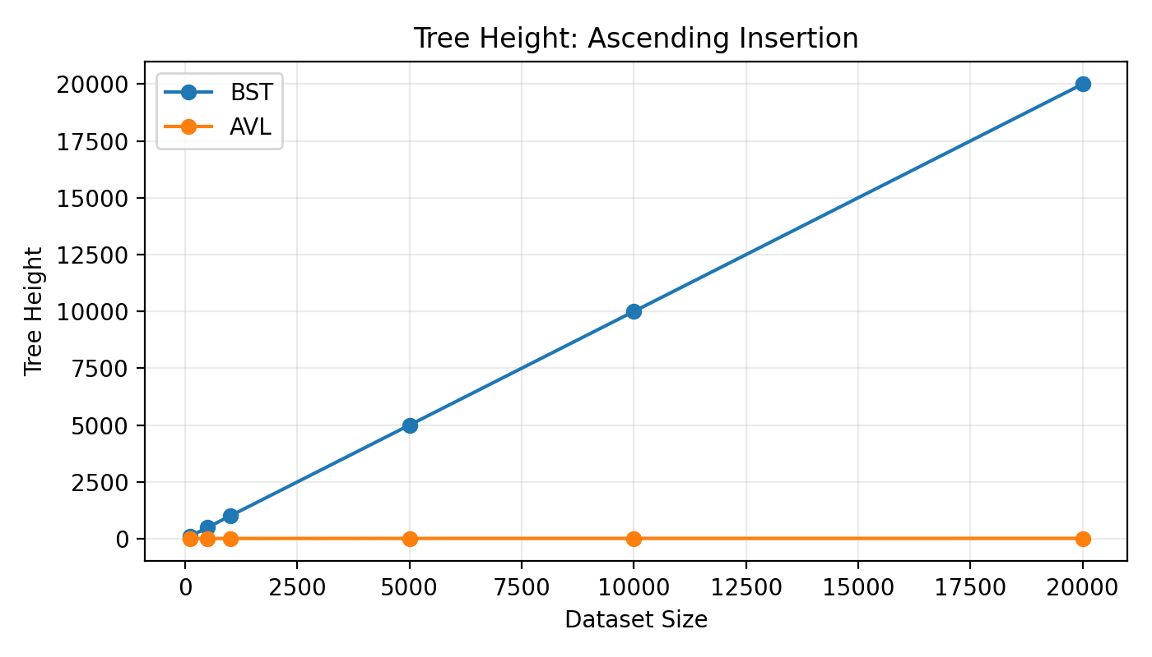
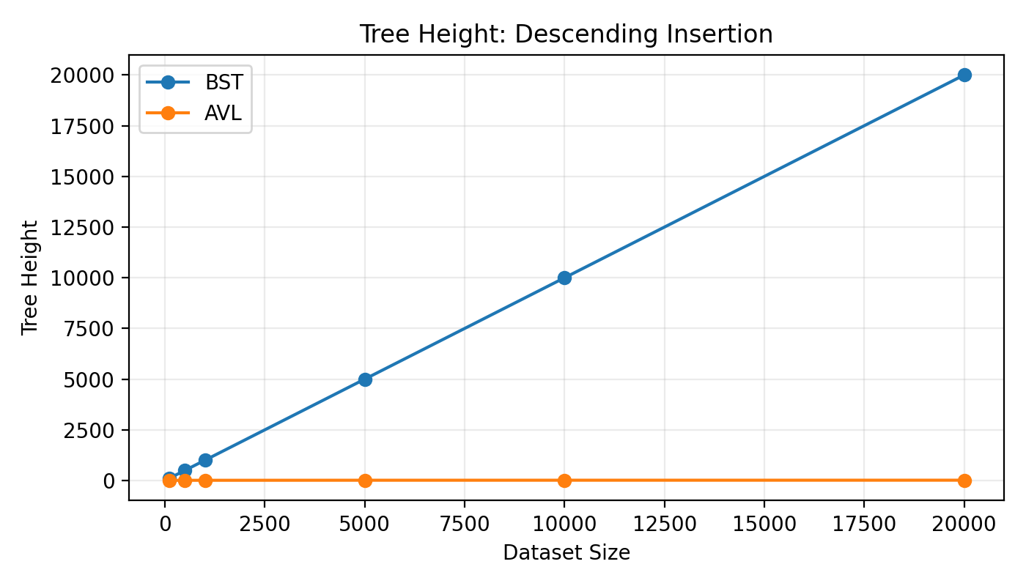
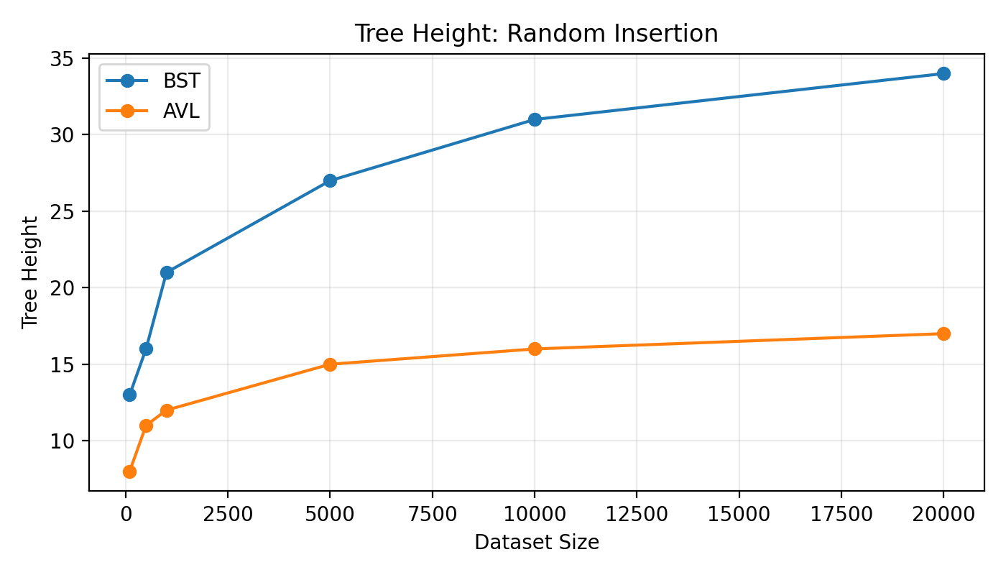

16. Discussion of Results
For ascending and descending insertion, the conventional BST height grows approximately with the number of elements because the tree becomes chain-like. In contrast, AVL height remains small and grows slowly. At 20,000 elements, AVL height is 15 for both ascending and descending cases.
For random insertion, the BST is not completely skewed, but its height is still larger than AVL: 34 versus 17 at 20,000 elements. The insertion-time measurements also demonstrate an important trade-off. AVL insertion can take more time on random data because balance checks and rotations add overhead. Therefore, the project does not claim that AVL is always faster for insertion; its main advantage is controlled height and predictable tree-based search behavior.

17. BST vs AVL vs Hash Table
Structure | Main Strength | Main Limitation
BST | Simple ordered tree structure | Can become skewed
AVL | Guaranteed balanced height | Rotation and balancing overhead
Hash Table | Very fast average lookup | Does not naturally maintain sorted order
The appropriate structure depends on the application. AVL is particularly relevant when ordered data and predictable logarithmic tree operations are required.

18. Industry Relevance
Balanced search trees are relevant to software systems that need ordered data and efficient searching, insertion and deletion. The project connects the theoretical balancing rule to practical concerns such as predictable performance, maintaining sorted structure and handling changing data.

19. Limitations
- AVL implementation is more complex than a basic BST.
- Height or balance information must be maintained.
- Rotations introduce update overhead.
- AVL is not universally faster for insertion, as demonstrated by some random-data measurements.
- The project uses synthetic rather than production-scale application data.
- The current experiment emphasizes height, insertion time and search comparisons; a larger study could add deletion timing and memory measurements.

20. AVL and Modern Alternatives
Red-Black Trees provide another self-balancing BST approach and use a different balancing rule. Hash tables provide average O(1) lookup but do not preserve the same natural sorted-tree structure. These structures illustrate that data-structure selection should be based on the required operations rather than on a single universal performance measure.

21. Future Scope
- Compare AVL with Red-Black Trees using the same experimental datasets.
- Add deletion-performance experiments.
- Measure memory usage and number of rotations.
- Run experiments on larger datasets.
- Study real-world ordered-indexing applications.
- Investigate parallel or distributed tree-based searching.

22. Conclusion
The project demonstrates why self-balancing trees are important. A conventional BST can become highly skewed under unfavorable insertion orders, causing its height and worst-case search time to grow linearly. AVL trees address this weakness by maintaining a balance factor of -1, 0 or +1 and applying rotations when necessary. The experimental results provide a clear example: with 20,000 ascending elements, the BST reached height 20,000 while AVL maintained height 15. At the same time, the insertion-time results show that balancing has a computational cost, particularly for some random datasets. Thus, the project supports the conclusion that AVL trees are valuable for maintaining predictable tree height and search behavior, while involving additional update overhead.

23. References
- Adelson-Velsky, G. M., & Landis, E. M. (1962). An algorithm for the organization of information.
- Cormen, T. H., Leiserson, C. E., Rivest, R. L., & Stein, C. Introduction to Algorithms.
- GeeksforGeeks. AVL Tree data structure and AVL tree rotations.
- IBM documentation and educational material on data structures.
- Oracle documentation on tree-based and collection data structures.
- Research literature on self-balancing binary search trees.
- Project implementation and synthetic experimental datasets generated in C.

24. Appendix: Implementation and Experiment
The Google Colab project contains the C programs used for dataset generation, BST implementation, AVL implementation, rotation testing, large-scale experiments and search-comparison experiments. The generated result files and graphs form the experimental evidence for this report.

Appendix A – Dataset Generation
The dataset generator created ascending, descending and randomized integer sequences for each of the six selected dataset sizes. The files were reused across the BST and AVL experiments.

Appendix B – Project Outputs
- BST experiment results
- AVL experiment results
- Combined AVL/BST experiment CSV
- Search-comparison results CSV
- Height graphs for ascending, descending and random insertion
- Search-comparison graphs for ascending, descending and random insertion

