04.03.01.timeseries_analysis.R

Yerim

Thu Feb 08 22:43:43 2018

#rmarkdown::render("04.03.01.timeseries_analysis.r", "pdf_document")  
  
library(TTR)  
library(forecast)  
  
# reading data ------------------------------------------------------------  
kings <- scan('https://robjhyndman.com/tsdldata/misc/kings.dat', skip=3)  
births <- scan("http://robjhyndman.com/tsdldata/data/nybirths.dat")  
souvenir <- scan("http://robjhyndman.com/tsdldata/data/fancy.dat")  
  
# basic timeseries analysis -----------------------------------------------  
head(births)

## [1] 26.663 23.598 26.931 24.740 25.806 24.364

head(kings)

## [1] 60 43 67 50 56 42

head(souvenir)

## [1] 1664.81 2397.53 2840.71 3547.29 3752.96 3714.74

kingstimeseries <- ts(kings)  
birthstimeseries <- ts(births, frequency=12, start=c(1946,1))  
birthstimeseries2<- ts(births, frequency=12, start=c(1946,7))  
birthstimeseries3 <- ts(births, frequency=10, start=c(1946,1))  
birthstimeseries4 <- ts(births, frequency=6, start=c(1946,1))  
head(birthstimeseries)

## Jan Feb Mar Apr May Jun  
## 1946 26.663 23.598 26.931 24.740 25.806 24.364

head(birthstimeseries2)

## Jul Aug Sep Oct Nov Dec  
## 1946 26.663 23.598 26.931 24.740 25.806 24.364

head(birthstimeseries3)

## Time Series:  
## Start = c(1946, 1)   
## End = c(1946, 6)   
## Frequency = 10   
## [1] 26.663 23.598 26.931 24.740 25.806 24.364

head(birthstimeseries4)

## Time Series:  
## Start = c(1946, 1)   
## End = c(1946, 6)   
## Frequency = 6   
## [1] 26.663 23.598 26.931 24.740 25.806 24.364

plot.ts(birthstimeseries)

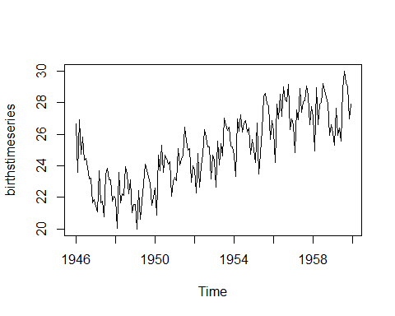

plot.ts(birthstimeseries2)

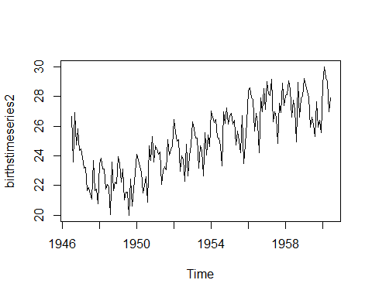

plot.ts(birthstimeseries3)

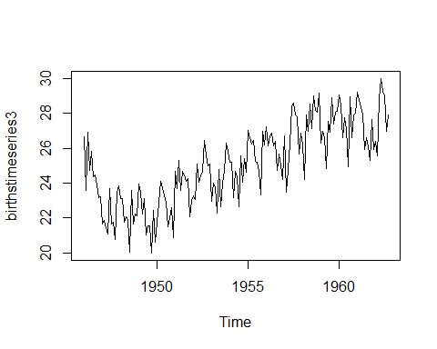

plot.ts(kingstimeseries)

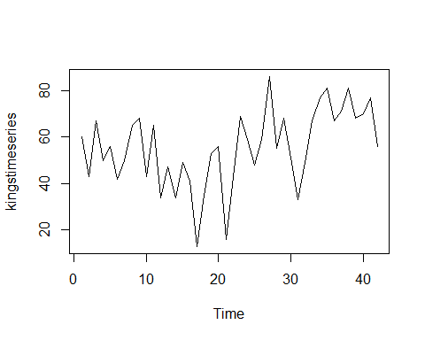

souvenirtimeseries <- ts(souvenir, frequency= 12, start=c(1987,1))  
souvenirtimeseries

## Jan Feb Mar Apr May Jun Jul  
## 1987 1664.81 2397.53 2840.71 3547.29 3752.96 3714.74 4349.61  
## 1988 2499.81 5198.24 7225.14 4806.03 5900.88 4951.34 6179.12  
## 1989 4717.02 5702.63 9957.58 5304.78 6492.43 6630.80 7349.62  
## 1990 5921.10 5814.58 12421.25 6369.77 7609.12 7224.75 8121.22  
## 1991 4826.64 6470.23 9638.77 8821.17 8722.37 10209.48 11276.55  
## 1992 7615.03 9849.69 14558.40 11587.33 9332.56 13082.09 16732.78  
## 1993 10243.24 11266.88 21826.84 17357.33 15997.79 18601.53 26155.15  
## Aug Sep Oct Nov Dec  
## 1987 3566.34 5021.82 6423.48 7600.60 19756.21  
## 1988 4752.15 5496.43 5835.10 12600.08 28541.72  
## 1989 8176.62 8573.17 9690.50 15151.84 34061.01  
## 1990 7979.25 8093.06 8476.70 17914.66 30114.41  
## 1991 12552.22 11637.39 13606.89 21822.11 45060.69  
## 1992 19888.61 23933.38 25391.35 36024.80 80721.71  
## 1993 28586.52 30505.41 30821.33 46634.38 104660.67

logsouvenierstimeseries <- log(souvenirtimeseries)  
plot.ts(logsouvenierstimeseries)

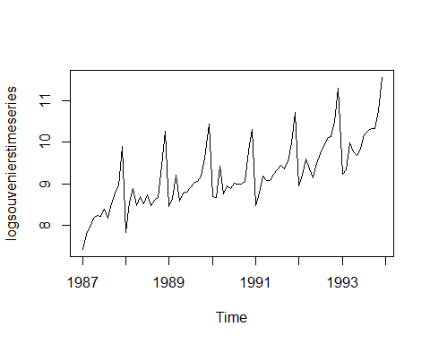

# decompose non-seasonal data ---------------------------------------------  
kingstimeseries.SMA3 <- SMA(kingstimeseries, n=3)  
plot.ts(kingstimeseries.SMA3)

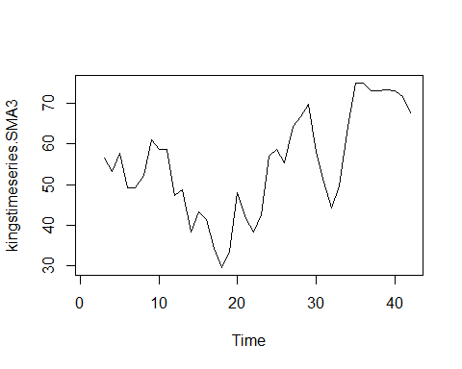

kingstimeseries.SMA8 <- SMA(kingstimeseries, n=8)  
plot.ts(kingstimeseries.SMA8)

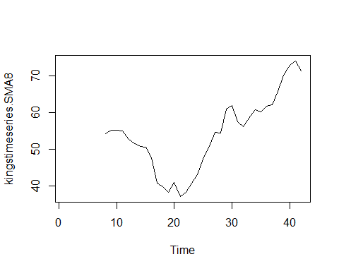

# Decompose Seasonal data------  
birthstimeseries.components <- decompose(birthstimeseries)  
# decompose(birthstimeseries, type="additive")  
# decompose(birthstimeseries, type="multiplicative")  
birthstimeseries.components$seasonal

## Jan Feb Mar Apr May Jun  
## 1946 -0.6771947 -2.0829607 0.8625232 -0.8016787 0.2516514 -0.1532556  
## 1947 -0.6771947 -2.0829607 0.8625232 -0.8016787 0.2516514 -0.1532556  
## 1948 -0.6771947 -2.0829607 0.8625232 -0.8016787 0.2516514 -0.1532556  
## 1949 -0.6771947 -2.0829607 0.8625232 -0.8016787 0.2516514 -0.1532556  
## 1950 -0.6771947 -2.0829607 0.8625232 -0.8016787 0.2516514 -0.1532556  
## 1951 -0.6771947 -2.0829607 0.8625232 -0.8016787 0.2516514 -0.1532556  
## 1952 -0.6771947 -2.0829607 0.8625232 -0.8016787 0.2516514 -0.1532556  
## 1953 -0.6771947 -2.0829607 0.8625232 -0.8016787 0.2516514 -0.1532556  
## 1954 -0.6771947 -2.0829607 0.8625232 -0.8016787 0.2516514 -0.1532556  
## 1955 -0.6771947 -2.0829607 0.8625232 -0.8016787 0.2516514 -0.1532556  
## 1956 -0.6771947 -2.0829607 0.8625232 -0.8016787 0.2516514 -0.1532556  
## 1957 -0.6771947 -2.0829607 0.8625232 -0.8016787 0.2516514 -0.1532556  
## 1958 -0.6771947 -2.0829607 0.8625232 -0.8016787 0.2516514 -0.1532556  
## 1959 -0.6771947 -2.0829607 0.8625232 -0.8016787 0.2516514 -0.1532556  
## Jul Aug Sep Oct Nov Dec  
## 1946 1.4560457 1.1645938 0.6916162 0.7752444 -1.1097652 -0.3768197  
## 1947 1.4560457 1.1645938 0.6916162 0.7752444 -1.1097652 -0.3768197  
## 1948 1.4560457 1.1645938 0.6916162 0.7752444 -1.1097652 -0.3768197  
## 1949 1.4560457 1.1645938 0.6916162 0.7752444 -1.1097652 -0.3768197  
## 1950 1.4560457 1.1645938 0.6916162 0.7752444 -1.1097652 -0.3768197  
## 1951 1.4560457 1.1645938 0.6916162 0.7752444 -1.1097652 -0.3768197  
## 1952 1.4560457 1.1645938 0.6916162 0.7752444 -1.1097652 -0.3768197  
## 1953 1.4560457 1.1645938 0.6916162 0.7752444 -1.1097652 -0.3768197  
## 1954 1.4560457 1.1645938 0.6916162 0.7752444 -1.1097652 -0.3768197  
## 1955 1.4560457 1.1645938 0.6916162 0.7752444 -1.1097652 -0.3768197  
## 1956 1.4560457 1.1645938 0.6916162 0.7752444 -1.1097652 -0.3768197  
## 1957 1.4560457 1.1645938 0.6916162 0.7752444 -1.1097652 -0.3768197  
## 1958 1.4560457 1.1645938 0.6916162 0.7752444 -1.1097652 -0.3768197  
## 1959 1.4560457 1.1645938 0.6916162 0.7752444 -1.1097652 -0.3768197

birthstimeseries.components$trend

## Jan Feb Mar Apr May Jun Jul  
## 1946 NA NA NA NA NA NA 23.98433  
## 1947 22.35350 22.30871 22.30258 22.29479 22.29354 22.30562 22.33483  
## 1948 22.43038 22.43667 22.38721 22.35242 22.32458 22.27458 22.23754  
## 1949 22.06375 22.08033 22.13317 22.16604 22.17542 22.21342 22.27625  
## 1950 23.21663 23.26967 23.33492 23.42679 23.50638 23.57017 23.63888  
## 1951 24.00083 24.12350 24.20917 24.28208 24.35450 24.43242 24.49496  
## 1952 24.27204 24.27300 24.28942 24.30129 24.31325 24.35175 24.40558  
## 1953 24.78646 24.84992 24.92692 25.02362 25.16308 25.26963 25.30154  
## 1954 25.92446 25.92317 25.92967 25.92137 25.89567 25.89458 25.92963  
## 1955 25.64612 25.78679 25.93192 26.06388 26.16329 26.25388 26.35471  
## 1956 27.21104 27.21900 27.20700 27.26925 27.35050 27.37983 27.39975  
## 1957 27.44221 27.40283 27.44300 27.45717 27.44429 27.48975 27.54354  
## 1958 27.68642 27.76067 27.75963 27.71037 27.65783 27.58125 27.49075  
## 1959 26.96858 27.00512 27.09250 27.17263 27.26208 27.36033 NA  
## Aug Sep Oct Nov Dec  
## 1946 23.66213 23.42333 23.16112 22.86425 22.54521  
## 1947 22.31167 22.26279 22.25796 22.27767 22.35400  
## 1948 22.21988 22.16983 22.07721 22.01396 22.02604  
## 1949 22.35750 22.48862 22.70992 22.98563 23.16346  
## 1950 23.75713 23.86354 23.89533 23.87342 23.88150  
## 1951 24.48379 24.43879 24.36829 24.29192 24.27642  
## 1952 24.44475 24.49325 24.58517 24.70429 24.76017  
## 1953 25.34125 25.42779 25.57588 25.73904 25.87513  
## 1954 25.98246 26.01054 25.88617 25.67087 25.57312  
## 1955 26.40496 26.45379 26.64933 26.95183 27.14683  
## 1956 27.44150 27.45229 27.43354 27.44488 27.46996  
## 1957 27.56933 27.63167 27.67804 27.62579 27.61212  
## 1958 27.46183 27.42262 27.34175 27.25129 27.08558  
## 1959 NA NA NA NA NA

birthstimeseries.components$type

## [1] "additive"

plot(birthstimeseries.components)

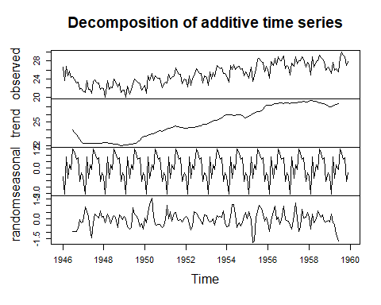

plot.ts(birthstimeseries.components$seasonal)

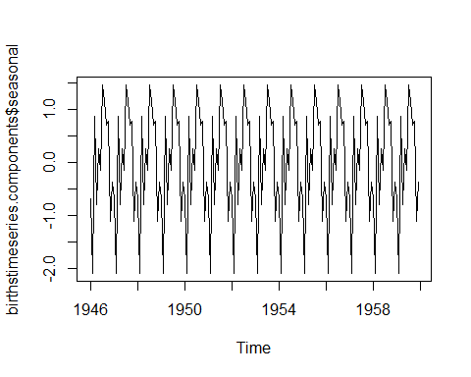

plot.ts(birthstimeseries.components$trend)

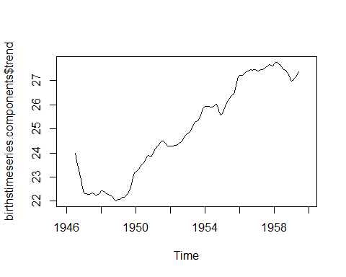

# Seosonal adjusting ------------------------------------------------------  
  
birthstimeseries.seasonally.adjusted <- birthstimeseries - birthstimeseries.components$seasonal  
plot(birthstimeseries.seasonally.adjusted, main="seasonally adjusted") #계절적인 요소가 제거된 시계열 모형

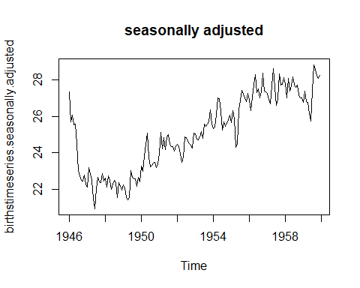

op <- par(no.readonly = TRUE)  
par(mfrow=c(1,3))  
  
plot(birthstimeseries, main="timeseries")  
plot(birthstimeseries.components$seasonal, main="seasomal")   
plot(birthstimeseries.seasonally.adjusted, main="seasonally adjusted") #계절적인 요소가 제거된 시계열 모형

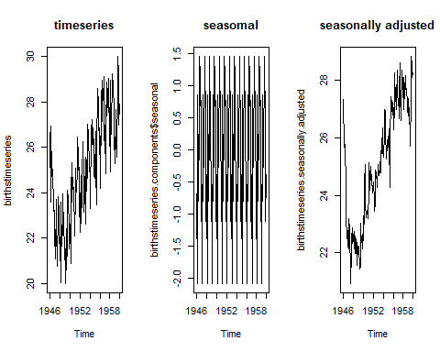

par(mfrow=c(1,1))