04.04.01.multi.dimensional_MDS_.R

Yerim

Fri Feb 09 23:39:51 2018

# MDS multi dimensional scaling 다차원 척도법----------------------------------------------------------------  
  
  
data("eurodist")  
head(eurodist)

## [1] 3313 2963 3175 3339 2762 3276

str(eurodist)

## Class 'dist' atomic [1:210] 3313 2963 3175 3339 2762 ...  
## ..- attr(*, "Size")= num 21  
## ..- attr(*, "Labels")= chr [1:21] "Athens" "Barcelona" "Brussels" "Calais" ...

loc <- cmdscale(eurodist)  
loc

## [,1] [,2]  
## Athens 2290.274680 1798.80293  
## Barcelona -825.382790 546.81148  
## Brussels 59.183341 -367.08135  
## Calais -82.845973 -429.91466  
## Cherbourg -352.499435 -290.90843  
## Cologne 293.689633 -405.31194  
## Copenhagen 681.931545 -1108.64478  
## Geneva -9.423364 240.40600  
## Gibraltar -2048.449113 642.45854  
## Hamburg 561.108970 -773.36929  
## Hook of Holland 164.921799 -549.36704  
## Lisbon -1935.040811 49.12514  
## Lyons -226.423236 187.08779  
## Madrid -1423.353697 305.87513  
## Marseilles -299.498710 388.80726  
## Milan 260.878046 416.67381  
## Munich 587.675679 81.18224  
## Paris -156.836257 -211.13911  
## Rome 709.413282 1109.36665  
## Stockholm 839.445911 -1836.79055  
## Vienna 911.230500 205.93020

x <- loc[, 1]  
y <- loc[, 2]  
plot(x, y, type = "n", main = "eurodist")  
text(x, y, rownames(loc), cex = 0.8)  
abline(v = 0, h = 0, col = "red")

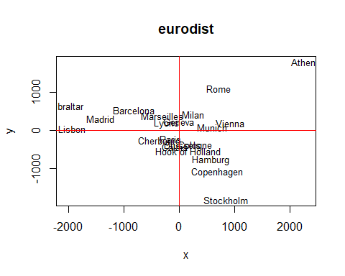

# PCA ---------------------------------------------------------------------  
  
  
library(datasets)  
data("USArrests")  
head(USArrests)

## Murder Assault UrbanPop Rape  
## Alabama 13.2 236 58 21.2  
## Alaska 10.0 263 48 44.5  
## Arizona 8.1 294 80 31.0  
## Arkansas 8.8 190 50 19.5  
## California 9.0 276 91 40.6  
## Colorado 7.9 204 78 38.7

mydata <- USArrests  
fit <- princomp(mydata, cor = TRUE)  
summary(fit)

## Importance of components:  
## Comp.1 Comp.2 Comp.3 Comp.4  
## Standard deviation 1.5748783 0.9948694 0.5971291 0.41644938  
## Proportion of Variance 0.6200604 0.2474413 0.0891408 0.04335752  
## Cumulative Proportion 0.6200604 0.8675017 0.9566425 1.00000000

summary(fit, loadings = T)

## Importance of components:  
## Comp.1 Comp.2 Comp.3 Comp.4  
## Standard deviation 1.5748783 0.9948694 0.5971291 0.41644938  
## Proportion of Variance 0.6200604 0.2474413 0.0891408 0.04335752  
## Cumulative Proportion 0.6200604 0.8675017 0.9566425 1.00000000  
##   
## Loadings:  
## Comp.1 Comp.2 Comp.3 Comp.4  
## Murder -0.536 0.418 -0.341 0.649  
## Assault -0.583 0.188 -0.268 -0.743  
## UrbanPop -0.278 -0.873 -0.378 0.134  
## Rape -0.543 -0.167 0.818

loadings(fit)

##   
## Loadings:  
## Comp.1 Comp.2 Comp.3 Comp.4  
## Murder -0.536 0.418 -0.341 0.649  
## Assault -0.583 0.188 -0.268 -0.743  
## UrbanPop -0.278 -0.873 -0.378 0.134  
## Rape -0.543 -0.167 0.818   
##   
## Comp.1 Comp.2 Comp.3 Comp.4  
## SS loadings 1.00 1.00 1.00 1.00  
## Proportion Var 0.25 0.25 0.25 0.25  
## Cumulative Var 0.25 0.50 0.75 1.00

plot(fit, type = "lines")

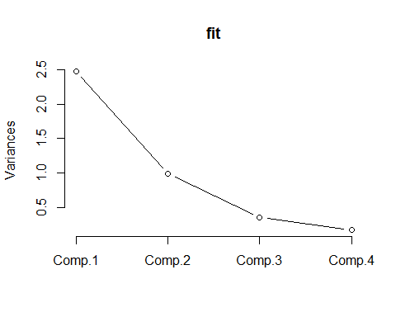

fit$scores

## Comp.1 Comp.2 Comp.3 Comp.4  
## Alabama -0.98556588 1.13339238 -0.44426879 0.156267145  
## Alaska -1.95013775 1.07321326 2.04000333 -0.438583440  
## Arizona -1.76316354 -0.74595678 0.05478082 -0.834652924  
## Arkansas 0.14142029 1.11979678 0.11457369 -0.182810896  
## California -2.52398013 -1.54293399 0.59855680 -0.341996478  
## Colorado -1.51456286 -0.98755509 1.09500699 0.001464887  
## Connecticut 1.35864746 -1.08892789 -0.64325757 -0.118469414  
## Delaware -0.04770931 -0.32535892 -0.71863294 -0.881977637  
## Florida -3.01304227 0.03922851 -0.57682949 -0.096284752  
## Georgia -1.63928304 1.27894240 -0.34246008 1.076796812  
## Hawaii 0.91265715 -1.57046001 0.05078189 0.902806864  
## Idaho 1.63979985 0.21097292 0.25980134 -0.499104101  
## Illinois -1.37891072 -0.68184119 -0.67749564 -0.122021292  
## Indiana 0.50546136 -0.15156254 0.22805484 0.424665700  
## Iowa 2.25364607 -0.10405407 0.16456432 0.017555916  
## Kansas 0.79688112 -0.27016470 0.02555331 0.206496428  
## Kentucky 0.75085907 0.95844029 -0.02836942 0.670556671  
## Louisiana -1.56481798 0.87105466 -0.78348036 0.454728038  
## Maine 2.39682949 0.37639158 -0.06568239 -0.330459817  
## Maryland -1.76336939 0.42765519 -0.15725013 -0.559069521  
## Massachusetts 0.48616629 -1.47449650 -0.60949748 -0.179598963  
## Michigan -2.10844115 -0.15539682 0.38486858 0.102372019  
## Minnesota 1.69268181 -0.63226125 0.15307043 0.067316885  
## Mississippi -0.99649446 2.39379599 -0.74080840 0.215508013  
## Missouri -0.69678733 -0.26335479 0.37744383 0.225824461  
## Montana 1.18545191 0.53687437 0.24688932 0.123742227  
## Nebraska 1.26563654 -0.19395373 0.17557391 0.015892888  
## Nevada -2.87439454 -0.77560020 1.16338049 0.314515476  
## New Hampshire 2.38391541 -0.01808229 0.03685539 -0.033137338  
## New Jersey -0.18156611 -1.44950571 -0.76445355 0.243382700  
## New Mexico -1.98002375 0.14284878 0.18369218 -0.339533597  
## New York -1.68257738 -0.82318414 -0.64307509 -0.013484369  
## North Carolina -1.12337861 2.22800338 -0.86357179 -0.954381667  
## North Dakota 2.99222562 0.59911882 0.30127728 -0.253987327  
## Ohio 0.22596542 -0.74223824 -0.03113912 0.473915911  
## Oklahoma 0.31178286 -0.28785421 -0.01530979 0.010332321  
## Oregon -0.05912208 -0.54141145 0.93983298 -0.237780688  
## Pennsylvania 0.88841582 -0.57110035 -0.40062871 0.359061124  
## Rhode Island 0.86377206 -1.49197842 -1.36994570 -0.613569430  
## South Carolina -1.32072380 1.93340466 -0.30053779 -0.131466685  
## South Dakota 1.98777484 0.82334324 0.38929333 -0.109571764  
## Tennessee -0.99974168 0.86025130 0.18808295 0.652864291  
## Texas -1.35513821 -0.41248082 -0.49206886 0.643195491  
## Utah 0.55056526 -1.47150461 0.29372804 -0.082314047  
## Vermont 2.80141174 1.40228806 0.84126309 -0.144889914  
## Virginia 0.09633491 0.19973529 0.01171254 0.211370813  
## Washington 0.21690338 -0.97012418 0.62487094 -0.220847793  
## West Virginia 2.10858541 1.42484670 0.10477467 0.131908831  
## Wisconsin 2.07971417 -0.61126862 -0.13886500 0.184103743  
## Wyoming 0.62942666 0.32101297 -0.24065923 -0.166651801

biplot(fit) # 주성분 분석 도표로 나타내는 것

