Kazakh British Technical University
Databases

Laboratory Work №2

Full Name: Sarsenov Yernar

23.09.2026
Almaty
Normalization
Task-1:
The booking_receipt table violates First Normal Form.
Reason: The seat_numbers column contains non-atomic, multi-valued data. 1NF requires every attribute to contain single, atomic values.

Task-2:
First Normal Form
Eliminated multi-valued values in seat_numbers by making each row represent a single seat.
- Table: booking_receipt_1NF (booking_id, passport_number, full_name, flight_number, departure_airport_name, departure_city, arrival_airport_name, arrival_city, airline_name, seat_number, ticket_price).
- Primary Key: (booking_id, passport_number).
Second Normal Form
Eliminated partial dependencies by splitting attributes that depend on only part of the primary key.
- Resulting Tables:
- Passenger (passport_number, full_name)
- Booking (booking_id, flight_number, departure_airport_name, departure_city, arrival_airport_name, arrival_city, airline_name, ticket_price)
- Booking_Passenger (booking_id [FK], passport_number [FK], seat_number)
Third Normal Form
Eliminated transitive dependencies so non-key attributes only depend on primary keys.
- Final 3NF Schema:
- Passengers (passport_number, full_name)
- Airports (airport_name, city)
- Flights (flight_number, airline_name, departure_airport_name [FK], arrival_airport_name [FK])
- Bookings (booking_id, flight_number [FK], ticket_price)
- Booking_Seats (booking_id [FK], passport_number [FK], seat_number)

Task-3:
Functional Dependencies:
- booking_id -> flight_number, ticket_price
- flight_number -> airline_name, departure_airport_name, arrival_airport_name
- departure_airport_name -> departure_city
- arrival_airport_name -> arrival_city
- passport_number -> full_name
- booking_id, passport_number -> seat_number

Task-4:
Is Flights in 3NF? Yes.
Explanation: flight_id is the primary key. All non-key attributes depend directly and solely on flight_id. Foreign entities (departing_airport_id, arriving_airport_id, airline_id) are referenced via integer primary keys, avoiding transitive dependencies within the Flights table itself

DDL
Creating initial DDL tables:
CREATE TABLE airline_info (airline_id INT, airline_code VARCHAR(30), airline_name VARCHAR(50), airline_country VARCHAR(50), created_at TIMESTAMP, updated_at TIMESTAMP, info VARCHAR(50));
CREATE TABLE airport (airport_id INT, airport_name VARCHAR(50), country VARCHAR(50), state VARCHAR(50), city VARCHAR(50), created_at TIMESTAMP, updated_at TIMESTAMP);
CREATE TABLE baggage_check (baggage_check_id INT, check_result VARCHAR(50), created_at TIMESTAMP, updated_at TIMESTAMP, booking_id INT, passenger_id INT);
CREATE TABLE baggage (baggage_id INT, weight_in_kg DECIMAL(4,2), created_at TIMESTAMP, updated_at TIMESTAMP, booking_id INT);
CREATE TABLE boarding_pass (boarding_pass_id INT, booking_id INT, seat VARCHAR(50), boarding_time TIMESTAMP, created_at TIMESTAMP, updated_at TIMESTAMP);
CREATE TABLE booking_flight (booking_flight_id INT, booking_id INT, flight_id INT, created_at TIMESTAMP, updated_at TIMESTAMP);
CREATE TABLE booking (booking_id INT, flight_id INT, passenger_id INT, booking_platform VARCHAR(50), created_at TIMESTAMP, updated_at TIMESTAMP, status VARCHAR(50), price DECIMAL(7,2));
CREATE TABLE flights (flight_id INT, sch_departure_time TIMESTAMP, sch_arrival_time TIMESTAMP, departing_airport_id INT, arriving_airport_id INT, departing_gate VARCHAR(50), arriving_gate VARCHAR(50), airline_id INT, act_departure_time TIMESTAMP, act_arrival_time TIMESTAMP, created_at TIMESTAMP, updated_at TIMESTAMP);
CREATE TABLE passengers (passenger_id INT, first_name VARCHAR(50), last_name VARCHAR(50), date_of_birth DATE, gender VARCHAR(50), country_of_citizenship VARCHAR(50), country_of_residence VARCHAR(50), passport_number VARCHAR(20), created_at TIMESTAMP, updated_at TIMESTAMP);
CREATE TABLE security_check (security_check_id INT, check_result VARCHAR(20), created_at TIMESTAMP, updated_at TIMESTAMP, passenger_id INT);

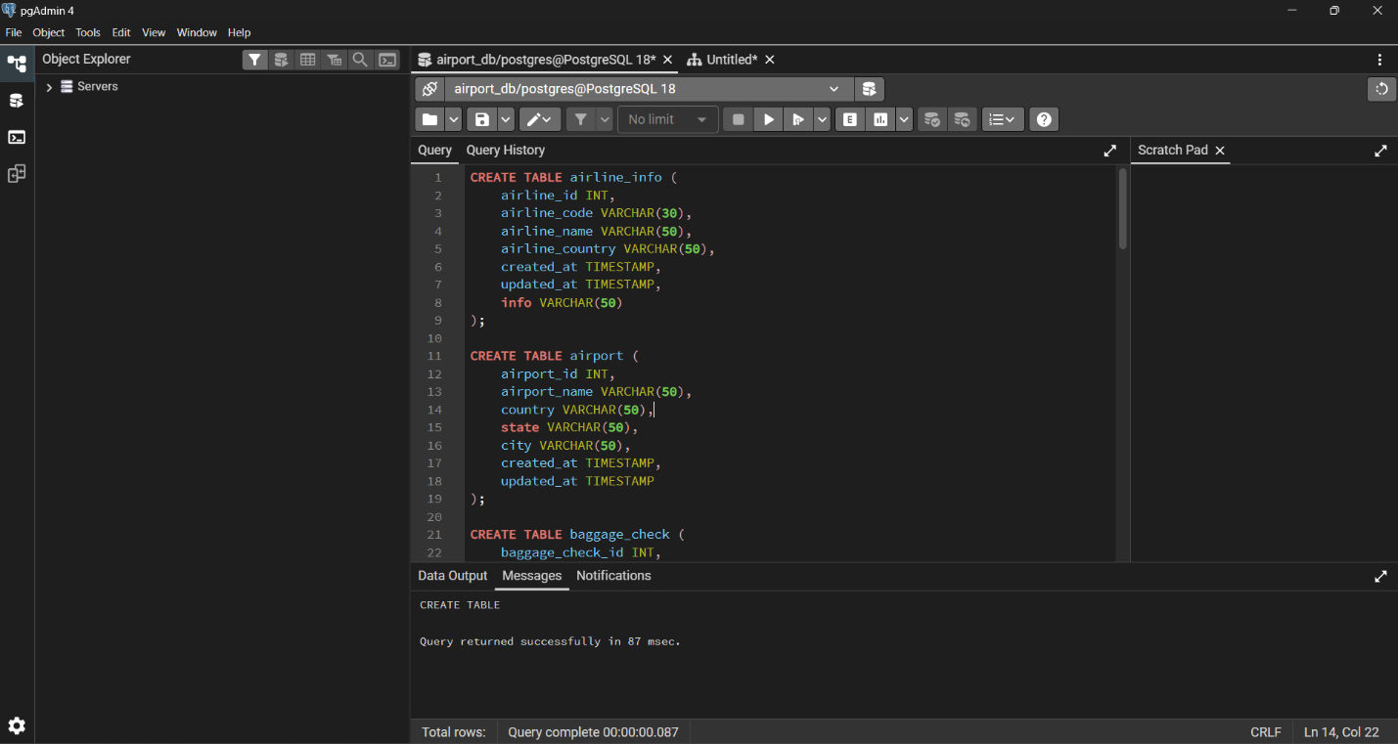

Adding primary keys:
ALTER TABLE airline_info ADD PRIMARY KEY (airline_id);
ALTER TABLE airport ADD PRIMARY KEY (airport_id);
ALTER TABLE baggage_check ADD PRIMARY KEY (baggage_check_id);
ALTER TABLE baggage ADD PRIMARY KEY (baggage_id);
ALTER TABLE boarding_pass ADD PRIMARY KEY (boarding_pass_id);
ALTER TABLE booking_flight ADD PRIMARY KEY (booking_flight_id);
ALTER TABLE booking ADD PRIMARY KEY (booking_id);
ALTER TABLE flights ADD PRIMARY KEY (flight_id);
ALTER TABLE passengers ADD PRIMARY KEY (passenger_id);
ALTER TABLE security_check ADD PRIMARY KEY (security_check_id);
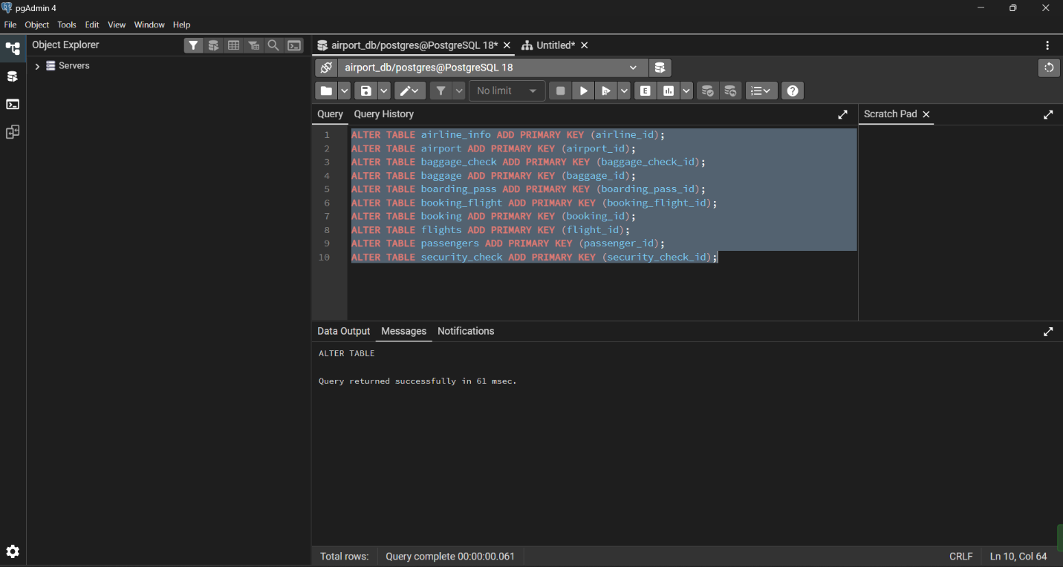

Setting NOT NULL constraints:

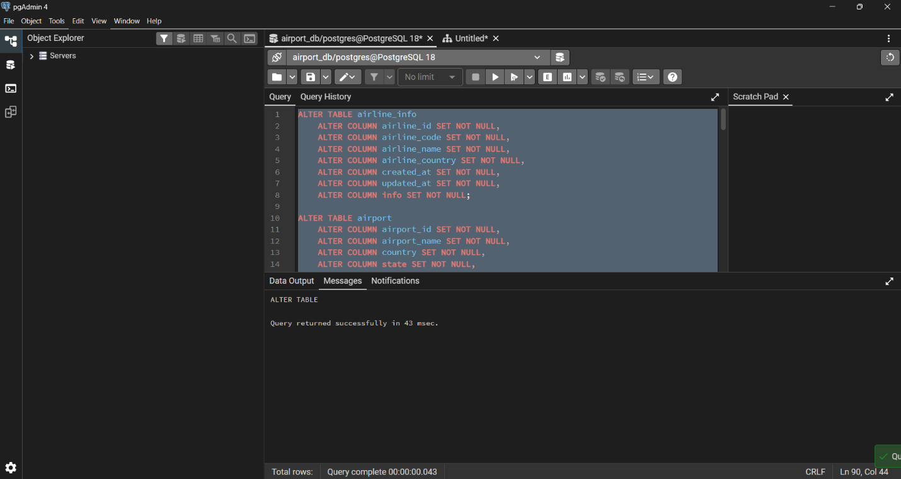

Renaming tables, columns, changing data types, and dropping columns:
ALTER TABLE airline_info RENAME TO airline;
ALTER TABLE booking RENAME COLUMN price TO ticket_price;
ALTER TABLE flights ALTER COLUMN departing_gate TYPE TEXT;
ALTER TABLE airline DROP COLUMN info;
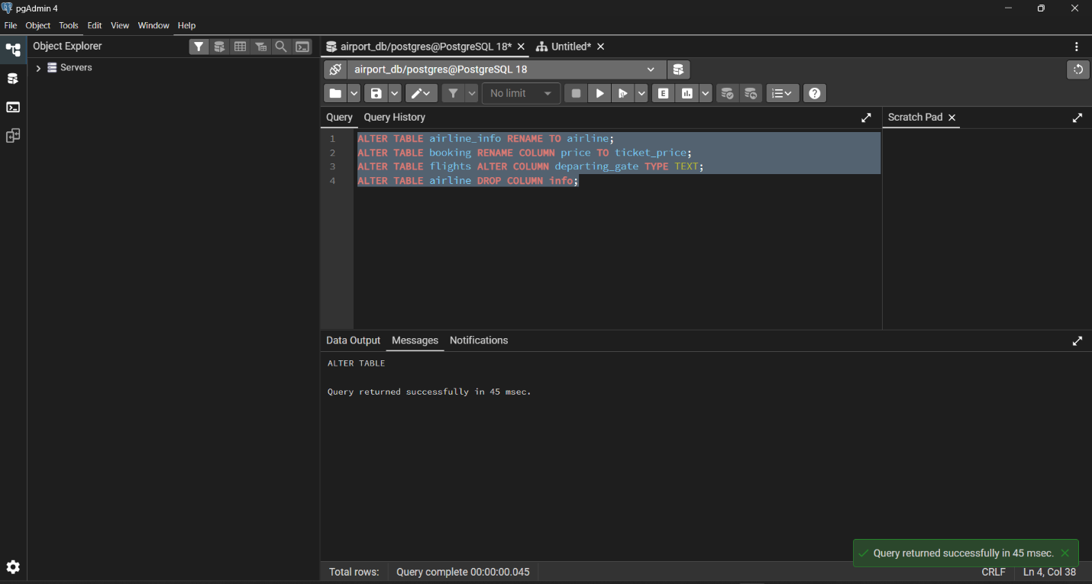

Creating Foreign Key relationships:
ALTER TABLE security_check
ADD CONSTRAINT fk_security_check_passenger
FOREIGN KEY (passenger_id) REFERENCES passengers (passenger_id);

ALTER TABLE booking
ADD CONSTRAINT fk_booking_passenger
FOREIGN KEY (passenger_id) REFERENCES passengers (passenger_id);

ALTER TABLE baggage_check
ADD CONSTRAINT fk_baggage_check_passenger
FOREIGN KEY (passenger_id) REFERENCES passengers (passenger_id);

ALTER TABLE baggage_check
ADD CONSTRAINT fk_baggage_check_booking
FOREIGN KEY (booking_id) REFERENCES booking (booking_id);

ALTER TABLE baggage
ADD CONSTRAINT fk_baggage_booking
FOREIGN KEY (booking_id) REFERENCES booking (booking_id);

ALTER TABLE boarding_pass
ADD CONSTRAINT fk_boarding_pass_booking
FOREIGN KEY (booking_id) REFERENCES booking (booking_id);

ALTER TABLE booking_flight
ADD CONSTRAINT fk_booking_flight_booking
FOREIGN KEY (booking_id) REFERENCES booking (booking_id);

ALTER TABLE booking_flight
ADD CONSTRAINT fk_booking_flight_flight
FOREIGN KEY (flight_id) REFERENCES flights (flight_id);

ALTER TABLE flights
ADD CONSTRAINT fk_flights_departing_airport
FOREIGN KEY (departing_airport_id) REFERENCES airport (airport_id);

ALTER TABLE flights
ADD CONSTRAINT fk_flights_arriving_airport
FOREIGN KEY (arriving_airport_id) REFERENCES airport (airport_id);

ALTER TABLE flights
ADD CONSTRAINT fk_flights_airline
FOREIGN KEY (airline_id) REFERENCES airline (airline_id);
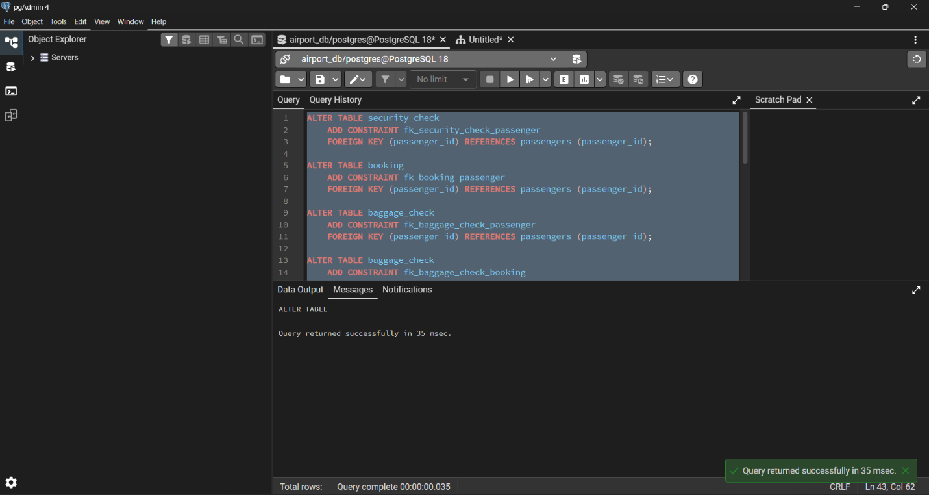

Database ERD:
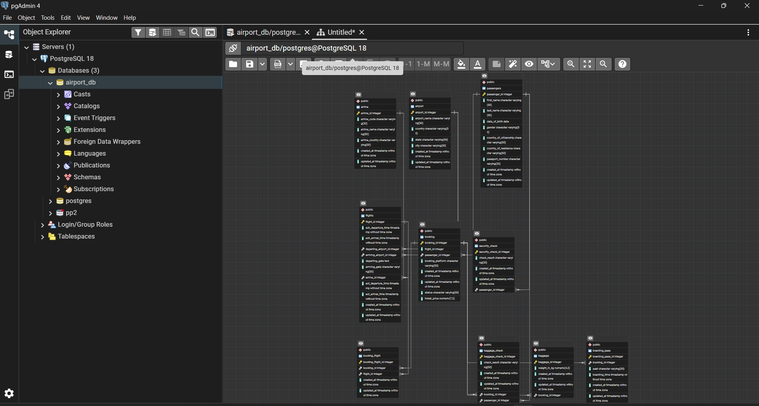

Normalization
Task-5:
Creating 3NF normalized tables:
CREATE TABLE nf_airport (
airport_name VARCHAR(100) PRIMARY KEY,
city VARCHAR(50) NOT NULL
);

CREATE TABLE nf_airline (
airline_name VARCHAR(50) PRIMARY KEY
);

CREATE TABLE nf_flight (
flight_number VARCHAR(10) PRIMARY KEY,
airline_name VARCHAR(50) NOT NULL REFERENCES nf_airline (airline_name),
departure_airport_name VARCHAR(100) NOT NULL REFERENCES nf_airport (airport_name),
arrival_airport_name VARCHAR(100) NOT NULL REFERENCES nf_airport (airport_name)
);

CREATE TABLE nf_passenger (
passport_number VARCHAR(20) PRIMARY KEY,
full_name VARCHAR(100) NOT NULL
);

CREATE TABLE nf_booking (
booking_id INT PRIMARY KEY,
flight_number VARCHAR(10) NOT NULL REFERENCES nf_flight (flight_number),
ticket_price DECIMAL(9,2) NOT NULL
);

CREATE TABLE nf_booking_seat (
booking_id INT NOT NULL REFERENCES nf_booking (booking_id),
seat_number VARCHAR(5) NOT NULL,
passport_number VARCHAR(20) NOT NULL REFERENCES nf_passenger (passport_number),
PRIMARY KEY (booking_id, seat_number)
);
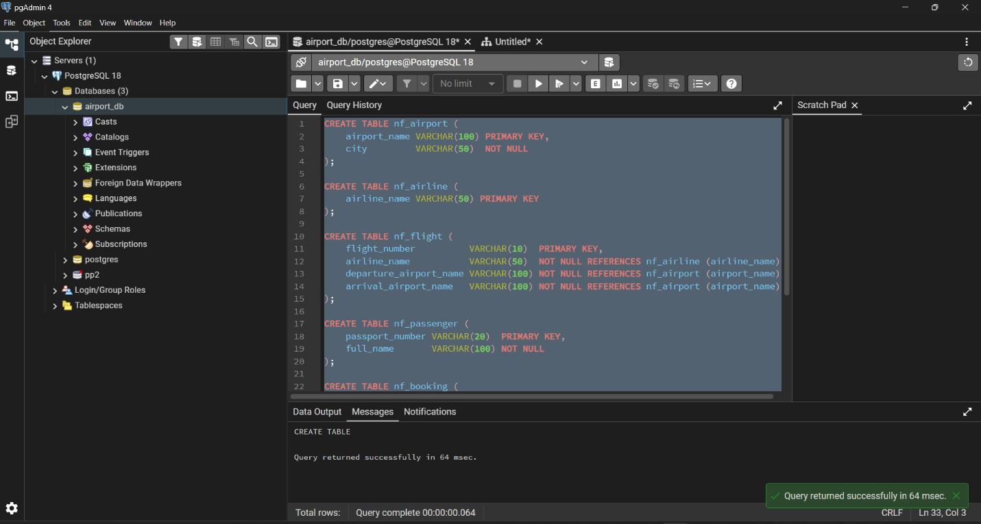

Inserting sample data into 3NF tables:
INSERT INTO nf_airport (airport_name, city) VALUES
('Almaty International Airport', 'Almaty'),
('Nursultan Nazarbayev Intl. Airport', 'Astana'),
('Aktobe International Airport', 'Aktobe'),
('Los Angeles International Airport', 'Los Angeles');

INSERT INTO nf_airline (airline_name) VALUES
('Air Astana'),
('SCAT Airlines'),
('Delta Air Lines');

INSERT INTO nf_flight (flight_number, airline_name, departure_airport_name, arrival_airport_name) VALUES
('KC901', 'Air Astana', 'Almaty International Airport', 'Nursultan Nazarbayev Intl. Airport'),
('KC902', 'Air Astana', 'Nursultan Nazarbayev Intl. Airport', 'Almaty International Airport'),
('DV501', 'SCAT Airlines', 'Almaty International Airport', 'Aktobe International Airport'),
('DV502', 'SCAT Airlines', 'Aktobe International Airport', 'Almaty International Airport'),
('DL101', 'Delta Air Lines', 'Almaty International Airport', 'Los Angeles International Airport'),
('DL102', 'Delta Air Lines', 'Los Angeles International Airport', 'Almaty International Airport');

INSERT INTO nf_passenger (passport_number, full_name) VALUES
('N1111111', 'Yernar Sarsenov'),
('N2222222', 'Aknur Nurlanova'),
('N3333333', 'Didar Serikbayev'),
('N4444444', 'Nikita Slepakov'),
('N5555555', 'Michael Jackson'),
('N6666666', 'Diana Damenova');

INSERT INTO nf_booking (booking_id, flight_number, ticket_price) VALUES
(1001, 'KC901', 45000.00),
(1002, 'KC902', 47000.00),
(1003, 'DV501', 60000.00),
(1004, 'DV502', 61000.00),
(1005, 'DL101', 350000.00),
(1006, 'DL102', 340000.00);

INSERT INTO nf_booking_seat (booking_id, seat_number, passport_number) VALUES
(1001, '12A', 'N1111111'),
(1002, '5B', 'N2222222'),
(1003, '20F', 'N3333333'),
(1004, '3C', 'N4444444'),
(1005, '1A', 'N5555555'),
(1006, '14D', 'N6666666');
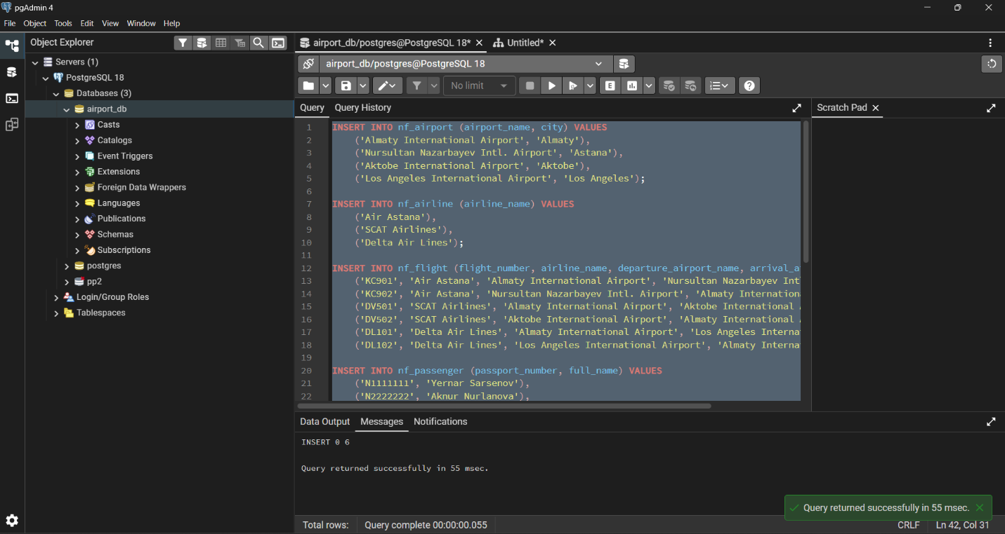

Result:

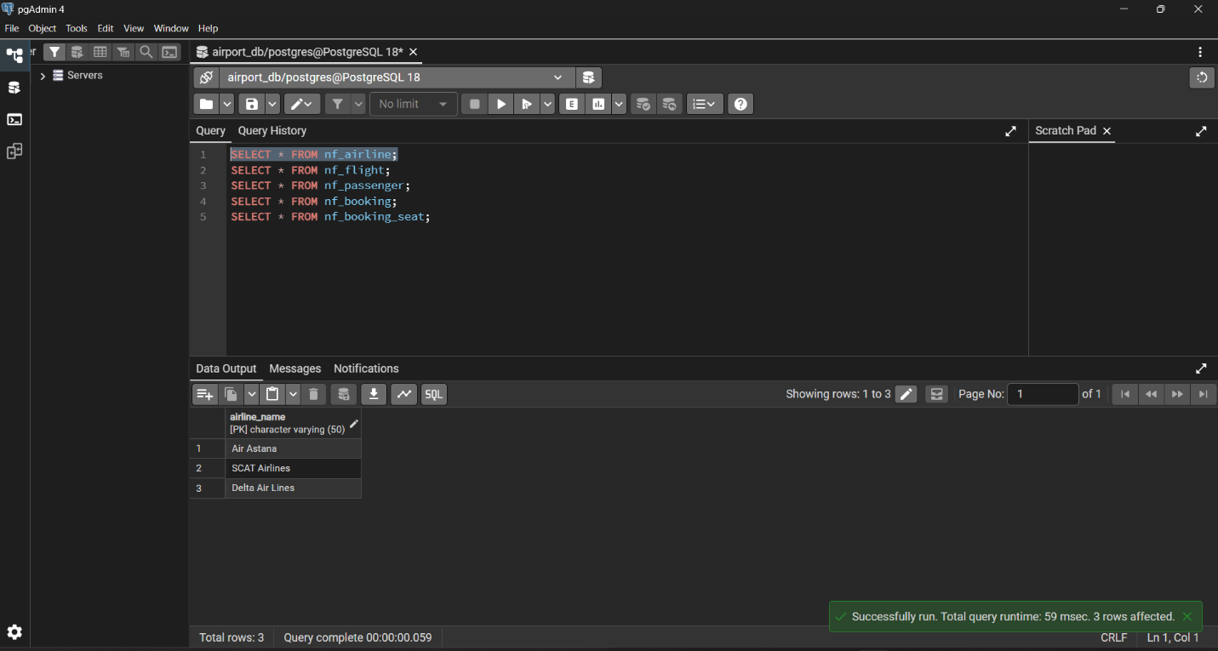
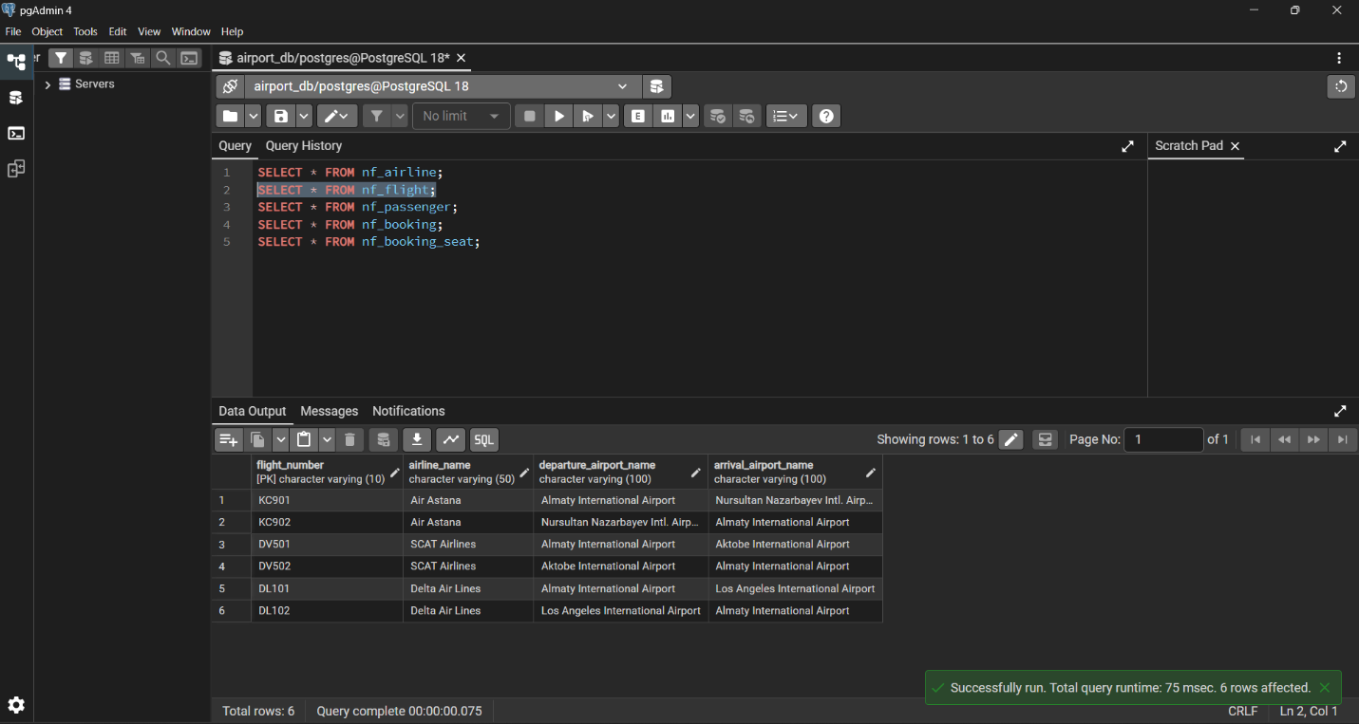
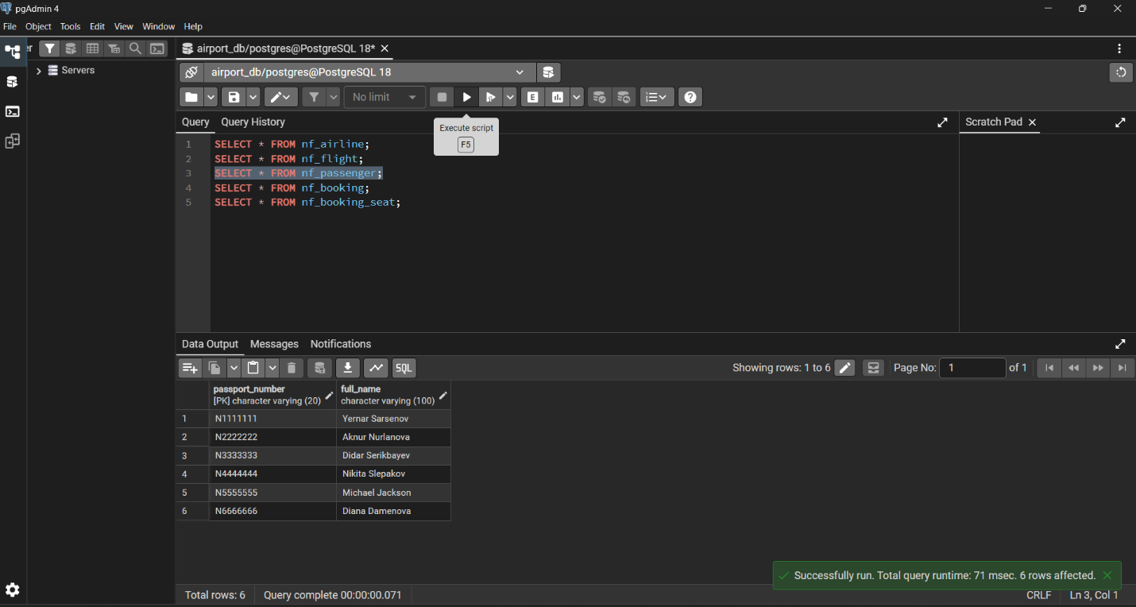

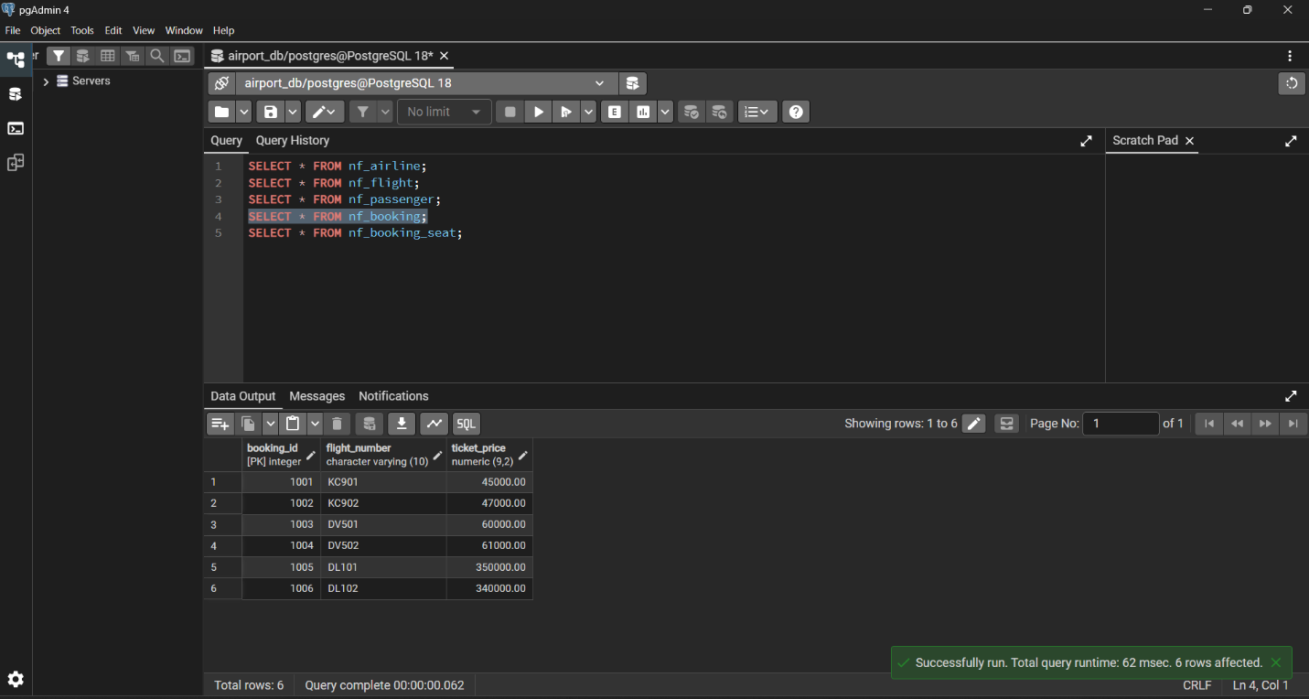
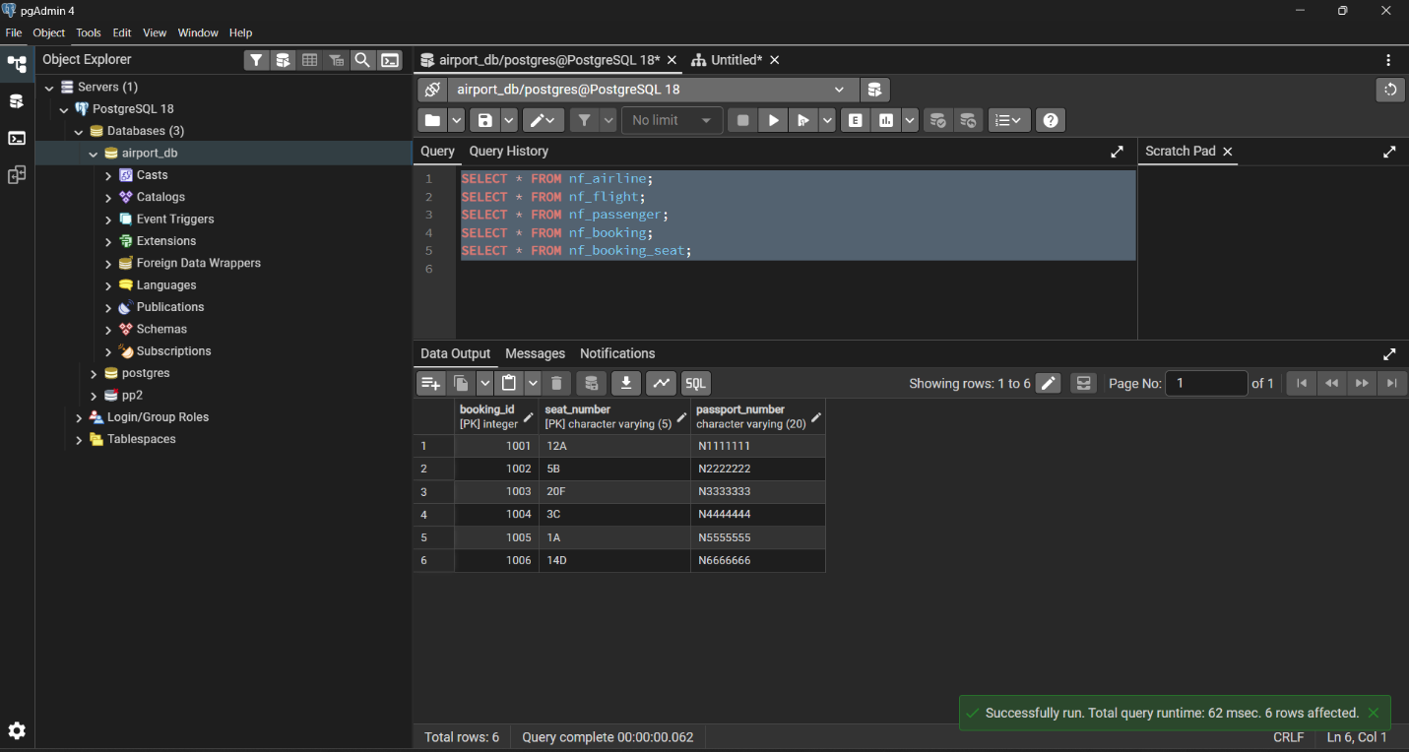

Reconstructing original booking receipt using JOIN:
SELECT b.booking_id,
p.full_name AS passenger_full_name,
p.passport_number AS passenger_passport_number,
f.flight_number,
f.departure_airport_name,
dep.city AS departure_city,
f.arrival_airport_name,
arr.city AS arrival_city,
f.airline_name,
bs.seat_number,
b.ticket_price
FROM nf_booking b
JOIN nf_booking_seat bs ON bs.booking_id = b.booking_id
JOIN nf_passenger p ON p.passport_number = bs.passport_number
JOIN nf_flight f ON f.flight_number = b.flight_number
JOIN nf_airport dep ON dep.airport_name = f.departure_airport_name
JOIN nf_airport arr ON arr.airport_name = f.arrival_airport_name
ORDER BY b.booking_id, bs.seat_number;
