Kazakh British Technical University
Databases

Laboratory Work №4

Full Name: Sarsenov Yernar

06.10.2026
Almaty
DQL
Task-1:
Retrieve all airline names in uppercase:
SELECT UPPER(airline_name) AS airline_name_upper
FROM airline;
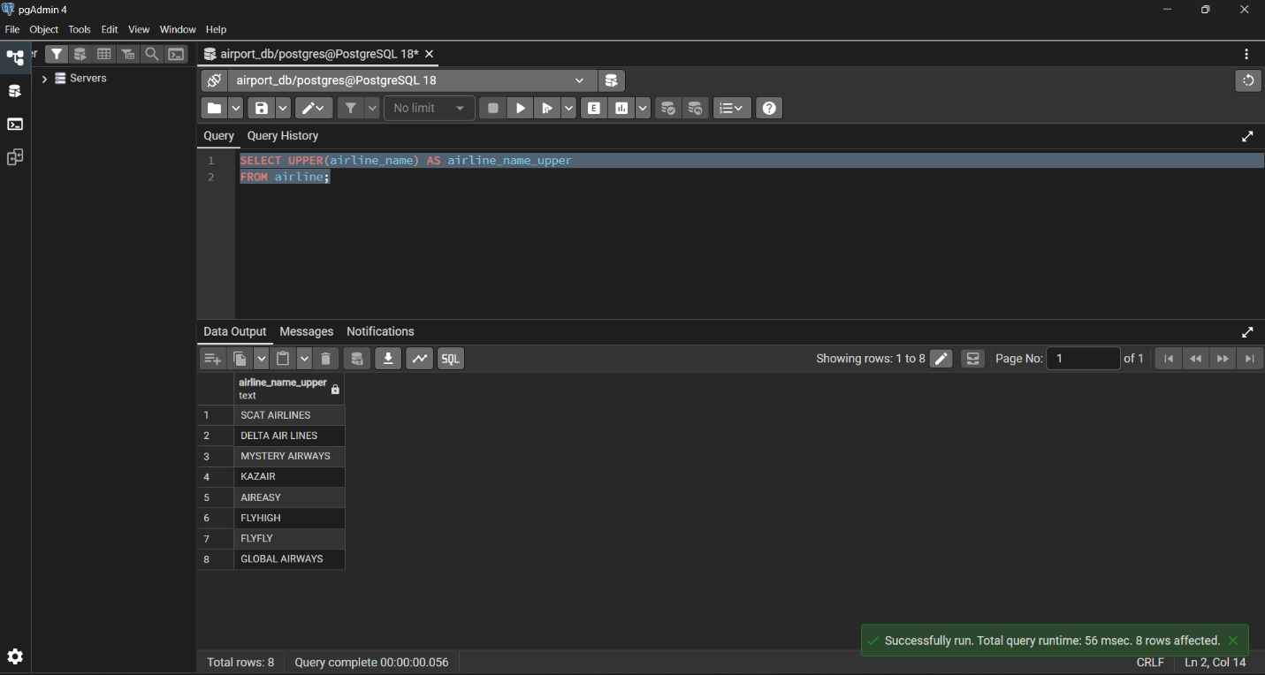
Task-2:
Replace any occurrence of the word "Air" in airline names with "Aero":
SELECT airline_name, REPLACE(airline_name, 'Air', 'Aero') AS new_name
FROM airline;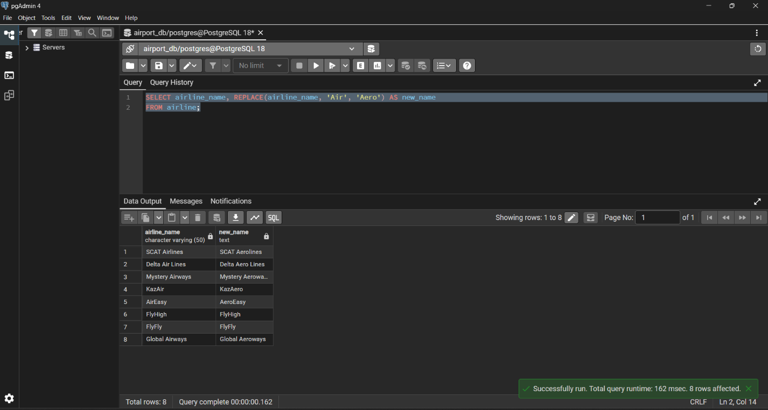
Task-3:
Fing all flight numbers that coordinates with both airline 1 and airline 2:
SELECT flight_id FROM flights WHERE airline_id = 1
INTERSECT SELECT flight_id FROM flights WHERE airline_id = 2;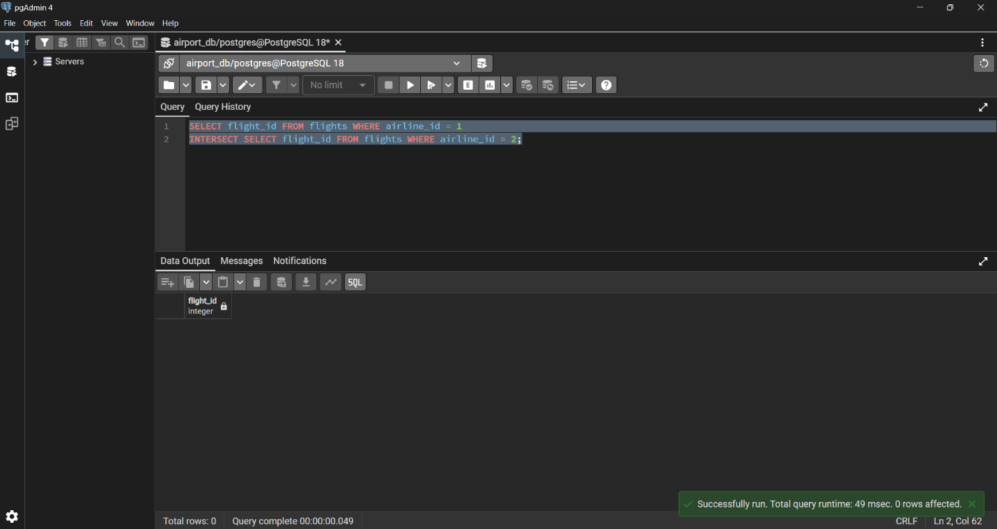
Task-4:
Retrieve airports that contain the word "Regional" and "Air" in their names:
SELECT * FROM airport
WHERE airport_name ILIKE '%Regional%' AND airport_name ILIKE '%Air%';
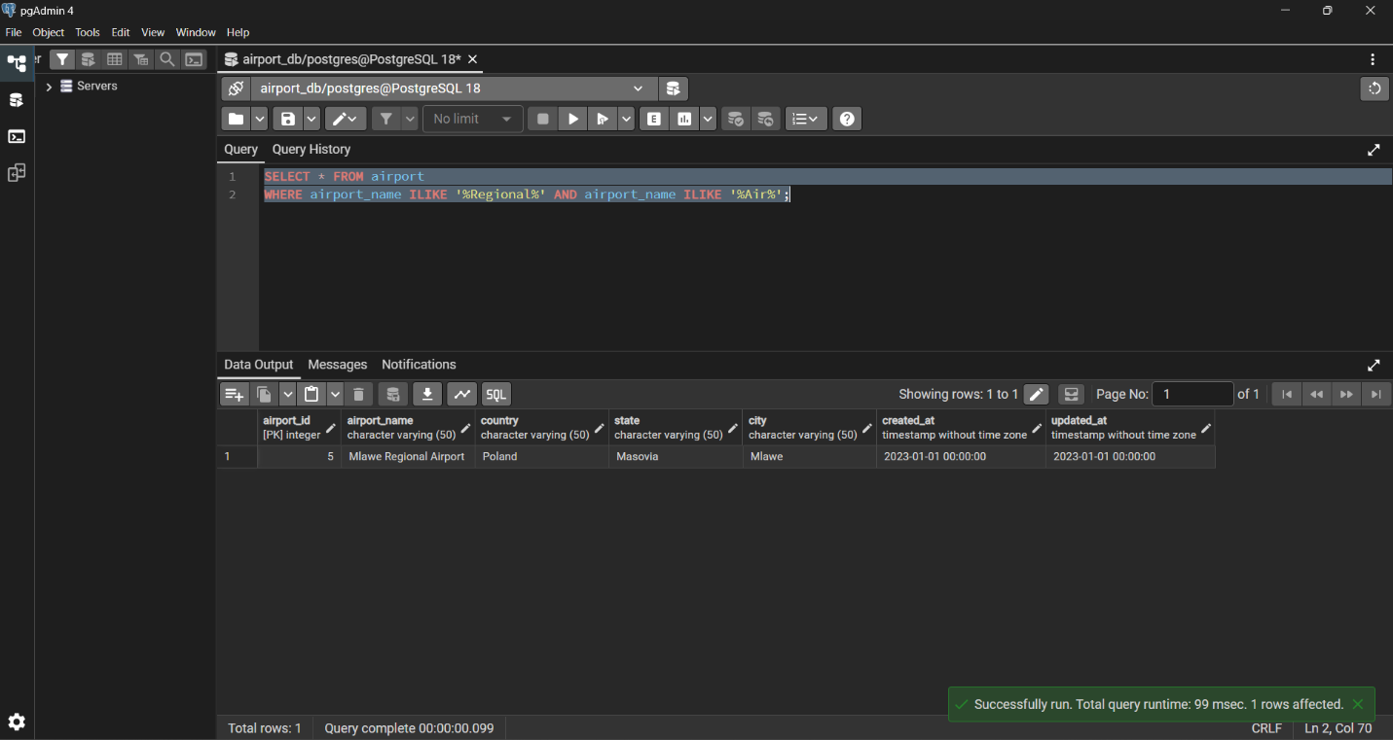
Task-5:
Retrieve passenger names and format their birth dates as 'Month DD, YYYY':
SELECT first_name, last_name,
TO_CHAR(date_of_birth, 'Month DD, YYYY') AS birth_date_formatted
FROM passengers;
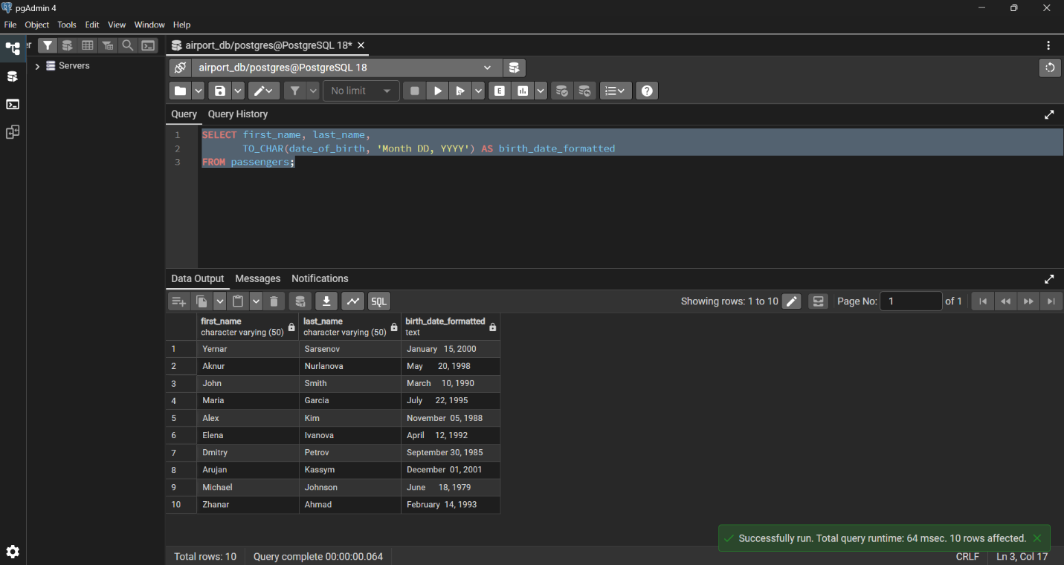
Task-6:
Find flight numbers that have been delayed based on the actual arrival time.
SELECT flight_id, sch_arrival_time, act_arrival_time FROM flights
WHERE act_arrival_time > sch_arrival_time;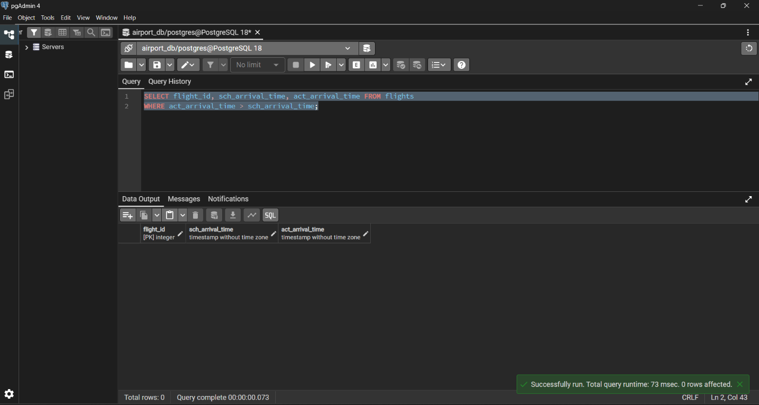
Task-7:
Find flights that arrived late according to their actual arrival time compared to the scheduled arrival time:
SELECT flight_id, sch_arrival_time, act_arrival_time FROM flights
WHERE act_arrival_time > sch_arrival_time;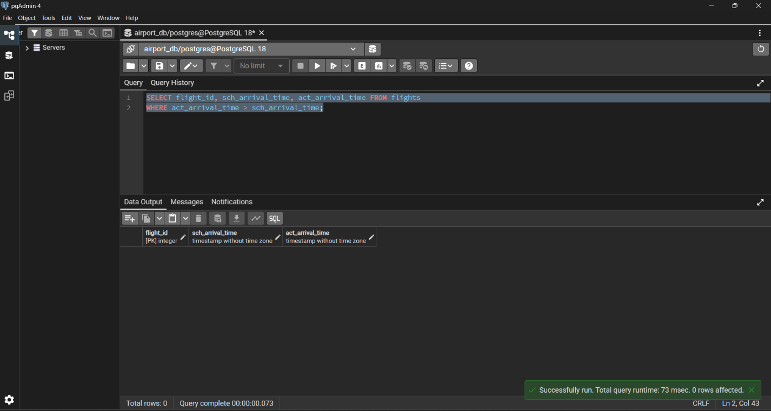

Task-8:
Show airlines from any of: ('France','Portugal','Poland') created between '2023-11-01' and '2024-03-31':
SELECT * FROM airline
WHERE airline_country IN ('France', 'Portugal', 'Poland') AND created_at BETWEEN '2023-11-01' AND '2024-03-31';
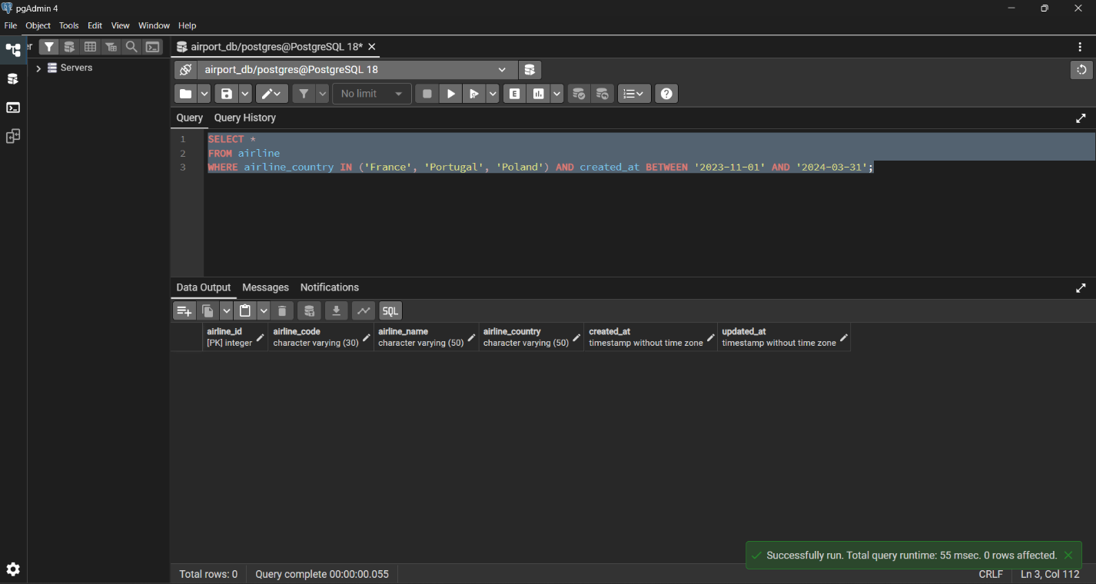

Task-9:
Find top3 overweighted baggage with more than 25kg:
SELECT * FROM baggage
WHERE weight_in_kg > 25
ORDER BY weight_in_kg DESC
LIMIT 3;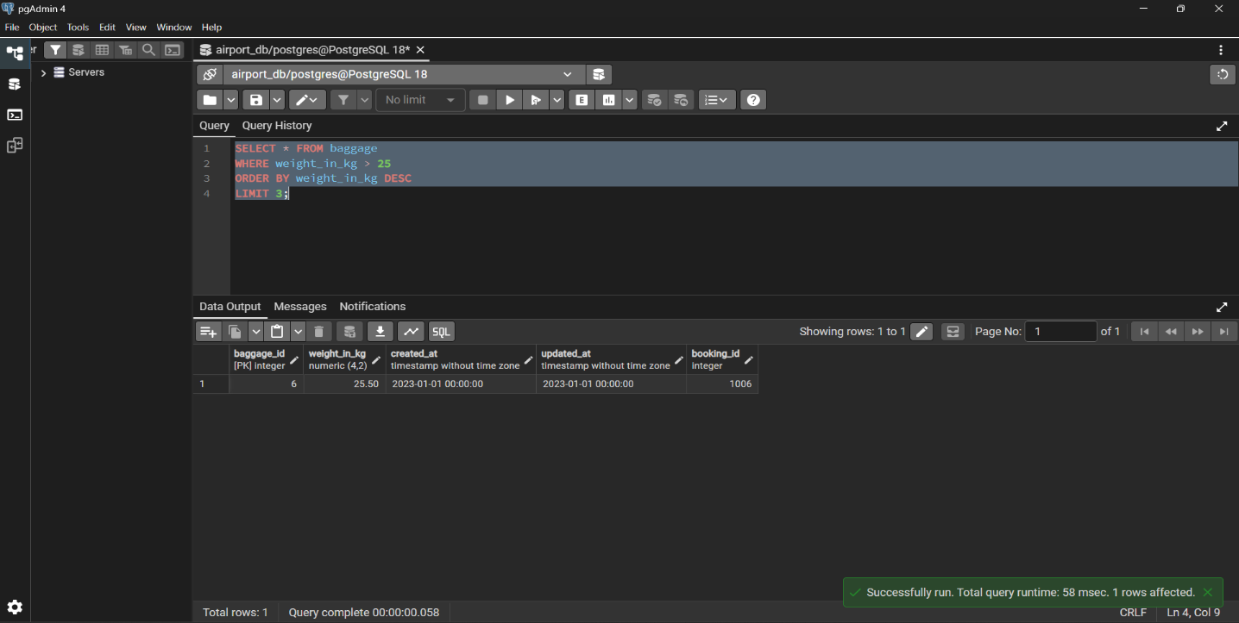
Task-10:
Find the youngest passengers’ full name:
SELECT first_name, last_name, date_of_birth FROM passengers
ORDER BY date_of_birth DESC
LIMIT 1;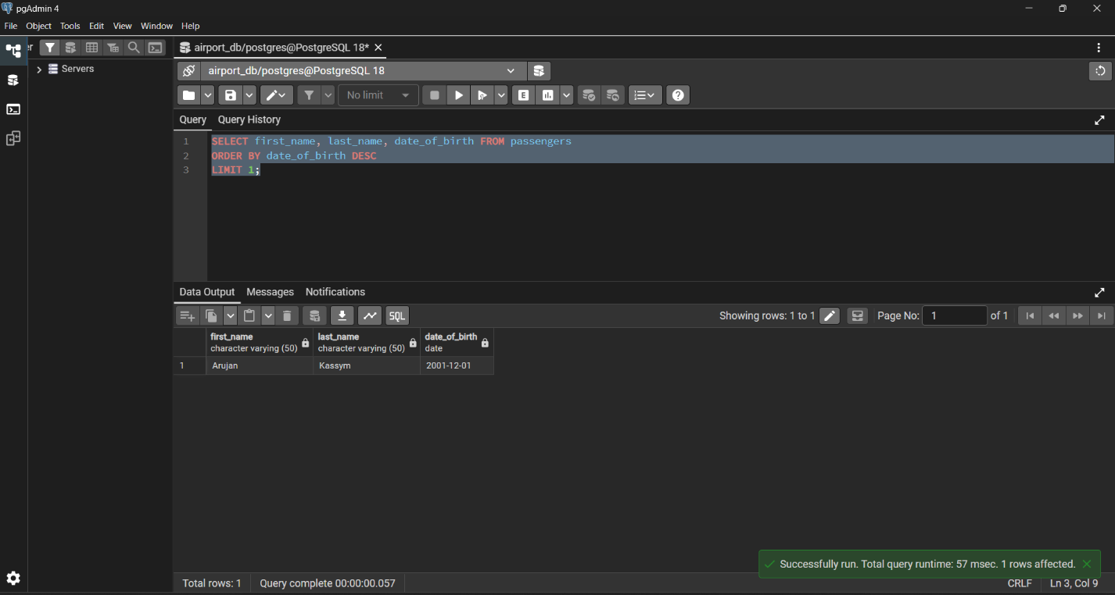

Task-11:
Find the cheapest booking price on each booking platform:
SELECT booking_platform, MIN(ticket_price) AS cheapest_price FROM booking
GROUP BY booking_platform;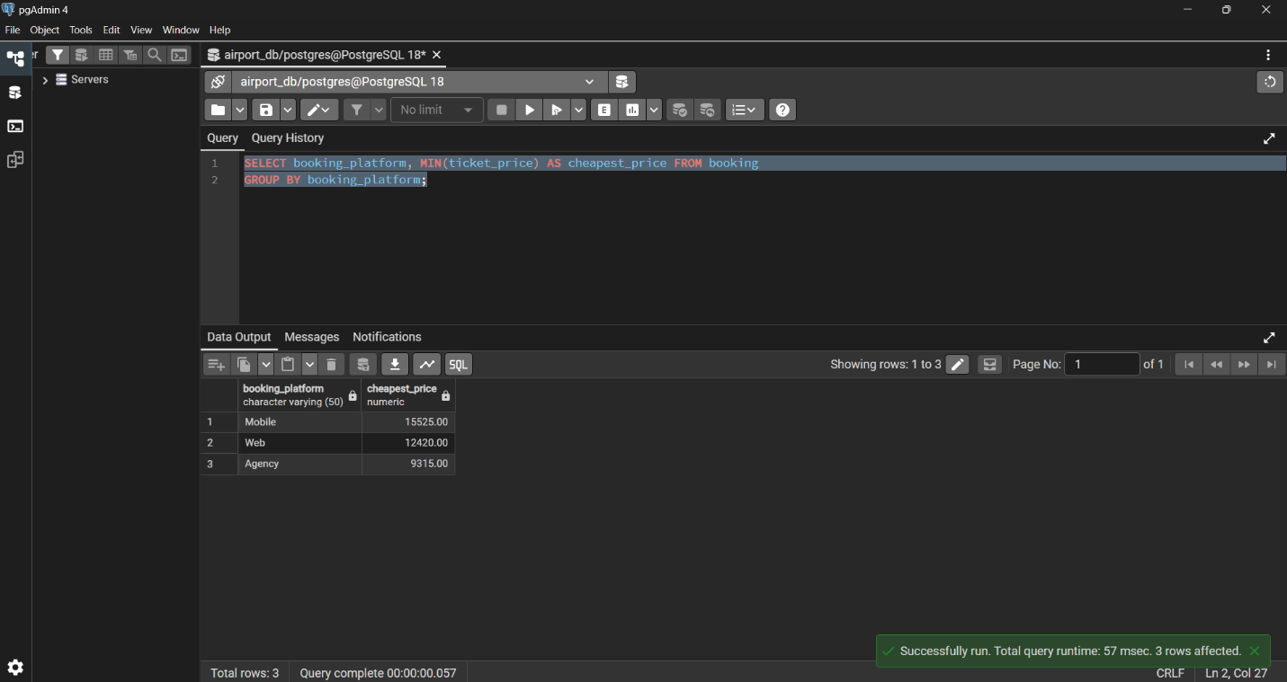

Task-12:
Return airlines whose airline_code contains a digit:
SELECT * FROM airline
WHERE airline_code ~ '[0-9]';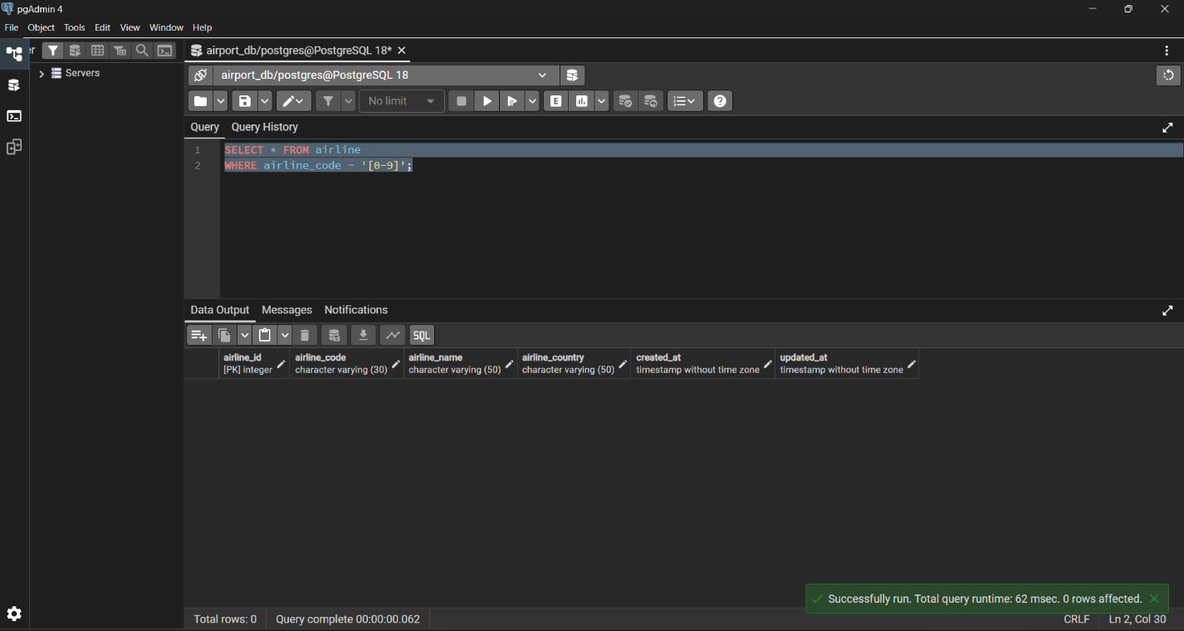

Task-13:
List the top5 most recently created airlines:
SELECT * FROM airline
ORDER BY created_at DESC
LIMIT 5;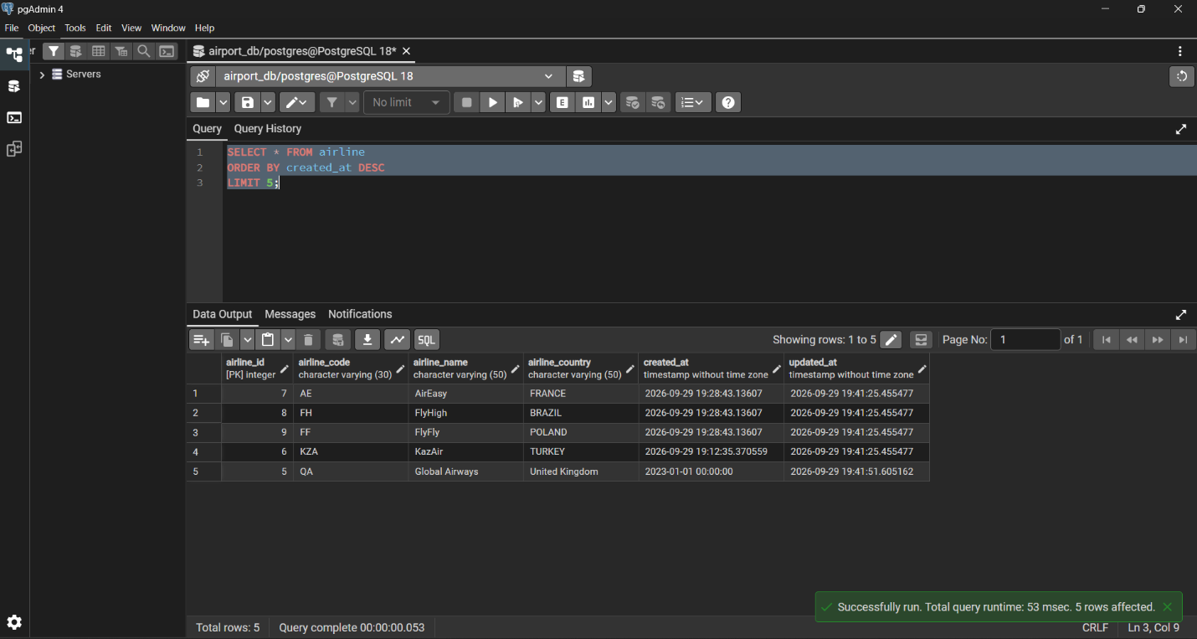

Task-14:
Return all rows where booking_id is between 200 and 300 inclusive and check_result <> 'Checked':
SELECT * FROM baggage_check
WHERE booking_id BETWEEN 200 AND 300 AND check_result <> 'Checked';
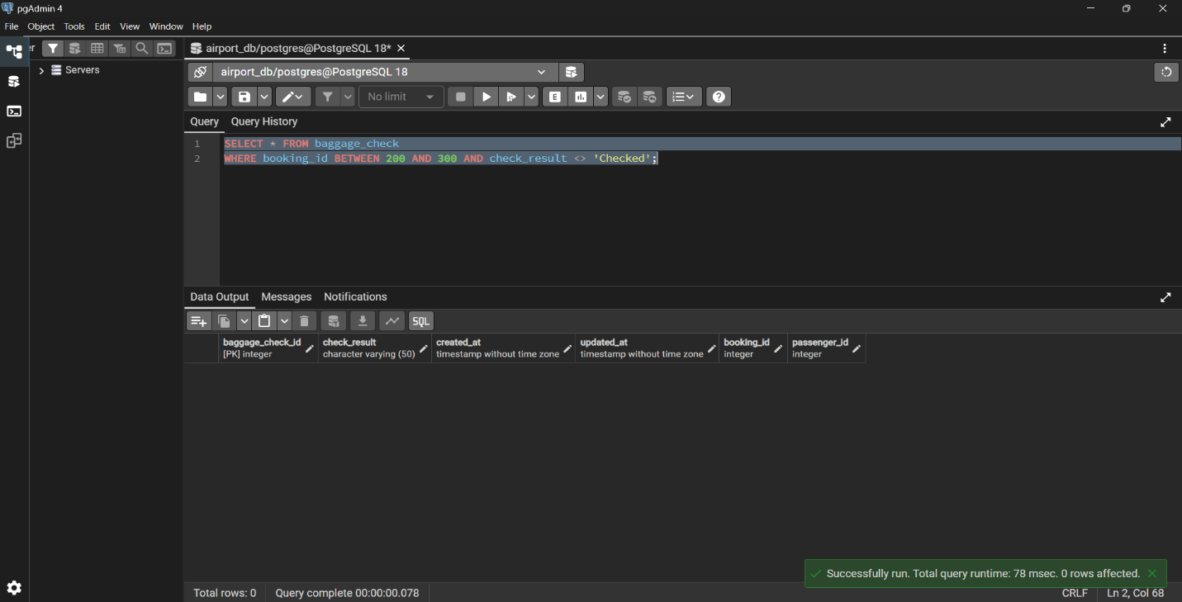
Task-15:
Baggage checks where update_at is in the same month as created_at but occurs earlier than created_at:
SELECT * FROM baggage_check
WHERE DATE_TRUNC('month', updated_at) = DATE_TRUNC('month', created_at) AND updated_at < created_at;