Kazakh British Technical University
Databases

Laboratory Work №3

Full Name: Sarsenov Yernar

29.09.2026
Almaty
DML

Task-1:
Generate and Insert 200 Random Rows
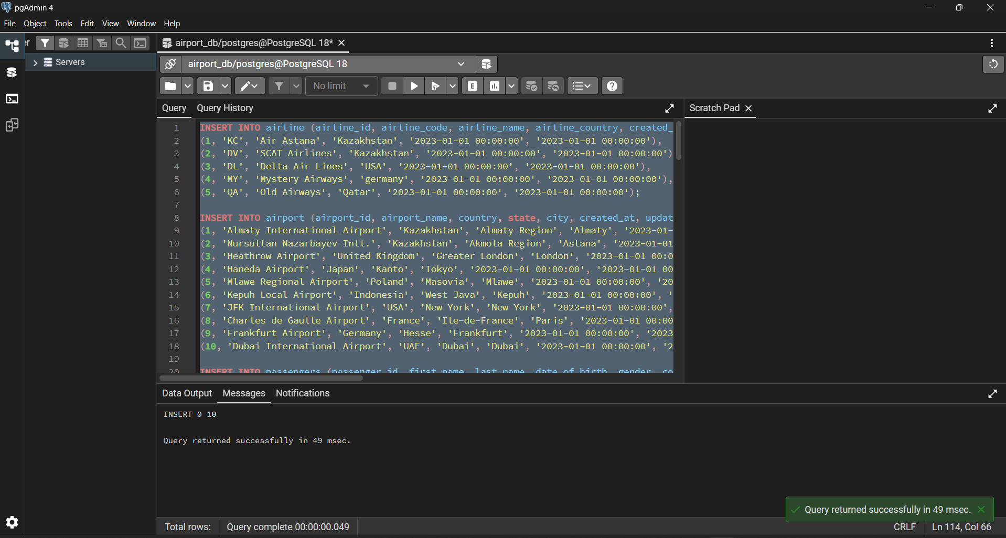

Task-2:
Insert "KazAir" Airline:
INSERT INTO airline (airline_id, airline_code, airline_name, airline_country, created_at, updated_at)
VALUES ((SELECT COALESCE(MAX(airline_id), 0) + 1 FROM airline), 'KZA', 'KazAir', 'Kazakhstan', NOW(), NOW());
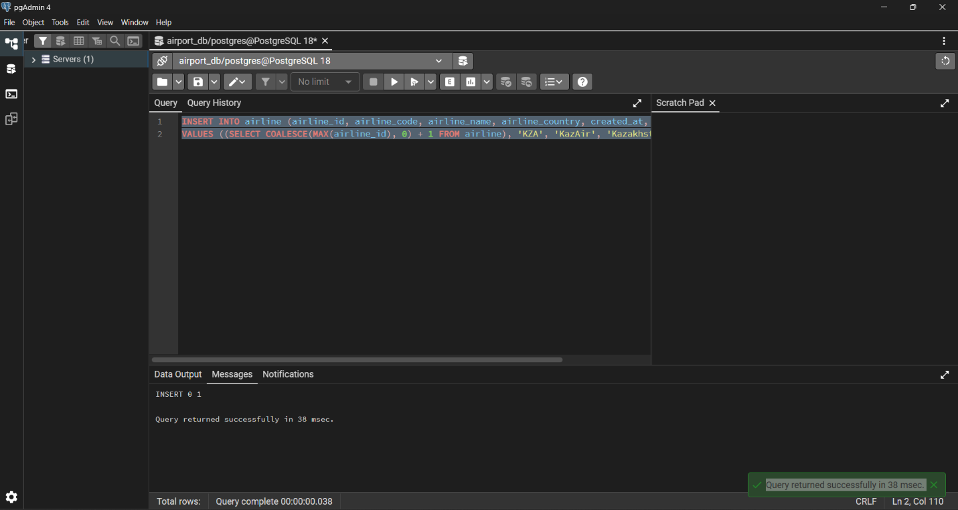
Task-3:
Update "KazAir" Country:
UPDATE airline
SET airline_country = 'Turkey', updated_at = NOW()
WHERE airline_name = 'KazAir';
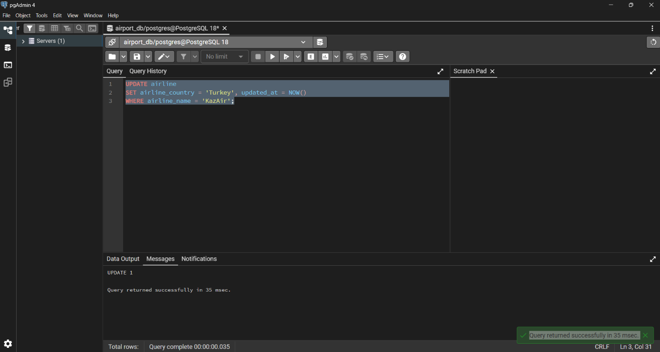

Task-4:
Batch Insert Airlines:
INSERT INTO airline (airline_id, airline_code, airline_name, airline_country, created_at, updated_at)
SELECT
(SELECT COALESCE(MAX(airline_id), 0) FROM airline) + ROW_NUMBER() OVER (),
code, name, country, NOW(), NOW()
FROM (VALUES
('AE', 'AirEasy', 'France'),
('FH', 'FlyHigh', 'Brazil'),
('FF', 'FlyFly', 'Poland')
) AS t(code, name, country);
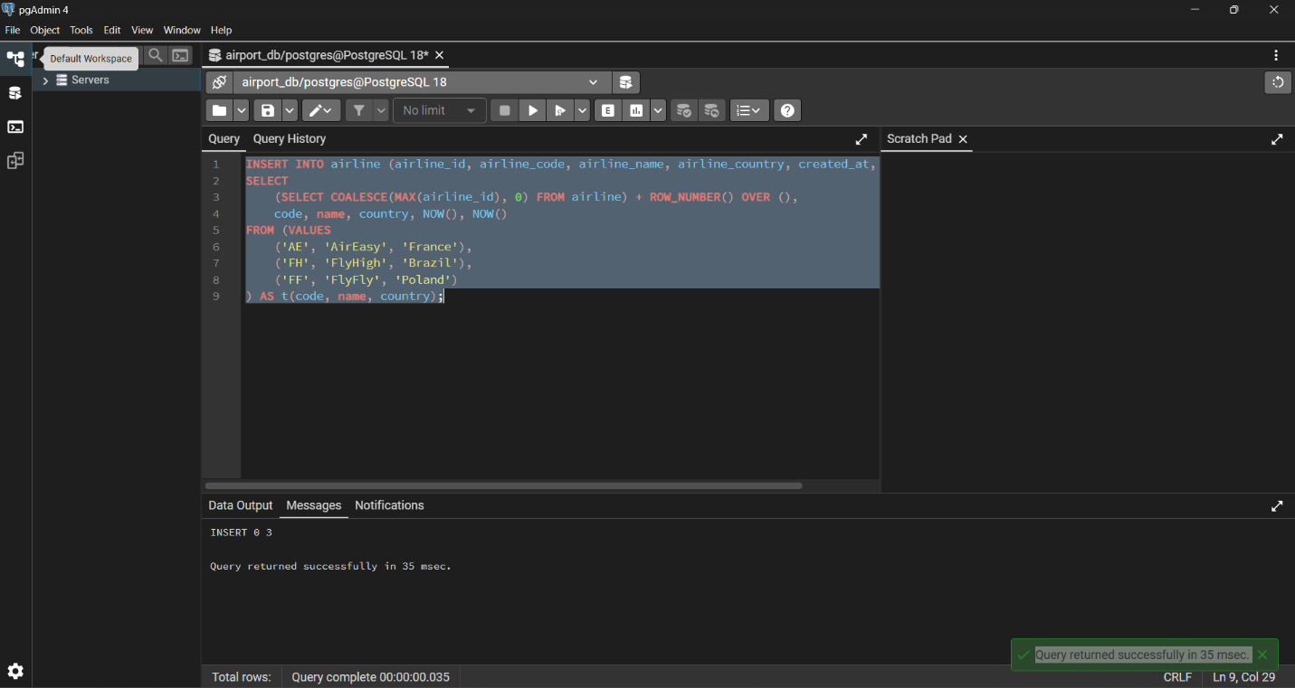

Task-5:
Delete Flights Arriving in 2024
Firstly:
DELETE FROM booking_flight
WHERE flight_id IN (
SELECT flight_id FROM flights WHERE EXTRACT(YEAR FROM sch_arrival_time) = 2024
);
Only then:
DELETE FROM flights
WHERE EXTRACT(YEAR FROM sch_arrival_time) = 2024;

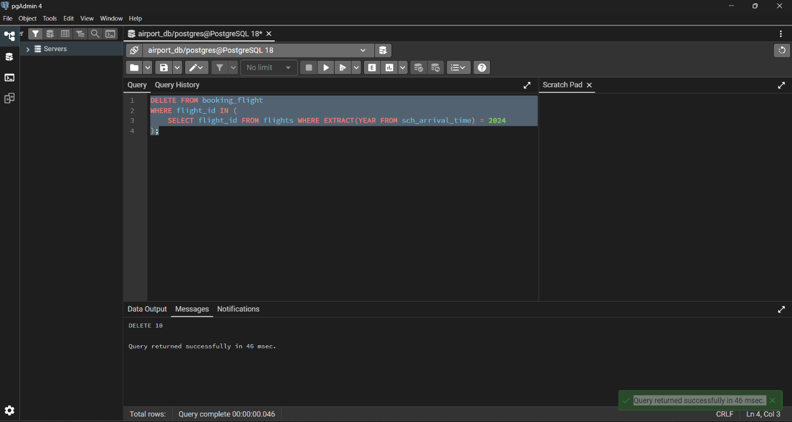

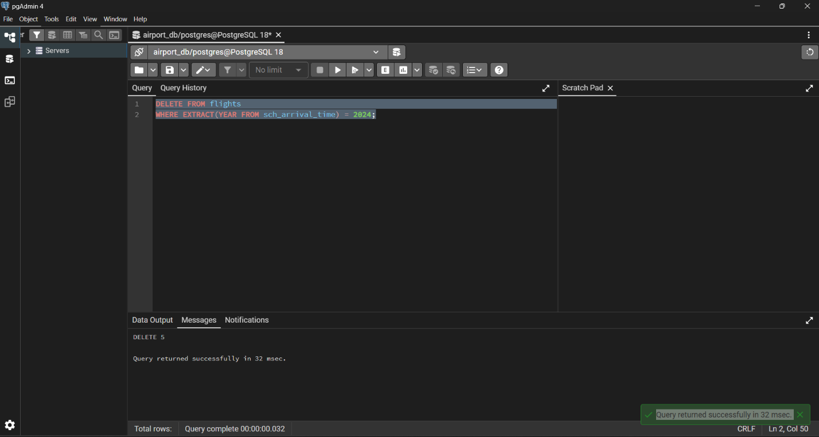

Task-6:
UPDATE booking
SET ticket_price = ticket_price * 1.15,
updated_at = NOW();
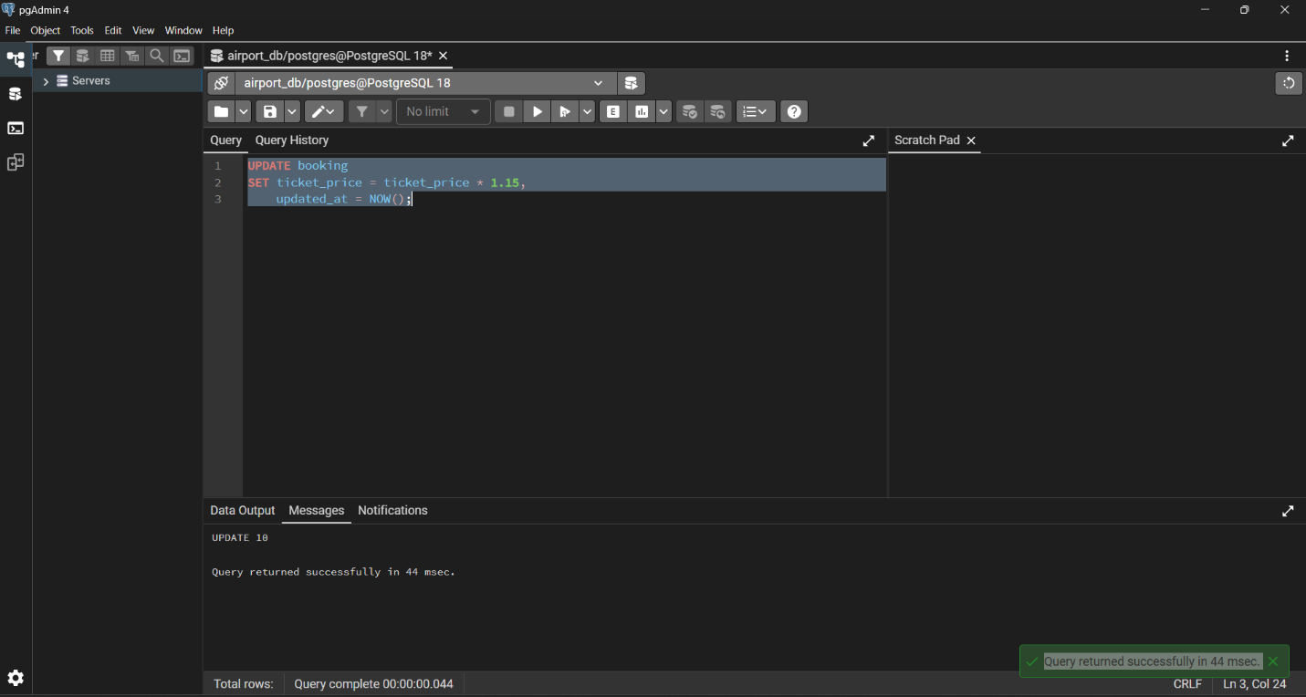

Task-7:
Delete Tickets which are cheaper than 10000:
Firstly:
DELETE FROM baggage_check
WHERE booking_id IN (SELECT booking_id FROM booking WHERE ticket_price < 10000);

DELETE FROM baggage
WHERE booking_id IN (SELECT booking_id FROM booking WHERE ticket_price < 10000);

DELETE FROM boarding_pass
WHERE booking_id IN (SELECT booking_id FROM booking WHERE ticket_price < 10000);

DELETE FROM booking_flight
WHERE booking_id IN (SELECT booking_id FROM booking WHERE ticket_price < 10000);

Only then:
DELETE FROM booking
WHERE ticket_price < 10000;
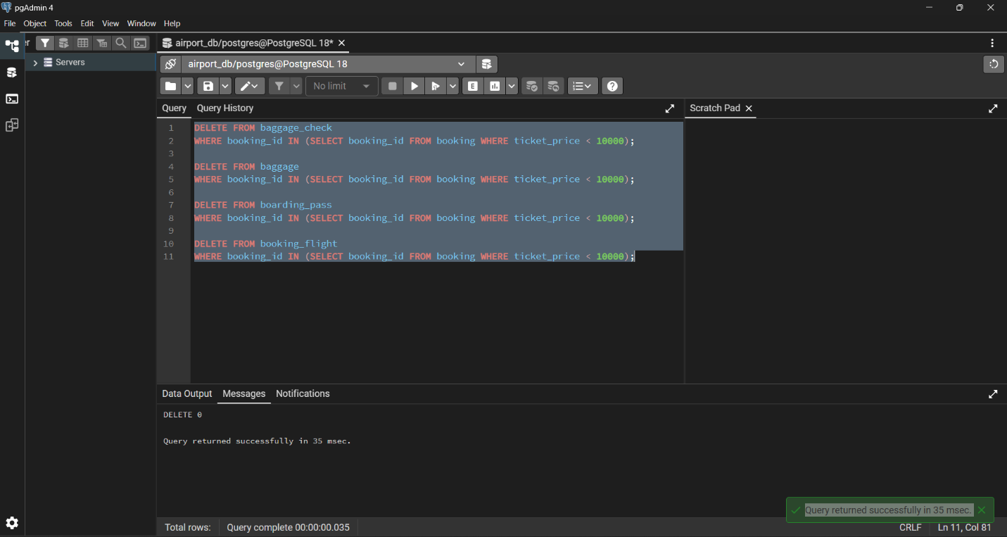

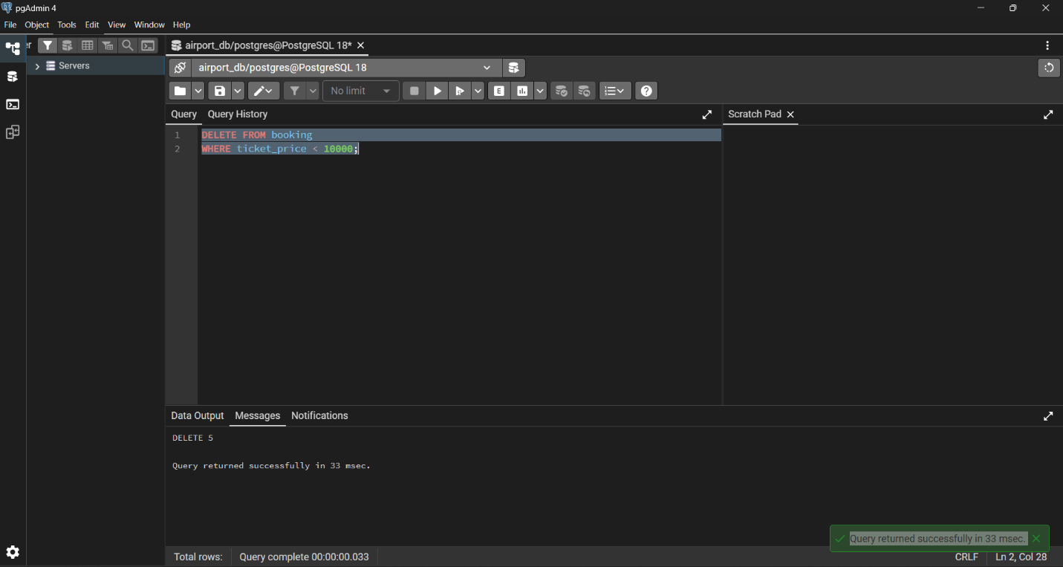

Task-8:
UPDATE airline
SET airline_code = 'UNK'
WHERE airline_code IS NULL;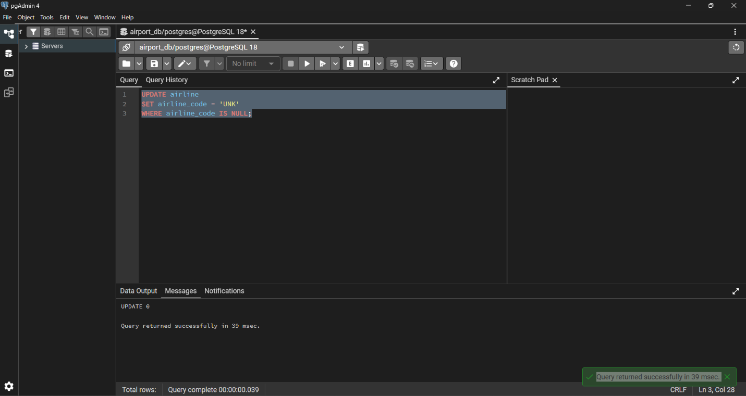

Task-9:
DELETE FROM baggage_check
WHERE created_at < '2023-06-01'
AND check_result = 'Not checked';
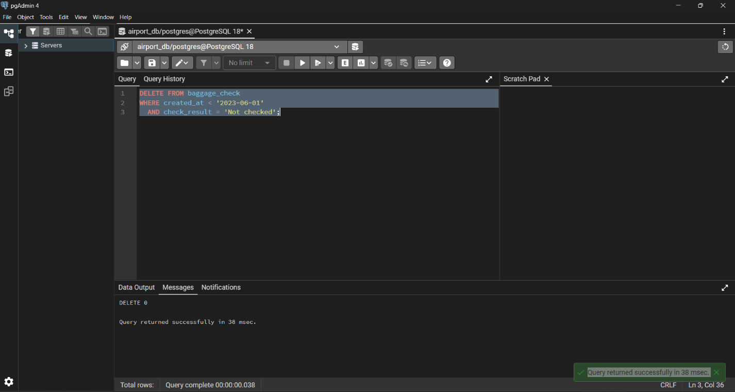

Task-10:
DELETE FROM airport
WHERE state IS NULL
AND city IN ('Mlawe', 'Kepuh');
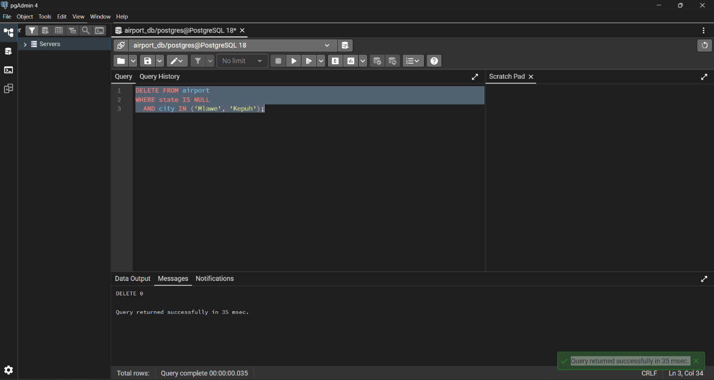

Task-11:
INSERT INTO baggage_check (baggage_check_id, check_result, created_at, updated_at, booking_id, passenger_id)
VALUES (
(SELECT COALESCE(MAX(baggage_check_id), 0) + 1 FROM baggage_check),
'Not checked',
NOW(),
NOW(),
(SELECT booking_id FROM booking ORDER BY random() LIMIT 1),
(SELECT passenger_id FROM passengers ORDER BY random() LIMIT 1)
)
RETURNING baggage_check_id, created_at;
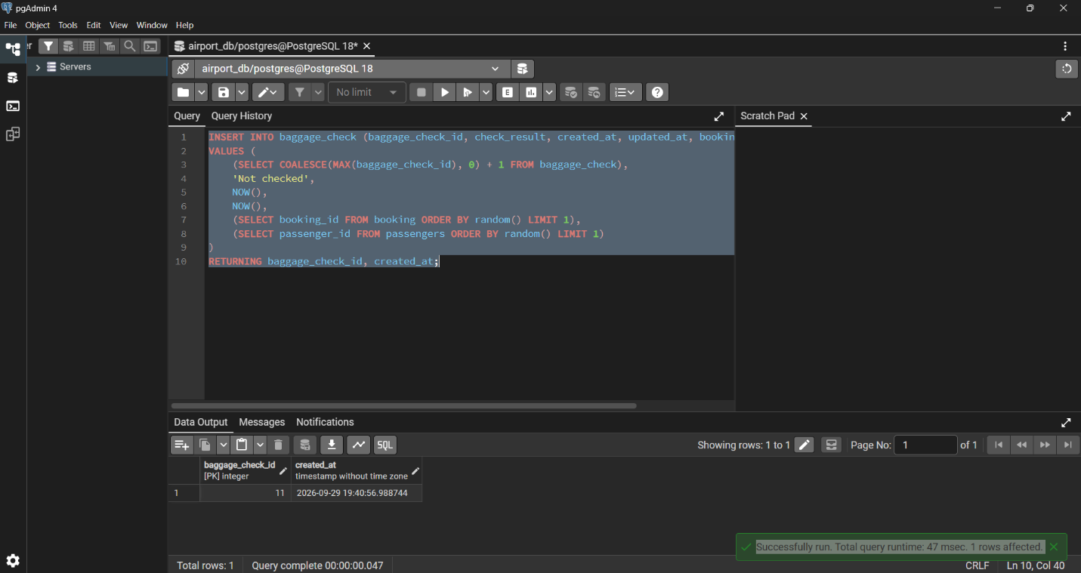

Task-12:
UPDATE airline
SET airline_country = UPPER(airline_country),
updated_at = NOW();
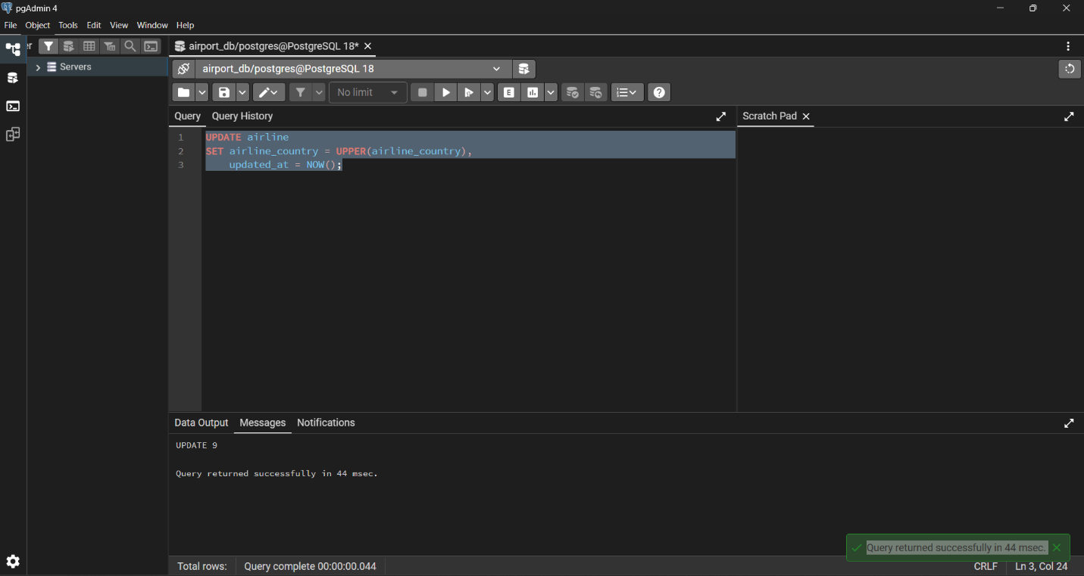

Task-13:
UPDATE airline
SET airline_name = 'Global Airways',
airline_country = 'United Kingdom',
updated_at = NOW()
WHERE airline_id = 5;
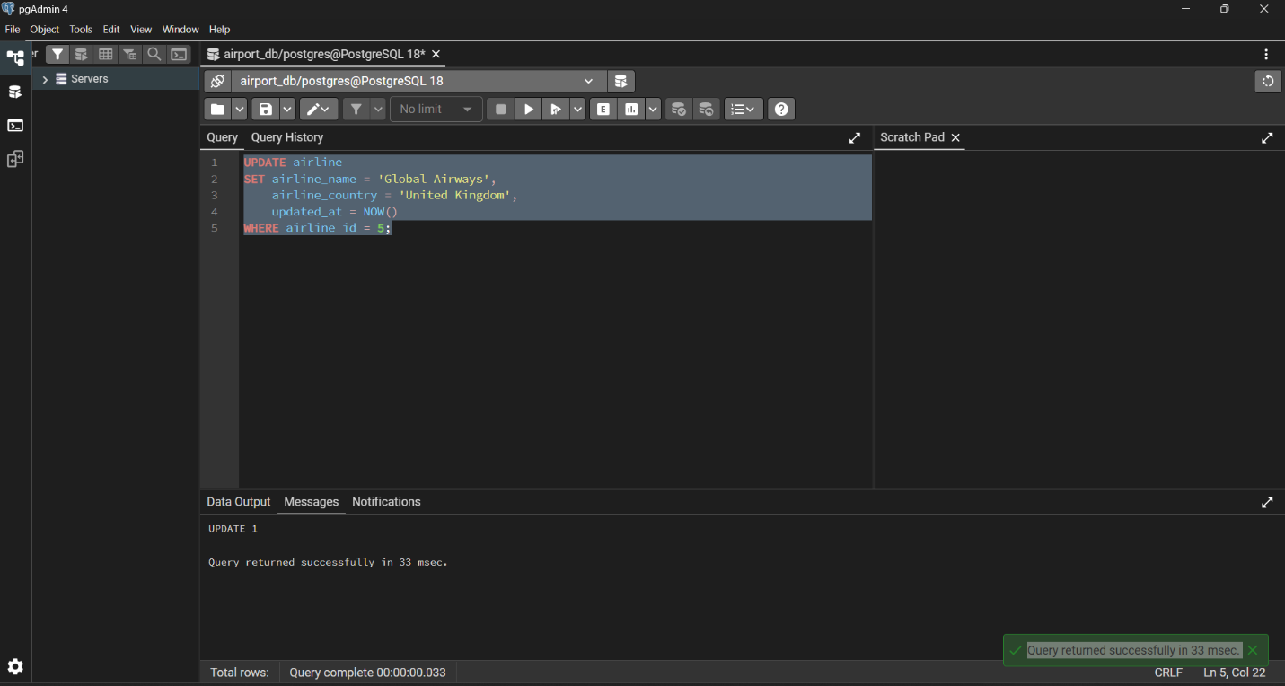

Task-14:
UPDATE airport
SET state = 'Capital District',
updated_at = NOW()
WHERE city IN ('Astana', 'London', 'Tokyo');

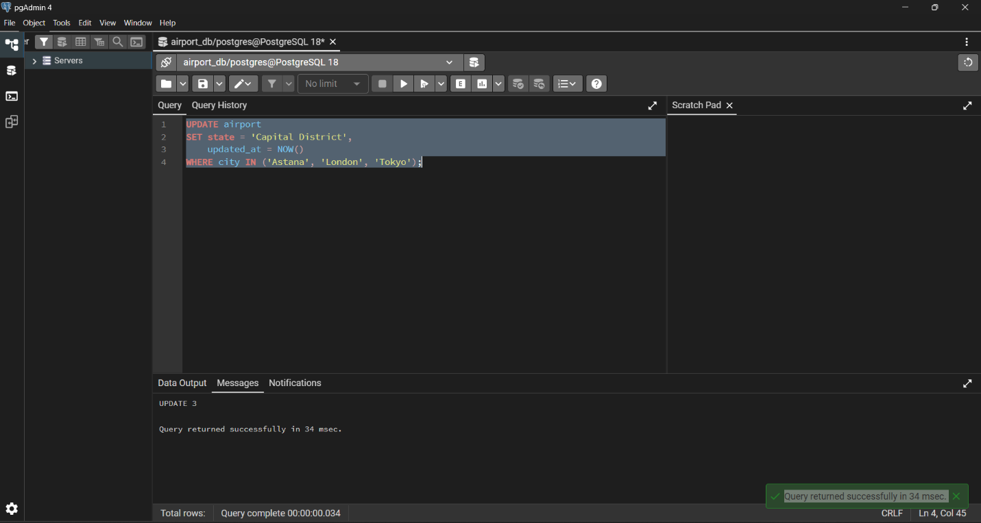

Task-15:
UPDATE baggage_check
SET check_result = 'Checked',
updated_at = NOW()
WHERE check_result = 'Not checked'
AND created_at >= '2024-03-01'
AND created_at < '2024-04-01';
