ELK Stack

Elasticsearch installation cmd:
PS C:\ELK\elasticsearch\bin> Invoke-Expression -command ".\elasticsearch-service install"
Status check:
PS C:\ELK\elasticsearch\bin> Invoke-Expression -command ".\elasticsearch-service manager"
To check running status:
http://localhost:9200/
kibana:
http://localhost:5601/
Node: An individual server
Cluster: group of connected nodes
Index: A data structure storing horizontal data
Each horizontal split is called a shard
Horizontal line called – Document (is a json document)
- Create new Index
PUT http://localhost:9200/schools
{
"acknowledged": true,
"shards_acknowledged": true,
"index": "customer"
}

- POST http://localhost:9200/schools /_bulk (defining schema)
Content-type: application/x-ndjson
Body available at : https://shrip.com/ekl_1

{"index":{"_index":"schools", "_type":"school", "_id":"1"}}
{"name":"ABC School", "description":"CBSE", "street":"Nagan","city":"paprola", "state":"HP", "zip":"176115", "location":[31.8955385, 76.8380405],"fees":2000, "tags":["Senior Secondary", "beautiful campus"], "rating":"3.5"}
{ "index":{"_index":"schools", "_type":"school", "_id":"2"}}
{"name":"Saint Paul School", "description":"ICSE Afiliation", "street":"PGI", "city":"Delhi", "state":"Delhi", "zip":"110075","location":[28.5733056, 77.0122136], "fees":5000,"tags":["Good Faculty", "Great Sports"], "rating":"4.5"}
{"index":{"_index":"schools", "_type":"school", "_id":"3"}}
{"name":"Crescent School", "description":"State Board Affiliation", "street":"Tonk Road","city":"Jaipur", "state":"RJ", "zip":"176114","location":[26.8535922, 75.7923988],"fees":2500, "tags":["Well equipped labs"], "rating":"4.5"}

- How to search
URL: POST htt://localhost:9200/schools/_search
Header: application/json
Body:
{"query":{"query_string":{"query":"CBSE"}}}
Search in all indexes except school:
URL: POST http://localhost:9200/sechools-/_search
- The ignore_unavailable option allows these indices to be skipped, when set to True
POST htt://localhost:9200/schools/_search?ignore_unavailable=true
?allow_no_indices=true
- Works with * if results aren’t index
POST http://localhost:9200/sechools/_close

- Counting number of hits:
http://localhost:9200/schools*/_search?filter_path=hits.total
Document APIs
POST http://localhost:9200/schools/school/4
{"name":"XYZ School", "description":"Special", "street":"Nagan","city":"paprola", "state":"HP", "zip":"176115", "location":[31.8955385, 76.8380405],"fees":2000, "tags":["Senior Secondary", "beautiful campus"], "rating":"3.5"}
Automatic Index creation : manually
Update elasticsearch.yml file in config as below:
action.auto_create_index:false
- Automatic Index creation – Documents API
PUT url:9200/_cluster/settings
{“persistent”:{“action.auto_create_index”:”true”}}
CURL cmds:
curl -X PUT "localhost:9200/_cluster/settings" -H 'Content-Type: application/json' -d'
{
"persistent": {
"action.auto_create_index": "twitter,index10,-index1*,+ind*"
}
}
'
curl -X PUT "localhost:9200/_cluster/settings" -H 'Content-Type: application/json' -d'
{
"persistent": {
"action.auto_create_index": "false"
}
}
'
curl -X PUT "localhost:9200/_cluster/settings" -H 'Content-Type: application/json' -d'
{
"persistent": {
"action.auto_create_index": "true"
}
}

-> Parent-Child -> Overwriting. To avoid overwriting, op_type=create

#PUT create a new index -> books

POST url: 9200/books/chapter/1?op_type=create
{"text":"this is chapter 1"}

POST url: 9200/books/article/1?parent=1
{"text":"This is article 1 of chapter 1"}

#GET api
GET url:9200/schools/school/2
#GET with parameters
GET url:9200/schools/school/2?fields=name,description,fee
Ex: http://localhost:9200/schools/school/2?_source=name
Delete:
DELETE http://localhost:9200/schools/school/2

To work logstash follow below steps:
Creat logstash.json file in bin folder of C:\ELK\logstash\bin
input {
beats {
port => 5044
type => "log"
}
}
output {
elasticsearch {
hosts => "localhost:9200"
manage_template => false
index => "%{[@metadata][beat]}-%{+YYYY.MM.dd}"
document_type => "%{[@metadata][type]}"
}
}

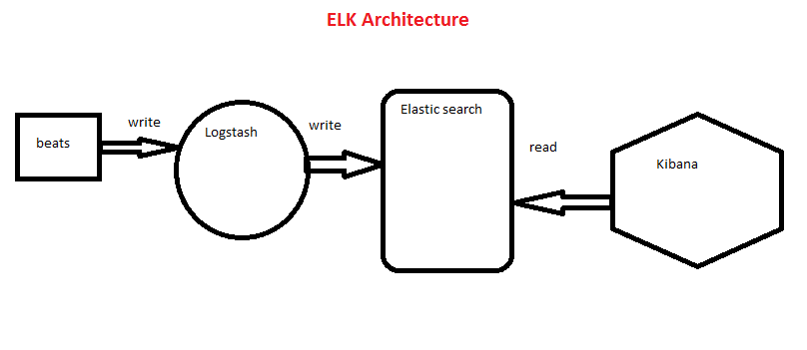
Make service running all the time by below cmd:
PS C:\ELK\elasticsearch\bin> Invoke-Expression -command ".\elasticsearch-service manager"

Install :
PS C:\ELK\nssm\win64> Invoke-Expression -Command ".\nssm install logstash"

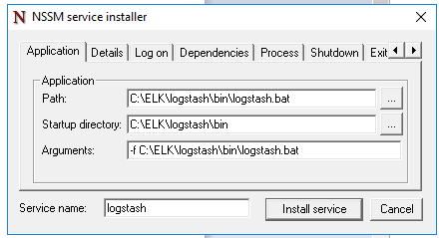

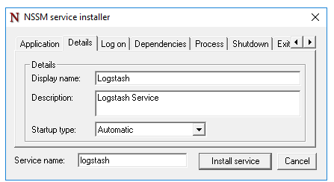

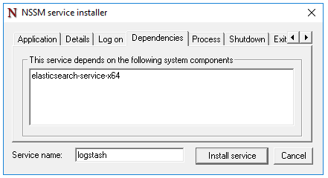

Click Install Service button

Install KIBANA:
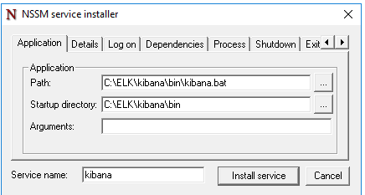
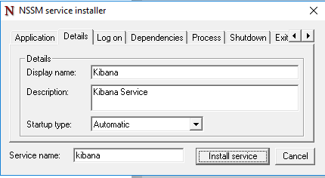

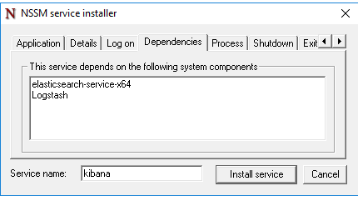

Click Install Service button
Services.msc to check all 3 services are running or not.

