**Assignment #4: Responsive Web Design (Media Queries + Bootstrap Grid)**   
  
Student: Yernur Syrlibayev

Group: SE-39

**Overview**

This project demonstrates the use of responsive typography, layout adaptation, and hover effects using **HTML**, **CSS**, and **Bootstrap**.  
It is designed to adjust smoothly across different screen sizes while keeping the structure clean and visually balanced.

**Objectives**

* Implement responsive text using relative units like em, rem, and %.
* Create a flexible layout using the **Bootstrap Grid System**.
* Style boxes with hover effects to add interactivity.
* Showcase professional, modern web design principles.

**Technologies Used**

* **HTML5** for page structure
* **CSS3** for styling and transitions
* **Bootstrap 5** for responsive grid and layout
* **Live Server** (VS Code) for local development and testing

### ****Features****

1. **Responsive Typography**  
   The font size and layout automatically adjust when resizing the browser window.
2. **Responsive Boxes**  
   Three boxes that align horizontally on large screens and stack on smaller devices.  
   Each box changes visually when hovered.
3. **Bootstrap Grid System**  
   The three colored columns demonstrate Bootstrap’s grid behavior (col-md-4).  
   They align side by side on desktop and stack vertically on smaller screens.

.

1. **About Me Section**  
   Includes short information about the developer and contact details, with a clean two-column layout.

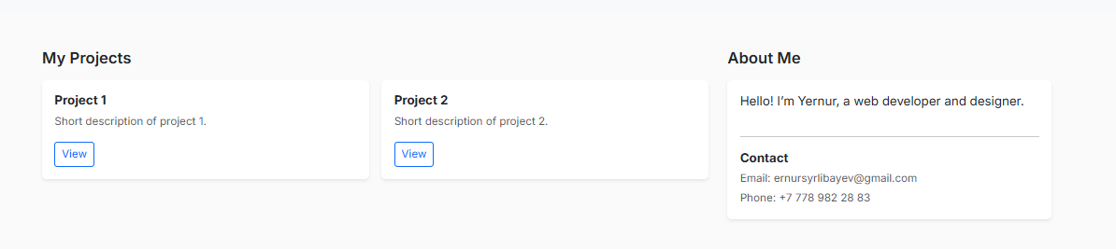

### ****Hover Effects****

Each .box has a smooth hover effect using CSS transitions:

.box:hover {

transform: translateY(-10px) scale(1.05);

box-shadow: 0 15px 30px rgba(0, 255, 255, 0.3);  
}

### ****Conclusion****

This project showcases a clean, responsive layout that combines **typography scaling**, **Bootstrap grid**, and **interactive hover styling**.  
It’s a solid foundation for more complex UI/UX projects and front-end portfolios.