**My First Webpage**

Student Name: Yernur Syrlibayev  
Group: SE-2439

Objective  
By the end of this assignment, I was able to understand the structure and purpose of HTML. I used basic and intermediate HTML tags to create a simple webpage. I applied knowledge of text formatting, images, links, lists, tables, and forms. I published my first webpage online.

Part 1: Introduction to HTML

Step 0: Create a new HTML file  
I created a file named index.html and added the basic HTML boilerplate with doctype, html, head, title, and body tags. The page title was set to "My First Webpage".

Step 1: Structure text using HTML tags  
I added headings from h1 to h3 with my name, course, and "About Me". I wrote a short paragraph describing myself.

Step 2: HTML Lists  
I created an ordered list of my hobbies and an unordered list of my favorite websites.

Step 3: Images and Links  
I inserted my photo using the img tag and added two clickable links to YouTube and Instagram.

Step 4: HTML Buttons  
I added a simple button with the text "Click Me".

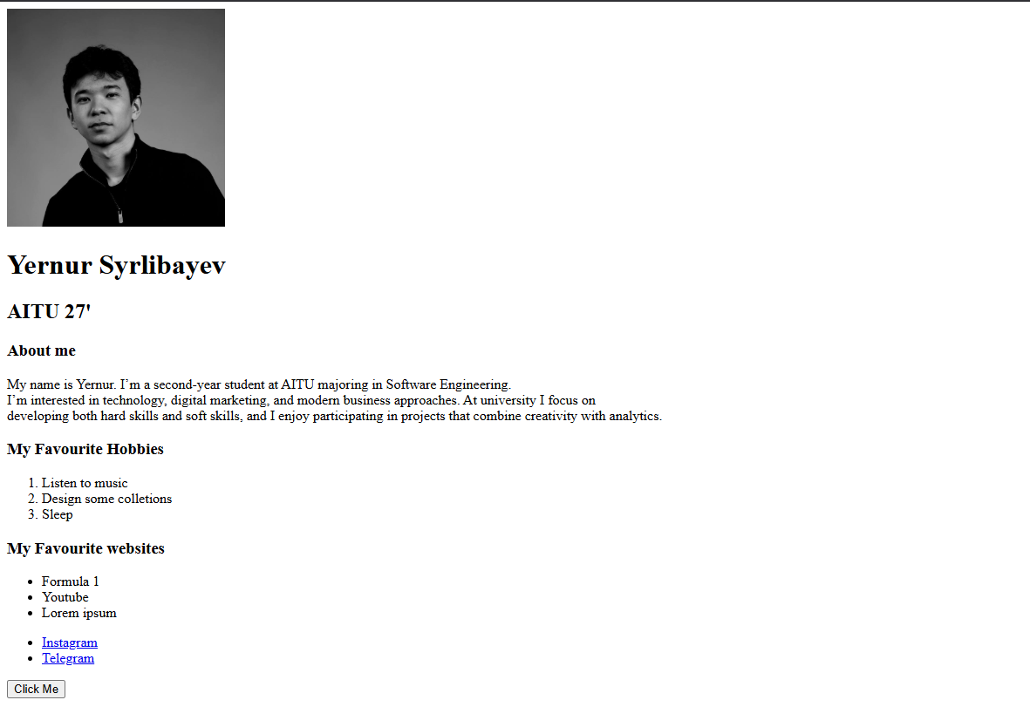

Part 2: Intermediate HTML

Step 5: Tables  
I created a table with columns "Subject", "Day", and "Time" and filled it with a simple weekly class schedule.

Step 7: Emojis  
I wrote a paragraph about my mood today and included at least three emojis.

Step 8: HTML Forms  
I created a form with fields for Name, Email, Favorite Color, and a Submit button.

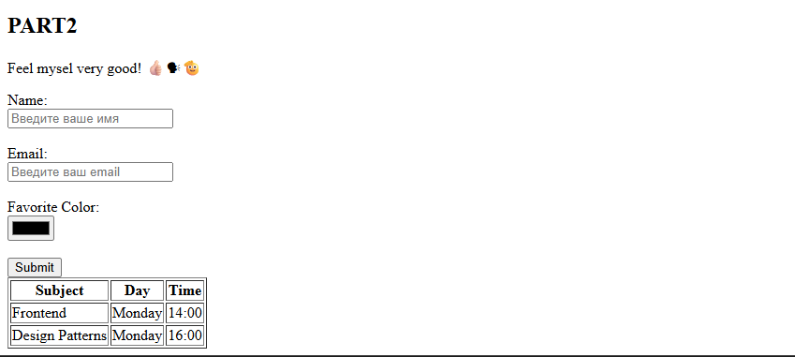

Step 9: Publish Your First Website  
I published my webpage using GitHub Pages. The page works correctly online.  
URL: <https://github.com/yernurdev/web1assign1>

Brief Summary  
I started by creating the basic HTML structure. Then I added headings, paragraphs, lists, images, links, and buttons. I created tables and forms to practice more advanced HTML. I added emojis to personalize the page. Finally, I uploaded the project to GitHub and published it using GitHub Pages. The webpage runs without errors and meets all the assignment requirements.