Assignment 4
Student: Yernur Darmenov
Group: SE-2523

1 Introduction
This project implements the Facade structural design pattern for a small online book shop. A customer selects one book and a quantity. OrderFacade provides one placeOrder method that coordinates stock reservation, payment, shipping and confirmation. The main result is a simple client that does not need to know the service call order or the rollback rules.
The program uses Java 17 and runs in the console. Three books are predefined. Prices and balances are whole tenge. All data stays in memory and resets at the next run. Payment changes a learning balance, and shipping checks for a nonempty address and generates a number.

Class responsibilities
Class | Responsibility
Book | Book ID, title and price.
Customer | Name, address and current balance.
Order | Order data, total, status and shipping number.
InventoryService | Catalog, available stock, reservation and release.
PaymentProcessor | Balance check, charge and refund.
ShippingService | Address check and shipping number generation.
NotificationService | Confirmation status check, message creation and output.
OrderFacade | Service coordination and rollback.
Main | Four prepared demonstrations through the facade.

Order processing
The facade checks the customer and asks InventoryService to validate quantity and stock. It reserves the books, calls PaymentProcessor, creates a shipment and confirms the order. NotificationService then prints the confirmation. Each service performs its own operation; the facade decides when to call it.

2 UML class diagram
Figure 1 shows the nine application classes and their main relationships. Public methods use + and private fields use -. Parameter names are shortened for readability.
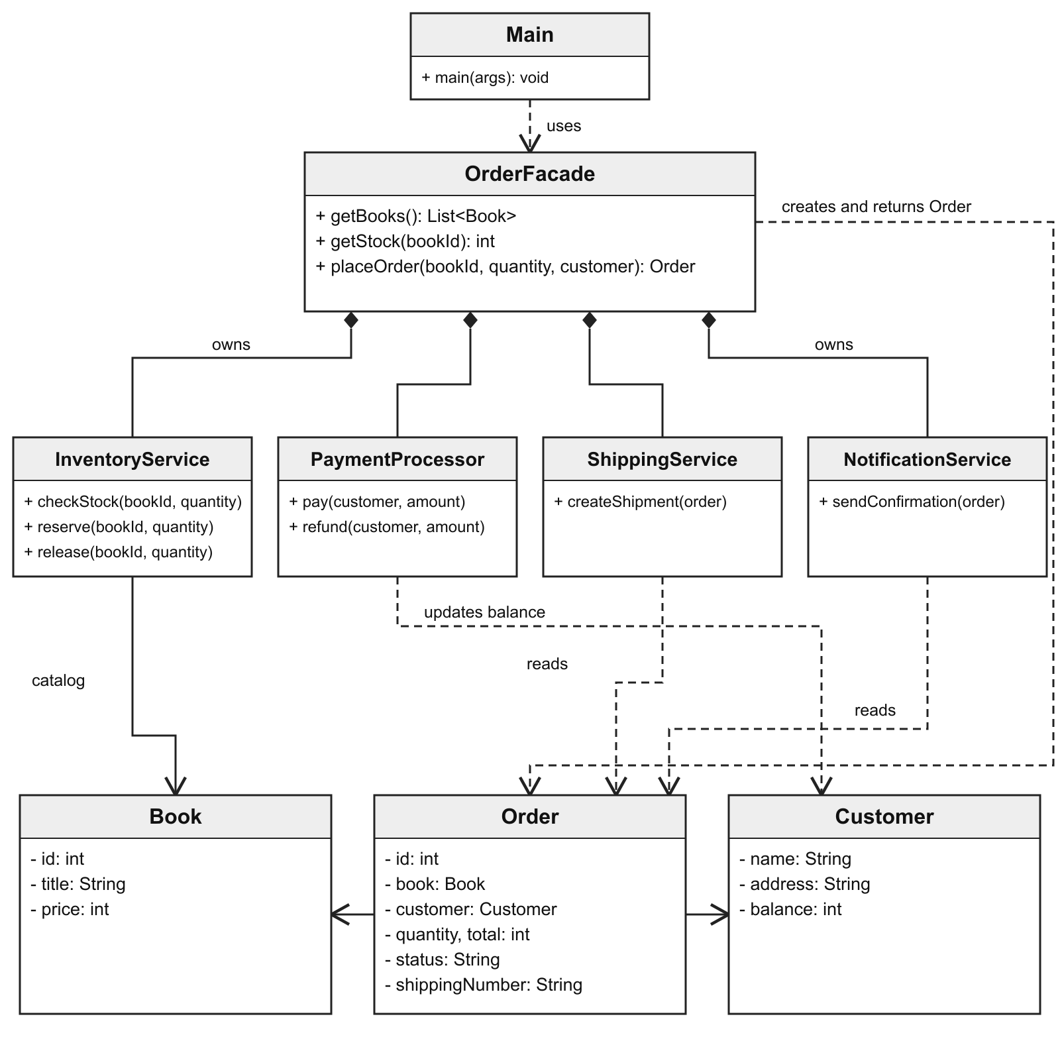
Figure 1 Facade subsystem and data classes
A filled diamond means composition: OrderFacade creates and holds each service. A solid arrow means association, such as Order storing a Book or Customer reference. A dashed arrow means dependency, such as PaymentProcessor using Customer to update the balance.
There are no extends or implements relationships between the application classes. The Facade pattern does not require inheritance or interfaces. Getters, constructors, the test class and client dependencies on data objects are omitted to keep the diagram readable.

3 Clean Code principles
The following excerpts come from the implemented Java classes. Each example explains one design choice in this project.

Meaningful names
Main uses a method name that describes the customer action. The arguments show which book, quantity and customer are involved.
Order order = shop.placeOrder(book.getId(), quantity, customer);

Single responsibility
PaymentProcessor owns the balance check and the charge. OrderFacade calls pay rather than repeating this payment logic.
if (customer.getBalance() < amount) {
throw new IllegalStateException("Not enough money");
}
customer.setBalance(customer.getBalance() - amount);

Hidden subsystem details
The payment service is a private field in OrderFacade. The public API accepts data and returns an Order; Main does not receive service objects.
private final PaymentProcessor payment = new PaymentProcessor();

Small methods and early validation
ShippingService.createShipment has one focused task. An invalid address is rejected before a shipping number is issued.
String address = order.getCustomer().getAddress();
if (address == null || address.isBlank()) {
throw new IllegalArgumentException("Delivery address is required");
}
return "SHIP-" + nextShippingNumber++;

Explicit error handling
In the facade catch block, paid prevents a refund when no money was charged. The reservation is released because reserve completed before try. The original exception is passed to the client.
if (paid) {
payment.refund(customer, order.getTotal());
}
inventory.release(bookId, quantity);
order.cancel();
throw e;

4 Demonstration and verification
The project was compiled and run with JDK 17.0.20.1. Main uses the same shop and a book priced at 3000 KZT for all four demonstrations. Its before and after output shows the following state changes.
Scenario | Stock before / after | Balance before / after
Successful order of 2 books | 5 / 3 | 10000 / 4000 KZT
Request for 10 books | 3 / 3 | 10000 / 10000 KZT
Insufficient money | 3 / 3 | 1000 / 1000 KZT
Empty delivery address | 3 / 3 | 10000 / 10000 KZT

Insufficient stock stops processing before payment. A payment rejection releases the books. An empty address fails during shipping after payment, so the facade refunds the charge and releases the reservation. Only a successful order produces a confirmation.
OrderFacadeTest also checks ordering again after rollback, buying the exact remaining stock, distinct order and shipment numbers, zero and negative quantities, an unknown book, a missing customer and a null address. It uses standard Java assertions without a testing library.

Run commands
mkdir -p out
javac --release 17 -encoding UTF-8 -d out src/*.java
java -cp out Main
java -ea -cp out OrderFacadeTest
The final test message is All facade checks passed. The -ea option is required to enable assertions.

5 Conclusion
OrderFacade hides the sequence of subsystem calls and the recovery steps after an error. Main only requests an order and handles its result or exception. The services remain independent of the facade and keep public methods that an advanced client could call directly.
The rollback is ordinary Java code. Books are reserved before the try block, and paid becomes true only after payment succeeds. This makes it clear which completed actions must be undone. The project deliberately uses a fixed catalog, integer prices and in-memory state so the pattern is easy to follow.

6 GitHub repository
https://github.com/yernururue/facade-pattern

