# Schematic view

Control Unit « CU »

Wiring unit « WU »

Power Unit « PU »

# Elements

## Control Unit

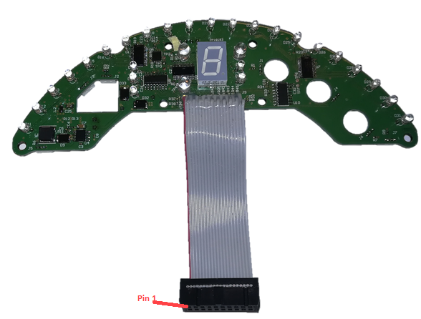

Figure 1: Control Unit "CU" with its 20-pin flat-cable

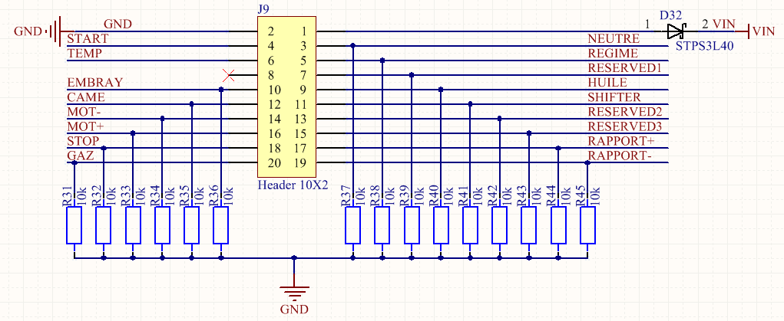

Figure 2: CU 20-pin header

## Wiring Unit

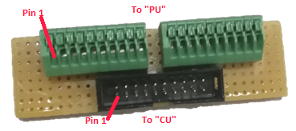

Figure 3: Wiring Unit "WU"

## Power Unit

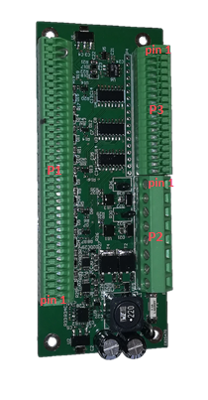

Figure 4: Power Unit "PU"

# Connectors reference

