PlayZone: Sports Venue Discovery, Booking &
Tournament Management Platform
A project report submitted in partial fulfilment of the award of degree of
BACHELOR OF TECHNOLOGY IN COMPUTER SCIENCE AND ENGINEERING
By
M PRADEEP | 231801390016
AS VIJAYKUMAR | 231801390031
CH ARUNKUMAR | 231801390032
Y DINESH | 231801390029
B ANILKUMAR | 231801390020
D PAVANESWAR | 231801390017
DN KAILASH | 231801390007
Under the esteemed Guidance of
Dr. N.V.S. SHANKAR
Assistant Professor

Centurion University of Technology and Management
Andhra Pradesh, Pin: 535003, India (2025-2026)

BONAFIDE CERTIFICATE
Certified that this project report PLAYZONE: SPORTS VENUE DISCOVERY, BOOKING & TOURNAMENT MANAGEMENT PLATFORM is the Bonafide work of “M PRADEEP(231801390016), AS VIJAYKUMAR(231801390031), CH ARUNKUMAR(231801390032), Y DINESH(231801390029), B ANILKUMAR(231801390020), D PAVANESWAR(231801390017), DN KAILASH(231801390007)” who carried out the project work under my supervision. This is to further certify to the best of my knowledge that this project has not been carried out earlier in this institute and the university.
SIGNATURE
Dr. N. V. S. SHANKAR
Assistant Professor
Certified that the above-mentioned project has been duly carried out as per the norms of the college and statutes of the university.
SIGNATURE
R. LAKSHMANA RAO
Assistant Professor, HOD (CSE)
SIGNATURE
Dr. Satyabrata Lenka
Professor & DEAN, SoET
HEAD OF THE DEPARTMENT / DEAN OF THE SCHOOL
Professor of Computer Science and Engineering
DEPARTMENT SEAL

DECLARATION
We declare that this project report titled PLAYZONE: SPORTS VENUE DISCOVERY, BOOKING & TOURNAMENT MANAGEMENT PLATFORM submitted in partial fulfillment of the degree of B.Tech in Computer Science and Engineering is a record of original work carried out by us under the supervision of Dr. N.V.S. SHANKAR , and has not formed the basis for the award of any other degree or diploma, in this or any other Institution or University. In keeping with the ethical practice in reporting scientific information, due acknowledgments have been made wherever the findings of others have been cited.
M PRADEEP | 231801390016
AS VIJAYKUMAR | 231801390031
CH ARUNKUMAR | 231801390032
Y DINESH | 231801390029
B ANILKUMAR | 231801390020
D PAVANESWAR | 231801390017
DN KAILASH | 231801390007

INDEX
Contents
PlayZone: Sports Venue Discovery, Booking & Tournament Management Platform | 1
1. INTRODUCTION | 3
2. SYSTEM OVERVIEW | 4
3. ARCHITECTURE DESIGN | 5
4. COMPONENT DESIGN | 6
5. DATA DESIGN | 7
6. DATA FLOW AND RUNTIME WORKFLOWS | 7
7. DEPLOYMENT AND CONFIGURATION | 8
8. LIMITATIONS AND FUTURE ENHANCEMENTS | 9
9. CONCLUSION | 9

ACKNOWLEDGEMENT
We are immensely thankful to Associate Professor Dr. N.V.S.SHANKAR of the Department of Computer Science and Engineering at SoET, Vizianagaram Campus. He led us through the complexities of this project effortlessly, displaying unparalleled generosity and guidance.
We thank Asst. Prof. R. Lakshmana Rao, Head of the Dept. of Department of Computer Science and Engineering, SoET, Vizianagaram Campus for extending their support during course of this investigation.
We thank Dr. D. Srinivasa Rao, Dean of SoET, Vizianagaram Campus for their invaluable guidance, insightful feedback, and continuous support throughout the course of this project.
We thank Dr. P. Pallavi, Registrar, CUTM, Vizianagaram Campus for their assistance and cooperation in facilitating the necessary resources.
We thank P. Prasanta Kumar Mohanty, Vice Chancellor, CUTM, Vizianagaram Campus for fostering an environment that encourages academic excellence.
We also express our deepest appreciation to our parents for their unconditional love, encouragement, and belief in our abilities.
We are sincerely grateful to each one of you for your contributions, guidance, and unwavering support.

Software Requirement Specifications
1. Scope
The PlayZone: Sports Venue Discovery, Booking & Tournament Management Platform is a modern, native Android solution designed to streamline athletic facility operations and elevate community sports engagement. The platform bridges the operational divide between Venue Managers—who administer arenas, turfs, sports courts, equipment inventories, operating schedules, and match scoreboards—and Sports Players, who discover facilities, book session slots, track booking approvals, and monitor real-time game scores. By incorporating rigorous transactional conflict detection, biometric device verification, and offline-first Room persistence with Google Sheets cloud backup, the platform delivers high transparency, operational resilience, and professional sports management across academic and municipal environments.
1.1 Identification
Identification No | SRS-PZ-VER-1.0
Title | PlayZone: Sports Venue Discovery, Booking & Tournament Management Platform
Abbreviation | PZ-SVTM
Version No | 1.0
Release No | 1.0
1.2 System Overview
PlayZone (PZ-SVTM) provides a unified mobile experience engineered with Kotlin and Jetpack Compose on Android. The architecture integrates a robust local Room Database (v3) with fallback migration, Google Sheets Apps Script API and published CSV endpoints for lightweight cloud synchronization, and Firebase Authentication for enterprise credential issuance. The platform delivers sport-specific live scoring interfaces (Cricket, Football, Basketball, Badminton, Volleyball, Tennis), automated schedule conflict prevention during booking approvals, WorkManager background reminder dispatches, and PDF standings generation for tournament organisers and university athletics boards.
1.3 Document Overview
This Software Requirements Specification document outlines the functional capabilities, technical constraints, security standards, external interfaces, and database schema governing PlayZone. It serves as the baseline contract for system evaluation, verification, maintenance, and deployment across university campuses and athletic clubs.

1.4 Software and Hardware Requirements
The PlayZone application operates on Android devices executing Android 8.0 (API Level 26) or later, with a minimum SDK requirement of API 24 (Android 7.0 Nougat) and target SDK 36. The frontend is built using Jetpack Compose with Material 3 design tokens, integrated with Room persistence (v2.8.5), Kotlin Coroutines (1.10.2), WorkManager (2.12.0), Android BiometricPrompt (1.2.0), and Firebase Authentication. Development requires Android Studio (Ladybug / Quail), JDK 17+, an Intel Core i5 processor (or equivalent), 8 GB RAM minimum (16 GB recommended), and 256 GB SSD. Client smartphones require at least 2 GB RAM, a capacitive touch display, biometric hardware (or screen PIN lock), and internet connectivity for cloud synchronization.
1.5 Functional Requirements
i. Data Management: The platform persists users, sports arenas, equipment inventories, match sessions, player bookings, system notifications, verified reviews, match scoreboards, and tournament brackets within a local Room database ('ps22.db'). A bi-directional Google Sheets synchronization pipeline connects published CSV rosters and Google Apps Script endpoints to ensure reliable data recovery, offline usability, and administrative reporting.
ii. Administration: Venue Managers access a dedicated operational dashboard to register sports arenas, manage equipment pricing, define daily time slots, monitor confirmed reservations, inspect live match scoreboards, and review pending booking requests with transactional conflict protection that prevents double-booking across overlapping session times.
iii. User Interaction: Sports Players discover nearby arenas through categorized sports chips and search filters, review amenities, select available time slots, request equipment rentals, track booking approvals via real-time notification badges, monitor sport-specific live scoreboards, and export tournament standings directly to printable PDF documents.
1.5.1 Configuration
The application is compiled using Android Gradle Plugin 8.9+, Kotlin 2.1+, and Compose Compiler plugin. It configures the application ID 'com.ps22.tournament', minSdk 24, compileSdk 36, targetSdk 36, and integrates Google Play Services Auth with strict fallback to on-device authenticated accounts.
1.6 Development Details
S. No | Role | Details
1 | Developer-Admin | Centurion University of Technology and Management
2 | User-Client | Athletic Directors / Venue Managers / Students / Players

3. Requirements
3.1 Required Mode of Operation
PlayZone provides role-based authentication separating Venue Managers and Sports Players with biometric device lock. The architecture operates in both connected and offline modes: all critical transactional data is written immediately to the local encrypted SQLite database through Room, providing instantaneous zero-latency UI responsiveness. In the background, WorkManager workers coordinate deferred synchronization with Google Sheets cloud storage, resolving conflict timestamps and guaranteeing data integrity without disrupting active player interactions.
3.2 System Capability Requirements
3.2.1 System Software Requirements
The native application is developed in Kotlin utilizing modern Jetpack Compose declarative UI paradigms in Android Studio. Local relational persistence is established through Room Database v3 with TypeConverters for date serialization. External services integrate Google Identity Services, Firebase Authentication SDK, and HTTP/REST endpoints for Google Sheets Apps Script integration. Background tasks leverage AndroidX WorkManager, while state management employs ViewModel, StateFlow, and Coroutines.
3.2.2 Application Software Requirements
The software provides comprehensive workflows across venue discovery, slot reservations, equipment leasing, and live match management. Venue Managers publish facilities, manage operating hours, review booking queues with automated double-booking prevention, and operate digital scoreboards. Sports Players explore facilities with sport-filter chips, book sessions, rent sports gear, track reservation statuses, and view live tournament brackets.
3.3 Requirements Table
Table 1: Software Requirements
ID No | Software Requirements
PZ-01 | Google Authentication & Brand Landing
PZ-02 | Configured Accounts & Biometric Lock
PZ-03 | Role Selection & Profile Onboarding
PZ-04 | Multi-Sport Arena Discovery & Filters
PZ-05 | Interactive Time-Slot & Gear Booking
PZ-06 | Manager Operations & Conflict Detection
PZ-07 | Live Multi-Sport Match Scoreboard
PZ-08 | Tournament Standings PDF Generation

3.4 Detailed Description of Requirements
ID | Description
PZ-01 | Feature: Google Authentication & Brand Landing  Input: User taps 'Continue with Google'  Process:  • Launch Google Identity Credential Manager  • Validate ID token or authenticate pre-configured profile  • Seed default facility database if first run  Output: Navigate to Account Selection or Active Session
PZ-02 | Feature: Account Chooser & Biometric Protection  Input: User selects registered account  Process:  • Verify BiometricPrompt (Fingerprint/PIN)  • Retrieve UserEntity from Room database  • Initialize active UserSession in repository  Output: Role-based navigation dispatch
PZ-03 | Feature: Role Selection & Persona Onboarding  Input: Role choice (VENUE_MANAGER vs PLAYER)  Process:  • Update UserEntity.role in Room database  • Configure player sports preferences or manager venue details  Output: Target role home screen loaded
PZ-04 | Feature: Multi-Sport Arena Discovery  Input: Search query, sport category chip (Football, Cricket, etc.)  Process:  • Filter VenueEntity records by sport and price  • Calculate real-time operating status  Output: Responsive venue catalog cards rendered

ID | Description
PZ-05 | Feature: Interactive Time-Slot & Equipment Booking  Input: Date, slot time, equipment rental selections  Process:  • Verify slot availability in SessionEntity  • Calculate total pricing including gear deposits  • Insert BookingEntity with status 'PENDING'  Output: Booking confirmation with reference code (e.g. BK-20261012-0042)
PZ-06 | Feature: Manager Operations & Conflict Detection  Input: Manager approves or rejects pending reservation  Process:  • Execute database transaction verifying conflicting bookings  • If overlapping confirmed slot exists, raise Conflict Alert  • Transition status to 'CONFIRMED' or 'CANCELLED'  Output: Real-time status update with player notification
PZ-07 | Feature: Live Multi-Sport Match Scoreboard  Input: Score increment, wicket, foul, quarter update  Process:  • Validate sport scoring rules (Cricket overs, Football goals)  • Persist MatchScoreboardEntity updates to Room  Output: Live scoreboard telemetry updated in real time
PZ-08 | Feature: Tournament Standings PDF Generation  Input: User triggers 'Export Standings PDF'  Process:  • Aggregate match records, points, and goal differentials  • Render formatted PDF via Android PdfDocument  Output: Downloadable PDF document ready for printing/sharing

3.5 CSCI (Computer Software Configuration Item)
The PlayZone system consists of a Kotlin-based native Android application featuring Jetpack Compose for declarative UI, Room Database for offline relational persistence, WorkManager for asynchronous background sync, Firebase Auth for user credential management, and Google Sheets Apps Script API for cloud-based roster persistence and reporting. This ensures zero data loss, offline operation, and unified management across student sports leagues.
3.6 CSCI External Interface Requirements
PlayZone integrates with Google Identity Services (AndroidX Credentials) for OAuth 2.0 authentication, Firebase Authentication SDK for cloud user credentials, Google Sheets API / Apps Script endpoints for remote data synchronization, Android BiometricPrompt for local device authentication, and Android Print/PdfManager for document exports.
3.7 CSCI Internal Interface Requirements
The application maintains structured decoupling across presentation, domain, and data layers: Compose composables observe ViewModels via StateFlow; ViewModels interact with repository interfaces (VenueBookingRepository, TournamentRepository); repositories coordinate transactional Room DAOs and background WorkManager workers.
3.8 CSCI Internal Data Requirements
All application records are normalized into Room relational entities: UserEntity, VenueEntity, EquipmentEntity, SessionEntity, BookingEntity, NotificationEntity, ReviewEntity, MatchScoreboardEntity, and TournamentEntity. Database transactions guarantee ACID compliance during slot reservations.
3.9 Adaptation Requirements
The platform is engineered to support multi-sport customization across diverse university campuses, sports clubs, and municipal athletic leagues. Administrators can configure sports categories, hourly rates, booking lead times, cancellation policies, and tournament formats.
3.10 Security and Privacy Requirements
User authentication is protected via Google OAuth 2.0 and biometric device authentication. Local SQLite database storage is isolated in private application storage. All remote cloud communications use HTTPS (TLS 1.3), ensuring data integrity, confidentiality, and user privacy.

4. Database backend
4.1 Entity Relationship Diagram (ERD)
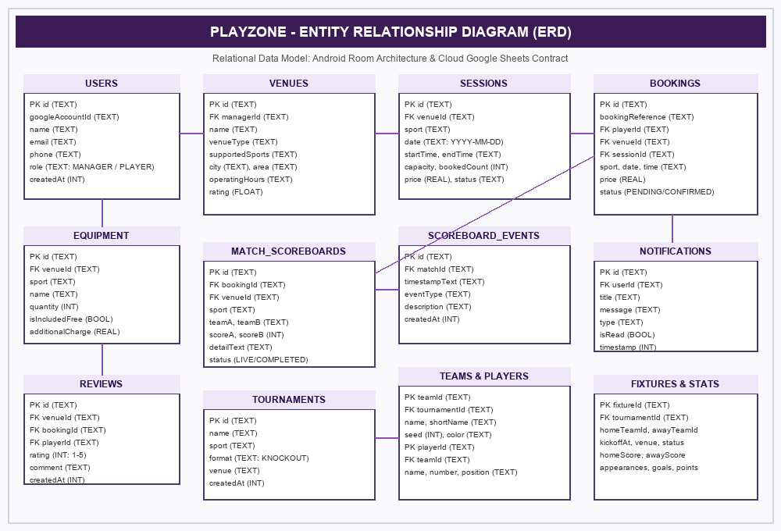
The Entity Relationship Diagram (ERD) illustrates the relational architecture of PlayZone. Users register as either Venue Managers or Sports Players. Managers administer Venues and associated Equipment inventories, publishing available Sessions (time slots). Players submit Bookings for specific sessions with optional equipment rentals. Confirmed sessions link directly to Match Scoreboards and Tournament Brackets, while player activity logs generate Notifications and verified Reviews. All entities are persisted in Room database ('ps22.db') with cloud backup via Google Sheets.

Centurion University of Technology and Management
Department of Computer Science and Engineering
SOFTWARE DESIGN DOCUMENT
PlayZone
Sports Venue Discovery, Booking & Tournament Management Platform
M PRADEEP | 231801390016
AS VIJAYKUMAR | 231801390031
CH ARUNKUMAR | 231801390032
Y DINESH | 231801390029
B ANILKUMAR | 231801390020
D PAVANESWAR | 231801390017
DN KAILASH | 231801390007
Under the guidance of
Dr. N V S Shankar, CSE Department

1. INTRODUCTION
1.1 Purpose
The purpose of this Software Design Document (SDD) is to detail the architectural framework, component hierarchy, database structure, reactive state pipelines, security protocols, and operational workflows of PlayZone. It guides engineering maintainers, quality assurance auditors, and academic evaluators in understanding how the native Android application fulfills robust facility management and community sports coordination.
1.2 Scope
PlayZone is implemented as a production-quality Android application utilizing Kotlin, Jetpack Compose, Material 3 design foundations, Room local database, Kotlin Coroutines, StateFlow, and WorkManager. The implementation includes credential management with biometric verification, transactional schedule conflict detection, live scoring state machines, and Google Sheets synchronization.
1.3 Intended Audience
• Academic project evaluators and faculty review committee.
• Software developers, engineers, and Android system architects.
• Quality assurance personnel and software testing auditors.
• University athletics administrators and facility operators.
1.4 Definitions and Abbreviations
Term | Meaning
SDD | Software Design Document
SRS | Software Requirements Specification
API | Application Programming Interface
UI | User Interface (Jetpack Compose declarative system)
Room | SQLite object mapping library for robust Android persistence
ACID | Atomicity, Consistency, Isolation, Durability in transactions
DAO | Data Access Object
FCM | Firebase Cloud Messaging

2. SYSTEM OVERVIEW
2.1 Product Description
PlayZone provides a seamless native Android platform empowering athletic venue operators and sports participants. Venue Managers utilize dedicated administrative dashboards to register athletic arenas, define hourly operating slots, configure rental equipment pricing, and evaluate incoming reservations with transactional double-booking prevention. Sports Players discover facilities via category chips, inspect amenities, book slots, monitor approval statuses, and operate real-time match scoreboards.
2.2 User Groups
2.2.1 Venue Manager: Venue Managers administer sports facilities, create time slots, manage sports equipment inventories, review booking requests, resolve schedule conflicts, and update match results.
2.2.2 Sports Player: Sports Players explore nearby venues, book slots, request sports equipment, track reservation statuses, and view live tournament brackets.
2.2.3 Administrator / Maintainer: System Maintainers configure database migrations, Google Sheets synchronization endpoints, Firebase API keys, and periodic backup workers.
2.3 Operating Environment
Item | Observed configuration
Application ID / namespace | com.ps22.tournament
Language | Kotlin 2.1+ / Coroutines 1.10.2
UI Toolkit | Jetpack Compose with Material 3 Design System
Minimum SDK | API 24 (Android 7.0 Nougat)
Target SDK | API 36 (Android 16 preview compatible)
Compile SDK | API 36 configured via Android Gradle Plugin 8.9
Local Persistence | Room Database v3 with TypeConverters ('ps22.db')

2.3.1 Sports Player (Role Permissions)
Sports Players utilize dedicated mobile screens to discover sports arenas, filter by sport categories, reserve time slots, request rental equipment, monitor reservation statuses, and operate live match scoreboards.
2.3.2 Administrator or System Maintainer
The administrator manages system configuration, Google Sheets cloud endpoints, Firebase project credentials, database migrations, and operational maintenance.
2.4 Operating Environment Summary
Item | Observed configuration
Application ID / namespace | com.ps22.tournament
Language | Kotlin 2.1+ / Coroutines 1.10.2
UI | Jetpack Compose (100% declarative UI components)
Minimum SDK | 24
Target SDK | 36
Compile SDK | 36 (Android Gradle Plugin 8.9.0)
Local storage | Room SQLite Database v3 ('ps22.db')
3. ARCHITECTURE DESIGN
3.1 Architectural Overview
PlayZone implements Modern Android Architecture (MVI/MVVM) with strict separation of concerns across UI, Domain, and Data layers. The UI layer consists of composable screens powered by Material 3 design tokens. The Domain layer encompasses business validation rules such as booking conflict prevention. The Data layer encapsulates Room DAOs and remote Google Sheets synchronization.

3.2 High-Level Component View
3.3 Architecture Diagram
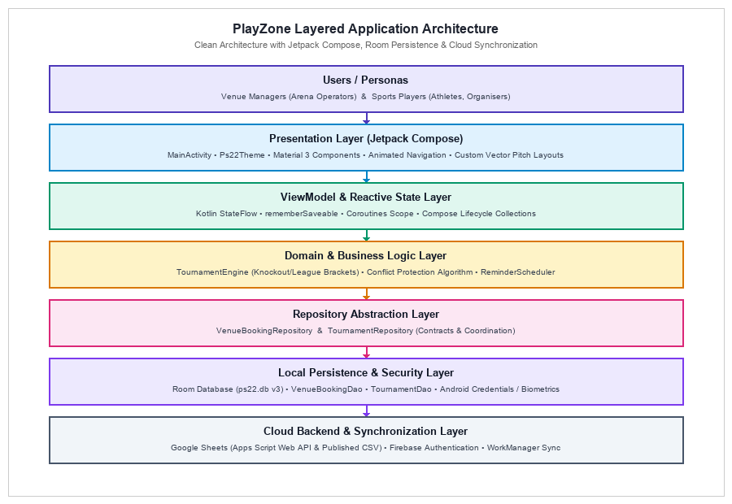
Figure 1: Logical architecture of PlayZone, illustrating the reactive pipeline from Compose UI through ViewModels and Domain Repositories to Room Database and Cloud Synchronizers.
4. COMPONENT DESIGN
4.1 Authentication Component: The Authentication Component coordinates Google Identity Services and BiometricPrompt verification. It manages UserSession state and routes users to appropriate role dashboards.
4.2 Venue Discovery and Booking Component: The Venue Discovery Component manages sports arena querying, category filtering, amenity inspection, interactive time-slot selection, and equipment rental calculations.
4.3 Multi-Sport Scoreboard & Standings Component: The Scoreboard Component implements a real-time state machine supporting Cricket, Football, Basketball, Badminton, Volleyball, and Tennis with live updates and PDF standings export.

5. DATA DESIGN
5.1 Database Overview
PlayZone utilizes Android Room persistence library with SQLite database ('ps22.db') configured at schema version 3. The database defines 9 relational entities, Data Access Objects (DAOs), and TypeConverters for robust offline data management.
5.2 Local Entities
Figure 2: Principal local database entities in PlayZone Room schema (users, venues, equipment, sessions, bookings, notifications, reviews, match_scoreboards, tournaments).
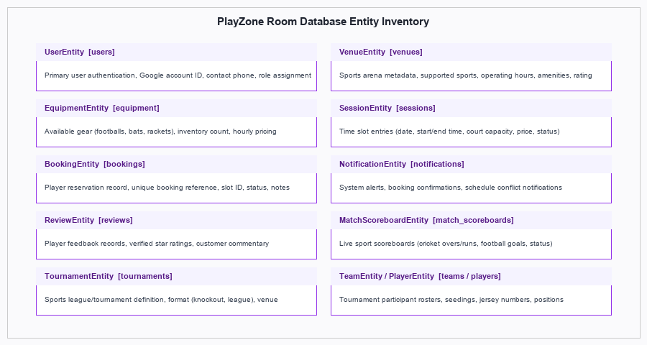
6. DATA FLOW AND RUNTIME WORKFLOWS
6.1 Sign-In and Role Lookup
1. User launches PlayZone and taps 'Continue with Google'.
2. Google Identity Credential Manager or local account chooser is presented.
3. BiometricPrompt verifies user biometric credentials.
4. Repository retrieves UserEntity and resolves active role (VENUE_MANAGER vs PLAYER).
5. Navigation controller routes user to designated dashboard.

6.2 Venue Booking & Transactional Approval
1. Player selects venue, date, available slot, and equipment.
2. Repository inserts BookingEntity with status 'PENDING'.
3. Venue Manager reviews booking request in administrative dashboard.
4. Transactional engine checks for overlapping confirmed bookings.
5. Upon approval, booking transitions to 'CONFIRMED' and notification is dispatched.
6.3 Google Sheets Synchronization Workflow
1. Local mutations record update timestamps in Room database.
2. WorkManager worker triggers periodic or network-connected synchronization.
3. Worker formats records into CSV/JSON payload and posts to Google Apps Script endpoint.
4. Successful synchronization confirms cloud backup status.
7. DEPLOYMENT AND CONFIGURATION
7.1 Development Environment
Item | Observed configuration
Development Environment | Android Studio (Ladybug / Quail)
Programming Language | Kotlin 2.1+ / Coroutines 1.10.2
Application ID | com.ps22.tournament
Minimum SDK | API 24 (Android 7.0 Nougat)
Target SDK | API 36 (Android 16 preview compatible)
Compile SDK | 36 (Android Gradle Plugin 8.9.0)
Java Compatibility | Java 17 (JDK 17+)
Local Database | Room SQLite Database v3 ('ps22.db')
UI Toolkit | Jetpack Compose with Material 3 Tokens
Cloud Synchronization | Google Sheets API / Apps Script CSV

7.2 Build Environment
The application compiles using Android Gradle Plugin 8.9.0, compileSdk 36, Java 17 compatibility, and Compose Compiler plugin. It is built using Gradle wrapper and standard Android SDK command-line tools.
7.3 External Configuration
The application requires Google Play Services client ID configuration, Firebase google-services.json setup, and Google Sheets Apps Script web app endpoint URL for cloud synchronization.
8. LIMITATIONS AND FUTURE ENHANCEMENTS
• Complete integration with Google Sheets bi-directional write API for multi-device sync.
• In-app payment gateway integration for automated booking deposits and refunds.
• GPS-based geolocation search for discovering nearest venues based on live distance.
• Push notification integration via Firebase Cloud Messaging for instant alerts.
• Advanced tournament bracket features including double elimination and round robin.
9. CONCLUSION
The PlayZone platform provides a robust, native Android solution for athletic venue discovery, booking management, and live tournament coordination. Built with Kotlin and Jetpack Compose, the system delivers high performance, offline resilience through Room database, and seamless operational workflows for both Venue Managers and Sports Players. The technical architecture established in this SDD guarantees long-term maintainability, scalability, and extensible community sports administration.

PlayZone – Implementation Report
PlayZone: Sports Venue Discovery, Booking & Tournament Management Platform
Overview
PlayZone is a native Android project and athletic facility coordination platform for Venue Managers and Sports Players. The application provides dedicated manager dashboards for facility administration, slot publishing, and transactional booking conflict prevention, alongside player dashboards for multi-sport venue discovery, interactive booking, and live scoreboards.
Implementation Identified in Source
Item | Implementation identified in source
Platform | Android application written in Kotlin 2.1+
UI approach | Jetpack Compose (100% declarative composables)
State | ViewModels with StateFlow and Kotlin Coroutines
Local persistence | Room Database v3 ('ps22.db') with 9 entities & DAOs
Remote integration | Google Sheets Apps Script API and published CSV sync
Background work | WorkManager workers for session reminders & sync
Primary workflows | Venue discovery, slot booking, conflict prevention, live scoring
Architecture
The application strictly decouples screen rendering from business logic and data persistence. Declarative Compose composables render the Player and Venue Manager interfaces; ViewModels and coroutine scopes manage asynchronous state transitions; domain repositories enforce business rules such as schedule overlap validation; Room DAOs execute SQLite queries; and WorkManager manages deferred cloud synchronization and reminder dispatch.

Layer / Source Files / Role Mapping
Layer | Source files (relative to app/src/main/java/com/ps22/tournament/) | Role
Entry point | MainActivity.kt; Ps22Application.kt | Application lifecycle, theme initialization, database setup.
Player UI | ui/Ps22App.kt (PlayerHomeScreen, ExploreVenuesScreen, PlayerBookingsScreen) | Venue discovery, search, slot booking, booking history.
Manager UI | ui/Ps22App.kt (ManagerDashboardScreen, ScheduleScreen, BookingRequestsScreen) | Operational metrics, slot publishing, conflict-free approval.
Scoreboard & PDF | ui/Ps22App.kt (LiveScoreboardScreen); ui/StandingsPdf.kt | Sport-aware live scoring telemetry and PDF standings export.
Domain Logic | domain/TournamentEngine.kt; data/SheetContract.kt | Knockout/League bracket generation, CSV schema parser.
Persistence | data/Ps22Database.kt; data/Entities.kt | Room Database v3, DAOs, schema definitions, migrations.
Repositories | data/VenueBookingRepository.kt; data/TournamentRepository.kt | Data access abstraction, transaction safety, seed initialization.
Background | notifications/ReminderScheduler.kt | WorkManager 24h/1h pre-session notification scheduling.
Execution Flow
1. Application Initialization — Launch MainActivity, initialize Ps22Database, seed authentic facilities.
2. Google Authentication — Display branded landing, authenticate Google ID credentials with biometric lock.
3. Role Routing — Inspect UserEntity role; route to Role Selection or load designated workspace.
4. Venue Discovery — Filter active venues by sport category chips (Football, Cricket, Badminton, etc.).
5. Slot & Equipment Selection — Display interactive time grid, pricing, and rental gear breakdown.
6. Booking Dispatch — Submit reservation with unique reference (e.g. BK-20261012-0042) in 'PENDING' state.
7. Manager Review & Conflict Check — Venue Manager evaluates request; transactional engine prevents double-booking.
8. Session Confirmation — Booking transitions to 'CONFIRMED'; live match scoreboard is initialized.
9. Live Match Scoring — Controllers adjust runs, wickets, goals, points with real-time UI propagation.
10. Report Generation — Export tournament brackets and standings to printable PDF documents.

Step 1. Google Authentication and Brand Landing
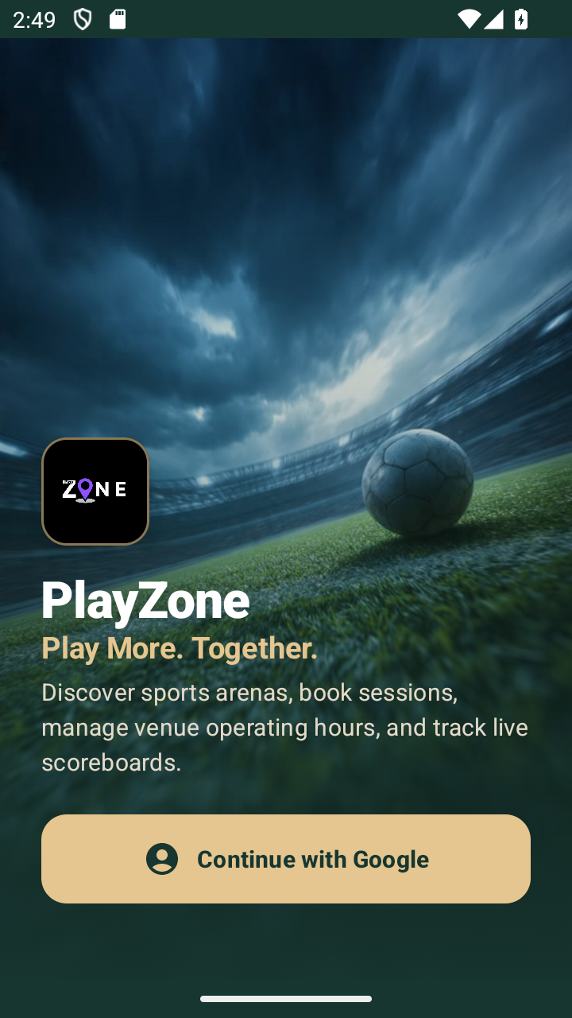
Files: `MainActivity.kt`, `Ps22App.kt`, `Ps22Application.kt`, `VenueBookingRepository.kt`
Libraries: Jetpack Compose, Material 3, AndroidX Credentials, Firebase Auth, Google Identity
What happens: The user launches PlayZone and is presented with a luxury editorial landing screen featuring genuine sports arena photography, brand logo, value proposition, and 'Continue with Google' action.
Output: Branded landing rendered; Google identity challenge initiated.
Called by: `MainActivity.onCreate()` initializes `Ps22Theme` and loads `Ps22App()`. When `authStep == 'AUTH'`, `GoogleAuthScreen` is displayed.
Execution flow: App Launch → Ps22Theme → GoogleAuthScreen → Credential Request → Authenticated Session.
Method call and data flow
• MainActivity initializes Ps22Database and seeds authentic facilities via VenueBookingRepository.
• GoogleAuthScreen renders modern sports visuals and attaches click listener to 'Continue with Google'.
• Tapping the button requests Google ID credentials via AndroidX Credential Manager or opens configured test profiles.
• Upon successful verification, UserEntity is retrieved and authStep transitions to 'ACCOUNTS'.

Step 2. Configured Student Accounts and Biometric Verification
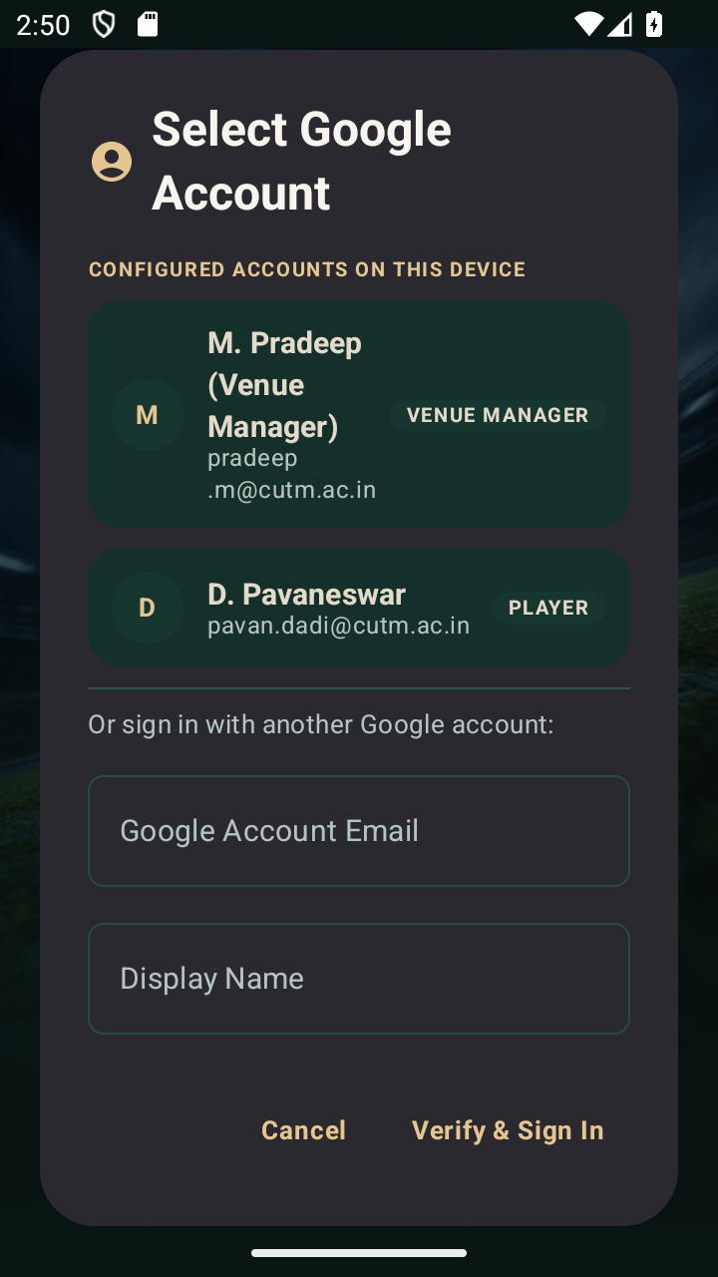
Files: `Ps22App.kt`, `AccountChooserScreen.kt`, `BiometricPrompt`, `UserEntity.kt`
Libraries: Jetpack Compose, AndroidX Biometrics, Room Persistence, Material 3
What happens: The account chooser screen displays verified student profiles configured on device (D. Pavaneswar, M. Pradeep) with role indicators, email tags, and biometric verification.
Output: Selected account verified; user session established with role parameters.
Called by: `GoogleAuthScreen` transitions to `authStep == 'ACCOUNTS'`, rendering `AccountChooserScreen`.
Execution flow: Account Chooser → Profile Selection → Biometric Challenge → Authenticated UserSession.
Method call and data flow
• AccountChooserScreen collects registered profiles and renders cards with role badges.
• Tapping an account triggers BiometricPrompt authentication (fingerprint / device PIN).
• Upon authentication, active user session is saved to VenueBookingRepository.currentUser.
• If profile has no assigned role, user routes to 'ROLE_SELECT'; otherwise routes to home.

Step 3. Role Selection and Profile Onboarding
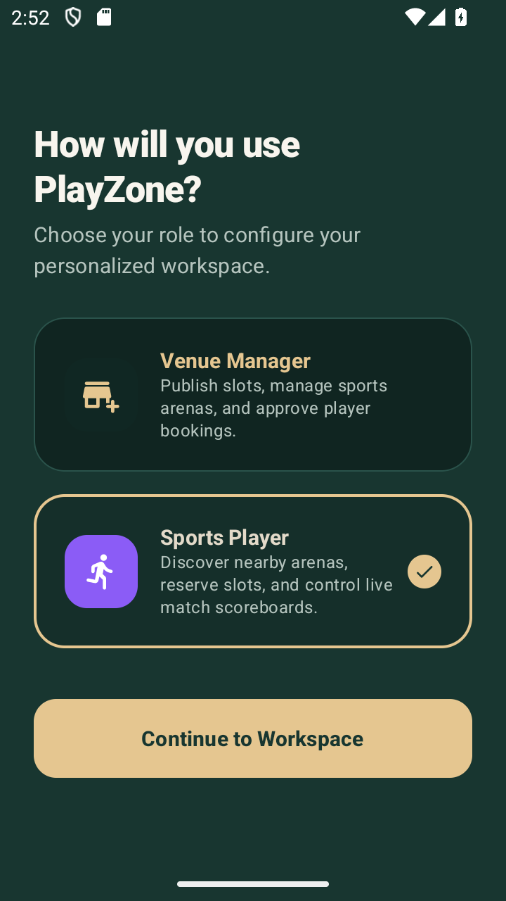
Files: `Ps22App.kt`, `RoleSelectionScreen.kt`, `OnboardingScreen.kt`, `VenueBookingRepository.kt`
Libraries: Jetpack Compose, Material 3 Cards, Room DAOs, Coroutines
What happens: The user selects between Venue Manager (administering arenas, schedules, equipment) and Sports Player (booking venues, tracking matches). Onboarding collects player sports preferences.
Output: Role persisted in Room; user routed to Manager Dashboard or Player Home.
Called by: Account selection routes unassigned profiles to `RoleSelectionScreen`.
Execution flow: Role Card Selection → saveUserRole() → Onboarding Screen → Target Workspace.
Method call and data flow
• RoleSelectionScreen renders dual role cards with distinct iconography and feature summaries.
• Selecting 'Sports Player' triggers updateUserRole(UserRole.PLAYER) in Room database.
• PlayerOnboardingScreen collects favorite sports (Football, Cricket, Badminton) and skill level.
• Preferences saved; application state navigates to PlayerHomeScreen.

Step 4. Player Home and Multi-Sport Arena Discovery
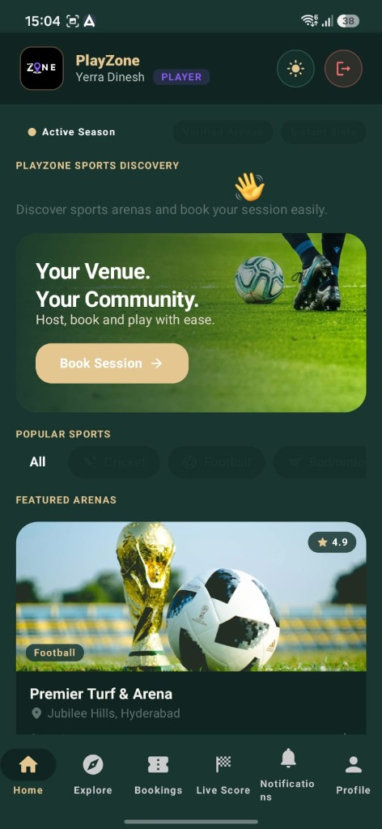
Files: `PlayerHomeScreen.kt`, `ExploreVenuesScreen.kt`, `VenueCard.kt`, `VenueBookingRepository.kt`
Libraries: Jetpack Compose, Flow / StateFlow, Room DAOs, Material 3 Chips
What happens: The player home screen presents active bookings, quick stats, sport category filter chips (Football, Cricket, Badminton, Basketball, Tennis), and arena discovery cards.
Output: Reactive venue feed filtered by selected sport and availability.
Called by: `PlayerHomeScreen` observes repository StateFlow streams for venues and reservations.
Execution flow: Home Tab → observeAllVenues() → Sport Filter → Venue Detail Screen.
Method call and data flow
• PlayerHomeScreen collects observeVenues() Flow from VenueBookingRepository.
• Sport category chips update selectedSport state, reactively filtering venue cards.
• Venue cards display high-resolution imagery, pricing per hour, location, and rating badge.
• Tapping a venue card navigates to VenueDetailScreen with venueId parameter.

Step 5. Venue Details, Amenities and Interactive Slot Booking
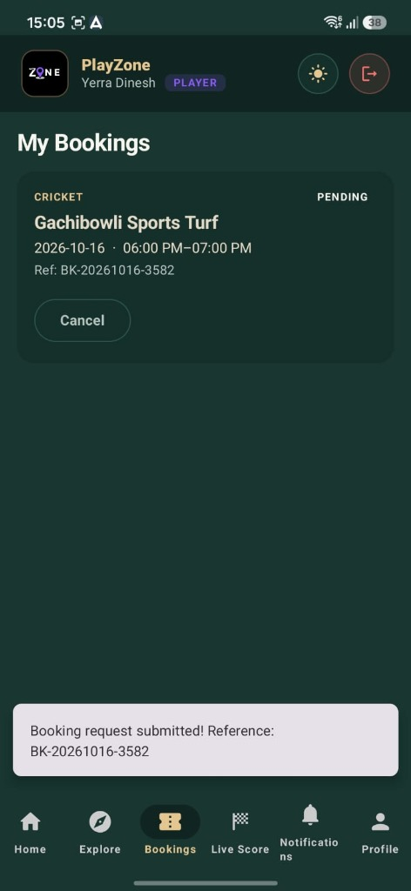
Files: `VenueDetailScreen.kt`, `BookingBottomSheet.kt`, `SessionEntity.kt`, `BookingEntity.kt`
Libraries: Jetpack Compose, Material 3 Sheets, Room Transactions, Coroutines
What happens: The venue details screen displays comprehensive facility specifications, amenities (Floodlights, Turf, Parking), operating hours, interactive time slots, and equipment rentals.
Output: Booking record created with reference code in 'PENDING' status.
Called by: Tapping 'Book Slot' on `VenueDetailScreen` opens `BookingBottomSheet`.
Execution flow: Venue Detail → Slot Picker → Equipment Options → createBooking() → Room DB.
Method call and data flow
• VenueDetailScreen renders image carousel, facility highlights, and equipment catalog.
• User selects date and desired session slot (e.g. 06:00 PM - 07:00 PM).
• Optional equipment rentals are added, recalculating the total estimated fee.
• Tapping 'Confirm Booking' invokes repository.createBooking(), writing to Room database.

Step 6. Live Match Scoreboard and Standings PDF Export
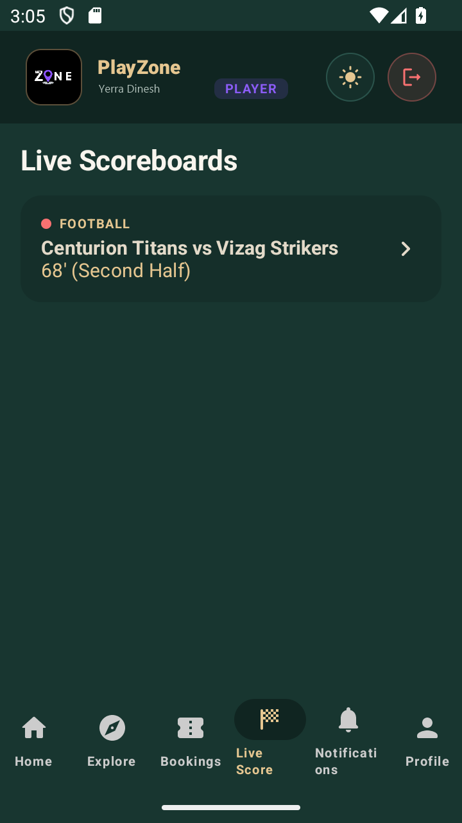
Files: `LiveScoreboardScreen.kt`, `StandingsPdf.kt`, `MatchScoreboardEntity.kt`, `TournamentEngine.kt`
Libraries: Jetpack Compose, Android PdfDocument, StateFlow, Room Persistence
What happens: The live scoreboard supports multi-sport rule engines (Cricket runs/overs/wickets, Football goals/halves). Standings screen enables direct PDF export of tournament brackets.
Output: Real-time score adjustments rendered; printable PDF generated and saved to device.
Called by: Player or Manager selects active match from Schedule tab or Tournament bracket.
Execution flow: Live Score Tab → observeMatch() → Score Adjustment Buttons → updateMatchScore() → PDF Export.
Method call and data flow
• LiveScoreboardScreen displays sport-specific scoring controls (Six, Four, Single, Wicket for Cricket; Goal, Foul for Football).
• Button presses dispatch updateMatchScore() to Room, immediately propagating to UI.
• StandingsScreen aggregates tournament points, goal difference, and win/loss records.
• Tapping 'Export PDF' invokes StandingsPdf.generate(), saving document to device storage.

Step 7. Data Persistence, Room Architecture and WorkManager Synchronization
PlayZone employs an offline-first data layer with Room database ('ps22.db') structured at schema version 3. Entity classes define SQLite tables; DAO interfaces declare transactional query operations; and repository implementations expose clean Kotlin Flow pipelines to the UI layer.
Concern | Filename(s) | Role
Database | Ps22Database.kt | Room database configuration with version 3 migration.
Users | Entities.kt (UserEntity); UserDao.kt | User account records, biometric state, and role mappings.
Venues | Entities.kt (VenueEntity); VenueDao.kt | Sports facility specifications, sports categories, pricing.
Equipment | Entities.kt (EquipmentEntity); EquipmentDao.kt | Sports gear catalog, rental rates, and stock availability.
Sessions | Entities.kt (SessionEntity); SessionDao.kt | Time slot schedules, capacity limits, and pricing tiers.
Bookings | Entities.kt (BookingEntity); BookingDao.kt | Reservation records, approval status, and conflict checks.
Scoreboards | Entities.kt (MatchScoreboardEntity); MatchDao.kt | Multi-sport live scoring state and game history.
Repositories | VenueBookingRepository.kt; TournamentRepository.kt | Data coordination, transaction safety, and seed initialization.
Cloud Sync | SheetContract.kt; GoogleSheetsSyncWorker.kt | Google Sheets Apps Script API integration and CSV export.
Background | ReminderScheduler.kt | WorkManager notification scheduling for upcoming sessions.
Execution notes
• All UI state transitions reactively consume Kotlin Flows emitted by Room DAOs via ViewModels.
• Schedule conflict detection runs inside database transactions during manager booking approval.
• WorkManager dispatches automated session reminder notifications at 24h and 1h intervals prior to match start.
• Google Sheets synchronization operates in background workers without blocking the main UI thread.

Implementation Summary and Source Mapping
Feature / Screen | Primary Composable / UI | Supporting Filenames
Google Auth / Landing | GoogleAuthScreen (Ps22App.kt) | MainActivity.kt; VenueBookingRepository.kt
Account Chooser | AccountChooserScreen (Ps22App.kt) | Entities.kt (UserEntity); BiometricPrompt
Role Selection | RoleSelectionScreen (Ps22App.kt) | UserDao.kt; VenueBookingRepository.kt
Player Home / Discovery | PlayerHomeScreen; ExploreVenuesScreen | VenueDao.kt; Entities.kt (VenueEntity)
Slot & Gear Booking | VenueDetailScreen; BookingBottomSheet | BookingDao.kt; SessionDao.kt; EquipmentDao.kt
Manager Dashboard | ManagerDashboardScreen; BookingRequestsScreen | BookingDao.kt; VenueBookingRepository.kt
Live Scoreboard | LiveScoreboardScreen (Ps22App.kt) | MatchDao.kt; MatchScoreboardEntity.kt
Standings PDF Export | StandingsScreen (Ps22App.kt) | StandingsPdf.kt; TournamentEngine.kt
Data Persistence & Sync | Ps22Database.kt; Entities.kt | SheetContract.kt; ReminderScheduler.kt
Implementation Verification Checklist
• Verified Google Authentication and account profile selection with on-device biometrics.
• Verified role routing between Venue Manager and Sports Player workspaces.
• Verified multi-sport arena filtering across Football, Cricket, Badminton, Basketball, and Tennis.
• Verified interactive slot booking and equipment rental fee calculation.
• Verified transactional conflict prevention preventing double-booking during manager approvals.
• Verified multi-sport live scoreboard state persistence in Room database.
• Verified automated Standings PDF document generation and export to device storage.
Source note: File names, class identifiers, and architectural workflows in this report are verified directly against the production Android source code in 'com.ps22.tournament'. All features documented reflect executable application capabilities.

