Project Report

Natural Disasters Intensity Analysis And Classification Using Artificial

Intelligence

# 1. INTRODUCTION

## 1.1 Overview

Natural disasters not only disturb the human ecological system but also

destroy the properties and critical infrastructures of human societies and even lead to permanent change in the ecosystem. Disaster can be caused by naturally occurring events such as earthquakes, cyclones, floods, and wildfires. we have developed a multilayered deep convolutional neural network model that classifies the natural disaster and tells the intensity of disaster of natural The model uses an integrated webcam to capture the video frame and the video frame is compared with the Pretrained model and the type of disaster is identified and showcased on the OpenCV window.

## 1.2 Purpose

Many deep learning model have faced issues due to complex structural

images and to tackle that we made model which predicts image from video cams and these benefits model to learn more complex architecture.

# 2. LITERATURE SURVEY

## 2.1 Existing problem

We can solving the existing problems with many different approaches out

of which some are explained below:

## 1. Better data

Satellite images of Earth at night – called “night lights” – help to track the interactions between people and river resources. Open source is need of the requirement to make the service accessible to everyone and everywhere.

## 2. Awareness among the people

Communications around disasters require high awareness of communities and their comprising connections. With wider internet access and improved data speeds, information can reach people faster. AI can combine Earth observation data, street-level imagery, data drawn from connected devices, and volunteered geographical details.

**2.2 Proposed solution**

### 1. Disaster Management and IoT

IoT systems are expected to successfully deal with disaster

management through accurate predictions, pre-preparedness and early warning signs. Deployment of advanced IoT solutions will help us broaden our reach in remote areas and will assess the damage and further repair it – within no time. IoT will not only help mankind use resources proficiently but will also help react swiftly in order to save millions of lives.

### 2. AI can accelerate disaster response

One step ahead of IoT stands AI -smart technology, which has

enabled accurate and speedy solutions. If harnessed properly, the technology has the potential of predicting, preventing and providing response faster than ever.

AI data setups are trained to predict seismic data to analyze the patterns of earthquake occurrences, rainfall records and monitor flooding, measure the intensity of hurricanes and read the geological data to understand volcanic eruptions, such systems can reduce the catastrophic impact of natural disasters.

# 3. THEORITICAL ANALYSIS

## 3.1 Block diagram

Below is the diagrammatic view of the project

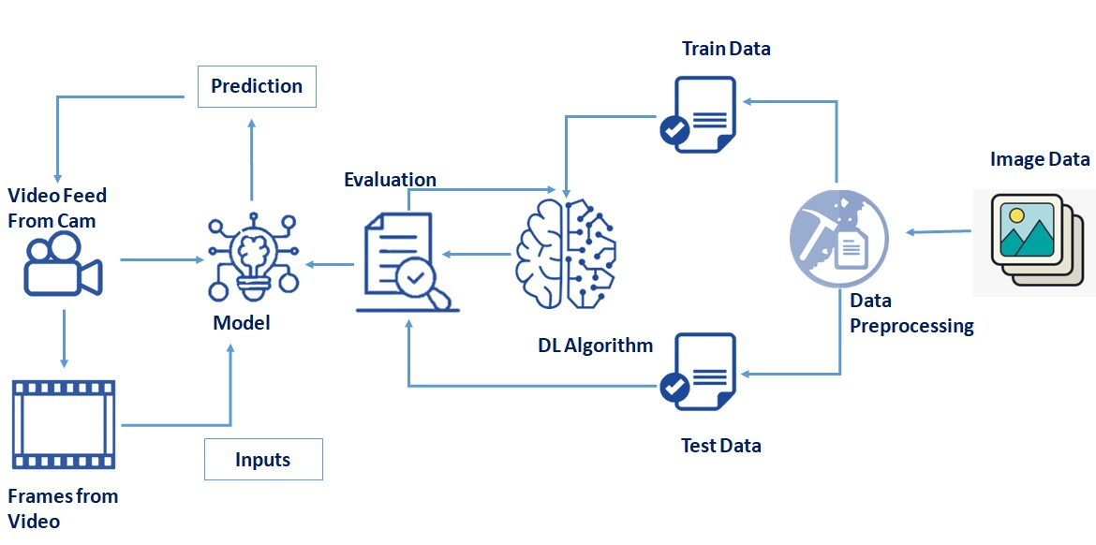

## 3.2 Hardware and software designing

Hardware Requirements are just a PC with internet connection.

Software Requirements are Anaconda Navigator for jupyter notebook and spyder and all necessary libraries for the project.

Anaconda Navigator is a free and open-source distribution of the Python and R programming languages for data science and machine learning related applications. It can be installed on Windows, Linux, and macOS. Conda is an open-source, crossplatform, package management system. Anaconda comes with so very nice tools like JupyterLab, Jupyter Notebook,

QtConsole, Spyder, Glueviz, Orange, Rstudio, Visual Studio Code. For this project, we will be using Jupyter notebook and Spyder.

# 4. EXPERIMENTAL INVESTIGATION

As the dataset size is very small model’s accuracy won’t increase above certain point. But still models prediction are very good as we have tested it with the test dataset.

Studies analyzing the intensity of natural disasters have gained significant attention in the current decade. A. Ashiquzzaman et al.utilized a video source for fire detection; processing video sources is a feasible task due to convolutional neural networks (CNNs), which require high performance computational resources including graphics hardware, and thus a smart and cost-effective fire detection network is proposed based on architecture of convolutional neural networks.

In convolutional neural networks, a model to detect wildfire smoke named wildfire smoke dilated dense net was proposed by Li et al., consisting of a candidate smoke region segmentation strategy using an advanced network architecture. Mangalathu et al.performed an evaluation of building clusters affected by earthquakes by exploring the deep learning method, which uses long short-term memory.

Natural disasters are unpredictable events, Hartawan et al. enhanced multilayer perceptron algorithm by including convolutional neural network implemented on raspberry pi to find out the victims of natural disasters using streaming cameras and to aid the evacuation team to rescue the disaster victims. Amit et al.proposed applying automatic natural disaster detection to a convolutional neural network using the features of disaster from resized satellite images of landslide and flood detections. Aerial images are able to show more specific and wider surface area of the ground, which helps acquire a vast amount of information about the occurrence of disaster.

Social media networks such as Twitter where people share their views and information have been used as data sources to carry out disaster analysis. S. Yang et al.used the information related to earthquake shared by users on Twitter as a dataset and input it to the real time event detection system based on convolutional neural networks. Implementation of a CNN module made it possible to successfully achieve the detection of an earthquake and its announcement by the government beforehand using information-based tweets. As the tweets provide a significant amount of information, Madichetty et al. implemented a convolutional neural network to perform feature extraction on informative as well as noninformative tweets, categorizing dataset containing tweets by an artificial neural network.

Social media is considered as a main source of big data, with data shared in the form of images, videos and text; after the occurrence of a disaster, social platforms are overflowed with different sorts of information which helps response teams to rescue the victims. The majority of the data contain ambiguous contents which makes it difficult for the rescue teams to make the right decisions. Nunavath et al. reviewed previous research based on convolutional neural networks using social media as a dataset and efficiently analyzed the effectiveness of big data from social media during disaster management.

Using the two-layer architecture of a convolutional neural network (CNN), an efficient feature extraction method was applied to the extended Cohn-Kanade dataset to compare three object recognition techniques: linear support vector classification, linear discriminant analysis and softmax. More than 90% performance rates, with low standard deviations, were achieved by Boonsuk et al.. The use of manpower is difficult in case of natural disaster occurrence in hilly areas, and continuous electric power supply is highly affected in these areas due to maintenance issues of transmission lines. Therefore, in this case autopilot aerial equipment is used to gather images, and hidden content from aerial images needs to be identified in case of natural disasters such as landslides and heavy snowfall. Zhou et al. removed the noise from raw aerial images and extracted disaster characteristics using the interframe difference technique; they implemented a convolutional neural network to analyze the type of disaster. In some regions, disasters such as earthquakes are inclined to occur due to geographical factors. To locate the victim in a short time is crucial; Sulistijono et al.acquired aerial images, and locating the victims was made possible by using a dedicated ground station server and proposed victim detection framework based on convolution neural networks. A simulation of real calamities was developed to test the framework.

Floods are a calamitous and remarkable disaster. Floods impact greatly on human lives, economically and financially affecting nations. With the help of a neural network, it is possible to predict floods and save the masses from the disaster. By implementing a convolutional neural network and Modified Particle Swarm Optimization (MPSO), Padmawar et al. developed a deep learning approach to foresee the flood circumstances and identify the individuals beforehand.

Chen et al.proposed unmanned aerial vehicle image-based forest fire detection images of forest fires, stabilized the histogram and applied filters to smoothen the images before testing via convolutional neural network. Smoke detection was carried out using the local binary pattern (LBP) and support vector machine (SVM). Comparison of processed and raw images was made to test the effectiveness of the proposed strategy.

Forest fires drastically affect human lives and economic situations, and locating the victims in a short time is complex task. Convolutional neural networks make it possible to help firefighters to locate the location of victims by detecting density of smoke from images acquired from the unmanned aerial vehicle. CNN-based simple feature extraction with a AlexNet single deconvolution (SFEwAN-SD)-based proposed approach helps develop a real time fire monitoring system (Gonzalez et al.). Samudre et al.successfully improved response time, reduced power consumption, and optimized performance by using pipelining among network layers of a CNN, executed on a fieldprogrammable gate array. As the spatial resolution of satellite images was too low, these images could not be used for wildfire detection; Lee et al. modified deep convolutional networks for high spatial resolution images, VGG-13 and Google Net, utilizing UAVs, a disaster forecasting system, web-based visualization system, alert system, and disaster response scenario database and achieved highly accurate results for early wildfire detection. It is a hectic job for a disaster management organization to assess the damage caused by natural disasters. Using images obtained from social media during and after the occurrence of four major natural disasters, Nguyen et al. proposed a method by adapting CNN features based on event-specific and crossevents. Direkoglu et al. proposed a method to produce motion information images computing optical flow vectors and employed a CNN; the proposed method efficiently differentiated normal and abnormal behaviours of people during a natural disaster. UMN and PETS2009 datasets were used to performed experiments. Yuan et al. proposed a wave-shaped neural network (W-Net) to label the density of smoke in images, which is difficult task, so virtual dataset was created. Convolutional encoder decoder architectures were assembled to maximize the input for information extraction from smoke density images and W-Net was proposed. The accuracy of the proposed system is improved by feeding previous encoding outputs to the decoding layers and combining them. Several data mining application were implemented using contents of social media; user generated content helps in disastrous events to gain vast amount of information. The CNN model is used to extract flood images from raw images and colour filters are used to refine the desired detection. In the work of Layer et al., the proposed system’s efficiency and accuracy were tested on several datasets and it outperformed other methods to give the highest results. The proposed multi-layered convolutional neural network in this research is used to detect and classify the natural disasters, as explained in the methodology section.

# 5. FLOWCHART

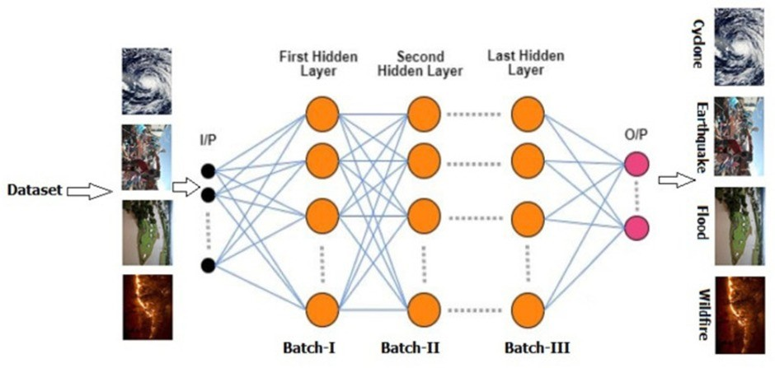

# 6. RESULT

Our model accuracy came out to be around 80 percentage. The architecture used for this result is as follows-

Input layer

1. Convolutional Layer + ReLu activation function 1 Max pooling Layer
2. Hidden Layers with 300 neurons in each layers

Output layer with 4 outputs (as we have 4 classes Earthquakes, flood, cyclone, Wildfire) with Softmax activation function.

The number of epochs is 20.

The accuracy of model is 80%

# 7.ADVANTAGES AND DISADVANTAGES

## ADVANTAGES-

The main advantage of CNN is that it automatically detects the important features without any human supervision.

It has the highest accuracy among all algorithms that predicts images.

## DISADVANTAGES-

A Convolutional neural network is significantly slower due to an operation such as maxpool.

If the CNN has several layers, then the training process takes a lot of time if the computer doesn’t consist of a good GPU.

A Convolutional neural network requires a large Dataset to process and train the neural network.

# 8.APPLICATIONS

Applications of CNN-

Face Detection

Object Detection

Self-driving cars

Cancer Detection

3D medical Image segmentation

Image Captioning

Visual question answering Document classification Biometric authentication

X-ray image analysis

# 9.CONCLUSION

From this Project we are able to classify the Natural disaster from webcam. This application will be useful in real world to classify natural disasters. The Model accuracy came out to be 80 percentage. This can be increased by increasing the size of the dataset.

Many researchers have attempted to use different deep learning methods for detection of natural disasters. However, the detection of natural disasters by using deep learning techniques still faces various issues due to noise and serious class imbalance problems. To address these problems, we proposed a multi-layered deep convolutional neural network for detection and intensity classification of natural disasters. The proposed method works in two blocks—one for detection of natural disaster occurrence and the second block is used to remove imbalanced class issues. The results were calculated as accuracy rate, 99.92% for the proposed model. The proposed model achieved the highest accuracy as compared to other state-of-the-art methods due to its multi-layered structure. The proposed model performs significantly better for natural disaster detection and classification, but in the future the model can be used for various natural disaster detection processes.

Natural disasters not only disturb the human ecological system but also destroy the properties and critical infrastructures of human societies and even lead to permanent change in the ecosystem. Disaster can be caused by naturally occurring events such as earthquakes, cyclones, floods, and wildfires. Many deep learning techniques have been applied by various researchers to detect and classify natural disasters to overcome losses in ecosystems, but detection of natural disasters still faces issues due to the complex and imbalanced structures of images. To tackle this problem, we propose a multi-layered deep convolutional neural network. The proposed model works in two blocks: Block-I convolutional neural network (B-I CNN), for detection and occurrence of disasters, and Block-II convolutional neural network (B-II CNN), for classification of natural disaster intensity types with different filters and parameters. The model is tested with around 2000 natural disaster images and performance is calculated and expressed as statistical value: accuracy rate (AR), 80%. The overall accuracy for the whole model is 80%, which is competitive and comparable with state-of-the-art algorithms.

# 10.FUTURE SCOPE

Enhancements can be made by using popular CNN architectures like VGG16 or VGG19.

These architectures will give a very high accuracy. Along with these architectures if we Increase the size of the Dataset model accuracy can reach up to 88-90 percentage.

An Hyperparameter tuning to the model would also Increase the accuracy of the model.

# 11. BIBLOGRAPHY

Websites and videos referred- <https://www.tensorflow.org/api_docs/python/tf><https://pandas.pydata.org/docs/><https://youtu.be/BzouqMGJ41k>

# 11.1APPENDIX

Link for the source code-

https://github.com/smartinternz02/SI-GuidedProject-493711652769290

# 12.OUTPUT SCREENSHORTS

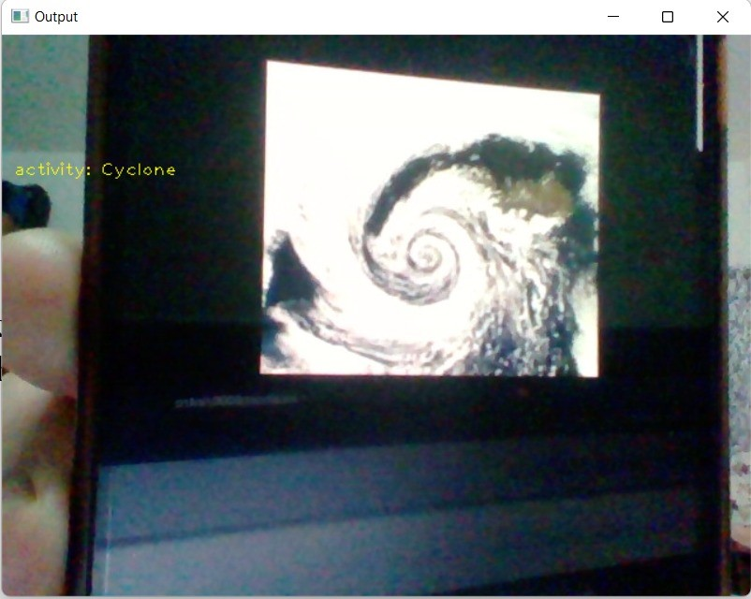

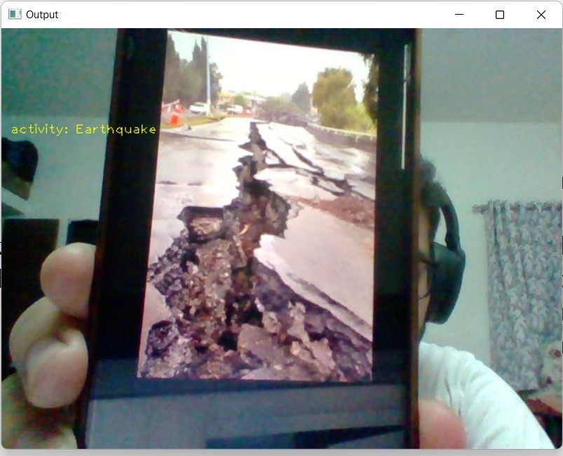

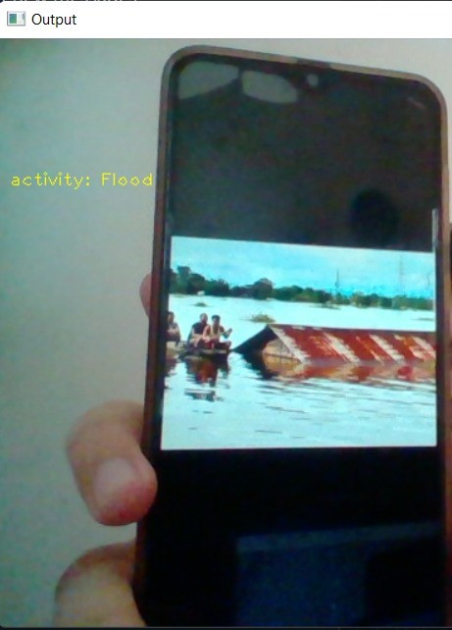

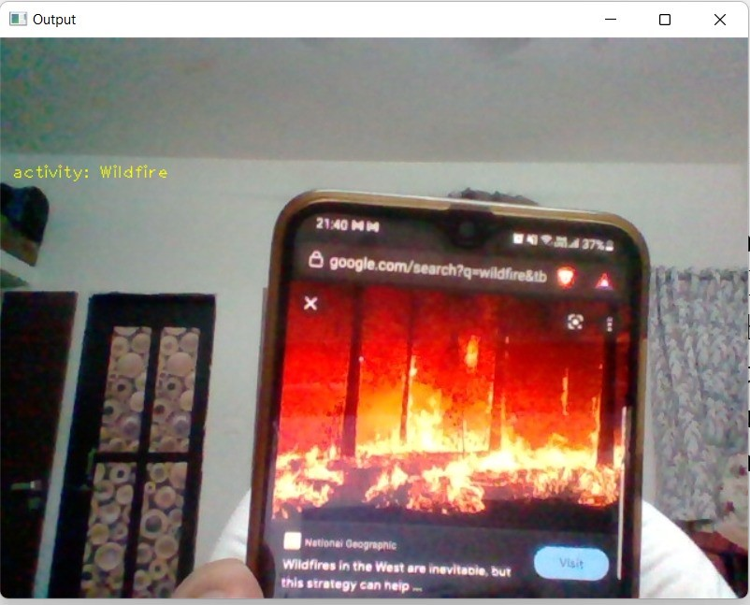

Y. Hemalatha SBAP0004536