1.Title and analytical question
Title:
Mismatch Between Price and Demand in Chicago Airbnb Listings: Identifying Overpriced and Underpriced Neighborhoods
Analytical Question:
Which Chicago neighborhoods exhibit the greatest mismatch between listing prices and actual guest demand, and what does this reveal about potentially overpriced or underpriced areas across different room types?
Target Audience:
Airbnb hosts, property investors, and market analysts
Why this matters:
Understanding the relationship between pricing and guest engagement is critical for identifying inefficiencies in the Airbnb market. Listings do not always perform in direct proportion to their price, and this mismatch can reveal important strategic insights. For example, areas with high engagement but relatively low prices may indicate underpriced opportunities, while areas with high prices but low engagement may suggest overpricing or weak demand. Similarly, some neighborhoods may sustain both high prices and strong engagement, reflecting premium market positioning, whereas others may struggle with low demand regardless of pricing.
By analyzing these patterns, this study goes beyond simply identifying expensive or popular areas and instead focuses on how effectively listings are positioned within the market. This helps hosts, investors, and analysts make more informed decisions about pricing strategies, location selection, and competitive positioning.
2. Data Files Used and Preparation
Data Files Used
This analysis uses two datasets from the Chicago Airbnb snapshot:
- listings.csv: The primary dataset containing detailed information about each Airbnb listing, including price, neighborhood, room type, availability, and review-related metrics such as reviews per month and number of reviews in the last 12 months.
- reviews.csv: A supplementary dataset containing review activity, including listing IDs and review dates, which provides additional insight into guest engagement over time.

Why These Files Were Selected
- The “listings.csv” dataset was selected as the core dataset because it contains the key variables required to analyze pricing, location, and listing characteristics. These fields are essential for identifying differences in pricing across neighborhoods.
- The “Reviews.csv” dataset was included to support the analysis of guest demand. Since direct booking or occupancy data is not available, review activity is used as a proxy for demand. Combining these two datasets enables the comparison of listing prices with engagement levels, which is central to identifying overpriced and underpriced neighborhoods.
Data Model and Relationships
A relationship was established between the listings and reviews datasets using the following key:
Listings.id = reviews.listing_id
A relationship model was used instead of a physical join because the reviews dataset contains multiple records for each listing. Using a join would duplicate listing-level data and distort metrics such as average price and listing counts.
By using a relationship, Tableau preserves the integrity of listing-level data while still allowing access to review-level information when needed. This ensures that comparisons between price and demand remain accurate and reliable.
Data Preparation and Cleaning Decisions
Several data preparation steps were performed to ensure the dataset supports accurate analysis:
- Data Type Standardization
Fields such as price, last_review, and review date were converted into appropriate numeric and date formats. This ensures correct aggregation and enables time-based analysis.
- Handling Missing Engagement Data
The reviews_per_month field contains null values for listings with no recent review activity. These values were retained and interpreted as low or no demand, rather than being removed, to ensure that low-engagement listings are included in the analysis.
- Outlier Awareness in Pricing
The price field was reviewed for extreme values. While outliers were not removed at this stage, their presence was considered when interpreting results to avoid misleading conclusions.
- Geographic Data Preparation
Latitude and longitude fields were verified and assigned geographic roles in Tableau to support spatial analysis and mapping.
2.1 What are the most important fields for your analysis? (question)
The most important fields in this analysis are Price, which represents the cost of listings and is used to identify expensive versus affordable areas, and Reviews per Month, which serves as a proxy for guest demand and engagement. Neighborhood is essential for comparing patterns across different areas of Chicago, while Room Type helps analyze differences between entire homes, private rooms, hotel rooms, and shared spaces. Finally, Availability (365) provides insight into listing supply conditions across the city. Together these fields are essential for evaluating the relationship between pricing and demand across neighborhoods.
2.2 What issues or limitations did you notice in the data? (question)
Several limitations were observed in the dataset. The most significant is that there is no direct measure of demand, as the dataset does not include booking or occupancy data. As a result, review activity is used as a proxy for demand, which may not fully represent actual booking behavior. Additionally, some listings have missing values for reviews per month, which may indicate little or no recent activity but could also reflect incomplete data collection. The price field also contains potential outliers, with extremely high or low values that may skew aggregated results and require careful interpretation. Finally, the neighborhood group field is largely missing across the dataset, which limits the ability to analyze broader geographic clusters beyond individual neighborhood names.
2.3 How did your data preparation choices affect the rest of your analysis? (question)
The data preparation choices ensured that both pricing and engagement metrics were accurately represented without distortion. Using a relationship instead of a join in Tableau prevented duplication of listing-level data, which was critical when comparing price and demand since the reviews dataset contains multiple records per listing. Retaining listings with low or missing engagement values rather than removing them allowed the analysis to capture both high-demand and low-demand areas, which is essential for identifying overpriced and underpriced neighborhoods. Overall these preparation steps improved the reliability and interpretability of the analysis and ensured that the findings were based on a complete and undistorted view of the data.

Screenshot 1: Tableau Data Model — Relationship between listings.csv and reviews.csv
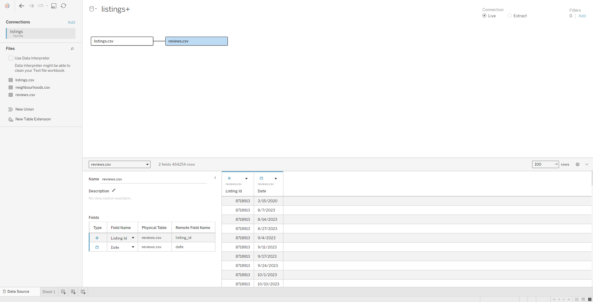
Screenshot 2: Tableau Data Source View — Fields used in the analysis

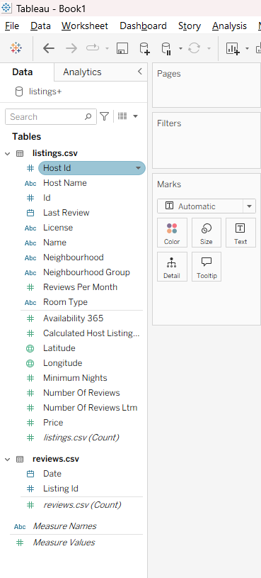

3.Spatial Analysis
Screenshot of the Map visualization
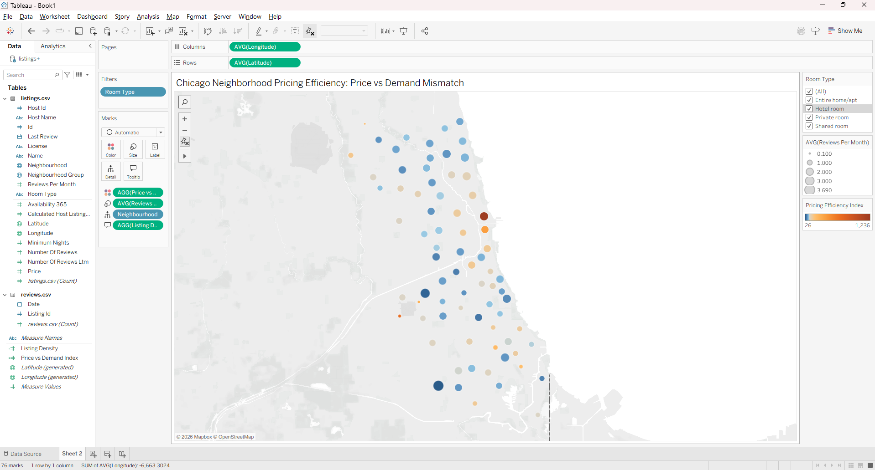
Why a Map is Appropriate
A map visualization is appropriate for this analysis because the dataset contains geographic coordinates (latitude and longitude) for Airbnb listings in Chicago. Mapping the data allows us to observe how pricing and demand vary across different locations in the city. Spatial patterns are difficult to identify in tables or standard charts, but a map makes it easier to detect clusters, trends, and regional differences. This is especially useful for understanding how neighborhood location influences listing performance.
Key Findings from the Map
Finding 1: Central areas show strong demand but inconsistent pricing efficiency
Listings in central Chicago, particularly in neighborhoods near the downtown core and lakefront such as Near North Side, tend to have higher review activity indicating strong guest demand. However, the pricing efficiency index reveals significant variation within these same areas, with some listings appearing heavily overpriced relative to their engagement levels. This suggests that hosts in high demand central areas are not consistently optimizing their pricing strategies despite having a location advantage.

Finding 2: Peripheral neighborhoods outperform expectations on demand
Contrary to expectations, listings located in outer neighborhoods such as Mount Greenwood, which leads all areas at 3.69 average reviews per month, and Archer Heights at 3.02, show stronger demand than many centrally located areas. This spatial pattern reveals that proximity to downtown does not guarantee higher guest engagement and that peripheral neighborhoods represent underrecognized opportunities in the Chicago Airbnb market.
Spatial Limitations and Ambiguity
One limitation of this map is that it uses point-based data without clearly defined neighborhood boundaries, which can make it difficult to precisely compare areas. Additionally, overlapping points in dense regions may obscure individual listings and reduce clarity. The analysis also assumes that reviews per month accurately represent demand, which may not fully capture seasonal trends or listing availability. Finally, geographic patterns may be influenced by external factors such as tourism, accessibility, or local amenities that are not directly included in the dataset.
3.1 What spatial pattern stands out most in Chicago? (question)
The most prominent spatial pattern is the concentration of high-demand listings in central Chicago, particularly near the downtown and lakefront areas. These locations show larger markers (indicating higher reviews per month), reflecting stronger demand. However, within these same areas, there is noticeable variation in the pricing efficiency index, with some listings appearing overpriced while others are underpriced relative to demand. This highlights a mismatch between pricing and demand even in the most active regions.
3.2 What does the map reveal that a non-map chart would not reveal as clearly? (question)
The map reveals geographic clustering and spatial relationships that would not be easily visible in a standard chart. While a bar chart or table could show average price or demand by neighborhood, it would not clearly illustrate how listings are distributed across the city or how demand changes gradually from central to peripheral areas. The map makes it easier to identify clusters of high-demand listings and observe how pricing efficiency varies within the same geographic region, providing a more intuitive understanding of location-based trends.
3.3What design choices did you make to improve readability? (question)
Several design choices were made to enhance readability and clarity. A diverging color palette was used to represent the pricing efficiency index, making it easier to distinguish between overpricing and underpricing. Marker size was used to represent reviews per month, allowing demand levels to be quickly identified. A room type filter was added to support interaction and enable focused analysis. Additionally, unnecessary map elements were minimized, and the view was zoomed to Chicago to reduce visual clutter and emphasize relevant data points.
4. Student-Defined Analysis
Analytical Question
Which Chicago neighborhoods exhibit the greatest mismatch between listing prices and guest demand, and which areas appear to be overpriced or underpriced relative to their level of customer engagement?
Rationale (Why this question matters)
Understanding the relationship between price and demand is critical for both hosts and customers. Listings that are priced too high relative to demand may struggle to attract bookings, while those priced lower despite strong demand may represent missed revenue opportunities. Identifying such mismatches helps reveal inefficiencies in the market and provides insights into how pricing strategies can be improved across different neighborhoods.
Key Factors / Predictors (Independent Variables)
The analysis focuses on three key predictors. Price represents the cost of a listing and is the primary variable used to identify overpriced and underpriced areas. Neighborhood captures geographic variation across Chicago and allows comparison of pricing and demand patterns across different parts of the city. Room Type differentiates between listing categories including entire homes, private rooms, hotel rooms, and shared spaces, enabling analysis of how listing type influences market positioning. Together these three factors determine how a listing competes within the Chicago Airbnb market.
Outcome Metric(s) (Dependent Variable)
The primary outcome metric is Reviews per Month, used as a proxy for guest demand and engagement. An additional derived metric was created, the Pricing Efficiency Index (Price ÷ Reviews per Month), which measures how well a listing's price aligns with its level of demand. A higher index value indicates potential overpricing relative to demand, while a lower value suggests stronger demand relative to price.

Visualization Strategy
Four visualizations were used to answer this question. First, a map encodes the Pricing Efficiency Index through color and Reviews per Month through marker size, enabling simultaneous spatial comparison of price and demand across Chicago neighborhoods, with a room type filter allowing focused analysis by listing category. Second, a scatter plot of Price vs. Reviews per Month with average reference lines divides listings into four quadrants including high price/high demand, high price/low demand, low price/high demand, and low price/low demand making it easy to identify overpriced and underpriced listings directly. Third, a bar chart of average reviews per month by room type compares demand levels across entire homes, private rooms, hotel rooms, and shared spaces. Fourth, a bar chart ranking the top neighborhoods by average reviews per month provides a clear comparison of demand levels across different areas of the city. Together these four visualizations allow simultaneous analysis of price, demand, location, and listing type.

Interpretation of Results
The analysis reveals that pricing and demand are not consistently aligned across Chicago neighborhoods. The scatter plot shows that the majority of listings priced above $200 fall below the average demand line, suggesting that higher-priced listings tend to generate less guest engagement. This pattern supports the central finding that higher prices do not consistently lead to higher demand.
The neighborhood bar chart reveals a surprising finding with Mount Greenwood leads all neighborhoods with 3.69 average reviews per month, followed by Archer Heights at 3.02, both of which are peripheral neighborhoods rather than central ones. This challenges the assumption that downtown proximity drives demand. Meanwhile, the room type analysis shows that entire home/apartment listings generate the highest average demand at 2.017 reviews per month, compared to hotel rooms at just 0.826.
The map further confirms that while central Chicago shows clustering of listings, pricing efficiency varies significantly even within the same area, indicating inconsistent pricing strategies among hosts in high-demand zones. Overall, these findings highlight meaningful pricing inefficiencies across the Chicago Airbnb market.

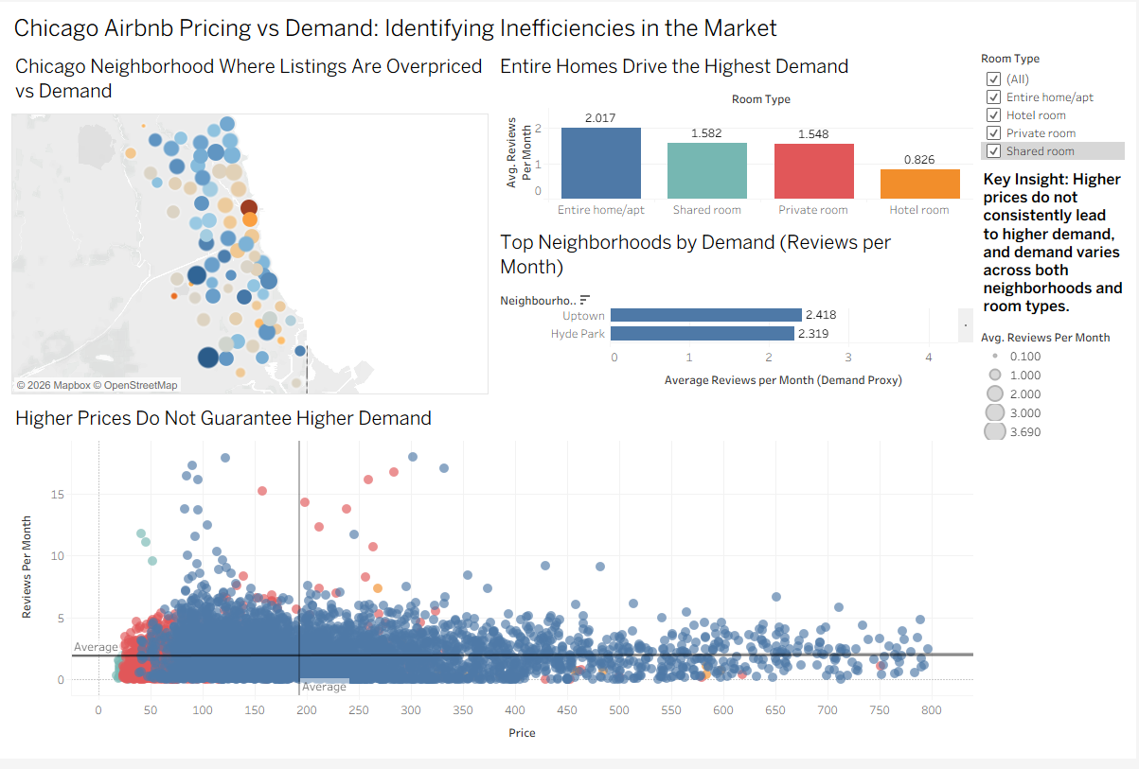

5. Dashboard and Design Rationale
The dashboard was designed to tell a progressive story, moving from a broad spatial overview down to detailed analytical insights. The layout begins with the map in the upper left, which serves as the entry point for the analysis. This positioning is intentional — the map gives the viewer an immediate geographic understanding of how pricing and demand are distributed across Chicago before diving into specific patterns. From there the viewer naturally moves to the room type bar chart and top neighborhoods bar chart on the right, which provide more focused comparisons. Finally, the scatter plot at the bottom ties everything together by showing the relationship between price and demand at the individual listing level.
Several design decisions were made to improve clarity and readability. A diverging color palette was applied to the map to represent the Pricing Efficiency Index, making it easy to visually distinguish between overpriced and underpriced areas at a glance. Marker size was used to encode reviews per month, allowing demand levels to be identified without adding extra visual elements. Reference lines for average price and average reviews per month were added to the scatter plot to divide listings into four meaningful quadrants, making it easier to classify listings as overpriced, underpriced, high performing, or low performing. A room type filter was included across the dashboard to allow interactive exploration by listing categories, enabling users to isolate patterns for entire homes, private rooms, hotel rooms, and shared spaces separately.
A key insight text box was added to the right side of the dashboard to summarize the central finding directly on the view, ensuring that even a quick glance at the dashboard communicates the main takeaway. Overall, the dashboard was kept clean and focused, with each chart serving a distinct analytical purpose that contributes to answering the central research question.
6. Findings and Recommendations
Three Key Findings
The first key finding is that higher prices do not consistently lead to higher demand across Chicago Airbnb listings. The scatter plot reveals that the majority of listings priced above $200 fall below the average demand line, indicating that guests are not engaging more with expensive listings. This pattern is consistent across multiple neighborhoods and suggests that price alone is not a reliable driver of guest activity in the Chicago market.
The second key finding is that peripheral neighborhoods outperform central areas in terms of guest demand. Contrary to the common assumption that downtown proximity drives engagement, Mount Greenwood leads all neighborhoods with an average of 3.69 reviews per month, followed by Archer Heights at 3.02. This suggests that guests are actively seeking out listings in outer neighborhoods, possibly due to affordability, local character, or availability, and that these areas represent underrecognized opportunities in the market.
The third key finding is that entire home and apartment listings generate the highest average demand at 2.017 reviews per month, significantly outperforming hotel rooms which average only 0.826 reviews per month. This indicates that guests strongly prefer the privacy and space of entire home listings over other room types, which has important implications for hosts deciding how to list their properties.
Recommendation
Based on these findings, hosts and investors should consider targeting underserved peripheral neighborhoods with competitively priced listings. Areas like Mount Greenwood and Archer Heights already demonstrate strong demand despite lower average prices, suggesting that well-priced entire home listings in these neighborhoods could generate strong and consistent guest engagement without competing directly with the saturated central Chicago market.

Limitation
A key limitation of this analysis is that reviews per month are used as a proxy for demand rather than actual booking or occupancy data. While review activity is a reasonable indicator of guest engagement, not all guests leave reviews, and review frequency can be influenced by factors such as listing age, host response rate, and seasonal patterns. This means that the demand estimates in this analysis may not fully reflect actual booking behavior.
Alternative Solution
If additional data were available, a valuable next step would be to incorporate seasonal trends by analyzing review dates from the reviews.csv file over time. This would allow the analysis to identify whether demand patterns shift across different months or seasons, providing a more dynamic and accurate picture of pricing efficiency throughout the year. Additionally, including data on minimum nights and availability could help refine the demand proxy and produce more reliable conclusions.
6.1 What is the most actionable insight from your dashboard?
The most actionable insight is that peripheral neighborhoods like Mount Greenwood and Archer Heights show the highest guest demand in the city while likely commanding lower prices than central areas. This creates a clear opportunity for hosts and investors to enter these markets with competitively priced entire home listings and capture strong demand without facing the intense competition and pricing pressure of downtown Chicago neighborhoods. Hosts already operating in these areas should be cautious about raising prices too aggressively given that the scatter plot consistently shows high-priced listings underperforming on demand.
6.2 What uncertainty remains in your conclusion?
The primary uncertainty in this analysis stems from the use of reviews per month as a demand proxy. It is possible that some high-performing listings simply have more engaged guests who are more likely to leave reviews, rather than actually receiving more bookings. Additionally, the snapshot nature of the dataset means that seasonal fluctuations are not captured, and the patterns observed may reflect conditions at one specific point in time rather than consistent long-term trends. The absence of actual occupancy or booking data means the conclusions should be interpreted as indicative rather than definitive.
6.3 What would you improve in a second iteration?
In a second iteration, the analysis would benefit from incorporating time-based review data to identify seasonal demand patterns across neighborhoods. A more refined demand metric combining reviews per month with availability and minimum nights would provide a stronger proxy for actual occupancy. Additionally, a scatter plot segmented by neighborhood rather than individual listings would allow for cleaner comparison of price and demand patterns at the neighborhood level, making it easier to identify which specific areas show the greatest pricing inefficiency without the visual clutter of thousands of individual data points.
7. AI/Prompt Engineering Process Summary
Process Summary
Generative AI tools, specifically ChatGPT and Claude, were used at several stages of this project to support brainstorming, variable selection, metric creation, visualization design, and dashboard review. The use of AI was iterative rather than one-time, with each prompt building on the previous response and becoming more specific as the project developed. Early prompts were broad and exploratory, focused on generating analytical question ideas, while later prompts became more targeted, asking for specific metrics and visualization strategies aligned with the available dataset.
AI was most helpful during the metric creation stage, where ChatGPT suggested a ratio based approach that directly led to the development of the Pricing Efficiency Index. This was a concrete example where AI accelerated the analytical process by proposing a direction that was then refined and implemented independently in Tableau as a calculated field.
However, AI was not always reliable. During the variable selection stage, ChatGPT suggested using occupancy rate as a key predictor, which was not directly available in the Chicago Airbnb dataset. This required independent verification by checking the actual dataset fields before proceeding. This experience highlighted the importance of always cross checking AI suggestions against real data rather than accepting them at face value.
The final dashboard differed significantly from the initial idea. The first concept was a simple single map showing price by neighborhood. Through iterative prompting and feedback, the dashboard evolved into a four chart layout combining a spatial map, scatter plot, room type bar chart, and neighborhood demand bar chart, each serving a distinct analytical purpose. Claude's review of the dashboard screenshot identified a specific design issue with the color encoding on the neighborhoods bar chart, which was corrected before final submission. Overall AI supported the process but all analytical decisions, interpretations, and design choices were made independently.
8. References
Inside Airbnb. (2026). Chicago Airbnb open data dataset.
Retrieved from: http://insideairbnb.com/get-the-data/
OpenAI. (2026). ChatGPT (GPT-4) [Large language model].
Retrieved from: https://chat.openai.com
Anthropic. (2026). Claude (Claude Sonnet) [Large language model].
Retrieved from: https://claude.ai
Tableau Software. (2026). Tableau Desktop [Data visualization software].
Retrieved from: https://www.tableau.com

Appendix A: Tableau Screenshots
Screenshot 1: Full dashboard view
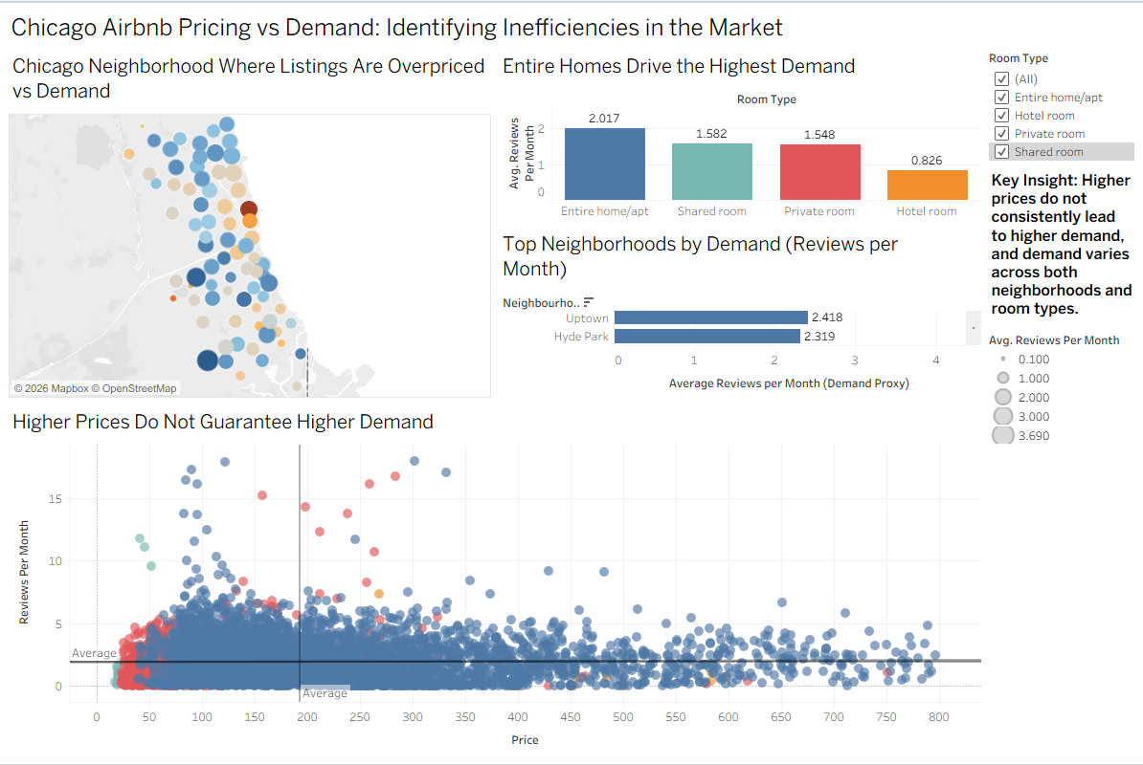
Screenshot 2: Data model showing relationship between listings.csv and reviews.csv
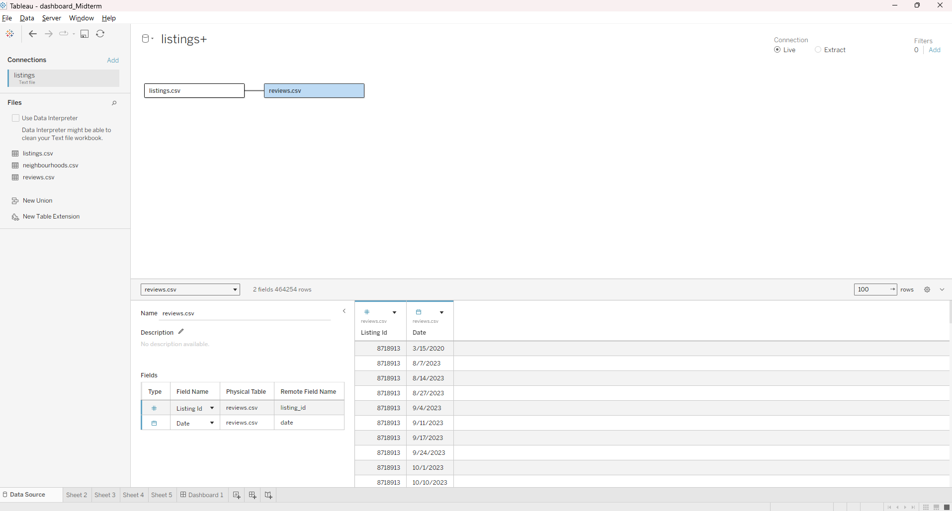
Screenshot 3: Calculated field for Pricing Efficiency Index
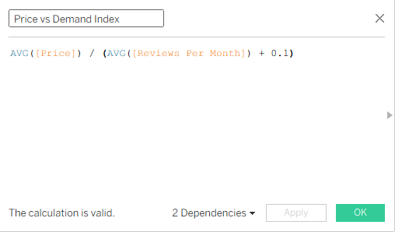

Screenshot 4: Map visualization sheet
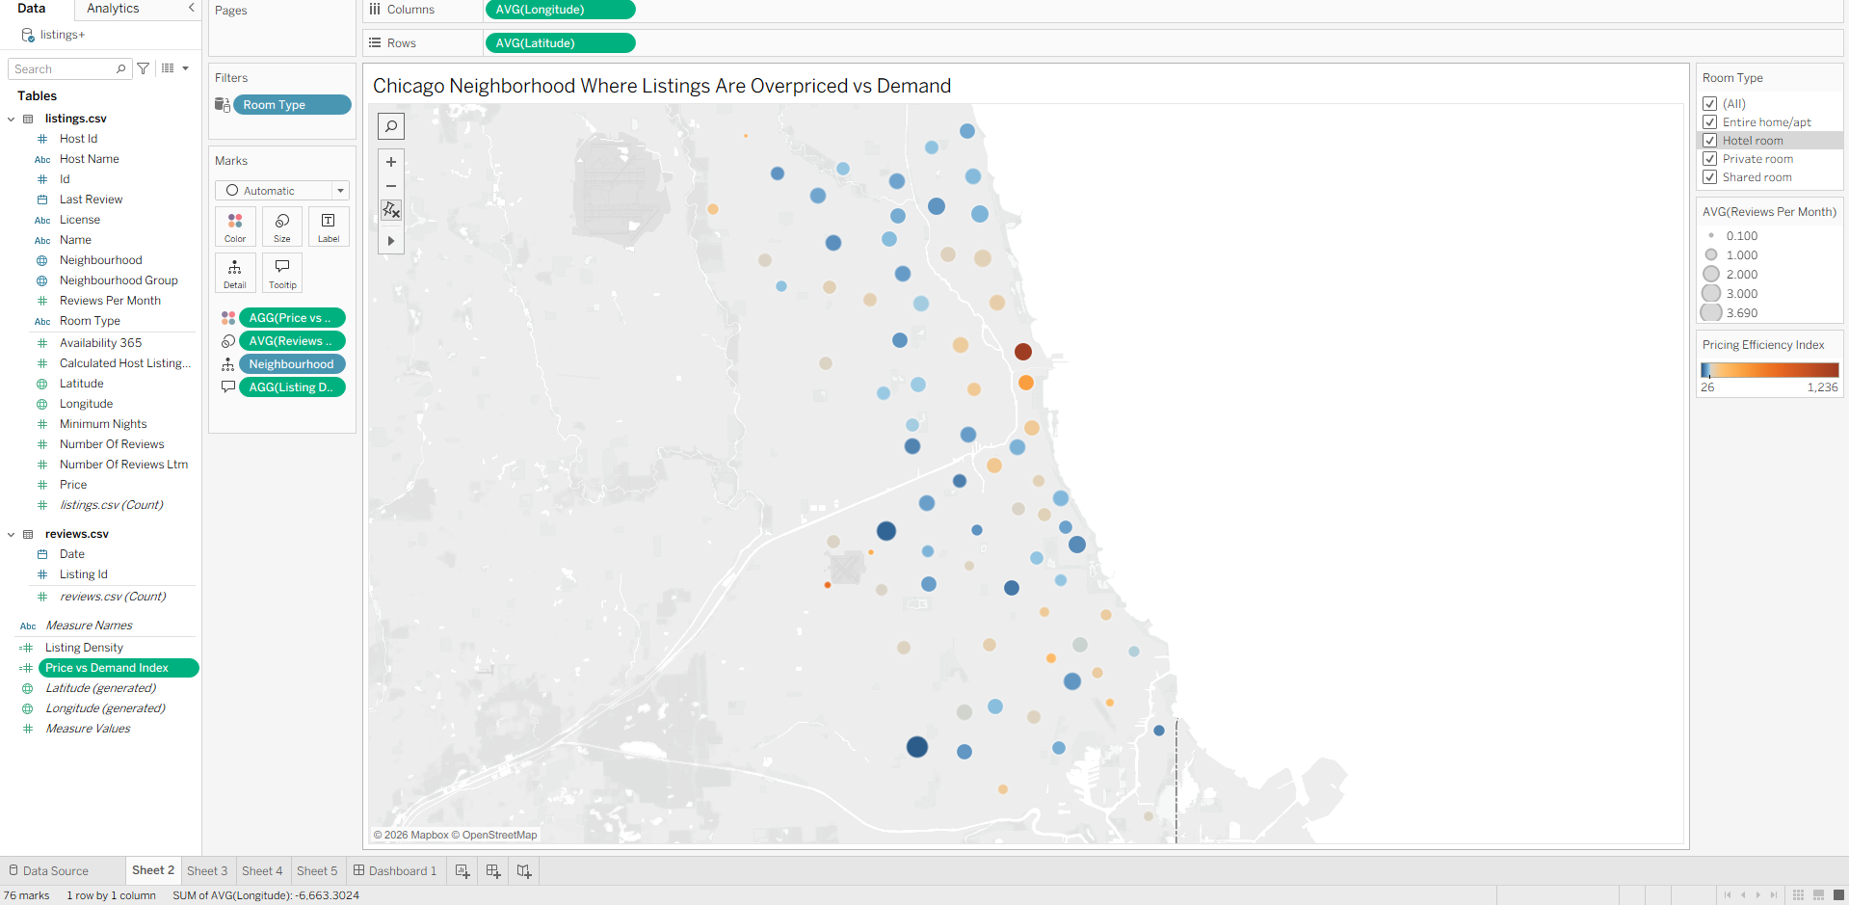
Screenshot 5: Scatter plot sheet
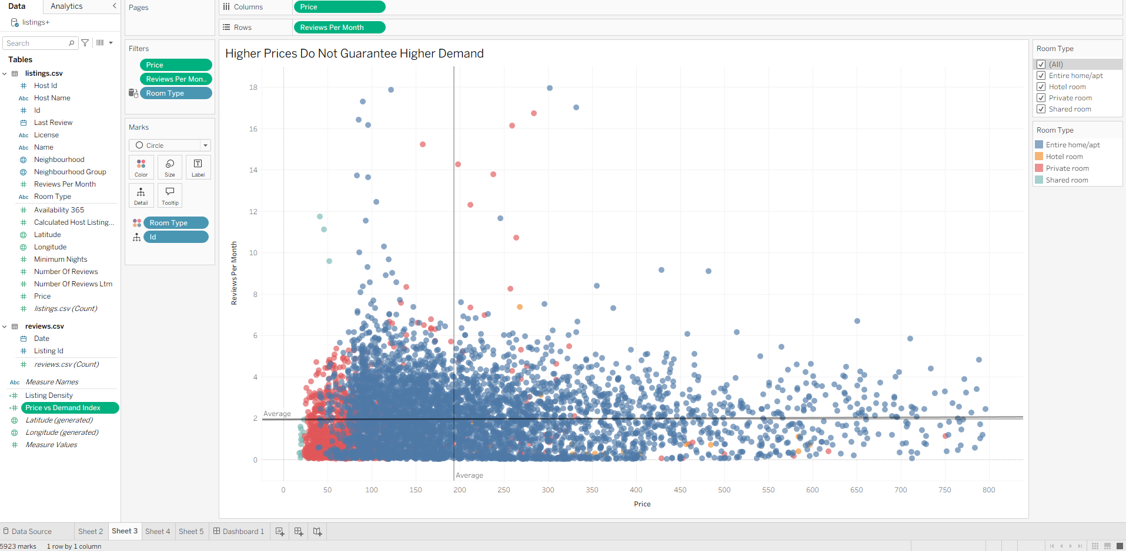

Screenshot 6: Room type bar chart sheet
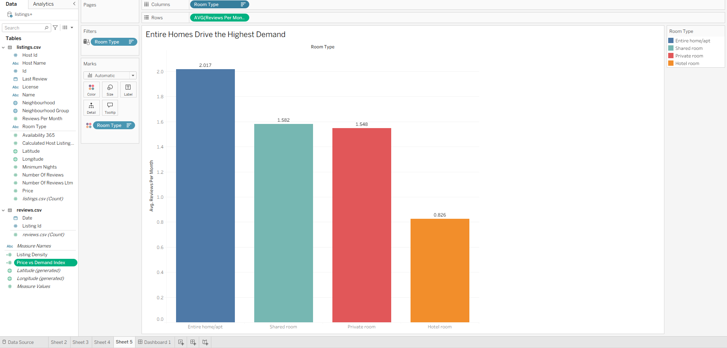

Screenshot 7: Neighborhoods bar chart sheet
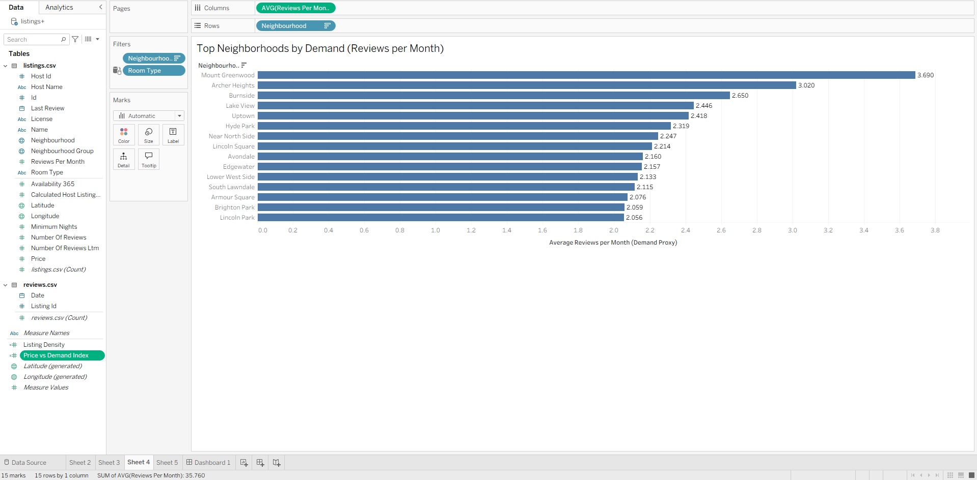

Appendix B: Prompt Tracking Sheet
Please refer to the attached Prompt Tracking Sheet (Tracking_Sheet_Mid_Term_Exam.xlsx) submitted alongside this report.
Appendix C: AI Interaction Screenshots
Screenshot 1: ChatGPT conversation where you defined the analytical question
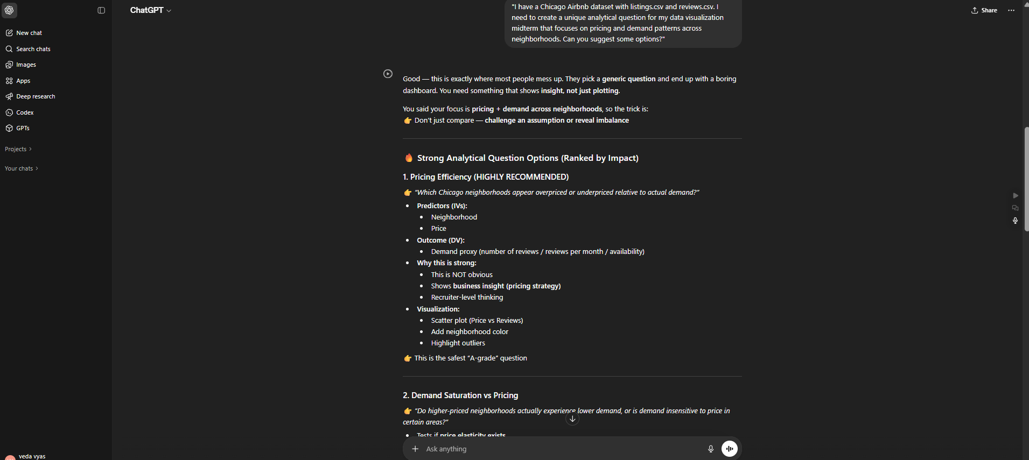
Screenshot 2: ChatGPT conversation where Pricing Efficiency Index metric was suggested
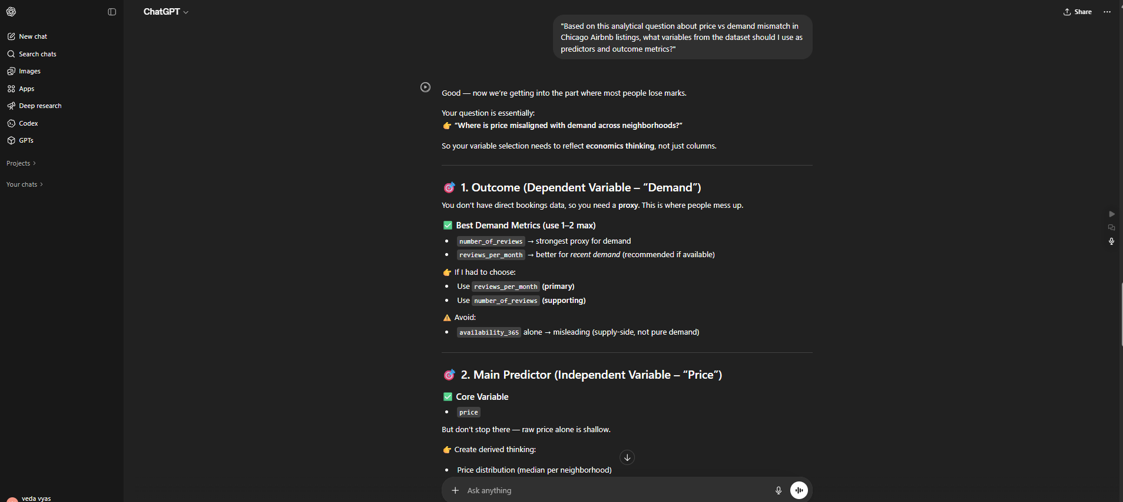

Screenshot 3: Claude conversation showing dashboard feedback and bar chart color fix suggestion
