Project Title
Develop a String Matching Application Using the Z-Algorithm for Efficient Pattern Searching
Project Report submitted for the partial fulfilment of grade for the course
Data Structures and Algorithms -3 (25CS2103E)
in
A.Y. 2026-2027
Submitted by: -
Rakesh Medikonda [2520030035]
Abhishek Kumar [2520030448]
Y. Venkat Sai [2520030278]
Team Number: 03
Section: 05
Under the guidance of
Swathi D
Assistant Professor, CSE

Hyderabad-500090, Telangana, India.

ABSTRACT
This project presents a string matching application based on the Z-Algorithm for efficient pattern searching in large text datasets. The application preprocesses a combined string consisting of the pattern, a delimiter, and the text to construct the Z-array. By analyzing the Z-array, all occurrences of the given pattern in the text can be identified efficiently. The project also implements the Naïve String Matching Algorithm to compare the performance of both techniques. The comparison focuses on execution time and efficiency for different text and pattern sizes. While the Naïve approach may perform repeated character comparisons and has a worst-case time complexity of O(n × m), the Z-Algorithm performs pattern matching in linear time with a complexity of O(n + m), where n is the text length and m is the pattern length. The project demonstrates the practical advantages of the Z-Algorithm for fast, scalable, and efficient string searching.
The system is implemented entirely in Java. It provides a Swing-based desktop interface in which the user enters (or loads) a text and a pattern, and the application displays and highlights every matching position together with the execution time of both algorithms. A console benchmark validates the implementation on 1,000 generated text–pattern records and on a worst-case input family.
Signature of the Guide

TABLE OF CONTENTS
1. Introduction 4
2. Literature Survey 5
3. Problem Statement and Objectives 6
4. System Design 7
5. Hardware and Software Requirements 9
6. Implementation 10
7. Results and Discussion 13
8. Conclusion 16
9. Future Scope 16
References 16

1. Introduction

1.1 Background
String matching is the problem of finding every position at which a short string, called the pattern, occurs inside a longer string, called the text. It is one of the most frequently used operations in computing and sits behind the search box of a text editor, the "find" feature of a browser, keyword search in document systems, plagiarism detection, log analysis, and the analysis of DNA and protein sequences.
A straightforward approach, known as the Naïve method, aligns the pattern with every possible position of the text and compares characters one by one. When the text or pattern contains many repeated characters, the same characters are compared again and again, and the running time grows to O(n × m), where n is the length of the text and m is the length of the pattern.

1.2 Motivation
As text sizes grow, the repeated comparisons of the Naïve method become a real bottleneck. The Z-Algorithm removes this repetition by pre-computing, for every position of a string, how much of the string starting there matches the beginning of the string. Using this information, all occurrences of a pattern can be located in a single left-to-right pass, giving a guaranteed running time of O(n + m).

1.3 Scope of the Project
This project develops a complete Java application around the Z-Algorithm. It accepts a text and a pattern, finds all occurrences, highlights them, and compares the execution time with the Naïve algorithm on the same input. A benchmark module validates correctness and performance on 1,000 test records and on adversarial inputs.

2. Literature Survey

2.1 Existing System
- Uses simple (Naïve) string matching.
- Compares the pattern with the text repeatedly at every position.
- Worst-case time complexity is O(n × m).
- Performance drops sharply as the input text grows larger and more repetitive.

2.2 Proposed System
- Uses the Z-Algorithm for efficient pattern searching.
- Builds a Z-array to avoid unnecessary repeated comparisons.
- Time complexity is O(n + m), with O(n + m) auxiliary space for the Z-array.
- Displays all matching positions and compares execution time with the Naïve method.
- Provides a simple Java Swing user interface and a console benchmark.

2.3 Related Algorithms
Several other linear-time string matching algorithms exist. The Knuth–Morris–Pratt (KMP) algorithm pre-computes a failure function for the pattern. Boyer–Moore scans the pattern from right to left and skips text using bad-character and good-suffix rules, and is very fast in practice on natural-language text. Rabin–Karp compares rolling hash values of the pattern and of text windows. The Z-Algorithm is conceptually simple, and the Z-array it builds can also be reused for other problems such as finding the longest common prefix of suffixes, string periodicity, and counting distinct substrings.
Algorithm | Time complexity | Main idea
Naïve | O(n × m) worst case | Compare at every alignment
Z-Algorithm | O(n + m) | Z-array over pattern + # + text
KMP | O(n + m) | Prefix (failure) function
Boyer–Moore | O(n / m) best, O(n × m) worst* | Right-to-left scan, skip rules
Rabin–Karp | O(n + m) average | Rolling hash comparison
Table 2.1: Comparison of common string matching algorithms (*basic form without the Galil rule)

3. Problem Statement and Objectives

3.1 Problem Statement
Searching for a particular word or pattern in a large amount of text is time-consuming with a basic character-by-character method. This project builds an efficient string matching application based on the Z-Algorithm that accepts a text and a search pattern, identifies every occurrence, and returns the result efficiently.

3.2 Objectives
- Implement the Z-Algorithm to find all occurrences of a pattern in a given text.
- Build a Z-array to eliminate unnecessary repeated character comparisons.
- Compare the performance of the Z-Algorithm against the Naïve String Matching Algorithm.
- Provide a simple, interactive interface for entering text and pattern and viewing results.
- Validate correctness and measure performance on a test set of 1,000 text–pattern records.

4. System Design

4.1 Z-Array
For a string S of length L, the Z-array Z[0 … L−1] is defined so that Z[i] is the length of the longest substring starting at position i that is also a prefix of S (Z[0] is conventionally left as 0). For example, for S = "aabxaab", Z = [0, 1, 0, 0, 3, 1, 0].

4.2 Pattern Matching with the Z-Array
To search for a pattern P (length m) in a text T (length n), the application forms the combined string S = P + "#" + T, where "#" is a delimiter character that occurs in neither P nor T. The delimiter guarantees that no Z-value can exceed m. A position i in S with Z[i] = m means that the m characters starting there equal P; the corresponding starting position in the text is i − (m + 1).

4.3 The Z-Box Technique
The Z-array is built in one pass while maintaining a window [l, r), called the Z-box, which is the right-most segment that matches a prefix of S. For a new position i:
- If i lies inside the Z-box (i < r), the value Z[i − l] is already known, so Z[i] is initialised to min(r − i, Z[i − l]) without any comparison.
- The value is then extended by explicit character comparisons only while characters keep matching.
- If the extended match goes beyond r, the Z-box is moved to [i, i + Z[i]).
Because the right end r of the Z-box never moves left, every character of S is compared successfully at most once, and the total work is O(n + m).

4.4 Flow of the Application
User input (text + pattern)
▼
Pre-processing: combine pattern + delimiter + text
▼
Z-Algorithm: construct the Z-array
▼
Pattern occurrence detection (Z[i] = m)
▼
Matching positions + execution time (Z and Naïve)
▼
Result display / performance comparison
Figure 4.1: Flow chart of the string matching application

4.5 Worked Example
Let the pattern be P = "aab" and the text T = "baabaa". The combined string is S = "aab#baabaa" (length 10).
i | 0 | 1 | 2 | 3 | 4 | 5 | 6 | 7 | 8 | 9
S[i] | a | a | b | # | b | a | a | b | a | a
Z[i] | 0 | 1 | 0 | 0 | 0 | 3 | 1 | 0 | 2 | 1
Table 4.1: Z-array of "aab#baabaa"
Only Z[5] equals m = 3, so the pattern occurs at text position 5 − (3 + 1) = 1. Indeed T[1..3] = "aab". Position 8 has Z = 2, which is a partial match ("aa") but not a full one.

4.6 Complexity
Algorithm | Time | Space
Z-Algorithm | O(n + m) | O(n + m)
Naïve | O(n × m) worst, O(n) typical on random text | O(1) auxiliary
Table 4.2: Complexity summary

5. Hardware and Software Requirements

5.1 Software
- Java Development Kit (JDK) 11 or later (developed and tested on JDK 21) – core programming language.
- Java Swing (part of the JDK) – graphical user interface; no external libraries are needed.
- Visual Studio Code with the Extension Pack for Java (or any Java IDE) – development environment.
- GitHub – source-code management and version control.

5.2 Hardware
- Standard PC / laptop with a modern multi-core processor.
- Minimum 4 GB RAM (8 GB recommended for larger test datasets).
- Internet connection for GitHub access.

6. Implementation

6.1 Project Structure
File | Purpose
Main.java | Entry point: opens the GUI, or runs the benchmark with the argument "benchmark"
ZAlgorithm.java | Z-array construction and pattern search, O(n + m)
NaiveMatcher.java | Naïve search used as the baseline for comparison
StringMatcherApp.java | Swing GUI: input, highlighting, position list, timing bar chart
Benchmark.java | 1,000-record test set, worst-case test, CSV output
Table 6.1: Source files

6.2 How to Run
Compile all files with "javac *.java". Run "java Main" to open the application, or "java Main benchmark" to run the benchmark. In Visual Studio Code, open Main.java and click Run above the main method.

6.3 User Interface
The interface has a text area for the input text, a field for the pattern, and buttons to Search, Clear, load a .txt file, and run a worst-case demonstration. After a search, all occurrences are highlighted in the text, listed with line and column numbers, and the execution times of the Z-Algorithm and the Naïve method are shown both numerically and as a bar chart. The application also verifies that both algorithms return identical positions. For texts of up to 60 characters, the combined string and its Z-array are displayed for teaching purposes.

6.4 Source Code
Main.java
/**
* Entry point of the project.
* java Main -> opens the GUI (String Matching using Z-Algorithm)
* java Main benchmark -> runs the 1000-record benchmark in the console
*/
public class Main {
public static void main(String[] args) throws Exception {
if (args.length > 0 && args[0].equalsIgnoreCase("benchmark")) {
Benchmark.main(new String[0]);
} else {
StringMatcherApp.main(args);
}
}
}

ZAlgorithm.java
import java.util.ArrayList;
import java.util.List;

/**
* Z-Algorithm string matching - O(n + m) time.
* Combined string = pattern + delimiter + text
*/
public class ZAlgorithm {

private static final char DELIMITER = '\u0001';

/** Builds the Z-array: z[i] = length of longest substring starting at i that is also a prefix of s. */
public static int[] buildZArray(String s) {
int n = s.length();
int[] z = new int[n];
int l = 0, r = 0; // [l, r) = rightmost Z-box
for (int i = 1; i < n; i++) {
if (i < r) {
z[i] = Math.min(r - i, z[i - l]); // reuse earlier work
}
while (i + z[i] < n && s.charAt(z[i]) == s.charAt(i + z[i])) {
z[i]++;
}
if (i + z[i] > r) {
l = i;
r = i + z[i];
}
}
return z;
}

/** Returns the combined string (pattern + delimiter + text). */
public static String combine(String text, String pattern) {
return pattern + DELIMITER + text;
}

/** Returns all 0-based starting positions of pattern in text. */
public static List<Integer> search(String text, String pattern) {
List<Integer> positions = new ArrayList<>();
int m = pattern.length();
if (m == 0 || m > text.length()) return positions;

int[] z = buildZArray(combine(text, pattern));
for (int i = m + 1; i < z.length; i++) {
if (z[i] >= m) {
positions.add(i - (m + 1));
}
}
return positions;
}
}

NaiveMatcher.java
import java.util.ArrayList;
import java.util.List;

/** Naive string matching - O(n x m) worst case. Used for comparison. */
public class NaiveMatcher {

public static List<Integer> search(String text, String pattern) {
List<Integer> positions = new ArrayList<>();
int n = text.length(), m = pattern.length();
if (m == 0 || m > n) return positions;

for (int i = 0; i <= n - m; i++) {
int j = 0;
while (j < m && text.charAt(i + j) == pattern.charAt(j)) {
j++;
}
if (j == m) positions.add(i);
}
return positions;
}
}

The complete source of StringMatcherApp.java and Benchmark.java is provided with the project files.

7. Results and Discussion

7.1 Application Output
Figure 7.1 shows a search for the pattern "abab" in a sample text. All seven occurrences are highlighted and listed with their positions; the status line reports that both algorithms agree.
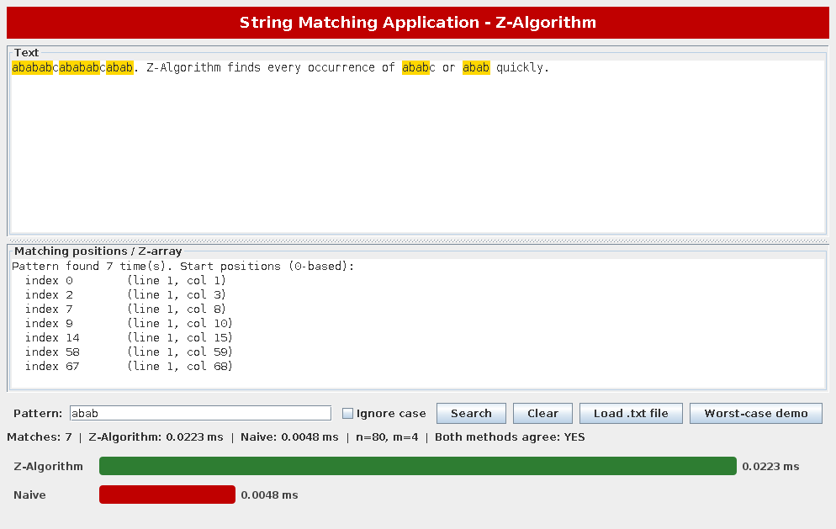
Figure 7.1: Application output for pattern "abab"
Figure 7.2 shows the worst-case demonstration (text of 200,000 "a" characters, pattern of 2,000 "a" characters followed by "b"). The pattern does not occur, but the Naïve method must examine about two thousand characters at almost every position, whereas the Z-Algorithm completes in a single linear pass.
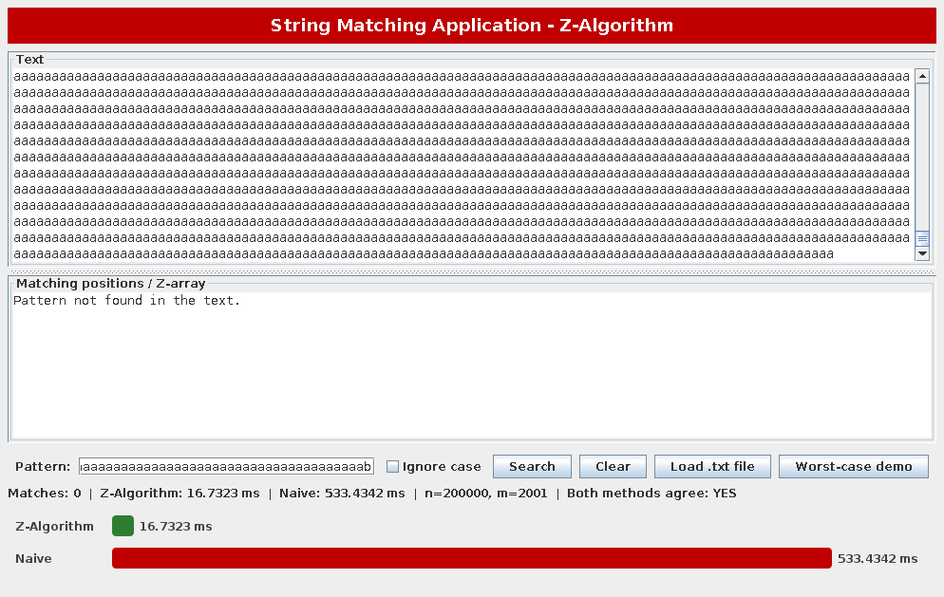
Figure 7.2: Worst-case demonstration (n = 200,000, m = 2,001)

7.2 Test 1: 1,000 Generated Records
One thousand text–pattern records over the DNA alphabet {A, C, G, T} were generated with a fixed random seed: 400 small texts (100–1,000 characters), 400 medium texts (10,000–100,000 characters) and 200 large texts (200,000–500,000 characters). Half of the patterns were taken from the text (guaranteed to match) and half were random. For every record the position lists of the two algorithms were compared.
Size | Records | Avg. text length | Z (ms) | Naïve (ms) | Outputs identical
Small | 400 | 543 | 0.1135 | 0.0211 | Yes
Medium | 400 | 55,601 | 0.4488 | 0.3096 | Yes
Large | 200 | 351,332 | 2.5690 | 1.8867 | Yes
Table 7.1: Results on 1,000 records (average time per record)
The outputs of the Z-Algorithm and the Naïve method were identical for all 1,000 records, which validates the correctness of the implementation. On random text over a four-letter alphabet, the Naïve method rarely matches more than one or two characters before failing, so it behaves almost linearly, and its lower constant factor makes it slightly faster than the Z-Algorithm, which must build an auxiliary array of size n + m. This is an expected result and shows that the advantage of the Z-Algorithm is not a speed-up on every input but a guaranteed worst-case bound.

7.3 Test 2: Worst Case for the Naïve Method
For the second test the text consists only of the character "a" and the pattern is m − 1 characters "a" followed by "b", with m = n / 20. This forces the Naïve method to perform about (n − m) × m character comparisons.
Text length n | Pattern length m | Z (ms) | Naïve (ms) | Speed-up
20,000 | 1,000 | 0.204 | 18.562 | 91x
40,000 | 2,000 | 0.345 | 69.400 | 201x
80,000 | 4,000 | 0.644 | 274.413 | 426x
160,000 | 8,000 | 1.323 | 988.265 | 747x
Table 7.2: Worst-case execution times
The Naïve time grows roughly four-fold each time n doubles, as expected for O(n × m) with m proportional to n, while the Z-Algorithm time only doubles, in line with O(n + m). For n = 160,000 the Z-Algorithm is about 747 times faster. Exact timings depend on the machine and on JVM warm-up, but the growth trend is reproducible.

7.4 Observations
- The Z-Algorithm returned exactly the same match positions as the Naïve method in all tests.
- The Z-Algorithm has a guaranteed linear running time independent of the input, so it is the safer choice when inputs may be highly repetitive.
- On random text with a large alphabet the Naïve method is competitive; the difference appears on repetitive data such as low-entropy logs, DNA repeats and synthetic adversarial inputs.
- The Z-Algorithm needs O(n + m) extra memory for the Z-array, whereas the Naïve method needs none.

8. Conclusion
The project demonstrates how the Z-Algorithm provides efficient pattern searching in text. A complete Java application was developed that finds and highlights all occurrences of a pattern and compares the Z-Algorithm with the Naïve method. Validation on 1,000 records showed identical results for both algorithms, and the worst-case experiments confirmed the O(n + m) versus O(n × m) behaviour: for n = 160,000 the Z-Algorithm was about 747 times faster than the Naïve method. The proposed application is useful for document searching, keyword identification, and other text-processing tasks such as plagiarism-related pattern detection, and its simple Swing interface makes it easy to demonstrate and extend.

9. Future Scope
- Extend the application to support approximate (fuzzy) string matching for near-matches, not just exact patterns.
- Add support for searching across multiple documents or files at once.
- Integrate additional string-matching algorithms (KMP, Boyer–Moore, Rabin–Karp) for a broader performance comparison.
- Build a full plagiarism-detection module using the pattern-matching engine as its core.
- Provide a web version (for example with Spring Boot) or a runnable JAR for wider accessibility.

References
[1] T. H. Cormen, C. E. Leiserson, R. L. Rivest and C. Stein, Introduction to Algorithms, 3rd ed., MIT Press, 2009 (chapter on string matching).
[2] D. Gusfield, Algorithms on Strings, Trees, and Sequences: Computer Science and Computational Biology, Cambridge University Press, 1997.
[3] D. E. Knuth, J. H. Morris and V. R. Pratt, "Fast pattern matching in strings," SIAM Journal on Computing, vol. 6, no. 2, pp. 323–350, 1977.
[4] R. S. Boyer and J. S. Moore, "A fast string searching algorithm," Communications of the ACM, vol. 20, no. 10, pp. 762–772, 1977.
[5] R. M. Karp and M. O. Rabin, "Efficient randomized pattern-matching algorithms," IBM Journal of Research and Development, vol. 31, no. 2, pp. 249–260, 1987.
[6] Oracle, Java Platform Standard Edition Documentation – Swing Tutorial, docs.oracle.com.

