Department of Computer Science and Engineering
2026-2027
Odd Semester


DATA STRUCTURES AND ALGORITHMS-3
(25CS2103E)

Develop a String Matching Application Using the Z-Algorithm for Efficient Pattern Searching

Rakesh Medikonda 2520030035
Abhishek Kumar 2520030448
Y. Venkat Sai 2520030278
Team Number: 03 | Section: 05

COURSE INSTRUCTOR

Dr. J Sirisha Devi
Professor
Department of Computer Science and Engineering
TITLE OF THE PBL
Develop a String Matching Application Using the Z-Algorithm for Efficient Pattern Searching
1. CASE STUDY / PROJECT DESCRIPTION
String matching is the problem of finding every position at which a short string, called the pattern, occurs inside a longer string, called the text. It is a fundamental operation in computing and is used behind text-editor search, browser find features, document keyword search, plagiarism detection, log analysis, and DNA and protein sequence analysis.
In a simple Naïve string matching approach, the pattern is aligned with every possible position of the text. Characters are compared one by one, and when a mismatch occurs the algorithm moves to the next alignment. This method is easy to understand and implement, but repeated characters can cause the same comparisons to be performed many times. Its worst-case running time is O(n × m), where n is the text length and m is the pattern length.
The proposed project develops a complete Java string matching application based on the Z-Algorithm. The application accepts a text and a search pattern, preprocesses a combined string formed from the pattern, a delimiter, and the text, constructs the Z-array, detects every full match, and displays the matching positions. The project also implements the Naïve method so that both methods can be tested on exactly the same inputs.
The main motivation is to avoid unnecessary repeated character comparisons. The Z-Algorithm pre-computes, for every position in a string, the length of the longest substring beginning at that position that is also a prefix of the whole string. This information is reused through the Z-box technique. As a result, the pattern can be searched in guaranteed O(n + m) time.
1.1 Existing System
• The conventional approach uses Naïve string matching and checks the pattern at every possible alignment.
• The same characters may be compared repeatedly, especially when the input contains long repeated sequences.
• The worst-case time complexity is O(n × m), so performance can degrade sharply for large and repetitive inputs.
• Although the Naïve algorithm can be competitive on random text, it does not provide the same guaranteed linear-time bound.
1.2 Proposed System
• The application uses the Z-Algorithm to search for all occurrences of a pattern.
• The combined string pattern + delimiter + text is used to build a Z-array.
• A Z-value equal to the pattern length identifies a complete occurrence.
• The application reports 0-based match positions and highlights occurrences in the Swing interface.
• Execution time of the Z-Algorithm and Naïve method is shown numerically and through a comparison bar chart.
• A benchmark validates the outputs on 1,000 generated records and evaluates a worst-case family for the Naïve algorithm.
1.3 Applications / Case Study Examples
Text editors and browsers use string-search operations when a user presses a Find or Ctrl+F command. The same basic requirement appears in document management systems, where a keyword must be located quickly in a large document. A pattern matching engine is also useful in plagiarism-related analysis, where repeated phrases or patterns are searched across text.
Another important example is biological sequence analysis. DNA strings use a small alphabet such as A, C, G, and T, so repeated subsequences can occur frequently. The project benchmark uses this four-letter DNA alphabet to test the algorithms on controlled inputs. The results show why a guaranteed linear-time method is valuable when repeated characters or patterns are common.
A further application is log analysis. Large logs may contain repeated prefixes, error codes, timestamps, or status strings. Searching such data with repeated character-by-character comparisons can become expensive. The Z-Algorithm provides predictable performance because its running time depends linearly on the combined input size.
1.4 Features of the Developed Application
• Text area for entering or loading text from a .txt file.
• Pattern field for entering the search pattern.
• Search and Clear controls.
• Optional case-insensitive search control.
• Highlighting of every occurrence in the text.
• Listing of 0-based positions together with line and column information.
• Display of Z-Algorithm and Naïve execution times.
• Bar-chart comparison of the two execution times.
• Worst-case demonstration for visually showing the performance gap.
• For short texts, the combined string and Z-array can be displayed for teaching and verification.
1.5 Hardware and Software Requirements
The implementation uses Java Development Kit 11 or later and was developed and tested on JDK 21. Java Swing, which is part of the JDK, is used for the graphical interface and no external GUI libraries are required. Visual Studio Code with the Java Extension Pack, or another Java IDE, can be used for development. GitHub is identified in the project report for source-code management and version control.
The hardware requirement is a standard PC or laptop with a modern multi-core processor. A minimum of 4 GB RAM is specified, with 8 GB recommended for larger test datasets. Internet access is useful for GitHub access.
1.6 Problem Statement
Searching for a particular word or pattern in a large amount of text can be time-consuming with a basic character-by-character method. The project therefore builds an efficient string matching application based on the Z-Algorithm that accepts a text and search pattern, identifies every occurrence, and returns the result efficiently.
1.7 Objectives
• Implement the Z-Algorithm to find all occurrences of a pattern in a given text.
• Build a Z-array to eliminate unnecessary repeated character comparisons.
• Compare the performance of the Z-Algorithm against the Naïve String Matching Algorithm.
• Provide a simple interactive interface for entering text and pattern and viewing results.
• Validate correctness and measure performance on a test set of 1,000 text–pattern records.
ALGORITHM / PSEUDO CODE
2. Z-ALGORITHM: BASIC IDEA
For a string S of length L, the Z-array Z[0 … L−1] stores the length of the longest substring starting at position i that is also a prefix of S. Z[0] is conventionally set to 0. For example, for S = "aabxaab", the Z-array is [0, 1, 0, 0, 3, 1, 0].
To search for a pattern P of length m in a text T of length n, the project forms the combined string S = P + "#" + T. The delimiter is chosen so that it does not occur in either the pattern or the text. This prevents a Z-match from crossing the boundary between the pattern and the text.
2.1 Step-by-Step Z-Array Construction
• Set all Z values initially to zero and maintain a Z-box [l, r), representing the right-most segment that matches a prefix of S.
• Start scanning from i = 1 because Z[0] is conventionally zero.
• If i lies inside the Z-box, reuse the already computed value at the mirrored position i − l. Initialize Z[i] to min(r − i, Z[i − l]).
• Extend the match by directly comparing S[Z[i]] with S[i + Z[i]] while the characters are equal and the end of the string is not reached.
• If the new match extends beyond r, move the Z-box to [i, i + Z[i]).
• Continue until every position has been processed. The resulting array contains all prefix-match lengths.
The key efficiency comes from the Z-box. Previously computed information is reused instead of restarting comparisons from the beginning of the pattern. The right end of the Z-box never moves backwards, which is the basis for the O(n + m) time bound.
2.2 Detecting Pattern Occurrences
After building the Z-array for P + delimiter + T, inspect positions beginning at m + 1. Whenever Z[i] is equal to or greater than m, the pattern occurs in the text. The corresponding 0-based text position is i − (m + 1).
For example, if P = "aab" and T = "baabaa", the combined string is "aab#baabaa". At index 5, Z[5] = 3, which equals the pattern length m = 3. Therefore the pattern begins at text position 5 − (3 + 1) = 1.
2.3 Worked Z-Array Example
i | 0 | 1 | 2 | 3 | 4 | 5 | 6 | 7 | 8 | 9
S[i] | a | a | b | # | b | a | a | b | a | a
Z[i] | 0 | 1 | 0 | 0 | 0 | 3 | 1 | 0 | 2 | 1

Table 2.1: Z-array for the combined string "aab#baabaa".
Only Z[5] equals m = 3, so the pattern occurs at text position 1. Position 8 has Z[8] = 2, which indicates a partial match of "aa" and therefore does not count as a complete occurrence.
2.4 Pseudocode for the Z-Array
BUILD-Z-ARRAY(S)
n ← length(S)
create array Z[0 … n-1] filled with 0
l ← 0, r ← 0
for i ← 1 to n-1
if i < r
Z[i] ← min(r - i, Z[i - l])
while i + Z[i] < n and S[Z[i]] = S[i + Z[i]]
Z[i] ← Z[i] + 1
if i + Z[i] > r
l ← i
r ← i + Z[i]
return Z
2.5 Pseudocode for Pattern Search
Z-SEARCH(TEXT, PATTERN)
m ← length(PATTERN)
if m = 0 or m > length(TEXT)
return empty list
S ← PATTERN + DELIMITER + TEXT
Z ← BUILD-Z-ARRAY(S)
positions ← empty list
for i ← m + 1 to length(S)-1
if Z[i] ≥ m
positions.add(i - (m + 1))
return positions
2.6 Naïve Algorithm for Comparison
The comparison algorithm checks the pattern at every valid text alignment. At each position it advances through the pattern until a mismatch is found or all m characters match. If all m characters match, the starting position is recorded. In the worst case this requires O(n × m) time and O(1) auxiliary space.
NAIVE-SEARCH(TEXT, PATTERN)
positions ← empty list
n ← length(TEXT), m ← length(PATTERN)
if m = 0 or m > n
return positions
for i ← 0 to n - m
j ← 0
while j < m and TEXT[i + j] = PATTERN[j]
j ← j + 1
if j = m
positions.add(i)
return positions
2.7 Complexity Analysis
Algorithm | Time Complexity | Space / Main Requirement
Z-Algorithm | O(n + m) | O(n + m) for the combined string/Z-array
Naïve | O(n × m) worst case; often near O(n) on random text | O(1) auxiliary space
KMP | O(n + m) | Prefix/failure function
Boyer–Moore | O(n / m) best, O(n × m) worst* | Right-to-left scan and skip rules
Rabin–Karp | O(n + m) average | Rolling hash comparison

Table 2.2: Comparison of common string matching approaches.
2.8 Flow of the Application
• User input: text and pattern.
• Pre-processing: combine pattern + delimiter + text.
• Z-Algorithm: construct the Z-array using the Z-box.
• Pattern occurrence detection: check positions where Z[i] = m.
• Run the Naïve method on the same input for comparison.
• Display matching positions, highlighted occurrences, execution times, and agreement between the methods.
The implementation follows this sequence from input to output. The Z-Algorithm performs the main search, while the Naïve implementation provides a correctness baseline and a practical performance comparison.

CODE
3. PROJECT STRUCTURE
File | Purpose
Main.java | Entry point; opens the GUI or runs the benchmark with the argument "benchmark".
ZAlgorithm.java | Constructs the Z-array and performs Z-Algorithm pattern search in O(n + m).
NaiveMatcher.java | Naïve search implementation used as the baseline for comparison.
StringMatcherApp.java | Swing GUI for input, highlighting, position display, timing, and chart.
Benchmark.java | 1,000-record test set, worst-case test, and CSV output.

Table 3.1: Source files described in the supplied project report.
3.1 Main.java
/**
* Entry point of the project.
* java Main -> opens the GUI (String Matching using Z-Algorithm)
* java Main benchmark -> runs the 1000-record benchmark in the console
*/
public class Main {
public static void main(String[] args) throws Exception {
if (args.length > 0 && args[0].equalsIgnoreCase("benchmark")) {
Benchmark.main(new String[0]);
} else {
StringMatcherApp.main(args);
}
}
}

3.2 ZAlgorithm.java
import java.util.ArrayList;
import java.util.List;
/**
* Z-Algorithm string matching - O(n + m) time.
* Combined string = pattern + delimiter + text
*/
public class ZAlgorithm {
private static final char DELIMITER = '\u0001';
/** Builds the Z-array: z[i] = length of longest substring starting at i that is also a prefix of s. */
public static int[] buildZArray(String s) {
int n = s.length();
int[] z = new int[n];
int l = 0, r = 0; // [l, r) = rightmost Z-box
for (int i = 1; i < n; i++) {
if (i < r) {
z[i] = Math.min(r - i, z[i - l]); // reuse earlier work
}
while (i + z[i] < n && s.charAt(z[i]) == s.charAt(i + z[i])) {
z[i]++;
}
if (i + z[i] > r) {
l = i;
r = i + z[i];
}
}
return z;
}
/** Returns the combined string (pattern + delimiter + text). */
public static String combine(String text, String pattern) {
return pattern + DELIMITER + text;
}
/** Returns all 0-based starting positions of pattern in text. */
public static List<Integer> search(String text, String pattern) {
List<Integer> positions = new ArrayList<>();
int m = pattern.length();
if (m == 0 || m > text.length()) return positions;
int[] z = buildZArray(combine(text, pattern));
for (int i = m + 1; i < z.length; i++) {
if (z[i] >= m) {
positions.add(i - (m + 1));
}
}
return positions;
}
}

3.3 NaiveMatcher.java
import java.util.ArrayList;
import java.util.List;
/** Naive string matching - O(n x m) worst case. Used for comparison. */
public class NaiveMatcher {
public static List<Integer> search(String text, String pattern) {
List<Integer> positions = new ArrayList<>();
int n = text.length(), m = pattern.length();
if (m == 0 || m > n) return positions;
for (int i = 0; i <= n - m; i++) {
int j = 0;
while (j < m && text.charAt(i + j) == pattern.charAt(j)) {
j++;
}
if (j == m) positions.add(i);
}
return positions;
}
}

3.4 Running the Application
The supplied project report specifies compilation with "javac *.java". Running "java Main" opens the application, while "java Main benchmark" runs the benchmark in the console. In Visual Studio Code, Main.java can be opened and the Run control above the main method can be used.
3.5 User Interface Behaviour
The Swing interface contains a text area, a pattern field, Search and Clear controls, a .txt loading option, a case-insensitive option, and a worst-case demonstration. After a search, matching text is highlighted and positions are listed with line and column information. The execution times of both algorithms are displayed numerically and as a bar chart. The application also checks that the two methods return identical positions.
The supplied report states that the complete source of StringMatcherApp.java and Benchmark.java is provided with the project files. The code reproduced above is the core source code explicitly included in the supplied report; the unreproduced classes are not silently reconstructed here.

RESULTS
4.1 APPLICATION OUTPUT
The application successfully finds and highlights pattern occurrences, lists their positions, reports execution times for both algorithms, and verifies that the two methods agree. The supplied project report includes screenshots for a normal search and for a worst-case input.
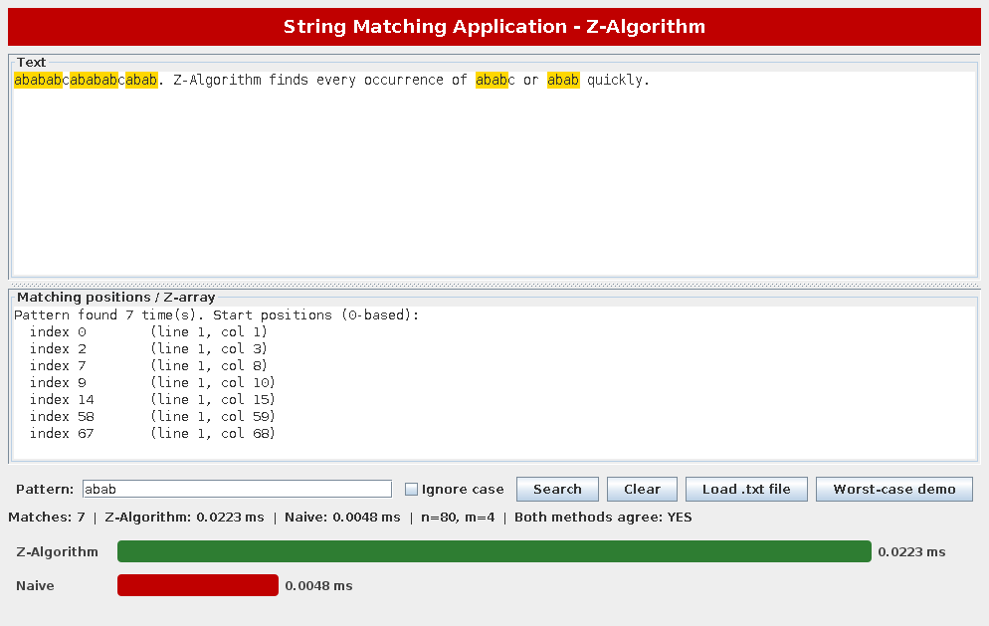
Figure 4.1: Application output for the pattern "abab". Seven occurrences are highlighted and both algorithms agree.

4.2 WORST-CASE DEMONSTRATION
For the worst-case demonstration, the text contains a large run of the character "a" and the pattern consists of many "a" characters followed by "b". The pattern does not occur, but the Naïve method performs long comparisons at almost every alignment. The Z-Algorithm completes the search using its linear-time procedure.
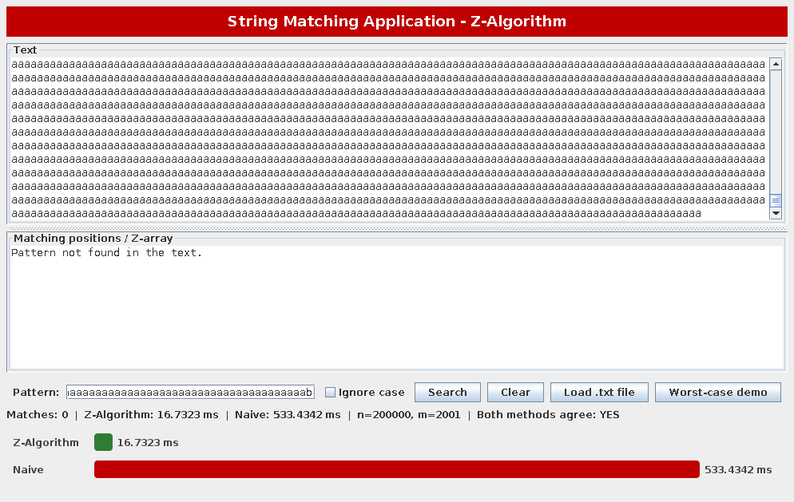
Figure 4.2: Worst-case demonstration from the supplied project report.
4.3 TEST 1: 1,000 GENERATED RECORDS
One thousand text–pattern records over the DNA alphabet {A, C, G, T} were generated with a fixed random seed. The set contains 400 small texts, 400 medium texts, and 200 large texts. Half of the patterns were taken from their text so that a match was guaranteed, while the remaining patterns were random. For every record, the position lists returned by the two algorithms were compared.
Size | Records | Avg. text length | Z (ms) | Naïve (ms) | Outputs identical
Small | 400 | 543 | 0.1135 | 0.0211 | Yes
Medium | 400 | 55,601 | 0.4488 | 0.3096 | Yes
Large | 200 | 351,332 | 2.5690 | 1.8867 | Yes

Table 4.1: Results on 1,000 records (average time per record).
The outputs of the Z-Algorithm and the Naïve method were identical for all 1,000 records, validating the correctness of the implementation. On random text over a four-letter alphabet, the Naïve method rarely matches more than one or two characters before failing. Its lower constant factor therefore makes it slightly faster in these particular random tests. The important advantage of the Z-Algorithm is its guaranteed worst-case bound.
4.4 TEST 2: WORST CASE FOR THE NAÏVE METHOD
For the second test, the text consists only of the character "a" and the pattern is m − 1 characters "a" followed by "b", with m = n / 20. This forces the Naïve method to perform about (n − m) × m character comparisons.
Text length n | Pattern length m | Z (ms) | Naïve (ms) | Speed-up
20,000 | 1,000 | 0.204 | 18.562 | 91x
40,000 | 2,000 | 0.345 | 69.400 | 201x
80,000 | 4,000 | 0.644 | 274.413 | 426x
160,000 | 8,000 | 1.323 | 988.265 | 747x

Table 4.2: Worst-case execution times.
The Naïve time grows roughly four-fold each time n doubles, consistent with O(n × m) when m is proportional to n. The Z-Algorithm time only doubles, consistent with O(n + m). At n = 160,000, the Z-Algorithm is about 747 times faster in the reported experiment. Exact timings depend on the machine and JVM warm-up, but the growth trend is reproducible.
4.5 Observations
• The Z-Algorithm returned exactly the same match positions as the Naïve method in all tests.
• The Z-Algorithm provides a guaranteed linear running time independent of the input.
• On random text with a large alphabet, the Naïve method can be competitive because mismatches usually occur quickly.
• The performance difference becomes clear on repetitive data, low-entropy logs, DNA repeats, and adversarial inputs.
• The Z-Algorithm requires O(n + m) extra memory for the Z-array, whereas the Naïve method uses O(1) auxiliary space.
4.6 CONCLUSION
The project demonstrates how the Z-Algorithm provides efficient pattern searching in text. A Java application was developed that finds and highlights all occurrences of a pattern and compares the Z-Algorithm with the Naïve method. Validation on 1,000 records showed identical results for both algorithms, while the worst-case experiments confirmed the expected O(n + m) versus O(n × m) behaviour. In the reported n = 160,000 experiment, the Z-Algorithm was about 747 times faster than the Naïve method.
The application is useful for document searching, keyword identification, and text-processing tasks such as plagiarism-related pattern detection. Its Swing interface also makes the algorithm easy to demonstrate, test, and extend.
4.7 FUTURE SCOPE
• Extend the application to support approximate or fuzzy string matching for near-matches.
• Add support for searching across multiple documents or files at once.
• Integrate KMP, Boyer–Moore, and Rabin–Karp for a broader performance comparison.
• Build a full plagiarism-detection module using the pattern-matching engine as its core.
• Provide a web version, for example using Spring Boot, or a runnable JAR for wider accessibility.
REFERENCES
[1] T. H. Cormen, C. E. Leiserson, R. L. Rivest and C. Stein, Introduction to Algorithms, 3rd ed., MIT Press, 2009 (chapter on string matching).
[2] D. Gusfield, Algorithms on Strings, Trees, and Sequences: Computer Science and Computational Biology, Cambridge University Press, 1997.
[3] D. E. Knuth, J. H. Morris and V. R. Pratt, "Fast pattern matching in strings," SIAM Journal on Computing, vol. 6, no. 2, pp. 323–350, 1977.
[4] R. S. Boyer and J. S. Moore, "A fast string searching algorithm," Communications of the ACM, vol. 20, no. 10, pp. 762–772, 1977.
[5] R. M. Karp and M. O. Rabin, "Efficient randomized pattern-matching algorithms," IBM Journal of Research and Development, vol. 31, no. 2, pp. 249–260, 1987.
[6] Oracle, Java Platform Standard Edition Documentation – Swing Tutorial.

