A PROJECT TITLE

ON

Multi-Class Cricket Match Result Prediction Using Multinomial Logistic Regression

project report submitted in partial fulfilment of the requirements for the Course

MACHINE LEARNING

BACHELOR OF TECHNOLOGY

In

A.Y.: 2026-27

By

Y. Venkata Sai Roll No. 2520030278

D. Tejas Roll No. 2520030407

Under the Esteemed guidance of

Dr.Rani

Associate Professor, CSE

Department of Computer Science and Engineering





Abstract
Predicting the outcome of a cricket match is valuable to fans, analysts, coaches and sports organisations, yet traditional approaches based on expert opinion and simple historical averages cannot capture the combined influence of team form, venue and toss. This project presents the design, implementation and evaluation of a machine learning system that predicts the result of a cricket match as one of three classes: Win, Loss or No Result. Using a dataset of 1,200 matches described by 17 attributes, the study covers data inspection, cleaning, exploratory analysis, encoding and scaling, leakage-aware feature selection, model training, hyperparameter tuning and evaluation. A Multinomial Logistic Regression (MLR) model is proposed and compared with a majority-class baseline, k-Nearest Neighbours, Decision Tree and Random Forest classifiers. Using only pre-match information, the tuned MLR reaches 89.6% test accuracy and a weighted ROC-AUC of 0.970, comparable to Random Forest (90.8%), while also providing class probabilities and interpretable coefficients. Recent form is found to be the dominant predictor, whereas toss and venue have little influence. The rare No Result class is not detected reliably, which is discussed as a key limitation. Models that additionally use in-match scores reach 100% accuracy, which is shown to be data leakage rather than genuine predictive skill.
Keywords: Cricket match prediction; Multinomial logistic regression; Multi-class classification; Sports analytics; Data leakage; Supervised learning

1. Introduction

1.1 Purpose of the Project
Cricket is one of the most widely followed sports in the world, and the ability to anticipate the result of a match is of interest to fans, analysts, coaches, broadcasters and franchise management. Match results depend on many interacting factors, such as the recent form of the teams, the venue, the outcome of the toss and the decision to bat or field first. In practice, forecasts are still largely based on expert opinion, manual statistical analysis and simple historical averages, which are subjective, slow to update and unable to combine many factors at once.
A machine learning solution can learn from a large number of past matches, combine several factors simultaneously and express its prediction as a probability that quantifies uncertainty. The problem is also naturally multi-class, because a match may end in a win, a loss or no result (for example, when it is abandoned). This project therefore builds a data-driven prediction tool for cricket match results, and additionally investigates which factors genuinely influence the outcome and how information that would not be available before a match can silently inflate the apparent accuracy of a model.

1.2 Problem Statement
Given the description of a cricket match, namely the teams, the venue, the toss result, the toss decision and a recent-form score (and, in the full dataset, the innings runs and wickets), the task is to predict the Match Result, which takes one of three values: Win, Loss or No Result. This is a supervised, multi-class classification problem. The expected output of the system is the predicted class together with the probability assigned to each class. The central difficulty is to build a model that is accurate using only information available before the match, and to avoid features that merely restate the outcome.

1.3 Existing Methods and Disadvantages
Traditional prediction relies on expert judgement, hand-computed statistics and simple historical averages. These approaches are subjective, cannot capture non-linear, multi-factor patterns and usually give a single verdict instead of a calibrated probability. Recent machine learning studies apply logistic regression, support vector machines, random forests, decision trees, XGBoost and neural networks to cricket data, with reported accuracies in the region of 78% to 85% [1], [7]. However, results from different studies are difficult to compare because they use different formats, features and datasets.
Several limitations remain. Complex ensembles and neural networks offer limited interpretability and can overfit small datasets [3]; most studies address binary winner prediction and ignore the No Result outcome; and a number of models use in-match statistics that are not available when the prediction is needed, which risks data leakage and over-optimistic accuracy. Few studies report a simple, transparent baseline that also outputs class probabilities.

1.4 Proposed System
The proposed system is a complete machine learning pipeline built around Multinomial Logistic Regression (MLR), which handles the three outcome classes natively through the softmax function, returns a probability for every class and exposes interpretable coefficients. The pipeline cleans the Cricket Match Dataset, removes identifiers and non-predictive columns, one-hot encodes categorical attributes, standardises numerical attributes, and uses only pre-match features to avoid leakage. The model is tuned by grid search with five-fold stratified cross-validation and compared with a majority-class baseline, k-Nearest Neighbours, a Decision Tree and a Random Forest. The contribution of the work is a leakage-aware, transparent and reproducible benchmark for three-class cricket result prediction, together with an explicit demonstration of how in-match statistics inflate accuracy.

1.5 Research Objectives( atleast 4)
- Collect and prepare the Cricket Match Dataset (1,200 matches, 17 attributes) for three-class result prediction.
- Clean and preprocess the data: remove non-predictive columns, check duplicates and missing values, encode categorical attributes and scale numerical attributes.
- Perform exploratory data analysis to find patterns between Match Result and toss, venue, teams, recent form and innings statistics.
- Select features that are available before the match to prevent data leakage, and quantify the leakage caused by in-match statistics.
- Develop a Multinomial Logistic Regression model, tune it with grid search and cross-validation, and compare it with baseline classifiers.
- Evaluate the models with accuracy, precision, recall, F1-score, ROC-AUC and confusion matrices, and report the predicted class with outcome probabilities.

2. Literature Survey (recent studies from 2-3 years)
Ten recent studies (2024 to 2026) on cricket match outcome prediction and related cricket analytics using machine learning are reviewed below. DOIs were checked against publisher or indexing records at the time of writing.
S.No. | Title | Reference with DOI | Problem or gap addressed | Objective of the Research | Focus of the paper (Methods used) | Inference | Recommendations for future research
1 | Cricket data analytics: Forecasting T20 match winners through machine learning | S. Chakraborty et al., 2024, KES Journal, Feb. 2024, doi: 10.3233/KES-230060 | Predicting T20 winners before the first ball from past team performance and rankings. | Forecast T20 match winners pre-match and compare standard classifiers. | Logistic regression, SVM, random forest, decision tree and XGBoost on ESPNCricinfo data. | Random forest performed best with 84.06% accuracy. | Add venue, toss and live match features; validate on new tournaments.
2 | Utilizing machine learning for comprehensive analysis and predictive modelling of IPL-T20 cricket matches | P. N. Gour and M. F. Khan, 2024, Indian J. Sci. Technol., vol. 17, no. 7, pp. 592-597, doi: 10.17485/IJST/v17i7.2944 | Forecasting IPL results from player statistics, form and historical data. | Build a predictive model for IPL match results from player and match history. | SVM, random forest, logistic regression, decision tree and KNN using form, fitness and past results. | Several standard classifiers can exploit historical player and form data for IPL prediction. | Combine team-level context with ensembles and report probabilities.
3 | Enhanced cricket match prediction using kernel methods for feature extraction and back-propagation neural networks | K. Dhinakaran and S. Anbuchelian, 2026, Sci. Rep., doi: 10.1038/s41598-026-36555-6 | Real-time outcome prediction while an ODI innings is in progress. | Predict the result at every over using the evolving match state. | League Championship Algorithm feature extraction with a back-propagation neural network; six match-state criteria. | BPNN reported 89.5% training accuracy versus 82.3% to 87.8% for SHAP, LASSO-SVM, LASSO-XGBoost and BART baselines. | Test generalisation on unseen tournaments and other formats.
4 | Enhancing T20 cricket match prediction using XGBoost algorithm and statistical techniques: a comparative analysis of various regression algorithms | A. Tyagi et al., 2025, in Artificial Intelligence and Applications (ICAIA 2024), Springer, pp. 317-328, doi: 10.1007/978-981-97-8074-7_23 | Run-rate methods ignore wickets, venue and toss; second-innings prediction is under-studied. | Predict the score of each innings to forecast the T20 result. | XGBoost and random forest regressor compared with linear regression and decision tree. | The XGBoost-based model addresses limits of simple run-rate approaches. | Extend to classification of the final result and add player-level features.
5 | Player performance predictive analysis in cricket using machine learning | F. Bharadwaj et al., 2024, Rev. Intell. Artif., vol. 38, no. 2, Apr. 2024, doi: 10.18280/ria.380208 | Match outcome depends on player performance, yet team composition is rarely modelled. | Predict ODI outcomes from team composition and player-independent factors. | Supervised learning on player-level and contextual match features. | Team composition and contextual factors both carry predictive signal for ODI results. | Combine player features with form and venue effects.
6 | WIN-IPL: Winning insights and predictions for IPL matches using machine learning | B. Sushanth et al., 2026, Proc. Third Congress on Control, Robotics, and Mechatronics, Springer, doi: 10.1007/978-981-96-9771-7_9 | Need to combine player form, pitch, weather and past performance in one model. | Improve predictive accuracy for IPL match outcomes. | Regression, classification and ensemble methods trained on historical match data. | Multi-factor historical data supports data-driven IPL prediction. | Add live conditions and richer player features.
7 | IPL team winning prediction using machine learning | L. Milendra, Rohit S., Jithin C. and G. P. Anand, 2025, IJARCCE, doi: 10.17148/IJARCCE.2025.141139 | Capturing non-linear relations among team, player, venue and toss features. | Predict IPL outcomes from 2008-2024 data. | Several ML models; XGBoost on team stats, player performance, venue and toss. | XGBoost was best with about 78% accuracy and gave feature insights. | Validate on later seasons and add in-match inputs.
8 | IPL match win predictor | P. Kala et al., 2025, J. Emerg. Technol. Innov. Res., vol. 12, no. 4, doi: 10.56975/jetir.v12i4.560395 | IPL winners are hard to guess until the last ball. | Estimate win probability for the batting and bowling teams. | Logistic regression, random forest and naive Bayes on historical IPL data. | ML on historical IPL data can estimate win probabilities. | Include live match state and more seasons.
9 | IPL match win predictor | Pawan S. et al., 2026, Int. J. Sci. Res. Sci. Technol., pp. 201-208, May 2026, doi: 10.32628/IJSRST26133127 | Match conditions change ball by ball, so static pre-match models are limited. | Estimate winning chances from ball-by-ball data. | Logistic regression, random forest, SVM and XGBoost on run rate, required rate, wickets and balls left. | Prediction improves in the final stages of a match. | Deploy as a real-time application.
10 | IPL match winning analysis with player stats using machine learning | R. Prodduturu et al., 2025, ICE-ELINVO 2023, AIP Conf. Proc., doi: 10.1063/5.0260970 | The role of player statistics in explaining IPL match wins. | Analyse IPL match winning using player statistics. | Machine learning models on player-level statistics. | Player statistics are a useful source of predictive features. | Combine player statistics with team and venue context.
Research gap addressed by this work
The reviewed studies show that classical classifiers (logistic regression, SVM, random forest) and gradient-boosted or neural models are widely used for cricket prediction, with reported accuracies between roughly 78% and 85% [1], [7]. Three gaps motivate the present project. First, most work treats the problem as binary winner prediction, whereas a No Result outcome also occurs in practice. Second, many models rely on in-match statistics, so leakage between predictors and the outcome is rarely examined explicitly. Third, simple multinomial models that supply class probabilities and interpretable coefficients are seldom reported as transparent baselines. This project addresses all three.

3. Methodology

3.1 Proposed System Flow Diagram
The proposed pipeline is shown in Figure 3.1. The cleaned dataset is encoded and scaled, restricted to pre-match features, split into stratified training and test sets, used to train the Multinomial Logistic Regression model and the baselines, tuned by grid search with cross-validation, and finally evaluated on the held-out test set.
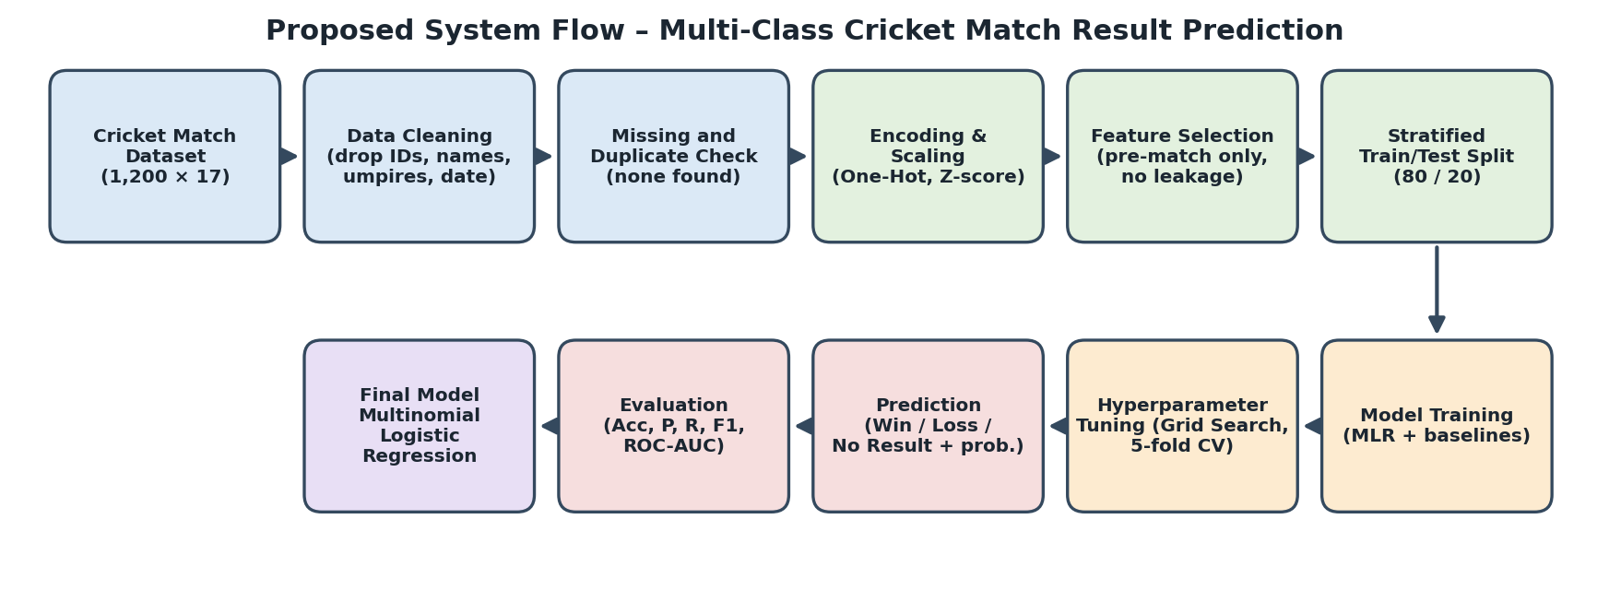
Figure 3.1: Proposed system flow diagram

3.2 Dataset Description
The Cricket Match Dataset, described in the project presentation as collected through a cricket data / sports API, is stored as an Excel workbook (sheet "Cricket Match Data"). It contains 1,200 matches played between 1 January 2021 and 24 September 2023, each described by 17 attributes (the presentation mentions 18; the supplied workbook has 17). The attributes comprise a match identifier, the date, the city and venue, the two teams, the toss result and decision, the runs and wickets of both innings, a recent-form score, the player of the match, two umpires and the match result. The target variable is Match Result with three classes: Win (620 matches, 51.7%), Loss (540, 45.0%) and No Result (40, 3.3%), so the classes are imbalanced. Eight teams and eight venues appear, five attributes are numerical and eleven are text, and no values are missing. Table 3.1 summarises the attributes and how each is used.
Table 3.1: Attributes of the Cricket Match Dataset
Attribute | Type | Description | Use in this study
Match ID | Integer | Unique identifier of the match | Dropped
Date | Text | Match date (1 Jan 2021 to 24 Sep 2023) | Dropped
City | Categorical (8) | Host city; duplicates Venue | Dropped
Venue | Categorical (8) | Stadium where the match was played | Used
Team 1, Team 2 | Categorical (8) | The two competing franchise teams | Used
Toss Result | Categorical (2) | Won Toss / Lost Toss | Used
Toss Decision | Categorical (2) | Bat / Field | Used
First / Second Innings Runs | Integer | Runs scored in each innings | Leakage test only
First / Second Innings Wickets | Integer | Wickets lost in each innings | Leakage test only
Recent Form Score | Float (2.0 to 9.8) | Pre-match recent-form rating | Used
Player of Match | Categorical (99) | Best player, known after the match | Dropped
Umpire 1, Umpire 2 | Categorical (7) | Match officials | Dropped
Match Result | Categorical (3) | Win / Loss / No Result | Target

3.3 Experimental Setup
All experiments were run on a CPU-only machine (no GPU is required; every model trains in seconds) under Ubuntu 24.04 Linux, using Python 3.12.3 in a script/Jupyter-style workflow that is also compatible with Google Colab, the environment used in the project presentation. The main libraries were pandas 3.0.2, NumPy 2.4.4, scikit-learn 1.8.0, matplotlib 3.10.8, seaborn 0.13.2, SciPy for statistical tests and openpyxl for reading the workbook. A fixed random seed of 42 was used for the train/test split, cross-validation and all stochastic models so that results are reproducible.

3.4 Data Preprocessing
- Data inspection and schema validation: the workbook was loaded into a 1,200 x 17 data frame; five columns are integer, one is floating point and eleven are text (the date is stored as text).
- Duplicate removal: no duplicate rows were found, so none were removed.
- Missing-value analysis and imputation: no missing values exist in any column, so no imputation was needed.
- Outlier analysis: the 1.5 x IQR rule flags 40 values in each of First and Second Innings Runs. These are exactly the 40 No Result matches (abandoned or truncated innings with very low scores). They are genuine records and were retained.
- Categorical encoding: Venue, Team 1, Team 2, Toss Result and Toss Decision are one-hot encoded (28 binary columns).
- Numerical scaling: Recent Form Score (and, in the leakage experiment, the four innings statistics) is standardised to zero mean and unit variance using the training data only.
- Target-label preparation: Match Result is label-encoded as Loss = 0, No Result = 1, Win = 2.
- Train/test split and prevention of data leakage: a stratified 80/20 split gives 960 training and 240 test matches (test: 108 Loss, 8 No Result, 124 Win). Encoding and scaling are fitted inside a scikit-learn Pipeline on training data only, and in-match statistics are excluded from the main experiment.

3.5 Exploratory Data Analysis
Exploratory analysis was performed to understand the target and its relationship with the predictors. Figure 3.2 shows that the target is imbalanced, with No Result matches forming only 3.3% of the data.
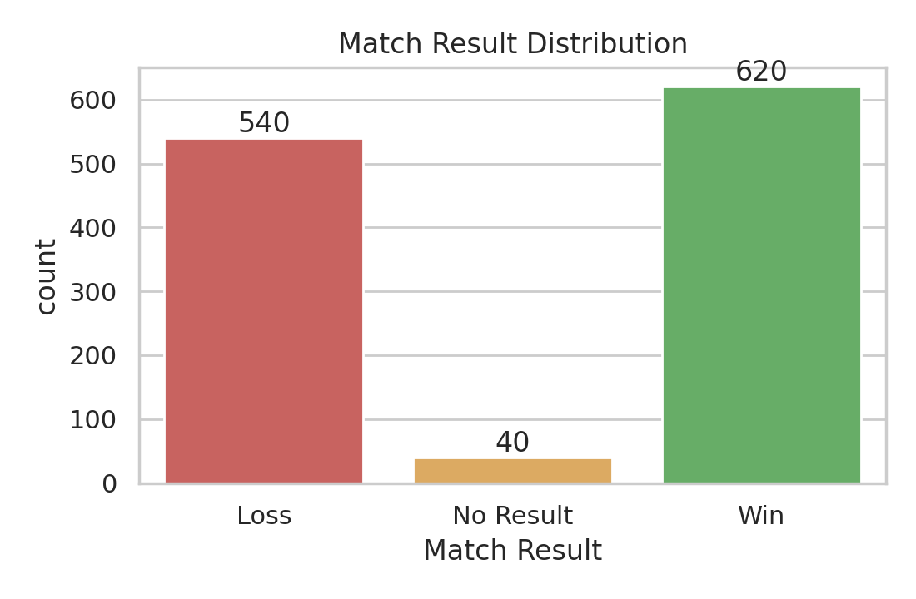
Figure 3.2: Distribution of Match Result
Figure 3.3 compares the result with the toss outcome and the toss decision. Winning the toss does not improve the chance of winning the match: the win rate is 49.6% for teams that won the toss and 53.7% for those that lost it. Chi-square tests confirm that neither the toss result (chi-square = 4.16, p = 0.125) nor the toss decision (chi-square = 0.80, p = 0.672) is significantly associated with the result. Venue (p = 0.426), Team 1 (p = 0.107) and Team 2 (p = 0.768) are likewise not significantly associated.
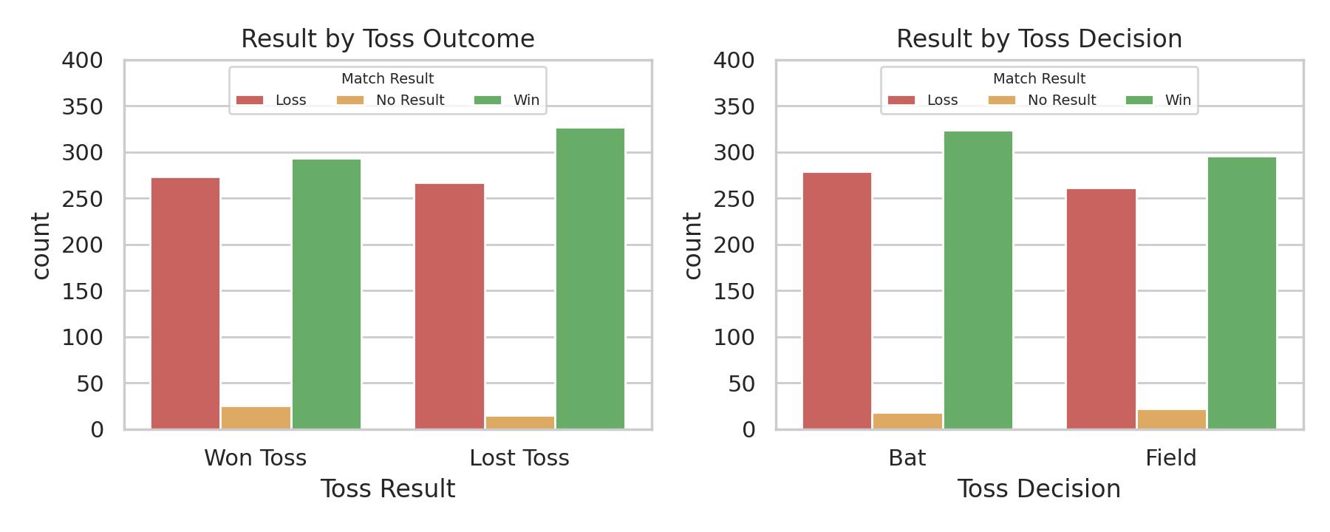
Figure 3.3: Match Result by toss outcome and toss decision
Recent form, in contrast, is strongly related to the result (Figure 3.4). The mean Recent Form Score is 7.94 for Win, 4.21 for Loss and 4.85 for No Result (one-way ANOVA F = 1501, p < 0.001). Winners never score below 6.0 and losers never above 6.49, so only a narrow band between 6.0 and 6.49 overlaps; No Result matches span a wide mid-range (3.03 to 6.91) that overlaps both other classes.
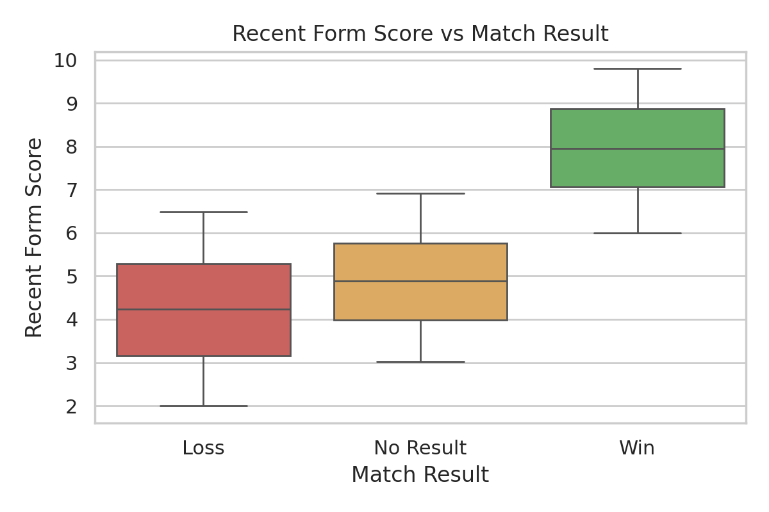
Figure 3.4: Recent Form Score by Match Result
The innings statistics are almost perfectly informative about the result (Figure 3.5). In all 620 Win matches the first innings total exceeds the second, and in all 540 Loss matches it is lower. No Result matches have very small scores. Because these values are only known once play has finished, they are a form of leakage for a pre-match prediction task.
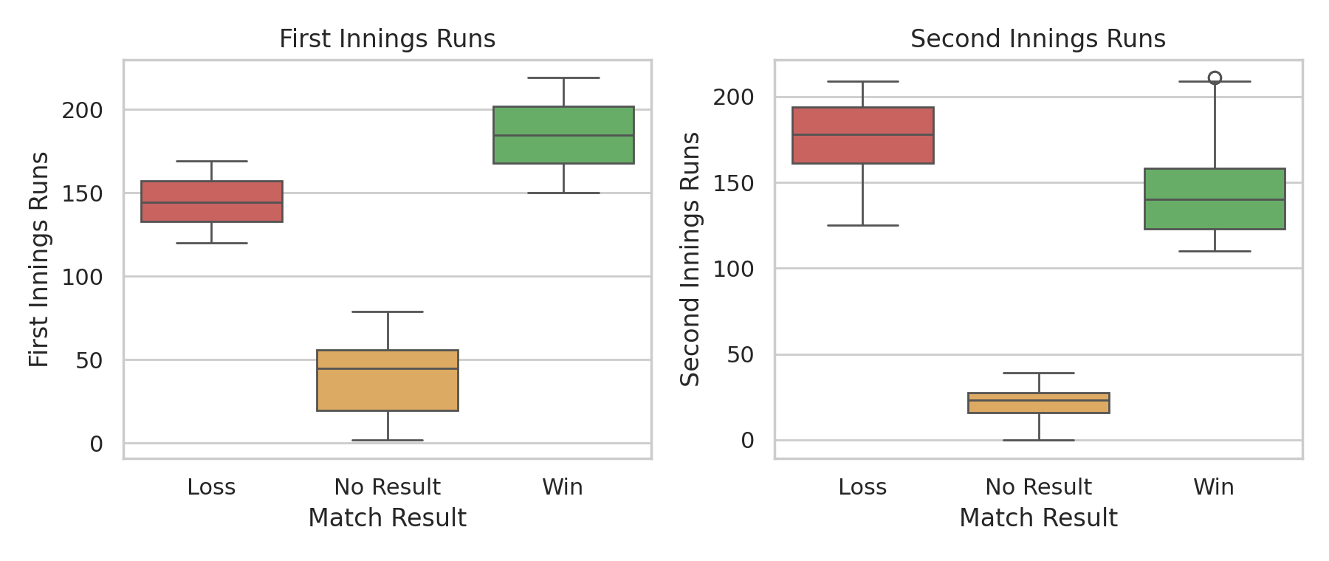
Figure 3.5: First and second innings runs by Match Result
The correlation heatmap (Figure 3.6) shows that Recent Form Score is positively correlated with Second Innings Wickets (0.75) and First Innings Runs (0.54) and negatively with First Innings Wickets (-0.61). First Innings Runs and Second Innings Wickets are also strongly related (0.70).
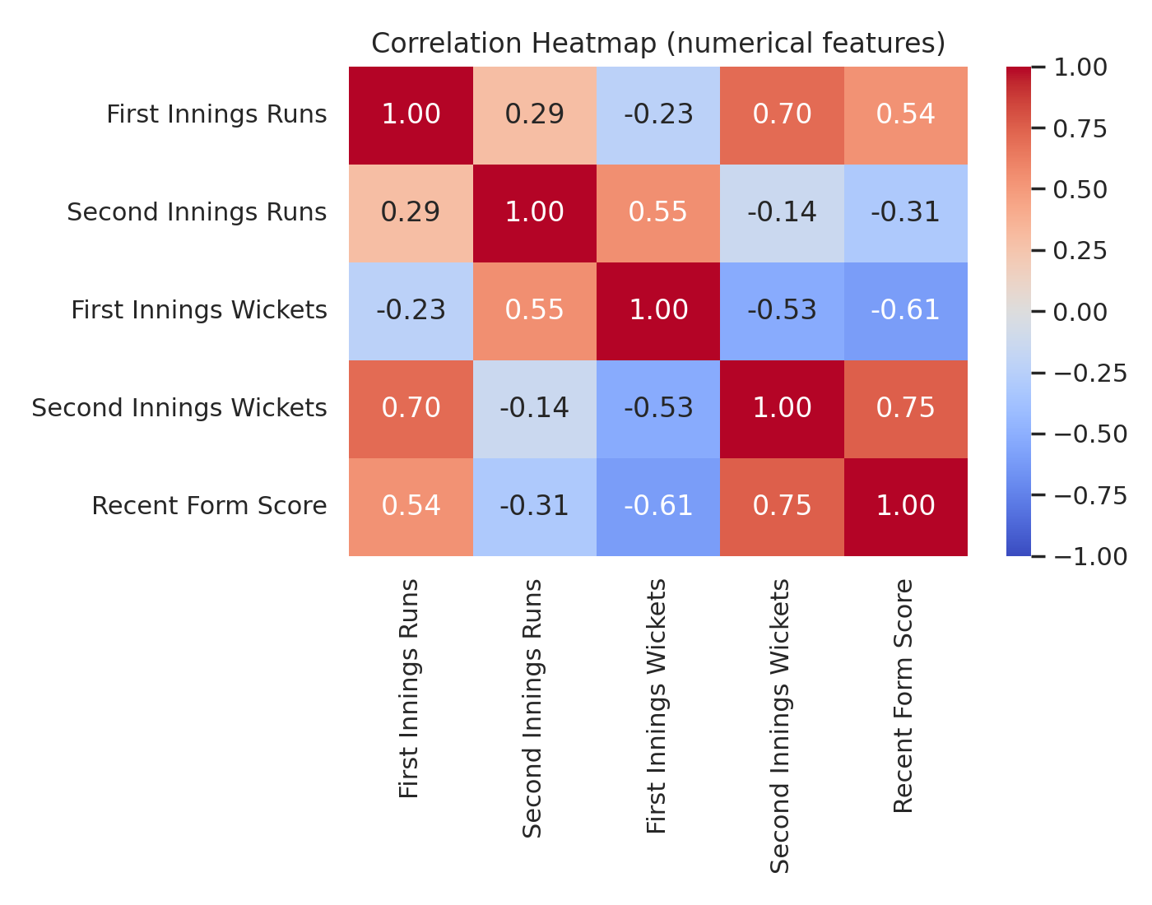
Figure 3.6: Correlation heatmap of numerical attributes

3.6 Feature Engineering and Feature Selection (if applicable)
No new variables were derived; the work concentrates on correct feature selection. The selected pre-match features are Recent Form Score, Venue, Team 1, Team 2, Toss Result and Toss Decision, which expand to 29 model inputs after one-hot encoding. The rejected features are: Match ID and Date (identifiers with no predictive meaning); City (redundant, because in every record the Venue equals the city name followed by "Stadium"); Player of Match (only known after the match); and Umpire 1 and Umpire 2 (irrelevant to the outcome). The four innings runs and wickets columns are also rejected from the main experiment because they are only known after play and effectively encode the result; they are used only in a separate leakage experiment (33 inputs).

3.7 Model Building and Training
The proposed model is Multinomial Logistic Regression. For a feature vector x, the probability of class k is P(y = k | x) = exp(w_k . x + b_k) / sum_j exp(w_j . x + b_j) (the softmax function), and the model is trained by minimising the multinomial cross-entropy (log) loss with L2 regularisation using the L-BFGS optimiser (maximum 2,000 iterations). The default regularisation strength is C = 1.
Four baselines are used for comparison: a majority-class (dummy) classifier; k-Nearest Neighbours with k = 5; a Decision Tree with default settings; and a Random Forest with 200 trees. All models are wrapped in the same preprocessing pipeline and trained on the 960 training matches. Generalisation is monitored with five-fold stratified cross-validation on the training set, and the 240 test matches are used only for the final evaluation.

3.8 Hyperparameter Tuning(if applicable)
Hyperparameters of the MLR were tuned with GridSearchCV over the regularisation inverse strength C in {0.01, 0.1, 1, 10, 100} and class_weight in {none, balanced}, giving ten settings and 50 model fits (five-fold stratified cross-validation on the training set). The weighted F1-score was used as the selection metric because it matches the metric reported in the results. The best setting was C = 10 with no class weighting, with a mean cross-validated weighted F1 of 0.904. Table 3.2 lists all settings.
Table 3.2: Grid-search results (mean 5-fold CV weighted F1-score)
C (inverse regularisation) | class_weight = none | class_weight = balanced
0.01 | 0.903 | 0.855
0.1 | 0.897 | 0.838
1 | 0.899 | 0.835
10 | 0.904 | 0.837
100 | 0.903 | 0.841

3.9 Model Evaluation
Because this is a three-class problem, performance is measured on the held-out test set with: accuracy (correct predictions divided by all predictions); precision = TP / (TP + FP); recall = TP / (TP + FN); F1-score = 2 x precision x recall / (precision + recall); the confusion matrix; and the one-vs-rest ROC-AUC. Precision, recall and F1 are reported as support-weighted averages over the three classes, and the macro F1-score is added because the No Result class is rare and weighted averages can hide poor performance on it. Per-class metrics and one-vs-rest ROC curves are also reported.

4. Results and Discussion

4.1 Preprocessing Results
Table 4.1 summarises the data before and after preprocessing. No missing values or duplicates were found, six non-predictive columns were dropped, and the six selected pre-match attributes expanded to 29 model inputs after one-hot encoding and scaling.
Table 4.1: Preprocessing summary
Item | Before | After
Records x columns | 1,200 x 17 | 1,200 x 7 (6 predictors + target)
Missing values | 0 | 0 (no imputation needed)
Duplicate rows | 0 | 0
Columns dropped | - | Match ID, Date, City, Player of Match, Umpire 1, Umpire 2
Encoded / scaled features | 6 raw predictors | 29 (28 one-hot + 1 scaled numeric)
With in-match statistics (leakage test) | - | 33 features
Training / test records | 1,200 | 960 / 240 (stratified 80/20)
Class counts (train) | - | Loss 432, No Result 32, Win 496
Class counts (test) | - | Loss 108, No Result 8, Win 124

4.2 Model Performance
Table 4.2: Model performance on the test set using pre-match features (precision, recall and F1 are support-weighted; AUC is one-vs-rest weighted)
Model | Accuracy | Precision | Recall | F1-score | ROC AUC
Existing study [1] (Random Forest, T20 winner) | 0.841 | - | - | - | -
Majority-class baseline | 0.517 | 0.267 | 0.517 | 0.352 | 0.500
k-Nearest Neighbours (k = 5) | 0.879 | 0.854 | 0.879 | 0.865 | 0.937
Decision Tree | 0.892 | 0.895 | 0.892 | 0.892 | 0.909
Random Forest | 0.908 | 0.878 | 0.908 | 0.893 | 0.968
MLR, default (C = 1) | 0.900 | 0.870 | 0.900 | 0.884 | 0.970
MLR, tuned (C = 10) - proposed | 0.896 | 0.869 | 0.896 | 0.882 | 0.970

The "Existing study" row quotes the random-forest accuracy reported in [1] for T20 winner prediction; only accuracy is available, and the comparison is indicative because the dataset and task differ. Table 4.3 gives the per-class performance of the tuned MLR, and Table 4.4 compares cross-validated accuracy with test accuracy before and after adding in-match statistics.
Table 4.3: Per-class performance of the tuned MLR (test set)
Class | Precision | Recall | F1-score | Support
Loss | 0.896 | 0.880 | 0.888 | 108
No Result | 0.000 | 0.000 | 0.000 | 8
Win | 0.902 | 0.968 | 0.934 | 124
Macro average | 0.599 | 0.616 | 0.607 | 240
Weighted average | 0.869 | 0.896 | 0.882 | 240

Table 4.4: Cross-validated accuracy and effect of in-match statistics (data leakage)
Model | 5-fold CV accuracy (pre-match, mean +/- sd) | Test accuracy (pre-match features) | Test accuracy (with in-match statistics)
Majority-class baseline | 0.517 +/- 0.002 | 0.517 | 0.517
k-Nearest Neighbours | 0.851 +/- 0.021 | 0.879 | 1.000
Decision Tree | 0.891 +/- 0.010 | 0.892 | 1.000
Random Forest | 0.917 +/- 0.007 | 0.908 | 1.000
Multinomial Logistic Regression | 0.915 +/- 0.011 | 0.900 | 1.000

4.3 Visual Results and discussion
Figure 4.1 compares the models on the test set. The majority-class baseline reaches only 0.517 accuracy, so every learned model captures real signal. Random Forest (0.908), the default MLR (0.900), the tuned MLR (0.896) and the Decision Tree (0.892) are within about two percentage points of one another, which corresponds to only a handful of the 240 test matches; the differences are therefore not meaningful. The MLR has the highest ROC-AUC (0.970 versus 0.968 for Random Forest), and its cross-validated accuracy (0.915) is virtually identical to that of Random Forest (0.917).
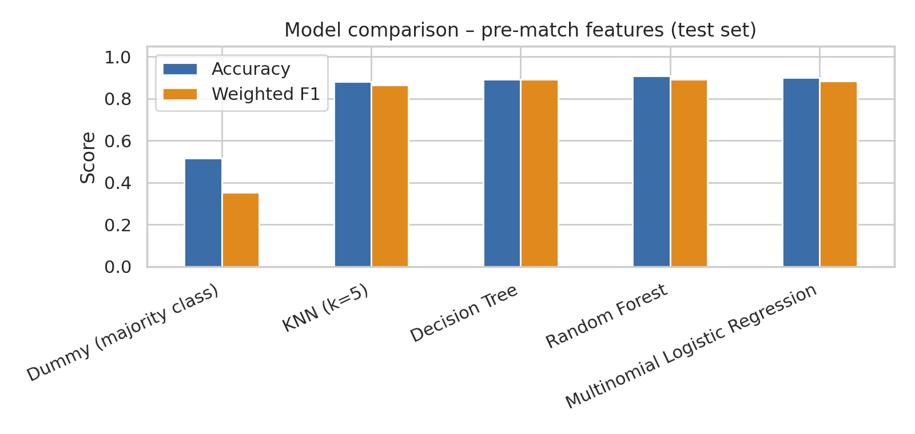
Figure 4.1: Comparison of models on the test set (pre-match features)
The confusion matrix of the tuned MLR (Figure 4.2, left) shows 95 of 108 Loss and 120 of 124 Win matches classified correctly. The main confusion is between Loss and Win (12 Loss matches predicted as Win and 4 Win matches predicted as Loss), which occurs where the Recent Form Score lies in the overlapping band around 6.0 to 6.5. None of the eight No Result matches is identified (seven are predicted as Loss and one as Win), giving zero precision, recall and F1 for that class and a macro F1 of 0.607 against a weighted F1 of 0.882. Overall accuracy therefore overstates performance on the rare class. The one-vs-rest ROC curves (Figure 4.3) show the same picture: AUC is 0.991 for Win and 0.961 for Loss but only 0.776 for No Result, so the model ranks No Result matches better than chance yet never ranks them first.
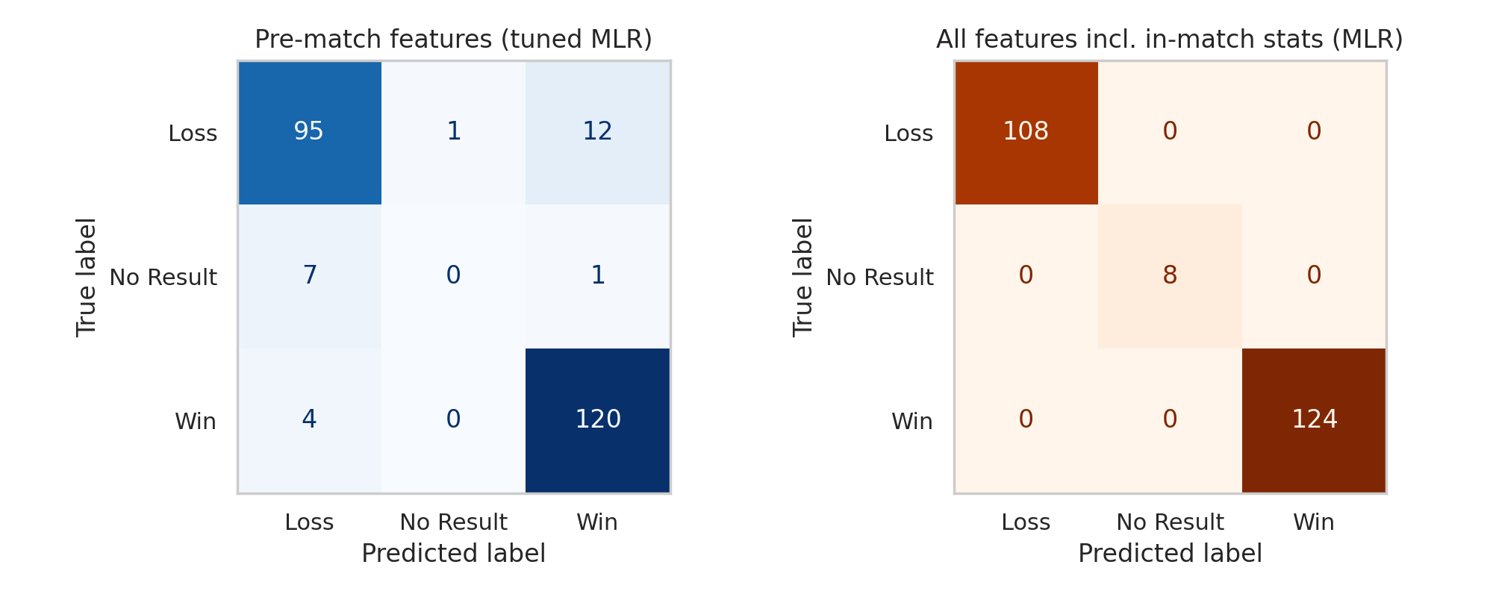
Figure 4.2: Confusion matrices of the tuned MLR: pre-match features (left) and all features including in-match statistics (right)
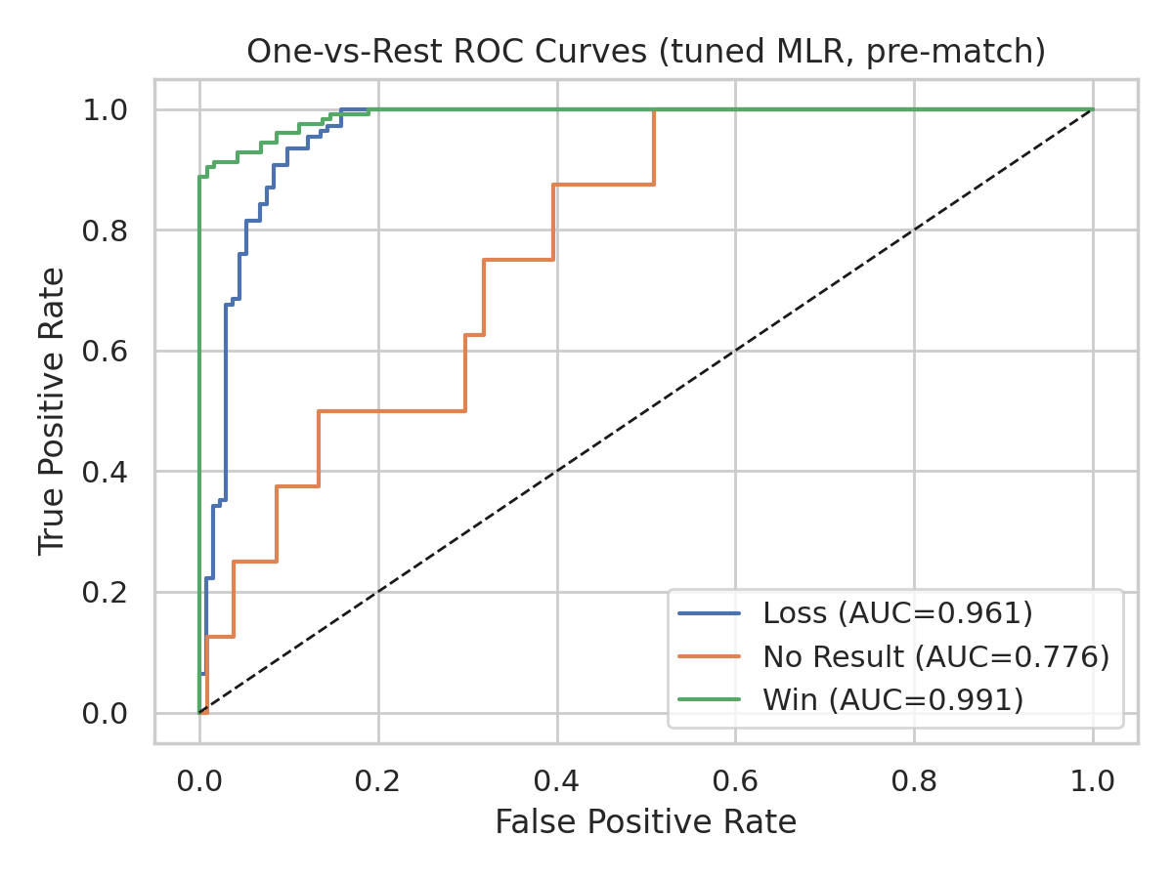
Figure 4.3: One-vs-rest ROC curves of the tuned MLR (pre-match features)
The MLR performs as well as the more flexible models because the signal is dominated by one strong, roughly monotonic predictor. Figure 4.4 shows the largest coefficients: the standardised Recent Form Score has a coefficient of +8.29 for Win, -4.75 for Loss and -3.54 for No Result, several times larger than any other feature (every team, venue and toss coefficient is about 1.1 or less in magnitude). This agrees with the exploratory tests, in which toss, venue and teams were not significantly associated with the result. A linear model in standardised space is therefore sufficient, and non-linear models cannot add much, while the MLR additionally supplies class probabilities and interpretable coefficients.
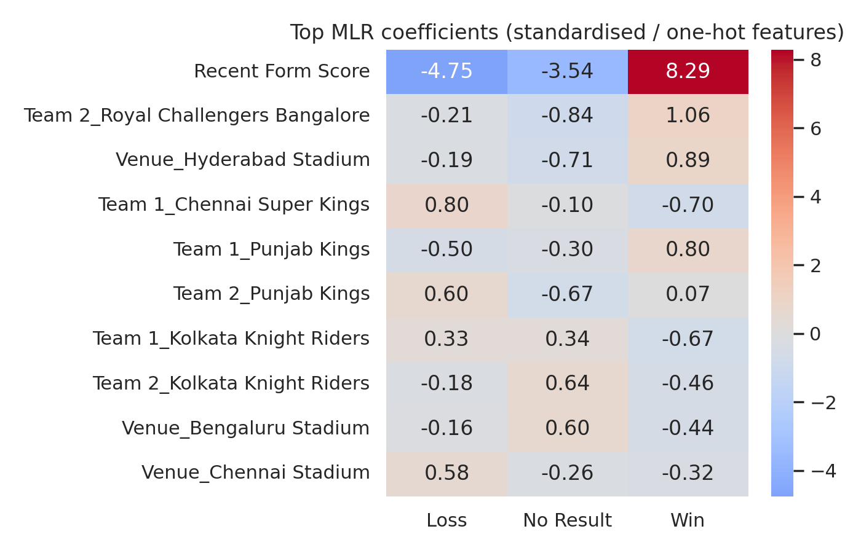
Figure 4.4: Largest coefficients of the tuned MLR
The learning curve (Figure 4.5) shows that training accuracy falls from 1.00 to about 0.93 while cross-validated accuracy rises from about 0.85 to 0.92 and the two converge after roughly 450 examples. The small final gap (about 0.015) indicates low variance and little overfitting, and the plateau suggests that more matches of the same kind would add little, because the limit is the information in the features rather than the amount of data. The gap between cross-validated accuracy (0.915) and test accuracy (0.900 for the default MLR) is also small.
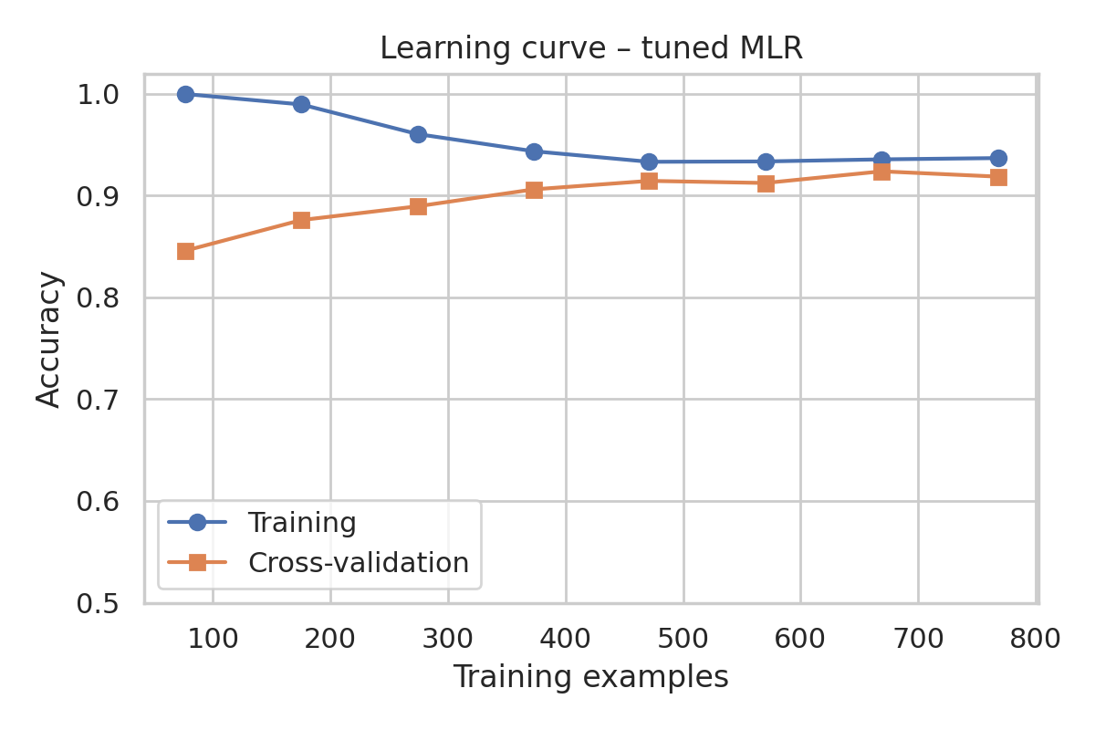
Figure 4.5: Learning curve of the tuned MLR (accuracy versus training size)
Tuning did not improve test accuracy (0.896 versus 0.900 for the default model), although it raised the cross-validated weighted F1 slightly (0.904 versus about 0.900), which shows that the model is insensitive to regularisation strength. Balanced class weights lowered the weighted F1 in cross-validation (Table 3.2). In an exploratory run that optimised macro F1 instead, balanced weights raised No Result recall to 3 of 8 but cut overall accuracy to 82.5% and No Result precision to 0.097, so the trade-off between overall accuracy and rare-class detection remains open.
Effect of data leakage
When the four in-match statistics are added, every model, including the simple MLR, reaches 1.000 accuracy (Table 4.4, Figure 4.2 right). This is not predictive skill: in all Win matches the first innings total exceeds the second, and in all Loss matches it is lower, so the result can be read directly from the scores. Such features can only support post-match verification, which is why the main results use pre-match features only.
Limitations
The test set contains only eight No Result matches, so estimates for that class are very uncertain. The dataset also has unusually regular structure (for example, every Win has a Recent Form Score of at least 6.0, every Loss at most 6.49, and the innings scores determine Win and Loss exactly), so the absolute accuracy figures should not be assumed to transfer to real-world match data. Finally, No Result outcomes are often caused by weather or abandonment, which none of the available pre-match attributes describes.

5. Conclusion
This project developed a machine learning system that predicts the result of a cricket match as Win, Loss or No Result from a dataset of 1,200 matches. After cleaning, encoding, scaling and leakage-aware feature selection, a Multinomial Logistic Regression model was trained, tuned and compared with a majority-class baseline, k-Nearest Neighbours, a Decision Tree and a Random Forest.
Using only pre-match information, the tuned MLR achieved 89.6% test accuracy, a weighted F1 of 0.882 and a weighted ROC-AUC of 0.970, essentially matching Random Forest (90.8%) and clearly beating the 51.7% majority baseline, while remaining interpretable and providing class probabilities. Recent form is by far the most informative feature; toss, venue and team identity add little. Two findings qualify these results. The rare No Result class was not detected (macro F1 0.607), and models that use in-match scores reach 100% accuracy only because those scores determine the result. The MLR is therefore a practical, transparent predictor of Win and Loss before a match, but not yet of No Result outcomes.

6. Future Work
- Use larger, real-world and more diverse cricket datasets (several formats and tournaments) and validate on external data.
- Collect more No Result matches and weather or pitch information, and apply resampling or cost-sensitive learning to detect them.
- Evaluate additional algorithms and ensembles such as gradient boosting and XGBoost, and calibrate probabilities.
- Perform deeper hyperparameter optimisation, for example random or Bayesian search with nested cross-validation.
- Investigate explainable AI techniques such as SHAP for per-match explanations.
- Evaluate robustness over time using time-based splits and monitor model drift across seasons.
- Develop a deployable web or mobile application that returns the predicted result and class probabilities in real time.

7. References
[1] S. Chakraborty, A. Mondal, A. Bhattacharjee, A. Mallick, R. Santra, S. Maity and L. Dey, "Cricket data analytics: Forecasting T20 match winners through machine learning," KES Journal, Feb. 2024, doi: 10.3233/KES-230060.
[2] P. N. Gour and M. F. Khan, "Utilizing machine learning for comprehensive analysis and predictive modelling of IPL-T20 cricket matches," Indian Journal of Science and Technology, vol. 17, no. 7, pp. 592-597, 2024, doi: 10.17485/IJST/v17i7.2944.
[3] K. Dhinakaran and S. Anbuchelian, "Enhanced cricket match prediction using kernel methods for feature extraction and back-propagation neural networks," Scientific Reports, 2026, doi: 10.1038/s41598-026-36555-6.
[4] A. Tyagi, A. Kaur, A. Kamboj, C. Chaulia, G. Mohan and M. Singh, "Enhancing T20 cricket match prediction using XGBoost algorithm and statistical techniques: A comparative analysis of various regression algorithms," in Artificial Intelligence and Applications (ICAIA 2024), Springer, 2025, pp. 317-328, doi: 10.1007/978-981-97-8074-7_23.
[5] F. Bharadwaj et al., "Player performance predictive analysis in cricket using machine learning," Revue d'Intelligence Artificielle, vol. 38, no. 2, Apr. 2024, doi: 10.18280/ria.380208.
[6] B. Sushanth, K. Sai Siddartha, S. Somani, B. Ganesh and R. Hariharan, "WIN-IPL: Winning insights and predictions for IPL matches using machine learning," in Proc. Third Congress on Control, Robotics, and Mechatronics, Springer, 2026, doi: 10.1007/978-981-96-9771-7_9.
[7] L. Milendra, Rohit S., Jithin C. and G. Paavai Anand, "IPL team winning prediction using machine learning," International Journal of Advanced Research in Computer and Communication Engineering (IJARCCE), 2025, doi: 10.17148/IJARCCE.2025.141139.
[8] P. Kala et al., "IPL match win predictor," Journal of Emerging Technologies and Innovative Research, vol. 12, no. 4, 2025, doi: 10.56975/jetir.v12i4.560395.
[9] Pawan S. et al., "IPL match win predictor," International Journal of Scientific Research in Science and Technology, pp. 201-208, May 2026, doi: 10.32628/IJSRST26133127.
[10] R. Prodduturu et al., "IPL match winning analysis with player stats using machine learning," in Proc. 6th International Conference ICE-ELINVO 2023, AIP Conference Proceedings, 2025, doi: 10.1063/5.0260970.

Signature of the Guide Course Instructor

