Installation of Kubernetes on Linux

The installation of Kubernetes on Linux is a straight forward process. Follow the below steps to install the Kubernetes. In the installation of Kubernetes, each step is mandatory.

**Step 1:** In this step, we have to update the necessary dependencies of a system using two commands.

The first command is used to get all the updates. Execute the following command in the terminal; it will ask to enter the system's password.

1. sudo apt-get update

**Output:**

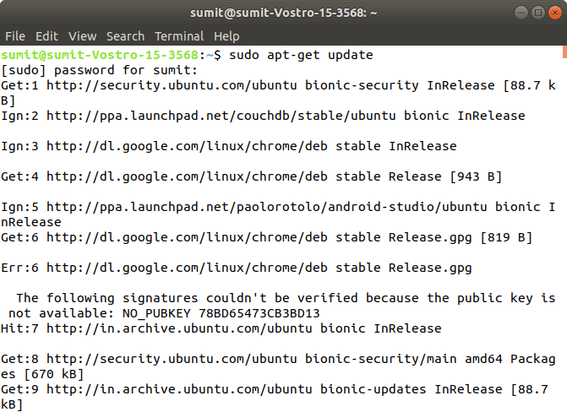

When the first command is successfully executed, type the following second command, which is used to make the repositories.

1. sudo apt-get install -y apt-transport-https

**Output:**

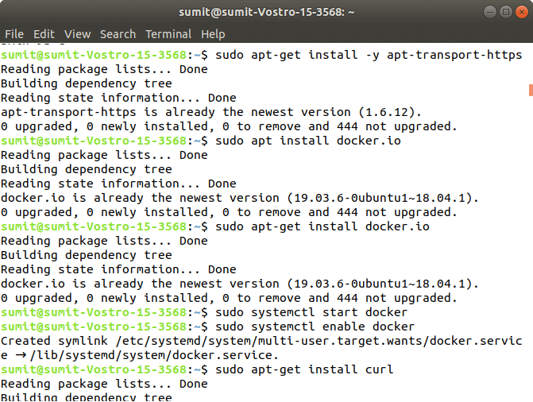

**Step 2:** After the above steps are successfully executed, we have to install the dependencies of docker in this step.

Type the following command to install the docker. In the installation process, we have to choose Y for confirmation of the installation.

1. sudo apt install docker.io

**Output:**

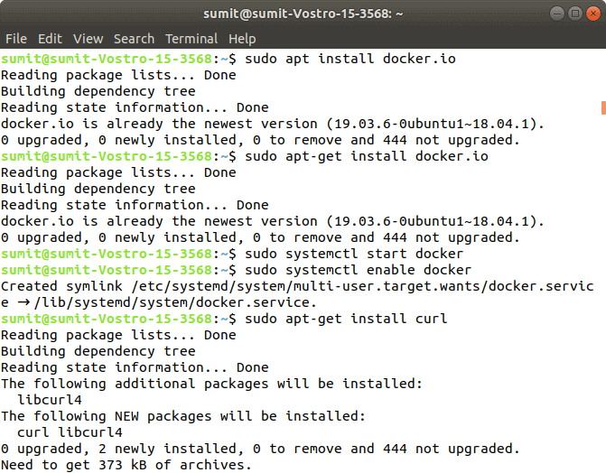

After installing the docker, we have to type the different two commands for starting and enabling the docker. Type the following first command, which starts the docker:

1. sudo systemctl start docker

Now, type the following second command, which enables the docker:

1. sudo systemctl enable docker

**Output:**

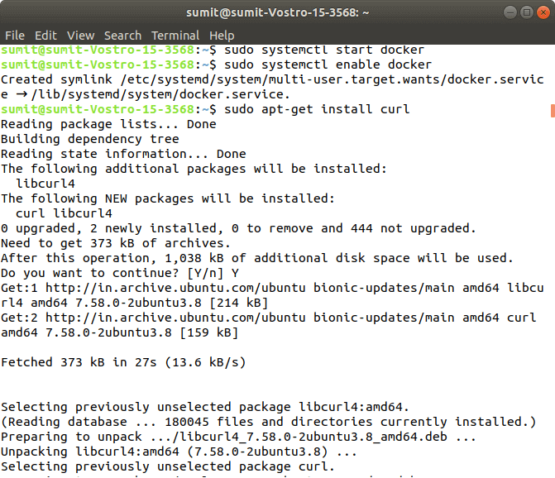

Now, we can check the version of docker by typing the following command:

1. Docker -version

**Output:**

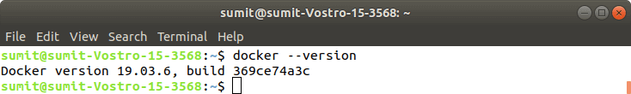

**Step 3:** After the successful execution of all the commands of the second step, we have to install the curl command. The curl is used to send the data using URL syntax.

Now, install the curl by using the following command. In the installation, we have to type Y.

1. sudo apt-get install curl

**Output:**

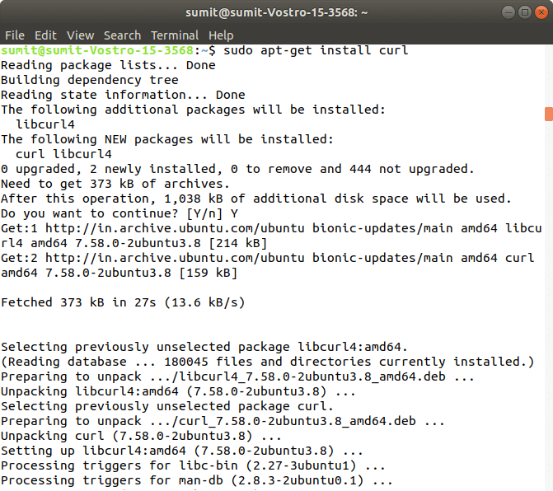

Now, we have to download the add package key for Kubernetes by the following command:

1. sudo curl -s https://packages.cloud.google.com/apt/doc/apt-key.gpg | sudo apt-key add

**Output:**

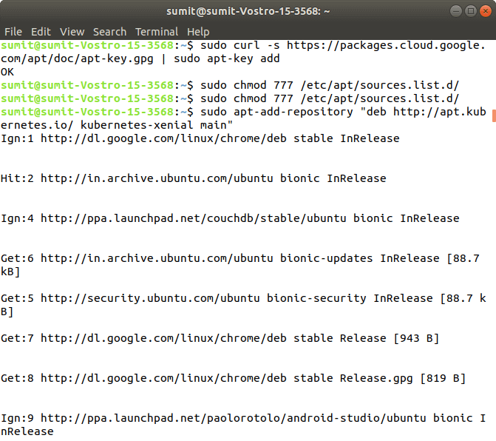

If you get an error from the above command, then it means your curl command is not successfully installed, so first install the curl command, and again run the above command.

Now, we have to add the Kubernetes repositories by the following command:

1. sudo apt-add-repository "deb http://apt.kubernetes.io/ kubernetes-xenial main"

**Output:**

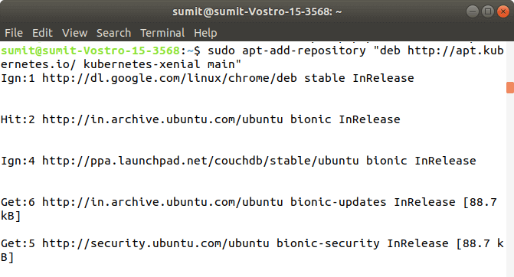

After the successful execution of the above command, we have to check any updates by executing the following command:

1. sudo apt-get update

**Output:**

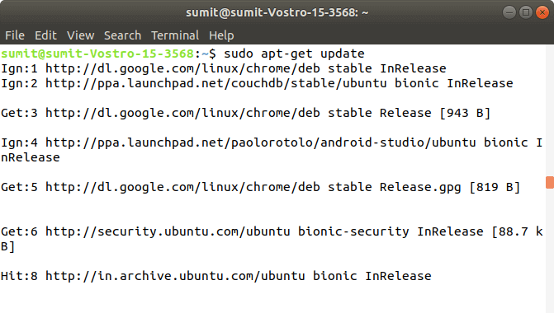

**Step 4:** After the execution of the above commands in the above steps, we have to install the components of Kubernetes by executing the following command:

1. sudo apt-get install -y kubelet kubeadm kubectl kubernetes-cni

**Output:**

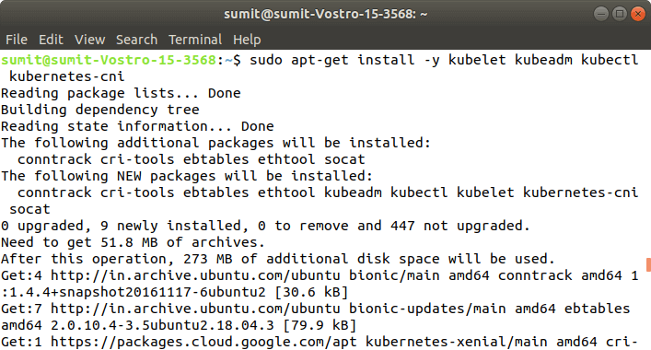

**Step 5:** After the above installation is done, we have to initialize the kubeadm by executing the following command. The following command disables the swapping on other devices:

1. sudo swapoff -a

**Output:**

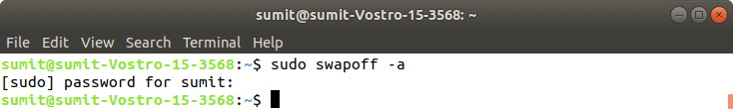

Now, we have to initialize the kubeadm by executing the following command:

1. sudo kubeadm init

**Output:**

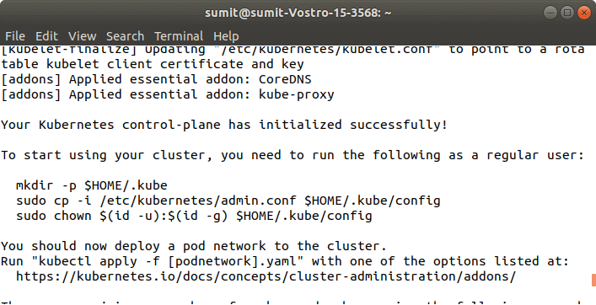

**Step 6:** After the above command is successfully executed, we have to run the following commands, which are given in the initialization of kubeadm. These commands are shown in the above screenshot. The following commands are used to start a cluster:

1. mkdir -p $HOME/.kube
2. sudo cp -i /etc/kubernetes/admin.conf $HOME/.kube/config
3. sudo chown $(id -u):$(id -g) $HOME/.kube/config

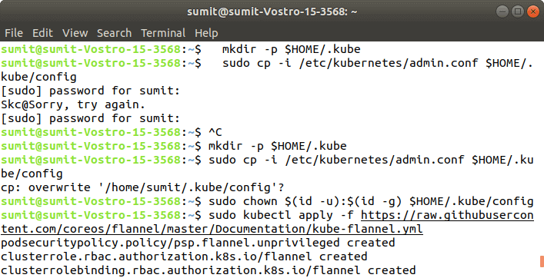  
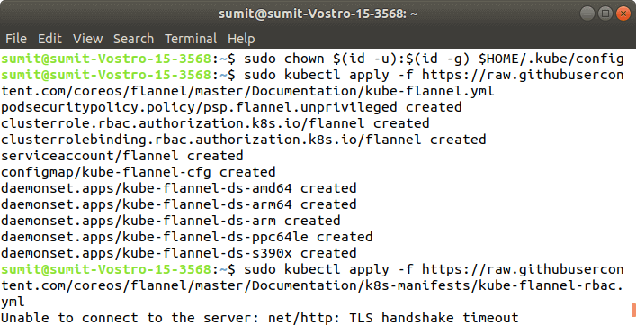

**Output:**

**Step 7:** In this step, we have to deploy the paths using the following command:

1. sudo kubectl apply -f https://raw.githubusercontent.com/coreos/flannel/master/Documentation/kube-flannel.yml

**Output:**

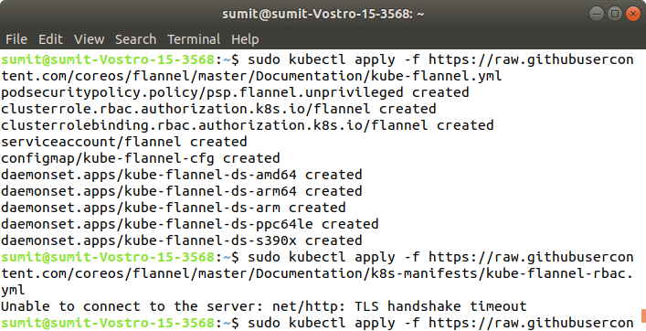

**Step 8:** After the execution of the above command, we have to run the following command to verify the installation:

1. sudo kubectl get pods --all-namespaces

**Output:**

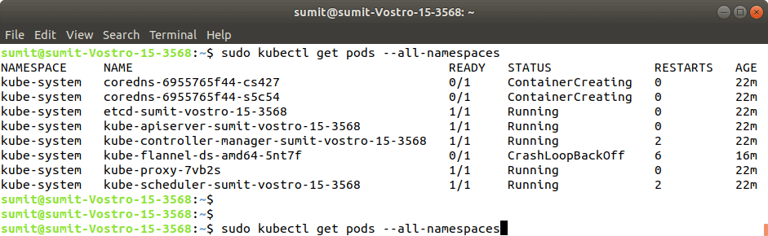

If the output is displayed as shown in the above screenshot. It means that the Kubernetes is successfully installed on our system.