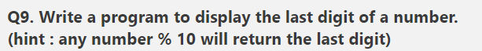

https://forms.gle/BEduJodq8YeofWub8