**Insert the following documents into a movies collection.**

db.movies.insertMany(

[

{

title:"Fight Club",

writer:"Chuck Plahniuk",

year:1999,

actors:["Brad Pitt","Edward Norton"]

},

{

title:"Pulp Fiction",

writer:"Quentin Tarantino",

year:1994,

actors:["BJohn Travolta","Uma Thurman"]

},

{

title:"Inglorious Basterds",

writer:"Quentin Tarantino",

year:2009,

actors:["Brad Pitt","Diane Kruger","Eli Roth"]

},

{

title:"The Hobbit: An Unexpected Journey",

writer:"J.R.R. Tolkein",

year:2012,

actors:["Brad Pitt","Diane Kruger","Eli Roth"]

},

{

title : "The Hobbit: The Desolation of Smaug",

writer : "J.R.R. Tolkein",

year : 2013,

franchise : "The Hobbit"

},

{

title : "The Hobbit: The Battle of the Five Armies",

writer : "J.R.R. Tolkein",

year : 2012,

franchise : "The Hobbit"

synopsis : Bilbo and Company are forced to engage in a war against an array of

combatants and keep the Lonely Mountain from falling into the hands of a rising darkness.

},

{

title :”Pee Wee Herman's Big Adventure ”

},

{

title :”Avatar”

}

]

)

**1.Get all documents**

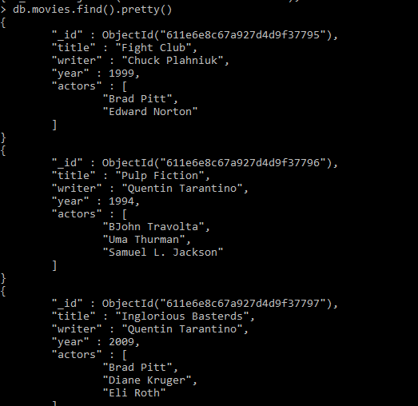

**2.Get all documents with writer set to "Quentin Tarantino"**

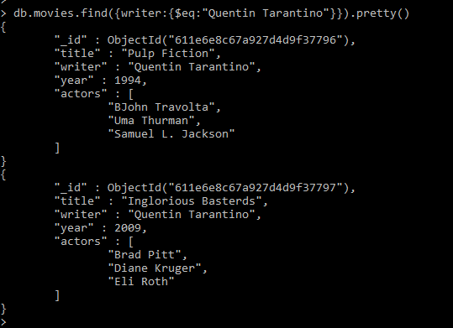

**3.Get all documents where actors include "Brad Pitt"**

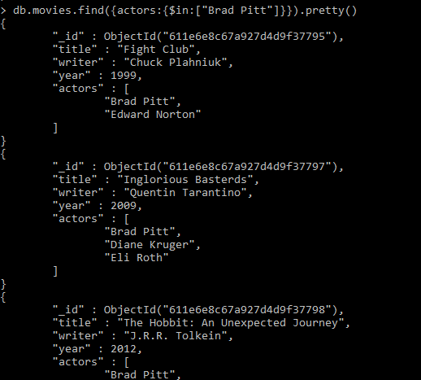

**4.Get all documents with franchise set to "The Hobbit"**

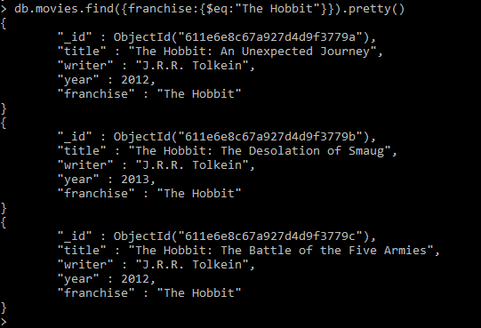

**5.Get all movies released in the 90s**

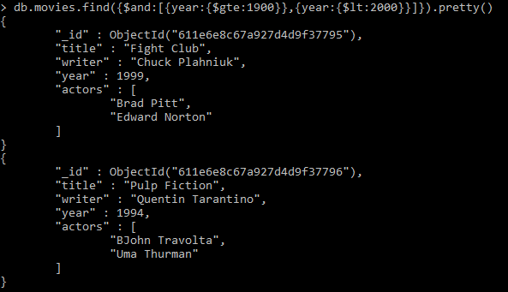

**6.Get all movies released before the year 2000 or after 2010**

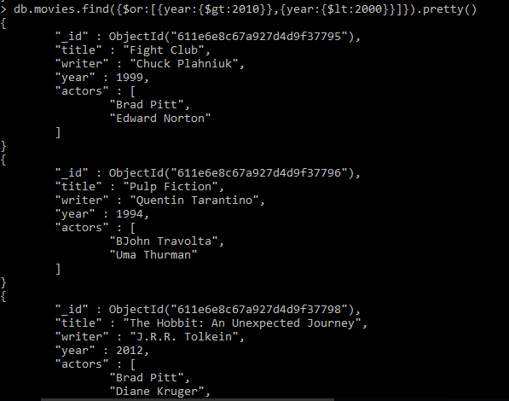

**Update Documents**

**1 .add a synopsis to "The Hobbit: An Unexpected Journey" : "A reluctant hobbit, Bilbo Baggins, sets out to the Lonely Mountain with a spirited group of dwarves to reclaim their mountain home - and the gold within it - from the dragon Smaug."**



**2. add a synopsis to "The Hobbit: The Desolation of Smaug" : "The dwarves, along with Bilbo Baggins and Gandalf the Grey, continue their quest to reclaim Erebor, their homeland, from Smaug. Bilbo Baggins is in possession of a mysterious and magical ring."**

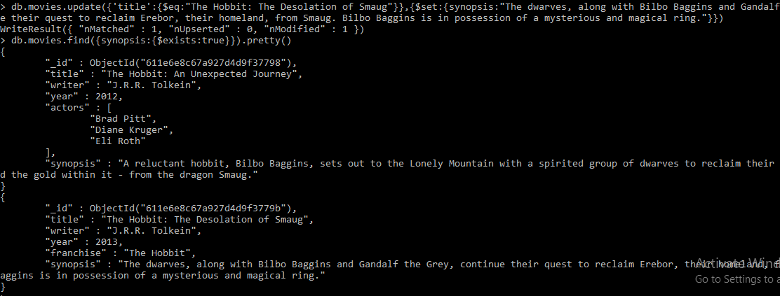

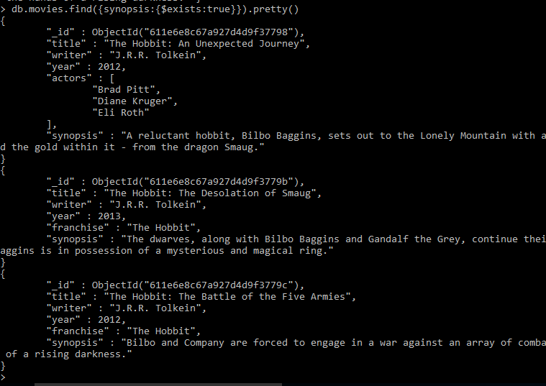

**3. add an actor named "Samuel L. Jackson" to the movie "Pulp Fiction"**

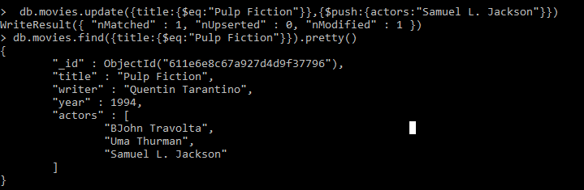

**Text Search**

**1. find all movies that have a synopsis that contains the word "Bilbo"**

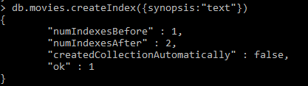

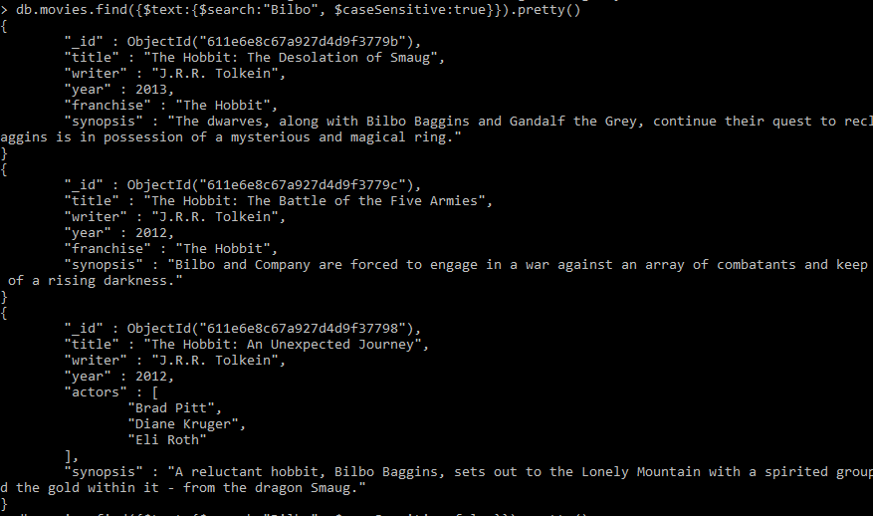

**2. find all movies that have a synopsis that contains the word "Gandalf"**

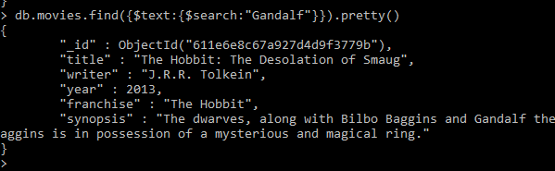

**3. find all movies that have a synopsis that contains the word "Bilbo" and not the word "Gandalf"**

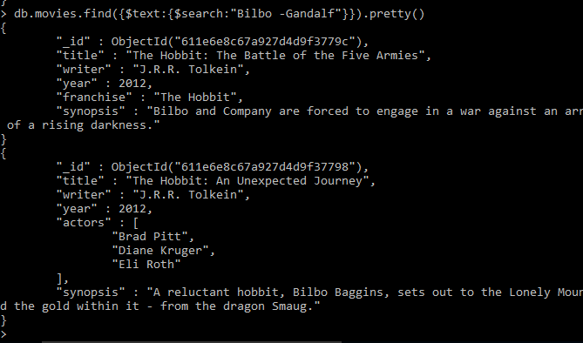

**4. find all movies that have a synopsis that contains the word "dwarves" or "hobbit"**

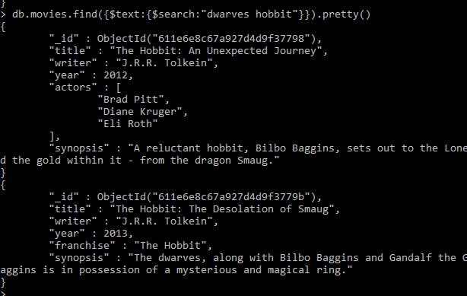

**5. find all movies that have a synopsis that contains the word "gold" and "dragon"**

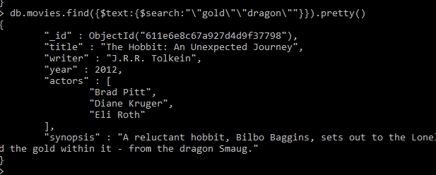

**Delete Documents**

**1. delete the movie "Pee Wee Herman's Big Adventure"**



**2. delete the movie "Avatar"**

