Angeles University Foundation

Angeles City

College of Computer Studies
PTF10 – INTRODUCTION TO DATA SCIENCE

Final Project

Project Title: Data Science Project

General Objective: By Group, using Python, in a Jupyter Notebook, analyze an open-source dataset.

Specific Objectives:
The students should be able to:

Read the data in the format it was created (.csv /.txt / .html / .json)

Note:

Search for a dataset that interests you. Make sure the dataset has at least 1000 rows and 10 columns.

Look for datasets related to topics you find interesting, such as health, technology, social media, economics, etc.

Use Numpy/Pandas libraries

Use Matploblib / Seaborn libraries for visualization

Instructions:

Complete the required information given below. Using the Template provided, submit it as a python notebook in MyClass .

PART 1: DATASET

1.1 Dataset Name/Title: ClinVar Variant Summary (variant_summary.txt.gz)

1.2 Data Source: National Center for Biotechnology Information (NCBI), U.S. National Institutes of Health (NIH)

1.3 URL: https://ftp.ncbi.nlm.nih.gov/pub/clinvar/tab_delimited/variant_summary.txt.gz
About the database: https://www.ncbi.nlm.nih.gov/clinvar/

1.4 Overview:
ClinVar is a free public archive where clinical labs, researchers and expert panels report what they think a human genetic variant (a change in the DNA letters) does to health: pathogenic (causes disease), benign (harmless) or uncertain. Each row is one variant on one genome build, with its gene, chromosome position, linked condition, clinical significance, review status (how strongly it was checked) and number of submitting labs. The file is updated regularly; we used the November 2026 release. It is a tab-separated text file (.txt.gz), about 440 MB compressed.
Why we chose it: it is real health data, very large (9.3 million rows) and messy, so it tests every step of the data science process: loading, cleaning, exploring and visualizing.

1.5 Number of Rows: 9,354,555 (raw file); 4,641,203 unique variants after cleaning
Every variant is listed once per genome build (GRCh37 and GRCh38), so keeping only GRCh38 halves the file; 2,420 more duplicates were then removed.

1.6 Number of Columns: 43

1.7 Column Descriptions:
# | Column | Description
1 | AlleleID | ClinVar ID for the allele (the specific DNA change)
2 | Type | Kind of variant: single nucleotide variant, deletion, duplication, etc.
3 | Name | Standard (HGVS) name of the variant
4 | GeneID | NCBI Gene ID
5 | GeneSymbol | Short gene name(s), e.g. BRCA1; several separated by ;
6 | HGNC_ID | Official gene ID from the HUGO Gene Nomenclature Committee
7 | ClinicalSignificance | Overall germline label: Pathogenic, Likely pathogenic, Uncertain significance, Likely benign, Benign, Conflicting…
8 | ClinSigSimple | Simplified label: 1 = at least one pathogenic/likely pathogenic, 0 = none, -1 = no data
9 | LastEvaluated | Date the variant was last evaluated (text, e.g. "Mar 05, 2019")
10 | RS# (dbSNP) | ID in the dbSNP database
11 | nsv/esv (dbVar) | ID in the dbVar database (large structural variants)
12 | RCVaccession | ClinVar record IDs for each variant–condition pair
13 | PhenotypeIDS | IDs of the linked conditions in other databases (MedGen, OMIM…)
14 | PhenotypeList | Names of the linked conditions; several separated by |
15 | Origin | Where the variant came from: germline, somatic, de novo, etc.
16 | OriginSimple | Simplified origin
17 | Assembly | Genome build (DNA map): GRCh37, GRCh38, NCBI36
18 | ChromosomeAccession | Reference sequence ID of the chromosome
19 | Chromosome | Chromosome number (1–22, X, Y, MT)
20 | Start | Start position on the chromosome
21 | Stop | End position on the chromosome
22 | ReferenceAllele | Original DNA letters
23 | AlternateAllele | Changed DNA letters
24 | Cytogenetic | Chromosome band, e.g. 17q21.31
25 | ReviewStatus | How the label was reviewed (single submitter, multiple submitters, expert panel, practice guideline…)
26 | NumberSubmitters | How many labs/groups submitted this variant
27 | Guidelines | Guideline flags (e.g. ACMG secondary-findings list)
28 | TestedInGTR | Whether a genetic test for it is listed in the Genetic Testing Registry (Y/N)
29 | OtherIDs | IDs in other databases
30 | SubmitterCategories | Code for the kind of organizations that submitted
31 | VariationID | ClinVar variation ID (one per variant; used to remove duplicates)
32 | PositionVCF | Position in VCF file format
33 | ReferenceAlleleVCF | Original letters, VCF format
34 | AlternateAlleleVCF | Changed letters, VCF format
35 | SomaticClinicalImpact | Tumor (somatic) classification tier
36 | SomaticClinicalImpactLastEvaluated | Date of that somatic classification
37 | ReviewStatusClinicalImpact | Review status of the somatic classification
38 | Oncogenicity | Whether the variant drives cancer (oncogenic / benign…)
39 | OncogenicityLastEvaluated | Date of that oncogenicity classification
40 | ReviewStatusOncogenicity | Review status of the oncogenicity classification
41 | SCVsForAggregateGermlineClassification | Submission IDs behind the germline label
42 | SCVsForAggregateSomaticClinicalImpact | Submission IDs behind the somatic label
43 | SCVsForAggregateOncogenicityClassification | Submission IDs behind the oncogenicity label

Columns 35–43 were added recently for cancer (somatic) classifications. We used 11 of the 43 columns.

PART 2: THE PYTHON NOTEBOOK

Note: Use markdown and code for the following:

2.1 Libraries used
pandas – loading the file, cleaning, grouping and counting
numpy – missing values (np.nan), log-scale math
matplotlib – all charts (titles, axis labels, legends, custom colors and fonts)
seaborn – chart theme (whitegrid)
os / gc – file paths and freeing memory
import numpy as np
import pandas as pd
import matplotlib.pyplot as plt
import seaborn as sns

2.2 Data Acquisition (How the dataset was loaded)
1. Downloaded the compressed file from NCBI with wget inside Google Colab.
2. Read 5 rows first to see all 43 columns.
3. Loaded the full file with pd.read_csv in chunks of 500,000 rows (the full file is too big for Colab's memory), keeping only the 12 columns we need and only rows on genome build GRCh38.
for chunk in pd.read_csv(RAW_FILE, sep="\t", usecols=COLS, dtype=str,
chunksize=500_000, quoting=3):
parts.append(chunk[chunk["Assembly"] == "GRCh38"])
df = pd.concat(parts, ignore_index=True)

Result: 9,354,555 rows read; 4,639,270 kept. Peak memory about 3.7 GB, well under Colab's 12 GB.

2.3 Data Cleaning and Exploration

2.3.1 Data Cleaning
Duplicates: kept one row per VariationID with df.drop_duplicates(), removing 2,420 rows → 4,641,203 unique variants.

2.3.1.1 Handling Missing Values
ClinVar never leaves a cell empty; it writes missing data as "-", "na", "not provided", "not specified", "See cases" or -1. df.isna() found 0 missing values, but we counted 2,864,360 hidden missing codes. We replaced them all with np.nan, then decided per column:
PhenotypeList (condition), 45% missing: kept as NaN and skipped only in the condition chart (dropping would lose almost half the data).
LastEvaluated (date), 6%: kept as NaN and skipped only in the yearly chart.
ClinicalSignificance / ReviewStatus, ~5%: kept, treated as "no germline label" (mostly tumor records that use a different system).
GeneSymbol, <0.1%: kept and skipped in gene charts.
We did not drop whole rows, because a row missing one field still has useful information in the others.
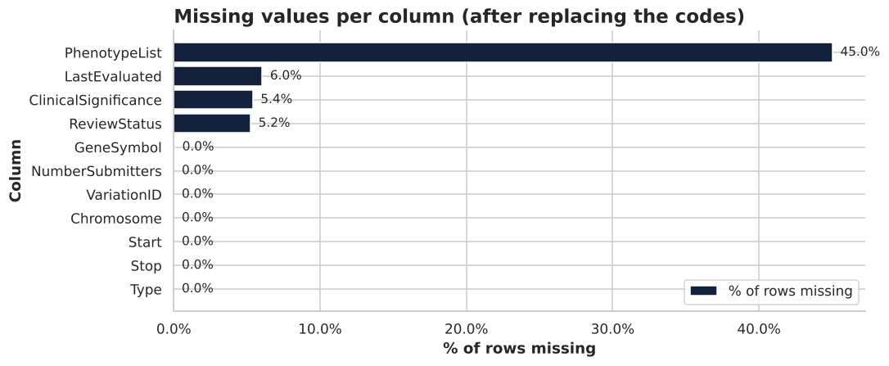
Missing values per column after replacing the codes.

2.3.1.2 Removing Outliers
Dates: 111 review dates before 1990 are impossible placeholders (ClinVar began in 2013; the oldest value was 1965-01-01). Set to missing.
NumberSubmitters: the IQR rule (fence = 1.0) would flag 22.5% of rows. These are real (popular variants get many labs), so we kept them. Not every statistical outlier is an error.
Variant length (Stop − Start + 1): most variants are 1 letter long, but some copy-number changes span up to ~159 million letters. We removed the top 0.1% (above 1.4 million letters; 4,642 rows) from the length analysis only.
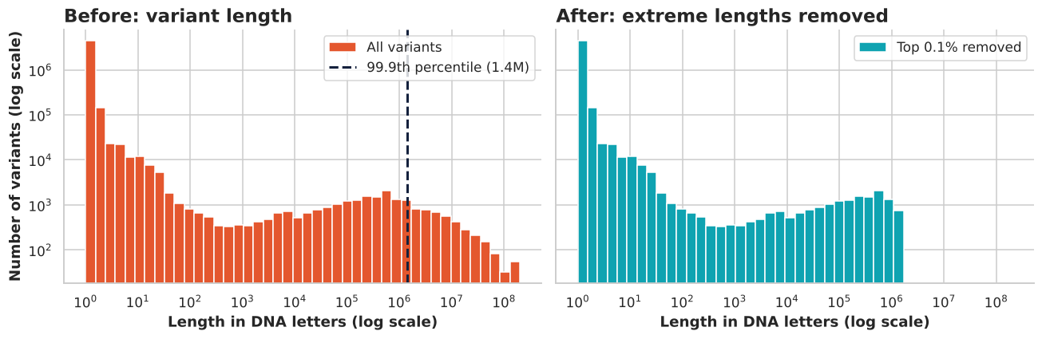
Variant length before and after removing the top 0.1% (log scales).

2.3.1.3 Converting data types if necessary
All 11 columns were loaded as text (object). We converted:
Start, Stop, NumberSubmitters → numbers (int64) with pd.to_numeric
LastEvaluated → datetime with pd.to_datetime(format="%b %d, %Y"), plus a new Year column
Type, Chromosome, labels, ReviewStatus → category (saves memory)
New columns: Group (104 label spellings → 5 groups: P/LP, VUS, B/LB, Conflicting, Other) and Stars (review-status text → ClinVar's 0–4 trust score).

2.3.2 Data Exploration

You can use df.head(), df.tail(), df.info(), df.describe(), and some other descriptive statistics functions such as df.describe()
We used df.head(), df.tail(), df.info(), df.describe() (numeric and category columns) and value_counts(). Key results:
Clean table: 4,641,203 rows × 15 columns; 4,391,047 have a germline label.
Labels: 54.6% uncertain (VUS), 32.5% benign, 8.6% pathogenic, 4.2% conflicting.
30,373 unique genes; median submitters per variant = 1 (maximum 97).

2.4 Exploratory Data Analysis (EDA)

2.4.1 Visualize Data
Note: Create at least 5 basic data visualizations such as: Line plots, bar charts, histogram. Scatter plot, Pie Chart. Be sure to give information to the visualization such as giving it a title, x and y axis labels and legends. Changing of font and color for the visualization to be more appealing will be necessary.
We made 8 charts (pie, bar, line, histogram, scatter, stacked bar). Each has a title, x/y axis labels and a legend, a custom font and size, and consistent colors: red = pathogenic, amber = uncertain, green = benign, slate = conflicting.
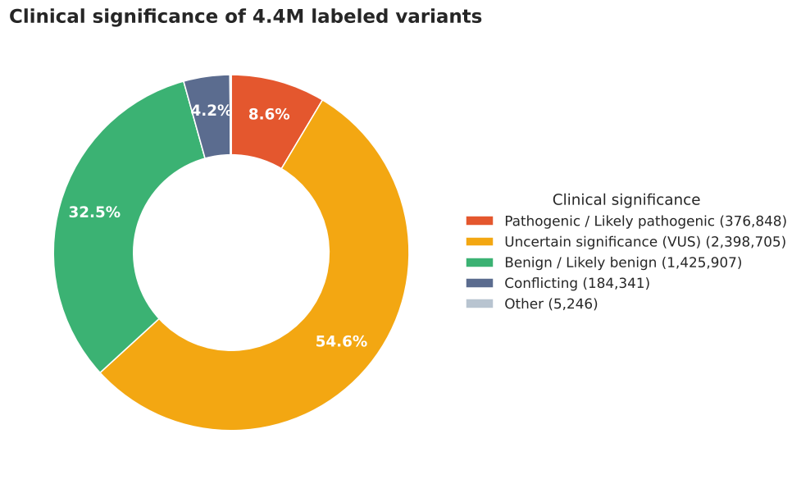
Chart 1 – Pie chart: clinical significance of labeled variants.
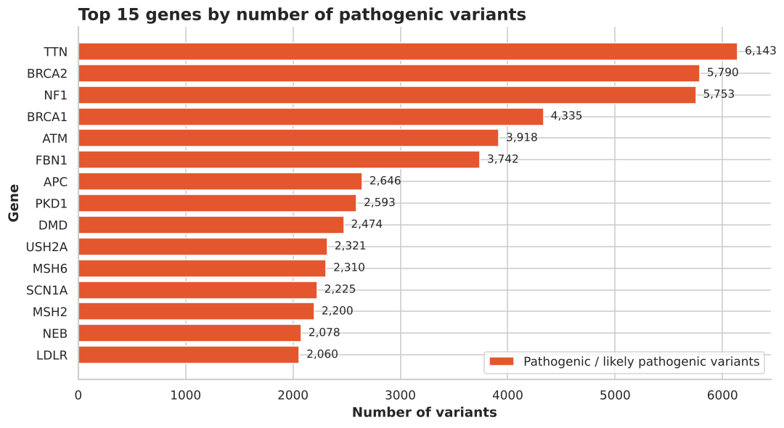
Chart 2 – Bar chart: top 15 genes by number of pathogenic variants.
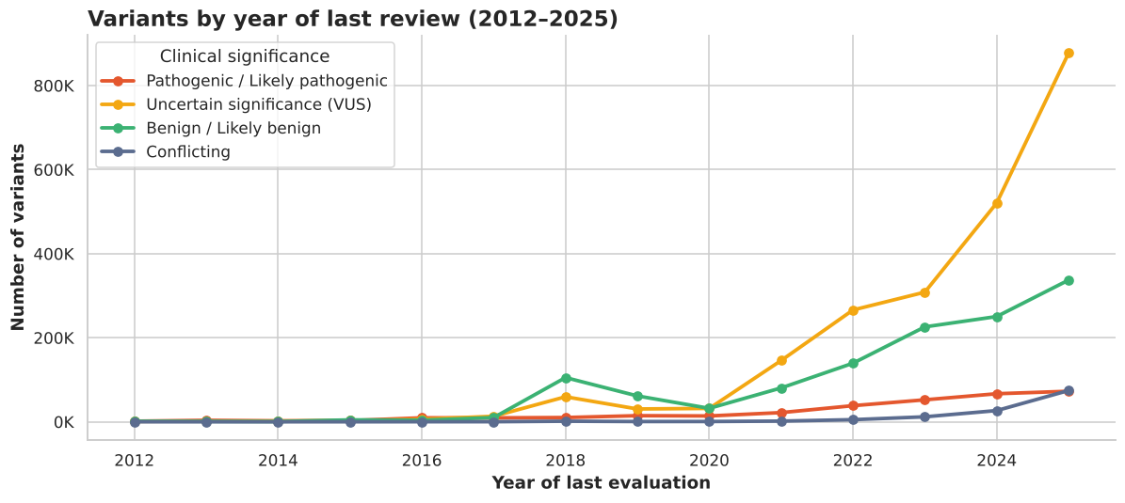
Chart 3 – Line plot: variants by year of last review, 2012–2025.
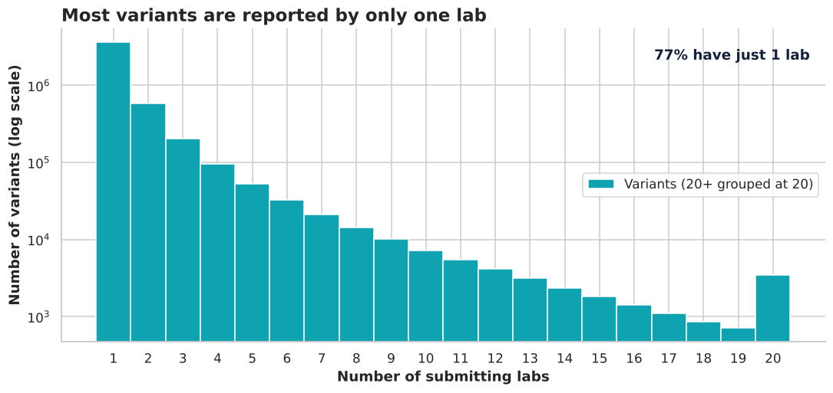
Chart 4 – Histogram: number of labs reporting each variant.
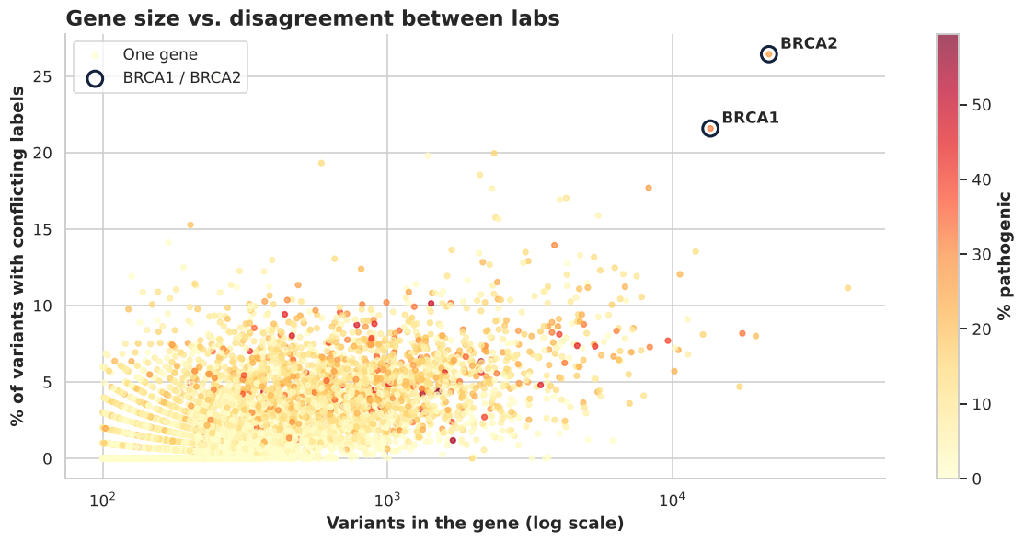
Chart 5 – Scatter plot: gene size vs. share of conflicting labels.
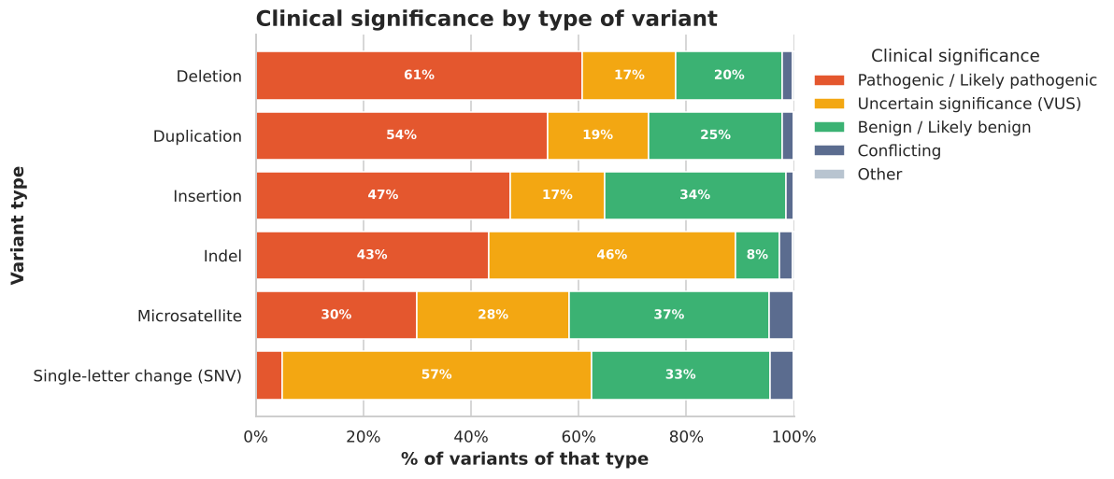
Chart 6 – Stacked bar chart: clinical significance by variant type.
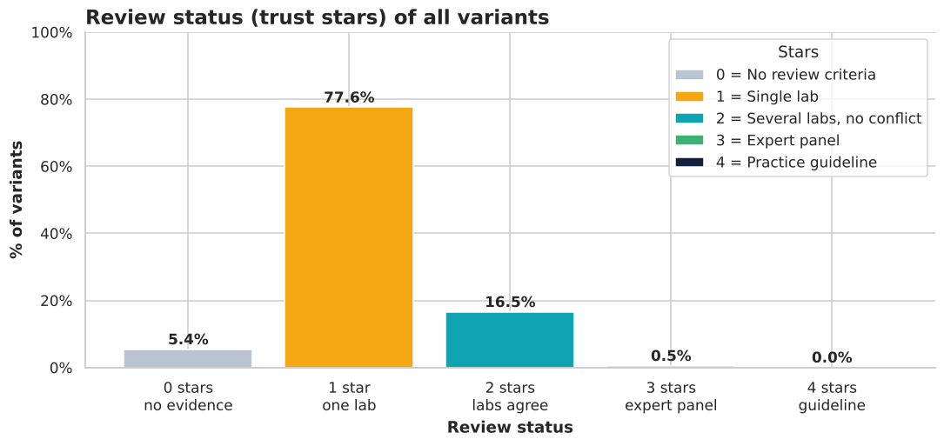
Chart 7 – Bar chart: review status (trust stars).
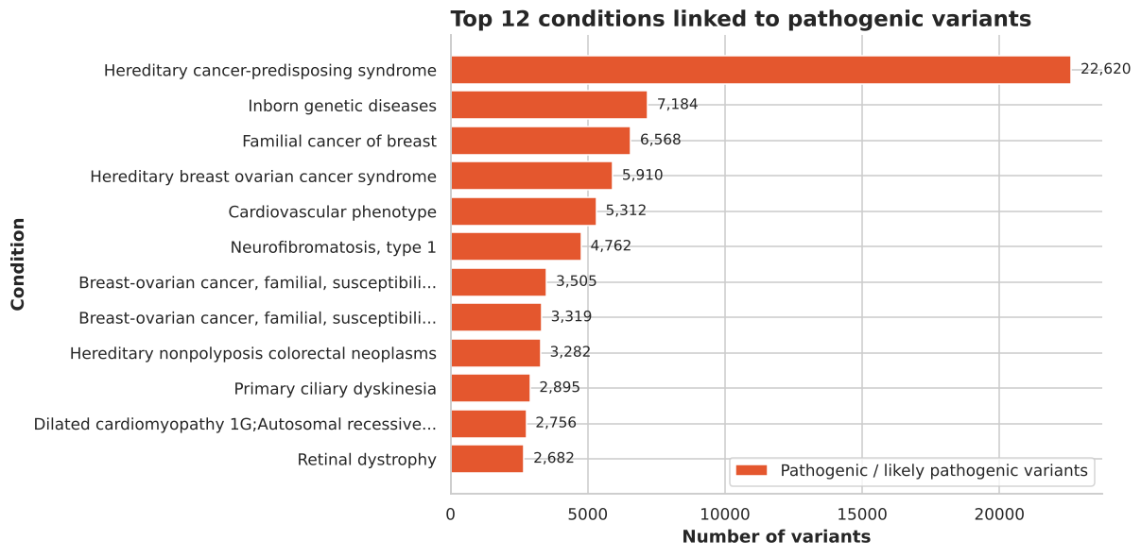
Chart 8 – Bar chart: top conditions linked to pathogenic variants.

2.4.2 Insights
What insights did you get in the exploratory data analysis process? (base your insights on your given visualization)
1. Most variants are still unknown (Chart 1). 54.6% are uncertain (VUS); only 8.6% are pathogenic. A VUS on a DNA test leaves doctors unable to say if it is dangerous.
2. A few genes dominate (Chart 2). TTN, BRCA2, NF1, BRCA1 and ATM have the most pathogenic variants. TTN is the largest human gene; BRCA1/2 are the main breast/ovarian cancer genes.
3. Uncertainty grows faster than answers (Chart 3). Reviews rose from about 33K variants (2017) to about 1.36M (2025), and the uncertain line rises far faster than the pathogenic line.
4. Most variants have no second opinion (Chart 4). About 77% are reported by only one lab.
5. Bigger genes have more disagreement (Chart 5). Across 7,288 genes the rank correlation between size and conflict rate is 0.68. BRCA2 (26%) and BRCA1 (22%) stand out.
6. Big DNA changes are easier to judge (Chart 6). Deletions are 61% pathogenic; single-letter changes are only 5% pathogenic and 57% uncertain.
7. Expert review is rare (Chart 7). 77.6% of variants have 1 star (one lab); only 0.5% were checked by an expert panel or guideline.
8. Cancer leads the conditions (Chart 8). "Hereditary cancer-predisposing syndrome" is linked to ~22,600 pathogenic variants, far ahead of the rest.
9. Cleaning was essential. Without it every count would be doubled, 104 label spellings would split the charts, and 45% of conditions hide behind "not provided".
These are patterns in a public database, not medical advice.

PART 3: PROJECT DEMONSTRATION
Present the Project in class for at most 15 minutes.

Submission Guidelines:

Submit the file as a .ipynb in MyClass

Evaluation Criteria:

Criteria | Description | Weight | Score | Weighted Score
Purpose | The application clearly achieves its intended purpose. | 5%
Error Handling | The application is error-free and handles edge cases effectively. | 5%
 |  | 20%
  Features/Functionalities
  The application is comprehensive, accurate in data exploration and analysis, and all components work correctly.
 |  | 25%
  Visualizations
  Plots and charts are insightful, well-designed, and effectively communicate information.
 |  | 25%
  Project Presentation
  The presentation is comprehensive, clear, and effectively conveys the application’s goals and outcomes.
Ability to Respond to Questions | The student demonstrates a strong understanding by effectively answering questions. | 10%
 | The application represents a significant creative accomplishment and achieves its intended purpose. | 10%
  Overall Impact

Scoring Guidance
0 = Unacceptable: Does not meet the criteria at all.
1 = Poor: Meets the criteria minimally with significant shortcomings.
2 = Fair: Partially meets the criteria with some issues.
3 = Good: Meets the criteria adequately with minor issues.
4 = Very Good: Exceeds expectations with few minor improvements needed.
5 = Excellent: Fully meets or exceeds expectations with no noticeable flaws.

Total Score Calculation
Total Weighted Score = Sum of (Score × Weight)

Final Grade:
s90-100% = Excellent
80-89% = Very Good
70-79% = Good
60-69% = Satisfactory
Below 60% = Needs Improvement

Prepared by:  DR. JOEY S. AVILES  Faculty Member, CCS | Evaluated by:  MS. MELISSA M. PANTIG, MCS  Program Chair, BSCS | Approved by:  DR. LILIBETH T. CUISON  Dean, College of Computer Studies

