**FORECAST PLOTS FOR EACH TIMESERIES DATA (0-49)**

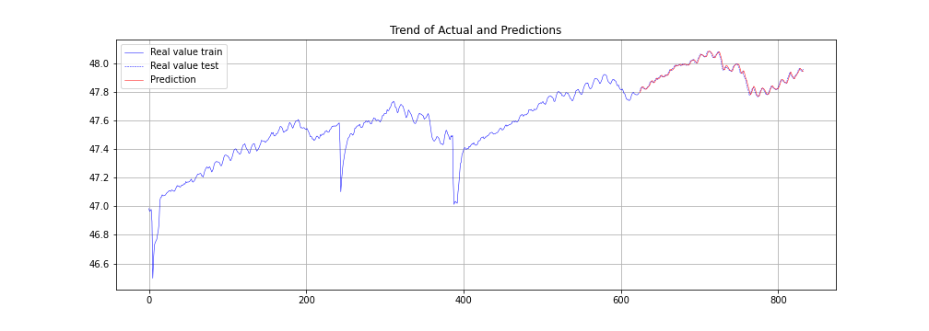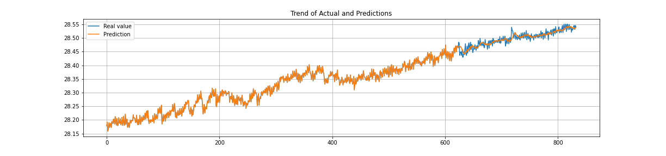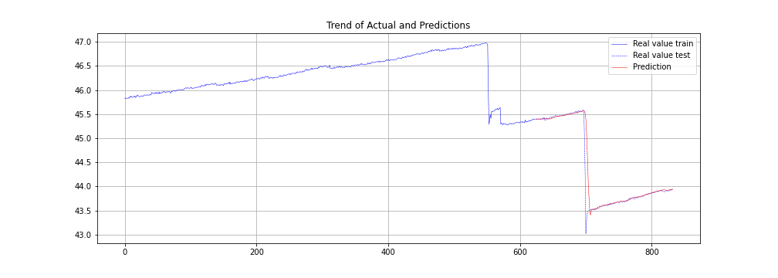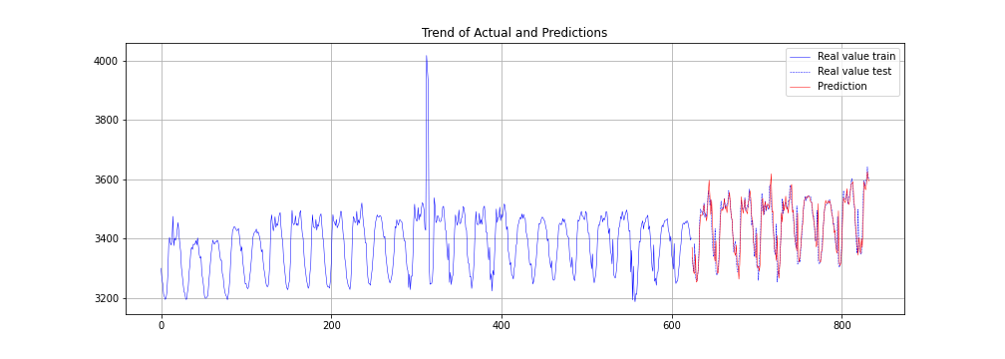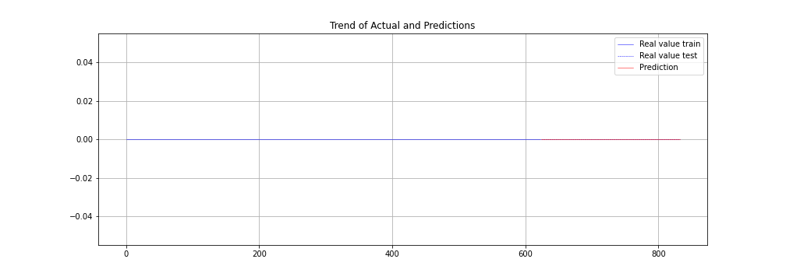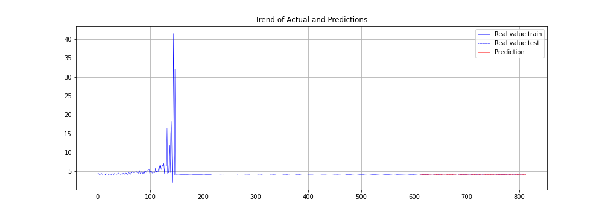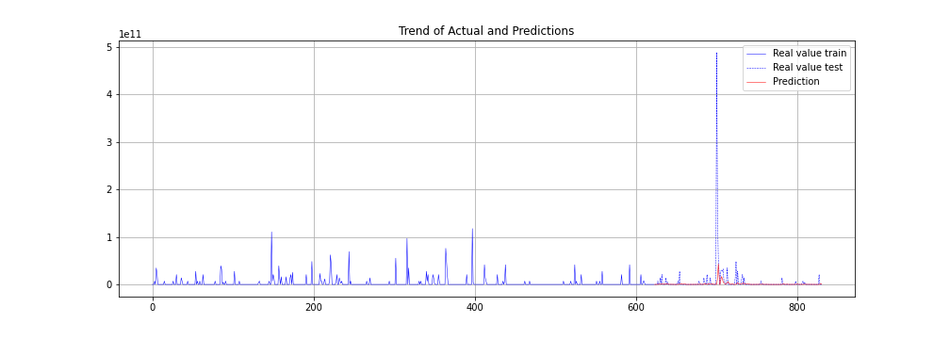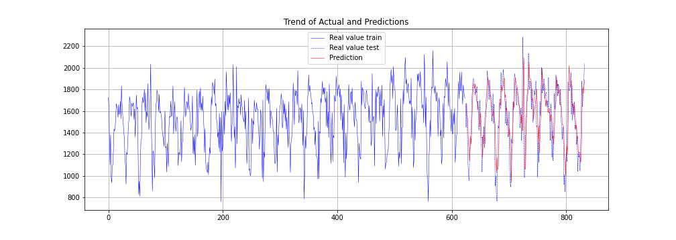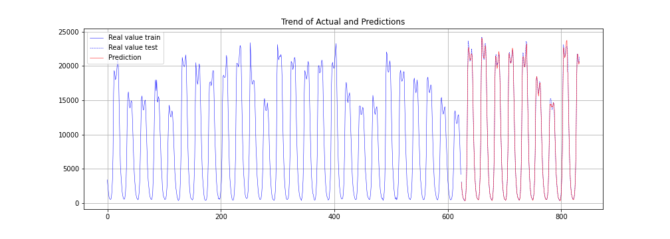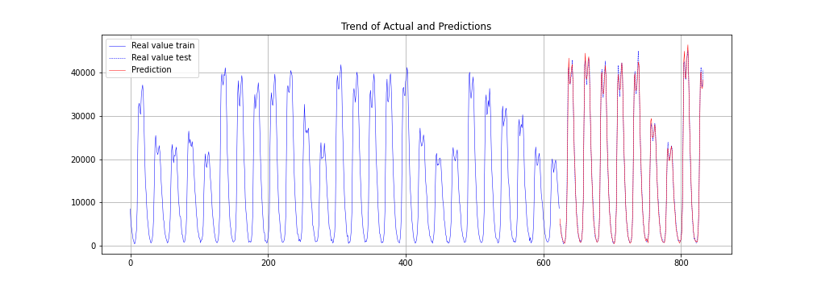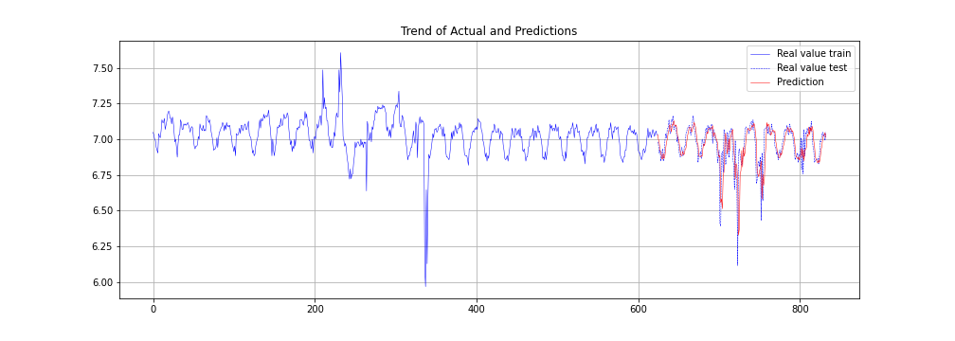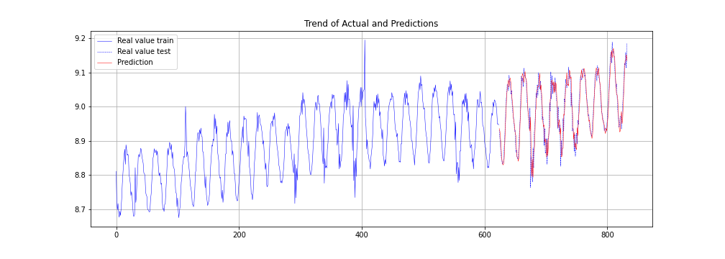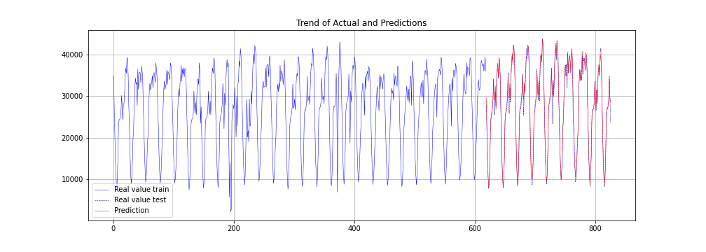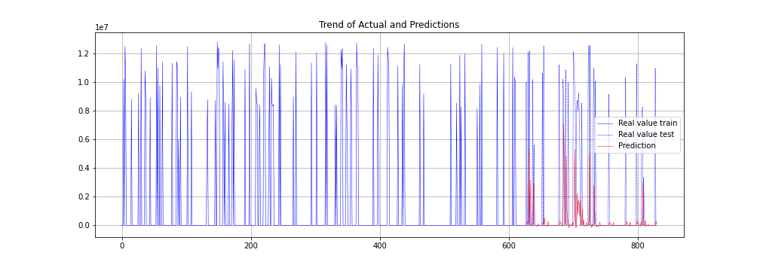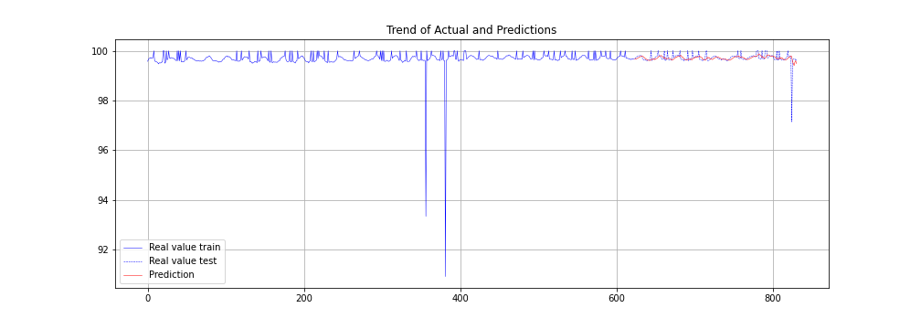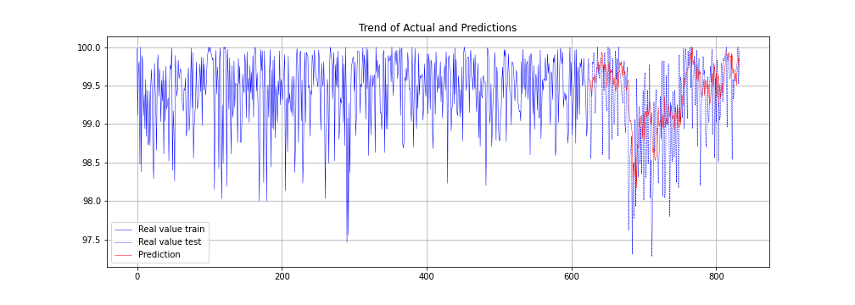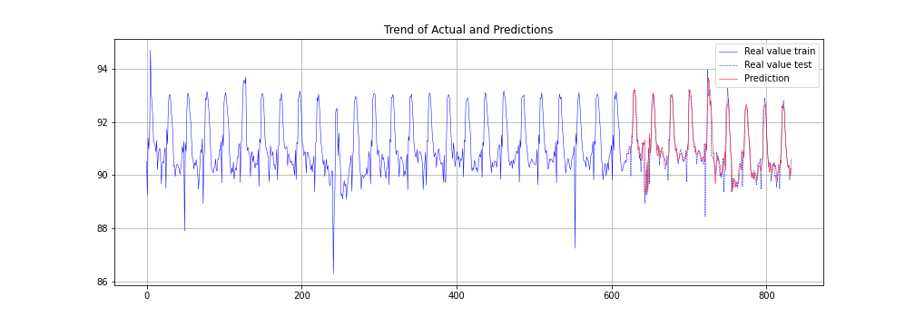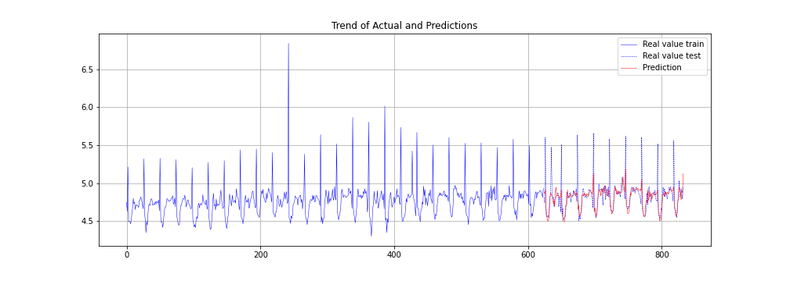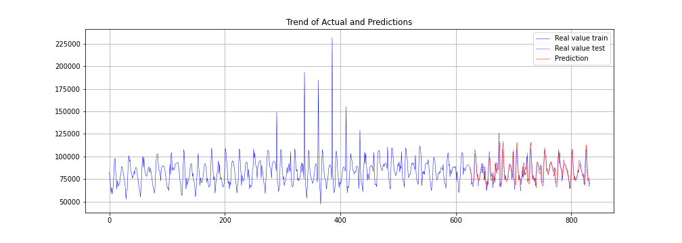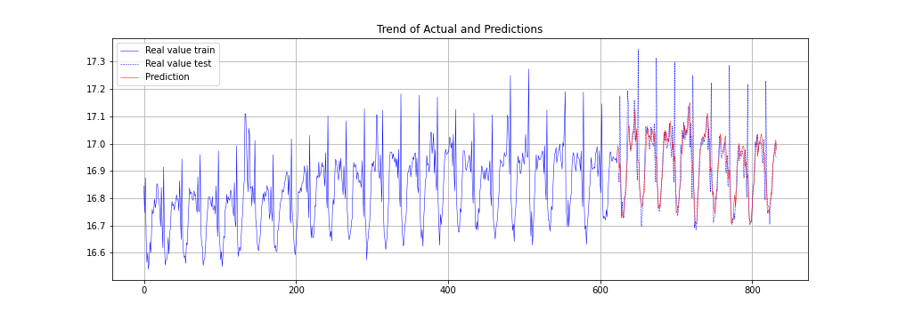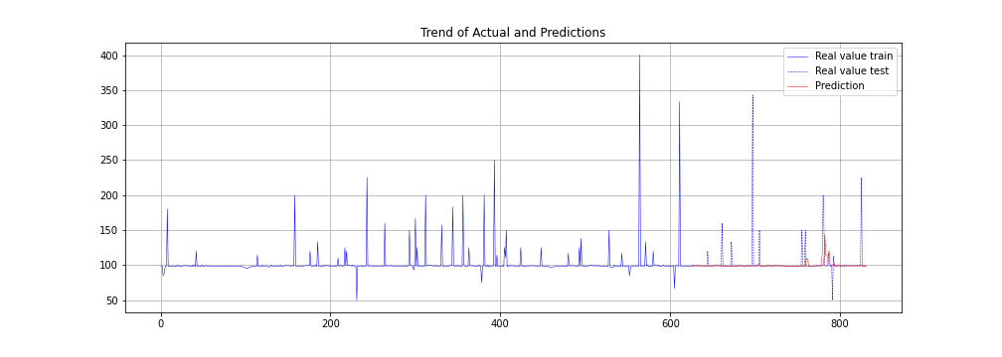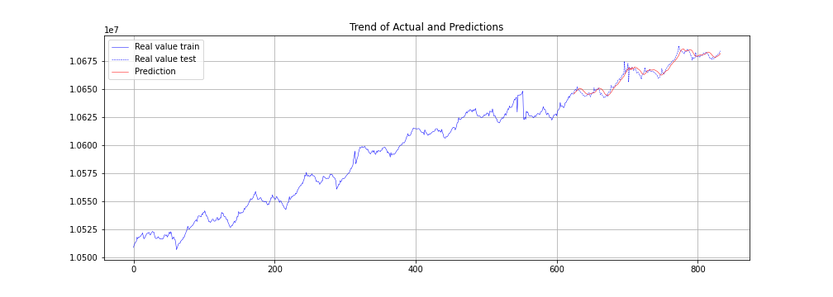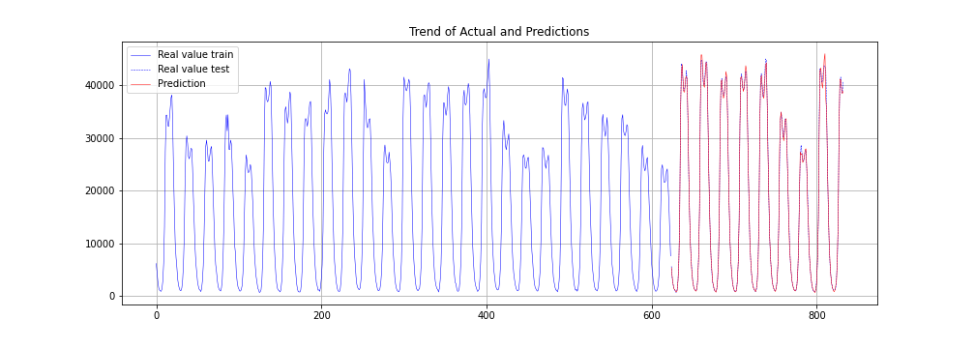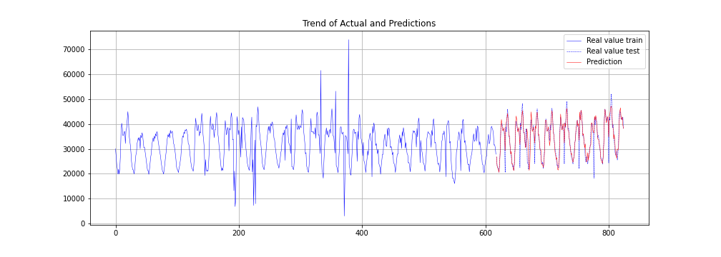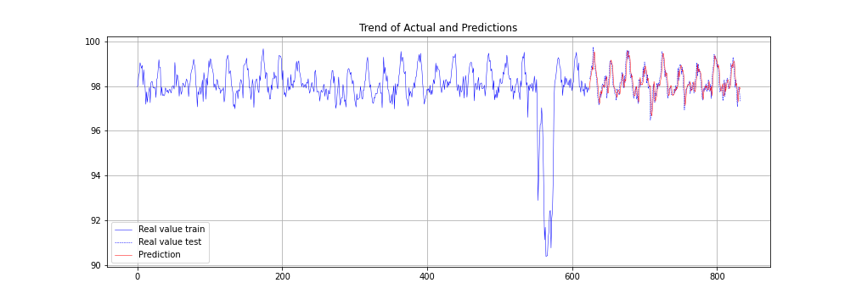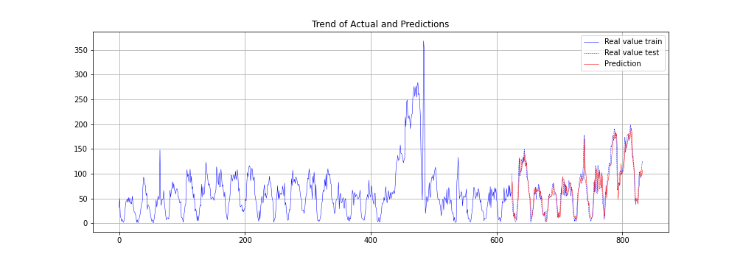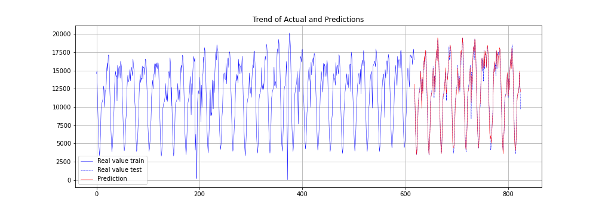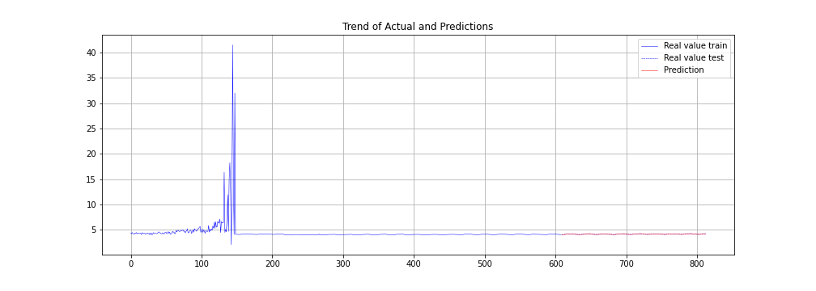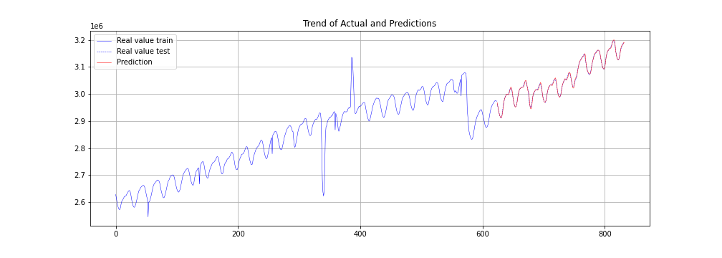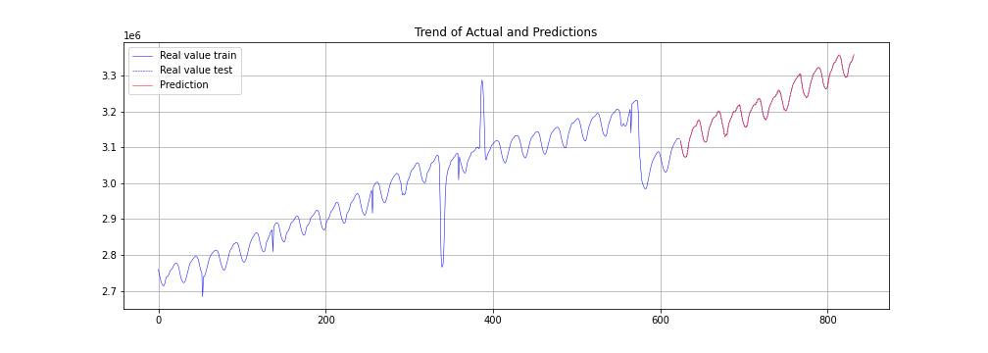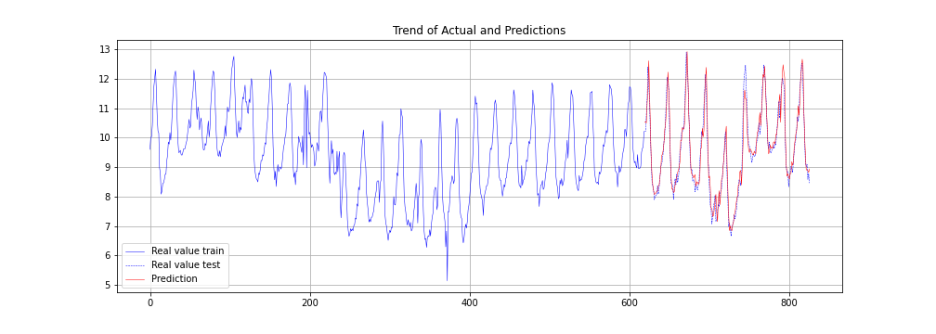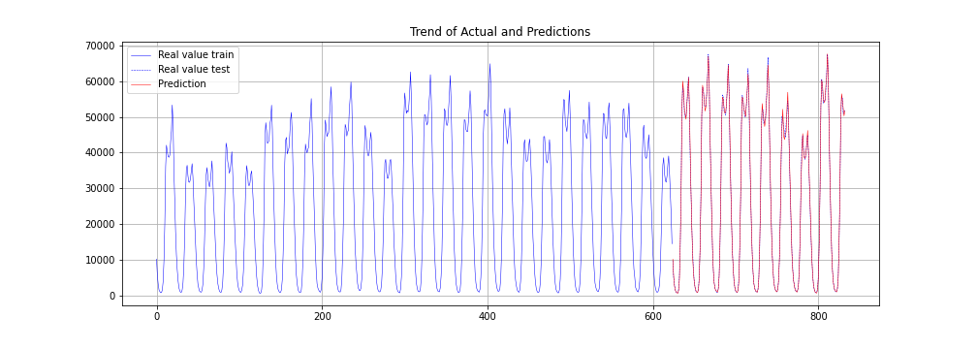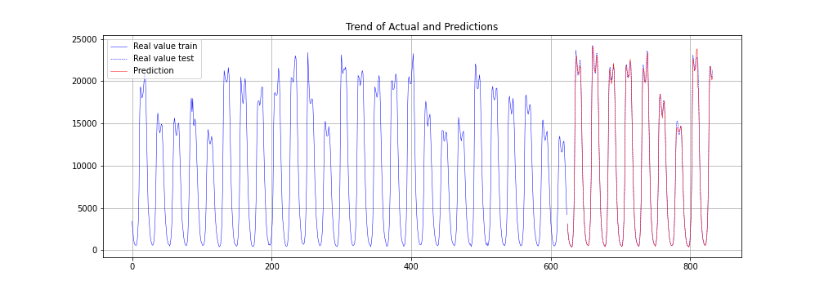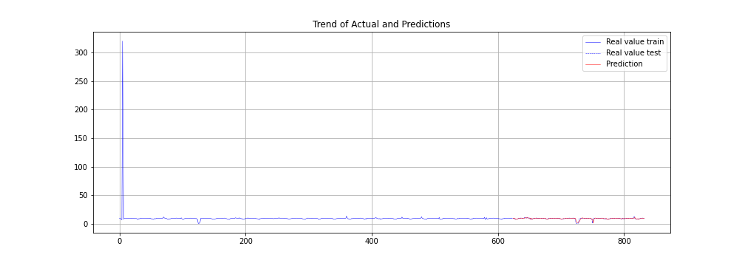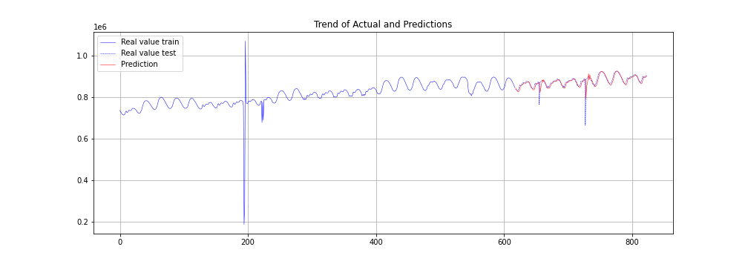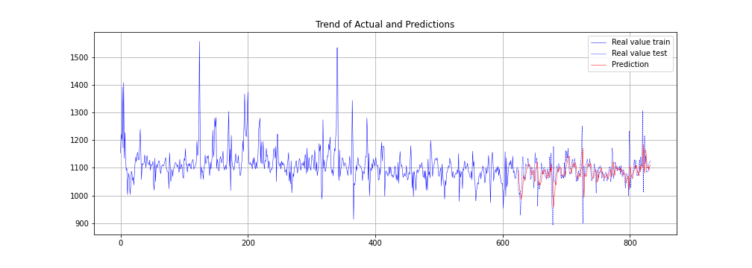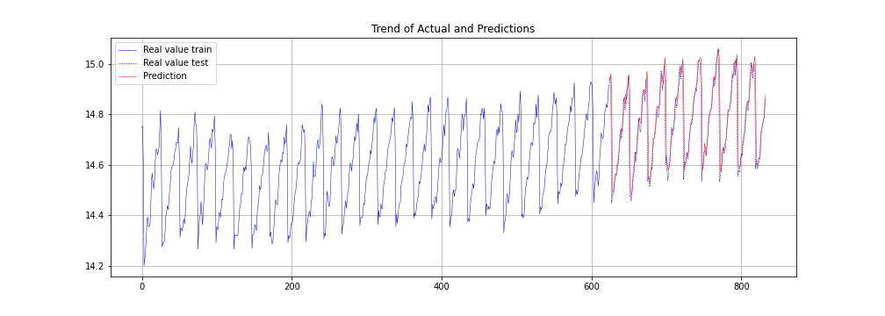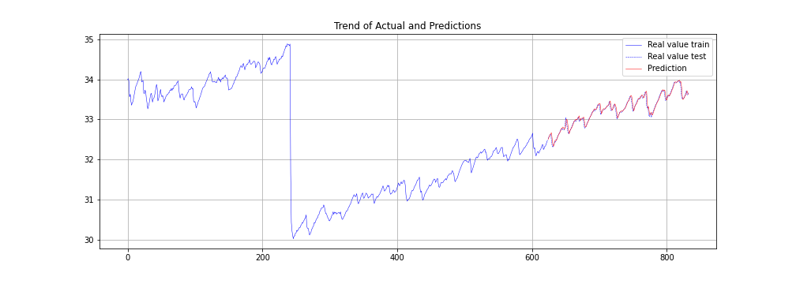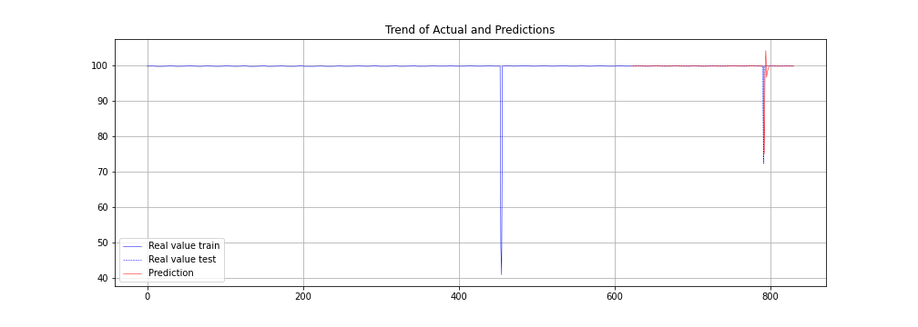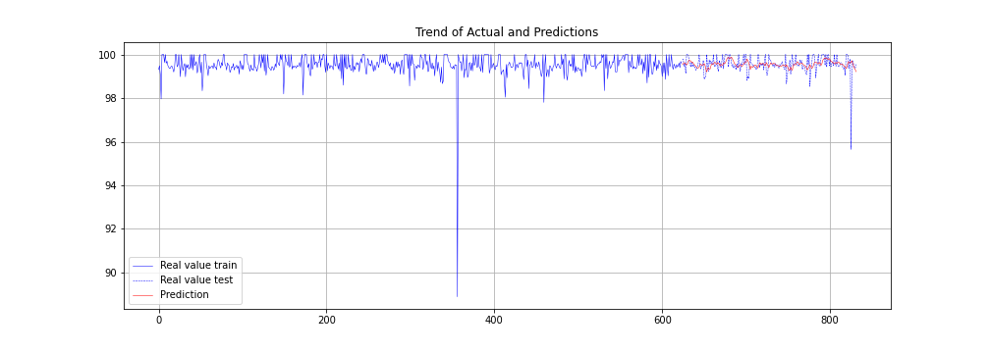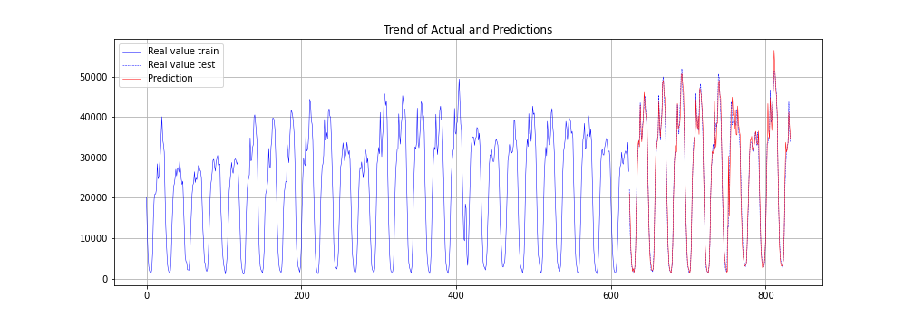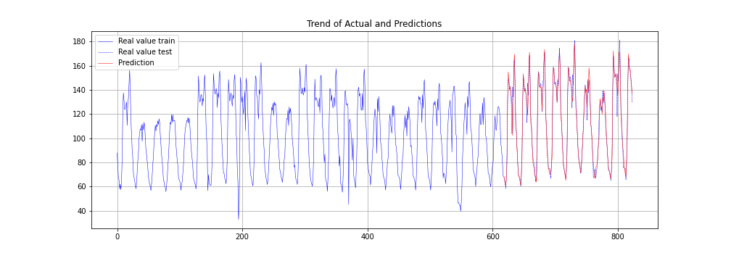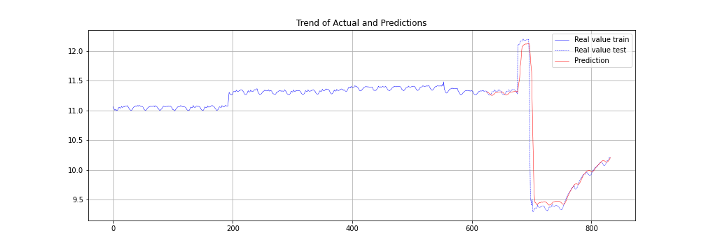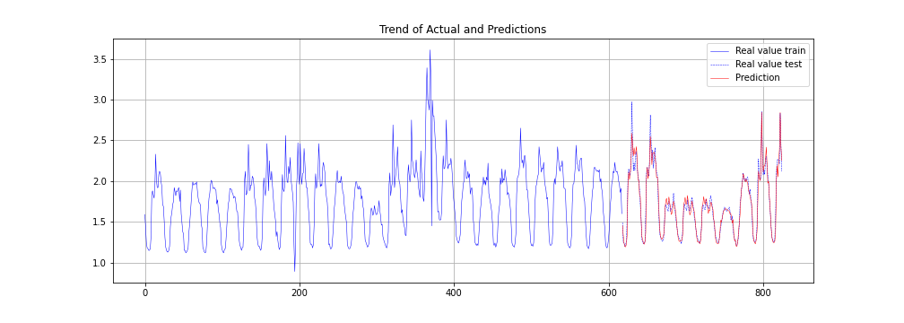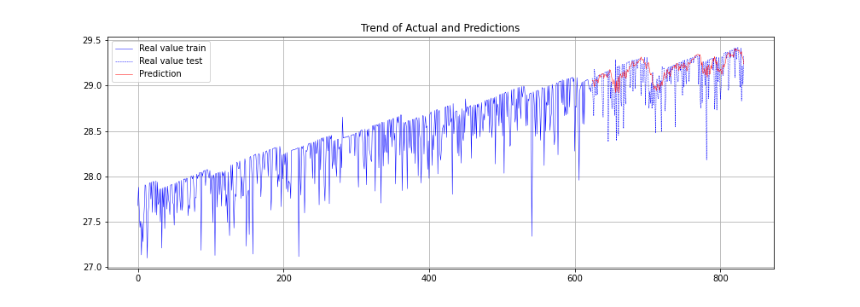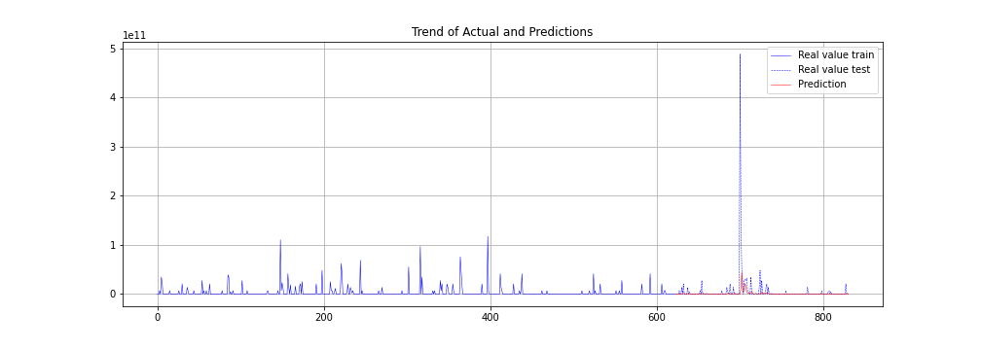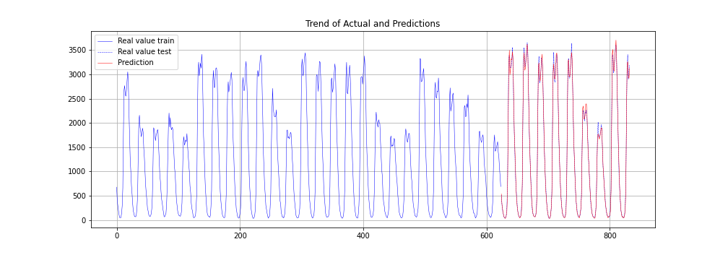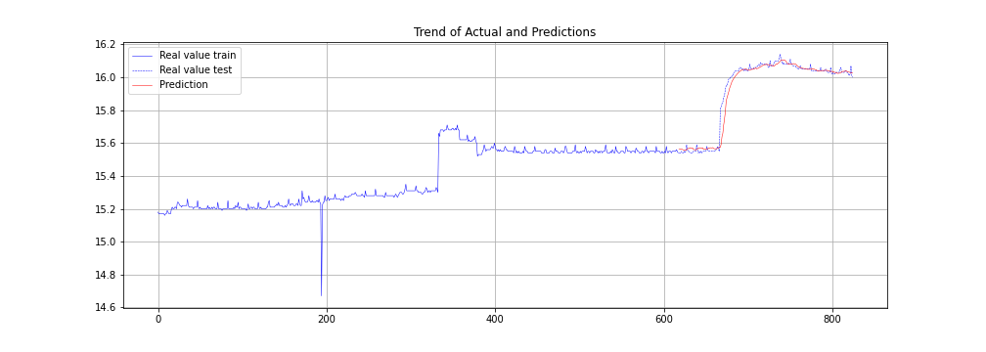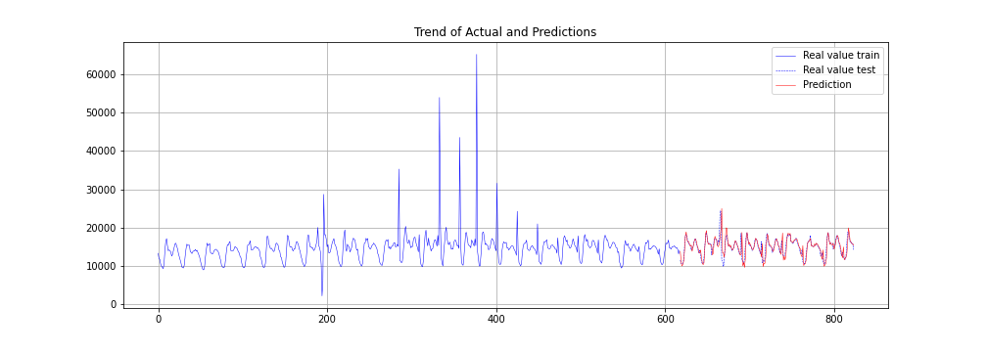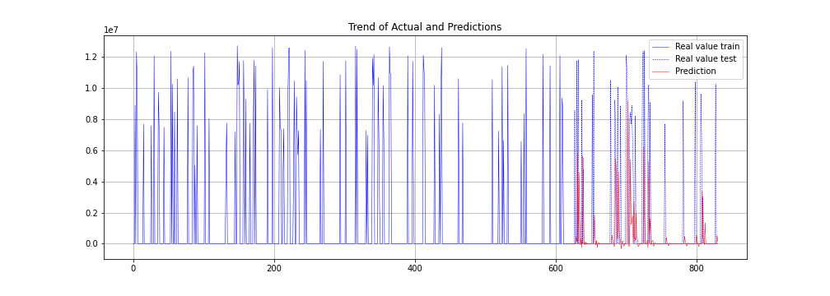

**SCORE TABLE FOR EACH DATAFILE(0-49)**

|  |  |  |  |  |
| --- | --- | --- | --- | --- |
| Sno. | Mae | mse | rmse | mape |
| 0 | 0.00959 | 0.000151 | 0.012292 | 0.020013 |
| 1 | 0.010154 | 0.000156 | 0.012475 | 0.035633 |
| 2 | 0.055815 | 0.067119 | 0.259073 | 0.127757 |
| 3 | 27.3482 | 1978.104 | 44.47588 | 0.79791 |
| 4 | 0 | 0 | 0 | 0 |
| 5 | 0.015047 | 0.000423 | 0.020556 | 0.359561 |
| 6 | 5.6E+09 | 1.29E+21 | 3.59E+10 | 38980816 |
| 7 | 148.6449 | 42232.02 | 205.5043 | 10.69871 |
| 8 | 279.6553 | 203602.2 | 451.223 | 5.478514 |
| 9 | 732.0327 | 1149656 | 1072.22 | 10.84537 |
| 10 | 0.078259 | 0.015456 | 0.124321 | 1.138162 |
| 11 | 0.025426 | 0.001197 | 0.034599 | 0.283182 |
| 12 | 815.2981 | 1644913 | 1282.542 | 3.20051 |
| 13 | 1746033 | 1.57E+13 | 3957316 | 5787825 |
| 14 | 0.0941 | 0.046751 | 0.21622 | 0.094625 |
| 15 | 0.413506 | 0.307578 | 0.554597 | 0.418137 |
| 16 | 0.311476 | 0.235638 | 0.485425 | 0.343557 |
| 17 | 0.084188 | 0.024115 | 0.155291 | 1.671114 |
| 18 | 6068.432 | 83426450 | 9133.808 | 7.273196 |
| 19 | 0.053344 | 0.007868 | 0.088701 | 0.313523 |
| 20 | 5.189277 | 515.0099 | 22.69383 | 3.519714 |
| 21 | 2283.675 | 8877280 | 2979.477 | 0.021413 |
| 22 | 467.4463 | 591857.9 | 769.323 | 4.284516 |
| 23 | 1704.848 | 8682367 | 2946.586 | 5.811403 |
| 24 | 0.317228 | 0.159847 | 0.399809 | 0.323242 |
| 25 | 14.59145 | 380.829 | 19.51484 | 37.79413 |
| 26 | 402.3704 | 366242.3 | 605.1796 | 3.814001 |
| 27 | 0.014892 | 0.000419 | 0.020474 | 0.35586 |
| 28 | 3117.889 | 18059842 | 4249.688 | 0.102169 |
| 29 | 2862.275 | 14176960 | 3765.231 | 0.088954 |
| 30 | 0.263711 | 0.124556 | 0.352924 | 2.727055 |
| 31 | 616.4436 | 819256.3 | 905.1278 | 4.110164 |
| 32 | 278.2714 | 206151.6 | 454.0393 | 5.399682 |
| 33 | 0.560329 | 1.251221 | 1.11858 | 11.61635 |
| 34 | 8629.288 | 4.27E+08 | 20666.23 | 1.032198 |
| 35 | 32.39646 | 2688.276 | 51.84858 | 2.987091 |
| 36 | 0.039842 | 0.008068 | 0.08982 | 0.271306 |
| 37 | 0.041732 | 0.00438 | 0.06618 | 0.125678 |
| 38 | 0.333017 | 6.793387 | 2.606412 | 0.383845 |
| 39 | 0.256678 | 0.176019 | 0.419547 | 0.258553 |
| 40 | 1511.864 | 6187256 | 2487.419 | 9.601218 |
| 41 | 4.092912 | 42.40166 | 6.511655 | 3.704571 |
| 42 | 0.119817 | 0.125673 | 0.354504 | 1.190325 |
| 43 | 0.054026 | 0.005956 | 0.077176 | 3.024596 |
| 44 | 0.155955 | 0.052798 | 0.229778 | 0.539668 |
| 45 | 5.61E+09 | 1.29E+21 | 3.59E+10 | 3329299 |
| 46 | 59.51254 | 6907.899 | 83.11377 | 8.648508 |
| 47 | 0.020616 | 0.001622 | 0.040278 | 0.129823 |
| 48 | 922.4132 | 3068208 | 1751.63 | 6.616706 |
| 49 | 1651960 | 1.38E+13 | 3711675 | 1269120 |