Man Utd and Ivan Perisic hopeful of completing transfer before Inter leave for tour of China

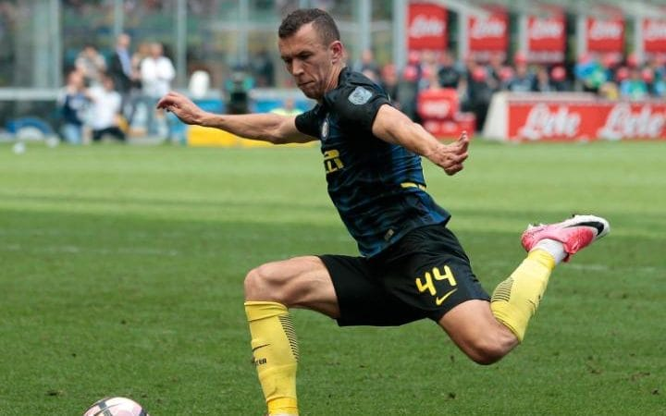Ivan Perisic looks to be heading to Old Trafford  CREDIT: GETTY IMAGES

Ivan Perisic hopes to be omitted from Inter Milan’s tour party as Manchester United scramble to wrap up [a £44 million deal for the unsettled Croatia winger](http://www.telegraph.co.uk/football/2017/07/14/inter-milan-eye-anthony-martial-loan-move-package-would-see/) before the Italian club fly to China on Tuesday afternoon.

Inter’s squad are due to report at the club’s Appiano Gentile training base on Tuesday morning ahead of a mid-afternoon flight from Milan’s Malpensa airport to Nanjing for the start of their pre-season tour of China.

Perisic was due back in Milan on Monday after returning to Croatia for treatment on a tooth abscess that had forced him to leave Inter’s pre-season training camp in Riscone di Brunico a day early last week. But he hopes to be excused from Tuesday's flight in order to join United’s tour of the US and undergo a medical there.

United are expected to pay an initial £39.5 million for Perisic with the fee rising to £44 million with add-ons. Inter are close to signing Senegal forward Keita Balde from Lazio as a replacement for Perisic, who cut a glum, detached figure on a picture with Inter’s squad last week as he pushes hard to secure a transfer to Old Trafford.

Perisic posted and subsequently deleted a message on Instagram on Monday with a praying emoji next to a plane taking off, a thinly veiled reference to his hopes of skipping Inter’s flight to China. Ed Woodward, United’s executive vice-chairman, is still in London as he oversees negotiations. United were due to play Real Salt Lake in the early hours of Tuesday and face Manchester City in Houston on Friday.

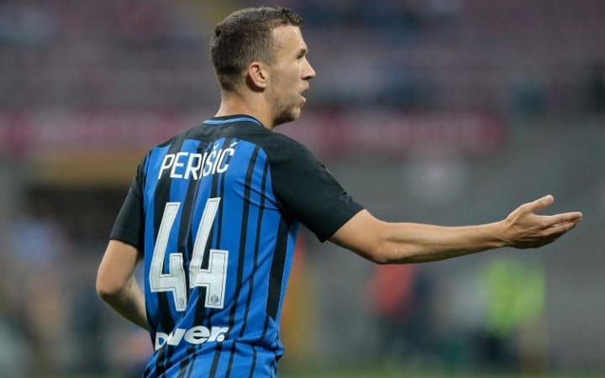

Perisic in action for Inter last season

United manager Jose Mourinho wants Perisic in as soon as possible and also hopes to sign a defensive midfielder, with [Chelsea’s Nemanja Matic a target](http://www.telegraph.co.uk/football/2017/07/14/jose-mourinho-refuses-rule-outnemanja-matic-move-andzlatan-ibrahimovic/).

Tottenham have been playing hard ball over Eric Dier and Roma are reluctant to sell Radja Nainggolan. Perisic would become United’s third summer signing after Victor Lindelof and Romelu Lukaku and take their spending to almost £165 million.

Although there is a possibility of[Zlatan Ibrahimovic signing a new deal with United](http://www.telegraph.co.uk/football/2017/07/12/football-transfer-news-rumours-zlatan-ibrahimovic-sign-new-man/) and being available again from Christmas after a cruciate knee ligament injury, Mourinho is desperate to bolster his attack in the short-term following the departures of the Swedish striker and Wayne Rooney.

Mourinho has hinted at continuing interest in Real Madrid striker, Alvaro Morata, despite senior club sources claiming negotiations for the Spaniard ended when they signed Lukaku. The United manager also mentioned the name of Arsenal forward, Alexis Sanchez, unprompted on Sunday but if the club do want the Chilean and plan to challenge Manchester City for his signature they have kept their interest well hidden.

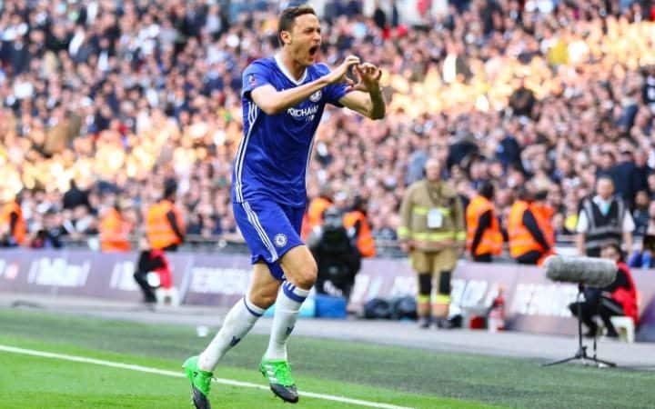

Nemanja Matic remains a Manchester United target

Rooney ended his 13-year stay at United when he re-signed for boyhood club Everton last week. But an offer remains on the table for England striker to become a United ambassador once he retires from playing.

United announced when Rooney signed his last contract in February 2014 that he will “become a club ambassador when he retires from the game” and they remain keen for that to happen, despite the 31-year-old opting to return to Everton.

Although the ambassadorial role is not a contractual right, Woodward has a close relationship with Rooney and United have left the door open for him. That would be despite Everton remaining the first love of Rooney, who admitted upon his unveiling at Goodison Park last week that he secretly wore Everton pyjamas at home throughout his time at Old Trafford.

Rooney also claimed he knew his United career was over last November and questioned whether he deserved to lift the League Cup and Europa League after only feeling a bit part of the playing squad.

출처 : http://www.telegraph.co.uk/football/2017/07/17/man-utd-ivan-perisic-hopeful-completing-transfer-inter-leave/