Antonio Conte signs new two-year £19.2m Chelsea deal but does not extend his contract

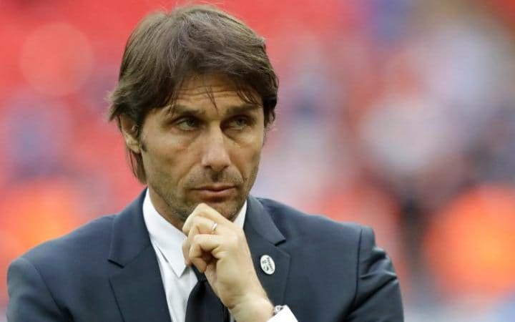Antonio Conte had a very successful first season at Chelsea CREDIT: AP

[Antonio Conte](http://www.telegraph.co.uk/football/2017/07/10/diego-costa-has-chelsea-door-closed-behind-antonio-conte-rules/) has eased doubt about his immediate Chelsea future but still raised fresh questions about his longer-term status after agreeing on Tuesday to improve but not extend his contract.

Although both Chelsea and Conte conveyed their delight at an enhanced new deal that is believed to be worth £19.2 million until 2019, the previous expectation of a more lengthy commitment, potentially until 2021, has not been realised.

Conte had indicated in May that he wanted to “extend” his contract for many years but he has been frustrated this summer by the club’s failure to sign Romelu Lukaku, while his handling of Diego Costa’s future has also caused tension. [Conte informed Costa by text message that he was not in his plans](http://www.telegraph.co.uk/football/2017/06/08/antonio-contes-decision-dump-diego-costa-text-threatens-cost/).

Even so, the pay rise does still represent a reward for Conte’s achievement in winning the Premier League in his first season in England and arrives ahead of the club’s pre-season tour to Asia and [fixtures against Arsenal](http://www.telegraph.co.uk/football/2016/09/24/arsenal-vs-chelsea---live/), Bayern Munich and Inter Milan.

Chelsea also announced on Tuesday that they would be appointing two of Conte’s compatriots to his coaching team. Paolo Vanoli will join as first team assistant and Davide Mazzotta will also work as an assistant with particular responsibility for player analysis. Conte used Mazzotta as his opposition scout for the Italian national team during Euro 2016 and the 47-year-old has also worked as an Under-17s coach at Lecce. The backroom appointments follow the departure of Steve Holland to become assistant to England manager Gareth Southgate.

“I am very happy to have signed a new contract with Chelsea,” said Conte. “We worked extremely hard in our first year to achieve something amazing, which I am very proud of. Now we must work even harder to stay at the top.  The Chelsea fans have given me so much support since I arrived here one year ago and it is important we continue to succeed together.”

Club director Marina Granovskaia described Conte’s achievement last season at “incredible” but also stressed the importance next season of the club’s return to the Champions League. “This new contract reflects our belief that he can continue to deliver results both domestically and as we return to European competition in the Champions League,” said Granovskaia. Chelsea have so far signed midfielder Tiemoue Bakayoko from French champions Monaco for £40 million and also bought defender Antonio Rudiger from Roma for £29 million.

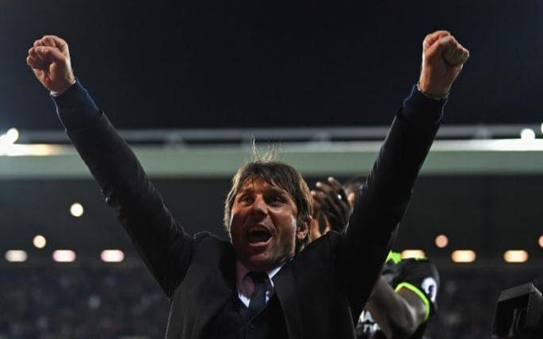

Conte celebrates winning the Premier League title

Conte has also signalled the departure of key players, with Costa and midfielder Nemanja Matic both absent from the squad that has travelled to Asia. Since missing out on Lukaku, Chelsea have made enquiries regarding Alvaro Morata, Andrea Belotti and Pierre-Emerick Aubameyang, while Alexis Sanchez has not been fully discounted – despite Arsenal’s public insistence he will not be sold.

Conte steered Chelsea to a club record 13 consecutive league victories en route to a Premier League record 30 wins in a season that also culminated in [an FA Cup final defeat against Arsenal](http://www.telegraph.co.uk/football/2017/07/18/arsene-wenger-promises-arsenal-will-not-sell-alexis-sanchez/). The two clubs meet in the Community Shield on Aug 6.

출처 : http://www.telegraph.co.uk/football/2017/07/18/antonio-conte-signs-new-two-year-deal-chelsea/