What Muslim women want in the bedroom - and why a halal sex manual is a good thing

The mystery of the female orgasm has a long and tumultuous history

This week, a new book entitled [The Muslimah Sex Manual: A Halal Guide to Mind Blowing Sex](https://www.amazon.com/Muslimah-Sex-Manual-Halal-Blowing-ebook/dp/B071X4GPLK) shocked the British media, with candid advice on everything from kissing to the cowgirl position.

Just like women all around the world, Muslim women have sex, too. Who knew? Yet it seems some Muslims are shocked when it's talked about openly, too.

The book's author, who writes under the pen name Umm Muladhat but has chosen to remain anonymous, has been credited with writing the first ever halal sex manual for women. Some have gone further, claiming she is the Muslim answer to Belle De Jour.

If there's one thing that Muslims can certainly claim they've mastered, it's procreation. After all, the world's youngest demographic is Muslim and this is also the fastest growing segment due to birth rates. So you can do the maths, right?

Of course, the deed, and [the enjoyment of the deed](http://www.telegraph.co.uk/women/sex/7-books-will-transform-sex-life/) are two separate matters. And as women, don’t we know it?



Author Shelina Janmohamed thinks all women are in need of sexual guidance  CREDIT:SHELINA JANMOHAMED/SHELINA JANMOHAMED

The mystery of the female orgasm has a long and tumultuous history, varying from the thirteenth century idea that it was required for procreation, via Victorian prudery when us women were supposed to lie back and think of England during a patriotic act of supposedly miserable sacrifice, through to the re-discovery of female pleasure in the 1960’s and onto the ground breaking series *Sex and City,* which revealed that, gosh, women sit and talk about sex too. And even like it.

The history of sex, pleasure and women’s enjoyment follow a similar pattern in many Muslim cultures. At the time of the Prophet Muhammad, sex and sexual pleasure were openly talked about and considered part of a fulfilling marital life. In fact, a woman can divorce her husband if he doesn’t have sex with her for a certain period as he’s not fulfilling her rights. Many famous Muslim thinkers have written detailed books on the physical and spiritual delights of sex for both men and women.

At the time of the Prophet Muhammad, sex and sexual pleasure were openly considered part of a fulfilling marital life. In fact, a woman can divorce her husband if he doesn’t have sex with her for a certain period as he’s not fulfilling her rightsShelina Janmohamed

It’s why practices like FGM – which claim to control women’s sexuality – are not just physically abhorrent, but against the very spirit of Islamic attitudes to sex. Sex is something to be celebrated and enjoyed by both men and women. In fact, the coy attitudes to physical pleasure are very much rejected in Islamic teachings.

And yet sex specifically, and women’s bodies more generally, have become a taboo in many Muslim circles. Why has this feeling of dirtiness, shame and policing of one of the great human delights extolled in Islamic traditions taken hold?

It is a good question to ask. It might be to do with a suppression of women’s rights and voices and a heartbreaking denial of human value. Some argue that it is South Asian culture that has seeped into Muslim thinking and claimed the mantle of religious teachings. It may be, as some have argued, an absorption of European colonial attitudes which saw sex as dirty and something to create guilt.

There’s no notion of original sin in Islam, or that women are inherently evil temptresses. It’s worth remembering that European colonialists were shocked when they arrived in the Muslim world, seeing the women as exotic and even depraved because sex was a much more open topic.

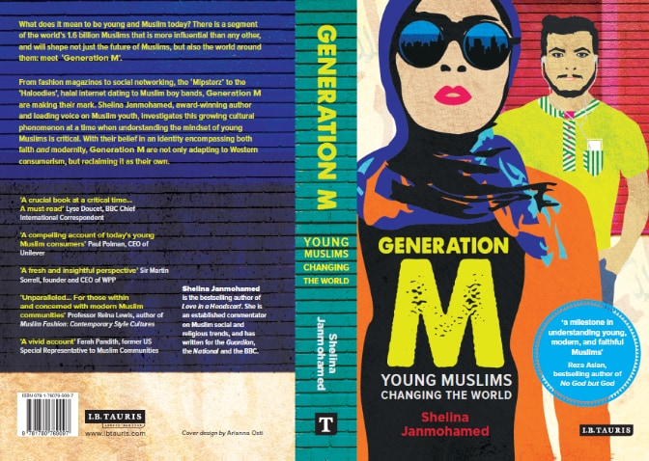

Shelina Janmohamed's Generation M: Young Muslims Changing the World CREDIT:SHELINA JANMOHAMED/SHELINA JANMOHAMED

Whatever the reason for today’s attitudes in some circles, which seek to deny women’s right to sexual delight, it needs to change. Every woman has an absolute right to sexual pleasure, and this goes for Muslim women too.

Sometimes, sex is simply not talked about because it is considered ‘dirty’ or something that a ‘nice’ Muslim woman doesn’t do. All entirely erroneous of course. But it can leave Muslim women lacking in awareness, knowledge and confidence in the bedroom. Or worse, it can leave them vulnerable to acts that they don’t want to participate in, or lacking in confidence to speak up for what they do want.

*The Muslimah Sex Manual: A Halal Guide to Mind Blowing Sex* is therefore a welcome step to busting myths and giving Muslim women confidence. If Muslim women are not enjoying their full sexual potential, then any guide that can help them to maximise their pleasure must be something to be welcomed.

It makes a difference to[today’s young Muslim women](http://www.telegraph.co.uk/women/life/welcome-to-generation-m-muslim-women-are-set-to-define-our-globa/) that it’s written for a contemporary audience, using today’s lingua franca when it comes to sex.

Why has this feeling of dirtiness, shame and policing of one of the great human delights extolled in Islamic traditions taken hold?Shelina Janmohamed

The intersectionality of culture, being a minority and having a British Muslim woman author, especially in a time of rising Islamophobia and also blatant misogyny makes such an intervention powerful.

Psychosexual disorders among women are rising generally, so all support is much needed.

In particular, the perspective of Islamic teachings and the open attitude to sex can be liberating for women, and offer confidence in engaging with their sexual partner.

We shouldn’t make the mistake of belittling Muslim women’s aspirations for better sex. All women are still striving to figure this out, and be confident in it. Women’s magazines and their alluring headlines (“ten ways to achieve pleasure” or “how to help him reach your G-spot”) continue to attract generation after generation of women.

Yet hand in hand with this, we women continue to grapple with owning our own sexuality on our own terms and having the confidence to enjoy it as we choose, in the face of homogenous ideas of sexuality, pornification and uncertain ideas of what should really be going on in our bedrooms.

Perhaps my favourite part of the whole 'Shock: Muslim women are also in need of sexual guidance!' is the response the book’s author says she’s received from men. They want a book to help them to pleasure their wives. As women, I think we can all say amen to that.

*Shelina Janmohamed is the author of*[*“Generation M: Young Muslims Changing the World”*](https://www.amazon.co.uk/Generation-Young-Muslims-Changing-World/dp/1780769091)

출처 : http://www.telegraph.co.uk/women/sex/muslim-women-want-bedroom-first-halal-sex-manual-ladies-powerful/