What does Alvaro Morata bring to Chelsea and is he a better option than Romelu Lukaku?

Man Utd and Chelsea have both spent big money on strikers the other was supposedly interested in buying but who got the best deal?

[Chelsea’s £58million signing of Alvaro Morata](http://www.telegraph.co.uk/football/2017/07/19/alvaro-morata-verge-completing-chelsea-move/) means the London club has once again broken their transfer record for a Spanish centre-forward. Unlike that sorry Fernando Torres affair, this time the player they are buying is pre-peak and at 24 years old can still improve.

Manchester United’s pursuit of the striker was well reported but they ended up spending £75million on Romelu Lukaku instead, supposedly from under the noses of Chelsea, giving us the strange situation in which [Man Utd and Chelsea have signed the others’ number one target](http://www.telegraph.co.uk/football/2017/07/07/chelsea-match-manchester-uniteds-offer-romelu-lukaku-leaving/). Was the whole thing deliberately misleading? Who got the better deal?

The answer is, of course, subjective to circumstance and situation. The team is the priority and the collective is what wins trophies, but the individuals within that group often decide the outcome of matches. These two players occupy the same position but are markedly different.

Lukaku is nothing but a brilliant goalscorer, a number nine by trade, while Morata is more of a nine-and-a-half, a great finisher with the ability to burn defenders for pace, but a player whose game is about more than just scoring.

There are similarities in Morata’s style of play to former Real Madrid great, Raul, another striker who tended to drop deep, link play and that scored important goals in the big games. Morata is great in the air, hugely intelligent on and off the ball, moves well and contributes to the team... but Lukaku scores lots of goals. One is rounded, the other a specialist. Which would you prefer?

It is a problem Morata has had throughout his career. He made more appearances as a substitute for Real Madrid in all competitions last season than starts and although few players in world football would displace Karim Benzema from a starting XI, it is interesting that the same problem was true for Morata at Juventus the season before that, where he scored seven and assisted seven in 34 Serie A games - 18 of which were from the bench.

Morata doesn’t specialise in one particular area but is great in several, and appears to be a victim of his own quality. At Real Madrid, the goalscorer was Cristiano Ronaldo and the creator Karim Benzema - no room for Morata. At Juventus, Paulo Dybala scored the goals while Mario Mandzukic annoyed the defence. Morata was an excellent squad player. Max Allegri described him as "one of the few players in the world who can play with any kind of forward" and though he admits himself that his time at Juve was affected by the breakdown of a relationship, he still hasn't established himself as a first choice striker.

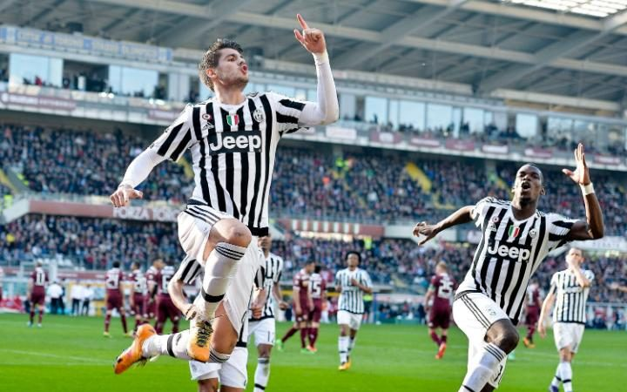

Alvaro Morata played with Paul Pogba during his time at Juventus CREDIT: AP

Jose Mourinho was hugely critical of United's frustrating inability to finish chances last season and Lukaku’s goalscoring record in the Premier League will have been key to United’s switch of focus to signing the former Everton player. His close friendship with Paul Pogba certainly didn’t hurt either - creating that kind of chemistry and understanding between important attacking players can take years. Then again, Morata already knows how to play alongside Pogba...

The point being, Lukaku is one of the most lethal strikers in Europe, a goal poacher with the physique of a target man and a player with purpose. His mission is clear, singular and obvious: find a way to goal and at times this pursuit of personal glory can backfire as Lukaku opts to shoot when teammates are in better scoring positions. That mindset is what a 30 goal a season striker must have but it can -  sometimes - come back to haunt a manager.

Lukaku guarantees goals and has proven for several seasons now that he can score them in the Premier League, but offers less to the team as a whole. While Lukaku spends his game looking to make runs off the shoulder of the last man, others must work harder behind him defensively.

That is not to say that Lukaku doesn’t work - he does - but offers a reason as to why he isn’t the first choice forward for Belgium. [If Lukaku doesn’t score](http://www.telegraph.co.uk/football/2017/07/18/romelu-lukaku-nets-first-goal-man-utd-asvalencia-sent-against/), what does he bring to the team? It sounds like a stupid question but are goals enough?

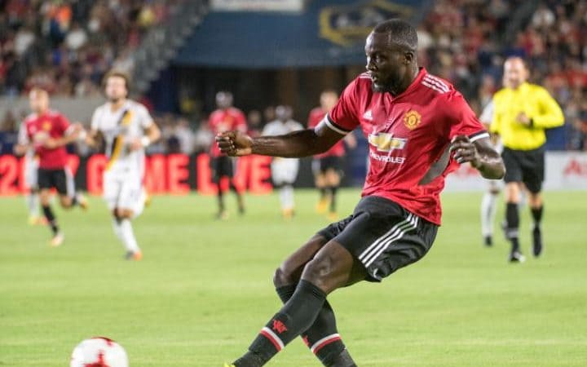

Romelu Lukaku is in America with his Man Utd teammates and scored during a friendly against Real Salt Lake CREDIT: GETTY IMAGES

Mourinho has players working in a system which suits an Old Trafford traditional prowling striker and the team is built for a poacher to take those opportunities (think Andy Cole, Ruud Van Nistelrooy and Ole Gunnar Solskjaer) but Morata is the better footballer. He can create chances for himself.

Conte already has a player on his books with the single-minded approach of Lukaku but Costa, an aggressive livewire, doesn’t appear to be the easiest player to look after and tends to drift in and out of form. He scored 20 goals in the Premier League last season while spearheading Conte's attack but with Eden Hazard a very individually minded player, Chelsea might offer more going forward (and defend better) with a more team-focused player alongside him.

With Morata through the middle, Chelsea now have a clever striker capable of adjusting to circumstance on the pitch and who can help construct the quick passing moves that Hazard, Willian and Pedro are so adept at playing, making full use of that dynamic frontline. Lukaku is not the kind of player to spring a one-two move together, nor is he able to sprint away from defenders on the counter-attack like Morata can.

Costa is quick too, but batters his way into goalscoring positions and forces defences open with sheer determination rather than crafting opportunities with skill. An absolute nightmare to play against, Costa just isn’t the best at link-play between forwards and this is perhaps the main reason he hasn’t really performed as hoped at international level with Spain, and another reason Conte isn't desperate to hold onto him.



Morata played in the Champions League final against ex-club Juventus for Real Madrid CREDIT: GETTY IMAGES

Morata completes a complicated puzzle, fulfilling the roles of both goalscorer and creator, acutely aware of the needs of the team. He brings more to the group than a specialist would, suggesting Conte wants to divide the responsibility of scoring across his forward line, meaning the team isn’t dependent on just one.

Tellingly, Mourinho has worked with both Morata and Lukaku before. His is an informed decision but if Lukaku goes missing or gets injured, how will United cope?

Both managers need goals. Both strikers will get them and while Lukaku will very probably score more, Chelsea have just made their team that bit stronger.

It is the collective that wins trophies but sometimes an individual decides the match. It is up to the managers to get the most out of theirs, whether first choice or not.