Ryan Giggs interview: Romelu Lukaku will face big pressure as Manchester United's No 9

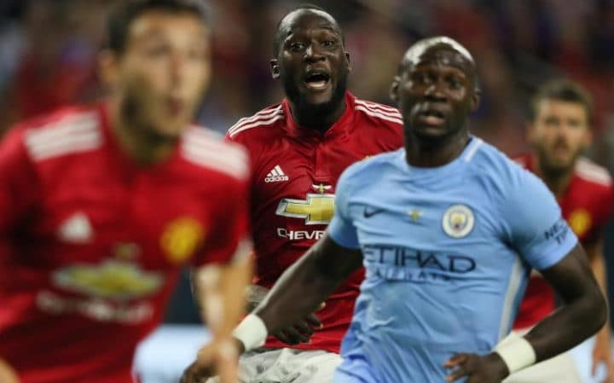Romelu Lukaku in pre-season action against Man City CREDIT: GETTY IMAGES

Ryan Giggs says Romelu Lukaku can be the catalyst for Manchester United to play a more free-flowing brand of football this season.

The United legend has warned [Lukaku he will be under more scrutiny at Old Trafford](http://www.telegraph.co.uk/football/2017/07/21/man-utd-2-man-city-0-romelu-lukaku-proves-class-jose-mourinhos/) than at any time in his career, but he has called on others to raise their game to support the £90 million striker.

After a year of rebuilding in Jose Mourinho’s first season in charge, Giggs expects a more ruthless United competing for the title.

“The main reason Jose bought Lukaku is for goals and to turn all those draws at Old Trafford into wins,” said Giggs. “There will be a lot of pressure and scrutiny on him but those around him also need to step up and score more. Juan Mata did his fair share, but [Anthony] Martial, Marcus [Rashford] and [Henrikh] Mkhitaryan have got to get double figures. So although the most pressure will be on Lukaku, the onus is on the whole team.

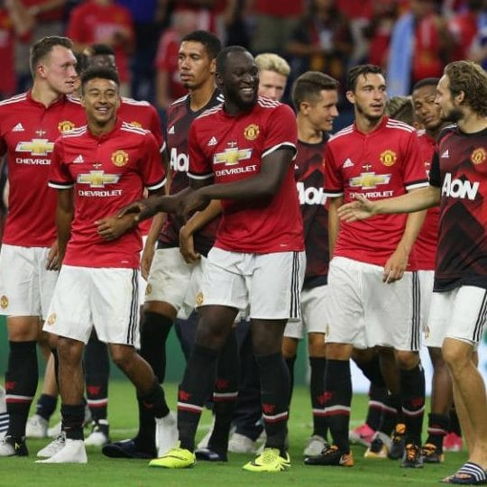

Romelu Lukaku is already a popular member of the United squad CREDIT: GETTY IMAGES

“I’ve been interested in how Jose has played Lukaku and Martial up front in pre-season. He will have analysed last season and seen how in some games you need two up front, and maybe with Mata or Mkhitaryan playing behind. That is something we did not see last year. Jose is a winner and will see where it can improve and tweaking the system can do that.”

Lukaku follows an illustrious tradition of United strikers and Giggs wants the Belgian to embrace the weight of the red shirt.

He will score a lot of goals, but it is in the bigger games where he will be judgedRyan Giggs

“You can only tell in the games whether a player has what it takes,” said Giggs. “There are some games where you are trying to break a side down – like when United played Burnley last season – and you hear the groans in the stadium after the first misplaced pass or chance. That is what you have to deal with.

“Michael Owen, Andy Cole, Ruud van Nistelrooy and all those great strikers missed chances but their mentality was ‘next time, I will score’. Everyone knows Lukaku can score, but it’s about the mental strength to believe if you miss a chance, or go a few games without a goal, the goal will come. If you have that you can get 25 goals or more.

“Experience helps. At United you have had players like [Zlatan] Ibrahimovic or [Robin] Van Persie come in and immediately think ‘this is the place for me’.

“The centre forwards of United come under pressure if they do not score. At another club you can go a few games without scoring and it is under the radar. Not at United. He is going to have to deal with that, but the flip side is he will get far more chances than he did at Everton and West Brom because at Old Trafford they will be constantly going forward. I look back to that Burnley game last season when they had 30 shots. He will score a lot of goals, but it is the bigger games and the away games where judgements will be made.”

While Lukaku seeks to follow a distinguished line of United goalscorers, Giggs paid tribute to the departed Wayne Rooney for helping the club through the difficult reconstruction process following Sir Alex Ferguson’s retirement.

Giggs is sure Rooney – United’s record goalscorer – will receive an appreciative response when he returns in Everton colours in September.

“I saw first hand the help he gave the likes of Marcus Rashford when he was coming through,” said Giggs. “It was not just the young players, but everyone who came to the club.

“Wayne was the leader in the dressing room and when Sir Alex left a lot of leaders left like Rio [Ferdinand], [Nemanja] Vidic, Gary Neville, [Patrice] Evra and I retired as a player. That was a lot in a short space of time and he and Michael Carrick took on the mantle of making sure everyone knew what it meant to be a Manchester United player.

“He beat a record many people thought would not be beaten. To go past Bobby [Charlton] you not only have to be at the club for a long time but be capable of dealing with all that pressure.”