- Which option best describes this tree? 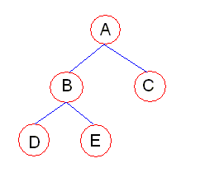

- Not a tree
- A tree
- A binary tree
- A proper binary tree
- A complete binary tree
- A perfectly balanced binary tree
Ans. : e
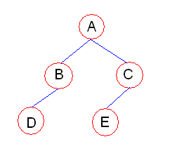
2. Which option best describes this tree?

    - Not a tree
    - A tree
    - A binary tree
    - A proper binary tree
    - A complete binary tree
    - A perfectly balanced binary tree
Ans. : c

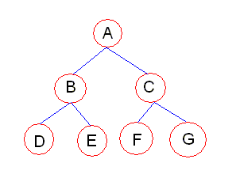
3. Which option best describes this tree
- Not a tree
- A tree
- A binary tree
- A proper binary tree
- A complete binary tree
- A perfectly balanced binary tree
Ans. : f
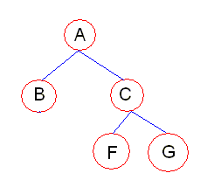
4. Which option best describes this tree?
- Not a tree
- A tree
- A binary tree
- A proper binary tree
- A complete binary tree
- A perfectly balanced binary tree
Ans : d
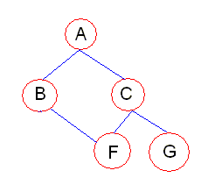
- Which option best describes this tree?
  - Not a tree
  - A tree
  - A binary tree
  - A proper binary tree
  - A complete binary tree
  - A perfectly balanced binary tree
Ans. : a
- Which traversal around the tree will give the order D - E - B - F - G - C – A
  - Pre-order traversal
  - Post-order traversal
  - In-order traversal
  - None
Ans. : b
- Which traversal around the tree will give the order D - B - E - A - F - C – G
  - Pre-order traversal
  - Post-order traversal
  - In-order traversal
  - None
Ans. : c
- Which traversal around the tree will give the order A - B - D - E - C - F – G
  - Pre-order traversal
  - Post-order traversal
  - In-order traversal
  - None
Ans. : a
A. B.
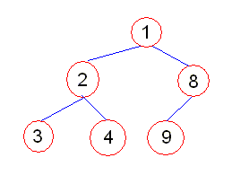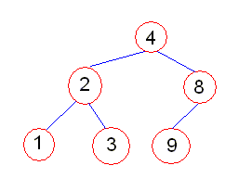
C. D.
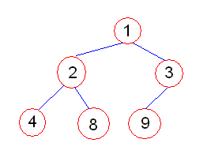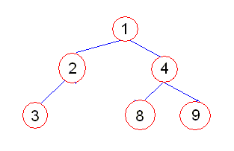

- Which trees are heaps, with the heap ordering taken as <= on integers
  - A, B, C
  - A, C
  - A, C, D
  - B
Ans. : b
- Which data structure has the fastest insertion procedure?
  - Binary search tree
  - Ordered array
  - Heap
  - Unordered linked list
  - Ordered linked list
Ans. : d
A. B.
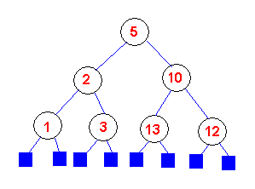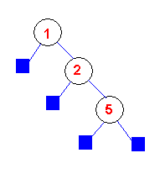
C. D.
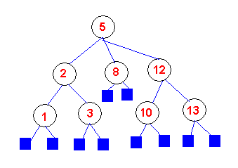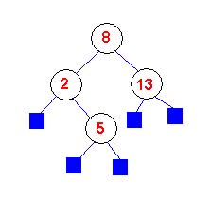
- Which of the following are binary search trees?
  - A,C
  - B
  - B,C
  - B,D
  - A,B,C,D
Ans. : d

12. A Tree is a ____________ type of Data Structure.
- sequential
- linear
- Non-Linear
- hybrid
Ans)C

13. A Pre Order Traversing of Non empty Binary Tree is called as a _________
- BFS
- Depth-First Order
- Linear
- Sequential
Ans)B

14. The Non leaf nodes of a tree are also known as _____ nodes.
- Internal
- external
- outer
- root
Ans)A

15. A Binary Tree of height h, that contains exactly 2h-1 is called a __________
- B tree
- complete binary tree
- Fully Binary Tree
- AVL tree
Ans)c

16. A collection of one or more trees is _________.
- Forest
- Graph
- complete binary tree
- full binary tree
Ans)A

17. A balanced order-n multi way search tree in which each non-root node contains as least (n-1)/2 keys is called as_______________.

- B Tree
- complete binary tree
- full binary tree
- AVL tree
Ans)A

18. Height of a Complete Binary Tree that contains n elements is _____
- log(n*n)
- log₂(n+1)
- log(n+1)
- log(n)
Ans)B

19. A node that does not have any child nodes is called.
- Empty
- Root
- Child
- Leaf
Ans)D

20. A tree having larger data than root in right sub tree and smaller data in left sub tree is called
- Search Tree
- Binary Tree
- Complete Tree
- AVL Tree
Ans)D

21. The drawing of every binary tree with n elements, n>0 has exactly how many edges
- n
- 2n-1
- n-1
- n *log n
Ans)A

22. When comparing to element degree, the degree of a tree is?
- Max
- Min
- NULL
- None
Ans)A

23. How many nodes do have an almost complete strictly Binary Tree.
- 2n-1
- 2n
- n-1
- n*n
Ans)A

24. If a Binary Tree of Height is h, then that Tree having at most how many elements?
- h-1
- 2h
- 2^(h-1)
- 2^h-1
Ans)D

25. Tree with a difference of one in height of left and right sub-trees is called
- Binary tree
- Binary search tree
- AVL tree
- Balanced binary tree
Ans)B

26. Traversing a tree in order of left, right and then root is called
- Inorder
- Preorder
- Postorder
- None
Ans)C

27. What is the Level of the Root of a Tree
- 0
- 1
- -1
- None
Ans)B

28. In Order Traversing of Non empty Binary Tree is called as
- Depth-first order
- breadth-first order
- Symmetric order
- non symmetric order
Ans)C

29. A node which is a parent of all the nodes is called as
- Empty
- Root
- Child
- Leaf
Ans)B

30. Of the following tree structure, which is efficient considering space and time complexities?
- Incomplete Binary Tree
- Binary Tree
- Full Binary Tree
- Complete Binary Tree
Ans)D

31. Traversing a tree in order of root, left and then right is called
1) Preorder
2) Depth-first order
3) Inorder
- 1 and 2
- 2 and 3
- 1 and 3
- All
Ans)A

32. Traversing a tree in order of left, root and then right is called
1) Symmetric order
2) Depth-first order
3) Inorder
- 1 and 2
- 2 and 3
- 1 and 3
- All
Ans)c

33. Which of the following remarks about tree indexing are true?
1) It is efficient in dealing with strings of variable length
2) It is efficient if there are few member of data items
3) The number of disk accesses can’t exceed the length of the particular string that is searched
- 1 and 2
- 2 and 3
- 1 and 3
- All
Ans)C

34. In binary search tree which traversal is used for getting ascending order values ________.
- Reverse order
- Preorder
- Postorder
- Inorder
Ans)D

35. The numbers of null pointer are there in N number binary tree is ________.
- N
- N+1
- N/2
- N-1
Ans)B

36. The complexity of Binary search is ___________
- O(log n*n)
- O(log (n+1))
- O(log n)
- O(log n/2)
Ans)C

37. The number of different trees are possible with n nodes are_________
- n-1
- n+1
- n
- n/2
Ans)A

38. B-tree (failure nodes at same level) of nodes in k-ary tree of depth n is ______.
- 1/n
- 1/k
- I+k
- 1+n

Ans)B

39. AVL trees achieve the goal that search, insertion and deletion in a tree with n nodes can all be achieved in the time that is _________
- O(log n/2)
- O(log (n+1))
- O(log n*n)
- O(log n)
Ans)D

40. Given a height balanced tree. If we add one more node, ________ nodes gets unbalanced.
- TWO
- THREE
- ONE
- ZERO
Ans)B

41. Children of the same node are called
- Leaves
- branches
- siblings
- terminals
Ans)C

42. In a binary tree which traversal will print the elements in ascending order?
- preorder
- Postorder
- Inorder
- depends on data
Ans)C

43. A class which is used to traverse through the objects maintained by a container class.
- Protocol Class
- maxin class
- Concrete Class
- Iterative Class
Ans)D

44. The header node in the link list sometime called as
1)base
2)anchor
3)footer
- 1 and 2
- 2 and 3
- 1 and 3
- None
Ans)A

45. what are the different traversal techniques available for trees
1)pre-order
2)postorder
3)inorder
- 1 and 2
- 2 and 3
- 1 and 3
- None
Ans)A

46. In an AVL tree, at what condition the balancing is to be done?
1)pivotal value greater than 1
2)pivotal value less than 1
3)pivotal value equal to 2
- 1 and 2
- 1 and 3
- 2 and 3
- All
Ans)D

47. Max or min tree i.e. also a complete binary tree known as
1)max heap
2)min heap
3)B+ tree
- 1 and 2
- 2 and 3
- 1 and 3
- None
Ans)A

48. A Full Binary Tree of height h contains exactly __________nodes
- 2^(h+1)
- 2^h-1
- 2^(h-1)
- 2h-1
Ans)D

49. The minimum balancing factor of an AVL tree is ______.
- 0
- -1
- 1
- -2
Ans)B

50. AVL trees achieve the goal that search, insertion and deletion in a tree with n nodes can all be achieved in the time that is
- O(log( n+1))
- O(log n^2)
- O(log n/2)
- O(log n)
Ans)D

51. In between threaded binary tree and lexical ordered binary tree the process of traversal is faster in __________ binary tree
- Threaded
- Lexial ordered
- both are same
- depends upon no. of nodes
Ans)B
52. A binary tree is a
  - A finite set of elements which is either empty or is partitioned into three disjoint subsets,which are again binary trees in themselves
  - A finite set of elements which is either empty or is partitioned into three disjoint subsets, which need not be a binary trees in themselves
  - A finite set of elements which is never empty and is partitioned into three disjoint subsets, which are again binary trees in themselves
  - None
Ans : a

53. A node that has no child is called
- father
- Leaf
- Ancestor
- descendant
Ans : b
54. If A is the root of a binary tree and B is the root of its left or right sub tree, then B is said to be, ____ of A
  - Left son
  - Right son
  - Both a and b
  - Either a or b
Ans : d

- If A is the root of a binary tree and B is the root of its left or right sub tree, then A is said to be, ____ of B
  - Left son
  - Right son
  - Father
  - 0
Ans : c

- Node n1 is an ancestor of node n2
  - If n1 is the father of n2
  - If n1 is the father of some ancestor of n2
  - Both a and b
  - Either a or b
Ans : c

- Node n2 is a descendant of n1
  - If n1 is the father of n2
  - If n1 is the father of some ancestor of n2
  - Both a and b
  - Either a or b
Ans : c
- Two nodes are brothers if
  - They are the left sons
  - They are the descendents of the same node
  - They are not the leaf nodes
  - They are the left and right sons of the same father
Ans : d

- The tree is said to be strictly binary tree if
  - Every level except possibly the deepest, in that binary tree is completely filled
  - Every non leaf node in a binary tree has nonempty left and right subtrees
  - If in that binary tree each node has exactly zero or two children
  - A binary tree where every node’s left subtree has keys less than the node's Key, and every right subtree has keys greater than the node's key
  - If it has leaves on more than one level
Ans : b,c

- which of the following statement is true
  - Root of the tree has a level 0
  - The level of any node is one more than the level of its father
  - The depth of binary tree is the maximum level of any leaf in the tree
  - All the above
Ans : d

- A Complete binary tree is,
  - A strictly binary tree
  - A strictly binary tree with all the leaves having their level equal to depth
  - Both a and b
  - None
Ans : b

- If a binary tree contains m nodes at level L, then it contains atmost ____ nodes at level L+1
  - 2^m
  - 2m
  - 2m+1
  - 2^m+1
Ans : b

- The maximum number of nodes possible at level L is
  - 2^(L +1)
  - 2L
  - 2^L
  - 2^L+1
Ans : c

- The total number of nodes in a complete binary tree of depth d is,
  - 2^(d+1)
  - 2^(d+1)-1
  - 2^(d+1)+1
  - None
Ans : b

- A binary tree of depth d is an “almost complete binary tree”, if it satisfies
  - Any node at level less than d-1 has two sons
  - Any node n1 in the tree with a right descendent at level d, n1 must have a left son and every left descendent of n1 is either a leaf at level d or has two sons
  - Both a and b
  - None
Ans : c

- Preorder is also known as
  - Root-First order
  - Symmetric order
  - Depth first order
  - None
Ans : c

- Inorder is also known as
  - Root-First order
  - Symmetric order
  - Depth first order
  - None
Ans : b

- What is the correct order, to traverse a non empty binary tree in preorder
1. Traverse the left subtree in preorder 3. Traverse the right subtree in preorder
a. 1, 2, 3
b. 2, 3, 1
c. 2, 1, 3
d. 3, 2, 1
Ans : c

- What is the correct order, to traverse a non empty binary tree in inorder
1. Traverse the left subtree in inorder 2. Visit the root 3. Traverse the right subtree in inorder
a. 1, 2, 3
b. 2, 3, 1
c. 2, 1, 3
d. 3, 2, 1
Ans : a

- What is the correct order, to traverse a non empty binary tree in preorder
1. Traverse the left subtree in postorder 2. Visit the root 3. Traverse the right subtree in postorder
a. 1, 2, 3
b. 2, 3, 1
c. 1, 3, 2
d. 3, 2, 1
Ans : c

- All the elements in the left subtree of a node n are less than the contents of n, and all elements in the right subtree of a node n are less than the contents of n. Binary tree with this property is called
  - Complete binary tree
  - Binary search tree
  - Ordered binary tree
  - Strictly binary tree
Ans : b, A binary tree where every node’s left subtree has keys less than the node's key, and every right subtree has keys greater than the node's key.

72. Which traversal does not use a stack?
- inorder
- level order
- postorder
- preorder
- all of these traversals uses a stack
Ans : b, Inorder, preorder, postorder traversal makes use of stack for implementing

14
/ \
2 11
/ \ / \
1 3 10 30
/ /
- 40

Fig 1.1

73. How many leaves does the tree in fig 1.1 have?
- 2
- 4
- 8
- 9
Ans : b
74. How many of the nodes have at least one sibling,in the tree of fig 1.1?
- 5
- 6
- 7
- 9
Ans : a
75. What is the value stored in the parent node of the node containing 30, in the tree of fig 1.1?
  - 10
  - 11
  - 14
  - None of the above
Ans : b
76. How many descendants does the root have, in the tree of fig 1.1?
- 0
- 2
- 4
- 8
Ans : d
77. What is the depth of the tree of fig 1.1?
- 2
- 3
- 4
- 8
Ans : b
78. How many children does the root have, in the tree of fig 1.1?
  - 2
  - 4
  - 6
  - 8
Ans : a
79. Which statement is correct, with regarding to the tree of fig 1.1?
- The tree is neither complete nor full.
- The tree is complete but not full.
- The tree is full but not complete.
- The tree is both full and complete.
Ans : a
80. What is the minimum number of nodes in a full binary tree with depth 3?
- 3
- 4
- 8
- 7
- 15
Ans : d, A binary tree in which each node has exactly zero or two children is called a Full binary tree.
81. What is the minimum number of nodes in a complete binary tree with depth 3?
- 3
- 4
- 11
- 15
Ans : d, A complete binary tree is a binary tree in which every level, except possibly the deepest, is completely filled.
82. Which traversal computes the total size of each directory in the UNIX file system?
- inorder
- level order
- postorder
- preorder
- two or more of the above traversals could be used
Ans : c,
83. Select the one true statement.
  - Every binary tree is either complete or full.
  - Every complete binary tree is also a full binary tree.
  - Every full binary tree is also a complete binary tree.
  - No binary tree is both complete and full.
Ans : b, every non-leaf node in a complete binary tree will have either 0 or 2
84. If T is a binary tree with 14 nodes. What is the minimum possible depth of T?

  - 0
  - 3
  - 4
  - 5
Ans : b, 2^(n+1)-1 = 14, calculate n, n=2.906. so the depth is 3
85. Select the one FALSE statement about binary trees:
  - Every binary tree has at least one node.
  - Every non-empty tree has exactly one root node.
  - Every node has at most two children.
  - Every non-root node has exactly one parent.
Ans : a, Empty tree with 0 nodes is also a binary tree
86. Consider the node of a complete binary tree whose value is stored in data[i] for an array implementation. If this node has a right child, where will the right child's value be stored?
- data[i+1]
- data[i+2]
- data[2*i + 1]
- data[2*i + 2]
Ans : d
87. The total number of nodes in a complete binary tree of depth d will be
- 2^d -1
- 2^(d+1)- 1
- 2^(d+1) + 1
- 2^(d+1)
Ans : b
88. For a strictly binary tree with n leaves, and level(i) for i between 1 and n equal the level of the i^{th} leaf is
- ε^{n}_{i=0}
- ε^{n}_{i=1}
- ε^{n}₀₌₁
- ε^{n}_{1=1,}
Ans : b,page number 243 of tenenbaum 2nd edition
89. a strictly binary tree with n leaves contains ______ nodes
  - 2n+1
  - 2n-1
  - 2n
  - None
Ans : b, page number 243 of tenenbaum 2nd edition
90. Which of the following traversals requires more than linear time in the worst case?
- inorder
- level order
- postorder
- preorder
- all of these traversals are linear time
Ans : e

91. In which of the following traversals is the node processed before the recursive calls to the children complete?
- inorder
- level order
- postorder
- preorder
- none of the above
Ans : d
92. Suppose that a binary tree includes 7 animals. What is the minimum number of NONLEAF nodes in the tree?
  - 1
  - 3
  - 5
  - 7
  - 8
Ans : b
Fig 1.2
93. What is the order of nodes visited using a pre-order traversal, in the tree in fig1.2?
14
/ \
2 11
/ \ / \
1 3 10 30
/ /
  - 40
  - 1 2 3 7 10 11 14 30 40
  - 1 2 3 14 7 10 11 40 30
  - 1 3 2 7 10 40 30 11 14
  - 14 2 1 3 11 10 7 30 40
Ans : d
94. What is the order of nodes visited using an in-order traversal, in the tree in fig1.2?
  - 1 2 3 7 10 11 14 30 40
  - 1 2 3 14 7 10 11 40 30
  - 1 3 2 7 10 40 30 11 14
  - 14 2 1 3 11 10 7 30 40
Ans : b
95. What is the order of nodes visited using post-order traversal, in the tree of fig1.2?
  - 1 2 3 7 10 11 14 30 40
  - 1 2 3 14 7 10 11 40 30
  - 1 3 2 7 10 40 30 11 14
  - 14 2 1 3 11 10 7 30 40
Ans : c
96. Consider this binary search tree: Suppose we remove the root,replacing it with
something from the left subtree. that will be the new root? (preserving the
subsets of the left and right subtrees)

14
/ \
2 16
/ \
1 5
/
4
  - 1
  - 2
  - 4
  - 5
Ans : d
97. Which of the following statement is true
A
B
C
D
E
F
G
H
I
J

Fig 1.3
    - The inorder D H B E A F C I G J
    - The postorder H D E B F I J G C A
    - The preorder A B D H C E F G I J
    - The postorder H D E F B I J G C A
    - The inorder D H B E A F C G I J
    - The preorder A B D H E C F G I J
    - The postorder H D E B G I J F C A
Ans : a, b, f
98. Consider the node of a complete binary tree whose value is stored in data[i] for an array implementation. If this node has a left child, where will the left child's value be stored?
- data[i+1]
- data[i+2]
- data[2*i + 1]
- data[2*i + 2]
Ans : c
99. Traversing a binary expression trees in preorder yields _____ form of expression
  - prefix
  - postfix
  - infix
  - none
Ans : a, Page no 241.Tenenbaum 1994 edition
- Traversing a binary expression trees in postorder yields _____ form of expression
  - prefix
  - postfix
  - infix
  - none
Ans : b, Page no 241.Tenenbaum 1994 edition
- Traversing a binary expression trees in preorder yields _____ form of expression
  - prefix
  - postfix
  - infix
  - none
Ans : c, Page no 241.Tenenbaum 1994 edition
- Traversing this binary expression tree in fig 1.3 in postorder yields
Fig 1.3
$
/ \
/ \
+ *
/ \ / \
A * + C
/ \ / \
B C A B

  - ABC*+ABC*+$
  - AB+*CAB+*C$
  - ABC*+AB+C*$
  - ABCABC+*+*$
Ans : c, Page no 242.Tenenbaum 1994 edition
- Traversing this binary expression tree in fig 1.3 in Inorder yields
  - (A*B+C)$(A*B)+C
  - A+B*C$A+B*C
  - (A+(B*C))$((A+B)*C)
  - A+(B*C)$(A+B)*C
Ans : c
- Traversing this binary expression tree in fig 1.3 in preorder yields
  - A+B*C$A+B*C
  - $AB+*CAB+*C
  - $+A*BC*+ABC
  - $+*+*ABCABC
Ans : c
- The preorder traversing of the tree gives the expression ABCEIFJDGHKL. What is the Inorder expression
  - ICEBJFKDGLHA
  - ECFIKDGBJLHA
  - EICFJBGDKHLA
  - EIFCBJDKGHLA
Ans : c, Page no 240.Tenenbaum 1994 edition
- The preorder traversing of the tree gives the expression ABCEIFJDGHKL. What is the postorder expression
  - ICEBJFKDGLHA
  - FJEILKGCBDHA
  - EICFJBGDKHLA
  - IEJFCGKLHDBA
Ans : d, Page no 240.Tenenbaum 1994 edition
- The preorder traversing of the tree gives the expression ABDGCEHIF. What is the Inorder expression
  - DBGHAEICF
  - DGBAHEICF
  - BGDEHACIF
  - DGABEHICF
Ans : b, Page no 240.Tenenbaum 1994 edition
- The preorder traversing of the tree gives the expression ABDGCEHIF. What is the postorder expression
  - GDBHIEFCA
  - GBDHIEFCA
  - GDBEIHCFA
  - GBDEIHCFA
Ans : a, Page no 240.Tenenbaum 1994 edition
- The Inorder traversing of the tree gives the expression DGBAHEICF. What is the postorder expression
  - GBDHIEFCA
  - GDBEIHCFA
  - GDBHIEFCA
  - GBDEIHCFA
Ans : c, Page no 240.Tenenbaum 1994 edition
- The Inorder traversing of the tree gives the expression DGBAHEICF. What is the preorder expression
  - ADBCGHEFI
  - ABDGCEHIF
  - ABDCGHEIF
  - ADBGCEHFI
Ans : b, Page no 240.Tenenbaum 1994 edition
- The Postorder traversing of the tree gives the expression GDBHIEFCA. What is the preorder expression
  - ADBCGHEFI
  - ABDCGHEIF
  - ADBGCEHFI
  - ABDGCEHIF
Ans : d, Page no 240.Tenenbaum 1994 edition
- The Postorder traversing of the tree gives the expression GDBHIEFCA. What is the Inorder expression
  - DBGHAEICF
  - BGDEHACIF
  - DGBAHEICF
  - DGABEHICF
Ans : c, Page no 240.Tenenbaum 1994 edition
- The Postorder traversing of the tree gives the expression IEJFCGKLHDBA. What is the Inorder expression
  - ICEBJFKDGLHA
  - EICFJBGDKHLA
  - ECFIKDGBJLHA
  - EIFCBJDKGHLA
Ans : b, Page no 240.Tenenbaum 1994 edition
- The Postorder traversing of the tree gives the expression IEJFCGKLHDBA. What is the Preorder expression
  - ABCIEFJDGKHL
  - ACBFIEJDGHKL
  - ABCEIFJDGHKL
  - ABCEIFDJGHLK
Ans : c, Page no 240.Tenenbaum 1994 edition
- The Inorder traversing of the tree gives the expression EICFJBGDKHLA. What is the postorder expression
  - ICEBJFKDGLHA
  - IEJFCGKLHDBA
  - FJEILKGCBDHA
  - EICFJBGDKHLA
Ans : b, Page no 240.Tenenbaum 1994 edition
- The Inorder traversing of the tree gives the expression EICFJBGDKHLA. What is the Preorder expression
  - ABCEIFJDGHKL
  - ABCIEFJDGKHL
  - ACBFIEJDGHKL
  - ABCEIFDJGHLK
Ans : a, Page no 240.Tenenbaum 1994 edition
117) Consider the following paragraph.
A tree is a data structure consisting of nodes connected to each other with references. Each node in a tree may be connected to one or two nodes. Each node contains one or more data fields and two references.

Which of the following is/are properly describing the above paragraph?

- Multiway search Trees

- Binary Trees

- Binary Search Trees

- General Trees

- AVL trees

Ans) B
118)Consider the following rules.
Rule 1: For Loop: The running time of a for loop is at most the running time of the statements inside the for loop (including test) times the number of iterations
Rule 2 : Nested Loop: The total running time of a statement inside a group of nested loops is the running time of the statement multiplied by the product of the sizes of all the loops.
Rule 3 : IF/ELSE : For the fragment
if( condition)
S1
else
S2
the running time of an if/else statement is never more than the running time of the test plus the larger of the two numbers namely, the running time of S1 and that of S2.
Which of the following is a / are valid rule(s) in connection with analysis of algorithms?
- Rule 3 only

- Rule 1 and Rule 3 only

- Rule 2 and Rule 3 only

- Rule 2 only

- All

Ans) E
119) Consider the following four statements with blank positions.
If one finds a node with a/an ……. (i)………, he should stop the trace at that point.
Consider the node with imbalance and ……….(ii)……….. on the layers immediately below this point on the path back to the new node.If these three nodes lie in a ………(iii)……… apply a …….(iv)………… rotation.If these three nodes lie in a dog-leg pattern (bend in the path), apply ……(v)……. rotation to correct the imbalance.
The above sentences are in connection with insertion of new nodes in to an AVL tree.

Which of the following are correct words for the above blank positions?

- (i)balance (ii)two nodes (iii) straight line (iv) single (v) double

- (i)imbalance (ii)three nodes (iii) straight line (iv) single (v) double

- (i)imbalance (ii)two nodes (iii) dog-leg (iv) single (v) double

- (i)imbalance (ii)two nodes (iii) straight line (iv) double (v) single

- (i)imbalance (ii)two nodes (iii) straight line (iv) single (v) double

Ans) E

120) Consider the following expression.
(A+B*C)$((A+B)*C)
Which of the following trees show(s) the equivalent expression tree for the above expression? (Note: $ denotes power.)
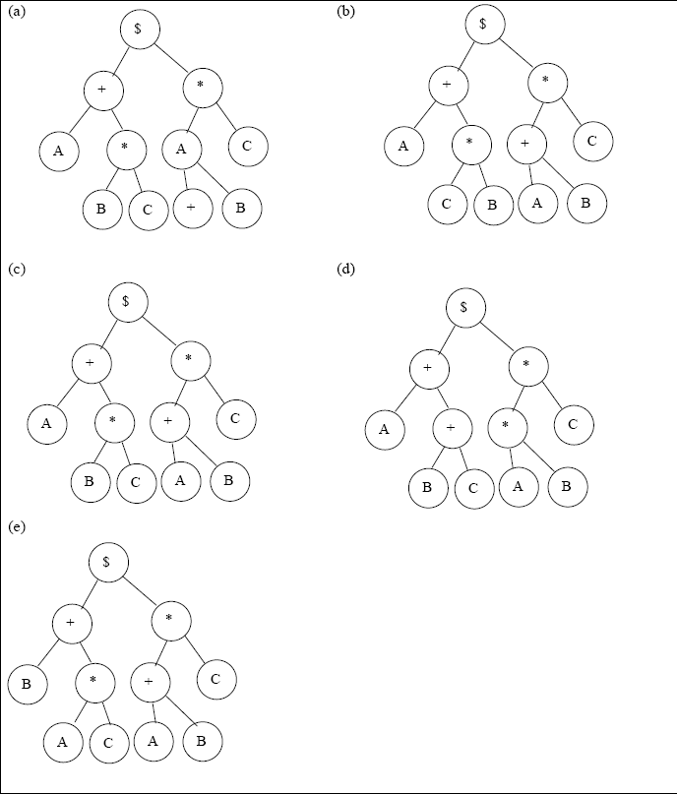
Ans) C

121) 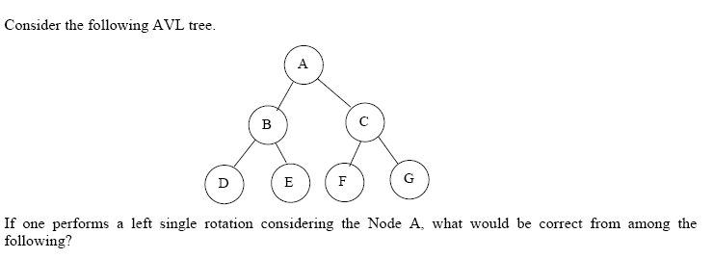

- New root is Node C.

- New root is Node B.

- Node A’s right child is Node F.

- Node A’s right child is Node C

- Node G’s left child and right child are null.
Ans)A, C, E

122)
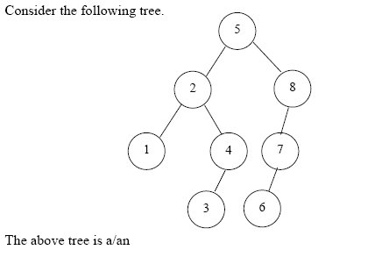
- AVL tree.

- Binary Search Tree.

- Binary Tree.

- General Tree.

- Multiway search Tree.

Ans) B, C

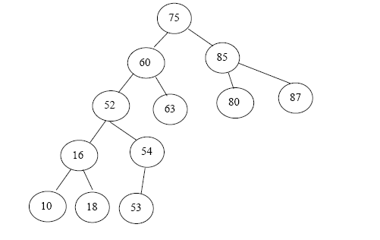
123) In above fig, if one wants to insert a new node p=55, what is the correct insertion point without violating the binary search property?
- Right child of node number 18

- Right child of node number 53

- Left child of node number 63

- Right child of node number 54

- Left child of node number 54

Ans) D

124) In the above fig ,if one wants to insert a new node p= 84 after inserting the new node p=55, to the above tree, what is the correct insertion point without violating the binary search property?
- Left child of node number 65

- Left child of node number 63

- Left child of node number 80

- Right child of node number 63

- Right child of node number 80

Ans) E

125) In the above fig ,if one wants to delete node number 60 from the tree after inserting the new node p=55 and thereafter another at p=84, what is/are the suitable replacing node(s) without violating the binary search properties?
- Node number 63

- Node number 54

- Node number 52

- Node number 53

- Node number 85

Ans) A

126) 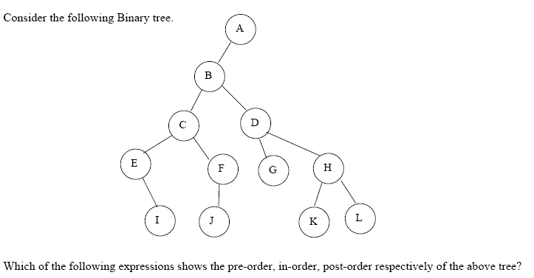
- ABCEIFJDHGKL, EICFJBGDKHLA, IEJFCGKLHDBA

- ABCEIFJDGHKL, IEJFCGKLHDBA, EICFJBGDKHLA

- ABCEIFJDGHKL, EICFJBGDKHLA, IEJFCGKLHDBA

- EICFJBGDKHLA, ABCEIFJDGHKL, IEJFCGKLHDBA

- ABCEIFJDGHKL, EICFJBGDKHAL, IEJFCGKLHDBA

Ans) C

