**Spring Boot CRUD Example with Spring MVC – Spring Data JPA – ThymeLeaf - Hibernate - Postgresql**

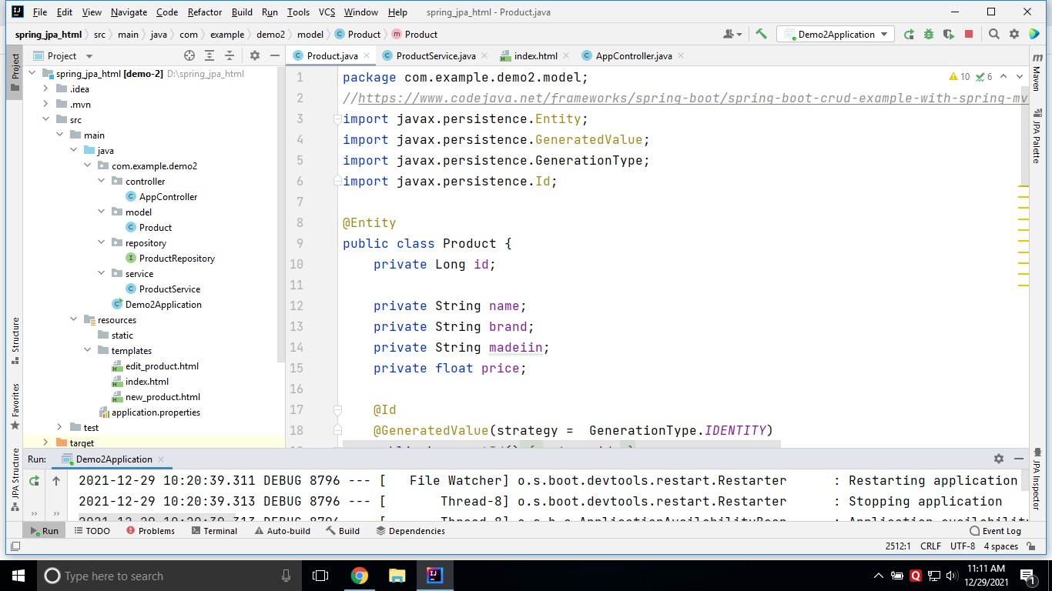

:: Home page ::

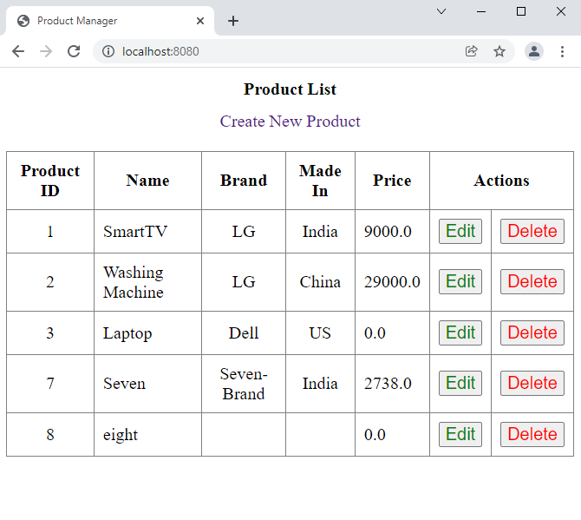

:: Edit the Record ::

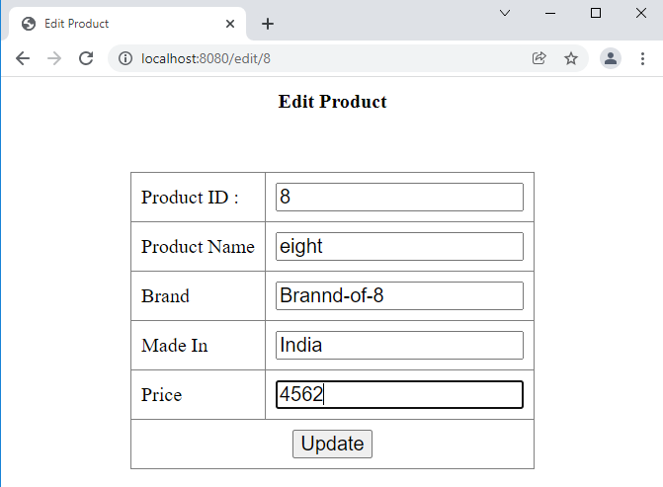

:: List of Products after EDIT ::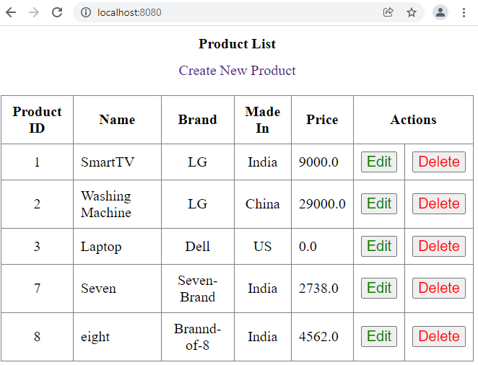

:: Create New Product ::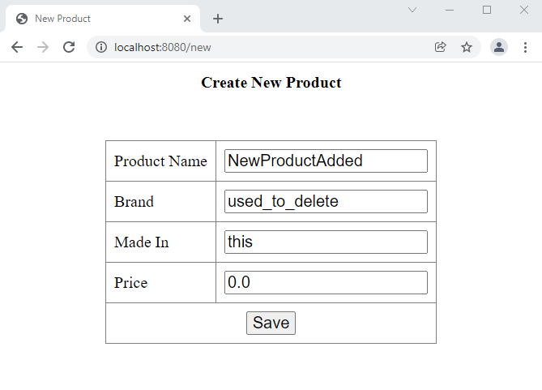

:: List of Products after adding NEW record ::

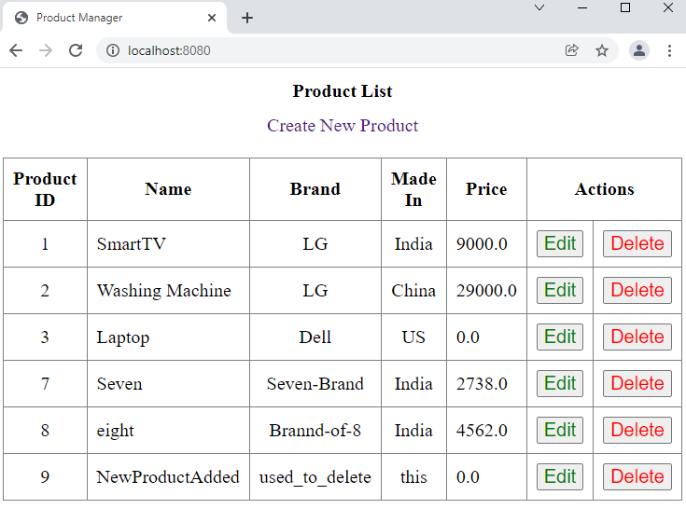

:: Deleting a record (ID No. 9) ::