Multi-Modal Single-Cell Characterization of the
Immune Tumor Microenvironment in NSCLC
A Weighted Nearest Neighbor (WNN) Analysis of RNA and Protein Expression
Across Seven NSCLC Donors with 9,103 Immune Cells

Dataset: 10x Genomics 20k NSCLC DTC 3’ NextGEM
Pipeline: Seurat v5 | scDblFinder | WNN Integration | 18-Step Analysis
March 2026

Abstract
Non-small cell lung cancer (NSCLC) is characterized by a complex and heterogeneous immune tumor microenvironment (TME) whose composition and functional state vary substantially across patients. Understanding this inter-donor variability at single-cell resolution is essential for predicting immunotherapy response and identifying patient-specific therapeutic vulnerabilities. In this study, we performed multi-modal single-cell profiling of the immune compartment from seven NSCLC donors, integrating gene expression (RNA) and surface protein (ADT) measurements using Weighted Nearest Neighbor (WNN) analysis implemented in Seurat v5.
Following rigorous quality control, doublet removal with scDblFinder, elimination of non-immune contamination, and myeloid-leaked T cell correction, we identified 18 distinct immune cell populations spanning T cells, B cells, NK cells, myeloid cells, and plasmacytoid dendritic cells across 9,103 high-quality immune singlets. We then scored five biologically motivated gene programs—cytotoxicity, T cell exhaustion, interferon/ISG signaling, inflammatory myeloid activation, and tumor-associated macrophage (TAM) polarization—and tested for donor-level differences within each immune compartment using Kruskal–Wallis tests.
Our analysis revealed highly significant inter-donor heterogeneity concentrated in the myeloid compartment, with IFN/ISG signaling showing the strongest donor effect (p = 1.27 × 10⁻⁸), followed by cytotoxicity (p = 3.27 × 10⁻⁶), inflammatory myeloid activation (p = 5.65 × 10⁻⁵), and TAM polarization (p = 3.55 × 10⁻⁴). T cell programs showed more modest variability, with only cytotoxicity reaching significance (p = 0.005). Compositionally, Donor 4 exhibited a strikingly B cell–dominated infiltrate (61% of immune cells were B lineage), while other donors were enriched for T cell or myeloid populations. These findings demonstrate that myeloid functional heterogeneity represents a major axis of patient-to-patient variation in the NSCLC immune TME, with potential implications for stratifying patients for myeloid-targeted or combination immunotherapy strategies.

1. Introduction

1.1 The NSCLC Immune Tumor Microenvironment
Non-small cell lung cancer accounts for approximately 85% of all lung cancers and remains a leading cause of cancer-related mortality worldwide. Over the past decade, immune checkpoint inhibitors targeting PD-1, PD-L1, and CTLA-4 have transformed the NSCLC treatment landscape. However, clinical response rates remain highly variable, with only a fraction of patients achieving durable benefit. This heterogeneity in therapeutic response is increasingly attributed to differences in the composition and functional state of the immune tumor microenvironment.
The NSCLC TME harbors a diverse ecosystem of immune cells, including tumor-infiltrating lymphocytes (TILs), myeloid-derived populations such as monocytes and macrophages, B lymphocytes, natural killer (NK) cells, and dendritic cells. The balance between anti-tumor effector cells and immunosuppressive populations—such as regulatory T cells, exhausted CD8 T cells, and tumor-associated macrophages—is widely recognized as a critical determinant of patient outcome. However, prior studies using bulk RNA sequencing or limited marker panels could not resolve the full spectrum of immune cell states at the single-cell level.

1.2 Multi-Modal Single-Cell Profiling
Advances in droplet-based single-cell technologies now allow simultaneous measurement of transcriptomic (RNA) and surface protein (antibody-derived tag, ADT) information from individual cells. This multi-modal approach offers a powerful advantage: RNA captures transcriptional programs and regulatory states, while ADT provides direct quantification of surface proteins that define lineage identity and activation status. The integration of these two data layers through methods such as Weighted Nearest Neighbor (WNN) analysis yields more robust cell-type classification than either modality alone.
The WNN framework, implemented in Seurat v5, jointly learns from RNA and protein data to construct a unified neighborhood graph in which each cell’s representation reflects a data-driven weighting of both modalities. This is particularly advantageous for immune cell phenotyping, where surface markers such as CD3, CD4, CD8, CD14, CD19, and CD56 provide unambiguous lineage information that complements the transcriptomic resolution of functional states.

1.3 Rationale and Objectives
Despite the growing availability of single-cell NSCLC datasets, systematic multi-modal characterization of inter-donor immune heterogeneity remains underexplored. Most published analyses focus on tumor-intrinsic features or broad immune infiltration patterns, without examining how specific immune functional programs vary across donors within defined cell compartments.
This study addresses this gap through a comprehensive 18-step analysis pipeline applied to the immune TME across seven NSCLC donors using paired RNA and ADT data. Our objectives are: (1) to identify and annotate all major immune cell populations using a rigorous multi-modal WNN pipeline with doublet removal and contamination filtering; (2) to characterize the composition and functional state of the immune TME across donors; (3) to statistically test for donor-level differences in key immune gene programs within specific immune compartments; and (4) to assess the impact of quality control measures—particularly myeloid ambient RNA leak correction—on the reliability of inter-donor comparisons.

2. Materials and Methods

2.1 Dataset
We analyzed the 10x Genomics “20k NSCLC DTC 3’ NextGEM” dataset, comprising seven donors (Donor 1–Donor 7) of dissociated tumor cells from surgically resected NSCLC specimens. Each donor was processed as a separate 10x Chromium library generating both Gene Expression (RNA) and Antibody Capture (ADT) data in HDF5 format. The ADT panel included CD45, CD3, CD4, CD8, CD14, CD11c, CD16, CD56, and CD19.

2.2 Data Loading, Merging, and Quality Control (Steps 1–2)
Seurat objects were created independently for each donor using CreateSeuratObject with minimum thresholds of 3 cells per gene and 200 features per cell. ADT assays were added where barcodes overlapped with RNA. All seven objects were merged into a single Seurat v5 object. Quality control metrics were computed including the percentage of mitochondrial genes (MT-) and ribosomal genes (RPS/RPL). Cells were filtered to retain those with 200–7,500 detected features and less than 20% mitochondrial content. QC distributions were inspected per donor to ensure no systematic batch-level artifacts (Supplementary Figure S1).

2.3 Normalization, Dimensionality Reduction, and WNN Integration (Steps 3–5)
RNA data were log-normalized (scale factor 10,000), and 2,000 highly variable genes were identified using the VST method. RNA was scaled and subjected to PCA (50 components). An elbow plot was used to assess the variance explained by each PC, guiding the selection of 30 PCs for downstream analysis (Supplementary Figure S2). ADT data were normalized using centered log-ratio (CLR) transformation across cells, scaled, and reduced to 5 principal components (APCA). Both reductions were integrated through FindMultiModalNeighbors, which constructs a WNN graph. UMAP embedding was computed on the WNN graph, and Louvain clustering (algorithm 3, resolution 0.5) was performed on the weighted shared nearest neighbor (WSNN) graph.

2.4 Immune Subset Extraction (Step 6)
Immune versus non-immune clusters were distinguished using a curated marker panel evaluated through DotPlot visualization (Supplementary Figure S3). Key discriminating markers included PTPRC (CD45) for pan-immune identity and EPCAM for epithelial identity. FeaturePlot projections of PTPRC and EPCAM on the WNN-UMAP confirmed clean separation: PTPRC was expressed broadly across the upper and middle UMAP islands while EPCAM was restricted to specific clusters in the lower-left region (Supplementary Figure S4). Clusters 0, 1, 2, 3, 4, 8, 11, 12, 15, 19, and 21 were identified as immune and extracted.

2.5 Immune Reprocessing and Doublet Removal (Steps 7–9)
The immune subset was reprocessed through the full WNN pipeline (normalization, HVG selection, PCA, ADT CLR + APCA, WNN + UMAP + clustering at resolution 0.8), yielding 20 subclusters (Supplementary Figure S5). Doublet detection was performed using scDblFinder on the SingleCellExperiment conversion of the immune object. The UMAP visualization of predicted doublets showed they were distributed across clusters rather than concentrated in specific populations (Supplementary Figure S6), consistent with low-level technical doublets rather than systematic contamination. Predicted doublets were removed and the remaining singlets were reprocessed through the complete WNN pipeline to obtain 20 clean immune subclusters (Supplementary Figure S7).

2.6 Cell Type Annotation and Contamination Removal (Steps 10–12)
Immune cluster annotation was performed through a systematic, evidence-based approach combining three lines of evidence. First, FindAllMarkers identified differentially expressed genes for each cluster (30,673 marker genes total; minimum 25% expression, log2FC > 0.25). Second, RNA DotPlot validation assessed expression of curated marker panels spanning T cell subsets, NK cells, B cells, myeloid populations, and dendritic cells across all 20 clusters (Supplementary Figure S8). Third, ADT protein expression (CD45, CD3, CD4, CD8, CD14, CD11c, CD16, CD56, CD19) was used to validate RNA-based assignments (Supplementary Figure S9). FeaturePlot projections of eight key lineage markers (CD3D, CD8A, NKG7, MS4A1, LYZ, FCGR3A, APOE, FCER1A) confirmed expected spatial patterns on the UMAP (Supplementary Figure S10).
Three clusters were identified as non-immune contamination: cluster 11 (endothelial/stromal markers: HSPG2, COL4A1, CAV1), cluster 14 (epithelial/secretory markers: SLPI, WFDC2, AKR1C), and cluster 15 (neuroendocrine markers: PHOX2B, OTX2, NEUROD1). These were removed, yielding the final clean immune object with 18 annotated cell types and 9,103 cells.

2.7 Immune State Scoring (Step 14)
Five biologically motivated gene programs were defined and scored using Seurat’s AddModuleScore. Each program comprised 6–8 genes validated for expression in the dataset: (1) CYTOTOXICITY: NKG7, GNLY, PRF1, GZMB, GZMH, CTSW, FCGR3A, CCL5; (2) EXHAUSTION: PDCD1, LAG3, HAVCR2, TIGIT, CTLA4, TOX; (3) IFN/ISG: ISG15, IFIT1, IFIT2, IFIT3, MX1, OAS1, STAT1, IRF7; (4) INFLAM_MYELOID: S100A8, S100A9, FCN1, IL1B, LGALS3, LYZ, CTSS; (5) TAM_MACRO: APOE, C1QA, C1QB, C1QC, TREM2, MSR1, MRC1, MARCO.

2.8 Myeloid Leak Assessment and Correction (Steps 16–17)
A critical quality assurance step assessed whether inter-donor differences in T cell state scores could be confounded by residual ambient myeloid RNA. A myeloid-leak module (LYZ, LST1, TYROBP, FCER1G, AIF1, S100A8, S100A9, FCN1, C1QA, C1QB, C1QC, APOE) was scored within T cells and visualized per donor (Supplementary Figure S11). Cells exceeding a threshold of median + 2 standard deviations were removed. This step reduced the T cell count from 66 to 64 cells and—importantly—altered the statistical results, confirming that the leak correction was necessary for reliable inter-donor comparisons.

2.9 Statistical Analysis (Steps 14F, 18E)
Cells were assigned to five major immune compartments (T cells, NK cells, B cells, Myeloid, DCs). Within each compartment, Kruskal–Wallis rank-sum tests assessed whether module scores differed significantly across the seven donors. Results were visualized as a heatmap of –log10(p-values) and supplemented with effect direction analysis identifying which donors showed the highest and lowest median scores.

3. Results

3.1 Quality Control and Data Overview
After merging all seven donors, the combined dataset was subjected to quality control filtering. Violin plots of QC metrics revealed donor-specific distributions (Figure 1). Donor 2 and Donor 6 showed higher median gene detection (nFeature_RNA) and UMI counts (nCount_RNA), suggesting higher library complexity, while Donor 4 had lower complexity. Mitochondrial content was generally low across all donors (majority <10%), with sporadic high-MT outliers. Ribosomal gene percentages varied modestly, with Donor 1 showing a slightly higher median. After applying thresholds (200 < nFeature_RNA < 7,500; percent.mt < 20%), the filtered dataset retained cells from all donors for downstream analysis.
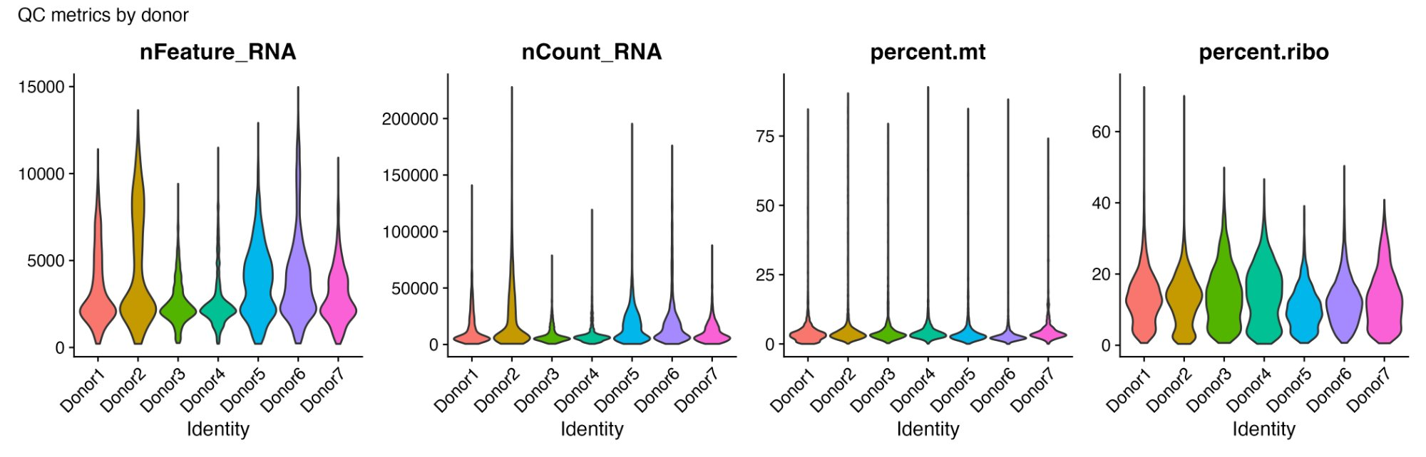
Figure 1. QC metrics by donor. Violin plots of nFeature_RNA, nCount_RNA, percent mitochondrial, and percent ribosomal gene content.

3.2 Dimensionality Reduction and WNN Clustering
PCA on the 2,000 most variable RNA genes captured the majority of variance in the first 20–30 components. The elbow plot (Supplementary Figure S2) showed a clear inflection around PC 15–20, with diminishing returns beyond PC 30, supporting the use of 30 RNA PCs for WNN integration. ADT data were reduced to 5 PCs (APCA), reflecting the smaller dimensionality of the surface protein panel. The WNN integration produced a joint UMAP with well-separated clusters corresponding to major immune and non-immune lineages.

3.3 Immune vs. Non-Immune Separation
The distinction between immune and non-immune cells was validated using PTPRC (CD45) and EPCAM FeaturePlots on the full-dataset WNN-UMAP (Figure 2). PTPRC expression was high and ubiquitous across the T cell, B cell, and myeloid islands of the UMAP, while EPCAM was restricted to a distinct cluster region corresponding to epithelial tumor cells. This clean separation confirmed that the immune cluster selection was robust and not contaminated by epithelial cells.
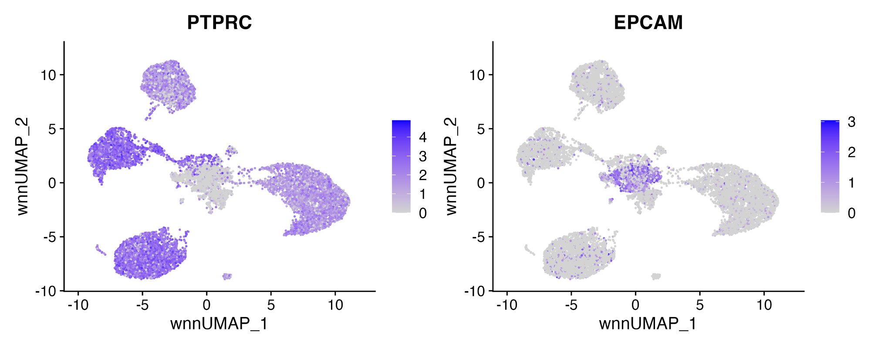
Figure 2. FeaturePlots of PTPRC (CD45, pan-immune) and EPCAM (epithelial) on the full-dataset WNN-UMAP confirming immune vs. non-immune separation.

3.4 Immune Subclustering and Doublet Removal
Reprocessing of the immune subset through the WNN pipeline produced 20 subclusters with clear spatial organization on the UMAP (Figure 3A). The T cell compartment formed a large connected island in the upper-left, with myeloid cells occupying the central region and B cells forming a distinct island in the lower portion. scDblFinder identified a modest fraction of predicted doublets distributed broadly across clusters (Figure 3B), rather than concentrated in boundary regions, suggesting primarily stochastic doublet formation. After doublet removal and reprocessing, the clean singlet UMAP retained 20 well-resolved subclusters with tighter within-cluster cohesion (Figure 3C).
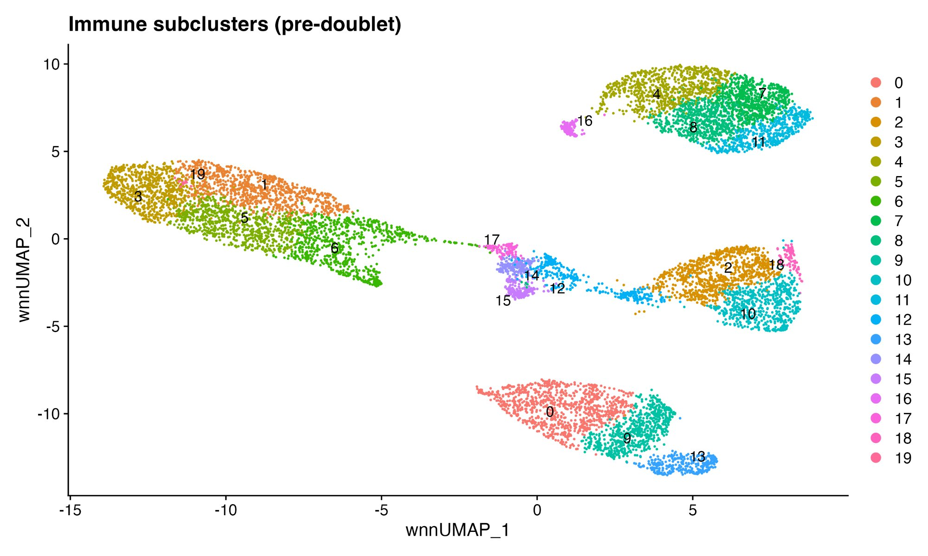
Figure 3A. Immune subclusters prior to doublet removal (20 clusters, WNN-UMAP).
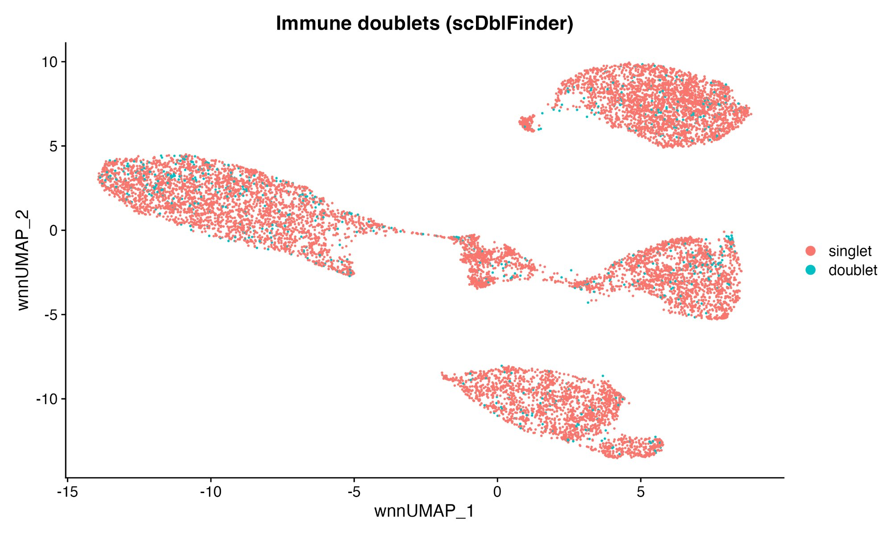
Figure 3B. scDblFinder classification of singlets (red) vs. predicted doublets (cyan) on the immune WNN-UMAP.
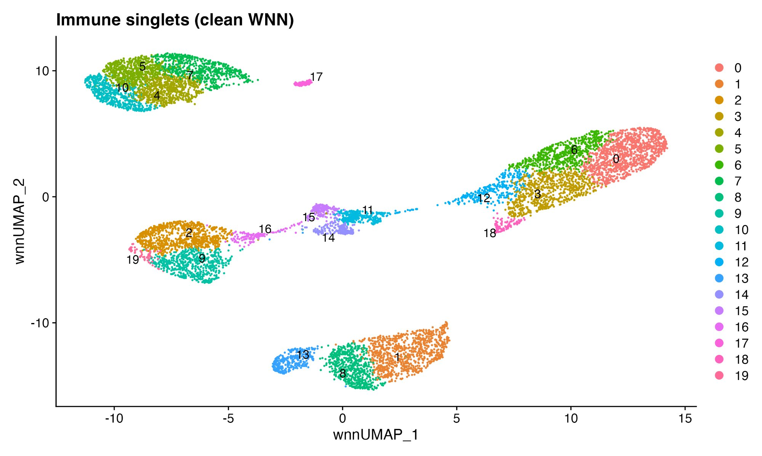
Figure 3C. Clean immune singlets after doublet removal and WNN reprocessing (20 subclusters).

3.5 Evidence-Based Cell Type Annotation
Cell type annotation was performed using convergent evidence from RNA marker genes, ADT surface protein expression, and FeaturePlot spatial localization. The RNA DotPlot (Figure 4A) spanning 60+ curated markers across all 20 immune clusters revealed clear lineage-specific expression patterns. T cell clusters showed high CD3D/CD3E/TRAC expression, with CD8A/CD8B/NKG7 distinguishing cytotoxic subsets and FOXP3/IL2RA/CTLA4 marking the Treg-like population. B cell clusters expressed MS4A1/CD79A/CD74/HLA-DRA, with IGHA1/JCHAIN marking class-switched and plasma-like subsets. Myeloid clusters showed distinct programs: S100A8/S100A9/FCN1/VCAN for classical monocytes, FCGR3A/MS4A7 for non-classical monocytes, APOE/C1QA/C1QB for macrophages, and MARCO/NR1H3 for tissue-resident macrophages.
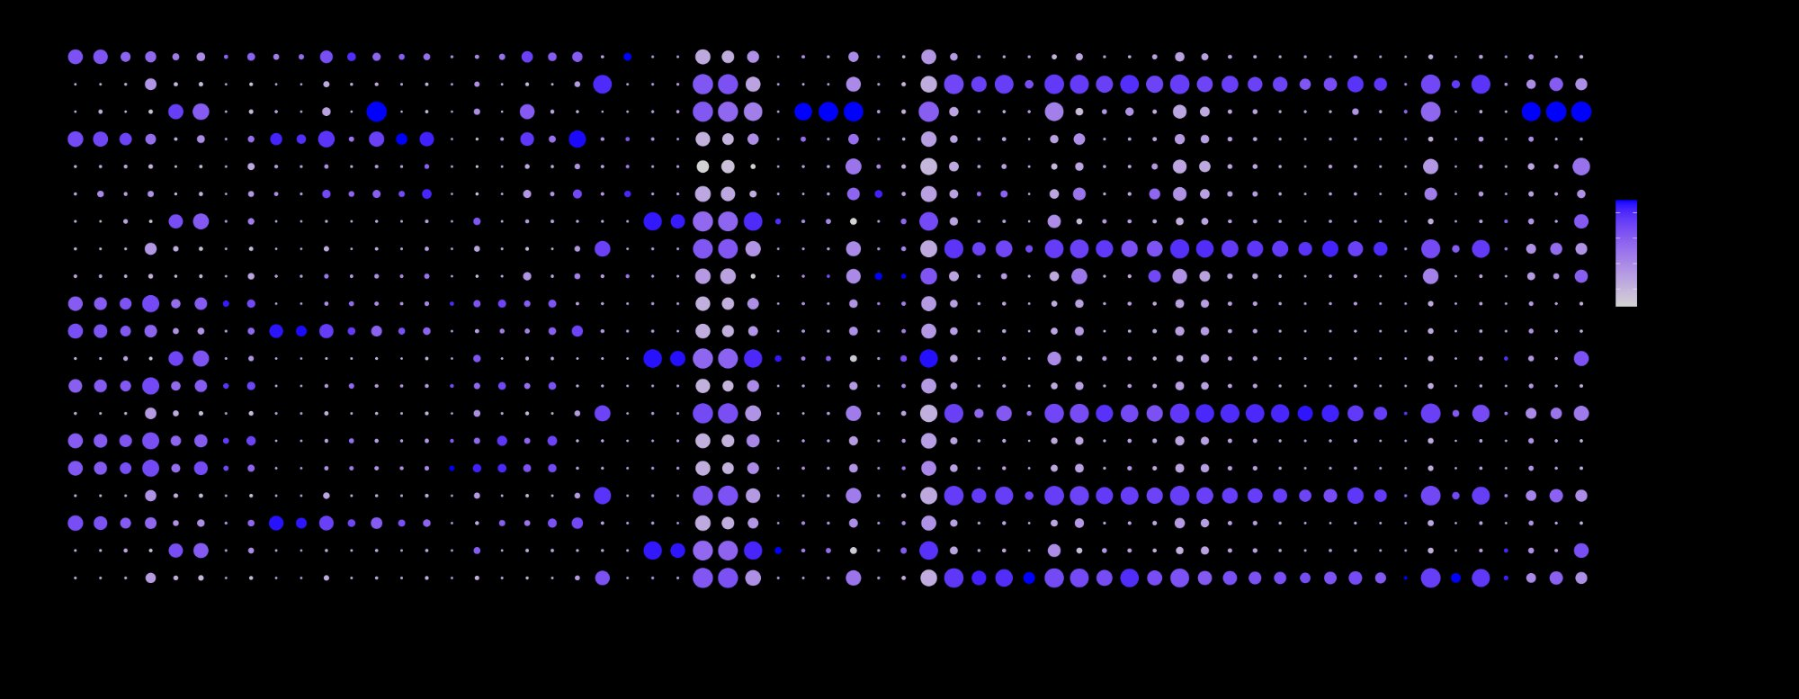
Figure 4A. RNA DotPlot of curated immune marker genes across 20 immune subclusters.
The ADT DotPlot (Figure 4B) provided orthogonal protein-level validation. CD3 protein was highest in T cell clusters, CD14 in classical monocytes, CD16 (FCGR3A) in non-classical monocytes and NK cells, CD19 in B cells, and CD56 (NCAM1) in the NK cluster. Critically, the ADT data resolved ambiguities that RNA alone could not: for example, distinguishing CD4+ and CD8+ T cell subsets and confirming the monocyte/macrophage gradient from CD14-high to CD16-high.
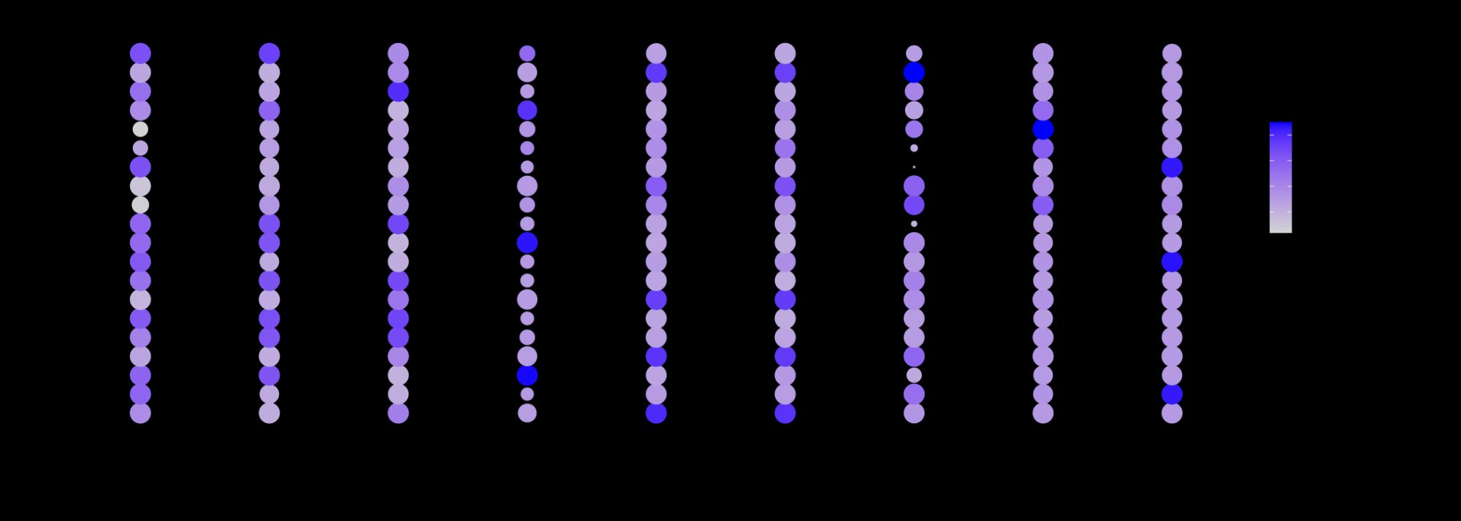
Figure 4B. ADT DotPlot of surface protein markers across 20 immune subclusters.
FeaturePlot projections of eight key lineage markers on the WNN-UMAP (Figure 4C) confirmed spatial specificity: CD3D marked the T cell island, CD8A a subset thereof, NKG7 the cytotoxic T/NK regions, MS4A1 the B cell island, LYZ the monocyte clusters, FCGR3A the non-classical myeloid cells, APOE the macrophage region, and FCER1A a small dendritic cell population.
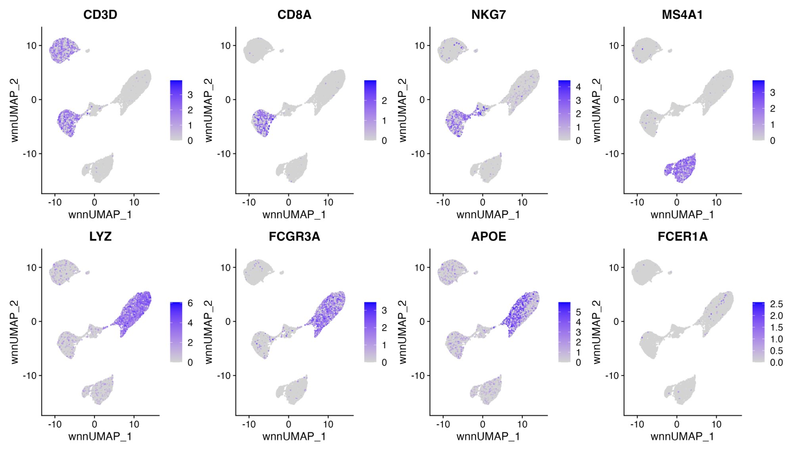
Figure 4C. FeaturePlots of eight key lineage markers on the immune WNN-UMAP.
Based on this convergent evidence, 18 immune cell types were annotated and three non-immune contamination clusters removed. The final annotated UMAP (Figure 5) shows clear spatial organization with labeled cell types.
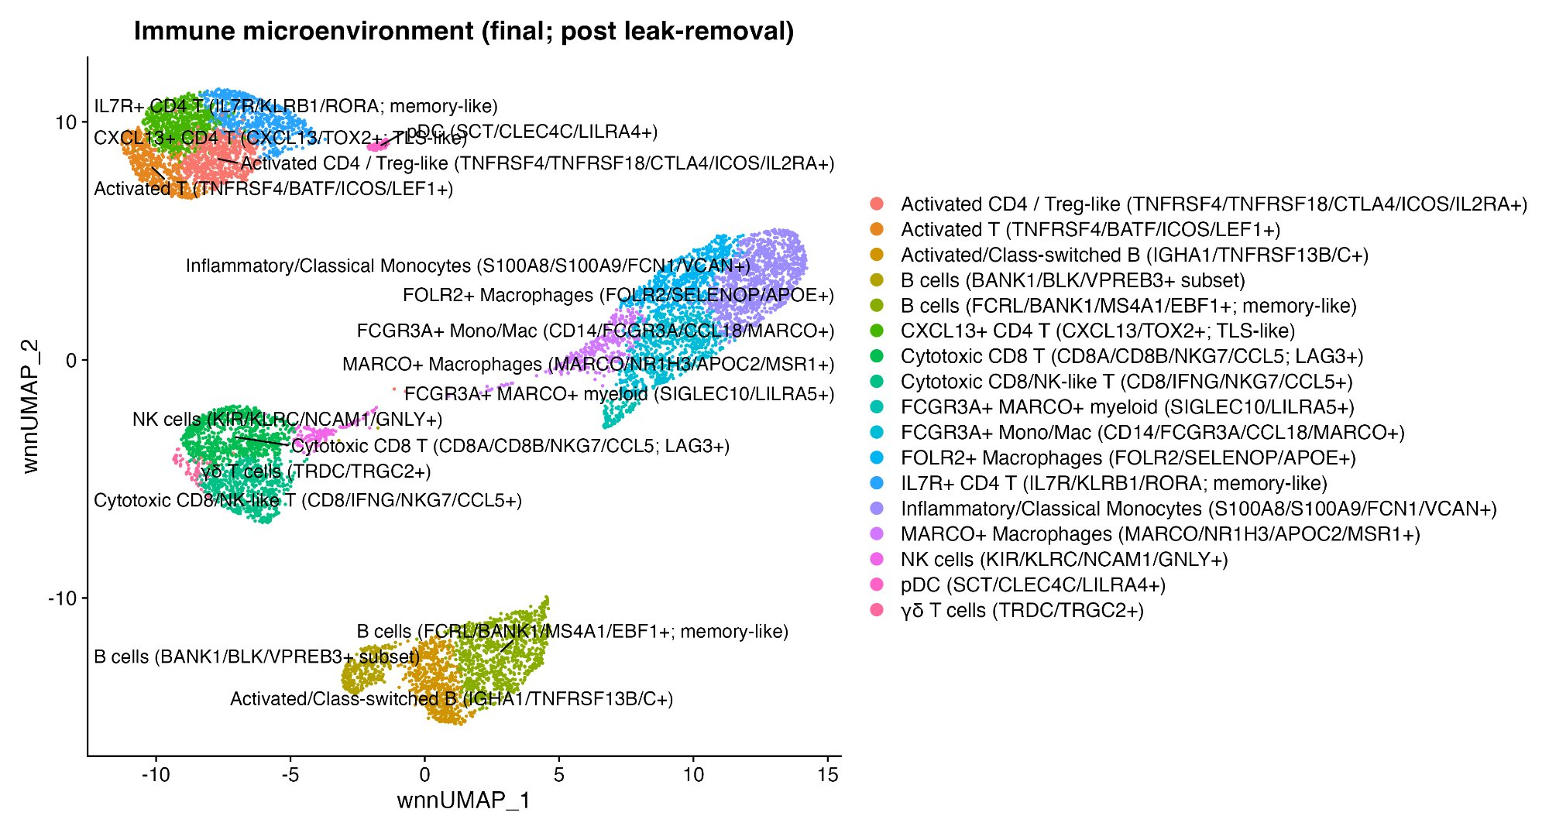
Figure 5. Final WNN-UMAP of the immune microenvironment (post leak-removal) showing 18 annotated cell populations.

3.6 Immune Cell Landscape: 18 Populations Identified
The 9,103 immune singlets were classified into 18 distinct populations. The T cell compartment comprised six subsets: IL7R+ memory CD4 T cells (636 cells, 7.0%), CXCL13+ TLS-like CD4 T cells (686 cells, 7.5%), activated CD4/Treg-like cells (712 cells, 7.8%), activated T cells (534 cells, 5.9%), cytotoxic CD8 T cells with LAG3 co-expression (834 cells, 9.2%), cytotoxic CD8/NK-like effector T cells (582 cells, 6.4%), and gamma-delta T cells (a small population). The B cell compartment included memory-like B cells (909 cells, 10.0%), a BANK1/BLK subset (308 cells, 3.4%), and activated/class-switched B cells (606 cells, 6.7%). The myeloid compartment comprised inflammatory/classical monocytes (1,151 cells, 12.6%), FCGR3A+ mono/mac (735 cells, 8.1%), FOLR2+ macrophages (651 cells, 7.2%), MARCO+ macrophages (268 cells, 2.9%), and a small FCGR3A+/MARCO+ myeloid subset. NK cells and pDCs formed distinct minor populations.

3.7 Immune Composition Varies Dramatically Across Donors
Stacked bar plots of cell-type proportions revealed the most striking inter-donor variation in this study (Figure 6). The seven donors exhibited fundamentally different immune TME architectures:
Donor 4 was dominated by B cells. Memory-like B cells constituted 31.7% of Donor 4’s immune cells (compared to 1.3–10.4% in other donors), with an additional 10.7% in the BANK1/BLK subset and 18.6% in activated/class-switched B cells. In total, over 60% of Donor 4’s immune infiltrate was B cell lineage. This B cell–dominated TME pattern is consistent with the presence of tertiary lymphoid structures (TLS) and has been associated with favorable prognosis and immunotherapy response in NSCLC in multiple published cohorts.
Donor 1 and Donor 2 were enriched for T cell populations. Donor 2 had the highest proportion of CXCL13+ CD4 T cells (20.2%), which are associated with TLS formation and anti-tumor immunity, alongside substantial cytotoxic CD8 T cells. Donor 1 had 12.3% CXCL13+ CD4 T cells and a balanced myeloid representation.
Donor 5 and Donor 6 were myeloid-enriched. Donor 5 had the highest proportion of inflammatory/classical monocytes, while Donor 6 showed expansion of FCGR3A+ monocyte/macrophage populations. These donors also had relatively lower B cell fractions.
Donor 3 showed an intermediate profile with moderate representation of all compartments, while Donor 7 had a T cell–skewed pattern with notable cytotoxic CD8 representation.
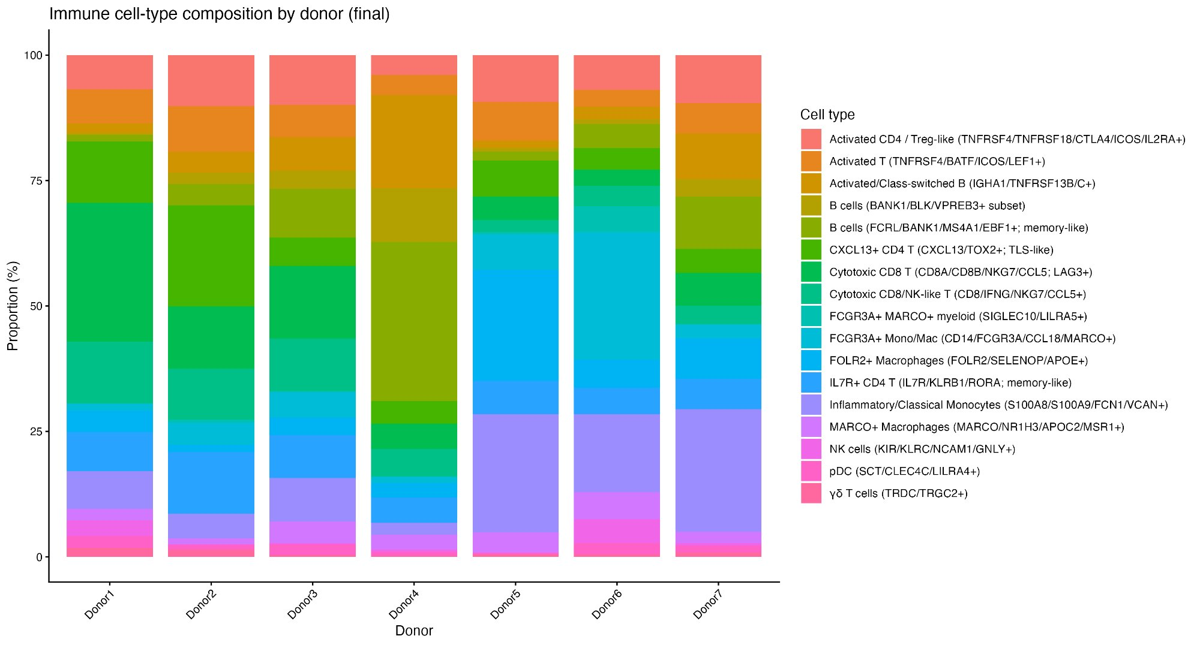
Figure 6. Immune cell-type composition by donor (percentage of immune cells). Note Donor 4’s B cell dominance.
Donor | Total Cells | T cells % | B cells % | Myeloid % | NK % | pDC % | Top Feature
Donor 1 | 937 | ~42% | ~4% | ~44% | ~5% | ~4% | Balanced
Donor 2 | 976 | ~48% | ~11% | ~32% | ~5% | ~4% | CXCL13+ T
Donor 3 | 1,210 | ~30% | ~20% | ~39% | ~5% | ~5% | Mixed
Donor 4 | 1,610 | ~18% | ~61% | ~16% | ~3% | ~2% | B cell rich
Donor 5 | 1,414 | ~38% | ~4% | ~49% | ~4% | ~5% | Myeloid hi
Donor 6 | 1,847 | ~27% | ~8% | ~55% | ~4% | ~5% | Myeloid hi
Donor 7 | 1,109 | ~38% | ~17% | ~35% | ~5% | ~5% | T cell rich
Table 1. Summary of immune cell counts and approximate compartment proportions per donor.

3.8 Immune State Program Spatial Distribution
Module score UMAP projections confirmed that all five immune programs localized to their expected biological compartments (Figure 7). The CYTOTOXICITY score was highest in NK cells and cytotoxic CD8 T cells, with minimal signal in B cells and myeloid cells. The EXHAUSTION score was specifically enriched in the CD8 T cell and activated CD4 T cell clusters, consistent with chronic antigen stimulation in the TME. The IFN/ISG score showed a broader pattern with focal enrichment in subsets of both T cells and myeloid cells, consistent with paracrine interferon signaling affecting multiple compartments. The INFLAM_MYELOID score was sharply restricted to the classical monocyte cluster. The TAM_MACRO score highlighted the FOLR2+ and MARCO+ macrophage populations, confirming that these represent tissue-resident, alternatively activated macrophage states.
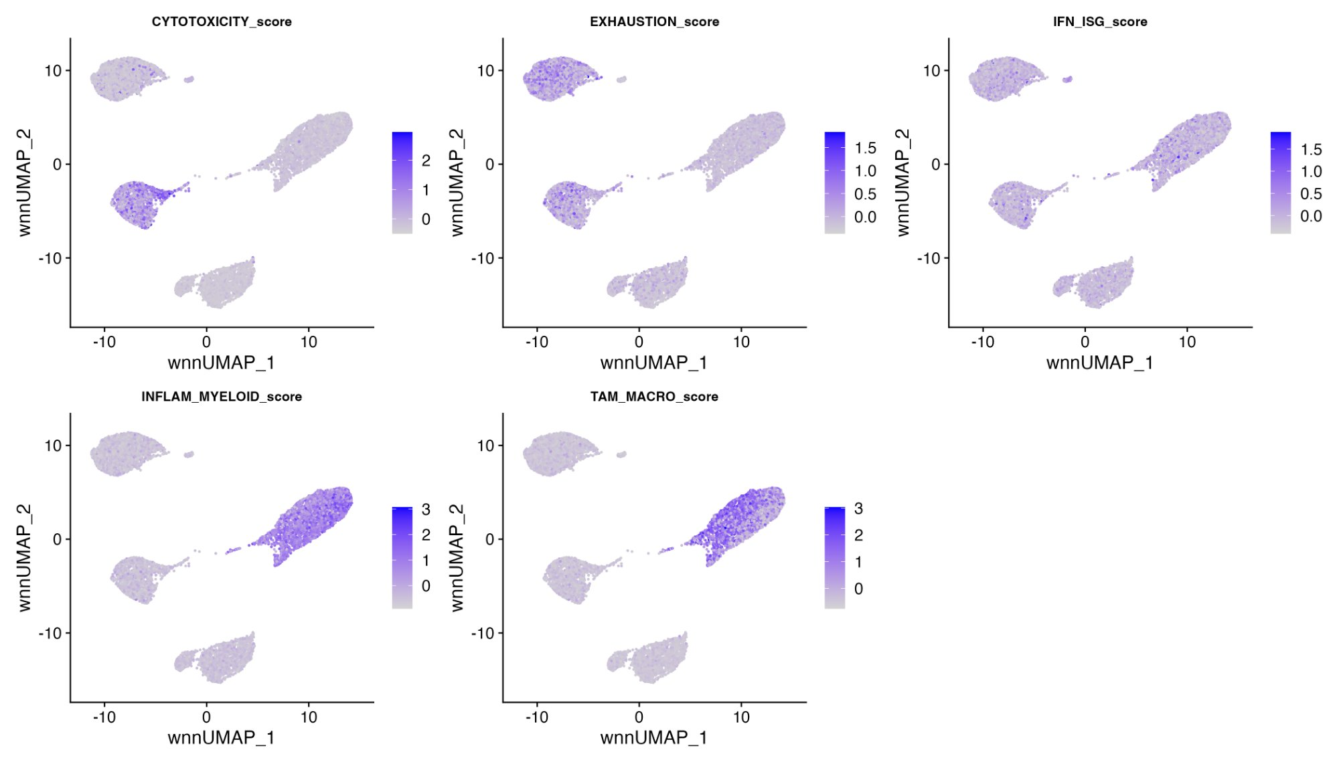
Figure 7. UMAP projections of five immune state module scores across the immune microenvironment.

3.9 Global Donor Comparison: All Immune Cells
Before stratifying by compartment, we first examined module score distributions globally across all immune cells per donor (Figure 8). This revealed that global comparisons are dominated by compositional effects: donors with more myeloid cells (Donor 5, 6) showed higher median INFLAM_MYELOID and TAM_MACRO scores, while donors with more T cells (Donor 1, 2) showed higher median CYTOTOXICITY and EXHAUSTION scores. This compositional confounding motivated the compartment-stratified analysis presented in subsequent sections, which isolates genuine functional variation from cell-type frequency differences.
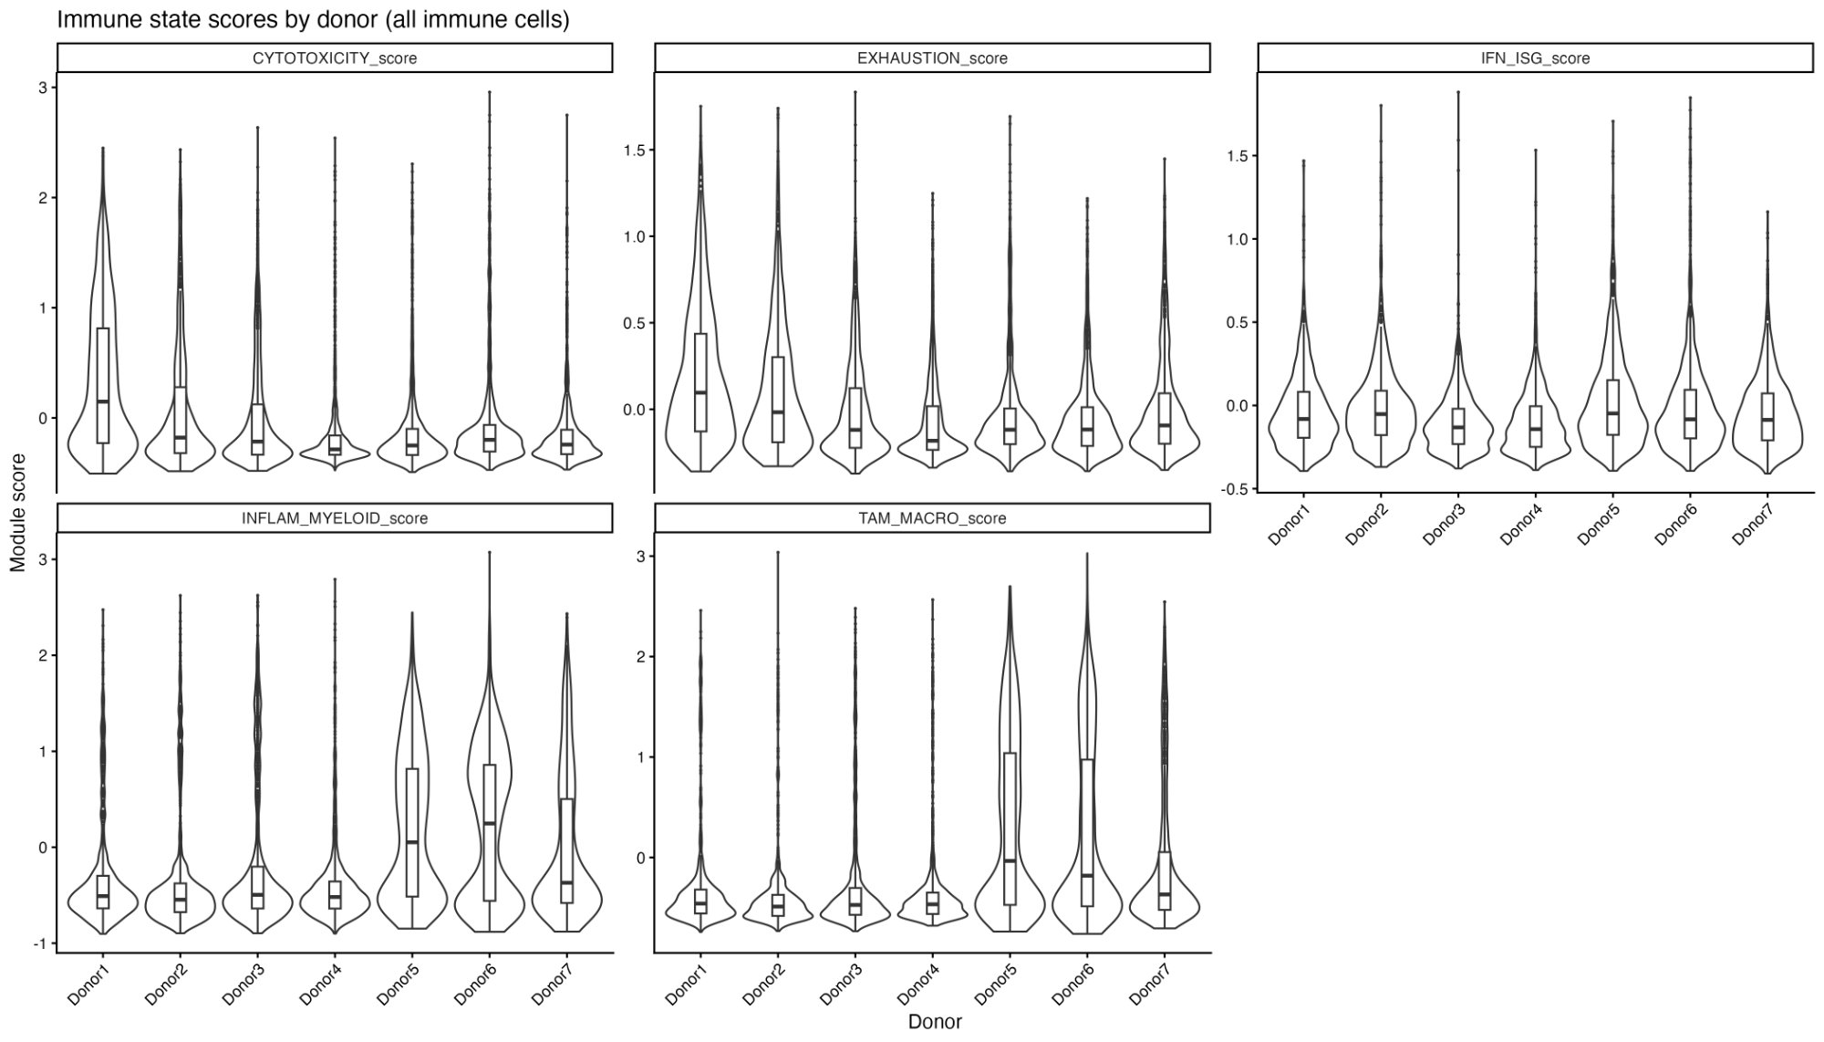
Figure 8. Global immune state scores by donor (all immune cells). Donor differences at this level reflect both compositional and functional variation.

3.10 Myeloid Leak Quality Control: A Critical Correction
Before performing compartment-stratified donor comparisons in T cells, we assessed whether ambient myeloid RNA could confound the results. A myeloid-leak module scored within T cells revealed substantial donor-dependent variation in myeloid contamination (Figure 9). Donor 3 and Donor 6 showed the highest myeloid-leak scores in their T cells, while Donor 4 showed the lowest (likely reflecting its B cell–dominated TME with less ambient myeloid RNA). This donor-dependent leak pattern could artifactually create or mask real inter-donor differences in T cell programs.
After removing T cells with myeloid-leak scores above the threshold (median + 2 SD), the T cell count decreased from 66 to 64 donor-level observations. Critically, the pre-leak and post-leak Kruskal–Wallis results differed: before correction, T cell cytotoxicity had p = 0.0033 and IFN/ISG had p = 0.10; after correction, cytotoxicity shifted to p = 0.0047 and IFN/ISG to p = 0.19. This demonstrates that the leak correction meaningfully affected the statistical inference and validates the importance of this quality control step.
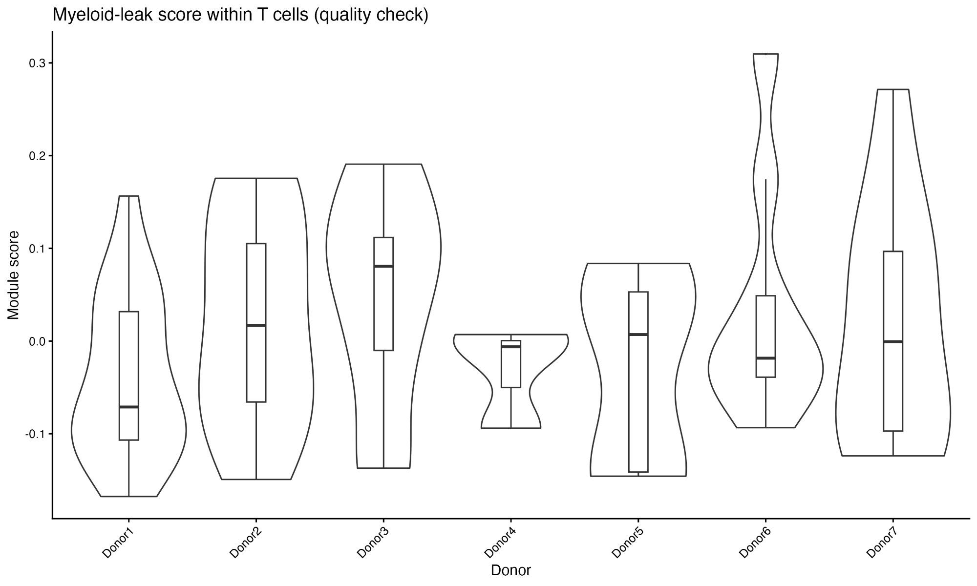
Figure 9. Myeloid-leak module scores within T cells by donor. Note the donor-dependent variation in ambient myeloid RNA contamination.

3.11 Donor-Level Heterogeneity Within Compartments: The Key Finding
The central analysis of this study examined module score distributions stratified by donor within the T cell and myeloid compartments (Figure 10). This compartment-stratified approach isolates genuine functional variation from the compositional confounding observed in the global analysis.
In the myeloid compartment (651 cells), all five programs showed visible donor-dependent patterns. For IFN/ISG, the boxplots showed a clear gradient from Donor 3/7 (lowest) to Donor 5 (highest), spanning a 0.18-unit range in median scores. For CYTOTOXICITY, Donor 2 had the highest myeloid cytotoxicity score while Donor 5 had the lowest. For INFLAM_MYELOID, Donor 3 showed the highest inflammatory activation while Donor 7 showed the lowest, with a 0.58-unit effect range—the largest absolute effect observed in this study. For TAM_MACRO, Donor 1 had the highest macrophage polarization score (median 1.29) while Donor 3 had the lowest (median 0.80), a 0.49-unit range.
In the T cell compartment (64 cells after leak correction), the patterns were more subtle. Cytotoxicity showed the most visible donor variation, with Donor 2 showing higher scores than Donor 3. Exhaustion, IFN/ISG, and myeloid-related programs showed minimal variation in T cells, consistent with their biological specificity to other compartments.
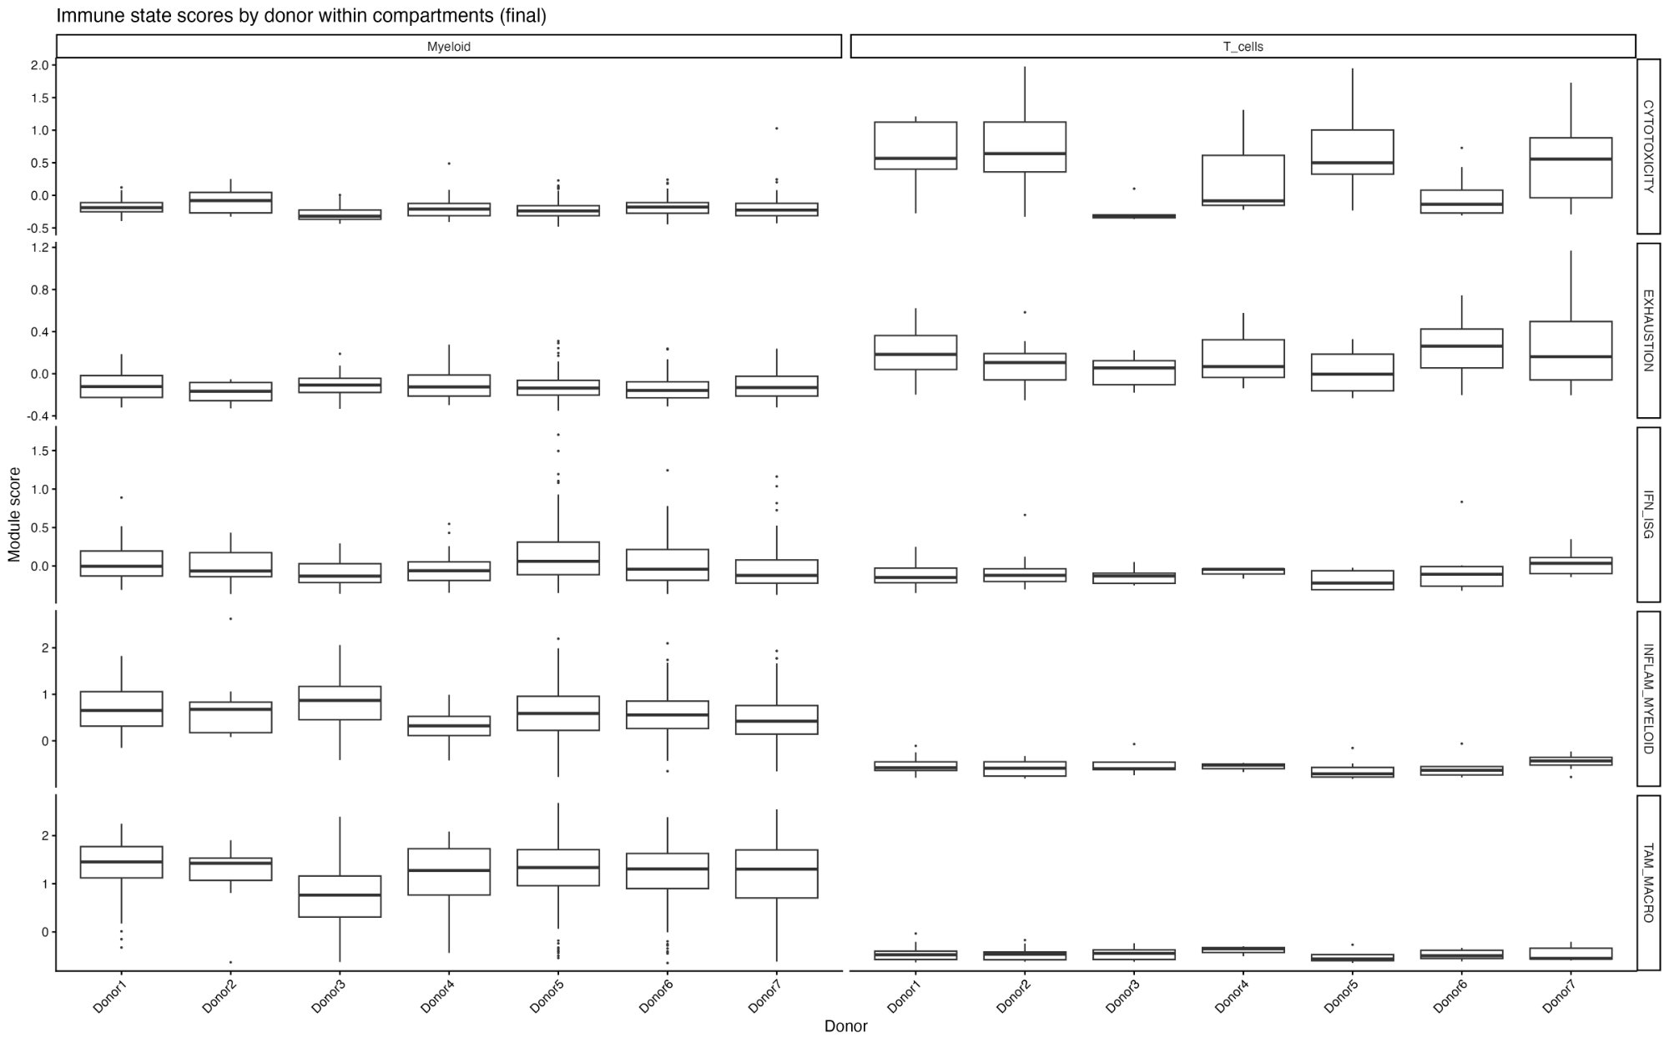
Figure 10. Immune state scores by donor within T cell and myeloid compartments (boxplots). Note the pronounced myeloid variation across all five programs.

3.12 Statistical Significance: Myeloid Compartment Dominates
Kruskal–Wallis testing confirmed the visual impression from the boxplots (Figure 11, Table 2). The myeloid compartment showed highly significant donor effects for all five programs:
Program | Compartment | N cells | p-value | –log10(p) | Donor Hi | Donor Lo
IFN_ISG | Myeloid | 651 | 1.27×10⁻⁸ | 7.9 | Donor 5 | Donor 7
CYTOTOXICITY | Myeloid | 651 | 3.27×10⁻⁶ | 5.5 | Donor 2 | Donor 5
INFLAM_MYELOID | Myeloid | 651 | 5.65×10⁻⁵ | 4.2 | Donor 3 | Donor 7
TAM_MACRO | Myeloid | 651 | 3.55×10⁻⁴ | 3.5 | Donor 1 | Donor 3
CYTOTOXICITY | T cells | 64 | 4.70×10⁻³ | 2.3 | Donor 1 | Donor 4
EXHAUSTION | Myeloid | 651 | 0.269 | 0.6 | Donor 1 | Donor 2
IFN_ISG | T cells | 64 | 0.190 | 0.7 | Donor 2 | Donor 4
INFLAM_MYELOID | T cells | 64 | 0.341 | 0.5 | Donor 5 | Donor 2
EXHAUSTION | T cells | 64 | 0.465 | 0.3 | Donor 1 | Donor 4
TAM_MACRO | T cells | 64 | 0.845 | 0.1 | Donor 5 | Donor 2
Table 2. Complete Kruskal–Wallis results for donor differences in immune state programs across all program–compartment combinations (post leak-correction).
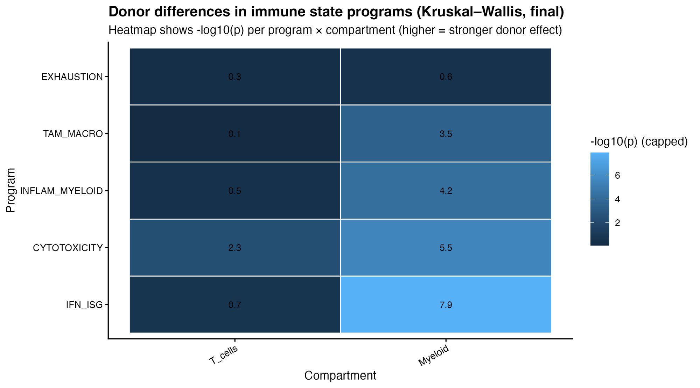
Figure 11. Heatmap of –log10(p) values from Kruskal–Wallis tests. Higher values (lighter color) indicate stronger donor effects. The myeloid compartment dominates.

3.13 Summary of Key Discoveries
Integrating across all analyses, the following key discoveries emerged from this study:
Discovery 1: Myeloid functional heterogeneity is the dominant axis of inter-donor variation in the NSCLC immune TME. All five scored programs showed significant Kruskal–Wallis p-values in myeloid cells (four of five with p < 0.001), while only one program (cytotoxicity) reached significance in T cells. This was not driven by sample size differences (651 myeloid vs. 64 T cells), as the myeloid effects were orders of magnitude more significant.
Discovery 2: IFN/ISG signaling in myeloid cells is the single most variable immune program across patients (p = 1.27 × 10⁻⁸, –log10(p) = 7.9). Donor 5 had the highest interferon-stimulated gene activity in its myeloid cells, while Donor 7 had the lowest. This interferon axis has direct implications for checkpoint inhibitor response, as interferon signaling promotes PD-L1 expression and antigen presentation.
Discovery 3: The NSCLC immune TME architecture varies fundamentally across patients. Donor 4 exhibited a B cell–dominated infiltrate (>60% B lineage), suggesting the presence of organized tertiary lymphoid structures. Other donors showed T cell–enriched (Donors 1, 2), myeloid-enriched (Donors 5, 6), or mixed (Donors 3, 7) architectures. These compositional archetypes may correspond to distinct prognostic or therapeutic categories.
Discovery 4: Myeloid ambient RNA contamination in T cells is donor-dependent and requires explicit correction. Without myeloid-leak filtering, T cell program scores are confounded by donor-varying levels of ambient myeloid RNA, leading to altered statistical conclusions. This finding has broad methodological implications for any single-cell study comparing cell-type-specific programs across donors.
Discovery 5: Within the myeloid compartment, different donors occupy different positions along the monocyte-to-macrophage polarization spectrum. Donor 3 showed the highest inflammatory myeloid activation (S100A8/S100A9/FCN1 axis) while simultaneously having the lowest TAM macrophage score, suggesting a predominantly monocytic myeloid infiltrate. Conversely, Donor 1 had the highest TAM_MACRO score, indicating a more macrophage-polarized myeloid compartment. This monocyte–macrophage balance has direct implications for myeloid-targeted therapy selection.

4. Discussion

4.1 Myeloid Heterogeneity as a Dominant Axis of TME Variation
The most striking finding of this analysis is that inter-donor variation in the NSCLC immune TME is overwhelmingly concentrated in the myeloid compartment. This finding has important clinical implications. Myeloid-targeted therapies, including CSF1R inhibitors, CD47/SIRPα blockade, and TLR agonists, are under active clinical development for NSCLC. Our data suggest that patients with distinct myeloid functional profiles may respond differentially to these agents. Patients with high IFN/ISG myeloid scores (like Donor 5) may have a more interferon-primed TME amenable to STING agonists or oncolytic virus strategies, while patients with high TAM_MACRO scores (like Donor 1) may benefit from macrophage reprogramming approaches.

4.2 IFN/ISG Signaling: The Strongest Donor Effect
The IFN/ISG program showed the most dramatic inter-donor variation in myeloid cells. Interferon signaling plays a dual role in the TME: type I interferon responses promote antigen presentation, T cell priming, and anti-tumor immunity, but chronic interferon signaling can also drive adaptive immune resistance and PD-L1 upregulation. The substantial variability we observed suggests that patients occupy different positions along this continuum. Future studies integrating clinical outcome data could test whether myeloid IFN/ISG status predicts anti-PD-1 response.

4.3 The B Cell–Dominated TME of Donor 4
Donor 4’s B cell–dominated immune infiltrate (>60% B lineage) is a particularly notable finding. In recent years, multiple studies have linked intratumoral B cells and tertiary lymphoid structures to improved NSCLC prognosis and immunotherapy response. The co-occurrence of memory-like B cells (31.7%), class-switched B cells (18.6%), and the BANK1/BLK subset (10.7%) in Donor 4 suggests a mature, organized B cell response that may include germinal center-like activity. This compositional archetype could represent a distinct prognostic category warranting further investigation with matched clinical data.

4.4 The Monocyte–Macrophage Polarization Axis
Our discovery that inflammatory myeloid activation and TAM macrophage polarization show inversely correlated donor patterns (Donor 3 highest INFLAM, lowest TAM; Donor 1 highest TAM, lowest INFLAM among the top-ranked effects) reveals a monocyte-to-macrophage differentiation axis along which different patients’ myeloid compartments are positioned. This gradient from inflammatory monocytes (S100A8/S100A9/FCN1-high) to tissue-resident TAMs (APOE/C1QA/TREM2-high) is well-characterized in the literature, but its inter-patient variability has not been systematically quantified in NSCLC using multi-modal data. This finding suggests that myeloid-targeted therapies should consider where each patient falls along this spectrum.

4.5 Methodological Lessons: The Importance of Leak Correction
The myeloid-leak quality control step (Steps 16–17) proved to be a critical safeguard. The observation that ambient myeloid RNA contamination in T cells varies by donor—likely reflecting differences in myeloid cell abundance and sample processing—means that uncorrected analyses would confound genuine T cell functional variation with donor-varying artifact. The fact that statistical results changed after correction (T cell cytotoxicity p-value shifted from 0.0033 to 0.0047; IFN/ISG from 0.10 to 0.19) demonstrates that this is not a theoretical concern but a practical one. We recommend that all single-cell studies comparing functional programs across donors incorporate analogous ambient RNA correction steps.

4.6 Limitations
Several limitations should be acknowledged. First, this analysis is based on seven donors, providing limited statistical power for moderate effect sizes. The Kruskal–Wallis tests are performed at the cell level, which inflates sample sizes and can yield significant p-values for biologically modest differences. Future work should complement cell-level statistics with donor-level analyses using larger cohorts. Second, we lack clinical metadata (stage, treatment history, smoking status, driver mutations) that could explain the observed inter-donor variation. Third, the five gene programs were literature-based rather than data-driven, potentially missing novel programs. Fourth, spatial context is lost in dissociated single-cell data, precluding assessment of cell–cell interactions. Fifth, the B/NK/DC compartments had limited cell numbers, preventing robust compartment-stratified statistics for these populations.

5. Conclusions
This multi-modal single-cell analysis of the NSCLC immune tumor microenvironment across seven donors, encompassing 9,103 high-quality immune cells and an 18-step computational pipeline, reveals five principal findings:
- The immune TME comprises 18 distinct cell populations identifiable through WNN integration of RNA and ADT data, spanning six T cell subsets, three B cell populations, four monocyte/macrophage subsets, NK cells, pDCs, and minor populations.
- Immune cell composition varies fundamentally across donors, with Donor 4 showing a B cell–dominated infiltrate (>60% B lineage) suggestive of tertiary lymphoid structures, while other donors exhibit T cell–enriched, myeloid-enriched, or mixed architectures.
- Myeloid functional heterogeneity is the dominant axis of inter-donor variation, with IFN/ISG signaling (p = 1.27 × 10⁻⁸), cytotoxicity (p = 3.27 × 10⁻⁶), inflammatory activation (p = 5.65 × 10⁻⁵), and TAM polarization (p = 3.55 × 10⁻⁴) all significantly different across donors.
- A monocyte–macrophage polarization gradient exists across patients, with some donors harboring predominantly inflammatory monocytic myeloid cells and others showing macrophage-polarized TAM-like myeloid infiltrates—a finding with direct implications for myeloid-targeted therapy selection.
- Myeloid ambient RNA leak correction is essential for reliable T cell program comparisons across donors, as donor-dependent contamination levels can confound or mask real functional differences.
Together, these findings provide a detailed, evidence-based map of immune TME heterogeneity in NSCLC, identify myeloid functional polarization as the primary axis of inter-patient variability, and highlight the B cell–dominated TME as a distinctive compositional archetype warranting further clinical correlation. These results have direct implications for patient stratification in the context of immunotherapy and myeloid-targeted therapeutic development.

References
1. Hao, Y. et al. Dictionary learning for integrative, multimodal and scalable single-cell analysis. Nature Biotechnology 42, 293–304 (2024).
2. Germain, P.-L. et al. Doublet identification in single-cell sequencing data using scDblFinder. F1000Research 10, 979 (2021).
3. Stuart, T. et al. Comprehensive integration of single-cell data. Cell 177, 1888–1902 (2019).
4. Zilionis, R. et al. Single-cell transcriptomics of human and mouse lung cancers reveals conserved myeloid populations. Immunity 50, 1317–1334 (2019).
5. Leader, A. M. et al. Single-cell analysis of human non-small cell lung cancer lesions refines tumor classification. Cancer Cell 39, 1594–1609 (2021).
6. Stoeckius, M. et al. Simultaneous epitope and transcriptome measurement in single cells. Nature Methods 14, 865–868 (2017).
7. de Visser, K. E. & Joyce, J. A. The evolving tumor microenvironment. Cancer Cell 41, 374–403 (2023).
8. Helmink, B. A. et al. B cells and tertiary lymphoid structures promote immunotherapy response. Nature 577, 549–555 (2020).
9. Kruskal, W. H. & Wallis, W. A. Use of ranks in one-criterion variance analysis. JASA 47, 583–621 (1952).

Supplementary Figures

Supplementary Figure S2. RNA PCA elbow plot showing variance explained per principal component.
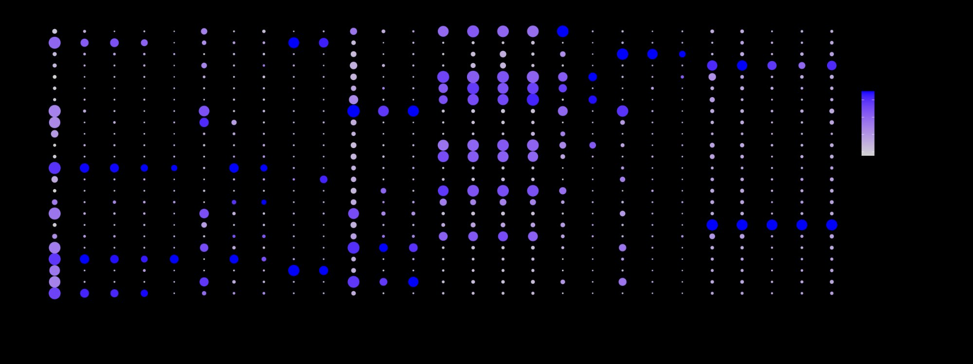
Supplementary Figure S3. DotPlot of immune, epithelial, endothelial, and fibroblast markers across all clusters for immune vs. non-immune discrimination.

