Seller & Inventory Management System
Flipkart Database Project
Ganesh Ram, Kamaraj College, Thoothukudi
This part of the project adds sellers and inventory tracking to the Flipkart database. Every product on Flipkart is actually supplied by some seller, and that seller needs to know how much stock is left for each product. This document explains the tables built for that, how they connect to the Product table from the earlier phase, and what the sample data and reports look like.
1. Seller & Inventory Table Design
The Seller table holds the basic details of a seller: who they are and how to reach them. Each seller gets a unique ID that other tables can point back to.
Column | Data Type | Constraint
Seller_ID | INT | Primary Key, Auto Increment
Seller_Name | VARCHAR(100) | Not Null
Email | VARCHAR(100) | Not Null, Unique
Phone | VARCHAR(15) | Not Null, Unique
Address | VARCHAR(255) | Not Null
The Inventory table keeps track of how many units of a product a seller currently has. It is kept separate from the Product table because the same product can be listed by more than one seller, each with their own stock count.
Column | Data Type | Constraint
Inventory_ID | INT | Primary Key, Auto Increment
Product_ID | INT | Foreign Key -> Product, Not Null
Seller_ID | INT | Foreign Key -> Seller, Not Null
Stock_Quantity | INT | Not Null, Check (>= 0)
Stock_Status | VARCHAR(20) | Not Null, Check (In Stock / Out of Stock / Low Stock)
Last_Updated | DATE | Not Null

To connect sellers to products, a Seller_ID column was added to the existing Product table with a foreign key pointing to Seller. This means one seller can supply many products, and one product (through the Inventory table) can have many stock records, one for each seller who sells it.
How the constraints are used
- Primary Key: gives every seller and every inventory row a unique identity (Seller_ID, Inventory_ID).
- Foreign Key: keeps Product linked to a real Seller, and Inventory linked to a real Product and Seller.
- Not Null: makes sure important details like name, email, and stock quantity are never left empty.
- Unique: stops two sellers from registering with the same email or phone number.
- Check: makes sure stock quantity can never go negative, and stock status is always one of the three allowed values.
2. Updated ER Diagram
The diagram below shows how the three tables are connected. A seller can supply many products, and each product can have many inventory entries (one for every seller stocking it).
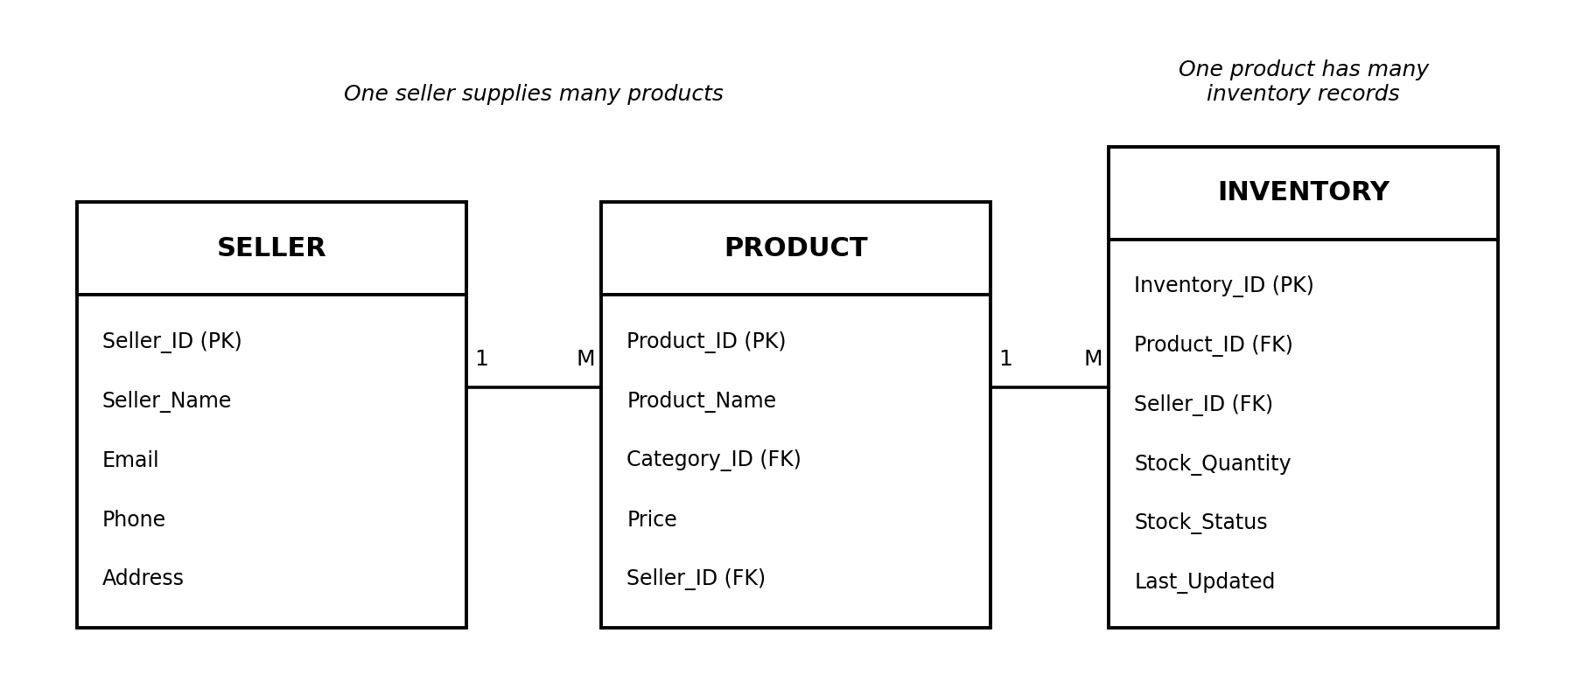
3. Sample Seller & Inventory Data
Sellers added for testing:
Seller_ID | Seller_Name | Email | Phone | Address
1 | Sri Electronics | srielectronics@gmail.com | 9840012345 | Chennai
2 | Fashion Hub | fashionhub@gmail.com | 9840012346 | Coimbatore
3 | Home Needs Store | homeneeds@gmail.com | 9840012347 | Madurai
4 | Gadget World | gadgetworld@gmail.com | 9840012348 | Bengaluru
5 | Trendy Wears | trendywears@gmail.com | 9840012349 | Hyderabad

Inventory records added for testing:
Product | Seller | Stock Qty | Status | Last Updated
Samsung Galaxy M14 | Sri Electronics | 50 | In Stock | 2026-09-20
boAt Airdopes 141 | Sri Electronics | 0 | Out of Stock | 2026-09-18
Mi Power Bank 20000mAh | Sri Electronics | 8 | Low Stock | 2026-09-21
Dell Inspiron Laptop | Gadget World | 15 | In Stock | 2026-09-19
Puma Running Shoes | Fashion Hub | 30 | In Stock | 2026-09-22
Levis Denim Jeans | Fashion Hub | 5 | Low Stock | 2026-09-20
Fastrack Wrist Watch | Trendy Wears | 0 | Out of Stock | 2026-09-17
Prestige Mixer Grinder | Home Needs Store | 20 | In Stock | 2026-09-23
Philips Air Fryer | Home Needs Store | 12 | In Stock | 2026-09-21
LG Microwave Oven | Home Needs Store | 3 | Low Stock | 2026-09-19
4. Inventory Analysis Report
Looking at the 10 inventory records added, here is what the data shows in simple terms:
- 5 products are currently In Stock.
- 3 products are Low Stock (fewer than 10 units left).
- 2 products are completely Out of Stock (boAt Airdopes 141 and Fastrack Wrist Watch).
- The highest stocked product is the Samsung Galaxy M14 with 50 units, sold by Sri Electronics.
- The average stock quantity across all 10 records works out to 14.3 units.
The two out-of-stock records above were also the oldest ones that had not been updated in several days, so the cleanup query in the script removes exactly those two rows to keep the inventory table current.
Report | Result
Total products In Stock | 5
Total products Out of Stock | 2
Total products Low Stock | 3
Highest stocked product | Samsung Galaxy M14 (50 units)
Average inventory quantity | 14.3 units
5. Query Output Screenshots
This section is meant to hold screenshots taken after actually running Seller_Inventory_Management.sql in MySQL Workbench (or a similar tool). Run each query one by one and paste a screenshot of its result below the matching heading before submitting:
- Products supplied by each seller
- Count of products supplied by each seller
- Available (In Stock) products
- Out-of-stock products
- Products with stock less than 10
- Seller-wise product report
- Stock availability report (count by status)
- Highest stocked product and average inventory quantity

