Networking Basics Teaching Guide
A detailed beginner-friendly handbook with visual explanations for classroom teaching
Audience | Students and beginners learning core networking concepts
Coverage | Definitions, models, addressing, protocols, traffic flow, security, and troubleshooting

How to Use This Guide
- Teach from simple to complex: start with what a network is, then move into addressing, protocols, and troubleshooting.
- Use the diagrams to pause and explain the flow, not just the definitions. Students usually remember pictures faster than terms.
- The guide is written so you can teach it as a single session or split it across multiple classes.

Suggested Teaching Sequence
1. Introduction to networking and why it matters
2. Types of networks and topologies
3. Devices, media, and basic communication flow
4. IP addressing, subnetting basics, DNS, and DHCP
5. OSI model, TCP/IP model, and transport protocols
6. Ports, packet delivery, security, and troubleshooting

Networking Fundamentals

What Networking Means
Networking is the process of connecting devices so they can exchange data and share services such as internet access, files, printers, and applications. The idea is simple: one device creates or requests data, and another device receives or provides it.

Where Students See It
Students already use networking every day when they browse a website, join a video call, print from a lab computer, stream content, or send a message from a phone. Anchoring the topic in these normal actions makes the technical terms easier to understand.
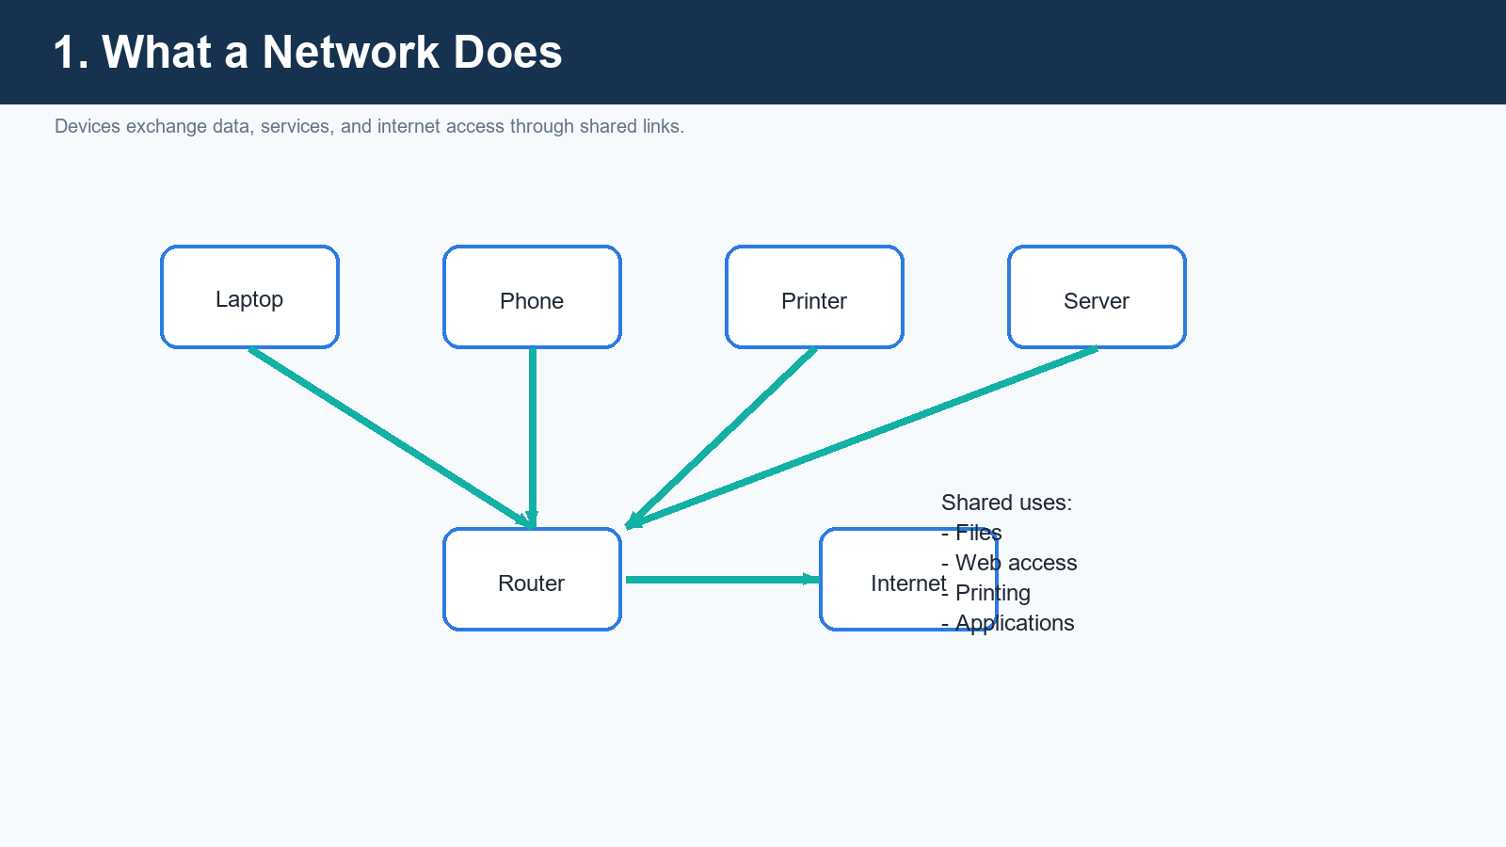
Figure 1. A network lets devices share resources and services.

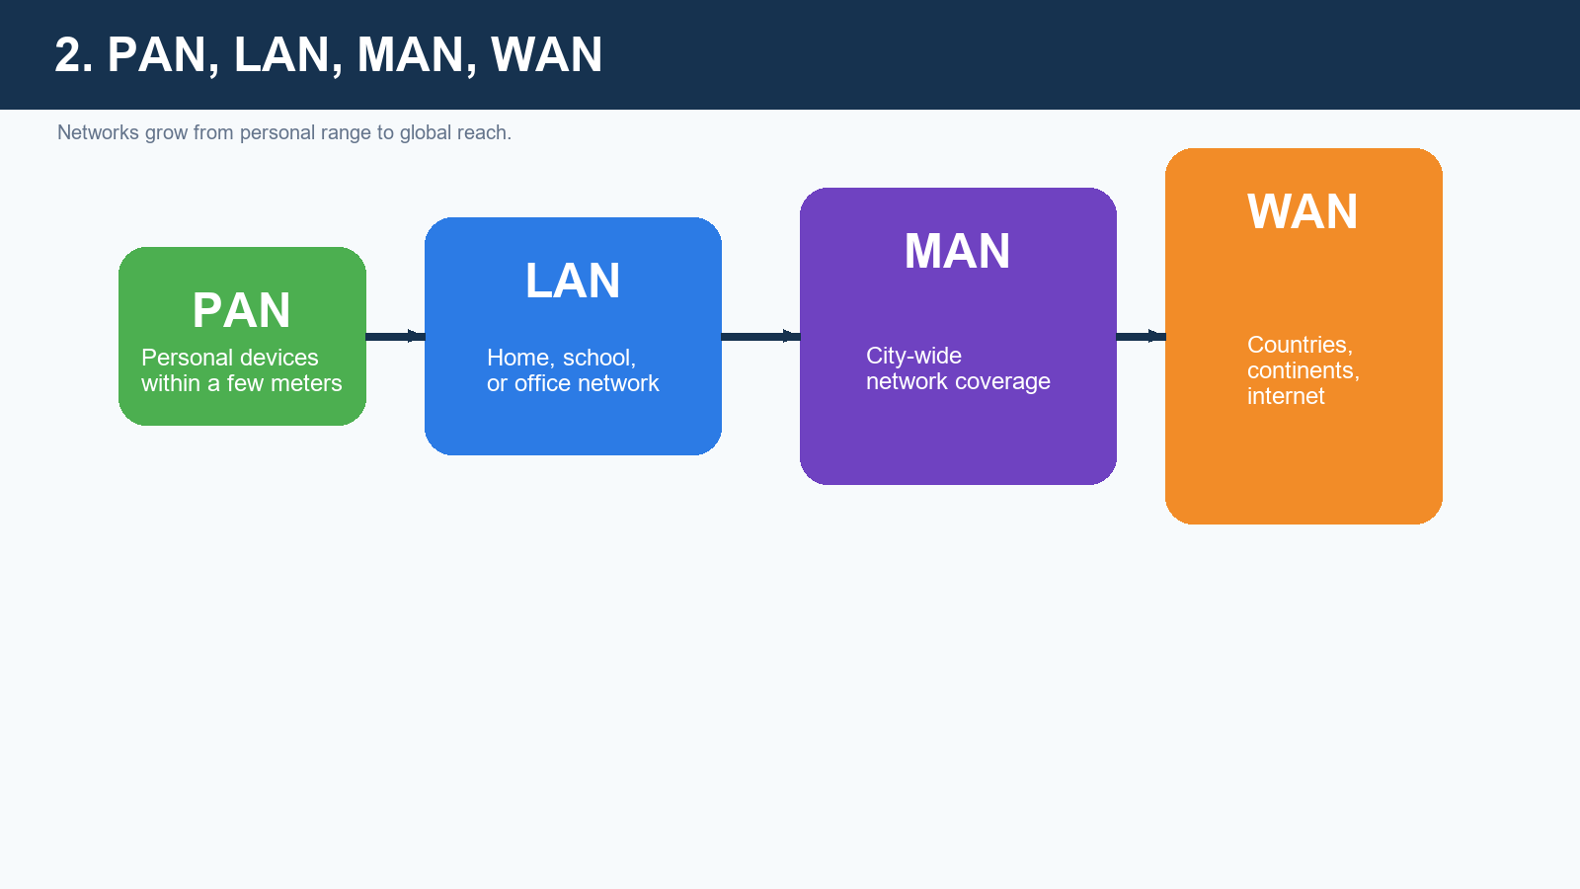
Figure 2. PAN, LAN, MAN, and WAN describe network size and reach.

Layouts and Devices

Topologies
A topology is the shape or arrangement of a network. It affects cost, maintenance, growth, and what happens when one link fails. Star topology is common in modern LANs because it is easier to manage than bus or ring layouts.

Devices
Devices in a network have different jobs. A switch moves traffic inside the same LAN, a router connects one network to another, a modem links the local site to the internet provider, and an access point adds Wi-Fi. A firewall applies security rules to traffic.

Media
Traffic can travel over copper cable, fiber optic cable, or wireless radio waves. Wired media is usually steadier and faster. Wireless media is more flexible and easier to move around with.
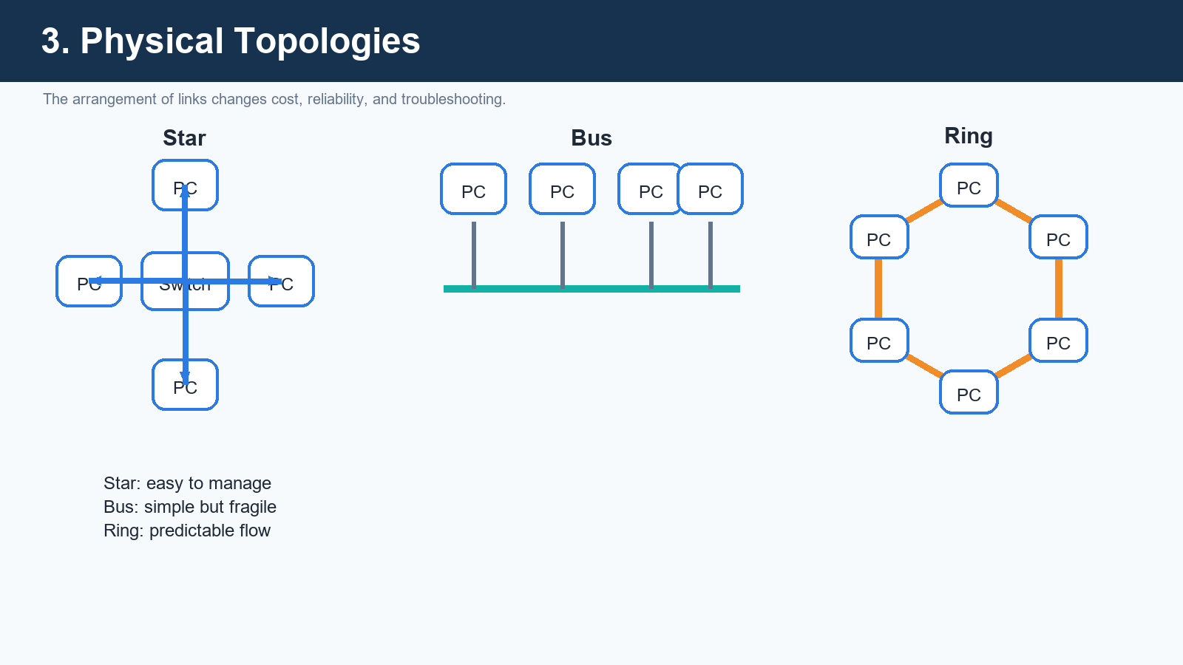
Figure 3. Common topologies change how devices are arranged and how failures spread.

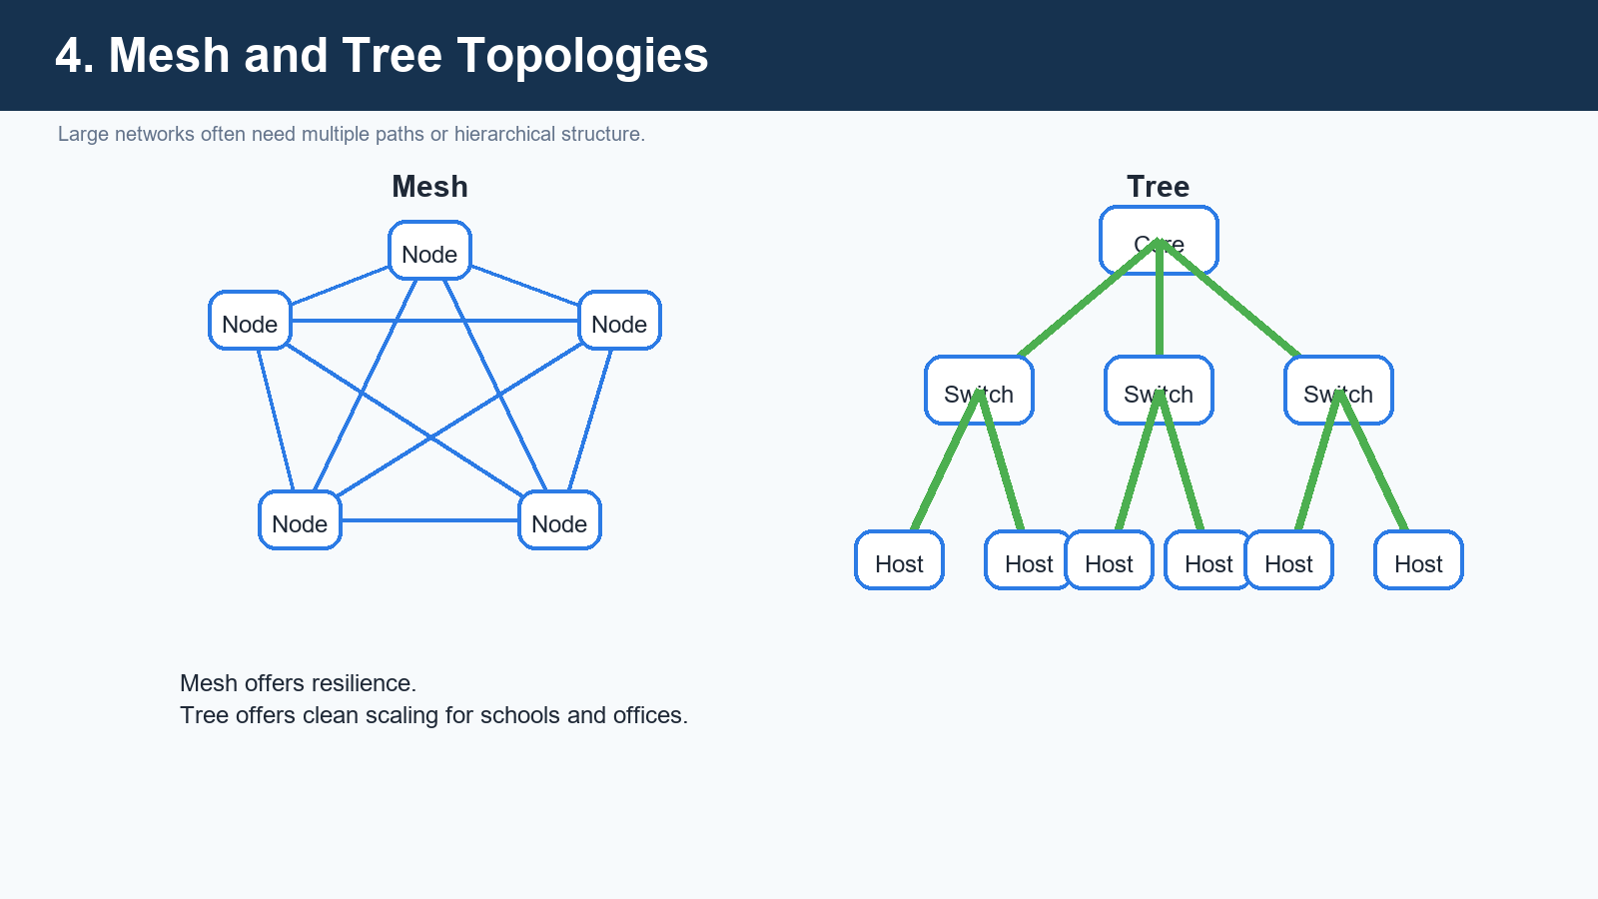
Figure 4. Mesh favors resilience; tree favors organized growth.

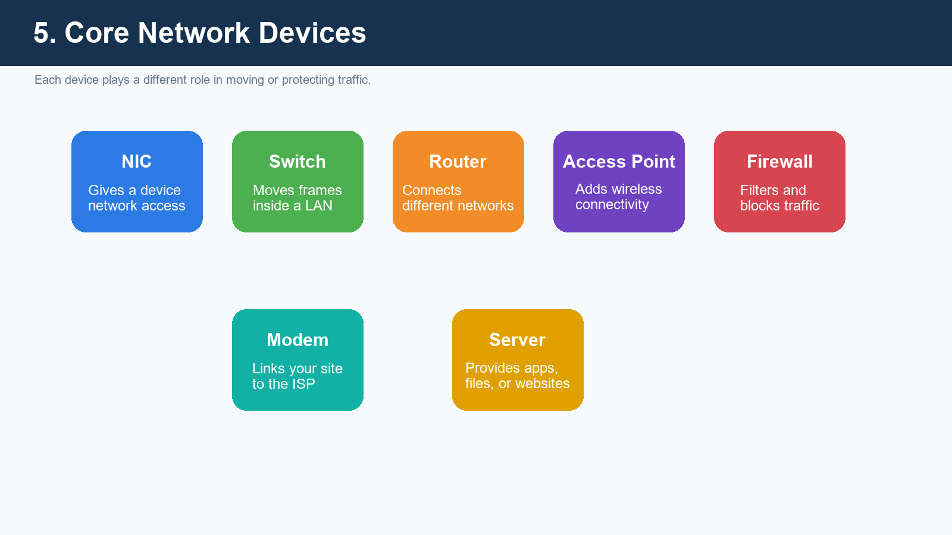
Figure 5. Switches, routers, firewalls, and access points each solve different jobs.

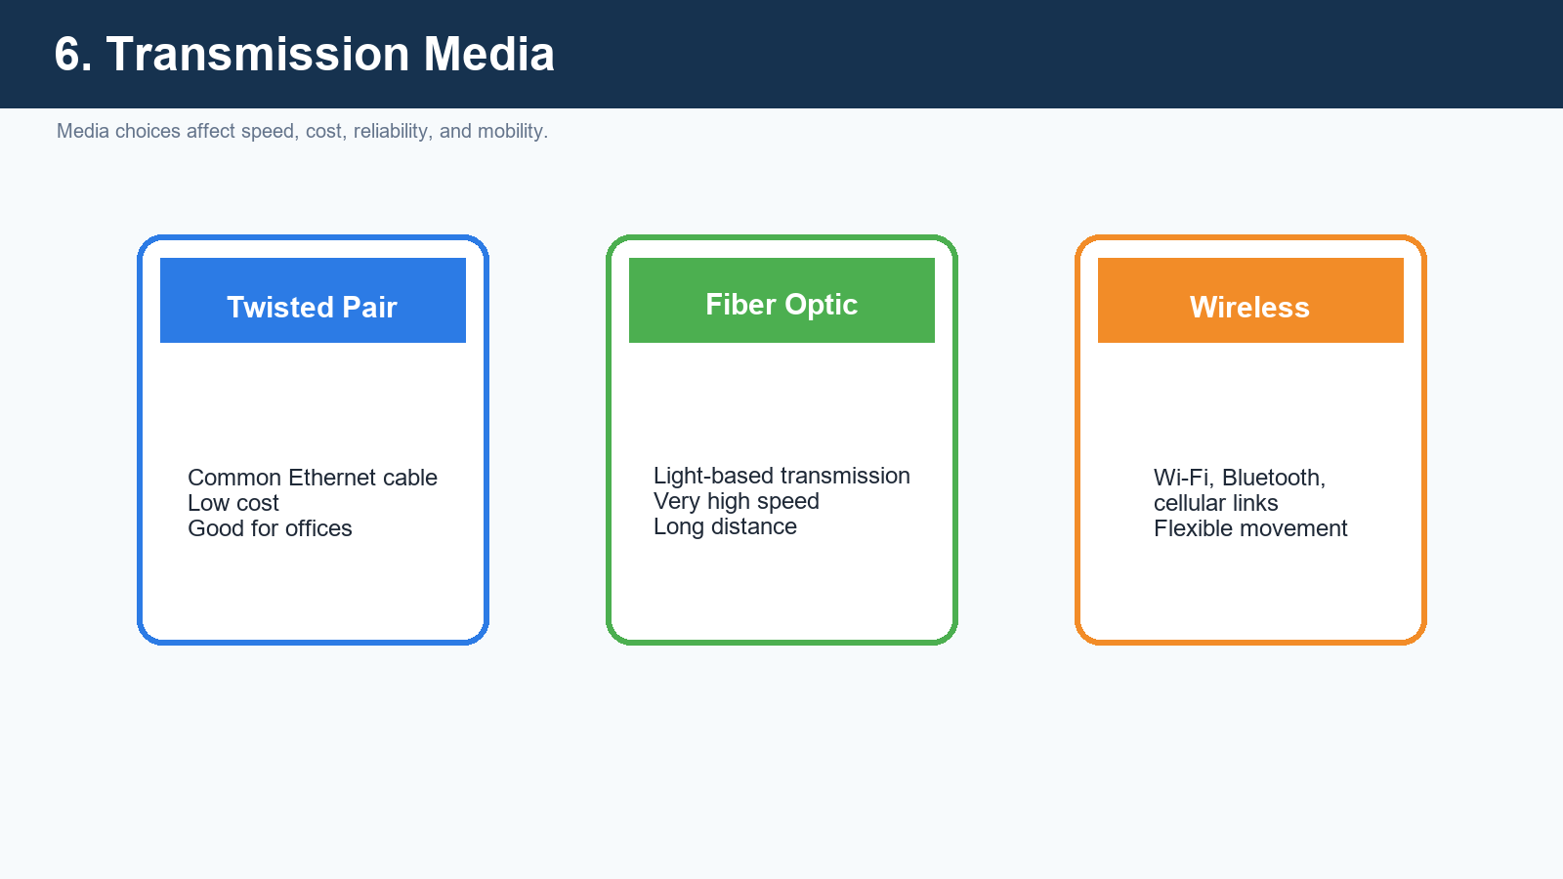
Figure 6. Wired and wireless media carry traffic with different tradeoffs.

Models and Communication Patterns

Client-Server and Peer-to-Peer
In the client-server model, users ask for resources from a central server. In peer-to-peer networking, devices can share directly with each other. Client-server is more common in schools, offices, and web applications because it is easier to secure and manage.

OSI and TCP/IP
The OSI model is a teaching model with seven layers, while the TCP/IP model is the practical model used by the internet. Both models help students understand where each protocol belongs and where problems may occur.

Encapsulation
As data moves down the stack, each layer adds its own control information. This is why the same message is called data, then a segment, then a packet, then a frame depending on the layer being discussed.
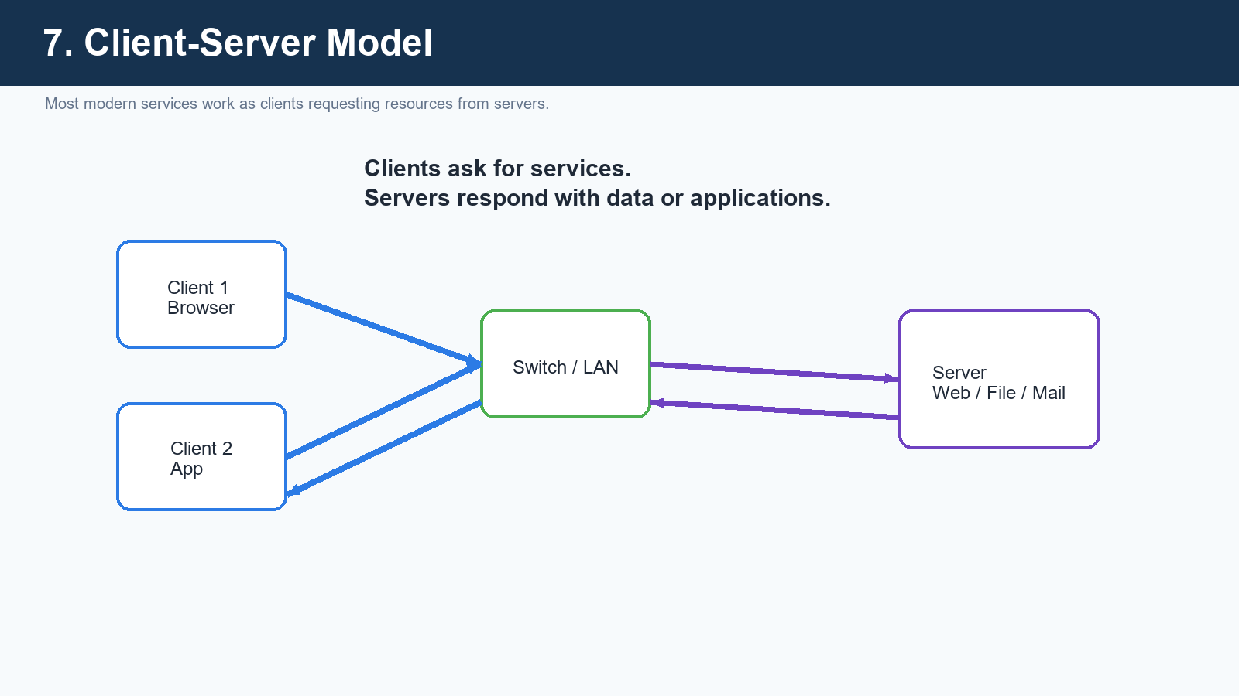
Figure 7. Clients send requests; servers answer with services and data.

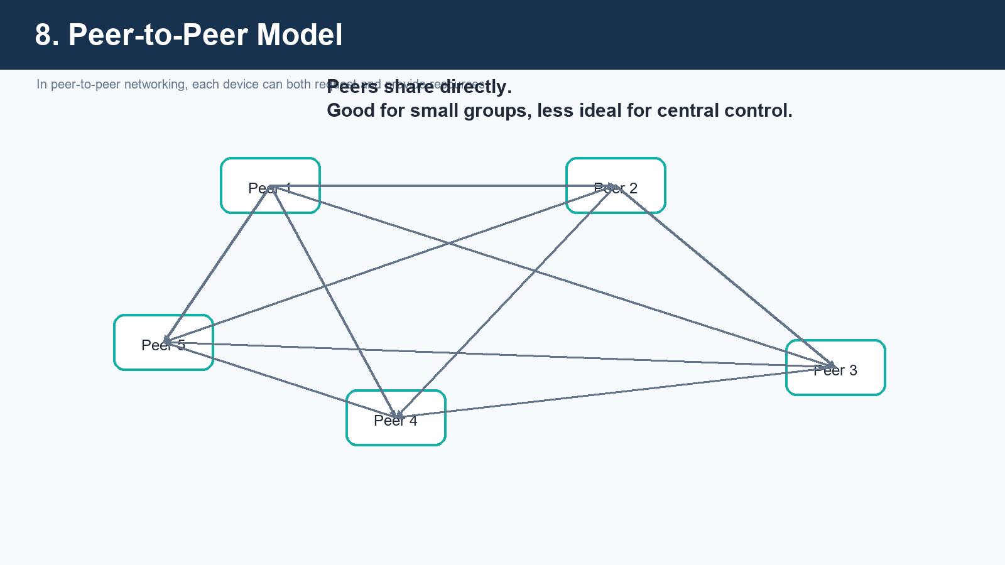
Figure 8. Peer-to-peer networks share resources directly without a central server.

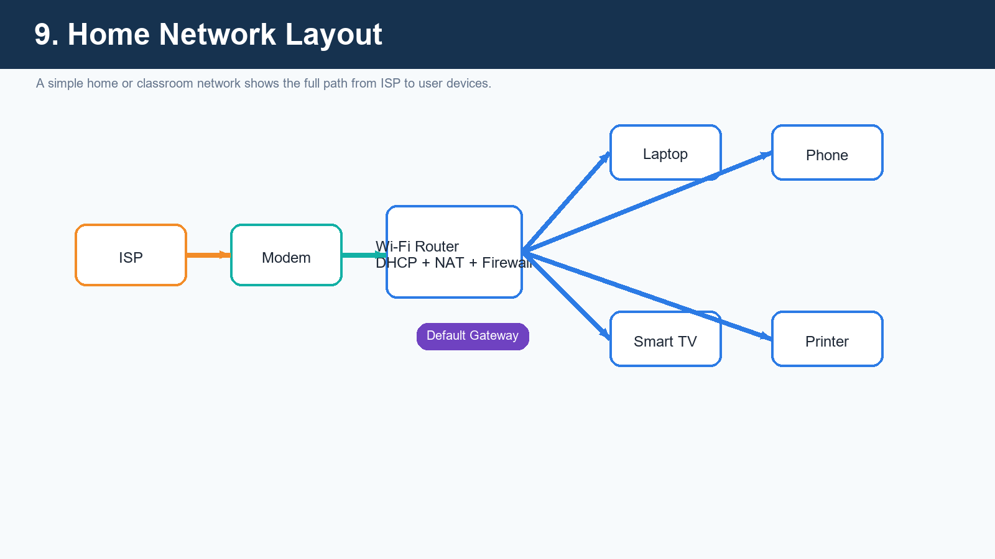
Figure 9. A home network typically centers around one router providing multiple services.

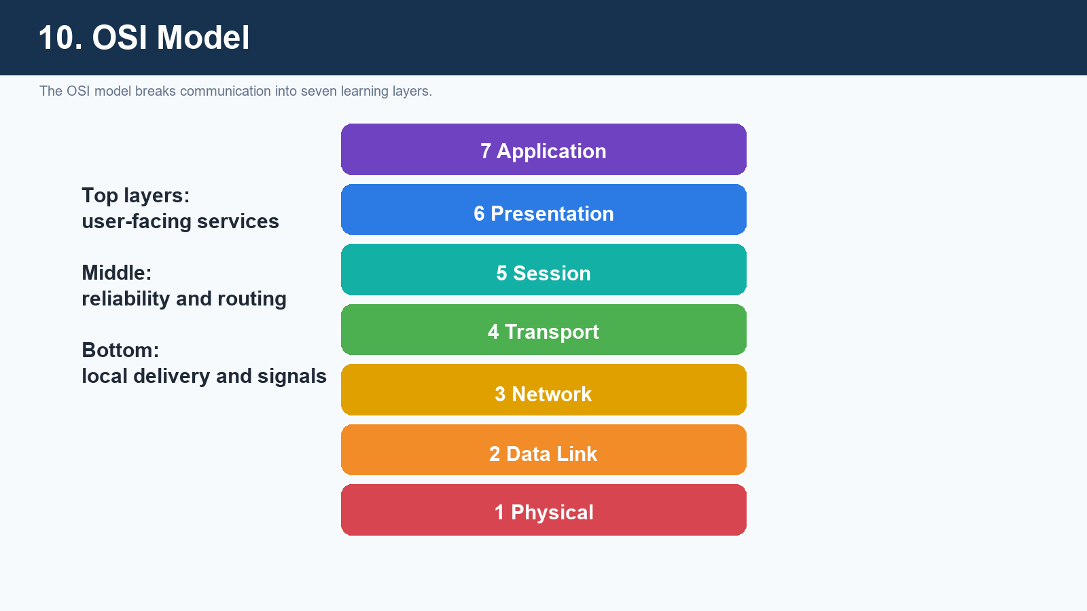
Figure 10. OSI is a teaching model that explains communication layer by layer.

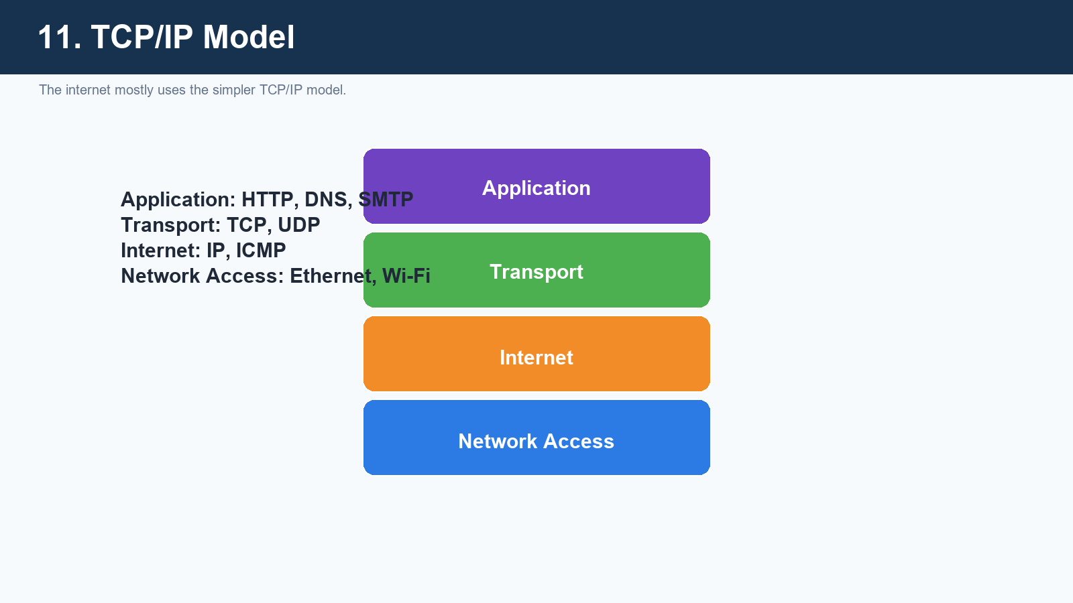
Figure 11. TCP/IP is the practical model used by the internet.

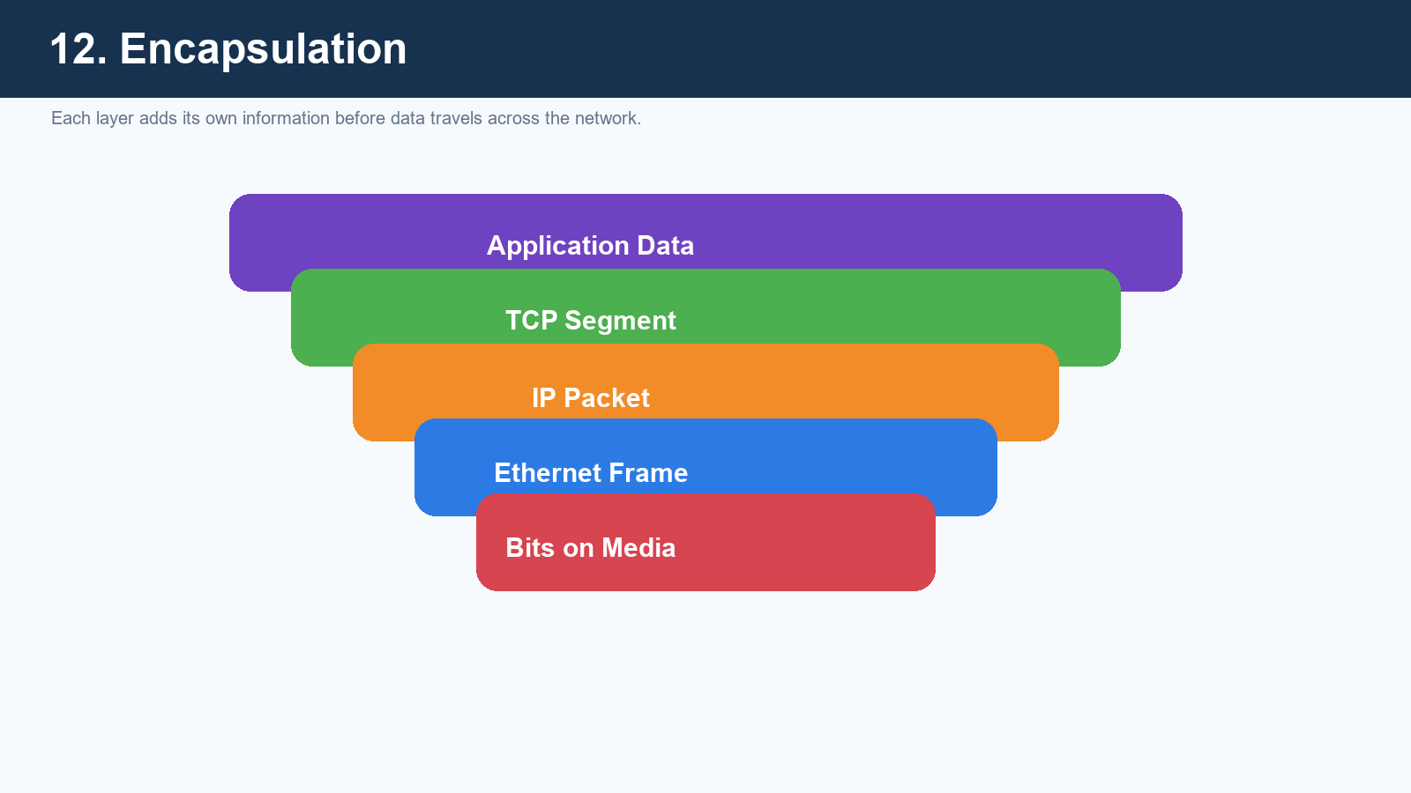
Figure 12. Data becomes segments, packets, frames, and finally signals.

Addressing and Core Services

IP and MAC Addresses
An IP address is a logical address used to identify a host on a network, while a MAC address is the physical hardware address used mainly for local delivery. A helpful teaching line is: IP says where the device is, MAC says who the device is.

Subnet Mask and Gateway
The subnet mask separates the network portion from the host portion of an address. The default gateway is the route a device uses when the destination is outside the local network.

DNS and DHCP
DNS converts human-friendly names into IP addresses, and DHCP automatically provides IP settings such as address, mask, gateway, and DNS server. These two services remove a huge amount of manual effort from networking.
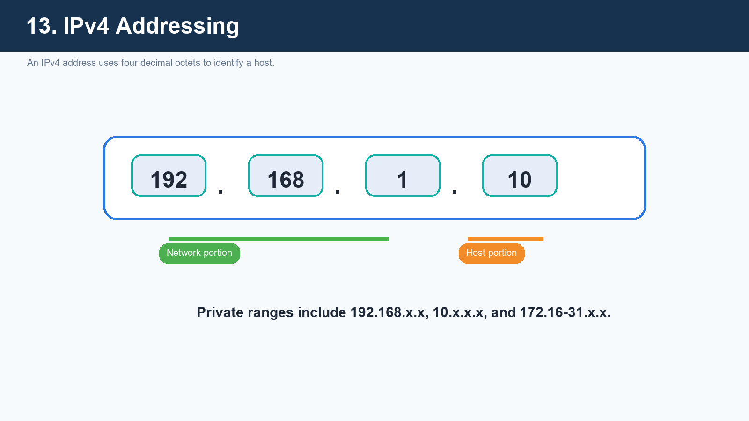
Figure 13. IPv4 addresses use four octets with network and host portions.

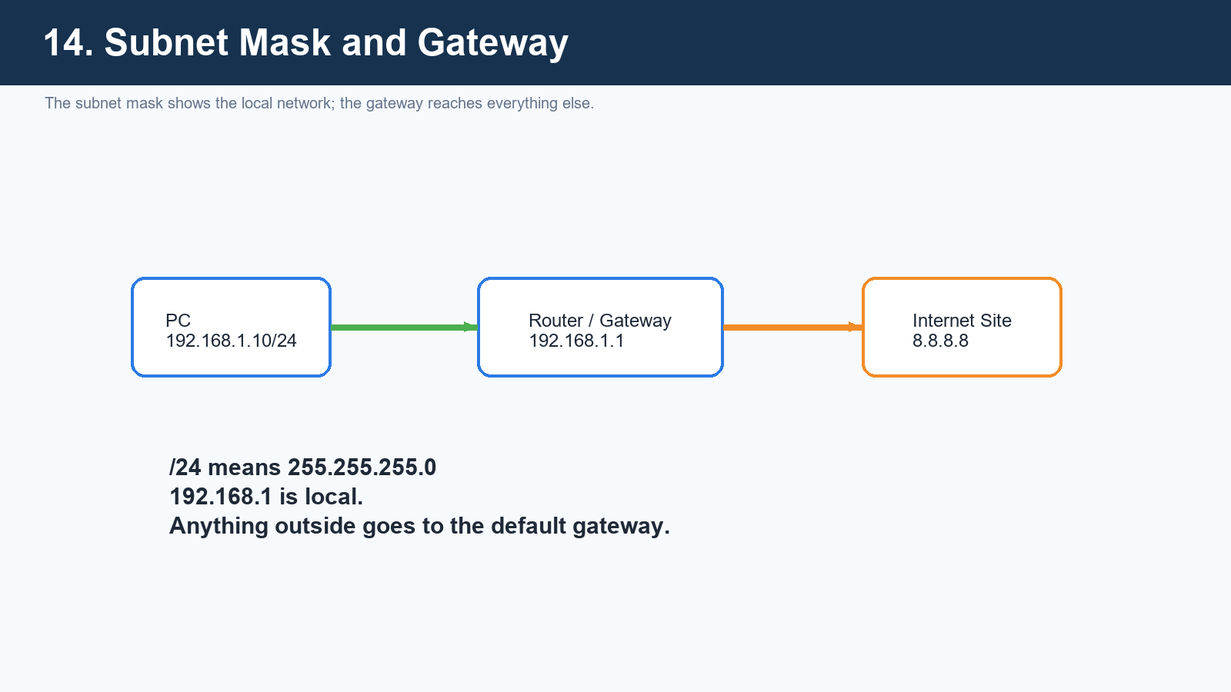
Figure 14. Subnet masks define the local range; gateways forward to remote networks.

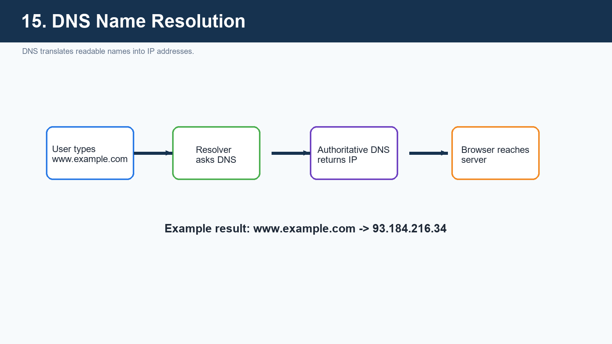
Figure 15. DNS is the internet's naming system.

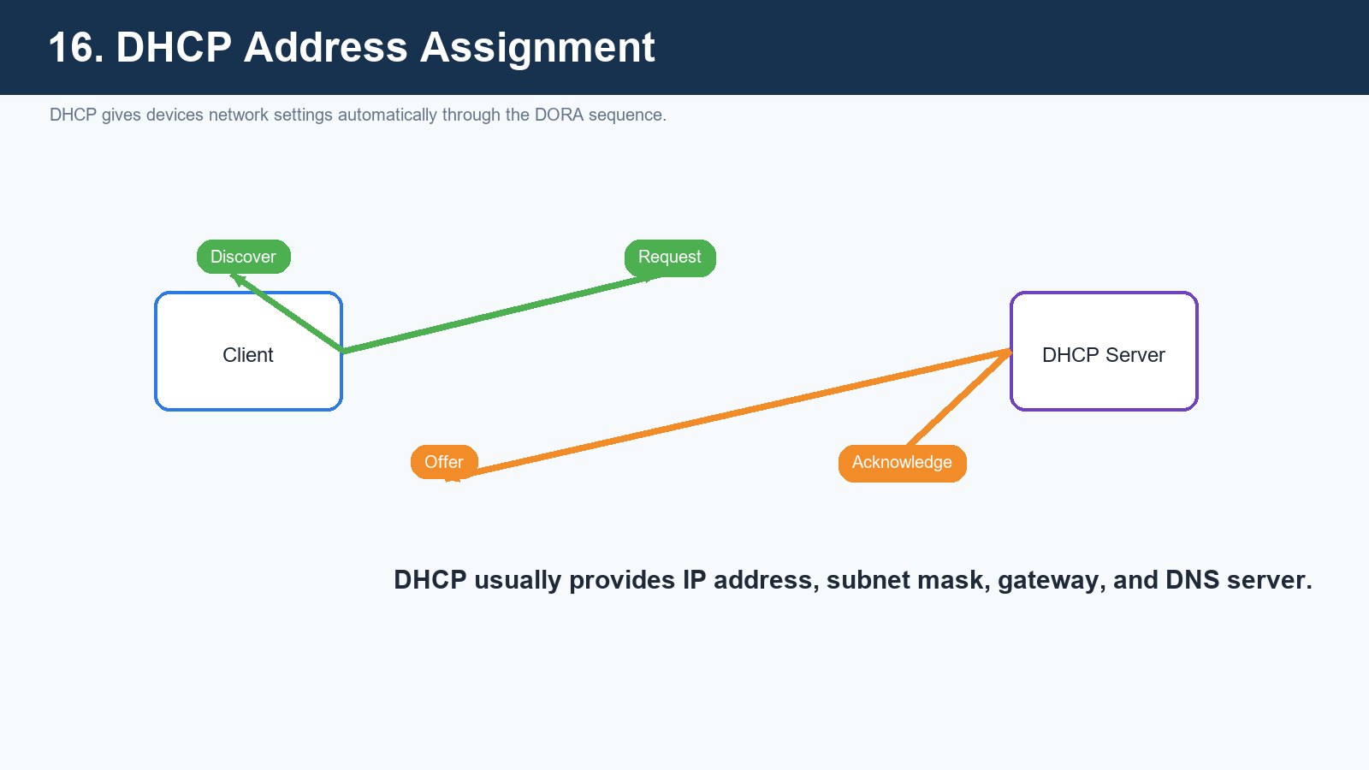
Figure 16. DHCP automates IP setup through Discover, Offer, Request, and Acknowledge.

Traffic Movement and Protocols

Switching and Routing
Switching happens inside a local network and relies heavily on MAC addresses. Routing happens between different networks and relies on IP addresses and routing decisions.

TCP and UDP
TCP builds a reliable conversation with acknowledgements, retransmissions, and ordered delivery. UDP sends quickly with less overhead, which is why it is useful for live audio, video, and gaming.

Ports and Sockets
Ports let a single device offer many services at once. A socket combines an IP address and port number, such as 192.168.1.20:443.

Packet Journey
When a user opens a website, the browser may query DNS, the host creates packets, routers forward the traffic, the server responds, and the browser rebuilds the content into a visible page.
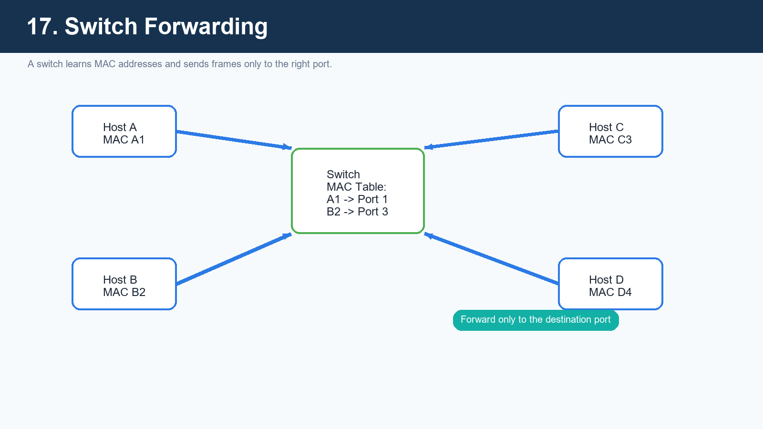
Figure 17. Switches use MAC tables to avoid sending every frame everywhere.

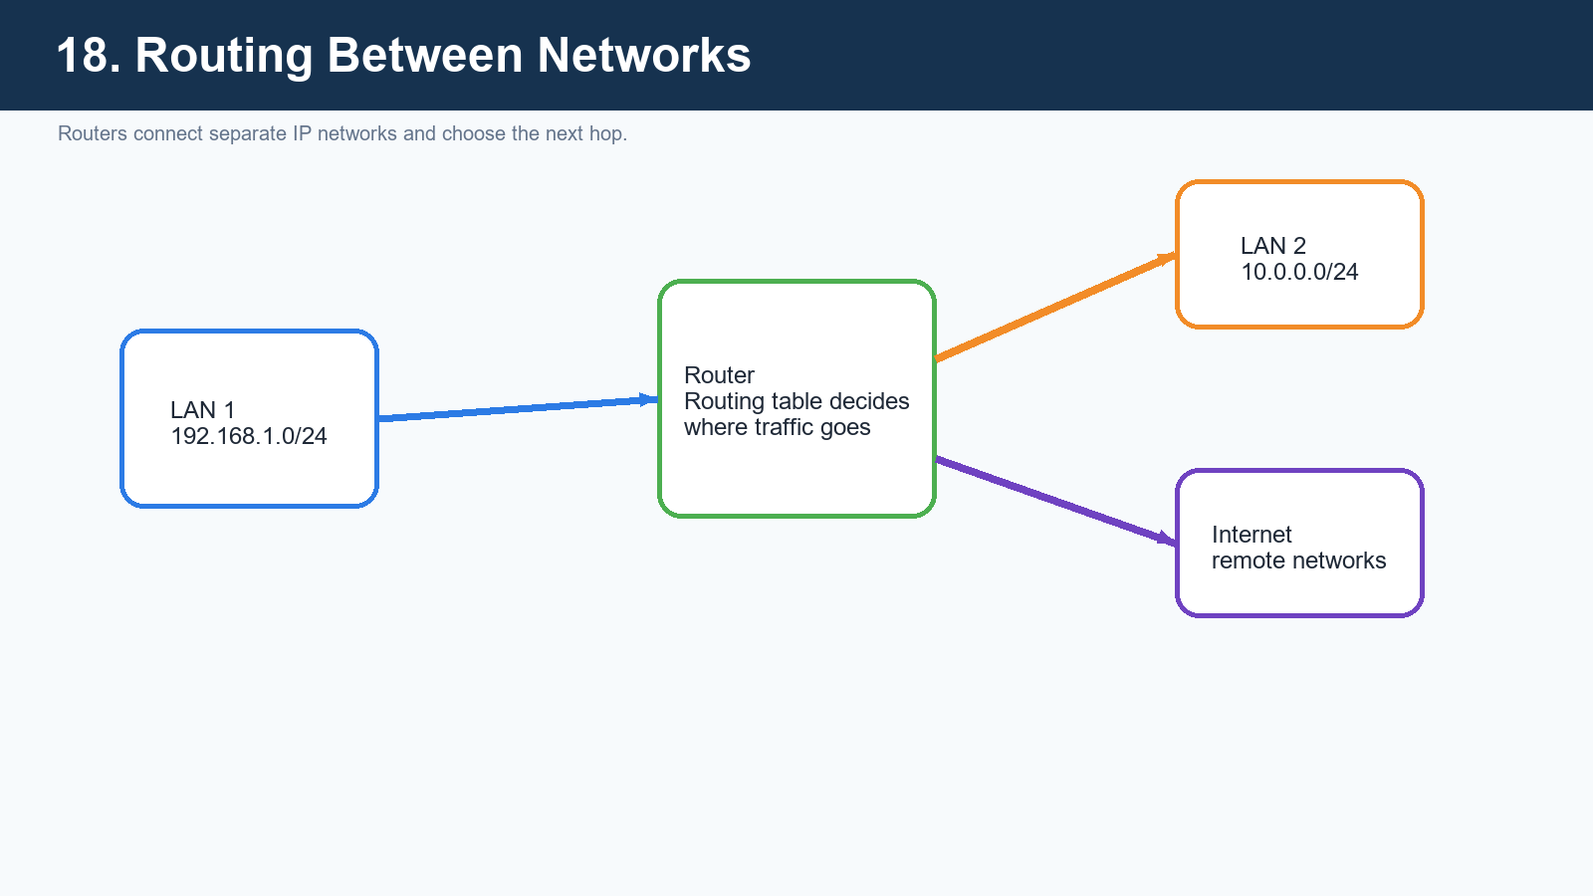
Figure 18. Routers move packets between different IP networks.

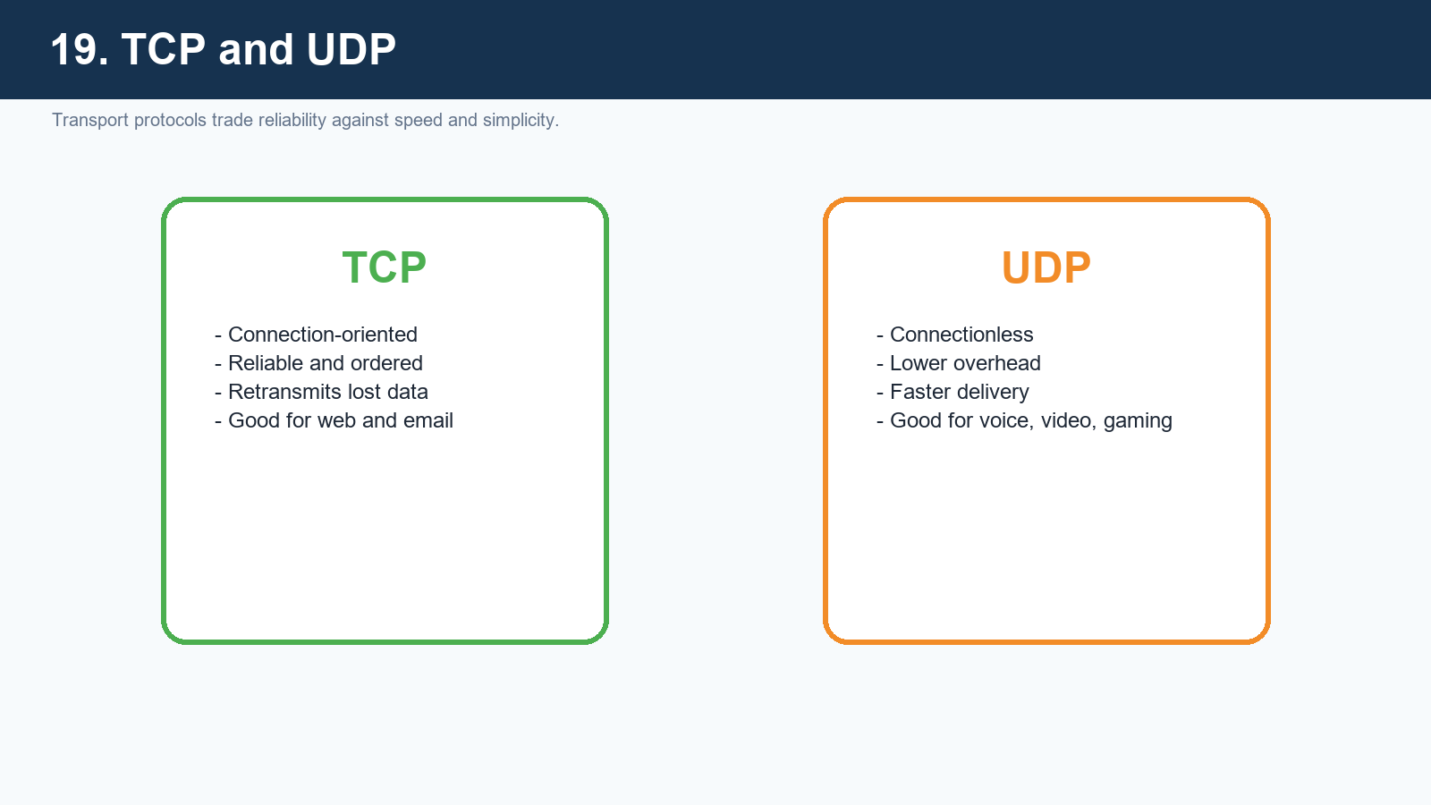
Figure 19. TCP emphasizes reliability; UDP emphasizes speed.

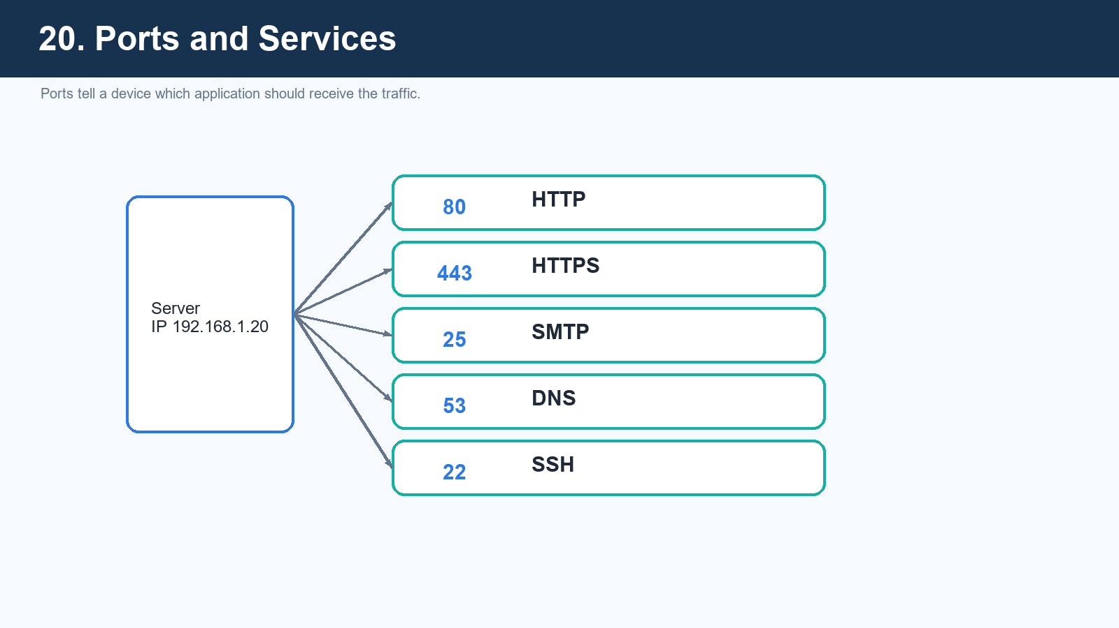
Figure 20. Ports separate web, mail, DNS, and other services on the same host.

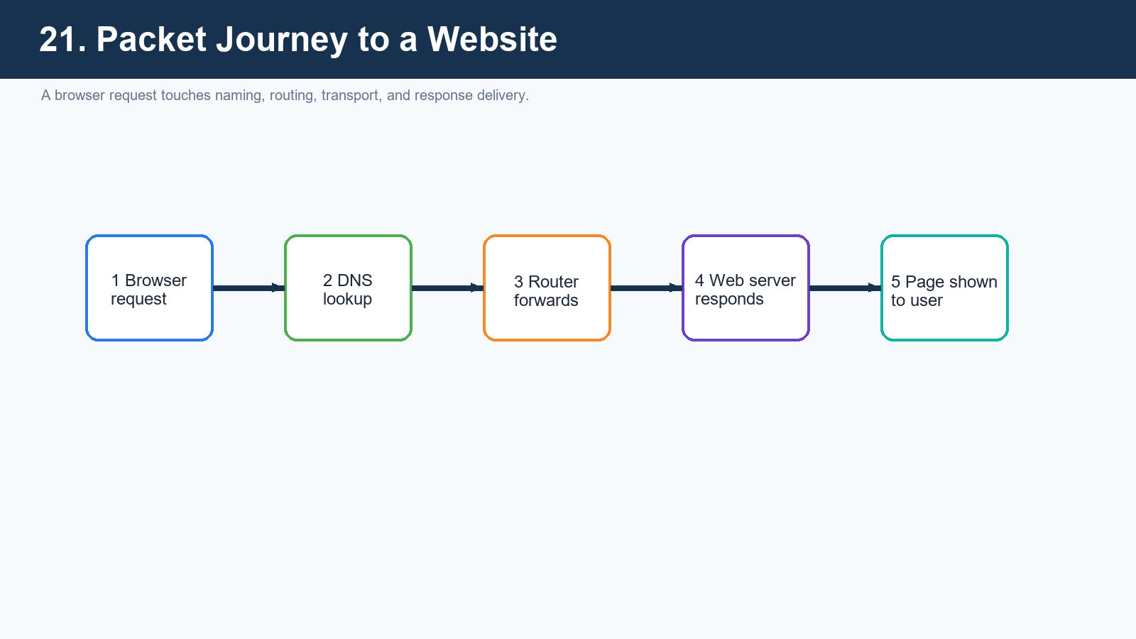
Figure 21. Opening one site involves several coordinated networking steps.

Security and Troubleshooting

Security Basics
Firewalls, encryption, authentication, strong passwords, safe Wi-Fi settings, and phishing awareness all support secure networking. Students should understand that networking is not only about connection, but also about controlled and trusted connection.

Troubleshooting Flow
Basic troubleshooting starts with physical checks, then IP settings, then reachability tests such as ping, then DNS checks, and finally service or firewall review. Teaching a repeatable method is often more valuable than teaching isolated commands.
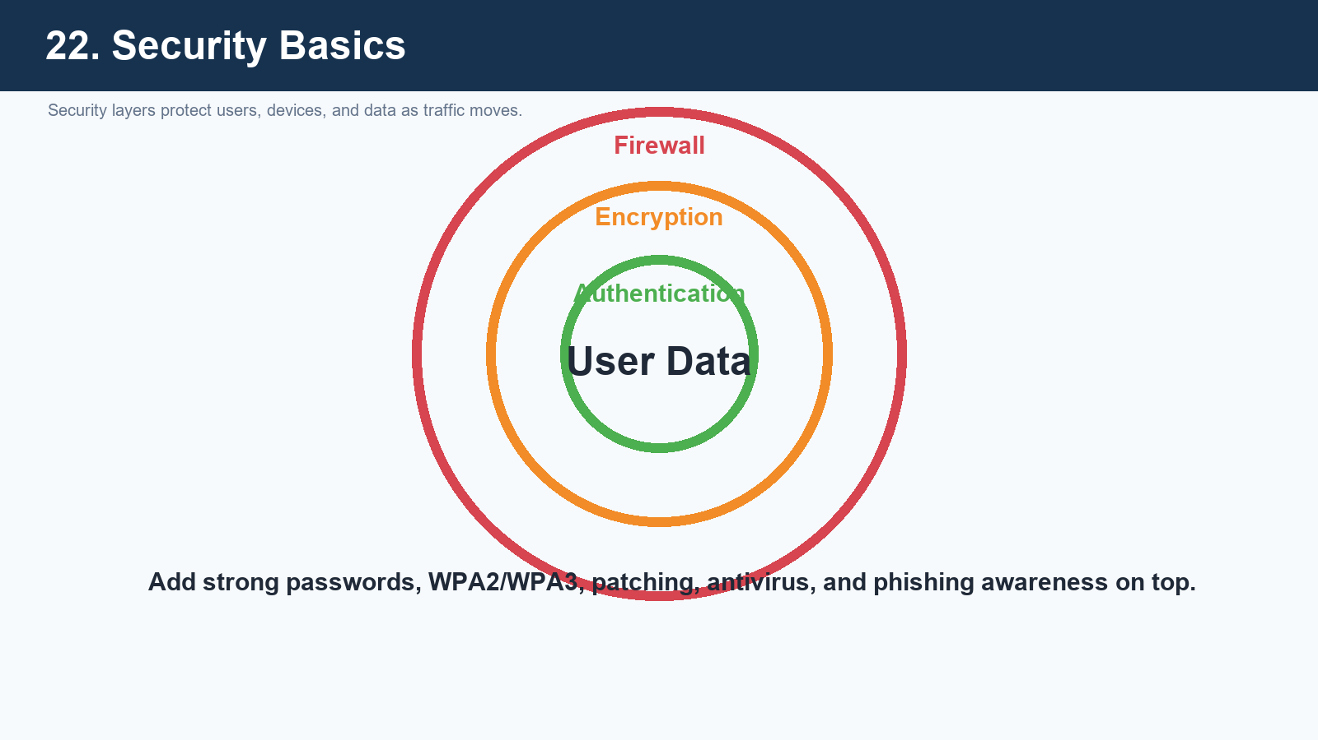
Figure 22. Networking security combines filtering, encryption, and identity checks.

Quick Revision Table
Term | Short Meaning | Example
LAN | A local network inside a limited area | School lab
WAN | A large network across long distances | Internet
Switch | Connects devices within a LAN | Computer to printer in same office
Router | Connects different networks | Home router to ISP
DNS | Turns names into IP addresses | google.com -> IP
DHCP | Assigns network settings automatically | Phone joins Wi-Fi
TCP | Reliable transport protocol | Web page loading
UDP | Fast transport protocol | Online game traffic
Firewall | Filters network traffic | Blocks unsafe access

Classroom Closing Summary
A strong beginner foundation in networking should answer five big questions: what devices are connected, how they are arranged, how they are addressed, how data moves, and how the network is protected. Once students are confident with those five, advanced topics such as subnetting, VLANs, routing protocols, and cloud networking become much easier to learn.

