**Assignment # 1**

**CSCS 351**

**Name: Yesheb Mark (22-10281)**

**Instructor: Dr. Saad Bin Saleem**

**TEST SUITE:**

My test suite named: (TestEmployee) consists of 5 test cases names are:

1. test_get_name
2. test_get_age
3. test_get_salary
4. test_update_salary
5. test_get_bonus

**The Tested Program (employee.py):**

class Employee:

def __init__(self,name,age,salary,phone_number,bonus):

self.name = name

self.age = age

self.salary = salary

self.phone_number = phone_number

self.bonus = bonus

def get_name(self):

return self.name

def get_age(self):

return self.age

def get_salary(self):

return self.salary

def get_phone_number(self):

return self.phone_number

def update_salary(self):

updated_salary = self.get_salary() + self.bonus

return updated_salary

def get_bonus(self):

return self.bonus

**The Testing Program (test_library.py):**

import unittest

from employee import Employee

class TestEmployee(unittest.TestCase):

def setUp(self):

self.e = Employee('Yesheb',23,67000,'0324-4348321',15000)

self.e.get_name()

self.e.get_age()

self.e.get_salary()

self.e.update_salary()

self.e.get_bonus()

#test_case_1

def test_get_name(self):

print('test_name')

self.assertEqual(self.e.get_name(), 'Yesheb')

#test_case_2

def test_get_age(self):

print('test_age')

self.assertEqual(self.e.get_age(),23)

#test_case_3

def test_get_salary(self):

print('test_salary')

self.assertEqual(self.e.get_salary(), 67000)

#test_case_4

def test_update_salary(self):

print('test_update_salary')

self.assertEqual(self.e.update_salary(), 82000)

#test_case_5

def test_get_bonus(self):

print('test_bonus')

self.assertEqual(self.e.get_bonus(), 15000)

if __name__ == '__main__':

unittest.main()

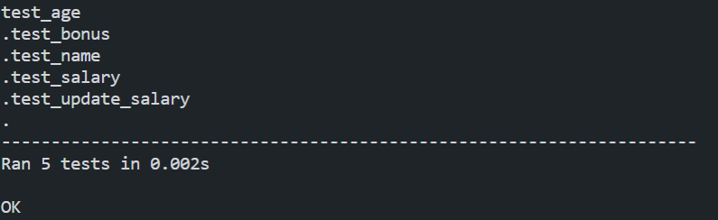**Output:**

**Results:**

5 out of 5 test cases are valid!