**OpenCV 4.5 setup on Windows 10/11 computers with Visual Studio 2017/2019/2022**

Fanglue Zhang

1. Create an empty C++ project. Make sure you are working for the “x64” system, and also make sure the configuration is for your working environment. In this document, I am using “Debug” mode for “x64” system.



1. Add the additional include folders for OpenCV in your environment in the following page (right click your project 🡪 Properties🡪VC++ Directories). The paths to add are “<your local opencv folder>\build\include\opencv2” and “<your local opencv folder>\build\include”

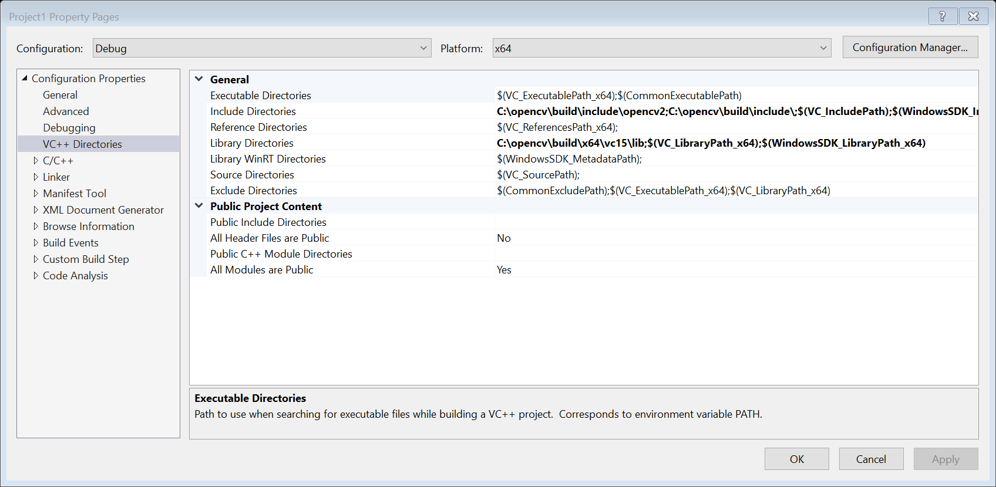

1. Add the additional library folders for OpenCV in your environment in the following page (right click your project 🡪 Properties🡪VC++ Directories). The path to add is “<your local opencv folder>\build\x64\vc15\lib”



1. Tell the linker the library to link when generating executable files. Add “opencv_world451d.lib” to “Additional Dependencies”. (If you are working for release mode, add “opencv_world451.lib”)

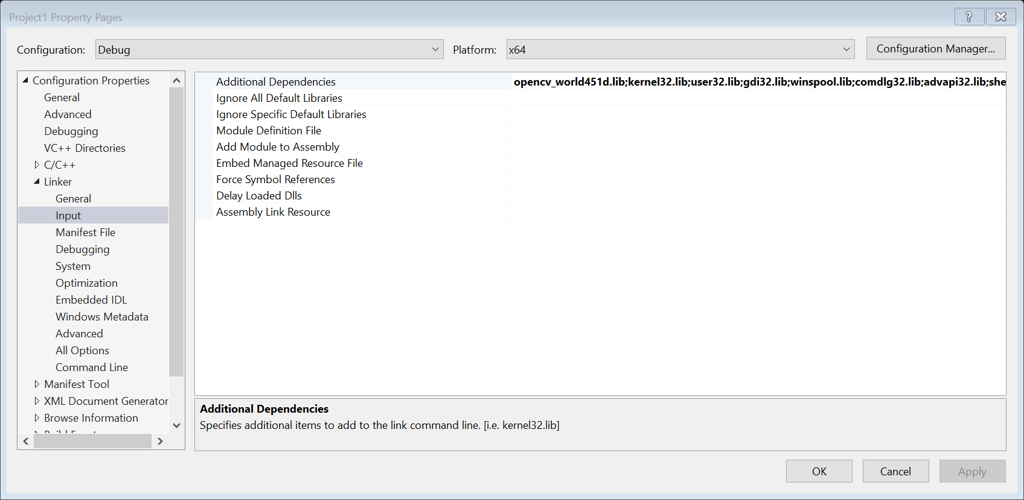

1. Add the folder containing DLL files to make your program runnable.

Add the following files to your project and try whether it works:

===========================main.cpp========================

int main(int argc, char* argv[]) {

const char* imagename = "image.jpg";//image name

Mat img = cv::imread(imagename, 1);

Mat canvas = cv::Mat(img.rows, img.cols, CV_8UC3); //unsigned char - byte 8 bits C3 -- 3 channels

Mat canvas2 = cv::Mat(10, 10, CV_64FC1);

cv::resize(img, img, cv::Size(960, 540));

//If failed

if (img.empty()) {

fprintf(stderr, "Can not load image %s\n", imagename);

return -1;

}

//Display

img = cgraProcessing(img);

cv::imshow("image", img);

//To wait for your input

waitKey();

img = cv::Scalar(125, 125, 125) + img; //Blue, Green, Red

cv::Mat roi = img(cv::Rect(0, 0, img.cols / 2, img.rows / 2));

roi.setTo(0);

imshow("image", img);

waitKey();

return 0;

}

====================Header.h========================

#pragma once

#include<opencv2/opencv.hpp>

using namespace cv;

cv::Mat cgraProcessing(cv::Mat& r);

====================Header.cpp=======================

#include "Header.h"

cv::Mat cgraProcessing(cv::Mat& r) {

for (int i = 0; i < r.rows; ++i) { // rows

for (int j = 0; j < r.cols; ++j) { // cols

// r.at<Vec3b>(i, j) = Vec3b(255) - r.at<Vec3b>(i, j); //cv::Scalar(255, 255, 255)

// r.at<Vec3b>(i, j)[0] = 255 - r.at<Vec3b>(i, j)[0];

// r.at<Vec3b>(i, j)[1] = 255 - r.at<Vec3b>(i, j)[1];

// r.at<Vec3b>(i, j)[2] = 255 - r.at<Vec3b>(i, j)[2];

r.at<uchar>(i, 3 * j + 0) = 255 - r.at<uchar>(i, 3 * j);

r.at<uchar>(i, 3 * j + 1) = 255 - r.at<uchar>(i, 3 * j + 1);

r.at<uchar>(i, 3 * j + 2) = 255 - r.at<uchar>(i, 3 * j + 2); //CV_8UC1, CV_8UC3, CV_32FC3,

}

}

return r;

}