

|  |
| --- |
|  |
| 晶圆键合力检测 |
| 用户手册 |

文档控制

1. 文档更新记录

A - 增加 M - 修订 D - 删除

| 日期 | 更新人 | 版本 | 变更类型（A*M*D） | 备注 |
| --- | --- | --- | --- | --- |
| 2019-05-04 | 陈锦伟 | 1.0.0 | A |  |
| 2019-08-12 | 陈锦伟 | 1.0.1 | M |  |
|  |  |  |  |  |
|  |  |  |  |  |

1. 文档审核记录

| 日期 | 审核人 | 职务 | 备注 |
| --- | --- | --- | --- |
|  |  |  |  |
|  |  |  |  |
|  |  |  |  |
|  |  |  |  |
|  |  |  |  |

1. 文档发行范围

| 分发单位 | 说明 |
| --- | --- |
|  |  |
|  |  |
|  |  |
|  |  |
|  |  |
|  |  |

目录

1.功能介绍 4

1.1功能 4

1.1.1功能概述 4

1.1.2功能结构图 4

1.2运行环境 4

2.界面功能说明 5

2.1主页 5

2.1.1主页界面 5

2.2系统设置 6

2.3算法参数设置 7

2.3.1算法参数介绍 7

2.3.2算法参数设置界面 7

2.4数据管理 8

2.4.1数据管理界面 8

2.5方案管理 8

2.6标定 10

3.操作流程说明 10

3.1操作准备 10

3.2操作流程 11

3.3清错 11

3.3.1功能介绍 11

3.3.2清错操作 12

3.3.2.1设备流程 12

4.注意事项 13

5.常见报错日志 13

6.WAFER IR_120A设备说明 15

# 1.功能介绍

## 1.1功能

### 1.1.1功能概述

WAFER BONDING FORCE MEASURE（中文名：晶圆键合力测量）是一款用于控制load port、加载晶圆，按规则执行测量动作，并计算出当前晶圆的键合力值的软件。

### 1.1.2功能结构图

晶圆键合力测量软件功能结构图如图1所示。

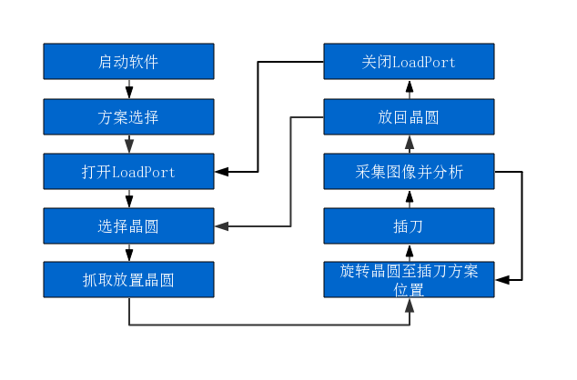

图1功能结构图

## 1.2运行环境

运行环境如表1所示。

**表1运行环境**

|  |  |
| --- | --- |
| 平台 | Windows 7 64位 |
| 处理器 | Inter(R) Core(TM)i3-7100 CPU @3.9GHz以上 |
| 运行内存 | 8G |
| 硬盘内存 | 250G以上 |

# 2.界面功能说明

## 2.1主页

### 2.1.1主页界面

晶圆键合力测量界面如图2所示。

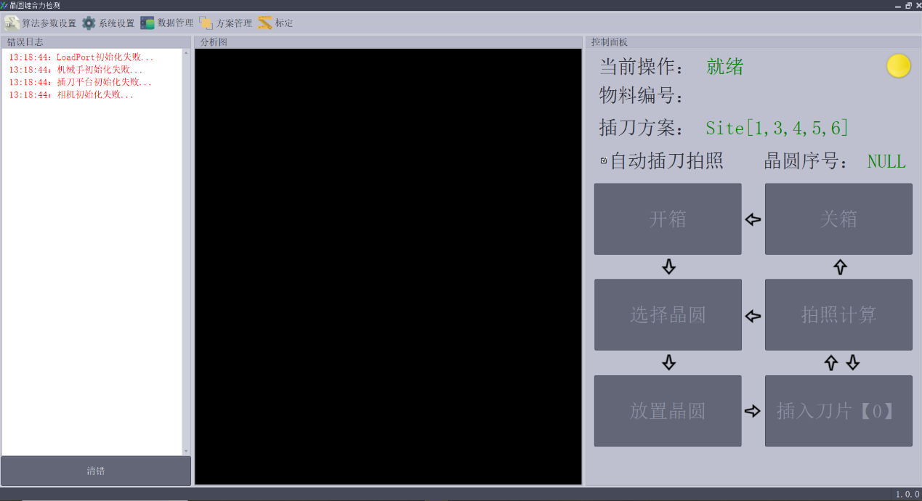

图2操作界面

主页界面包含功能选择栏、错误日志栏、分析图、控制面板及清错五大功能，功能模块如表2所示。

**表2 功能模块介绍**

|  |  |
| --- | --- |
| 模块 | 介绍 |
| 功能选择栏 | |
| 算法参数设置 | 设置晶圆相关参数，用于计算键合力 |
| 系统设置 | 连接设备 |
| 数据管理 | 管理采集图计算分析的结果数据 |
| 方案管理 | 管理晶圆插刀位置方案 |
| 标定 | 设置标定值，用于像素与实际距离之间的转换 |
| 分析图 | |
| 图像显示区域 | 显示摄像头所捕捉到的晶圆画面 |
| 控制面板 | |
| 当前操作 | 显示当前的操作状态 |
| 物料编号 | 显示当前所选物料序号 |
| 插刀方案 | 显示当前晶圆所需插刀位置 |
| 自动插刀拍照 | 根据插刀方案自动循环【插刀】-【拍照计算】 |
| 错误日志 | |
| 日志显示区域 | 显示当前硬件错误信息 |
| 清错 | 当操作错误导致异常、危险时，清除错误，使设备初始化 |

## 2.2系统设置

如图3为系统设置界面，系统设置界面包括【LoadPort】端口、【机械手】端口、【插刀平台】插刀深度及【相机】扩散等待时间。

【LoadPort】端口与【机械手】端口为设备连接端口，请根据实际端口号进行选择。

【插刀平台】插刀深度默认6500μm。

【相机】扩散等待时间为相机【拍照计算】延迟时间（晶圆粘合层扩散时间），该时间影响计算分析结果，请务必设置大于等于60S。

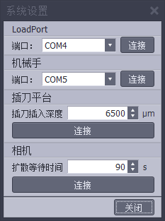

图3系统设置界面

## 2.3算法参数设置

### 2.3.1算法参数介绍

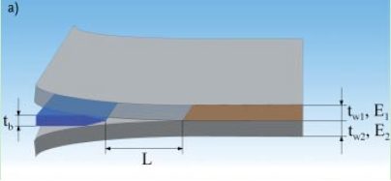

参数列表

|  |  |
| --- | --- |
|  | 刀片厚度 |
|  | 晶圆上半部分厚度 |
|  | 晶圆下半部分厚度 |
|  | 晶圆上半部分杨氏模量 |
|  | 晶圆下半部分杨氏模量 |
| L | 插入刀片后晶圆粘合层开裂长度 |

### 2.3.2算法参数设置界面

如图4为算法参数设置界面

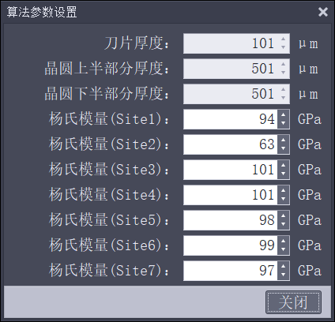

图4算法参数设置界面

## 2.4数据管理

### 2.4.1数据管理界面

如图5为数据管理界面，该界面记录LoadPort物料编号、所选晶圆序列、规格、站点、检测时间以及所得键合力，并可对其数据进行查看、导出、删除等操作。

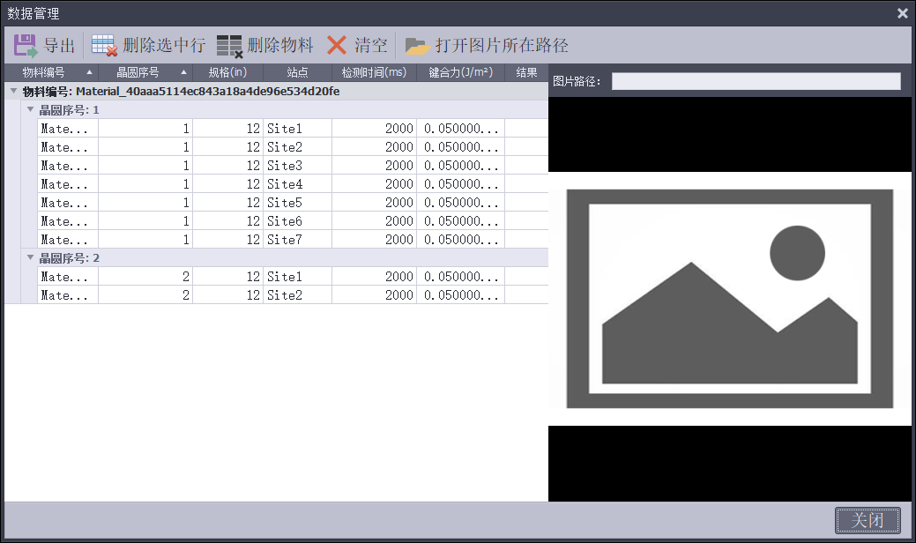

图5数据管理界面

## 2.5方案管理

图6是方案管理界面，该界面可对【插刀方案】进行新增、修改、删除及选中等操作。

选择【新增】或【修改】时，可对方案名称和站点进行修改。

【选中方案】时，可在【方案描述】中确认当前站点信息。

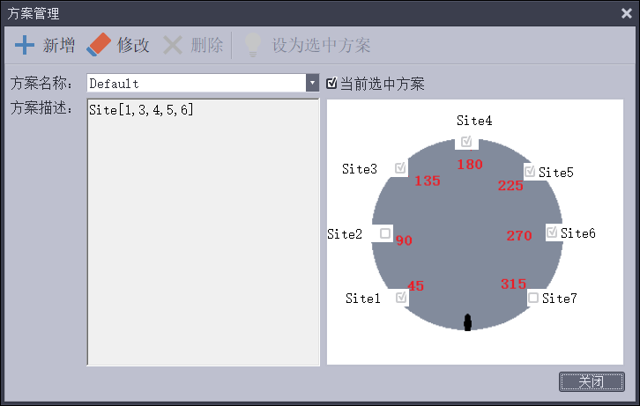

图6-1方案管理界面

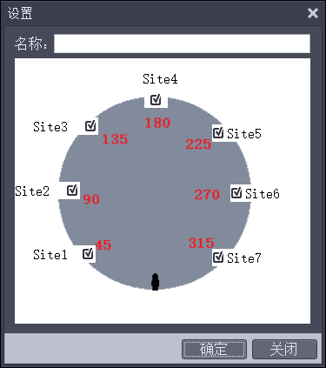

图6-2站点设置界面

## 2.6标定

图7为标定界面，使用测量工具，将测量所得距离与像素值进行计算DPI，用于后续数据分析时的数据转换。

操作步骤：

1. 在插刀平台上放置一把精度尺（精度尽量精准）。
2. 选择【标定】，进入标定界面。
3. 选择【测量】-【直线】在精度尺上画一条线段。
4. 输入线段的实际距离。
5. 点击【计算DPI】，计算出DPI值。

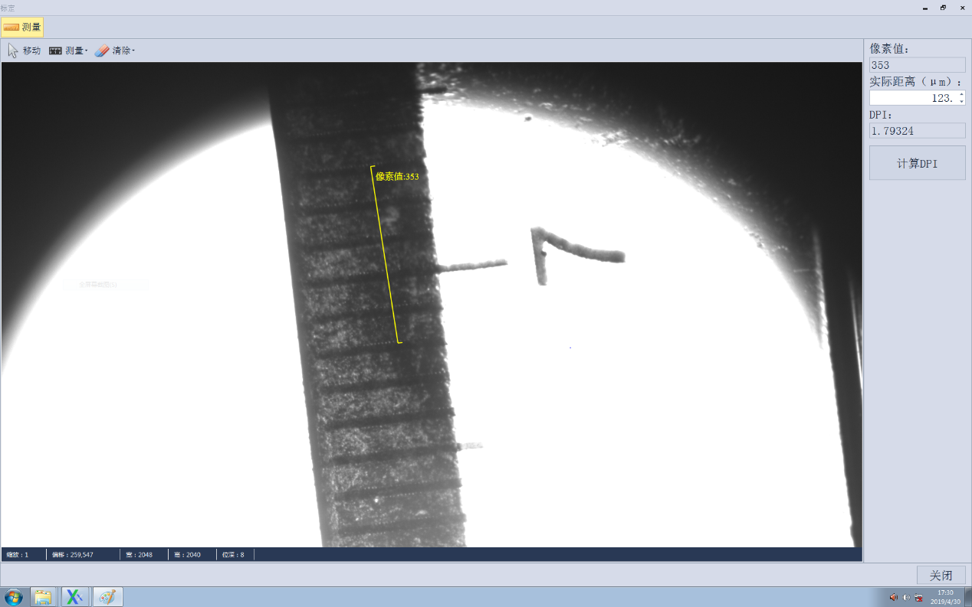

图7标定界面

# 3.操作流程说明

## 3.1操作准备

1. 启动软件，设备进行初始化。
2. 确认错误日志是否存在初始化错误（如果有，请连接设备或检查设备是否能正常使用，连接/检查完毕后，重启软件）。
3. 选择【算法参数设置】，设置计算键合力所需要的参数。
4. 选择【系统设置】，设置【插刀深度】及【相机扩散等待时间】。
5. 选择【标定】，测量距离，计算DPI（第一次启动或重新标定）。

## 3.2操作流程

1. 启动软件，设备进行初始化。
2. 点击【方案管理】，选择晶圆所需检测插刀方案。
3. 点击【开箱】，等待设备开启Load Port。
4. 点击【选择晶圆】，设置晶圆物料编号，选择所需要测量的晶圆序号。
5. 点击【放置晶圆】，机械手自动抓取所选编号的晶圆，放至插刀台上。
6. 待晶圆放至插刀台，插刀台吸气固定晶圆，点击【插入刀片】，插刀平台根据【}插刀方案】进行插刀。
7. 插刀完成后，点击【拍照计算】，摄像机自动采集图像并进行分析结果。
8. 再次点击【插入刀片】，插刀台旋转至插刀方案位置，并插入刀片。
9. 方案位置插刀完毕后，插刀台取消吸气，上升，机械手将晶圆放回Load Port，设备初始化。
10. 若继续选择晶圆进行测量，则循环④~⑨进行测量；若结束测量，待晶圆放回LoadPort后点击【关箱】，Load Port关闭并复位。

## 3.3清错

### 3.3.1功能介绍

清错功能是在设备运行过程中出现错误时，进行控制设备将其复位的一个过程。如图8为清错界面。

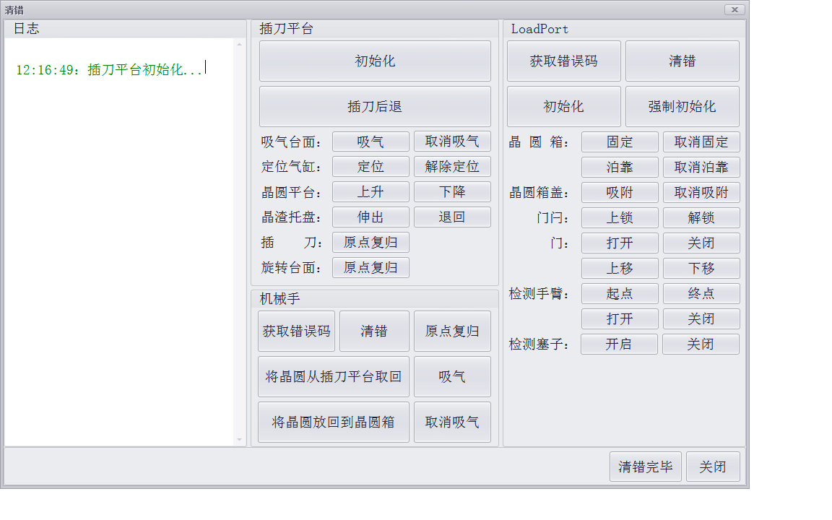

图8清错界面

### 3.3.2清错操作

#### 3.3.2.1设备流程

表3为软件操作流程及对应的设备流程。（**注：该流程用于设备报错时的设备还原参考，一般情况下请勿过多操作。**）

**表3 操作流程对应设备流程**

|  |  |
| --- | --- |
| 开箱 | 1.Load Port固定 |
| 2.Load Port泊靠 |
| 3.Load Port盖吸附 |
| 4.Load Port门闩上锁 |
| 5.Load Port打开 |
| 6.Load Port门下降 |
| 放置晶圆 | 1.机械手选取晶圆 |
| 2.吸气，固定晶圆 |
| 3.晶圆平台上升 |
| 4.机械手将晶圆放至插刀台上，取消吸气 |
| 5.机械手退回 |
| 6.晶圆台下降 |
| 7.定位气缸定位 |
| 8.吸气台面吸气 |
| 插刀【】 | 1.插刀平台旋转至插刀方案位置 |
| 2.晶渣盘伸出 |
| 3.刀片插入晶圆 |
| 拍照计算 | 1 晶渣托盘退回 |
| 2.摄像头拍摄干纹并计算 |
| 放回晶圆 | 1.晶渣托盘伸出 |
| 2.刀片后退 |
| 3.晶渣托盘退回 |
| 4.吸气台面取消吸气 |
| 5.晶圆台上升 |
| 6.机械手托起晶圆，吸气固定晶圆 |
| 7.机械手将晶圆放回原序号位置，插刀台初始化 |
| 7.机械手复位 |
| 关箱 | 1.Load Port门上升 |
| 2.Load Port门关闭 |
| 3.Load Port门闩解锁 |
| 4.Load Port盖取消吸附 |
| 5.Load Port取消泊靠 |
| 6.Load Port取消固定 |

# 4.注意事项

1. **开启设备前，请先检查设备连接是否正确、完整。**
2. **清错功能，需先【获取错误码】-【清错】，再根据错误进行还原，最后【清错完毕】-【关闭】。**
3. **关闭软件前，请先检查设备是否已经还原初始状态（晶圆台上无晶圆，机械手上无晶圆，LoadPort门关闭退回）。**
4. **紧急制动状态下，设备无法操作，点击【清错】前，请先拔出急停栓。**
5. **为了您的安全，请勿越过安全门。若已越过并报错，请将晶圆放回Load Port，还原设备初始状态。**
6. **设备正在运行中或晶圆未放回Load Port并关箱前，请勿关闭或重启软件。**
7. **软件开启或打开【清除】功能，设备都需做初始化，请耐心等待，切记在此期间勿进行其他操作。**
8. **分析数据请在关闭软件之前导出。**

# 5.常见报错日志

**Load Port：**

|  |  |
| --- | --- |
| 编号 | 错误描述 |
| A1 | Normal position error at FOUP open |
| A2 | Normal position error at FOUP close |
| A3 | Mapper storage error when Z-axis lowered |
| A4 | Parallel signal error from upper machine |
| FD | Interlock relay failure (Note 1) |
| FE | Communication failure (after 3 retries) |
| FF | Obstacle detection sensor failure (Note 1) |
| FC | Fan operation error |
| EE | Mapping mechanical(Adjustment) error (Note 2) |
| EF | Mapping mechanical(Sensor) error (Note 2) |
| 00 | Ok |
| 02 | Z-axis position: NG (Down) |
| 04 | Y-axis position: NG (Dock) |
| 07 | Wafer protrusion |
| 08 | Door forward/backward position: NG (Open) |
| 09 | Mapper arm position: NG (Open) |
| 10 | Mapper Z-axis position: NG (Down) |
| 11 | Mapper stopper position: NG (On) |
| 12 | Mapping end position: NG |
| 21 | FOUP clamp open error (Back) |
| 22 | FOUP clamp close error (Front) |
| 23 | Latch key open error |
| 24 | Latch key close error |
| 25 | Vacuum on error |
| 26 | Vacuum off error |
| 27 | Main air error |
| 42 | Z-axis position: NG (Up) |
| 44 | Y-axis position: NG (Undock) |
| 47 | Grass wafer protrusion (Option) |
| 48 | Door forward/backward position: NG (Close) |
| 49 | Mapper arm position: NG (Close) |
| 50 | Mapper Z-axis position: NG (Up) |
| 51 | Mapper stopper position: NG (Off) |
| 61 | FOUP clamp open error (Up) |
| 62 | FOUP clamp open error (Down) |
| 63 | FOUP clamp close error (Middle) |
| 超时 | 初始化 |
| …… | …… |

**机械手：**

|  |  |
| --- | --- |
| 00 | 【机械手】无错误 |
| 73 | 【机械手】未取得晶圆 |
| 74 | 【机械手】或【晶圆台】上存在晶圆 |
| 超时 | 【原点复归】 |
| …… | …… |

**清除完毕条件：1.机械手上无晶圆；**

**2.Load Port无存在错误；**

**3.插刀台上无晶圆；**

# 6.WAFER IR_120A设备说明

About “Warnings and Cautions”

"Warnings and Cautions" contain important information about using the TDK product

safely.

The safety labels affixed to your TDK product come in two different designs. Please check your labels and refer to an appropriate document as specified below.

●We take "DO NOT TOUCH" labels as an example. Note the difference of the following two safety labels.

1. DO NOT TOUCH

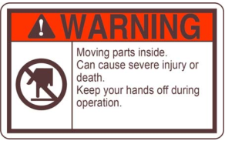

Customers in the United States will receive TDK products with the labels in the above

design, and are requested to refer to A-2 ~ A-4 page.

2. DO NOT TOUCH

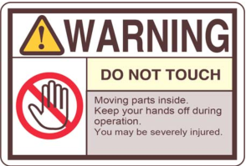

Warnings and Cautions

Proper operation and scheduled maintenance is essential to ensure the safe use products. Read this section carefully and understand "Warnings and Cautions" before beginning operation or maintenance.

* Safety labels in a following format are affixed on the products.

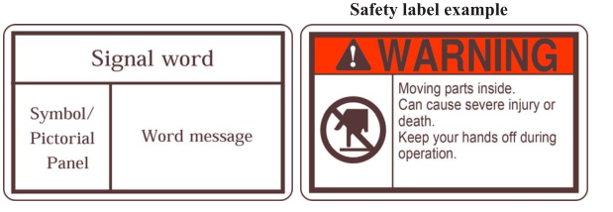

● WARNING and CAUTION are two signal words that are used to warn of potential hazards related to operators and machines.

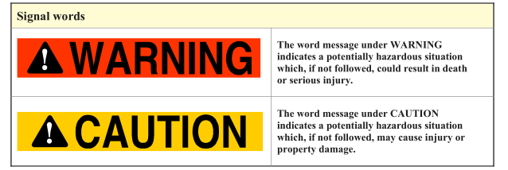

● Product safety labels and safety symbols

A product safety label contains a safety symbol.

Safety symbols are shown in the next page with their respective meanings.

Pay attention to the meaning and follow the instructions given in the message.

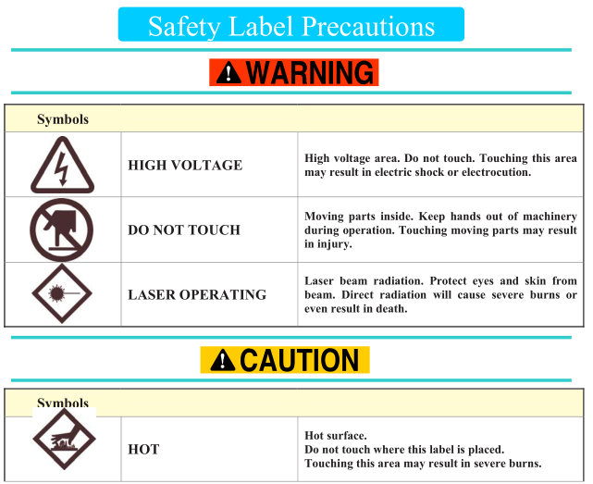

General Safety Precautions

Follow the documents that come with the product(s) (e.g. OPERATION MANUAL, MAINTENANCE

MANUAL, ENGINEERINGMANUAL) to operate and maintain machinery.

･ ･ When restarting a machine after a halt, call attention of other person(s) around to warn that the machine is about to restart. If the machine gets started without previous warning, this may startle a person and lead to personal injury.

･ ･ Do not operate the machine with the covers removed and/or doors opened. Removed covers and open doors disclose moving parts and allow easy access to them. Accidental contact with these parts can lead to personal injury.

･ ･ Wear designated safety boots to protect your feet from injury. Do not wear other types of shoes, slippers or sandals. You may be injured due to falling objects.

･ ･ Never operate with wet hands. You may get an electric shock.

･ ･ Do not wear gloves when operating. Parts of the gloves can be caught into the machine, resulting personal injury.

･ ･ Turn off the power before opening covers or doors. You may get an electric shock.

Do not place any tools or chemicals on top of machinery. Such objects may fall and cause injuries or property damage, which could cripple normal machine operation.

Do not climb on top of machinery. You may fall and suffer injuries.

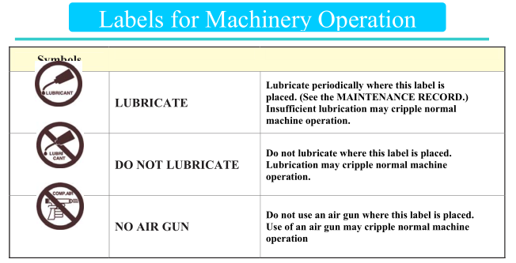

Maintenance

･Carry out maintenance as instructed in the MAINTENANCE RECORD.

(WAFER IR servicing for scheduled yearly maintenance is also recommended.)

･Turn off the power before connecting any optional devices. Connecting devices without turning off the power may result in crippling normal machine operation.

･Do not repair, disassemble or modify machines unless otherwise stated in the MAINTENANCE MANUAL.

This may result in crippling normal machine operation.

･If the machine fails to function properly or needs attention, refer to the MAINTENANCE MANUAL to solve the problem.

Equipment installation

Protect electrical devices (including the control box, motors, switches and CRT) from water, oil and chemicals. They can damage the electronics and cripple normal machine operation. This may even lead to a cause of a fire.

･Protect power and communication cables from being placed under something. If cables must run across the working area, provide sufficient protective covering over the cables.

･ If you must relocate the machine, contact TDK before moving it.

･ Refer to the SPECIFICATIONS FOR APPROVAL for your machine installation environment.

Disposal

Lead soldering is used in the product. Comply with the laws and regulations for product disposal in your area.

Warnings and Cautions

Proper operation and scheduled maintenance is essential to ensure the safe use of products. Read this section carefully and understand "Warnings and Cautions" before beginning operation or maintenance.

Safety labels in a following format are affixed on the products.

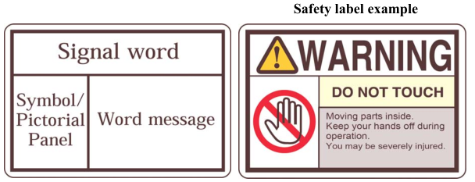

WARNING and CAUTION are two signal words that are used to warn of potential hazards related to operators and machines.

Product safety labels and safety symbols A product safety label contains a safety symbol.

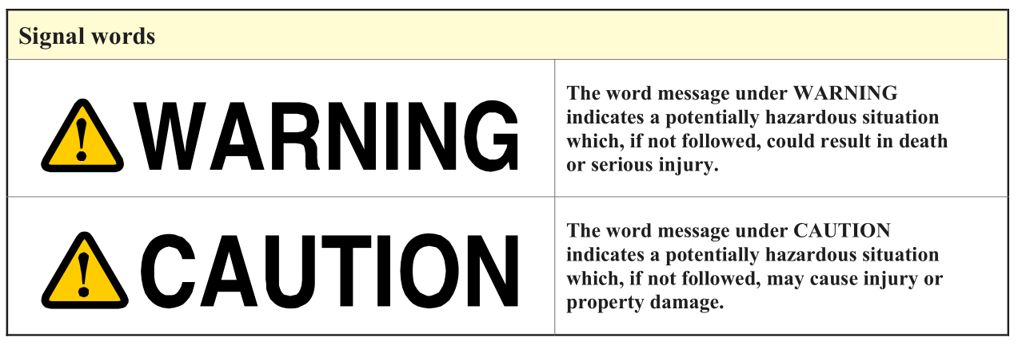

Safety symbols are shown in the next page with their respective meanings. Pay attention to the meaning and follow the instructions given in the message.

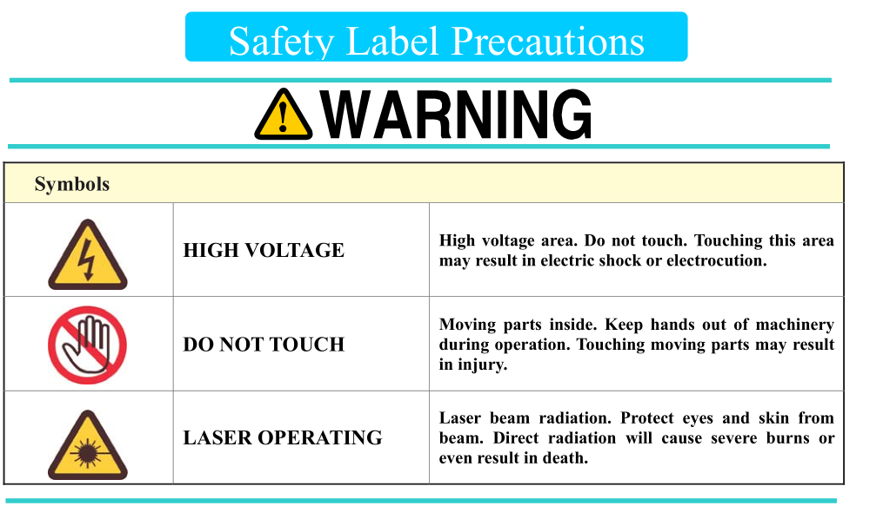

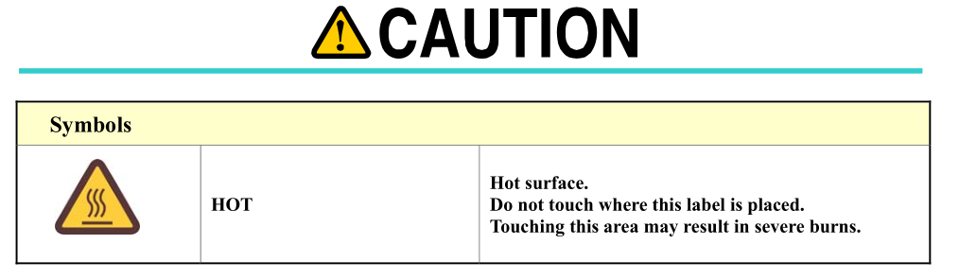

General Safety Precautions

Follow the documents that come with the product(s) (e.g. OPERATION MANUAL,

MAINTENANCE MANUAL, ENGINEERING MANUAL) to operate and maintain machinery.

･ When restarting a machine after a halt, call attention of other person(s) around to warn that the machine is about to restart. If the machine gets started without previous warning, this may startle a person and lead to personal injury.

･ Do not operate the machine with the covers removed and/or doors opened. Removed covers and open doors disclose moving parts and allow easy access to them. Accidental contact with these parts can lead to personal injury.

･ Wear designated safety boots to protect your feet from injury. Do not wear other types of shoes, slippers or sandals. You may be injured due to falling objects.

･ Never operate with wet hands. You may get an electric shock.

･ Do not wear gloves when operating. Parts of the gloves can be caught into the machine, resulting personal injury.

･ Turn off the power before opening covers or doors. You may get an electric shock.

Do not place any tools or chemicals on top of machinery. Such objects may fall and cause injuries or property damage, which could cripple normal machine operation.

･ Do not climb on top of machinery. You may fall and suffer injuries.

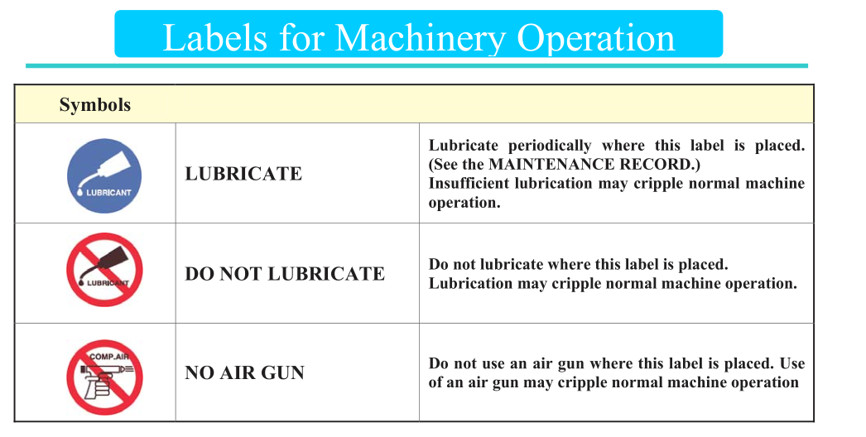  
Maintenance

･Carry out maintenance as instructed in the MAINTENANCE RECORD.

(WAFER IR servicing for scheduled yearly maintenance is also recommended.)

･Turn off the power before connecting any optional devices. Connecting devices without turning off the power may result in crippling normal machine operation.

･Do not repair, disassemble or modify machines unless otherwise stated in the MAINTENANCE MANUAL.

This may result in crippling normal machine operation.

･If the machine fails to function properly or needs attention, refer to the MAINTENANCE MANUAL to solve the problem.

Equipment installation

Protect electrical devices (including the control box, motors, switches and CRT) from water, oil and chemicals. They can damage the electronics and cripple normal machine operation. This may even lead to a cause of a fire.

･Protect power and communication cables from being placed under something. If cables must run across the working area, provide sufficient protective covering over the cables.

･ If you must relocate the machine, contact TDK before moving it.

･ Refer to the SPECIFICATIONS FOR APPROVAL for your machine installation environment.

Disposal

Lead soldering is used in the product. Comply with the laws and regulations for product disposal in your area.

Safety Precautions

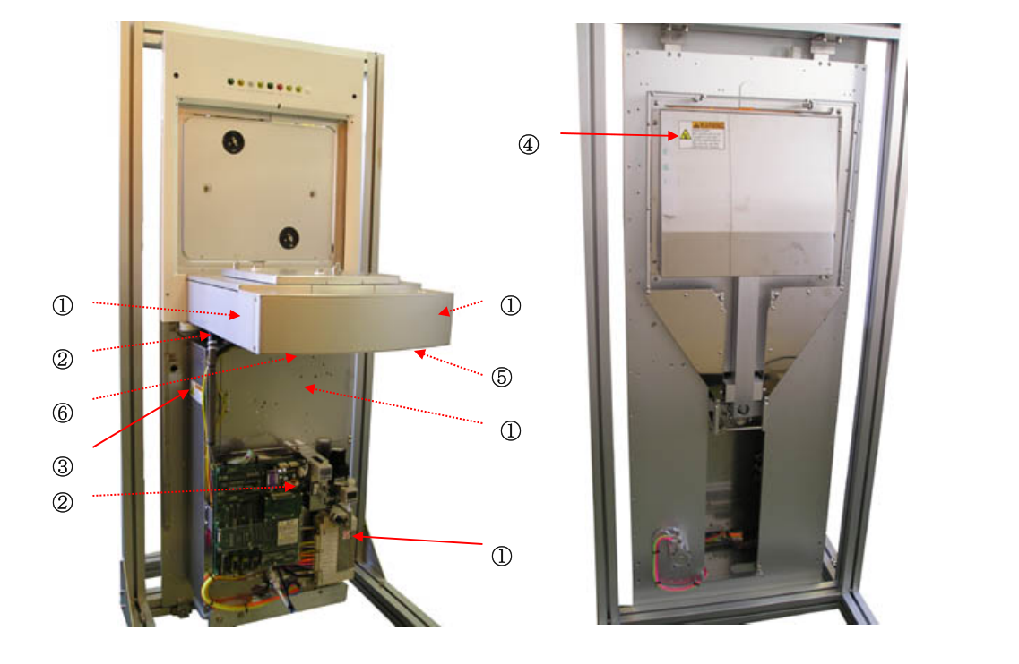

1. Don't decomposition

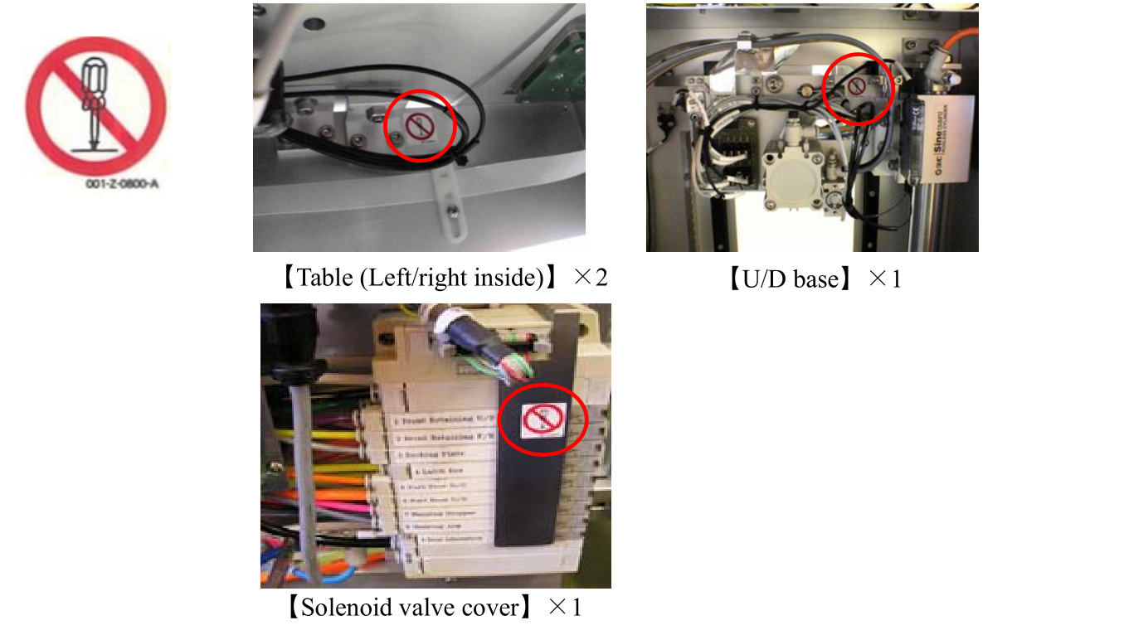

1. Case Earth

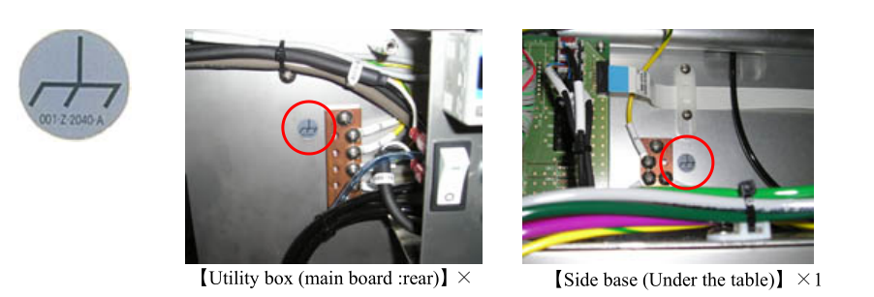

1. HEAVY OBJECT

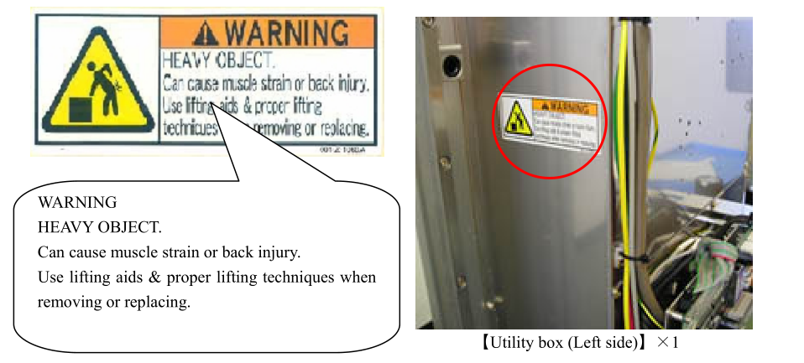

1. PINCH POINT

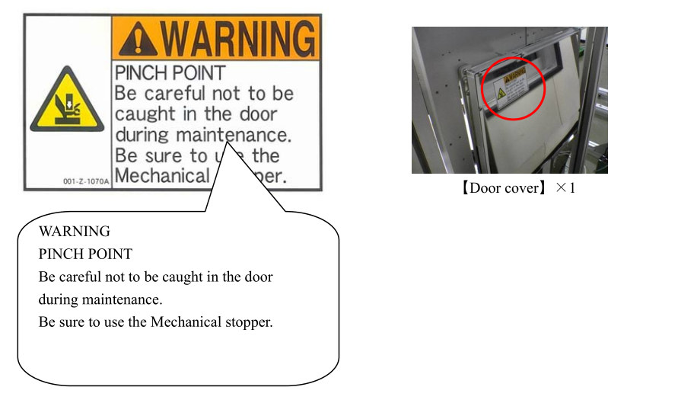

1. Manufacturing Label
2. Patent Marking Label

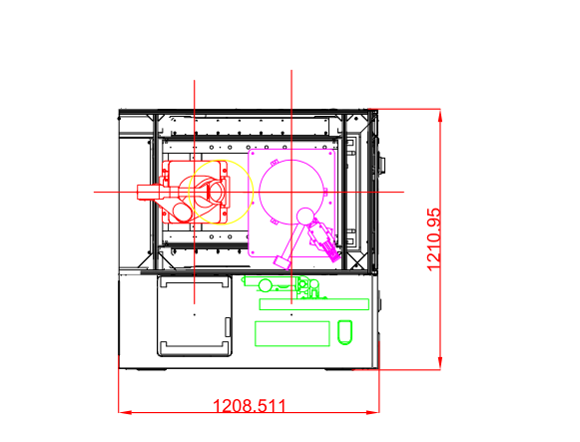

Installation

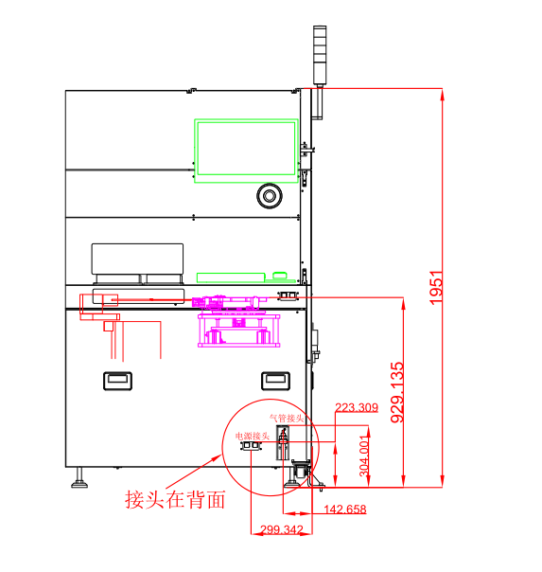

The following must be prepared or confirmed before installing the system.

◆ Install the machine in a clean room environment.

◆ installation plane opening size and the M8 screw positions

◆ installation plane level

Note ◇ The size, positions and level must comply with the SEMI Standards.

◆CDA : 0.52～0.6MPa(G)･30L/min(ANR)･Tube: External diameter ø6 ㎜

◆ Vacuum: -61±10kPa(G)･10L/min(ANR)･Tube: External diameter ø6 ㎜

◆ Power: 220v 10A

◆ Breaker capacity: 10A

Hardware Interlock

The system has a hardware interlock function that prevents foreign objects from getting caught in the door.

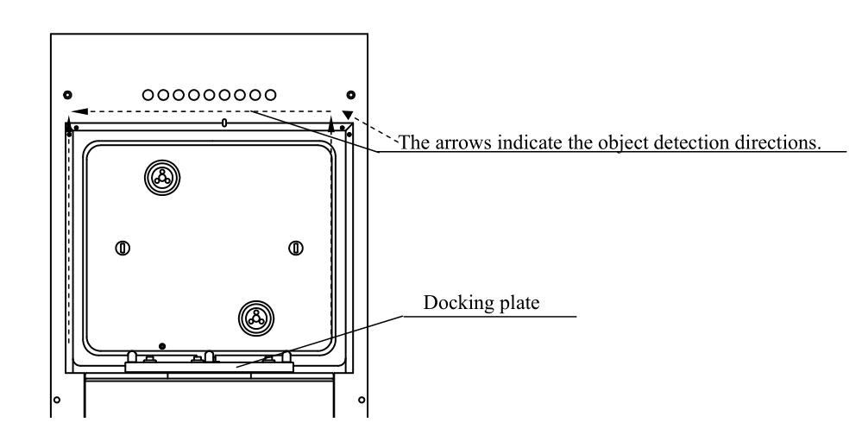

Obstacle Detection

The system detects foreign objects to prevent them (e.g., operator’s hand) from becoming caught in the FOUP door, load port plate unit or the surface of the FIMS.

If the photoelectric sensor on the outer frame of the FOUP docking plane detects an object other than a FOUP, the power for the solenoid valve will be cut off and all cylinders will stop.

Preventing Obstacles from Becoming Caught

The load port will not raise or lower the door unless the FOUP has been properly loaded.

(The output signal for the solenoid valve is blocked.)