

Proposal
For
Industry Research Project
Computing Technologies Department

Customer Relationship Management (CRM) & Inventory Management System (IMS)

Group 8

College of Science and Technology
Royal University of Bhutan

Read carefully before filling the form.

- Please do not alter the layout of the application form. Information must be filled in the spaces provided, under set format.
- Guidance notes in various fields should not be deleted.
- Required information should be duly filled in the specified fields.
- Required heads/fields which are not relevant to the project should be marked N/A (Not Applicable) or left blank and should not be deleted.
Guidelines and Forms

Introduction
Considering the geographical terrain, the Royal Government of Bhutan has recognized and endorsed ICT as an enabler of developmental activities. Therefore, installation of ICT infrastructure in the 20 districts with Local Area Network has been initialized and completed at the end of the 9th five year plan implementation phase. The potential of ICT attracted the attention of the development planners in Bhutan and the 10th FYP was designed to fully harness the potential of ICTs to achieve the developmental goal especially of poverty reduction of the Millennium Declaration and Gross National Happiness.

In order to address the IT HR need in the country and to promote and support IT industries in the country, the Information Technology Department (ITD) proposed to introduce a four year Bachelor of Engineering in Information Technology degree in 2009. The College launched BE (IT) with 30 students from the winter semester of 2010. Presently, ITD is supported by 13 teaching faculty and three technicians.

To provide wholesome IT knowledge and skills to the students, ITD introduced modular courses from 2011 in collaboration with NIIT under Chiphen Rigphel Project.

Submission Procedure
Duly filled proposal forms completed in all respects should be submitted in form of soft copy and a hard copy to project guide and project coordinator. On receipt of the applications the proposals will be evaluated by reviewer panel and proposal would then be defended by student groups. The project group may need to revise the proposal in light of the evaluator’s recommendations.

For further information, please contact:

Yeshi Jamtsho
Project Coordinator/Lecturer
yjamtsho.cst@rub.edu.bt

Table of Contents
Description Page #
1. Project Identification 1
A. Reference Number: 1
B. Project Title: 1
C. Project Internal Guide: 1
D. Organizations Involved in the Project: 1
E. Key Words: 2
F. Research and Development Theme: 2
G. Project Status: 2
H. Project Duration: 2
2. Scope, Introduction and Background of the Project 3
A. Scope of the Project: 3
B. Introduction (Project Background and Literature Review, Current State of the Art): 3
C. Challenges: 3
D. Motivation and Need: 3
3. Aim and Objectives of the Project 3
4. Methodology 4
A. Development / Research / Test Methodology: 4
B. Project Team: 4
C. Project Activities: 4
D. Key Milestones and Deliverables: 4
5. Benefits of the Project (Expected output/outcomes): 5
6. Risk Analysis/Feasibility 5
A. Risks of the Project: 5
A1. Comments: 5
7. Project Approval Certificate 6
8. Reviewers Panel Comments 7
10. Project Schedule / Milestone Chart /Workplan 8
13. Report Writing Guidelines 9
Bibliography 10

Note: To update the table of contents, right click in the table and select ‘update field’ and then select ‘Update Entire Table’.

Application for Final Year Project

1. Project Identification
- Reference Number:
(for office use only)

- Project Title:
Customer Relationship Management (CRM) & Inventory Management System (IMS)

- Project Internal Guide:
Name: |  | Mr. Pema Galey
Designation: |  | Assistant Lecture
Organization: |  | Information Technology
Mobile # : |  |  |  |  |  | Tel. # :
Email:
C1. Project External Guide:
Name:
Designation:
Organization:
Mobile # : |  |  |  |  |  | Tel. # :
Email:
C2. Student Group Lead:
Name: |  | Dago Tshering
Roll No: |  | 02220140
Department: |  | Information Technology
Mobile # : |  | 77733682 |  |  |  | Tel. # :
Email: |  | 02220140.cst@rub.edu.bt
- Organizations Involved in the Project:
(Please identify all affiliated organizations collaborating in the project, and describe their role/contribution to the project.)
D1. Industrial Organizations:
# | Organization Name |  |  |  | Role / Contribution
 | NewEdge Technologies
D2. Academic Organizations:
# | Organization Name |  |  | Role / Contribution
D3. Funding Organizations:
# | Organization Name |  |  |  | Role / Contribution
- Key Words:
(Please provide a maximum of 5 key words that describe the project. The key words will be incorporated in our database.)
<type here>

- Research and Development Theme:

<type here>

- Project Status:
(Please mark )
❑ New  Modification to previous Project
❑ Extension of existing project

- Project Duration:
Expected Starting Date:
Planned Duration in months:

2. Scope, Introduction and Background of the Project
- Scope of the Project:
This project aims to develop a web-based, integrated business management platform. The scope is strategically limited to core functionalities within two modules to ensure timely delivery within six months. The in-scope features for the MVP are:

- CRM Module: Customer/Contact database, simplified Lead & Opportunity tracking, basic Project & Milestone management, and a communication history log.
- IMS Module: Asset/Inventory tracking, stock level monitoring with low-stock alerts, and asset allocation to projects.
- Integration: A central database enabling core functionality of allocating inventory assets to specific customer projects.
- Core System: A basic dashboard, role-based access control (Admin, Staff, Viewer), and an audit trail.
Advanced features like a support ticket system, sales forecasting, purchase order automation, vendor management, depreciation tracking, and complex reporting are explicitly out-of-scope for this phase and are planned for a future phase.
- Introduction (Project Background and Literature Review, Current State of the Art):

(Detailed summary of what all has been done internationally in the proposed area quoting references and bibliography. Please note that this section demonstrates the depth of knowledge of the project team and builds the confidence of the evaluators about capability of the team in achieving the stated objectives.)
(Please describe the current state of the art specific to this research topic.)

Project Background

In the modern business landscape, particularly for technology and service-oriented firms, operational efficiency is directly tied to the seamless integration of customer-facing and internal operational processes. Many small and medium-sized enterprises (SMEs) and IT companies begin by managing customer relationships and inventory through disparate tools—often a combination of spreadsheets, standalone CRM platforms, and manual record-keeping. This approach quickly leads to significant challenges: sales teams lack real-time visibility into inventory levels, project managers cannot efficiently allocate resources to client projects, and management makes strategic decisions based on outdated or inconsistent data. This disconnect creates operational silos, inefficiencies, and a heightened risk of errors, ultimately impacting customer satisfaction and profitability. This project is born from the identified need to bridge this gap by developing a unified, affordable, and efficient integrated business management system tailored for such organizations.

Literature Review

Extensive research and industry practice underscore the critical value of Customer Relationship Management (CRM) systems as a foundational element for business growth and efficiency. The academic and commercial literature consistently highlights several key benefits:
- Centralized Customer Data and Enhanced Service: CRM systems are lauded for their ability to centralize customer data, providing a comprehensive, 360-degree view of customer interactions. This facilitates superior communication, personalization, and overall customer understanding, which are essential for enhancing service delivery and client satisfaction (Efficy, 2025; SuperOffice, 2025; Salesforce, 2024).
- Optimized Sales and Marketing Processes: The integration of CRM significantly enhances commercial effectiveness. By enabling sophisticated customer segmentation, targeted marketing campaigns, and efficient lead management, these systems optimize the entire sales pipeline. This allows companies to personalize their approach and meet specific customer needs more effectively (IJERA, 2005-2012; IJRDO, n.d.; Salesforce, 2024).
- Improved Organizational Productivity: Beyond customer-facing functions, CRM tools contribute substantially to internal efficiency. They automate routine administrative tasks and foster better collaboration between departments. This empowers staff, especially in complex IT service environments, to focus on higher-value, strategic activities, thereby increasing overall organizational productivity (CX Today, 2024; Salesforce, 2024).
- Strategic, Data-Driven Decision Making: A paramount advantage of modern CRM systems is their analytical capability. They transform raw data into valuable insights, supporting informed, data-driven decisions that improve resource allocation and guide customer-centric innovation. The advent of cloud-based solutions further ensures these benefits are scalable and secure, which is crucial for growing companies (CX Today, 2024; ScienceDirect, n.d.; Salesforce, 2024).
In summary, the literature conclusively shows that CRM adoption leads to enhanced customer relationships, improved operational efficiency, and sustained competitive advantages.

Current State of the Art

The current state of the art in business management software is bifurcated:
On one end of the spectrum, large-scale Enterprise Resource Planning (ERP) systems like SAP Business One, Oracle NetSuite, and Microsoft Dynamics 365 offer comprehensive solutions that fully integrate CRM, inventory management, supply chain, finance, and human resources. These systems represent the pinnacle of integration, effectively breaking down operational silos. However, their sophistication comes with prohibitive costs, extensive implementation timelines, and significant complexity, making them unsuitable for most SMEs and smaller IT firms.
On the other end, the market offers a plethora of standalone, best-of-breed solutions—affordable and simple CRMs (e.g., HubSpot, Zoho CRM) and separate inventory management systems. While these tools address individual needs effectively, they operate in isolation. The integration between them is often minimal, requiring manual data entry and synchronization, which reintroduces the very risks of error, data inconsistency, and operational delays they were meant to solve.
Therefore, a clear gap exists in the market for a right-sized solution: a system that offers the crucial, deep integration between CRM and inventory management—the core of many business operations—without the overwhelming complexity and cost of a full-scale ERP. This project aims to occupy that space by developing a modern, web-based, and user-friendly platform that provides this essential integration as its primary value proposition, effectively advancing the current state of the art for its target market.
- Challenges:
(Please describe the challenges, specific to this research topic, currently being faced internationally.)
The primary international challenges in this domain include:

- System Integration: Seamlessly connecting different business functions (CRM and IMS) without creating data silos is a complex software architecture challenge.
- Data Integrity: Ensuring real-time consistency of data across modules (e.g., stock levels update instantly when an asset is allocated to a project) is crucial yet difficult.
- Usability vs. Complexity: Balancing a simple, user-friendly interface with the powerful functionality needed to manage business operations is a key design challenge.
- Cost of Ownership: Developing and maintaining a reliable, secure, and scalable system that remains affordable for its target market.

- Motivation and Need:
(Please describe the motivation and need for this work.)
The motivation for this project stems from a clear market need for affordable, integrated business management tools. By building a system that connects customer activities directly to inventory status, businesses can achieve:

- Increased Operational Efficiency: Eliminate manual data transfer between systems and reduce errors.
- Improved Decision Making: Provide management with a real-time, unified view of sales pipelines and inventory availability.
- Enhanced Customer Satisfaction: Ensure promises made to customers regarding project timelines and product availability are based on accurate, live data.
- Scalable Foundation: Create a core platform that can be logically extended with more advanced features in the future.

3. Aim and Objectives of the Project
(Please write the actual aim of your project. Also, describe the measurable objectives of the project and define the expected results. Use results-oriented wording with verbs such as ‘to develop..’, ‘to implement..’, ‘to research..’, ‘to determine..‘, ‘to identify..’ The objectives should not be statements and should not include explanations and benefits. The objective should actually specify in simple words what the project team intends to achieve (something concrete and measurable/ deliverable). Fill only those objectives that are applicable to the proposed project.)
Aim:
To design, develop, and test integrated CRM and Inventory Management System that provides a unified platform for managing customer interactions and inventory assets.

Objectives:
- To analyze and define the functional and non-functional requirements for the MVP.
- To design a scalable system architecture using a React.js frontend and a Node.js/Java backend with a relational database.
- To implement the core CRM module features including customer profile management, lead tracking, and project management.
- To implement the core IMS module features including asset tracking, stock level monitoring, and low-stock alerts.
- To develop and integrate the key feature of allocating inventory assets to specific customer projects.
- To implement essential system features including user authentication, role-based access control, and a basic dashboard.
- To rigorously test the integrated system to ensure functionality, usability, and data integrity.
- To deploy the application to a live environment and create comprehensive system documentation.

4. Methodology
- Development / Research / Test Methodology:
(Please describe the technical details and justification of your development and research plan and test plan and testing strategies. Identify specialized equipment, facilities and infrastructure which are required for the project and their utilization plan. The block diagrams, system flow charts, high level algorithm details etc. have to be provided in this section. Also, describe the overall methodology to be used for the particular research topic)

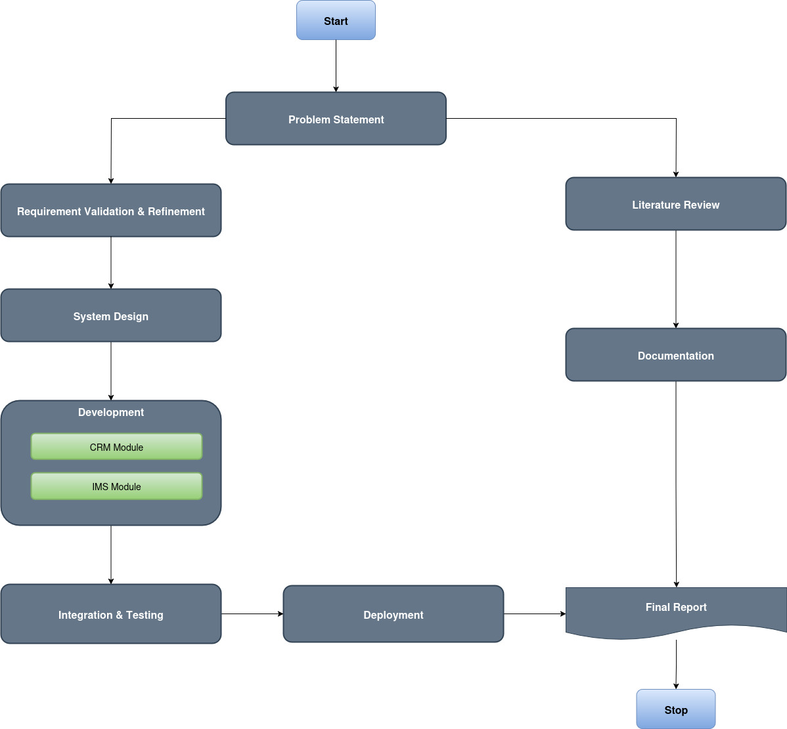

The project will adopt an Agile-Scrum methodology to manage development effectively. Work will be organized in two-week sprints, each culminating in a potentially shippable increment of the product. This iterative approach allows for continuous feedback, adaptability to changing requirements, and regular risk assessment.

1. Technical Stack & Architecture:
The system will follow a modern, scalable 3-tier architecture to ensure separation of concerns, maintainability, and ease of development.
- Presentation Tier (Frontend): A dynamic and responsive Single-Page Application (SPA) built using React.js. This will provide the user interface for all interactions.
- Application Tier (Backend): A Node.js server using the Express.js framework will expose a secure RESTful API. This tier will contain all the business logic for the CRM and IMS modules, handling requests from the frontend.
- Data Tier (Database): A PostgreSQL relational database will be used to ensure data integrity, support complex queries, and manage relationships between entities (e.g., Customers, Projects, Assets).

2. Development & Research Plan:

- Requirement Analysis: Conduct interviews and study existing processes to create a detailed Software Requirement Specification (SRS) document.
- System Design:
  - UI/UX Design: Create wireframes and mockups using tools like Figma to design an intuitive user experience.
  - Database Design: Model the database schema using an Entity-Relationship Diagram (ERD) to define tables, attributes, and relationships.
  - API Design: Define the endpoints, request/response structures, and data models for the REST API using OpenAPI/Swagger.
- Implementation:
  - Backend First: Develop the API endpoints and core logic. This allows for frontend development to proceed in parallel once initial endpoints are ready.
  - Frontend Development: Build React components for each module (Dashboard, CRM, IMS) that consume the backend API.
- Integration: Connect the frontend and backend, ensuring seamless data flow and error handling.

- Test Strategy:
A multi-layered testing approach will ensure software quality.
- Unit Testing: Test individual functions and components in isolation (using Jest for React, Mocha/Chai for Node.js).
- Integration Testing: Test the interactions between modules, especially the API endpoints and their interaction with the database (using Supertest).
- System Testing (End-to-End): Test the complete, integrated system to verify that it meets all requirements (using Cypress or Selenium).
- User Acceptance Testing (UAT): A pilot group will use the system to validate it against real-world business scenarios.

- Infrastructure:

- Version Control: Git with a repository hosted on GitHub.
- Development Environment: Local machines with Node.js and PostgreSQL installed.
- Production Environment: The application will be deployed on a cloud platform such as Heroku or AWS for public access.

System Architecture Diagram:

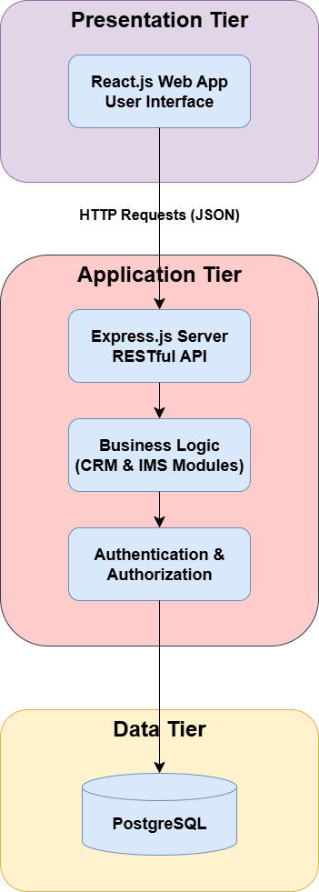

- Project Team:

Title / Position |  |  |  |  |  |  | Number
Project Internal Guide
Project External Guide
Student Team Members
Others (please specify)
Add more rows if required
- Project Activities:
(Please list and describe the main project activities, including those associated with the transfer of the research results to customers/beneficiaries. The timing and duration of research activities are to be shown in the Gantt chart in Section 8.)
- Requirement Analysis: Gather and finalize requirements for the MVP.

- System Design: Create architectural diagrams, database schema, and UI/UX wireframes.
- Environment Setup: Set up version control (Git), development, testing, and production environments.
- Backend Development: Implement API endpoints, database models, and core business logic.
- Frontend Development: Build user interfaces for CRM, IMS, and dashboard modules.
- Integration & Testing: Integrate frontend and backend; perform rigorous testing cycles.
- Deployment: Deploy the application to a physical s cloud server (e.g., AWS, Heroku, DigitalOcean).
- Documentation & Reporting: Write user manuals, technical documentation, and the final project report.

- Key Milestones and Deliverables:
(Please list and describe the principal milestones and associated deliverables of the project. A key milestone is reached when a significant phase in the project is concluded, e.g. selection and simulation of algorithms, completion of architectural design and design documents, commissioning of equipment, completion of test, etc.) The timing of milestones is also to be shown in the Gantt chart in Section 8.
The information given in this table will be the basis of project monitoring and marks assignment to the project group.
No. |  | Elapsed time from start (in months) of the project |  | Milestone |  | Deliverables
 |  |  | Project Planning Complete |  | Approved Proposal, Detailed Project Plan, Requirement Specification Document
 |  |  | System Design Complete |  | System Architecture Diagrams, Database Schema, UI/UX Mockups
 |  |  | Backend API Development Complete |  | Fully functional REST API for all MVP features
 |  |  | Frontend Development Complete |  | Fully functional React.js UI for all MVP features
 |  |  | Testing & Integration Complete |  | Fully integrated and tested system, Test Reports
 |  |  | Deployment & Documentation Complete |  | Deployed live application, User Manual, Final Project Report & Presentation
(Please add more rows if required.)

5. Benefits of the Project (Expected output/outcomes):
The primary output is a fully functional, web-based MVP that demonstrates the core value of an integrated CRM and IMS. The outcomes include:

- A proven software solution that can form the basis of a commercial product.
- A comprehensive project report detailing the entire development process.
- Practical experience for the students in full-stack development, project management, and system design.
- A valuable tool for the client organization to improve their operational efficiency and data-driven decision-making.

6. Risk Analysis/Feasibility
- Risks of the Project:
(Please describe the factors that may cause delays in, or prevent implementation of, the project as proposed above; estimate the degree of risk.)
(Please mark where applicable) | Low | Medium | High
- Technical risk | ❑ | ❑ | ❑
- Timing risk | ❑ | ❑ | ❑
- Budget risk | ❑ | ❑ | ❑

A1. Comments:
<type here>

7. Project Approval Certificate
(Approval of Project Proposal by the Competent Authority (Department Chairman) and Project Review Team is mandatory before the start of project execution.)
Project Review Team:

Sl # | Name | Signature
(Please add more rows if required.)

Project Coordinator
Name: | Yeshi Jamtsho
Designation: | Lecturer
Email: | yjamtsho.cst@rub.edu.bt
Date: |  |  | Signature:

Competent Authority – Head of Department
Name: | Parshu Ram Dhungyel
Designation: | Lecturer
Email: | parshuram.cst@rub.edu.bt
Date: |  |  | Signature  & stamp:

8. Reviewers Panel Comments

10. Project Schedule / Milestone Chart /Workplan

(Project schedule using MS-Project (or similar tools) with all tasks, deliverables, milestones, clearly indicated are preferred. Task should be measured in terms of hours)

Example:
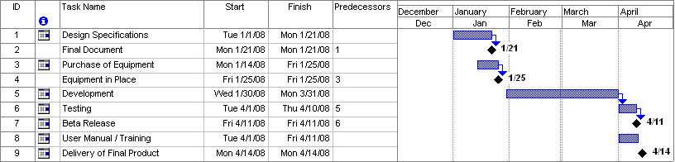
SPECIMEN

13. Report Writing Guidelines

(Project report will be written under the specified guidelines.)

Bibliography

<type here>

