Performance Benchmarking and Edge-Focused Hardware Acceleration of Battery SoC
Estimation Methods

BITS ZG628T: Dissertation
by
Yeshvanth M
2023HT01517
Dissertation work carried out at
Analog Devices India, Bangalore
Submitted in partial fulfilment of
M. Tech Embedded Systems degree programme
Under the Supervision of
Ganesh Ananthaswamy
Analog Devices India, Bangalore

BIRLA INSTITUTE OF TECHNOLOGY & SCIENCE
PILANI (RAJASTHAN)
September 2025

ABSTRACT

Battery State-of-Charge (SoC) estimation is a crucial task in electric vehicle Battery Management Systems (BMS), significantly impacting both performance and safety. Accurate estimation ensures reliable range prediction, prevents overcharging or deep discharge, and enhances the overall lifetime of the battery pack. While conventional methods such as Coulomb counting and Kalman filters have been widely adopted, they are limited by accumulated drift and reliance on detailed electrochemical models, which may not capture real-world nonlinearities effectively.

Recent advances in data-driven techniques offer an alternative path. Deep Neural Networks (DNNs), trained on extensive battery datasets, can model nonlinear behaviour with greater accuracy and adaptability across different operating conditions. However, the computational load of these models poses a challenge for embedded platforms. General-purpose CPU cores, particularly in resource-constrained automotive controllers, are unable to deliver the required throughput within tight energy and latency budgets, making direct deployment impractical.

To overcome this limitation, this thesis investigates a dedicated hardware accelerator tailored for SoC estimation using neural networks. The proposed SoC Engine is designed to offload compute-intensive matrix and vector operations from the host processor, enabling efficient inference of a fully connected feed-forward architecture. By combining low-latency computation with reduced power consumption, the accelerator demonstrates the feasibility of deploying high-accuracy, data-driven SoC estimation at the edge. This approach paves the way for future BMS designs that can seamlessly integrate advanced machine learning models without compromising efficiency or reliability.

Signature of the Student Signature of the Supervisor
Name: Yeshvanth M Name: Ganesh Ananthaswamy
Date: 16-09-2025 Date: 16-09-2025
Place: Bangalore Place: Bangalore
CONTENTS
1. Dataset Selection and Usage ..............................................................................,3
2. Model Selection and Training .............................................................................4
3. Model Evaluation.................................................................................................8
4. Plan of Work………............................................................................................10
5. Abbreviations......................................................................................................10
6. References...........................................................................................................11
Figure 1: Structure of a Feed-forward Fully Connected Network.................................4
Figure 2: Hyperparameter vs. Memory Usage Analysis Tool ......................................5
Figure 3: Optimization History Plot...............................................................................6
Figure 4: Hyperparameter Importance............................................................................6
Figure 5: Training and Validation Loss over Epochs...................................................7
Figure 6: True SOC vs. Predicted SOC scatter plot......................................................8
Figure 7: True SOC vs. Pred icted SOC for a single test file............................................9
Table 1: Best Hyperparamers............................................................................................7
Table 2: Obtained MSE and MAE…...................................................….........................9

- Dataset Selection and Usage

Dataset Description
The dataset used is LG_HG2_Prepared_Dataset_McMasterUniversity_Jan_2020, derived from experiments on a 3 Ah LG HG2 Li-ion cell. It includes a time series of five input features—voltage, current, temperature, plus moving-average current and moving-average voltage over a recent interval—and one target, the State of Charge (SoC). Multiple files in the dataset correspond to data collected under different ambient temperatures.

Data Preparation
- Training data consists of one long sequence of data collected during a standard driving cycle at room temperature.
- Validation and test data contain several separate sequences obtained from driving cycles at other temperatures, to check how well the model generalizes under differing conditions.
- The time-series inputs and targets are stored per sample, with matching sampling intervals, enabling models to be trained on full sequences.
- Data preprocessing includes normalization of input features. The dataset is split in such a way that the test data reflects environmental variability not seen during training.

Usage in This Work
In this project, the dataset is used to train and evaluate SoC estimation models (such as fully connected networks).
Key practices include:
- Selecting features that capture both instantaneous behaviour (voltage, current, temperature) and recent trends (via the moving-average features).
- Ensuring the model sees sequences for training, so that transient behaviours and temperature effects are learned.
- Structuring data splits so that test cases include temperature/profile combinations not present in training, allowing measurement of real-world generalization.

“This work employs the LG 18650HG2 Li-ion Battery dataset [Kollmeyer et al., 2020], available through Mendeley Data [DOI: 10.17632/cp3473x7xv.3].”

- Model Selection and Training
Model Selection
Selecting the right model architecture is a critical step in designing a State-of-Charge (SoC) estimation engine. While advanced architectures such as Convolutional Neural Networks (CNNs), Temporal Convolutional Networks (TCNs), or Long Short-Term Memory (LSTM) networks are known for their ability to capture temporal dependencies and extract high-level features from raw input signals, they also introduce significant overhead in terms of computational complexity and control logic. These factors directly influence power consumption, latency, and ease of hardware integration. In contrast, simpler architectures such as Fully Connected Networks (FCNs) reduce the need for specialized operators and provide a more predictable workload, which is highly desirable for low-power embedded and ASIC-oriented implementations.
In this work, a feed forward Fully Connected Network as shown in Figure 1, is chosen as the baseline model. The justification is twofold. First, from a hardware perspective, FCNs map cleanly onto multiply-accumulate (MAC) operations, which are highly amenable to parallelization and pipelining. This results in a predictable computational load and simplified data path design compared to convolutional layers, which require additional control logic for sliding windows, padding, and stride management. As a result, FCNs can be implemented with lower control overhead, reduced memory access complexity, and a smaller design footprint. These characteristics make them particularly suitable for low-power embedded processors and custom hardware accelerators.
Second, FCNs offer a favorable balance between model accuracy and energy efficiency. For SoC estimation, the relationship between input features (such as voltage, current, and temperature) and the target state can often be captured adequately by a structured, non-linear mapping without the need for specialized convolutional feature extraction. By carefully tuning hyperparameters such as the number of layers, neurons per layer, and activation functions, the FCN can achieve the required accuracy while minimizing both training and inference costs. This ensures that the model remains computationally lightweight, leading to reduced power consumption in embedded deployments where energy efficiency is a primary constraint.

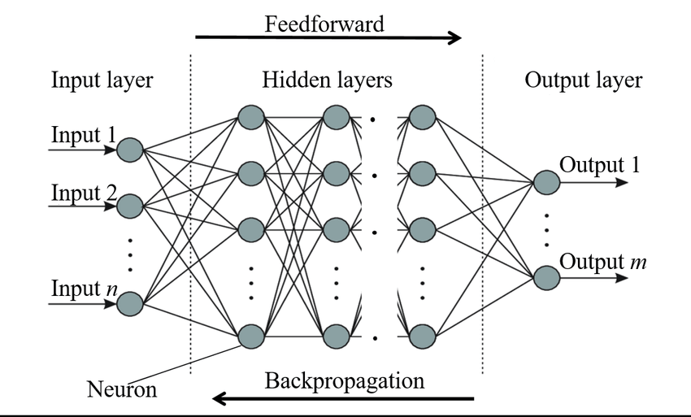
Figure 1
Hyperparameter Tuning

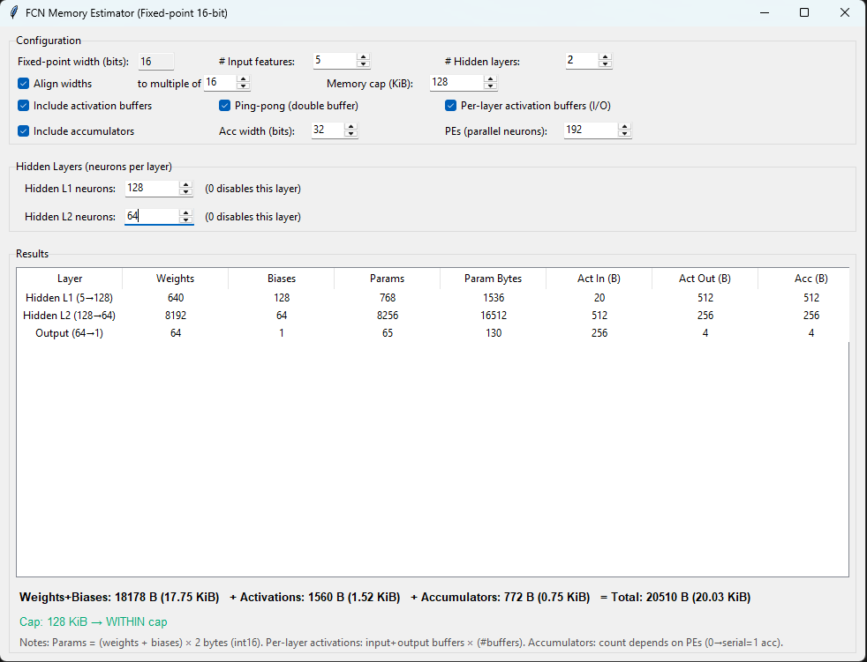
Figure 2

A small Python (Tkinter) tool, shown in Figure 2, was implemented to size fully connected networks under 16-bit fixed-point constraints and a user-set memory cap. The GUI allowed the user to configure the number of hidden layers and neurons per layer, optionally enforce width alignment (e.g., multiples of 16), and toggle activation buffer accounting (single, ping-pong, or per-layer I/O buffers). It also supported modeling of accumulators, with user-defined accumulator bit-width (typically 32-bit for int16 products) and parallelism (serial or partially parallel processing elements).
For each configuration, the tool computed per-layer memory using closed-form formulae: $weights = N_{i-1}×N$, biases = $N$, parameters bytes = (weights + biases) × 2, with an additional term for accumulator registers and activation input/output buffers. The output layer was included as a final stage ($N_{last}$→1). These quantities were then summed to report weights + biases, per-layer activations, accumulators, and the grand total in bytes/KiB, with live feedback against the memory cap.
The calculations were directly used to constrain Optuna’s search space: only architectures satisfying the memory budget (including alignment, buffer, and accumulator rules) were considered feasible. The tool thereby produced realistic ranges for hidden-layer widths (e.g., 64, 128, non-increasing across layers), a depth bound (2–3 hidden layers), and pruning rules for candidate networks that exceeded the cap. This ensured that Optuna explored architectures that were both hardware-compliant and more likely to meet latency and energy targets on the accelerator.

Hyperparameters were tuned with Optuna to balance accuracy and deploy ability. A TPE-style search with 100 trials (Figure 3) explored learning rate (log-scaled), network width, depth, and dropout—factors that most influence convergence, capacity, and generalization for a 5-feature SoC regression problem. The objective minimized validation MSE, using a consistent
train/validation split so trials were directly comparable.
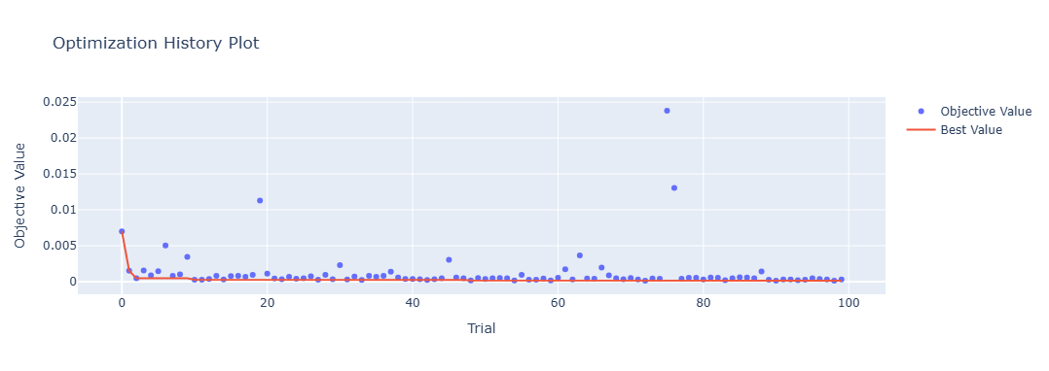
Figure 3
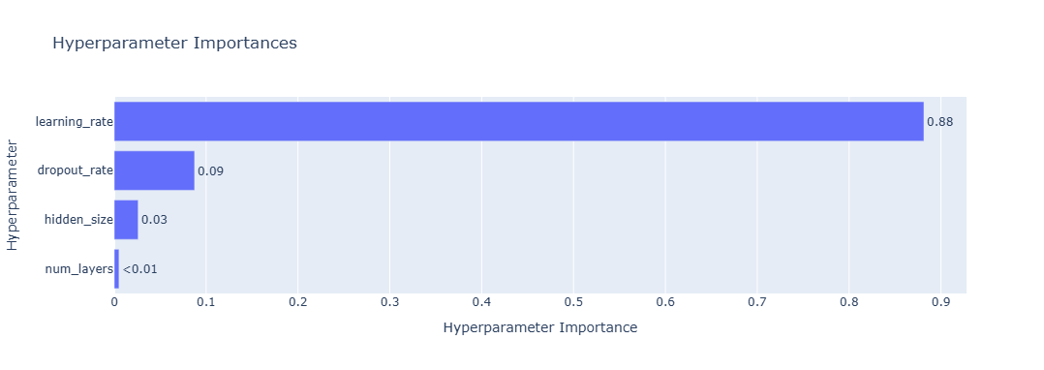
Figure 4
Runs showed that learning rate dominated hyperparameter importance ≈88% (Figure 4), with dropout rate a distant second (≈9%); the remaining variance was attributable to architecture choices already constrained by hardware. Accordingly, Optuna was configured to explore learning rate on a log scale (1e-5–1e-1) and dropout (0.10–0.50) most aggressively, while keeping hidden sizes and depth within a hardware-aligned space—hidden_size ∈ {64, 128} (multiples of 16 for vector/MAC alignment) and num_layers ∈ {1,2,3} to meet memory/latency limits. This design focused search effort where it mattered empirically (LR, then dropout), and ensured that any selected model remained straightforward to implement on the accelerator (on-chip footprint, no tail handling, batch=1). This setup identified compact FCN configurations that fit memory/latency budgets yet retained accuracy, and the optimization history and parameter-importance plots provide transparent evidence of which choices mattered most (typically learning rate first, then capacity and dropout).

Table 1: Best hyperparameters
Learning Rate | 7.2712$×{10}^{-5}$
Hidden Size | 128
Number of Layers | 2
Dropout Rate | 1.3202$×{10}^{-1}$

Training
After hyperparameter search, the final FCN was retrained from scratch using the best configuration returned by Optuna (hidden size and number of hidden layers) and the corresponding learning rate. The network took as input the predefined feature set and produced a single SoC estimate. Training used the Adam optimizer and optimized the mean-squared error (MSE) loss on a fixed training/validation split.
The model was trained for 50 epochs with mini-batches provided by the data loaders. At the end of each epoch, the validation loss was computed to monitor generalization. Training and validation loss curves were recorded and plotted (Figure 5) to verify convergence and to check for over/underfitting trends. (If a tuned dropout rate was part of the selected configuration, that value was used; otherwise, the model’s default dropout was applied.) artifact.
Upon completion, the trained weights were saved as a PyTorch checkpoint, containing the state_dict and input dimensionality) to enable deterministic reuse for evaluation, quantization, and deployment on the target hardware.

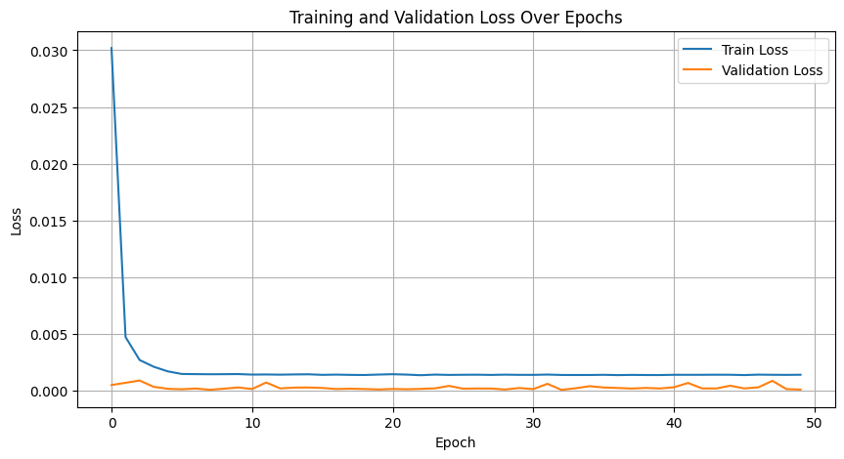
Figure 5

- Model Evaluation
The final FCN checkpoint was loaded and put in evaluation mode to disable dropout and use the stored BatchNorm statistics. Inference was run on the held-out test set using the same preprocessing pipeline as training.
Model accuracy was quantified with mean squared error (MSE) and mean absolute error (MAE) using scikit-learn. These metrics were computed between the scalar SoC predictions and the ground-truth labels, both expressed in normalized units $[0,1]$. Reporting both MSE and MAE provides sensitivity to large errors (MSE) and a robust central tendency (MAE).
A scatter plot of predicted vs. true SoC (Figure 6) was generated with the axes fixed to $[0,1]$ and an identity line $y=x$. Points lying close to the diagonal indicate accurate predictions; any systematic deviation from the line reveals bias (e.g., underestimation at high SoC or overestimation at low SoC). This plot complements the scalar metrics by highlighting heteroskedasticity or regime-specific errors and confirms that the trained model generalizes to unseen data under the same input feature definition.

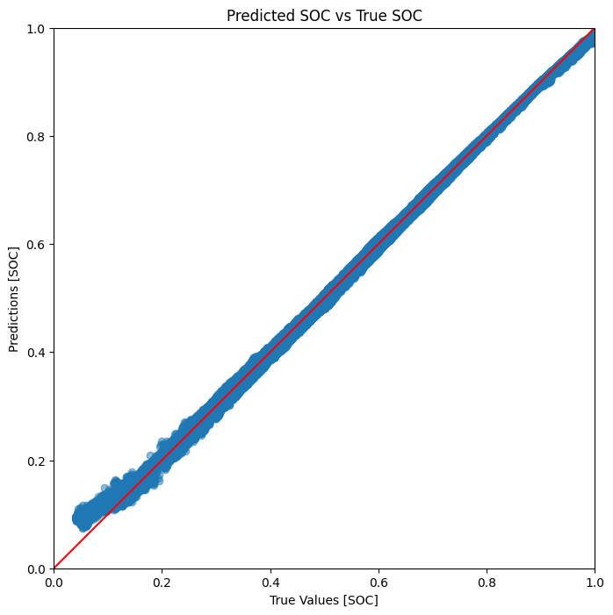
Figure 6
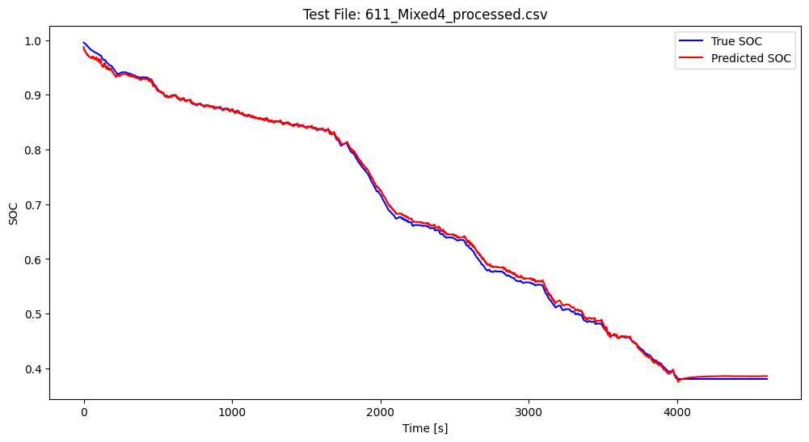
Figure 7

Table 2: Obtained MSE and MAE
MSE | 0.000158
MAE | 0.007935
RMSE | 0.012569

Test results
On the held-out test set (SoC normalized to $[0,1]$), the model achieved $MSE = 1.58×10⁻⁴$ and $MAE=$ $7.94×10⁻³$. This corresponds to an $RMSE ≈ 0.0126 (≈ 1.26\% SoC)$ and an average absolute error of $≈ 0.79\%$ $SoC$.

Interpretation
Errors at this level indicate accurate generalization across the test distribution. As a rule of thumb, if residuals are roughly symmetric, $\sim 95\%$ of predictions should fall within
$±2 × RMSE ≈ ±2.5\% SoC$ of the ground truth.

Context
The test set covered multiple temperatures and both charge/discharge profiles using the same preprocessing as training. A predicted-vs-true scatter (with the $y=x$ line) showed points clustered near the diagonal, consistent with the low MAE/MSE and with no visible signs of overfitting. These results meet typical accuracy targets for lab-grade SoC estimation and are suitable for downstream quantization and deployment.

- Plan for Work

Phases | Start Date-End Date | Work to be done | Status
Dissertation  Outline | 17 Jul 2025 – 30 Jul 2025 | Literature Review, dataset selection, training of baseline ML models and prepare Dissertation Outline | Done
Design &  Development | 30 Jul 2025 – 17 Sept 2025 | RTL Design, Implementation and  Testbench Development | In Progress
Testing | 18 Sept 2025 –29 Oct 2025 | RTL Simulation, Synthesis, PPA Analysis, final report writing, and presentation preparation | Pending
Dissertation Review | 30 Oct 2025 - 6 Nov 2025 | Submit Dissertation to Supervisor & Additional Examiner for review and feedback | Pending
Submission | 7 Nov 2025 – 11 Nov 2025 | Final Review and Submission of Dissertation | Pending

- Abbreviations

Abbreviation | Expansion
ASIC | Application-Specific Integrated Circuit
BMS | Battery Management System
CPU | Central Processing Unit
CNN | Convolutional Neural Network
DNN | Deep Neural Network
FCN | Fully Connected Network
GUI | Graphical User Interface
LSTM | Long Short-Term Memory
MAC | Multiply–Accumulate
MAE | Mean Absolute Error
ML | Machine Learning
MSE | Mean Squared Error
PPA | Power, Performance, and Area
RMSE | Root Mean Squared Error
RTL | Register Transfer Level
SoC | State of Charge
TCN | Temporal Convolutional Network
TPE | Tree-structured Parzen Estimator

- Literature References

[1] M. A. Hannan, D. N. T. How, M. S. H. Lipu, P. J. Ker, Z. Y. Dong, M. Mansur, and F. Blaabjerg,
“SOC Estimation of Li-ion Batteries with Learning Rate-Optimized Deep Fully Convolutional Network,”
IEEE Transactions on Power Electronics, vol. 36, no. 6, pp. 7349–7353, Jun. 2021,
doi: 10.1109/TPEL.2020.3041876.

[2] M. A. Hannan, M. S. H. Lipu, A. Hussain, and M. H. Md. Saad,
“Neural Network Approach for Estimating State of Charge of Lithium-Ion Battery Using Backtracking Search Algorithm,”
IEEE Access, vol. 6, pp. 10069–10079, 2018, doi: 10.1109/ACCESS.2018.2809441.

[3] Y.-H. Chen, T. Krishna, J. Emer, and V. Sze,
“Eyeriss: An energy-efficient reconfigurable accelerator for deep convolutional neural networks,”
IEEE Journal of Solid-State Circuits, vol. 52, no. 1, pp. 127–138, Jan. 2017, doi: 10.1109/JSSC.2016.2616357.

[4] Y.-H. Chen, T. Krishna, J. Emer, and V. Sze,
“Eyeriss v2: A flexible accelerator for emerging deep neural networks on mobile devices,”
IEEE Journal on Emerging and Selected Topics in Circuits and Systems, vol. 9, no. 2, pp. 292–308, June 2019, doi: 10.1109/JETCAS.2019.2910232.

