Quantum-like cognition and decision-making for autonomous agents: a survey from robotics to machine learning
[FILL: Firstname Lastname]¹*, [FILL: Second Author]²
¹[FILL: Department, Institution, City, Postcode, Country]
²[FILL: Department, Institution, City, Country]
*Corresponding author. E-mail: [FILL: email]; ORCID: [FILL: ORCID]
Abstract Autonomous robots and AI systems increasingly decide under ambiguity and in interaction with people whose judgements violate classical probability. Quantum cognition models beliefs as vectors in a Hilbert space and judgements as measurements, so that question order, context and interference between unresolved possibilities change the resulting probabilities. These quantum-probability (QP) models run on ordinary computers and need neither quantum hardware nor a quantum brain. This survey reviews 205 works covering the foundations, empirical tests and critiques of quantum cognition and its transfer to autonomous agents: quantum-like Bayesian networks, quantum-inspired machine learning and language models, quantum and quantum-inspired reinforcement learning, robot perception, emotion and decision models, multi-agent and human–machine teams, and human trust in AI. Every application is classified by model type and on a six-level evidence scale. The psychological evidence is substantial but contested: order effects obeying the parameter-free QQ equality are robust, whereas conjunction-fallacy and contextuality claims face credible classical rivals. Applications remain early: most are formal models or simulations, six reach a physical system, and none shows in a controlled comparison that a QP module improves an autonomous system’s task performance. The most defensible near-term use is human-facing, predicting human judgements, trust and preferences. Worked examples, an illustrative reinforcement-learning experiment, a comparison with classical methods and a benchmark proposal complete the survey.
Keywords Quantum cognition · Quantum probability · Decision-making · Autonomous agents · Human–robot interaction · Reinforcement learning
1 Introduction
1.1 Motivation
Classical autonomous systems rest on Kolmogorov probability. A robot’s belief is a probability distribution over states; new evidence is incorporated by Bayes’ rule; decisions maximise expected utility; and when the state is only partly observable the whole loop is formalised as a partially observable Markov decision process (Thrun et al. 2005; Lauri et al. 2023). Sensor fusion follows the same logic, with the Kalman filter as the optimal estimator for linear-Gaussian systems (Kalman 1960; Haykin 2001), and reinforcement learning (RL) assumes Markovian states and additive rewards (Sutton and Barto 2018). These assumptions have delivered reliable navigation, mapping and manipulation. They become fragile, however, in three situations that autonomous agents now meet routinely.
The first is interaction with people. Human judgement systematically violates classical probability: the probability of a conjunction is judged higher than that of one of its components (Tversky and Kahneman 1983), answers depend on the order in which questions are asked (Wang et al. 2014), and people who would choose the same option whatever the outcome of an uncertain event choose differently when the outcome is unknown, violating Savage’s sure-thing principle (Savage 1954; Shafir and Tversky 1992). A robot that predicts human intentions, calibrates trust or explains its choices with a model that cannot represent these patterns will be systematically wrong about its human partners (Song et al. 2022; Roeder et al. 2023). The second is ambiguity: when evidence is conflicting or the categories themselves are vague, a single joint probability distribution over all variables may not exist, a situation classical inference handles only with ad hoc devices (Ellsberg 1961; Blutner et al. 2013). The third is context and sequence: large language models (LLMs) and other learned systems also show order and framing effects (Binz and Schulz 2023; Tjuatja et al. 2024), so AI components that query one another in sequence can inherit context-dependent behaviour that no fixed joint distribution describes (Lo et al. 2025).
1.2 The quantum cognition hypothesis
Quantum cognition proposes that the mathematics of quantum theory, rather than its physics, provides a better description of these phenomena (Busemeyer and Bruza 2012; Pothos and Busemeyer 2013; Bruza et al. 2015). A belief state is a unit vector in a Hilbert space; a question is a subspace; the probability of an answer is the squared length of the state’s projection onto that subspace; and answering a question changes the state. Two principles do most of the work (Busemeyer and Wang 2015). Complementarity (incompatibility) means that some questions correspond to non-commuting projectors, so that answering one first changes the answer to the other and no joint distribution over both exists. Superposition means that, before a judgement is made, the state need not be in any definite answer; unresolved possibilities combine through amplitudes, and their interference can raise or lower probabilities relative to the classical law of total probability (Pothos and Busemeyer 2009). When all questions are compatible, QP reduces exactly to classical probability, so the framework is a generalisation rather than a replacement (Bruza et al. 2015). The strongest single piece of support is a parameter-free prediction, the quantum question (QQ) equality, which held across 70 national surveys (Wang and Busemeyer 2013; Wang et al. 2014). The most recent overview of the research programme summarises two decades of such tests (Huang et al. 2025a).
1.3 Scope, terminology and the role of quantum hardware
This survey addresses a different question from surveys of quantum computing for robotics (Petschnigg et al. 2019; Yan et al. 2024). Quantum-cognition models are linear-algebra models: states are vectors or density matrices of modest dimension, measurements are projectors or instruments, and dynamics are unitary or Lindblad evolutions, all of which run on standard CPUs and GPUs. Quantum hardware is therefore optional. Circuits for cognitive decision models have been run on trapped-ion processors (Widdows et al. 2023) and compositional language models on superconducting devices (Lorenz et al. 2023), but these demonstrations show feasibility rather than advantage, and noisy intermediate-scale devices (Preskill 2018) add latency and error without adding modelling power at these sizes. The practical barrier to adoption is not hardware but evidence: whether the effects are robust, whether QP models beat well-specified classical alternatives, and whether they improve what autonomous systems actually do. We therefore separate three families throughout: quantum-like models (QP mathematics on classical computers), quantum-inspired algorithms (classical heuristics borrowing quantum ideas, such as amplitude-based exploration) and quantum hardware implementations.
The survey covers (i) the psychological and mathematical foundations of quantum cognition, including open-system dynamics, quantum instruments and contextuality; (ii) quantum-like graphical models for decision support; (iii) quantum-inspired machine learning, deep learning and natural-language processing, including recent probes of LLMs; (iv) quantum and quantum-inspired reinforcement learning; (v) quantum-like models for robot perception, emotion, planning and embodied cognition; (vi) multi-agent systems, swarms and human–machine teams; and (vii) quantum models of human trust in automation. It excludes quantum control of physical qubits and quantum sensing, except where they are used as agent decision models, and it treats claims that the brain is a quantum computer only in the neuroscience discussion (Section 17). The contributions of the survey are stated in Section 1.4.
1.4 Related surveys and contributions
Existing reviews cover four neighbouring areas but not their intersection (Table 1). Surveys of quantum cognition in psychology, notably Pothos and Busemeyer (2022) and Huang et al. (2025a), with earlier reviews by Bruza et al. (2015) and Ashtiani and Azgomi (2015), summarise the evidence from human judgement and decision-making but do not discuss robots, reinforcement learning or other autonomous agents. Surveys of quantum robotics (Yan et al. 2024; Petschnigg et al. 2019) focus on quantum computing, sensing and communication hardware and treat cognition briefly or not at all. Reviews of quantum machine learning (Biamonte et al. 2017; Dunjko and Briegel 2018), quantum reinforcement learning (Meyer et al. 2022; Chen 2024), quantum mathematics in AI (Widdows et al. 2021), quantum-inspired information retrieval (Uprety et al. 2020) and quantum-cognitively inspired sentiment analysis (Liu et al. 2023) cover algorithms but not the human-facing decision problems of autonomous agents. A recent chapter surveys quantum models of cognition across AI, finance and defence without grading evidence (Maksymov 2025), and position papers argue for a convergence of quantum-like cognition and AI (Khrennikov 2022; Khrennikov 2026).
Table 1 Coverage of this survey compared with earlier reviews. ✓ = covered systematically; (✓) = covered partially; – = not covered. QC = quantum cognition; QRL = quantum reinforcement learning. The assessment is ours
Review | Focus | QC evidence and critiques | Robots and embodied agents | ML, DL and LLMs | QRL | Human–AI trust | Evidence grading
Ashtiani and Azgomi (2015) | Quantum-like decision formalisms | ✓ | – | – | – | – | –
Bruza et al. (2015) | Quantum cognition in cognitive science | ✓ | – | – | – | – | –
Pothos and Busemeyer (2022) | Quantum cognition (Annual Review) | ✓ | – | – | – | – | –
Huang et al. (2025a) | Overview of the research programme | ✓ | – | – | – | (✓) | –
Dunjko and Briegel (2018) | ML and AI in the quantum domain | – | (✓) | ✓ | ✓ | – | –
Meyer et al. (2022) | Quantum reinforcement learning | – | (✓) | – | ✓ | – | –
Widdows et al. (2021) | Quantum mathematics in AI | (✓) | – | ✓ | – | – | –
Yan et al. (2024) | Quantum robotics | – | ✓ | (✓) | (✓) | – | –
Maksymov (2025) | Quantum models of cognition in AI applications | (✓) | (✓) | (✓) | – | (✓) | –
This survey | Quantum cognition for autonomous agents | ✓ | ✓ | ✓ | ✓ | ✓ | ✓

To our knowledge, this survey is the first to make the following five contributions.
1. It connects the psychological evidence base to applications in robotics, reinforcement learning, machine learning and deep learning, large language models and human–AI trust within one framework (Sections 5–13).
2. It separates quantum-like, quantum-inspired and quantum-hardware work consistently throughout.
3. It grades every application study on a six-level evidence scale, from conceptual proposals to field deployment (Section 2 and Online Resource 1).
4. It confronts the applications with the critical literature and with classical competitors (Sections 5.6 and 14.2).
5. It provides worked examples, an illustrative experiment, a benchmark suite and a replication checklist, with reproducible code (Sections 10.5 and 18, Online Resource 2).
1.5 Organisation
Section 2 describes the review methodology and the evidence scale. Section 3 traces the development of quantum cognition, Section 4 introduces the mathematics needed for the rest of the survey, and Section 5 reviews the core phenomena and the evidence for and against QP models. Section 6 maps QP principles onto agent functions, and Sections 7–13 review applications to perception and fusion, decision-making and planning, machine learning and language models, reinforcement learning, embodied and social robots, multi-agent systems, and human–AI trust. Section 14 synthesises the evidence and compares QP models with classical alternatives. Sections 15–17 discuss limitations, implementation, ethics and biological grounding, Section 18 sets out benchmarks and a research agenda, and Section 19 concludes. Appendix A collects the derivations and Appendix B the experimental details.
2 Review methodology
The corpus was assembled in three stages. We began with a curated reading list of 102 items compiled for this survey and a companion survey on quantum computing in robotics. Every item was checked against publisher, arXiv or repository records. About twenty entries needed corrections to titles, author lists, years or identifiers; three items could not be located in any index and were replaced by the two verified papers of the same research group; two items whose titles did not exist were replaced by the real works that matched their topic; and two further items were dropped, one because it could not be found and one because it did not concern quantum models. Second, PDFs held by the authors were identified by their first-page text rather than their file names; 31 relevant works found in this way were added. Third, we ran structured web searches (Google Scholar-style queries, publisher sites, arXiv, PubMed and Semantic Scholar) in two streams: applications of quantum cognition to robots, agents, human–machine teams and reinforcement learning; and quantum cognition theory, critiques, machine learning, LLMs and neuroscience published from 2016 to 2026. This added 74 verified works. The final corpus contains 205 works: 74 application studies, 71 theory and evidence papers, 17 reviews and 43 background works (classical baselines, hardware and software). The searches were last run on [FILL: date of the final search]; database-level hit counts are reported in Online Resource 1 [FILL: add the database-level counts].
Each application and theory paper was read in full where a PDF was available (64 works) or from its abstract otherwise, and classified by model type and by the evidence level in Table 2. The levels grade how far the evidence goes toward an autonomous system, not the quality of the underlying science: a rigorous psychology experiment is E3 because it involves human data but no agent.
Each study was also classified by model type. Quantum-like models use QP mathematics on classical computers; quantum-inspired algorithms are classical heuristics that borrow quantum ideas, such as amplitude-based exploration; and quantum-hardware studies execute circuits on quantum processors. Application studies were further assigned to one of seven domains: quantum-like decision networks; machine learning, natural-language processing and information retrieval; deep learning and LLMs; reinforcement learning; robots and embodied agents; multi-agent systems and teams; and human–AI trust. The complete classification of the 74 application studies is given in Online Resource 1.
Table 2 Evidence levels used to classify theory and application studies, with the number of application studies (n = 74) and of all graded studies (n = 145) at each level
Level | Label | Definition | Typical example | n (appl.) | n (all)
E1 | Conceptual | Position or proposal without a formal model or data | Architectural proposals (Aerts et al. 2011b; Lawless 2020) | 6 | 8
E2 | Formal model | Mathematical model or algorithm; analytic or toy illustration only | Quantum emotion spaces (Yan et al. 2019) | 18 | 49
E3 | Human data | Model fitted to or tested on human behavioural or neural data | QQ equality in surveys (Wang et al. 2014); trust in AI (Roeder et al. 2023) | 9 | 46
E4 | Simulation or benchmark | Simulated agents, ML benchmark datasets or LLM probes | Quantum RL navigation (Hohenfeld et al. 2024) | 35 | 36
E5 | Physical system | Physical robot or real hardware system in the laboratory | Quantum-inspired RL on a mobile robot (Dong et al. 2012) | 6 | 6
E6 | Field deployment | Real-world deployment or large-scale study with real users or operators | None found | 0 | 0

Threats to validity. Several threats apply. Coverage may be incomplete because the terminology is inconsistent (“quantum-like“, “quantum-inspired” and “quantum” are used interchangeably) and because several recent works are preprints that have not yet been peer-reviewed. About 92 entries were classified from their abstracts rather than full texts, which may have led to errors in the assigned evidence level; when in doubt, we assigned the lower level. Evidence levels grade how far a study goes towards an autonomous system, not its scientific quality. Finally, the heterogeneity of tasks and metrics prevented a quantitative meta-analysis, so the synthesis is narrative.
3 Historical development
Figure 1 summarises five eras in the development of quantum cognition and its transfer to autonomous agents.
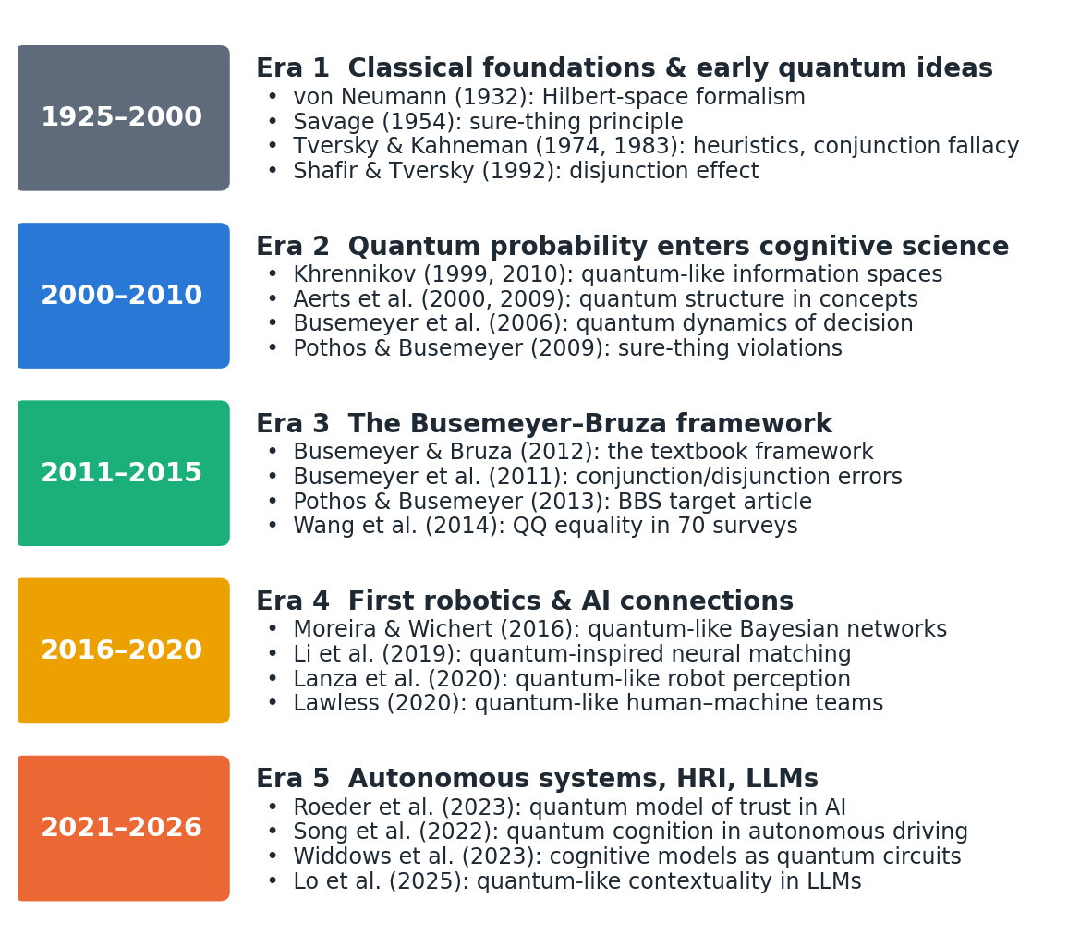
Fig. 1 Five eras of quantum cognition and its transfer to autonomous agents, with representative works
3.1 Classical foundations and early quantum ideas (1925–2000)
The formalism that quantum cognition borrows was consolidated by von Neumann, who represented states as vectors in a Hilbert space, observables as self-adjoint operators and measurement as projection (von Neumann 1932). Two of his results matter here. First, quantum probability is defined on a lattice of subspaces that is not distributive, so the classical identity P(A) = P(A∧B) + P(A∧¬B) can fail. Second, measurement changes the state, the property later exploited to model the constructive nature of human judgement.
Savage’s axiomatisation of subjective expected utility made the sure-thing principle a pillar of rational choice (Savage 1954). Cognitive science then developed along two lines that still shape autonomous systems: symbolic architectures, from which today’s cognitive architectures descend (Kotseruba and Tsotsos 2020; Laird et al. 2017), and probabilistic models, later formalised as Bayesian networks and probabilistic robotics (Thrun et al. 2005). Both assume that all variables can be placed in one sample space.
The heuristics-and-biases programme documented systematic departures from probability theory (Tversky and Kahneman 1974). The conjunction fallacy (judging “bank teller and feminist” more probable than “bank teller“) (Tversky and Kahneman 1983), ambiguity aversion in the Ellsberg paradox (Ellsberg 1961) and the disjunction effect in the Prisoner’s Dilemma (Shafir and Tversky 1992) became the benchmark phenomena that quantum models would later address.
3.2 Quantum probability enters cognitive science (2000–2010)
The Brussels group argued that concepts behave like quantum entities whose meaning is actualised by context. Aerts, D’Hondt and Gabora showed that the quantum-logical disjunction is not classical (Aerts et al. 2000), and Aerts later showed that membership judgements for combined concepts (the “guppy effect” and over- and underextension) are incompatible with classical models but reproduced in Fock space (Aerts 2009).
Khrennikov developed quantum-like models of information spaces (Khrennikov 1999) and a contextual probability framework in which interference arises from incompatible contexts rather than physical quantum effects (Khrennikov 2010). The “quantum-like” label used throughout this survey originates in this work.
Busemeyer, Wang and Townsend introduced quantum dynamics of decision-making, contrasting quantum and Markov random walks (Busemeyer et al. 2006). Pothos and Busemeyer then showed that interference between the “opponent defects” and “opponent cooperates” branches reproduces the disjunction effect that classical models cannot (Pothos and Busemeyer 2009), and Busemeyer, Wang and Lambert-Mogiliansky derived parameter-free empirical tests separating Markov and quantum models (Busemeyer et al. 2009). Bruza and colleagues asked whether the human mental lexicon is quantum-like (Bruza et al. 2009).
3.3 Consolidation of the framework (2011–2015)
The monograph by Busemeyer and Bruza unified the field’s principles, models and data (Busemeyer and Bruza 2012); it remains the standard reference (a second edition has since appeared). Its companion target article in Behavioral and Brain Sciences, with open peer commentary, made the case to mainstream cognitive science (Pothos and Busemeyer 2013).
Busemeyer, Pothos, Franco and Trueblood explained conjunction and disjunction errors as sequential projections (Busemeyer et al. 2011); Trueblood and Busemeyer modelled order effects in inference (Trueblood and Busemeyer 2011); and Wang and Busemeyer derived the QQ equality (Wang and Busemeyer 2013), confirmed in 70 national surveys (Wang et al. 2014).
Two-stage paradigms, in which an intermediate judgement is either elicited or not, became the main test of interference. Making a categorisation before an action (Wang and Busemeyer 2016), or a choice before a confidence rating (Kvam et al. 2015), changed later judgements in ways that violate the law of total probability.
A special issue of Topics in Cognitive Science set out the case for quantum models of cognition (Wang et al. 2013) and extended them to similarity (Pothos et al. 2013), vagueness (Blutner et al. 2013) and concept dynamics (Aerts et al. 2013). The Quantum Interaction conference series provided a venue shared with information retrieval and AI, where the first explicit bridge to AI and robotics was proposed (Aerts et al. 2011b; Aerts et al. 2011c). Survey articles consolidated the field (Ashtiani and Azgomi 2015; Bruza et al. 2015).
3.4 First connections to AI and robotics (2016–2020)
Quantum-like Bayesian networks replaced classical probabilities with complex amplitudes and gave decision-support systems a way to represent sure-thing violations (Moreira and Wichert 2016; Moreira 2017). In information retrieval and NLP, density-matrix language models (Sordoni et al. 2013) led to quantum-inspired neural networks for matching and sentiment (Zhang et al. 2018; Li et al. 2019). In RL, a separate line of quantum-inspired algorithms had already been validated on a mobile robot (Dong et al. 2008; Dong et al. 2012), and projective simulation offered a physics-motivated learning agent (Briegel and De las Cuevas 2012) tested on real robotic manipulation (Hangl et al. 2016).
Quantum-inspired multimodal fusion treated modalities as incompatible measurement contexts (Li et al. 2021a; Gkoumas et al. 2021). For robots, Lanza, Solinas and Mastrogiovanni proposed a quantum-like perception model in which percepts are qubit states and queries are measurements (Lanza et al. 2020), extended to multi-sensory integration (Lanza et al. 2021).
Early “quantum robot” architectures combined classical controllers with (then hypothetical) quantum processors (Benioff 1998; Dong et al. 2006); robot emotion was modelled as a qubit-encoded emotion space (Yan et al. 2019); and a quantum-like cognitive architecture was proposed as an alternative to resource-rational analysis (Moreira et al. 2020b). None of these architectures closed a real-time control loop with a quantum processor.
3.5 Quantum cognition for autonomous systems (2021–present)
Recent robot-facing work includes quantum-like pedestrian-intention models for automated driving (Song et al. 2022), quantum affective decision models for social robots (Ho and Hoorn 2022; Yan et al. 2021b), quantum-circuit planners and teleo-reactive controllers (Chella et al. 2022; Chella et al. 2026), and a social-robotics research programme (De Carolis et al. 2025). Multi-goal trade-offs appear in quantum-like evidence networks (Gao et al. 2025) and multi-attribute decision models (She et al. 2021). We found no study that applies quantum cognition to fault diagnosis in robots; the closest work is a fault-tolerant quantum filter for quantum systems (Gao et al. 2021), which addresses a different problem.
Quantum-cognitive fusion (Gkoumas et al. 2021), density-matrix matching (Zhang et al. 2025) and quantum-cognitive neural networks that reproduce human-like confidence (Maksimovic and Maksymov 2025) extend quantum-inspired ML. Since 2024, a new line probes LLMs for quantum-like structure: contextuality in LLM-derived probabilities (Lo et al. 2025), context effects in similarity judgements (Uprety et al. 2024), Bell-type correlations in concept combinations (Aerts et al. 2026), and probability-judgement fallacies (Imannezhad et al. 2026; Kang 2026).
Variational quantum policies and Q-functions (Chen et al. 2020; Jerbi et al. 2021; Skolik et al. 2022) were applied to robot navigation (Hohenfeld et al. 2024), arm control (Acuto et al. 2022) and automated driving (Sinha et al. 2025), while quantum-inspired experience replay continued the classical line (Wei et al. 2022). On the cognitive side, open-system quantum–Markov models describe how preferences and beliefs evolve (Busemeyer et al. 2020; Kvam et al. 2021; Epping et al. 2023), and quantum models of trust in AI track how human reliance changes during interaction (Roeder et al. 2023; van der Meer et al. 2025; Humr et al. 2025).
4 Mathematical foundations
This section gives the minimum machinery needed to read the rest of the survey; derivations are collected in Appendix A, and tutorials are available elsewhere (Yearsley and Busemeyer 2016; Yearsley 2017).
4.1 Complex vector spaces and inner products
A state is a vector |ψ⟩ in ℂⁿ. The inner product ⟨φ|ψ⟩ = Σᵢ φᵢ* ψᵢ is linear in its second argument and conjugate-linear in its first; the norm is ‖ψ‖ = √⟨ψ|ψ⟩. Complex amplitudes matter because probabilities are squared magnitudes: two paths to the same outcome add as amplitudes, and their relative phase determines whether they reinforce or cancel.
4.2 Hilbert spaces and orthonormality
A Hilbert space is a complete inner-product space; all models in this survey are finite-dimensional, so it is simply ℂⁿ with the standard inner product. An orthonormal basis {|eᵢ⟩} satisfies ⟨eᵢ|eⱼ⟩ = δᵢⱼ. In cognitive models each basis vector represents a fully resolved answer pattern, and different questions correspond to different bases of the same space.
4.3 Linear operators
Observables are Hermitian operators (A = A†); dynamics are unitary operators (U†U = I) that preserve norms, generated by a Hermitian Hamiltonian H through U(t) = exp(−iHt). Two operators are compatible when they commute (AB = BA). The commutator [A, B] = AB − BA measures incompatibility and is the formal source of order effects.
4.4 Projectors and the Born and Lüders rules
A projector P satisfies P = P† = P²; it projects onto the subspace spanned by the eigenvectors associated with an answer. The Born rule gives p(answer) = ‖P|ψ⟩‖² = ⟨ψ|P|ψ⟩, and the Lüders rule gives the post-answer state P|ψ⟩/‖P|ψ⟩‖. Sequential judgements therefore have probability p(A then B) = ‖P_{B} P_{A} |ψ⟩‖², which differs from p(B then A) when P_{A} and P_{B} do not commute. Mixed states are density matrices ρ (positive, unit trace), with p = tr(Pρ); general measurements are positive-operator-valued measures (POVMs) or quantum instruments, which are needed to model some combinations of effects (Section 5.2) (Ozawa and Khrennikov 2020; Fuyama et al. 2025).
4.5 Tensor products and composite systems
Composite systems live in tensor products: two binary questions that are compatible can be represented in ℂ² ⊗ ℂ² = ℂ⁴. States that cannot be written as products (entangled states) represent dependencies that are not reducible to separate beliefs, and have been used to model concept combination (Aerts and Sozzo 2011). For ML practitioners, tensor products are also the basis of tensor-network models (Stoudenmire and Schwab 2016). The dimension grows as 2ⁿ for n binary variables, which is the central computational limitation of naive QP models (Section 15.3). Hilbert-space multidimensional theory addresses this by choosing low-dimensional representations tailored to the questions asked (Busemeyer and Wang 2018).
4.6 Terminology
In quantum cognition these terms are used in a precise mathematical sense that should not be confused with claims about physical quantum states in the brain. Superposition denotes a state that is a linear combination of answer states, representing unresolved uncertainty that is not mere ignorance of a fixed answer. Measurement is the act of eliciting a judgement or decision, which projects the state and so changes subsequent judgements. Interference is the cross term that appears when the probability of an outcome is computed from two unresolved paths; it is responsible for violations of the law of total probability. Entanglement is non-separability of a composite state; in cognition it is usually diagnosed by Bell-type or CHSH inequalities, and such diagnoses require care because signalling between measurements (direct influence of context on marginal probabilities) can mimic it (Dzhafarov and Kujala 2016).
4.7 Quantum versus classical probability
Table 3 compares the two frameworks. Classical probability assigns probabilities to subsets of one sample space and is commutative and distributive; QP assigns them to subspaces, is non-commutative for incompatible questions and violates the distributive law. Both satisfy the basic axioms for a single set of compatible events, and QP reduces to classical probability when all projectors commute (Bruza et al. 2015). The difference matters only for incompatible questions, which is why careful experimental design is needed to discriminate the two.
Table 3 Classical versus quantum probability
Aspect | Classical (Kolmogorov) probability | Quantum probability
Events | Subsets of one sample space | Subspaces of a Hilbert space
State | Probability distribution | Unit vector |ψ⟩ or density matrix ρ
Probability rule | Measure of the subset | Born rule: ‖P|ψ⟩‖² or tr(Pρ)
Updating | Bayes’ rule (conditioning) | Lüders rule (projection) or quantum instrument
Conjunction | Commutative | Sequential and order-dependent for incompatible questions
Law of total probability | Always holds | Can be violated by interference terms
Distributive law | Holds | Fails for incompatible events
Joint distribution | Always exists | Exists only for compatible questions
Dynamics | Markov (Kolmogorov) equations | Unitary (Schrödinger) or open-system (Lindblad) equations
Relation | – | Reduces to classical probability when all projectors commute

Figure 2 illustrates the geometry of an order effect and Figure 3 the standard geometric picture for a single binary question; interference is illustrated in Figure 4 (Section 5.5). On the Bloch sphere, a pure state of one qubit is a point on the surface; a binary question is a diameter; the probability of “yes” is cos²(θ/2), where θ is the angle between the state and the “yes” pole. Two questions whose diameters are not aligned are incompatible.
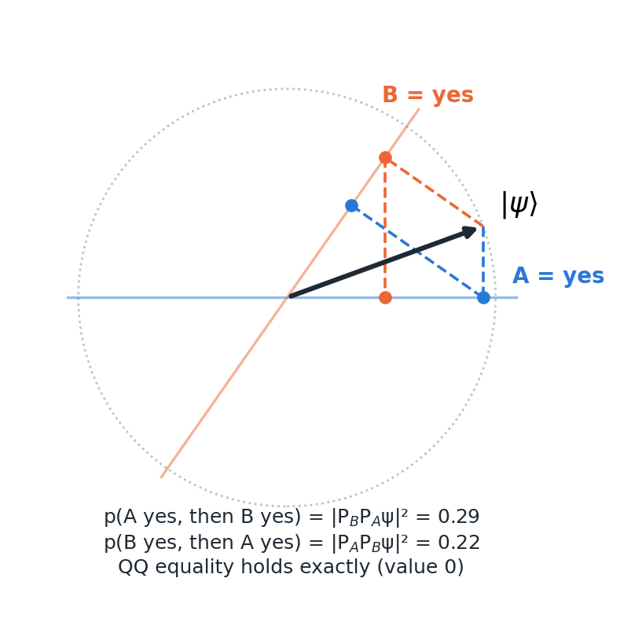
Fig. 2 Geometry of a question-order effect in a real two-dimensional belief space. The state |ψ⟩ is projected onto “A = yes” then “B = yes” (blue path) or in the reverse order (orange path). With the angles used in Example 1 (Section 5.3), p(A then B) = 0.29 and p(B then A) = 0.22, while the QQ equality is satisfied exactly
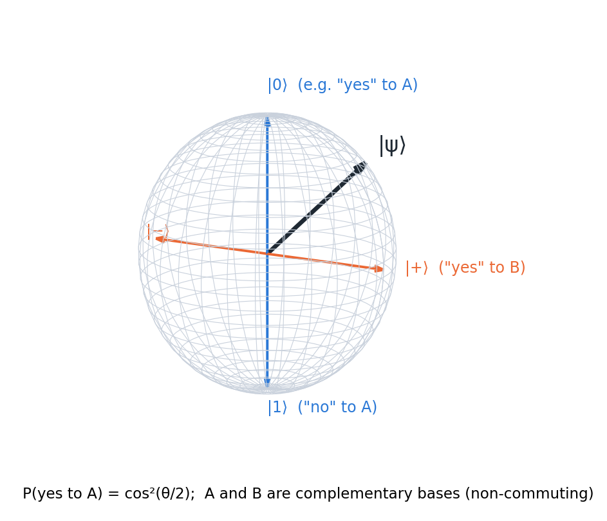
Fig. 3 Bloch-sphere representation of a single binary judgement. Complementary questions A and B correspond to orthogonal axes; the state |ψ⟩ has definite probabilities for both, but no joint distribution over the two answers
A glossary of symbols and notation is provided in Online Resource 1.
5 Core phenomena and the evidence for quantum cognition
5.1 Quantum cognition as a psychological theory
Quantum cognition is best understood as a family of formal models, not a single theory of mind. Its common core is the use of QP to represent judgement and decision processes in which the act of judging is constructive: a person does not read out a pre-existing answer but creates one in the context of the question, and that answer becomes part of the context for the next question (Busemeyer and Bruza 2012; Pothos and Busemeyer 2013). On this view the probabilistic “errors” catalogued by the heuristics-and-biases programme are not failures of a classical reasoner but signatures of a different, and arguably principled, probability calculus (Pothos et al. 2017). The Annual Review by Pothos and Busemeyer (Pothos and Busemeyer 2022) and the 2025 overview of the research programme (Huang et al. 2025a) are the authoritative summaries; Busemeyer and Wang give an accessible introduction (Busemeyer and Wang 2015).
5.2 Core postulates
Following (Busemeyer and Bruza 2012) and (Yearsley and Busemeyer 2016), a quantum cognitive model specifies five elements:
• A Hilbert space whose dimension is set by the number of distinguishable answer patterns (often 2–4 dimensions per question set).
• An initial belief state |ψ⟩ (or density matrix ρ) before any question is asked.
• A projector (or, more generally, an instrument) for each answer to each question, with incompatible questions represented in different bases.
• Born and Lüders rules for the probability of an answer and the updated state.
• Optionally, a Hamiltonian or Lindblad generator for how the state evolves between measurements, for example as evidence accumulates (Busemeyer et al. 2006; Busemeyer et al. 2020).
Two refinements are now standard. First, projective measurement alone cannot reproduce both question-order effects and response replicability (repeating a question returns the same answer), a result known as the response-replicability problem (Khrennikov et al. 2014). Quantum instruments, more general state-update maps, resolve this (Ozawa and Khrennikov 2020; Ozawa and Khrennikov 2021), and recent work argues that the non-classicality of cognition lies in non-commuting state updates rather than non-commuting observables (Fuyama et al. 2025; Busemeyer et al. 2025). Second, pure unitary dynamics predicts perpetual oscillation, so open-system (quantum–Markov, Gorini–Kossakowski–Sudarshan–Lindblad) models, in which the belief state couples to an environment and settles into a decision, have become the preferred dynamical framework (Busemeyer et al. 2020; Khrennikov 2023; Asano and Khrennikov 2026). These refinements increase flexibility and thus the burden of showing that a model is not merely descriptive (Section 15) (Broekaert et al. 2017).
5.3 Order effects and the QQ equality
If the questions “Is Clinton honest?” and “Is Gore honest?” are represented by non-commuting projectors P_{A} and P_{B}, then p(A yes, then B yes) = ‖P_{B} P_{A} ψ‖² differs from p(B yes, then A yes). Wang and Busemeyer showed that any such model, as long as the questions are represented by projectors and the state is pure, obeys a parameter-free constraint, the QQ equality: [p(AyBn) + p(AnBy)] − [p(ByAn) + p(BnAy)] = 0 (Wang and Busemeyer 2013). Classical Markov models that produce order effects do not generally satisfy it. Wang, Solloway, Shiffrin and Busemeyer tested the equality in 70 national surveys on question order and found it statistically supported, while anchoring-and-adjustment models failed to reproduce the pattern (Wang et al. 2014). Order effects also arise in inference, where evidence presented in different orders leads to different final beliefs (Trueblood and Busemeyer 2011; Trueblood et al. 2017).
Worked Example 1 makes the mechanism concrete (code in Online Resource 2). Take a real two-dimensional belief space with the state at 20°, question A at 0° and question B at 55°. Then p(A yes) = 0.883 and p(B yes) = 0.671; p(A yes, then B yes) = 0.291 while p(B yes, then A yes) = 0.221, an order effect of 7 percentage points; and the QQ quantity evaluates to zero to machine precision (Figure 2). The effect disappears exactly when the projectors commute: here the norm of their commutator is 0.66, and setting the two angles equal or orthogonal reduces it to zero.
Two cautions apply. The QQ equality is necessary rather than sufficient evidence for a quantum model: non-Hilbertian and classical models can also satisfy it (Aerts and Sassoli de Bianchi 2017; Kellen et al. 2018), and when interference plays no role the same order effects can be captured by a classical projection model (Moreira and Wichert 2017). The claim therefore rests on the combination of an a priori prediction and its robust confirmation, not on uniqueness.
5.4 The conjunction fallacy
In the classic Linda problem, people judge “Linda is a feminist bank teller” more likely than “Linda is a bank teller” (Tversky and Kahneman 1983). The quantum account treats the conjunction as a sequence of projections: judging the more representative property first (“feminist“) moves the state towards a subspace from which “bank teller” is more reachable than from the initial state (Busemeyer et al. 2011). Worked Example 2 shows this. With the state at 0°, “feminist” at 40° and “bank teller” at 80°, p(bank teller) = 0.030 but p(feminist, then bank teller) = 0.344, so the model produces a large conjunction fallacy without any free parameter beyond the three angles. The same model predicts disjunction errors and the relative size of both effects (Busemeyer et al. 2011).
The conjunction fallacy is also where the quantum account is most contested. Boyer-Kassem, Duchêne and Guerci derived testable consequences of the main quantum-like models and found experimental results at odds with them (Boyer-Kassem et al. 2016); web-scale tests suggest that emergent meaning in concept combination, rather than order, drives the effect (Aerts et al. 2017); and the “probability theory plus noise” model explains conjunction and related biases with noisy classical reasoning (Costello and Watts 2014; Costello and Watts 2018). A review of experimental designs shows that most studies have explored a narrow part of the possible outcome space (Veloz and Sobetska 2024). For autonomous systems, the practical conclusion is that conjunction-fallacy modelling alone is weak justification for adopting QP.
5.5 Interference and the disjunction effect
In the double-slit experiment, the pattern produced when the path is unobserved is not the sum of the patterns for each path. The decision analogue is the disjunction effect. In a one-shot Prisoner’s Dilemma, Shafir and Tversky found that 97% of participants defected when told the opponent had defected and 84% when told the opponent had cooperated, but only 63% when the opponent’s move was unknown (Shafir and Tversky 1992). The law of total probability requires the unknown case to lie between 0.84 and 0.97 (0.905 with equal priors). In QP the unknown-case probability is the classical mixture plus an interference term 2√(π₁p₁π₂p₂)cos θ, where π₁ and π₂ are the prior weights of the two branches (Appendix A.4). Worked Example 3 solves for this term (Figure 4): the observed 0.63 requires an interference term of −0.275, which corresponds to a phase θ ≈ 108° (Pothos and Busemeyer 2009). The model explains the violation, but in this form the phase is fitted to the very datum it explains, which is why later work has sought ways to predict it, as discussed in Section 7.3 (Moreira and Wichert 2016; Wichert et al. 2020). Yukalov and Sornette’s quantum decision theory provides an alternative formalism in which an “attraction factor” plays the role of interference and a quarter-law gives an a priori estimate of its size (Yukalov and Sornette 2011; Yukalov and Sornette 2016).
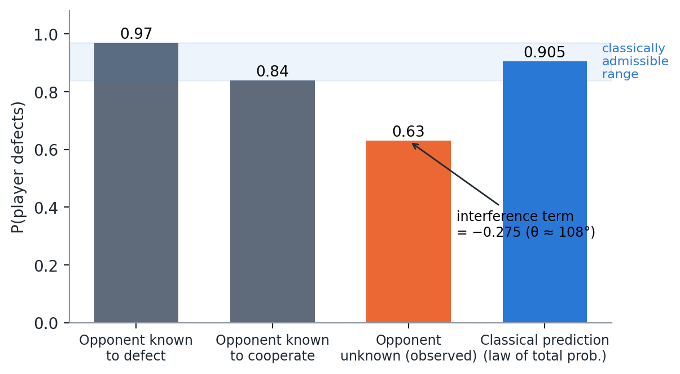
Fig. 4 Interference in the Prisoner’s Dilemma disjunction effect. Observed defection rates from Shafir and Tversky (1992) and the classical prediction from the law of total probability with equal priors. The observed rate for the unknown condition lies outside the classically admissible range; QP accommodates it with an interference term of −0.275 (phase ≈ 108°). Values computed with the code in Online Resource 2
5.6 Evidence for and against quantum models
The strongest evidence comes from three kinds of test. The first is a priori, parameter-free predictions confirmed in new data, above all the QQ equality (Wang et al. 2014). The second is dynamic signatures that Markov models cannot produce: interference of an intermediate choice on later confidence (Kvam et al. 2015), oscillations in preference strength (Kvam et al. 2021) and a Zeno-like slowing of belief change under frequent measurement (Yearsley and Pothos 2016). The third is quantitative model comparison, where Hilbert-space multidimensional models compared favourably with Bayesian networks (Busemeyer and Wang 2018) and a quantum sequential sampler compared favourably with the Bayesian sampler (Huang et al. 2025b). Contextuality analyses that control for direct influences have also found genuine contextuality in carefully designed tasks (Cervantes and Dzhafarov 2018; Basieva et al. 2019), and a temporal Bell inequality was violated in one of the tested cases (Waddup et al. 2023).
The picture is not one-sided. When the contextuality-by-default method was applied to earlier datasets, it found no true contextuality once direct influences were accounted for (Dzhafarov et al. 2016). In dynamic belief-change data, quantum advantages were confined to low-coherence conditions and shrank against a stronger Markov baseline (Busemeyer et al. 2019). An open-system model of choice and response time was needed for only a subset of participants, the rest being fitted adequately by a Markov model (Epping et al. 2023). The fair summary is therefore that QP models outperform standard classical models on a well-defined class of phenomena involving incompatible, sequential or context-dependent judgements, and are unnecessary elsewhere. This class is exactly the one autonomous agents encounter when they interact with people.
6 A framework for quantum-like autonomous agents
Figure 5 maps the QP principles of Section 5 onto the agent functions discussed in Sections 6–12.
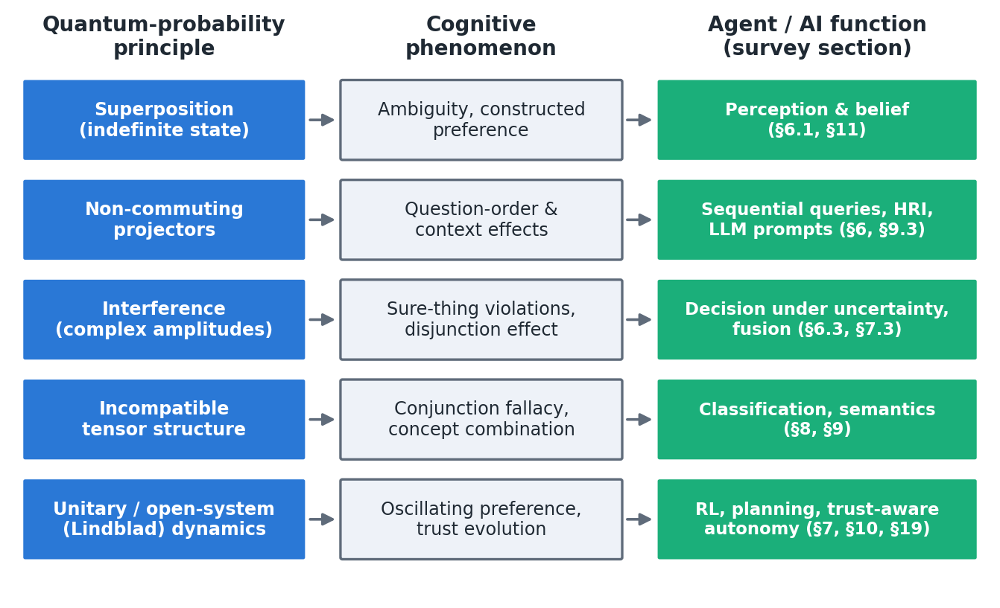
Fig. 5 From quantum-probability principles to cognitive phenomena and to the agent functions reviewed in this survey
The framework distinguishes three questions that recur in Sections 7–13: whether the judgements involved are incompatible (so that a single joint distribution does not exist), whether the agent’s task requires predicting or aligning with such judgements, and whether the QP model makes an a priori prediction that could fail. Only when all three hold is a QP module likely to add value over a classical model; Sections 14.2 and 14.3 turn this into a decision guide.
7 Perception, memory and multi-source fusion
7.1 Perception under sensor and feature ambiguity
Problem. Classical perception pipelines assume that each percept can be assigned a probability within one joint distribution over features. This assumption fails when features are not jointly measurable. Examples include ambiguous figures, vague categories whose boundaries shift with context (Blutner et al. 2013), similarity judgements that are asymmetric and order-dependent (Pothos et al. 2013), and robots whose limited sensors cannot resolve mutually exclusive interpretations. In these cases the order in which features are queried, or the framing of the query, changes the outcome.
Quantum-like approaches. Lanza, Solinas and Mastrogiovanni proposed the first explicitly quantum-like robot perception model: a percept is a qubit whose amplitudes encode the balance between two mutually exclusive interpretations, and perception is a measurement (Lanza et al. 2020). The multi-sensory extension encodes n normalised sensor readings in n qubits and defines “query operators” that let the robot read out its degree of belief in a target world state (Lanza et al. 2021). The work is a formal proof of concept evaluated in simulation, and runs on real quantum hardware produced large errors. No comparison with Bayesian or fuzzy fusion was reported, so the models demonstrate representability rather than improved perception. The quantum geometric model of similarity (Pothos et al. 2013) and quantum-like concept representations (Aerts 2009; Aerts et al. 2013) supply the cognitive templates such robot models could follow, and quantum-like Bayesian networks provide an inference engine for them (Section 7.3) (Moreira and Wichert 2014).
7.2 Memory and episode recognition
Problem. Human memory is reconstructive: whether an item is recognised depends on the retrieval cue and on earlier retrievals, and people can simultaneously endorse mutually exclusive memory claims (episodic over-distribution). A classical memory store with fixed item probabilities cannot produce these patterns without additional mechanisms.
Quantum-like approaches. The generalised quantum episodic memory model treats verbatim and gist traces as incompatible features and accounts for over-distribution and subadditivity (Trueblood and Hemmer 2017). Busemeyer, Ozawa, Pothos and Tsuchiya compared three ways of incorporating episodic memory into quantum judgement models, which differ in whether memory updates act like belief updates or like non-commuting projections (Busemeyer et al. 2025). Associative structure in the mental lexicon also has a quantum-like description (Bruza et al. 2009). For robots, the analogy is to context-dependent episodic retrieval in long-lived agents, for example recognising a place or a person under changing cues. No robot memory system based on these models has been reported. This is an open gap: the value of a QP memory for an artificial agent is unestablished, although the models suggest how an agent could reproduce, and therefore anticipate, human recall behaviour.
7.3 Fusion of non-independent sources
Problem. The Kalman filter is optimal for linear-Gaussian systems with known noise (Kalman 1960), and its non-linear and learned variants dominate robotic state estimation (Haykin 2001; Thrun et al. 2005). Its assumptions (a single joint distribution, independent noise, order-invariant updates) are appropriate for physical sensors measuring the same physical quantity. They break down when “sensors” are judgements from different contexts, for example a human report, a language instruction and a vision classifier, whose outputs cannot be embedded in one joint distribution. It is important to be precise here: for physical pose estimation from independent Gaussian sensors, QP adds nothing and the Kalman filter remains optimal (Section 14.4).
Quantum-like Bayesian networks and quantum-inspired fusion. Quantum-like Bayesian networks (QLBNs) replace the conditional probabilities of a Bayesian network with complex amplitudes, so marginalising over an unobserved node produces interference terms (Moreira and Wichert 2014; Moreira and Wichert 2016). The central difficulty is that every unobserved node adds a free phase. Successive work has proposed heuristics, including a similarity heuristic (Moreira and Wichert 2016), a “law of balance” and “law of maximum uncertainty” (Wichert et al. 2020) and influence diagrams that add utilities (Moreira et al. 2020a), to set the phases without fitting them to the data being predicted. Extensions combine QLBNs with belief entropy for multi-attribute decisions (She et al. 2021), with Dempster–Shafer evidence theory (Gao et al. 2025), and with entanglement to capture biased selection, where a biased entangled model achieved an RMSE of 3.4 on Prisoner’s Dilemma data, the best among the models compared (Meghdadi et al. 2022). In multimodal ML, quantum-inspired fusion treats each modality’s decision as a measurement in an incompatible basis; on video sentiment benchmarks this outperformed decision-level and content-level fusion and handled cases in which every unimodal classifier failed (Gkoumas et al. 2021; Li et al. 2021a). These results are on benchmark labels, not human decision data, and the incompatibility assumption itself was not tested.
8 Decision-making and planning under uncertainty
8.1 Violations of the independence axiom
Problem. Expected-utility theory and the POMDP formalism rest on Savage’s sure-thing principle (Savage 1954). Humans violate it (Section 5.5) (Shafir and Tversky 1992), and the Ellsberg paradox shows that ambiguity, not just risk, shapes choice (Ellsberg 1961). When an autonomous system must predict or collaborate with human decisions (in driving, triage, defence or shared control), a normative model will mispredict precisely those choices.
Quantum-like approaches. Quantum decision models represent the unresolved state of the world as a superposition, so that deciding with the uncertainty unresolved differs from deciding in each resolved case (Pothos and Busemeyer 2009; Busemeyer and Bruza 2012). Quantum decision theory treats prospects as superpositions and derives a quarter-law for the attraction factor (Yukalov and Sornette 2011; Yukalov and Sornette 2016). Its evolutionary extension addresses time-inconsistent choices (Yukalov 2020), and a quantum-conceptual account of expected-utility violations has been proposed (Aerts et al. 2011a). Interference also arises from an intermediate categorisation (Wang and Busemeyer 2016) or choice (Kvam et al. 2015), a pattern directly relevant to agents that must first classify a situation and then act on it. The most direct robotics application is Song et al.’s quantum-like Bayesian model of pedestrian crossing decisions for automated driving: the model captures crossings that a classical model treats as irrational and covers edge events in interactive scenes better than a Social-LSTM baseline (Song et al. 2022). That study is a simulation on trajectory data (E4), and its interference parameters appear to be set rather than learned. It nonetheless marks the point at which quantum cognition entered a safety-critical autonomy problem.
8.2 Planning under uncertainty
Classical planners. Classical planners and POMDP solvers represent belief as a distribution over a fixed state space (Lauri et al. 2023). They cannot represent the context-dependent preferences and goals of human partners, which may be constructed during interaction rather than retrieved (Kvam et al. 2021).
Quantum planning and quantum deliberation. Two different ideas are at work. The first uses quantum algorithms for search: Chella et al. formulated grid-map motion planning as a Grover-type search that amplifies valid paths and derived a condition for quadratic speed-up, demonstrated in noiseless simulation on small maps (Chella et al. 2022). This is quantum computing and inherits the limits of current noisy quantum hardware (Preskill 2018). The second uses quantum dynamics to model deliberation. Quantum walks over option networks can produce choice probabilities that violate the sure-thing principle (Martínez-Martínez and Sánchez-Burillo 2016), and Lindblad models describe how a deliberating agent escapes classical equilibria (Asano and Khrennikov 2026). Such models could let a planner anticipate how a human collaborator’s goals will shift, but none has yet been integrated into a robot planner. We found no evidence that QP planning improves plan quality for autonomous systems, and we regard this as an open research question rather than an established capability.
9 Machine learning, deep learning and language models
9.1 Feature learning and representation
Classical approach. Classical representation learning maps inputs to real-valued feature vectors, whether by linear projections such as PCA, non-linear embeddings such as t-SNE, or learned deep features (Krizhevsky et al. 2012). Probabilities are then obtained by a fixed read-out (for example softmax), which produces a single joint distribution over labels regardless of the order or context of the query.
Quantum and quantum-inspired approaches. Three distinct ideas appear in the literature and should not be conflated. Quantum kernel methods map data into a quantum feature Hilbert space and require quantum hardware for any advantage (Schuld and Killoran 2019; Biamonte et al. 2017). Their advantages are fragile, because trainability limits (Cerezo et al. 2021) and dequantisation results (Tang 2019; Aaronson 2015) often remove the claimed speed-up. Quantum-inspired representations use complex-valued vectors and density matrices on classical hardware: a word is a superposition of semantic “sememes“, a sentence is a mixture, and matching is a measurement (Li et al. 2019; Zhang et al. 2018; Zhang et al. 2025). Finally, quantum-cognitive representations aim to reproduce human-like judgement patterns rather than to improve accuracy (Maksimovic and Maksymov 2025). Tensor-network classifiers, which are classically simulable quantum-style models, reached below 1% test error on MNIST (Stoudenmire and Schwab 2016). Quantum-inspired matching models have typically performed comparably to strong CNN and RNN baselines rather than better, while offering representations their authors describe as more interpretable (Li et al. 2019). Those interpretability claims have not been tested with users.
9.2 Classification under label ambiguity
Problem. Real categories are vague and overlapping, and human annotators’ labels depend on which category is considered first (Blutner et al. 2013; Wang and Busemeyer 2016). A softmax classifier assigns a single distribution over labels and cannot represent the fact that the answer to “is it a cat?” depends on whether “is it wild?” was asked first. For ML systems trained on human labels, or used alongside human decision-makers, this is a modelling mismatch rather than label noise.
Quantum-cognitive approaches. Representing labels as non-commuting projectors on a learned state produces order-dependent label judgements (Worked Example 5, Section 14.5). Quantum-cognitively motivated decision fusion used this structure to combine modality-specific sentiment judgements (Gkoumas et al. 2021), and a survey of quantum-cognitively inspired sentiment analysis maps the design space (Liu et al. 2023). Quantum-cognitive neural networks that use tunnelling-inspired activations reproduced human-like confidence and uncertainty on image classification and trained up to 50 times faster than their classical counterpart. That human-likeness was assessed by simulation rather than against participant data (Maksimovic and Maksymov 2025). No study has yet shown that order-aware QP classifiers improve agreement with individual human annotators on a standard benchmark; this is a clear, testable gap (Benchmark 3, Section 18.3).
9.3 Knowledge representation and semantic similarity
Quantum logic has a long history in semantic representation. Widdows and Peters showed that negation and disjunction on word vectors behave as quantum-logical connectives, allowing unwanted word senses to be removed from queries (Widdows and Peters 2003). Density-matrix language models captured term dependencies for retrieval (Sordoni et al. 2013), and a survey of quantum-theory-inspired information retrieval covers representation, ranking and user cognition (Uprety et al. 2020). Widdows, Kitto and Cohen give the broadest account of quantum mathematics in AI (Widdows et al. 2021). Compositional quantum NLP (DisCoCat) was run on real quantum hardware for small sentence-classification tasks, a feasibility demonstration with small datasets, long queue times and no quantum advantage (Lorenz et al. 2023); two reviews cover the field (Widdows et al. 2024; Nausheen et al. 2025). Contextual word embeddings have been recast in terms of quantum contextuality, as a framework without an empirical evaluation (Svozil 2025). For agents, such as robots grounding language instructions or dialogue systems tracking context, the relevant contribution is a principled way to represent meaning that depends on context. The contribution does not come from quantum computation.
9.4 Quantum-inspired deep learning
Classical deep learning. In standard deep networks, activations are real numbers and output probabilities come from a softmax. Uncertainty is typically estimated post hoc (ensembles, dropout, Bayesian layers), and all outputs are assumed to live in one classical probability space.
Complex-valued, quantum-inspired networks. Complex-valued, quantum-inspired networks carry phases as well as magnitudes, so that intermediate representations can interfere. CNM encodes words as complex superpositions and sentences as density matrices and matched strong baselines on question answering (Li et al. 2019). A quantum many-body wave-function view of language modelling offered a theoretical justification for CNN structure (Zhang et al. 2018). Quantum-inspired networks for conversational emotion recognition (Li et al. 2021b) and multimodal sentiment (Li et al. 2021a) performed on a par with the state of the art. Quantum Bayesian neural networks propose quantum algorithms for posterior sampling but were evaluated only in classical simulation (Berner et al. 2021). The consistent pattern is parity, not superiority, on accuracy, with claims of interpretability that remain to be tested.
Training under uncertainty. Deep networks face vanishing gradients; variational quantum circuits face the more severe problem of barren plateaus, in which gradients vanish exponentially with the number of qubits for global cost functions (Cerezo et al. 2021). This is a limitation of quantum hardware models, not of quantum-like models run classically, which are trained with ordinary automatic differentiation (Bergholm et al. 2018; Broughton et al. 2020).
We found no evidence that “superposed weight updates” improve the training of classical deep networks, and we caution against the claim. Where quantum circuits are trained, gradients are estimated by parameter-shift rules and inherit barren-plateau and noise limits (Cerezo et al. 2021; Preskill 2018). Where quantum-inspired networks are trained classically, their complex-valued parameters are optimised by standard gradient descent. The contribution of quantum cognition to optimisation is therefore conceptual, for example modelling how a learner’s uncertainty about incompatible hypotheses evolves, rather than algorithmic.
9.5 Order effects in large language models
Transformer outputs depend on prompt order and framing. Human-like response biases in survey-style prompts were found only partially, and inconsistently, across nine LLMs (Tjuatja et al. 2024), while cognitive-psychology batteries revealed both human-like and non-human-like reasoning in GPT-3 (Binz and Schulz 2023). Quantum-cognition methods give these observations a precise vocabulary and test statistics. Lo, Sadrzadeh and Mansfield constructed a linguistic schema modelled on a contextual quantum scenario and, using a masked LM, found about 0.15% of instances contextual under the sheaf-theoretic criterion and about 71% under contextuality-by-default (Lo et al. 2025). Context effects in LLM similarity judgements mirror human order effects in some settings but not others (Uprety et al. 2024). Bell-type tests on LLM concept combinations reported violations and Bose–Einstein-like word statistics resembling human data (Aerts et al. 2026). GPT-5 committed far fewer conjunction fallacies than humans, and its judgement pattern was closer to early QP models than to the noisy variants that fit people (Imannezhad et al. 2026). An audit of question-order effects with the QQ equality found near-deterministic saturation in a small model, showing that the QQ test can be uninformative when an LLM’s answers are saturated (Kang 2026). Together these studies suggest that attention-based models exhibit some context effects that QP models describe well, but they do not show that transformers are quantum-like in general. The analogy between attention and “soft measurement” remains a hypothesis to be tested (Section 14.2).
10 Reinforcement learning
10.1 Violations of Markov assumptions
Problem. RL assumes the Markov property and stationary, additive rewards (Sutton and Barto 2018). Human feedback, which increasingly shapes RL for robots and LLMs, violates both: evaluations depend on what was asked before, preferences oscillate over time (Kvam et al. 2021), and trust evolves non-monotonically (Roeder et al. 2023). Reproducibility studies also show how sensitive deep RL is to seeds and hyperparameters, which sets a high bar for claims of improvement (Henderson et al. 2018).
Quantum-like models of reward sources. Open-system quantum–Markov models provide a principled way to model non-Markovian, context-dependent reward sources (Busemeyer et al. 2020; Epping et al. 2023). To our knowledge no RL algorithm has yet used such a model of the human reward-giver, which we identify as a promising direction (Section 18.4).
10.2 Exploration and quantum-inspired reinforcement learning
Every RL agent must balance exploiting what it knows against exploring what it does not. Classical agents use ε-greedy, softmax or optimism-based rules (Sutton and Barto 2018). Quantum-inspired RL replaces these with a representation in which each state holds a superposition of actions and action selection is a measurement.
Dong, Chen, Li and Tarn’s quantum RL (QRL) stores, for each state, amplitudes over “eigen-actions“; rewards drive Grover-style amplitude amplification of the chosen action, so the exploration probability adapts automatically (Dong et al. 2008). The robust quantum-inspired variant was validated on a real mobile robot and was more robust to the learning rate than temporal-difference learning (Dong et al. 2012), and quantum-inspired experience replay extends the idea to deep RL (Wei et al. 2022). These algorithms are classical and should be judged against modern classical exploration strategies. Our illustrative experiment in Section 10.5 does exactly this and finds a clear trade-off: faster early learning with noisy rewards, but no stable convergence. Projective simulation is a different, physics-motivated agent model in which deliberation is a random walk through episodic memory (Briegel and De las Cuevas 2012). Its convergence in Markov decision processes has been proved (Boyajian et al. 2020), a photonic hardware architecture has been proposed for it (Flamini et al. 2020), its quantum version offers a provable quadratic speed-up in deliberation (Paparo et al. 2014), a photonic experiment demonstrated a quantum speed-up in learning (Saggio et al. 2021), and its classical version has been benchmarked against Q-learning and SARSA (Melnikov et al. 2018) and used on real robots (Section 11). Variational-circuit RL is discussed in Section 10.
10.3 Variational-circuit and agent-theoretic reinforcement learning
Classical exploration strategies are simple, well understood and hard to beat on small problems (Sutton and Barto 2018). Deep RL for real robots has succeeded mainly through careful engineering and simulation-to-real transfer rather than new exploration principles (Lauri et al. 2023).
Three lines coexist. Quantum-inspired RL (Section 10.2) is classical (Dong et al. 2008; Dong et al. 2012; Wei et al. 2022). Quantum-agent theory proves speed-ups in deliberation (Paparo et al. 2014) and learning separations for parametrised quantum policies on specially constructed tasks (Jerbi et al. 2021), and a review covers ML and AI in the quantum domain (Dunjko and Briegel 2018). Variational-circuit RL replaces neural function approximators with parametrised quantum circuits (PQCs). Its most consistent benefit is parameter efficiency: 28 circuit parameters instead of 64 table entries in Frozen Lake (Chen et al. 2020); PQCs with 444–480 parameters matching networks about ten times larger in robot navigation, but losing in the more realistic dynamic environment (Hohenfeld et al. 2024); hybrid critics matching classical soft actor-critic with more than six times fewer parameters on a simulated arm (Acuto et al. 2022); and slightly higher mean area-under-curve than a classical baseline in simulated driving, with similar final policies (Sinha et al. 2025). Two surveys review the field (Meyer et al. 2022; Chen 2024). None of these results was obtained on quantum hardware in closed loop, and none shows better policies than tuned classical networks of comparable compute.
10.4 Value estimation under uncertainty
Temporal-difference learning is order-sensitive by construction: the same experiences presented in different orders yield different value estimates. Classical RL treats this as a nuisance that experience replay reduces. Quantum cognition suggests an alternative reading when the learner is human-like: order effects in the evaluation of evidence are systematic and predictable (Trueblood and Busemeyer 2011; Trueblood et al. 2017).
Quantum Q-learning with PQCs requires data re-uploading and trainable input and output weights to solve even CartPole; the best average PQC (302 parameters) needed about 500 episodes against about 250 for a 562-parameter network (Skolik et al. 2022). Interference in reward prediction has not been demonstrated as a benefit in any benchmark we found. In our own illustrative experiment (Section 10.5), amplitude-based exploration without a mechanism for reducing amplitudes became unstable under reward noise, which highlights a design gap rather than an advantage.
10.5 An illustrative experiment: quantum-inspired RL under reward noise
Problem setup. A tabular agent must reach the goal of a 6 × 6 grid with four internal walls (shortest path: 10 steps). Reaching the goal gives reward +1 and each step −0.01. In the noisy condition, Gaussian noise (σ = 0.5) is added to every reward. Each agent is trained for 300 episodes (maximum 200 steps each) with 30 random seeds.
Classical baselines. Because the state space is small, we use tabular Q-learning (learning rate 0.1, discount 0.95) with either ε-greedy exploration (ε decaying from 0.3 to 0.01) or softmax exploration (temperature decaying from 0.2 to 0.01). Deep Q-learning would behave similarly on this task at much higher cost.
Quantum-inspired agent. The quantum-inspired agent follows Dong et al.’s QRL (Dong et al. 2008): each state holds four action amplitudes (initially equal), actions are chosen by “measurement” with probability |amplitude|², state values are learned by TD(0), and the chosen action’s amplitude is amplified by L = ⌊k(r + V(s′))⌋ Grover iterations, capped at three, with k = 30 selected from {10, 30, 100}.
Results. With deterministic rewards, all three agents learned the optimal 10-step path in every seed (Figure 6). The ε-greedy agent converged fastest (first episode at which the 10-episode moving average fell to 15 steps or fewer: 60 ± 6), while QRL (134 ± 20) and softmax (128 ± 10) were similar. With noisy rewards, QRL learned fastest at first: its median path length was 70 steps at episode 100, against 153 for ε-greedy and 200 (no progress) for softmax. However, it did not stabilise. Over the last 50 episodes its mean path length was 67 ± 40 steps, against 14 ± 13 for ε-greedy and 16 ± 17 for softmax, and 5 of 30 seeds never met the convergence criterion. Varying k did not remove the instability (final means of 78, 67 and 74 steps for k = 10, 30 and 100). The reason is structural: amplitude amplification only increases the probability of rewarded actions, so an action amplified by a noisy positive reward is never de-amplified. The experiment is small and illustrative, but it shows why quantum-inspired RL must be compared with tuned classical baselines under realistic noise, and it points to a concrete design fix: amplitude updates that can also decrease. Full results are in Appendix B.
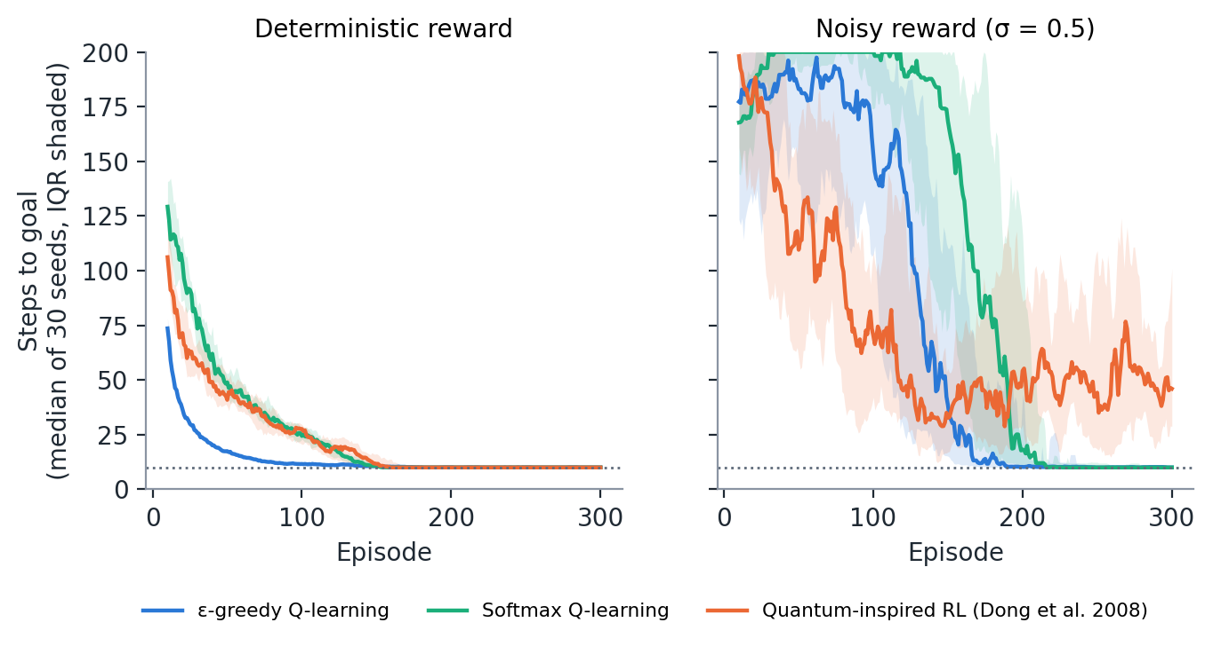
Fig. 6 Illustrative experiment (Section 10.5): steps to reach the goal in a 6 × 6 grid for ε-greedy Q-learning, softmax Q-learning and quantum-inspired RL (Dong et al. 2008), with deterministic (left) and noisy (right) rewards. Lines show the median of 30 seeds of the 10-episode moving average; shading shows the interquartile range; the dotted line is the optimal path length. Experiment run for this survey (code in Online Resource 2)
11 Embodied and social robots
11.1 Sensorimotor integration and quantum embodied cognition
Embodied agents must integrate signals whose meaning depends on the body’s state and the task. Predictive-processing accounts cast this as prediction-error minimisation over a generative model (Friston 2010; Clark 2013). Classical cognitive architectures implement it with symbolic and probabilistic modules (Laird et al. 2017; Kotseruba and Tsotsos 2020).
Robot-facing proposals fall into four groups (Online Resource 1, Table S1). The first is quantum-like perception models, already discussed (Lanza et al. 2020; Lanza et al. 2021). The second is quantum-circuit models of robot “thinking” and control: a classic–quantum dialogue model of robot creativity (Mannone et al. 2024), a teleo-reactive robot whose action rules are evaluated by quantum kernels and measurement-based circuits, reaching about 0.91 accuracy offline on wall-following data (Chella et al. 2026), and a neuro-cognitive agent architecture using Grover and Deutsch–Jozsa routines in a game environment (Daglarli 2025). The third is quantum models of robot emotion and affect: emotion spaces encoded in qubits (Yan et al. 2019), Plutchik-based emotion circuits for companion robots (Yan et al. 2021b), a review of emotion-space models (Yan et al. 2021c), the Q-Coppélia affective decision framework for HRI (Ho and Hoorn 2022), an early quantum-automata model of emotional robot behaviour (Lukac and Perkowski 2007) and the QUADRI social-robotics programme (De Carolis et al. 2025). The fourth is architectural positions (Aerts et al. 2011b; Moreira et al. 2020b). Most of this work is at E1–E2: circuits and formal models without user studies or classical baselines. The circuit-based models also blur the line between quantum-like modelling and quantum computing, which should be made explicit because only the former is deployable today.
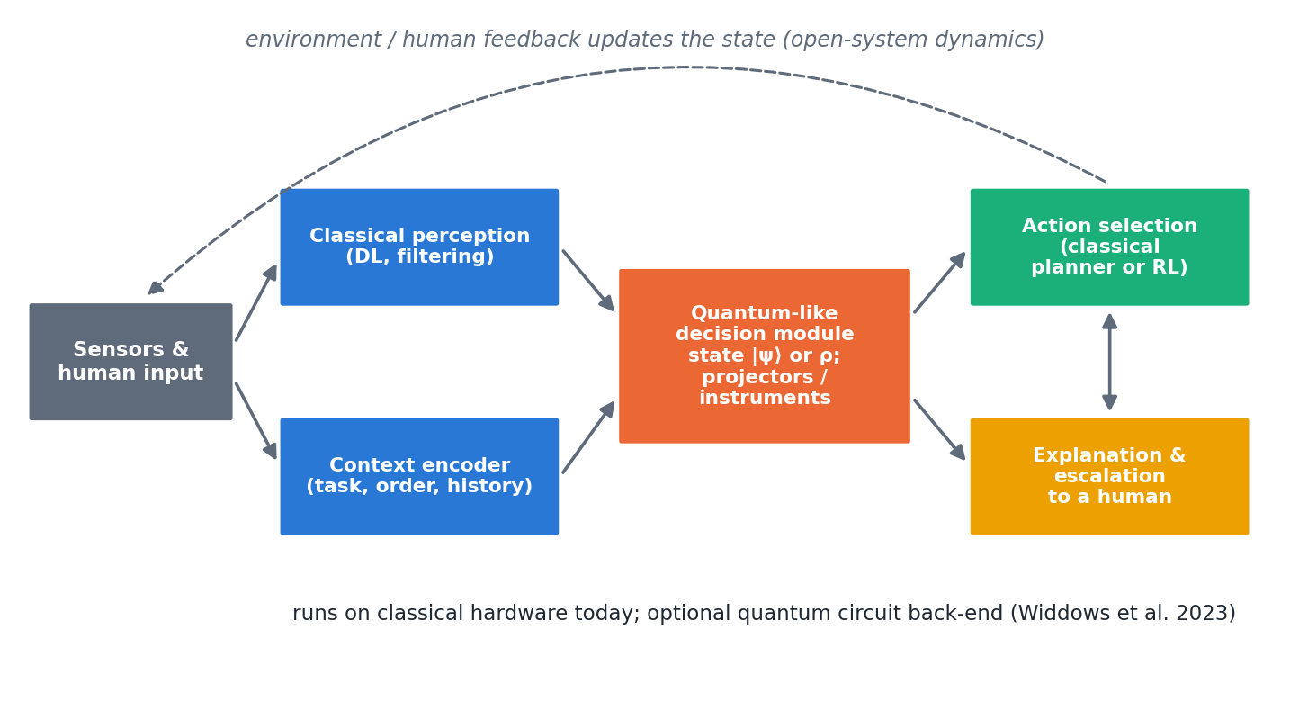
Fig. 7 A hybrid architecture for a quantum-like decision module in an autonomous agent. Classical perception and a context encoder feed a QP state; context-dependent measurements (projectors or instruments) produce graded, order-aware judgements that a classical planner or RL policy acts on, with explanation and escalation to a human. Feedback updates the state as an open system
11.2 Affordances and action selection
Classical robots typically treat affordances (what an object allows the robot to do) as discrete, independently detectable properties, and select actions by maximising expected utility over a fixed action set.
The most mature embodied line is not quantum cognition but projective simulation (PS) run classically. A real robot learned hierarchical manipulation skills through play, reaching 90% success in about 80 roll-outs in simulation (Hangl et al. 2016), and PS with active learning and behaviour composition solved previously unsolvable tasks and improved learning speed by about 30% (Hangl et al. 2020). Superposed affordances in the QP sense, where an object’s affordances are incompatible and the order of evaluation matters, have not been implemented on a robot. They remain a hypothesis (Section 12.4).
11.3 Predictive processing and physical interaction
Predictive processing treats perception and action as the minimisation of prediction error (Friston 2010; Clark 2013). Quantum-like models add one ingredient: the order in which predictions are tested can change the result. In physical interaction, such as handover, shared manipulation or co-driving, the human partner’s intentions are themselves constructed during the interaction (Kvam et al. 2021), so a robot that queries (by gesture, speech or motion) changes what it is trying to predict. We know of no experiment that tests this in physical HRI; the handover setting often cited for it has no published quantum-like study, and the related works listed in some bibliographies could not be verified (Section 2).
12 Multi-agent systems, swarms and human–machine teams
12.1 Multi-robot coordination and teams
Quantum game theory showed that entangled strategies can escape classical dilemmas (Eisert et al. 1999), but physical entanglement between robots is impractical and cannot be used to signal (Khoshnoud et al. 2020). Quantum-like approaches instead model interdependent agents. Lawless argues that interdependence in autonomous human–machine teams is quantum-like: team performance is not decomposable into member contributions (Lawless 2020; Lawless et al. 2023; Lawless and Moskowitz 2025). Human interaction data show context sensitivity that a quantum model fitted better than a matched classical model (Waddup et al. 2021). Quantum game models have been proposed for interaction-aware automated driving, although an independent reproduction could not confirm their collision results (Essalmi et al. 2025). Multi-robot emotion fusion (Yan et al. 2021a) and swarm rules expressed as quantum circuits (Mannone et al. 2022) remain formal models; the latter’s run on IBM hardware was very noisy.
12.2 Distributed quantum-like decisions
Networks of quantum decision-makers exchanging information converge to consensus and reproduce a dynamic disjunction effect (Yukalov et al. 2018; Yukalov et al. 2022), and affective AI has been framed as a “quantum operation” combining cognition and emotion (Yukalov 2023). Quantum stochastic walks give a network model of decision (Martínez-Martínez and Sánchez-Burillo 2016). PS swarms reproduce collective motion (Ried et al. 2019), foraging-dependent alignment (López-Incera et al. 2020) and queue formation with polarisation near 0.99 (Kong et al. 2026), all in simulation with classical PS. Quantum multi-agent RL gained 57.7% in reward over a parameter-matched classical baseline in a single simulated environment, but a larger classical model matched it (Yun et al. 2022).
12.3 Concept learning and semantic emergence
Entangled concept combinations (Aerts and Sozzo 2011), Fock-space concept dynamics (Aerts et al. 2013) and Bell-type structure in LLM language (Aerts et al. 2026) suggest that shared meaning in groups of agents could be modelled with quantum structure. Whether such models help artificial agents develop shared concepts is untested.
12.4 Open questions
• Can a quantum-like model of human teammates improve a robot team’s coordination with people, compared with Bayesian theory-of-mind models?
• Do quantum-like consensus models predict human–robot group decisions better than classical opinion dynamics?
• Are “superposed affordances” measurable in human behaviour during joint action, and do they help a robot anticipate its partner?
• Which multi-agent claims survive when compared with classical models of equal parameter count (Yun et al. 2022)?
13 Human–AI trust and oversight
Human trust in automation is the application domain in which quantum-like models have the strongest human-data support. Quantum models outperformed Markov models in predicting how people’s reliability judgements of an automated system evolve over an interaction (Roeder et al. 2023), and a quantum-inspired model was fitted to air-traffic controllers’ trust in automation, although with a very small sample (Pushparaj et al. 2021). Quantum-like trust models have been proposed for AI-supported decisions, including military decision aids (Humr et al. 2023; Humr et al. 2025; Humr and Canan 2026), and for the dynamics of human reliance on AI advice (van der Meer et al. 2025); computational trust between artificial agents has also been given a quantum-like formulation (Ashtiani and Abdollahi Azgomi 2019). These models share a common structure: the person’s trust is a state that is changed by each interaction, so the order in which the agent presents advice, explanations and errors becomes a design variable. For autonomous systems, the practical uses are to anticipate when a person’s reliance will shift, to choose the order and framing of explanations, and to trigger escalation to human oversight before trust and system capability diverge (Section 16.2). None of these models has yet been evaluated in closed loop with a robot.
14 Synthesis and comparison with classical approaches
14.1 Evidence map
Online Resource 1 (Table S1) lists every application study with its domain, model type, evidence level, task and main limitation, and Figure 8 summarises the distribution. Of the 74 application studies, 6 reach a physical system (E5). Two run small cognitive or language models on quantum processors (Widdows et al. 2023; Lorenz et al. 2023); three are robot studies that use quantum-inspired RL or classical projective simulation (Dong et al. 2012; Hangl et al. 2016; Hangl et al. 2020); and one demonstrates quantum-communication hardware on mobile robots (Khoshnoud et al. 2020). None of the six tests a quantum-cognition decision model on a robot, and no study reaches E6. Human-data validation (E3) is concentrated in decision networks and in human–AI trust, where quantum models outperformed Markov models in predicting how people’s reliability judgements evolve (Roeder et al. 2023) and a quantum-inspired model was fitted to air-traffic controllers’ trust in automation, with a very small sample (Pushparaj et al. 2021). Quantum-like trust models have also been proposed for AI-supported decisions (Humr et al. 2023; Humr et al. 2025; Humr and Canan 2026; van der Meer et al. 2025) and for computational trust between agents (Ashtiani and Abdollahi Azgomi 2019).
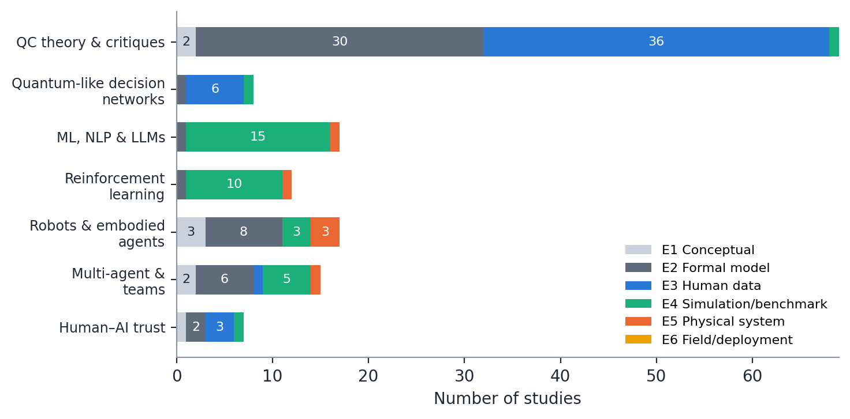
Fig. 8 Evidence levels of the 145 theory and application studies in the corpus, by domain (reviews and background works excluded). E1 conceptual; E2 formal model; E3 human data; E4 simulation or benchmark; E5 physical system; E6 field deployment. No study reaches E6
The psychological literature is mature, with a textbook (Busemeyer and Bruza 2012), a BBS target article (Pothos and Busemeyer 2013), tutorials (Yearsley and Busemeyer 2016; Yearsley 2017), reviews (Bruza et al. 2015; Pothos and Busemeyer 2022; Huang et al. 2025a) and an active critical literature (Section 14.2). Its models are fitted to human data, which places most of them at level E3.
Quantum decision theory (Yukalov and Sornette 2011; Yukalov and Sornette 2016), contextual probability (Khrennikov 2010; Khrennikov 2024), contextuality-by-default (Dzhafarov and Kujala 2016) and quantum-like heuristics (Huang et al. 2025c) provide alternative formalisms. A 2015 survey organised quantum-like decision models by formalism (Ashtiani and Azgomi 2015).
14.2 Quantum-like versus classical models
Table 4 summarises the comparison of quantum-like and classical approaches.
Table 4 Comparison of classical and quantum-like or quantum-inspired approaches
Criterion | Classical (Bayes, Markov, DRL) | Quantum-like or quantum-inspired | Current evidence
Order and context effects | Require extra mechanisms (anchoring, memory) | Arise from non-commuting projectors; a priori QQ constraint | Strong for QQ (Wang et al. 2014); classical accounts possible (Kellen et al. 2018)
Total-probability violations | Cannot be produced without changing the model | Interference terms | Replicated in two-stage tasks (Wang and Busemeyer 2016; Kvam et al. 2015)
Conjunction fallacy | Noise models (probability theory plus noise) | Sequential projection | Contested (Boyer-Kassem et al. 2016; Costello and Watts 2018)
Dynamics of belief and trust | Markov random walks | Quantum walks, open systems | Mixed: quantum better at low coherence (Busemeyer et al. 2019); trust (Roeder et al. 2023)
Physical state estimation | Kalman and particle filters (optimal) | No advantage expected | No comparison published
Classification accuracy | Strong deep-learning baselines | Parity on benchmarks | (Li et al. 2019; Li et al. 2021b)
RL performance | Tuned deep RL, scalable | Parameter-efficient PQCs; QiRL robust to learning rate | No better policies (Hohenfeld et al. 2024; Skolik et al. 2022)
Parameters and flexibility | Well understood | Phases and instruments add flexibility | Risk of over-fitting (Broekaert et al. 2017)
Interpretability | Varies | Geometric parameters; untested with users | No user studies
Hardware needs | CPU or GPU | CPU or GPU (quantum-like); QPU optional | Few-qubit demonstrations (Widdows et al. 2023)

When classical models win. When all variables are compatible (jointly measurable, context-free), QP reduces to classical probability and adds only parameters (Bruza et al. 2015). For physical state estimation, diagnosis from calibrated sensors (Blanke et al. 2016) and planning with known dynamics, Bayesian networks and filters are simpler, better understood and supported by mature tooling. Markov models remain adequate for most participants in several dynamic tasks (Busemeyer et al. 2019; Epping et al. 2023).
When quantum-like models win. QP models win where their a priori structure matches the phenomenon: question-order effects that obey the QQ equality (Wang et al. 2014), total-probability violations in two-stage decisions (Pothos and Busemeyer 2009; Wang and Busemeyer 2016) and interference of choice on confidence (Kvam et al. 2015). In direct comparisons, Hilbert-space multidimensional models compared favourably with Bayesian networks (Busemeyer and Wang 2018) and quantum-like influence diagrams predicted paradoxical choices that expected utility cannot (Moreira et al. 2020a). The main classical competitors are noisy classical reasoning (Costello and Watts 2014; Costello and Watts 2018), classical accounts of mirrored order effects (Kellen et al. 2018) and contextuality analyses that attribute effects to direct influences (Dzhafarov et al. 2016). Replies and new tests continue (Busemeyer and Wang 2017; Basieva et al. 2019).
Quantum versus deep reinforcement learning. Deep RL scales to high-dimensional robot control but requires large amounts of data and careful tuning, and its reported gains are fragile (Henderson et al. 2018).
PQC-based RL is parameter-efficient but not yet better or faster in wall-clock terms, and it has not been run in closed loop on hardware (Section 10). Quantum-inspired RL is cheap and can be robust to learning-rate choices (Dong et al. 2012), but our illustrative experiment shows instability under reward noise (Section 10.5). The claim that quantum RL is more interpretable is not supported by any user study we found.
Quantum cognition and transformer attention. Attention weights a set of tokens by their compatibility with a query, loosely analogous to a context-dependent measurement. The analogy is suggestive, and QP tools (the QQ equality, contextuality-by-default) are useful auditing instruments for LLMs (Lo et al. 2025; Kang 2026). However, transformers are classical functions of their input; order effects in LLMs can arise from training data and position encodings without any QP structure, and their human-likeness varies across models and prompts (Tjuatja et al. 2024; Imannezhad et al. 2026). QP models are best used here to describe and test LLM behaviour, not as a claim about its mechanism.
14.3 A decision guide
Figure 9 condenses the comparison into a decision guide. Keep a classical core for perception, estimation and control, where classical methods are optimal or nearly so. Add a quantum-like module only where the agent must predict, explain or align with judgements that are sequential, ambiguous or context-dependent. Typical cases are human intentions, trust and preferences, and the answers of other learned agents. Validate the module against a classical model with the same number of parameters and against a noise-augmented classical model.
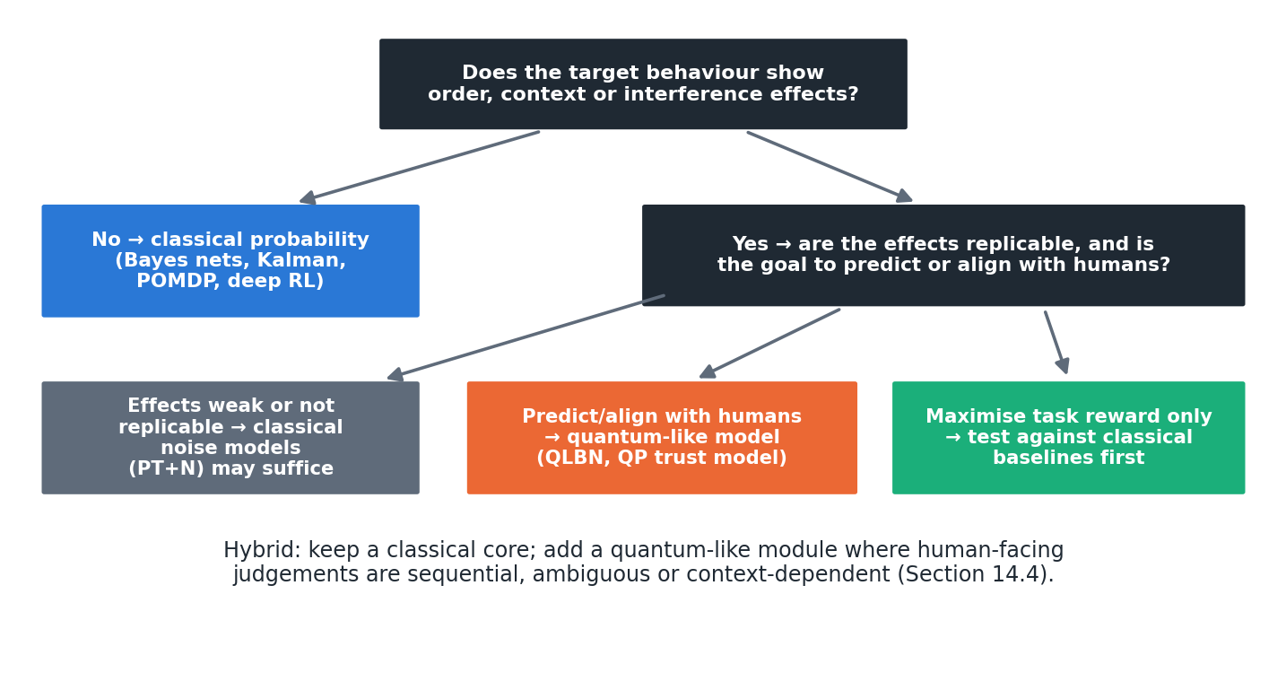
Fig. 9 Decision guide for choosing between classical and quantum-like models in an autonomous system
14.4 Worked comparison: fusion of physical and semantic cues
Problem setup. A robot estimates its position along a corridor from two sensors, a lidar reading z₁ = 2.10 m (variance 0.04) and a camera estimate z₂ = 1.90 m (variance 0.09). A human operator also reports whether the robot has “passed the doorway“, and a vision classifier gives its own judgement.
Classical approach. The Kalman update gives x̂ = 2.038 m with variance 0.028 m², and the result is identical whichever sensor is processed first (Kalman 1960). For this physical sub-problem, the Kalman filter is optimal and a QP model cannot improve on it.
Quantum-like approach. The QP model is applied only to the semantic judgement “has the robot passed the doorway?“, which combines two context-dependent cues: the operator’s report (p = 0.80 of “passed” when that cue is attended) and the classifier’s judgement (p = 0.30). With equal weights the classical mixture is 0.55. A QLBN adds an interference term 2√(0.5·0.80·0.5·0.30)·cos θ = 0.49 cos θ, giving 0.55 at θ = 90° (the classical case), 0.795 at θ = 60° and 0.305 at θ = 120°; at θ = 0 the unnormalised value exceeds 1, which is why QLBNs must renormalise (Moreira and Wichert 2016; Wichert et al. 2020). The phase encodes how the two cues interact in the human’s judgement, and it must be estimated from, or better predicted for, human data.
Comparison. The worked example shows the correct division of labour: physical fusion stays classical, and QP models the human-facing judgement. We found no published study that compares QP and classical fusion on robot pose estimation, and we do not expect QP to help there.
14.5 Worked comparison: classification under label ambiguity
Problem setup. An image of a large domestic-looking cat is judged by annotators on two questions: “cat?” and “wild animal?“. Human answers to such overlapping categories are order-dependent (Wang and Busemeyer 2016).
Classical approach. A CNN with independent sigmoid outputs (Krizhevsky et al. 2012) predicts p(cat) and p(wild) and, if a joint is needed, assumes conditional independence. The joint probability is the same whichever question is asked first.
Quantum-like approach. Represent the image as a state at 35° in a two-dimensional judgement space, with “cat” at 0° and “wild” at 60° (Worked Example 5). Then p(cat) = 0.671 and p(wild) = 0.821; p(cat, then wild) = 0.168 but p(wild, then cat) = 0.205. The model predicts a specific order effect and, through the QQ equality, a constraint on the four sequential answer patterns that can be tested on annotation data.
Comparison. No accuracy gains are claimed. The value of the QP model is that it predicts the order-dependence of human labels, which a softmax classifier cannot represent; whether modelling this improves learning from human labels is untested.
15 Limitations, assumptions and implementation
15.1 When quantum cognition does not help
QP models do not help when all relevant variables are compatible, which covers most physical sensing, estimation and control; the models then reduce to classical probability with extra parameters (Bruza et al. 2015). They do not help when the target effects are weak or absent in the population of interest: several conjunction-fallacy predictions failed (Boyer-Kassem et al. 2016), classical noise models explain many judgement biases (Costello and Watts 2014; Costello and Watts 2018), and in dynamic tasks many participants are fitted as well by Markov models (Epping et al. 2023). Nor do they help when the goal is simply to maximise an agent’s task reward, where no study has shown a QP decision module outperforming a tuned classical one. Finally, they do not help when the effects are artefacts of the measurement interface, for example saturated LLM outputs that render the QQ test uninformative (Kang 2026).
15.2 Interpretability
QP models are often described as interpretable because their parameters are geometric (angles between subspaces, phases). In practice, complex phases and high-dimensional density matrices are no easier for users to understand than neural weights, and interpretability claims for quantum-inspired networks have not been tested with users (Li et al. 2019; Li et al. 2021b). Interpretable quantum ML is an active research goal rather than an achievement (Flamini et al. 2024).
15.3 Computational overhead and real-time constraints
Quantum-like models are cheap at the scale of psychological experiments but scale exponentially if every binary variable becomes a qubit (Section 15.3). Quantum-hardware versions add queueing, noise and barren plateaus (Preskill 2018; Cerezo et al. 2021), and dequantisation shows that some claimed quantum speed-ups vanish against clever classical algorithms (Tang 2019; Aaronson 2015). Where accuracy gains have been measured, they are typically parity or small improvements on benchmarks (Sections 9–10).
A two- to eight-dimensional QP model can be evaluated in microseconds on an embedded CPU, so quantum-like decision modules are compatible with real-time control. Circuit-based implementations on cloud quantum processors are not: queueing and communication latencies are orders of magnitude larger than control cycles. Real-time use therefore implies classical simulation of the QP model.
A pure state over n binary variables needs 2ⁿ complex amplitudes (16 bytes each in double precision): 16 KB for n = 10, 16 MB for n = 20 and 16 GB for n = 30. Density matrices square these figures. Practical cognitive models avoid this by using low-dimensional spaces per question set (Busemeyer and Wang 2018) or tensor-network factorisations (Stoudenmire and Schwab 2016).
Applying a projector or a unitary costs O(d²) for a dense d-dimensional operator, and a Lindblad step costs O(d³). For the dimensions used in the literature (d ≤ 16), these costs are negligible. QLBNs add a phase per unobserved node, so exact inference grows with the number of interference terms, as in classical exact inference (Moreira and Wichert 2014).
15.4 Core assumptions and where they break down
QP models assume that belief states form a linear space, that a finite (usually small) dimension suffices, and that measurement outcomes are closed under the chosen projectors or instruments. Dynamic models further assume a specific Hamiltonian or Lindblad generator (Busemeyer et al. 2020; Asano and Khrennikov 2026).
Response replicability shows that simple projective models are too restrictive (Khrennikov et al. 2014); quantum instruments fix this at the cost of extra flexibility (Ozawa and Khrennikov 2020; Ozawa and Khrennikov 2021). Some order-effect data appear to be non-Hilbertian altogether (Aerts and Sassoli de Bianchi 2017). Signalling (direct influence of context on marginal probabilities) violates the assumptions under which Bell-type and contextuality tests are interpreted (Dzhafarov and Kujala 2016). Individual differences are often averaged away in aggregate fits (Epping et al. 2023).
Key unknowns for autonomous systems are: whether QP effects in laboratory tasks generalise to operational settings; how to set phases a priori rather than fit them (Wichert et al. 2020); how QP models should be learned from data at scale; and whether modelling human QP effects improves joint human–agent performance. A further source of uncertainty for this survey is that about 92 entries were classified from their abstracts, and several recent preprints have not yet been peer-reviewed (Section 2).
15.5 Quantum hardware and software
Current NISQ devices (Preskill 2018) suffice for the few-qubit circuits of cognitive models (Widdows et al. 2023), but noise distorts sensitive order-effect circuits and adds latency. There is no computational need for hardware at these sizes.
Connectivity limits matter only for large entangled models, which cognitive models do not yet use. Quantum hardware becomes relevant only if QP models are scaled to many interacting variables or used as quantum-agent learners with proven speed-ups (Paparo et al. 2014; Saggio et al. 2021).
For quantum-like models, NumPy or SciPy suffices (Online Resource 2), with QuTiP for open-system dynamics. For circuit implementations, Qiskit, PennyLane (Bergholm et al. 2018) and TensorFlow Quantum (Broughton et al. 2020) integrate with PyTorch and TensorFlow. Note that PyQuante, named in some roadmaps, is a quantum-chemistry package and is not suited to cognitive modelling.
16 Ethical, safety and transparency considerations
16.1 Transparency
A QP decision module can be explained in terms of its elements: which questions were asked, in which order, and how each answer changed the state. This is a potential transparency advantage over opaque neural policies, but it must be demonstrated with users. Designers should document the ordering of queries, because under QP the ordering is part of the decision.
16.2 Safety and escalation to human oversight
Quantum models of trust in AI provide the most direct safety application. They predict when human reliance will shift, which can trigger escalation or explanation (Roeder et al. 2023; Humr et al. 2025; Humr and Canan 2026; van der Meer et al. 2025). Formal verification of autonomous robots remains classical (Luckcuck et al. 2019; Dreossi et al. 2019); a QP module inside a verified system should be bounded by classical safety envelopes, so that its context-dependence cannot drive the system outside certified behaviour.
16.3 Accountability
Because QP models make outcomes depend on the sequence of interactions, logs must record the order and framing of queries to allow audit. An order-dependent model that is not logged is effectively unaccountable.
16.4 Bias and fairness
QP models reproduce human biases; that is their purpose in psychology. Used to predict people, they can help a system anticipate and correct for biased human inputs. Used to design an agent’s own decisions, they risk importing those biases deliberately. The choice should be explicit: model human bias, do not emulate it, unless emulation is required for natural interaction and is disclosed. Tests of LLMs show that AI systems may display human-like biases, fewer biases or different biases depending on the model (Binz and Schulz 2023; Tjuatja et al. 2024; Imannezhad et al. 2026).
17 Biological grounding
The Orch-OR theory proposes quantum computation in neuronal microtubules (Hameroff and Penrose 2014), and Fisher proposed nuclear-spin qubits in Posner molecules as a possible quantum memory (Fisher 2015). Tegmark estimated that decoherence times in the brain are far shorter than neural processing times, making sustained quantum computation implausible (Tegmark 2000). These hypotheses are contested and are not required by quantum cognition.
Predictive processing and the free-energy principle cast cognition as prediction-error minimisation (Friston 2010; Clark 2013). They provide a classical framework in which the constructive, context-dependent judgements that QP models describe could arise from hierarchical inference in which each query changes the prior for the next.
Several proposals show how classical neural systems could implement QP operations. Neural oscillators can realise unitary evolution, projection and state reduction (Busemeyer et al. 2017); uncertainty in neuronal firing can be represented as quantum-like superposition (Khrennikov et al. 2018); and generalised probability theory links neuronal networks and oscillations to quantum-like cognition (Khrennikov et al. 2025b; Khrennikov et al. 2025a; Khrennikov and Yamada 2025). These are existence proofs rather than empirical findings, but they remove the need for a quantum brain.
If QP structure arises from classical mechanisms such as context-dependent sampling, oscillatory coding and constructive inference, artificial agents can reproduce it with classical computation. The design question is therefore not whether to use quantum hardware but whether an agent should represent incompatible perspectives explicitly, as QP models do.
18 Open problems, benchmarks and research agenda
18.1 Validation programme
Because the literature contains almost no controlled comparisons on autonomous systems, we propose a two-phase validation programme. Each task has a classical baseline, a quantum-like model and an a priori QP prediction that can fail.
Phase 1: simulation benchmarks. A simulated mobile robot with injected faults receives diagnostic evidence from heterogeneous sources (sensor residuals, operator reports, log classifiers) presented in different orders. The baseline is a Bayesian-network or observer-based diagnoser (Blanke et al. 2016). The test is whether a QLBN predicts operators’ order-dependent diagnoses better, and whether exploiting it improves joint human–robot diagnosis accuracy. The quantum fault-tolerant filter (Gao et al. 2021) is not an appropriate baseline because it addresses quantum systems.
Fusion of physical sensors (baseline: Kalman or particle filter) combined with semantic cues from language or human reports. The prediction is that QP fusion helps only in the semantic, context-dependent channel; it should do no better than the Kalman filter on physical channels (Section 14.4).
Navigation where route advice from a human, a map and a learned model conflict. Baselines are POMDP planners and ensembles; the quantum-like model predicts the human’s acceptance of advice as a function of order and framing (Song et al. 2022; Roeder et al. 2023).
Classification of ambiguous images, with human labels collected under controlled question orders. The model predicts order-dependent label distributions and the QQ statistic; the baseline is a calibrated softmax classifier with annotator noise.
Phase 2: real systems. Human–robot handover, shared manipulation and guided navigation are natural platforms because a human judgement is embedded in the loop. The primary outcome is task success and human trust, not model fit alone.
Decision-support systems in which people accept or reject AI recommendations, as in air-traffic control (Pushparaj et al. 2021) or military decision aids (Humr and Canan 2026), offer realistic settings with measurable trust dynamics.
18.2 Metrics and baselines
Table 5 lists the metrics. Every study should report predictive accuracy on held-out data (not only fit), model complexity (parameters, AIC/BIC or cross-validated likelihood), a parameter-matched classical baseline, a noise-augmented classical baseline such as probability theory plus noise (Costello and Watts 2014), and at least one a priori QP test (the QQ equality, a total-probability test or a contextuality test with direct influences controlled) (Dzhafarov and Kujala 2016).
Table 5 Metrics and baselines for validating quantum-like models in autonomous systems
Metric | What it measures | Why it is needed
Held-out predictive log-likelihood | Out-of-sample prediction of human or agent judgements | Avoids rewarding flexible models that only fit
AIC, BIC and parameter count | Model complexity | QP phases and instruments add freedom
QQ statistic or total-probability test | An a priori QP prediction | Makes the QP model falsifiable
Contextuality-by-default with direct influences | Genuine contextuality | Separates contextuality from signalling
Task success, return or error | Autonomous-system performance | The outcome that matters for deployment
Trust and acceptance | Human reliance on the agent | Main target of human-facing QP models
Seeds and confidence intervals | Statistical robustness | RL results are seed-sensitive
Latency and compute | Real-time feasibility | Embedded deployment

18.3 Benchmark suite and replication checklist
Table 6 specifies four benchmarks that operationalise Section 18.1. Each pairs a classical baseline with an a priori QP test, so that a benchmark can falsify the QP model as well as support it.
Table 6 Proposed benchmark suite
Benchmark | Task | Classical baseline | QP model and a priori test | Primary metrics
B1 Fault diagnosis | Simulated robot faults; operator judgements under order-randomised evidence | Bayesian network or observer-based diagnosis | QLBN; QQ test on paired questions | Diagnosis accuracy; held-out likelihood
B2 Sensor fusion | Physical sensors plus semantic cues | Kalman or particle filter | QP only on the semantic channel; interference test | RMSE (physical); acceptance prediction
B3 Label ambiguity | Ambiguous images, counterbalanced question order | Calibrated softmax plus annotator model | Projector model; QQ test | Order-effect prediction; calibration
B4 RL under reward uncertainty | Tabular and continuous control with noisy or human rewards | ε-greedy, softmax, SAC or PPO | QiRL or PQC; parameter-matched comparison | Return; stability over ≥30 seeds

Each benchmark should be run with a pre-registered protocol: (1) state the QP model and its a priori prediction (for example the QQ equality or a total-probability violation) before collecting data; (2) collect human judgements under counterbalanced question orders; (3) fit the QP model, a parameter-matched classical model and a noise-augmented classical model on training data; (4) compare predictive performance on held-out data with cross-validated log-likelihood and report parameter counts; (5) for agent benchmarks, report task outcomes over 30 or more seeds with confidence intervals (Henderson et al. 2018); and (6) release code and data. The replication checklist in Table 7 applies.
All code for the worked examples and the illustrative experiment is provided as Online Resource 2 and will be released at [FILL: repository URL] under [FILL: licence].
Table 7 Replication checklist for quantum-cognition studies in autonomous systems
# | Requirement
1 | State whether the model is quantum-like, quantum-inspired or runs on quantum hardware.
2 | Pre-register the a priori QP prediction and how it could fail.
3 | Report the Hilbert-space dimension, state preparation, projectors or instruments, and all free parameters.
4 | Include a parameter-matched classical baseline and a noise-augmented classical baseline.
5 | Evaluate on held-out data; report likelihoods and parameter counts.
6 | Counterbalance question orders; test for direct influences before claiming contextuality.
7 | For agents, report ≥30 seeds, confidence intervals and hyperparameter search budgets for all methods.
8 | For hardware runs, report device, shots, noise and mitigation, and a noiseless simulation for comparison.
9 | Release code, data and the order and framing of all queries.

18.4 Research directions
Near term (1–3 years). The first priority is controlled comparisons: QP versus parameter-matched and noise-augmented classical models, on held-out human data, in HRI and decision-support settings (Benchmarks 1–4). Specific open problems are: learning QLBN phases from data with a priori constraints (Wichert et al. 2020); quantum-like models of human reward-givers for RL from human feedback (Section 10.1); quantum trust models that adapt in real time from physiological signals (Roeder et al. 2023); and QP audits of LLM components used in robots (Lo et al. 2025).
Medium term (3–7 years). Scaling QP models to many interacting variables requires low-rank, tensor-network or sampling-based representations (Stoudenmire and Schwab 2016), and learning algorithms that preserve the a priori constraints (such as the QQ equality) that make QP models testable.
Quantum-like models of human–machine team interdependence (Lawless et al. 2023) and networks of quantum decision-makers (Yukalov et al. 2022) should be tested against classical team and opinion-dynamics models in real human–robot teams.
Long term (7+ years). Quantum hardware may matter if quantum agents with proven speed-ups (Paparo et al. 2014; Saggio et al. 2021) can be embedded in robots, or if QP models grow beyond classical simulation. Neither is imminent.
Hybrid architectures (Figure 7) with a classical core and a quantum-like module can be deployed now; a quantum back-end is an optional long-term extension (Widdows et al. 2023).
19 Conclusion
Quantum cognition offers autonomous systems a mathematically precise way to represent judgements that are sequential, ambiguous and context-dependent. The psychological evidence for such effects is substantial for order effects and interference, weaker and contested for the conjunction fallacy and contextuality, and increasingly nuanced as open-system and instrument-based models mature. The applications to robots and AI are promising but early: most are formal models or simulations, a handful reach physical systems, and none demonstrates improved task performance in a controlled comparison.
The most defensible near-term role for quantum cognition is human-facing: predicting, explaining and aligning with human judgements, trust and preferences, where QP models have outperformed Markov and Bayesian alternatives on several human-data tests. Physical estimation and control should stay classical.
We call for (i) controlled comparisons against strong classical baselines; (ii) a priori, falsifiable QP predictions in every study; (iii) open benchmarks with human data collected under counterbalanced orders; (iv) clear labelling of quantum-like, quantum-inspired and quantum-hardware work; and (v) HRI experiments that measure joint human–robot outcomes.
We envisage autonomous agents that keep a classical core for perception and control but reason about people with models that respect how people actually judge. Such agents would ask questions in the right order, anticipate how their explanations change human trust, and escalate to human oversight when a person’s constructed preferences diverge from the agent’s plan. Reaching this vision depends less on quantum hardware than on careful experiments.
Acknowledgements
[FILL: acknowledgements, or delete this heading]
Declarations
Funding: [FILL: funding information, or "No funding was received for conducting this study."]
Competing interests: [FILL: "The authors have no competing interests to declare that are relevant to the content of this article."]
Ethics approval and consent to participate: Not applicable. This article is a literature review; the illustrative experiment uses simulated agents only and involves no human or animal participants.
Consent for publication: Not applicable.
Data availability: The classification of all application studies (domain, model type, evidence level, task and main limitation) is provided in Online Resource 1 and as a CSV file (Online Resource 3).
Materials availability: Not applicable.
Code availability: The Python code that reproduces the worked examples and the illustrative reinforcement-learning experiment is provided as Online Resource 2 [FILL: and at a public repository URL].
Author contribution: [FILL: CRediT statement, e.g., "A.B.: conceptualization, methodology, writing – original draft; C.D.: supervision, writing – review and editing."]
Supplementary information: Online Resource 1 (PDF): classification of the 74 application studies (Table S1) and glossary of symbols (Table S2). Online Resource 2 (Python): code for the worked examples and the illustrative experiment. Online Resource 3 (CSV): machine-readable version of Table S1.
Appendix A Mathematical derivations
A.1 Born and Lüders rules
For a pure state |ψ⟩ and projector P, p = ‖P|ψ⟩‖² = ⟨ψ|P|ψ⟩, and the post-measurement state is P|ψ⟩/‖P|ψ⟩‖. For a density matrix ρ, p = tr(Pρ) and ρ ↦ PρP / tr(Pρ).
A.2 Sequential probabilities and the order effect
Because P is idempotent and self-adjoint, p(A then B) = ‖P_{B} P_{A} ψ‖² = ⟨ψ|P_{A} P_{B} P_{A}|ψ⟩. Hence the order effect is p(A then B) − p(B then A) = ⟨ψ|P_{A} P_{B} P_{A} − P_{B} P_{A} P_{B}|ψ⟩, which vanishes for all ψ when [P_{A}, P_{B}] = 0.
A.3 Proof of the QQ equality
Write ⟨X⟩ = ⟨ψ|X|ψ⟩ and Ā = I − P_{A}. Then p(AyBn) = ⟨P_{A}⟩ − ⟨P_{A} P_{B} P_{A}⟩ and p(AnBy) = ⟨Ā P_{B} Ā⟩ = ⟨P_{B}⟩ − ⟨P_{A} P_{B}⟩ − ⟨P_{B} P_{A}⟩ + ⟨P_{A} P_{B} P_{A}⟩. Their sum is ⟨P_{A}⟩ + ⟨P_{B}⟩ − ⟨P_{A} P_{B}⟩ − ⟨P_{B} P_{A}⟩, which is symmetric in A and B. The same sum for the reverse order is therefore identical, and [p(AyBn) + p(AnBy)] − [p(ByAn) + p(BnAy)] = 0 for any pure state and any pair of projectors (Wang and Busemeyer 2013).
A.4 Interference and the law of total probability
Let the unresolved state be |ψ⟩ = a|ψ₁⟩ + b|ψ₂⟩, where |ψ₁⟩ and |ψ₂⟩ are the states after learning each resolution, and |a|² + |b|² = 1. Then p(D) = ‖P_{D} ψ‖² = |a|² p₁ + |b|² p₂ + 2 Re(a* b ⟨ψ₁|P_{D}|ψ₂⟩), where pᵢ = ‖P_{D} ψᵢ‖². Writing the cross term as 2√(|a|²p₁|b|²p₂) cos θ gives the interference form used in Section 5.5. With p₁ = 0.97, p₂ = 0.84 and |a|² = |b|² = 0.5, the observed 0.63 implies cos θ = −0.305 (θ ≈ 107.7°).
A.5 Condition for a conjunction fallacy
In a real two-dimensional space with the state at angle 0, “feminist” at α and “bank teller” at β, p(BT) = cos²β and p(F then BT) = cos²α cos²(β − α). The fallacy p(F then BT) > p(BT) occurs whenever cos α cos(β − α) > cos β, which holds, for example, for α = 40° and β = 80° (0.344 > 0.030).
A.6 Open-system (Lindblad) dynamics
Quantum–Markov models evolve a density matrix according to dρ/dt = −i[H, ρ] + Σₖ γₖ (Lₖ ρ Lₖ† − ½{Lₖ†Lₖ, ρ}), where the Hamiltonian H generates coherent (quantum-walk) deliberation and the operators Lₖ generate incoherent (Markov-walk) transitions (Busemeyer et al. 2020; Asano and Khrennikov 2026). Setting γₖ = 0 recovers unitary dynamics; setting H = 0 with suitable Lₖ recovers a Markov process.
A.7 Quantum instruments
A quantum instrument assigns to each outcome a completely positive map that may differ from the Lüders projection. Instruments allow response replicability and order effects to coexist (Ozawa and Khrennikov 2020; Ozawa and Khrennikov 2021) and underlie recent characterisations of cognitive measurements (Fuyama et al. 2025).
Appendix B Experimental details and worked-example values
Table 8 reports the illustrative reinforcement-learning experiment of Section 10.5 and Table 9 the values of the worked examples. No other experiments were run for this survey. All values can be reproduced with the code in Online Resource 2.
Table 8 Illustrative RL experiment (Section 10.5): 6 × 6 grid, 300 episodes, 30 seeds. Final = mean steps over the last 50 episodes (optimum 10); convergence = first episode at which the 10-episode moving average is ≤15 steps
Agent | Reward noise σ | Final steps (mean ± SD) | Convergence episode (mean ± SD) | Seeds converged | Total steps (mean)
ε-greedy Q-learning | 0 | 10.1 ± 0.0 | 60 ± 6 | 30/30 | 4,453
Softmax Q-learning | 0 | 10.0 ± 0.0 | 128 ± 10 | 30/30 | 8,162
Quantum-inspired RL (k = 30) | 0 | 10.0 ± 0.0 | 134 ± 20 | 30/30 | 7,362
ε-greedy Q-learning | 0.5 | 13.8 ± 13.4 | 154 ± 41 | 30/30 | 24,746
Softmax Q-learning | 0.5 | 16.2 ± 16.7 | 187 ± 28 | 30/30 | 32,885
Quantum-inspired RL (k = 30) | 0.5 | 67.1 ± 40.1 | 132 ± 42 | 25/30 | 25,122

Sensitivity of quantum-inspired RL to the amplification constant k (30 seeds; mean steps over the last 50 episodes / seeds converged): k = 10: 16.3 / 30 (σ = 0) and 78.1 / 5 (σ = 0.5); k = 30: 10.0 / 30 and 67.1 / 25; k = 100: 10.0 / 30 and 73.5 / 25.
Table 9 Values of the worked examples (computed with the code in Online Resource 2)
Example | Setup | Result
1 Order effect (Section 5.3) | State 20°, A 0°, B 55° | p(A) = 0.883; p(B) = 0.671; p(A→B) = 0.291; p(B→A) = 0.221; QQ = 0
2 Conjunction fallacy (Section 5.4) | State 0°, feminist 40°, bank teller 80° | p(BT) = 0.030; p(F→BT) = 0.344
3 Interference (Section 5.5) | Shafir and Tversky (1992): 0.97, 0.84, 0.63 | Classical 0.905; interference −0.275; θ = 107.7°
4 Kalman fusion (Section 14.4) | z₁ = 2.10 (var 0.04), z₂ = 1.90 (var 0.09) | x̂ = 2.038, var 0.028; order-invariant
4b Two-cue QLBN (Section 14.4) | p₁ = 0.80, p₂ = 0.30, equal weights | 0.795 (60°), 0.55 (90°), 0.305 (120°)
5 Label order (Section 14.5) | Image 35°, cat 0°, wild 60° | p(cat→wild) = 0.168; p(wild→cat) = 0.205

B.1 Extended worked examples
A question-order test for human–robot interaction. Suppose a service robot asks a user two questions before acting: “Is the task urgent?” (A) and “Should I follow the usual route?” (B). With the belief geometry of Worked Example 1, the model predicts p(A yes, then B yes) = 0.29 and p(B yes, then A yes) = 0.22, and the QQ equality constrains the four sequential patterns. A counterbalanced study, with a sample size set by a power analysis, can test the prediction; if it holds, the robot can choose the order that minimises misunderstanding, and log the order for accountability (Section 16.3).
A two-cue judgement with a quantum-like Bayesian network. Section 14.4 computed the interference term for two cues. In a full QLBN with n unobserved binary nodes, there are 2ⁿ paths and up to 2ⁿ(2ⁿ − 1)/2 pairwise interference terms. Heuristics that set all phases from a single principle keep the model testable (Moreira and Wichert 2016; Wichert et al. 2020). The renormalisation step (dividing by the sum over outcomes) must always be applied, because unnormalised quantum-like probabilities can exceed 1, as θ = 0 in Section 14.4 shows.
Adding de-amplification to quantum-inspired RL. The instability found in Section 10.5 suggests a simple modification: when the TD error is negative, apply a rotation that moves amplitude away from the chosen action, for example a reflection about the uniform state. Testing this against ε-greedy and softmax under the Benchmark 4 protocol is a natural next experiment.
References
Aaronson S (2015) Read the fine print. Nature Physics 11(4):291–293. https://doi.org/10.1038/nphys3272
Acuto A, Barillà P, Bozzolo L, Conterno M, Pavese M, Policicchio A (2022) Variational Quantum Soft Actor-Critic for Robotic Arm Control. Preprint at arXiv:2212.11681
Aerts D (2009) Quantum Structure in Cognition. Journal of Mathematical Psychology 53(5):314–348. https://doi.org/10.1016/j.jmp.2009.04.005
Aerts D, Sassoli de Bianchi M (2017) Beyond-quantum modeling of question order effects and response replicability in psychological measurements. Journal of Mathematical Psychology 79:104–120. arXiv:1508.03686
Aerts D, Sozzo S (2011) Quantum Structure in Cognition: Why and How Concepts Are Entangled. In: Quantum Interaction: 5th International Symposium, QI 2011, Aberdeen, UK, June 26–29, 2011, Revised Selected Papers. Lecture Notes in Computer Science, vol 7052. Springer, Berlin, Heidelberg, pp 116–127. https://doi.org/10.1007/978-3-642-24971-6_12
Aerts D, Aerts Arguëlles J, Beltran L, Beltran L, Sassoli de Bianchi M, Sozzo S, Veloz T (2017) Testing quantum models of conjunction fallacy on the World Wide Web. International Journal of Theoretical Physics 56(12):3744–3756. https://doi.org/10.1007/s10773-017-3288-8
Aerts D, Aerts Arguëlles J, Beltran L, Geriente S, Leporini R, Sassoli de Bianchi M, Sozzo S (2026) Identifying Quantum Structure in AI Language: Evidence for Evolutionary Convergence of Human and Artificial Cognition. Entropy 28(6):622. https://doi.org/10.3390/e28060622
Aerts D, Broekaert J, Czachor M, D'Hooghe B (2011a) A Quantum-Conceptual Explanation of Violations of Expected Utility in Economics. In: Quantum Interaction: 5th International Symposium, QI 2011, Aberdeen, UK, June 26–29, 2011, Revised Selected Papers. Lecture Notes in Computer Science, vol 7052. Springer, Berlin, Heidelberg, pp 192–198. https://doi.org/10.1007/978-3-642-24971-6_19
Aerts D, Czachor M, Sozzo S (2011b) Quantum Interaction Approach in Cognition, Artificial Intelligence and Robotics. In: Proceedings of the Fifth International Conference on Quantum, Nano and Micro Technologies (ICQNM 2011). IARIA, pp 35–40. arXiv:1104.3345
Aerts D, D'Hondt E, Gabora L (2000) Why the Disjunction in Quantum Logic Is Not Classical. Foundations of Physics 30(9):1473–1480. https://doi.org/10.1023/A:1026457918361
Aerts D, Gabora L, Sozzo S, Veloz T (2011c) Quantum Structure in Cognition: Fundamentals and Applications. In: Proceedings of the Fifth International Conference on Quantum, Nano and Micro Technologies (ICQNM 2011). IARIA. arXiv:1104.3344
Aerts D, Gabora L, Sozzo S (2013) Concepts and their dynamics: A quantum-theoretic modeling of human thought. Topics in Cognitive Science 5(4):737–772. https://doi.org/10.1111/tops.12042
Asano M, Khrennikov A (2026) Quantum-like models of cognition and decision making: open-systems and Gorini–Kossakowski–Sudarshan–Lindblad dynamics. Preprint at arXiv:2604.18643
Ashtiani M, Abdollahi Azgomi M (2019) A novel trust evolution algorithm based on a quantum-like model of computational trust. Cognition, Technology & Work 21(2):201–224. https://doi.org/10.1007/s10111-018-0496-9
Ashtiani M, Azgomi MA (2015) A survey of quantum-like approaches to decision making and cognition. Mathematical Social Sciences 75:49–80. https://doi.org/10.1016/j.mathsocsci.2015.02.004
Basieva I, Cervantes VH, Dzhafarov EN, Khrennikov A (2019) True contextuality beats direct influences in human decision making. Journal of Experimental Psychology: General 148(11):1925–1937. https://doi.org/10.1037/xge0000585
Benioff P (1998) Quantum Robots and Environments. Physical Review A 58(2):893–904. https://doi.org/10.1103/PhysRevA.58.893
Bergholm V, Izaac J, Schuld M, Gogolin C, Ahmed S, Ajith V, Alam MS, et al. (2018) PennyLane: Automatic differentiation of hybrid quantum-classical computations. Preprint at arXiv:1811.04968
Berner N, Fortuin V, Landman J (2021) Quantum Bayesian Neural Networks. Preprint at arXiv:2107.09599. https://doi.org/10.48550/arXiv.2107.09599
Biamonte J, Wittek P, Pancotti N, Rebentrost P, Wiebe N, Lloyd S (2017) Quantum machine learning. Nature 549(7671):195–202. https://doi.org/10.1038/nature23474
Binz M, Schulz E (2023) Using Cognitive Psychology to Understand GPT-3. Proceedings of the National Academy of Sciences 120(6):e2218523120. https://doi.org/10.1073/pnas.2218523120
Blanke M, Kinnaert M, Lunze J, Staroswiecki M (2016) Diagnosis and Fault-Tolerant Control. 3 edn. Springer, Berlin, Heidelberg. https://doi.org/10.1007/978-3-662-47943-8
Blutner R, Pothos EM, Bruza P (2013) A quantum probability perspective on borderline vagueness. Topics in Cognitive Science 5(4):711–736. https://doi.org/10.1111/tops.12041
Boyajian WL, Clausen J, Trenkwalder LM, Dunjko V, Briegel HJ (2020) On the Convergence of Projective-Simulation-Based Reinforcement Learning in Markov Decision Processes. Quantum Machine Intelligence 2(2):13. https://doi.org/10.1007/s42484-020-00023-9
Boyer-Kassem T, Duchêne S, Guerci E (2016) Quantum-like models cannot account for the conjunction fallacy. Theory and Decision 81(4):479–510. https://doi.org/10.1007/s11238-016-9549-9
Briegel HJ, De las Cuevas G (2012) Projective Simulation for Artificial Intelligence. Scientific Reports 2:400. https://doi.org/10.1038/srep00400
Broekaert J, Basieva I, Blasiak P, Pothos EM (2017) Quantum-like dynamics applied to cognition: A consideration of available options. Philosophical Transactions of the Royal Society A: Mathematical, Physical and Engineering Sciences 375(2106):20160387. https://doi.org/10.1098/rsta.2016.0387
Broughton M, Verdon G, McCourt T, Martinez AJ, Yoo JH, et al. (2020) TensorFlow Quantum: A Software Framework for Quantum Machine Learning. Preprint at arXiv:2003.02989
Bruza P, Kitto K, Nelson D, McEvoy C (2009) Is there something quantum-like about the human mental lexicon? Journal of Mathematical Psychology 53(5):363–377. https://doi.org/10.1016/j.jmp.2009.04.004
Bruza PD, Wang Z, Busemeyer JR (2015) Quantum cognition: A new theoretical approach to psychology. Trends in Cognitive Sciences 19(7):383–393. https://doi.org/10.1016/j.tics.2015.05.001
Busemeyer JR, Bruza PD (2012) Quantum Models of Cognition and Decision. Cambridge University Press, Cambridge. https://doi.org/10.1017/CBO9780511997716
Busemeyer JR, Wang Z (2015) What is quantum cognition, and how is it applied to psychology? Current Directions in Psychological Science 24(3):163–169. https://doi.org/10.1177/0963721414568663
Busemeyer JR, Wang Z (2017) Is there a problem with quantum models of psychological measurements? PLoS ONE 12(11):e0187733. https://doi.org/10.1371/journal.pone.0187733
Busemeyer JR, Wang Z (2018) Hilbert space multidimensional theory. Psychological Review 125(4):572–591. https://doi.org/10.1037/rev0000106
Busemeyer JR, Fakhari P, Kvam P (2017) Neural implementation of operations used in quantum cognition. Progress in Biophysics and Molecular Biology 130(Part A):53–60. https://doi.org/10.1016/j.pbiomolbio.2017.04.007
Busemeyer JR, Kvam PD, Pleskac TJ (2019) Markov versus quantum dynamic models of belief change during evidence monitoring. Scientific Reports 9:18025. https://doi.org/10.1038/s41598-019-54383-9
Busemeyer JR, Ozawa M, Pothos EM, Tsuchiya N (2025) Incorporating episodic memory into quantum models of judgment and decision. Philosophical Transactions of the Royal Society A: Mathematical, Physical and Engineering Sciences 383(2309):20240387. https://doi.org/10.1098/rsta.2024.0387
Busemeyer JR, Pothos EM, Franco R, Trueblood JS (2011) A Quantum Theoretical Explanation for Probability Judgment Errors. Psychological Review 118(2):193–218. https://doi.org/10.1037/a0022542
Busemeyer JR, Wang Z, Townsend JT (2006) Quantum Dynamics of Human Decision-Making. Journal of Mathematical Psychology 50(3):220–241. https://doi.org/10.1016/j.jmp.2006.01.003
Busemeyer JR, Wang Z, Lambert-Mogiliansky A (2009) Empirical Comparison of Markov and Quantum Models of Decision Making. Journal of Mathematical Psychology 53(5):423–433. https://doi.org/10.1016/j.jmp.2009.03.002
Busemeyer JR, Zhang Q, Balakrishnan SN, Wang Z (2020) Application of quantum–Markov open system models to human cognition and decision. Entropy 22(9):990. https://doi.org/10.3390/e22090990
Cerezo M, Sone A, Volkoff T, Cincio L, Coles PJ (2021) Cost function dependent barren plateaus in shallow parametrized quantum circuits. Nature Communications 12:1791. https://doi.org/10.1038/s41467-021-21728-w
Cervantes VH, Dzhafarov EN (2018) Snow Queen is evil and beautiful: Experimental evidence for probabilistic contextuality in human choices. Decision 5(3):193–204. https://doi.org/10.1037/dec0000095
Chella A, Gaglio S, Pilato G, Vella F, Zammuto S (2022) A Quantum Planner for Robot Motion. Mathematics 10(14):2475. https://doi.org/10.3390/math10142475
Chella A, Gaglio S, Pilato G, Vella F (2026) An Architecture for a Quantum Teleo-Reactive Robot. Entropy 28(7):731. https://doi.org/10.3390/e28070731
Chen SYC (2024) An introduction to quantum reinforcement learning (QRL). Preprint at arXiv:2409.05846
Chen SYC, Yang CHH, Qi J, Chen PY, Ma X, Goan HS (2020) Variational Quantum Circuits for Deep Reinforcement Learning. IEEE Access 8:141007–141024. https://doi.org/10.1109/ACCESS.2020.3010470
Clark A (2013) Whatever next? Predictive brains, situated agents, and the future of cognitive science. Behavioral and Brain Sciences 36(3):181–204. https://doi.org/10.1017/S0140525X12000477
Costello F, Watts P (2014) Surprisingly rational: probability theory plus noise explains biases in judgment. Psychological Review 121(3):463–480. https://doi.org/10.1037/a0037010
Costello F, Watts P (2018) Invariants in probabilistic reasoning. Cognitive Psychology 100:1–16. https://doi.org/10.1016/j.cogpsych.2017.11.003
Daglarli E (2025) A Generative Neuro-Cognitive Architecture Using Quantum Algorithms for the Autonomous Behavior of a Smart Agent in a Simulation Environment. Computers, Materials & Continua 84(3). https://doi.org/10.32604/cmc.2025.065572
De Carolis BN, Loglisci C, Palestra G, Violante S (2025) Quantum-Enhanced Social Robotics: The QUADRI Project. In: Adjunct Proceedings of the 33rd ACM Conference on User Modeling, Adaptation and Personalization (UMAP Adjunct '25). ACM, New York, NY, USA. https://doi.org/10.1145/3708319.3735545
Dong D, Chen C, Zhang C, Chen Z (2006) Quantum Robot: Structure, Algorithms and Applications. Robotica 24(4):513–521. https://doi.org/10.1017/S0263574705002596
Dong D, Chen C, Li H, Tarn TJ (2008) Quantum Reinforcement Learning. IEEE Transactions on Systems, Man, and Cybernetics, Part B: Cybernetics 38(5):1207–1220. https://doi.org/10.1109/TSMCB.2008.925743
Dong D, Chen C, Chu J, Tarn TJ (2012) Robust Quantum-Inspired Reinforcement Learning for Robot Navigation. IEEE/ASME Transactions on Mechatronics 17(1):86–97. https://doi.org/10.1109/TMECH.2010.2090896
Dreossi T, Fremont DJ, Ghosh S, Kim E, Ravanbakhsh H, Vazquez-Chanlatte M, Seshia SA (2019) VerifAI: A Toolkit for the Formal Design and Analysis of Artificial Intelligence-Based Systems. In: Computer Aided Verification (CAV 2019). Lecture Notes in Computer Science, vol 11561. Springer, Cham, pp 432–442. https://doi.org/10.1007/978-3-030-25540-4_25
Dunjko V, Briegel HJ (2018) Machine learning & artificial intelligence in the quantum domain: a review of recent progress. Reports on Progress in Physics 81(7):074001. https://doi.org/10.1088/1361-6633/aab406
Dzhafarov EN, Kujala JV (2016) Context–content systems of random variables: The Contextuality-by-Default theory. Journal of Mathematical Psychology 74:11–33. https://doi.org/10.1016/j.jmp.2016.04.010
Dzhafarov EN, Zhang R, Kujala J (2016) Is there contextuality in behavioural and social systems? Philosophical Transactions of the Royal Society A: Mathematical, Physical and Engineering Sciences 374(2058):20150099. https://doi.org/10.1098/rsta.2015.0099
Eisert J, Wilkens M, Lewenstein M (1999) Quantum Games and Quantum Strategies. Physical Review Letters 83(15):3077–3080. https://doi.org/10.1103/PhysRevLett.83.3077
Ellsberg D (1961) Risk, Ambiguity, and the Savage Axioms. The Quarterly Journal of Economics 75(4):643–669. https://doi.org/10.2307/1884324
Epping GP, Kvam PD, Pleskac TJ, Busemeyer JR (2023) Open system model of choice and response time. Journal of Choice Modelling 49:100453. https://doi.org/10.1016/j.jocm.2023.100453
Essalmi K, Garrido F, Nashashibi F (2025) Quantum game models for interaction-aware decision-making in automated driving. Preprint at arXiv:2509.01582. arXiv preprint
Fisher MPA (2015) Quantum cognition: The possibility of processing with nuclear spins in the brain. Annals of Physics 362:593–602. https://doi.org/10.1016/j.aop.2015.08.020
Flamini F, Hamann A, Jerbi S, Trenkwalder LM, Poulsen Nautrup H, Briegel HJ (2020) Photonic Architecture for Reinforcement Learning. New Journal of Physics 22(4):045002. https://doi.org/10.1088/1367-2630/ab783c
Flamini F, Krumm M, Fiderer LJ, Müller T, Briegel HJ (2024) Towards Interpretable Quantum Machine Learning via Single-Photon Quantum Walks. Quantum Science and Technology 9(4):045011. https://doi.org/10.1088/2058-9565/ad5907
Friston K (2010) The free-energy principle: a unified brain theory? Nature Reviews Neuroscience 11(2):127–138. https://doi.org/10.1038/nrn2787
Fuyama M, Khrennikov A, Ozawa M (2025) Quantum-like cognition and decision-making in the light of quantum measurement theory. Philosophical Transactions of the Royal Society A: Mathematical, Physical and Engineering Sciences 383(2309):20240372. https://doi.org/10.1098/rsta.2024.0372
Gao Q, Dong D, Petersen IR, Ding SX (2021) Design of a discrete-time fault-tolerant quantum filter and fault detector. IEEE Transactions on Cybernetics 51(2):889–899. https://doi.org/10.1109/TCYB.2019.2899877
Gao X, Yang H, Pan L, Pelusi D (2025) Quantum-like evidence networks decision-making model. Engineering Applications of Artificial Intelligence 157:111368. https://doi.org/10.1016/j.engappai.2025.111368
Gkoumas D, Li Q, Dehdashti S, Melucci M, Yu Y, Song D (2021) Quantum Cognitively Motivated Decision Fusion for Video Sentiment Analysis. In: Proceedings of the AAAI Conference on Artificial Intelligence. Vol 35, pp 827–835. https://doi.org/10.1609/aaai.v35i1.16165
Hameroff S, Penrose R (2014) Consciousness in the universe: A review of the `Orch OR' theory. Physics of Life Reviews 11(1):39–78. https://doi.org/10.1016/j.plrev.2013.08.002
Hangl S, Dunjko V, Briegel HJ, Piater J (2020) Skill Learning by Autonomous Robotic Playing Using Active Learning and Exploratory Behavior Composition. Frontiers in Robotics and AI 7:42. https://doi.org/10.3389/frobt.2020.00042
Hangl S, Ugur E, Szedmak S, Piater J (2016) Robotic Playing for Hierarchical Complex Skill Learning. In: Proceedings of the 2016 IEEE/RSJ International Conference on Intelligent Robots and Systems (IROS). IEEE, pp 2799–2804. arXiv:1603.00794
Haykin S (ed) (2001) Kalman Filtering and Neural Networks. Wiley, New York. https://doi.org/10.1002/0471221546
Henderson P, Islam R, Bachman P, Pineau J, Precup D, Meger D (2018) Deep reinforcement learning that matters. In: Proceedings of the AAAI Conference on Artificial Intelligence. Vol 32, pp 3207–3214. https://doi.org/10.1609/aaai.v32i1.11694
Ho JKW, Hoorn JF (2022) Quantum Affective Processes for Multidimensional Decision-Making. Scientific Reports 12:20468. https://doi.org/10.1038/s41598-022-22855-0
Hohenfeld H, Heimann D, Wiebe F, Kirchner F (2024) Quantum Deep Reinforcement Learning for Robot Navigation Tasks. IEEE Access 12:87217–87236. https://doi.org/10.1109/ACCESS.2024.3417808
Huang J, Busemeyer JR, Ebelt Z, Pothos EM (2025b) Bridging the gap between subjective probability and probability judgments: the Quantum Sequential Sampler. Psychological Review 132(4):916–955. https://doi.org/10.1037/rev0000489
Huang J, Epping GP, Trueblood JS, Yearsley JM, Busemeyer JR, Pothos EM (2025a) An overview of the quantum cognition research program. Psychonomic Bulletin & Review 32:2507–2556. https://doi.org/10.3758/s13423-025-02675-9
Huang J, Pleskac TJ, Busemeyer JR (2025c) Quantum Recognition Heuristics: A Tutorial Example of Quantum Heuristics. In: 2025 IEEE International Conference on Quantum Computing and Engineering (QCE). IEEE. https://doi.org/10.1109/QCE65121.2025.10486
Humr S, Canan M (2026) System Level Intervention for AI-Supported Decision-Making: A Quantum Cognition Perspective. In: Quantum AI and NLP (QNLPAI 2025). Communications in Computer and Information Science, vol 2659. Springer, Cham, pp 250–273. https://doi.org/10.1007/978-3-032-13883-5_14
Humr SA, Canan M, Demir M (2023) Temporal Evolution of Trust in Artificial Intelligence-Supported Decision-Making. Proceedings of the Human Factors and Ergonomics Society Annual Meeting 67(1):1936–1941. https://doi.org/10.1177/21695067231193672
Humr S, Canan M, Demir M (2025) A Quantum Probability Approach to Improving Human–AI Decision Making. Entropy 27(2):152. https://doi.org/10.3390/e27020152
Imannezhad P, Pothos EM, Wills AJ (2026) Divergent Patterns of Probabilistic Reasoning in Humans and GPT-5. Frontiers in Psychology 17:1782184. https://doi.org/10.3389/fpsyg.2026.1782184
Jerbi S, Gyurik C, Marshall SC, Briegel HJ, Dunjko V (2021) Parametrized Quantum Policies for Reinforcement Learning. In: Advances in Neural Information Processing Systems. Vol 34. arXiv:2103.05577
Kalman RE (1960) A new approach to linear filtering and prediction problems. Journal of Basic Engineering 82(1):35–45. https://doi.org/10.1115/1.3662552
Kang P (2026) Auditing Question-Order Effects in Large Language Models with the QQ Equality: Mechanism Characterization and a Saturation Caveat. Preprint at arXiv:2607.17219
Kellen D, Singmann H, Batchelder WH (2018) Classic-probability accounts of mirrored (quantum-like) order effects in human judgments. Decision 5(4):323–338. https://doi.org/10.1037/dec0000080
Khoshnoud F, Quadrelli MB, Esat II, Robinson D (2020) Quantum Cooperative Robotics and Autonomy. Preprint at arXiv:2008.12230
Khrennikov A (1999) Classical and Quantum Mechanics on Information Spaces with Applications to Cognitive, Psychological, Social, and Anomalous Phenomena. Foundations of Physics 29(7):1065–1098. https://doi.org/10.1023/A:1018885632116
Khrennikov A (2010) Ubiquitous Quantum Structure: From Psychology to Finance. Springer, Berlin, Heidelberg. https://doi.org/10.1007/978-3-642-05101-2
Khrennikov A (2022) Quantum probability for modeling cognition, decision making, and artificial intelligence. In: Accardi L, Mukhamedov F, Al Rawashdeh A (eds) Infinite Dimensional Analysis, Quantum Probability and Applications. Springer Proceedings in Mathematics & Statistics, vol 390. Springer, Cham, pp 89–100. https://doi.org/10.1007/978-3-031-06170-7_4
Khrennikov A (2023) Open systems, quantum probability, and logic for quantum-like modeling in biology, cognition, and decision-making. Entropy 25(6):886. https://doi.org/10.3390/e25060886
Khrennikov A (2024) Contextual measurement model and quantum theory. Royal Society Open Science 11(3):231953. https://doi.org/10.1098/rsos.231953
Khrennikov A (2026) Quantum-like cognition and AI toward the convergence of natural and artificial intelligence. Discover Artificial Intelligence 6:167. https://doi.org/10.1007/s44163-026-00909-w
Khrennikov A, Yamada M (2025) Quantum-like representation of neuronal networks' activity: modeling “mental entanglement”. Frontiers in Human Neuroscience 19:1685339. https://doi.org/10.3389/fnhum.2025.1685339
Khrennikov A, Basieva I, Dzhafarov EN, Busemeyer JR (2014) Quantum models for psychological measurements: An unsolved problem. PLoS ONE 9(10):e110909. https://doi.org/10.1371/journal.pone.0110909
Khrennikov A, Basieva I, Pothos EM, Yamato I (2018) Quantum probability in decision making from quantum information representation of neuronal states. Scientific Reports 8:16225. https://doi.org/10.1038/s41598-018-34531-3
Khrennikov A, Iriki A, Basieva I (2025a) Constructing a bridge between functioning of oscillatory neuronal networks and quantum-like cognition along with quantum-inspired computation and AI. BioSystems 257:105573. https://doi.org/10.1016/j.biosystems.2025.105573
Khrennikov A, Ozawa M, Benninger F, Shor O (2025b) Coupling quantum-like cognition with the neuronal networks within generalized probability theory. Journal of Mathematical Psychology 125:102923. https://doi.org/10.1016/j.jmp.2025.102923
Kong D, Xue K, Wang P, Xu Z (2026) Emergence of Longitudinal Queues in Group Navigation: An Interpretable Approach via Projective Simulation. Biomimetics 11(3):201. https://doi.org/10.3390/biomimetics11030201
Kotseruba I, Tsotsos JK (2020) 40 Years of Cognitive Architectures: Core Cognitive Abilities and Practical Applications. Artificial Intelligence Review 53(1):17–94. https://doi.org/10.1007/s10462-018-9646-y
Krizhevsky A, Sutskever I, Hinton GE (2012) ImageNet classification with deep convolutional neural networks. In: Advances in Neural Information Processing Systems 25 (NIPS 2012). Curran Associates, pp 1097–1105. https://papers.nips.cc/paper/2012/hash/c399862d3b9d6b76c8436e924a68c45b-Abstract.html
Kvam PD, Busemeyer JR, Pleskac TJ (2021) Temporal oscillations in preference strength provide evidence for an open system model of constructed preference. Scientific Reports 11:8169. https://doi.org/10.1038/s41598-021-87659-0
Kvam PD, Pleskac TJ, Yu S, Busemeyer JR (2015) Interference effects of choice on confidence: Quantum characteristics of evidence accumulation. Proceedings of the National Academy of Sciences 112(34):10645–10650. https://doi.org/10.1073/pnas.1500688112
Laird JE, Lebiere C, Rosenbloom PS (2017) A Standard Model of the Mind: Toward a Common Computational Framework across Artificial Intelligence, Cognitive Science, Neuroscience, and Robotics. AI Magazine 38(4):13–26. https://doi.org/10.1609/aimag.v38i4.2744
Lanza D, Solinas P, Mastrogiovanni F (2020) A Preliminary Study for a Quantum-like Robot Perception Model. Preprint at arXiv:2006.02771
Lanza D, Solinas P, Mastrogiovanni F (2021) Multi-sensory Integration in a Quantum-Like Robot Perception Model. In: Siciliano B, Laschi C, Khatib O (eds) Experimental Robotics: The 17th International Symposium (ISER 2020). Springer Proceedings in Advanced Robotics, vol 19. Springer, Cham, pp 502–509. https://doi.org/10.1007/978-3-030-71151-1_44
Lauri M, Hsu D, Pajarinen J (2023) Partially observable Markov decision processes in robotics: a survey. IEEE Transactions on Robotics 39(1):21–40. https://doi.org/10.1109/TRO.2022.3200138
Lawless WF (2020) Quantum-Like Interdependence Theory Advances Autonomous Human–Machine Teams (A-HMTs). Entropy 22(11):1227. https://doi.org/10.3390/e22111227
Lawless WF, Moskowitz IS (2025) An Entropy Approach to Interdependent Human–Machine Teams. Entropy 27(2):176. https://doi.org/10.3390/e27020176
Lawless WF, Moskowitz IS, Doctor KZ (2023) A Quantum-like Model of Interdependence for Embodied Human–Machine Teams: Reviewing the Path to Autonomy Facing Complexity and Uncertainty. Entropy 25(9):1323. https://doi.org/10.3390/e25091323
Li Q, Gkoumas D, Lioma C, Melucci M (2021a) Quantum-inspired multimodal fusion for video sentiment analysis. Information Fusion 65:58–71. https://doi.org/10.1016/j.inffus.2020.08.006
Li Q, Gkoumas D, Sordoni A, Nie JY, Melucci M (2021b) Quantum-inspired Neural Network for Conversational Emotion Recognition. In: Proceedings of the AAAI Conference on Artificial Intelligence. Vol 35, pp 13270–13278. https://doi.org/10.1609/aaai.v35i15.17567
Li Q, Wang B, Melucci M (2019) CNM: An Interpretable Complex-valued Network for Matching. In: Proceedings of the 2019 Conference of the North American Chapter of the Association for Computational Linguistics: Human Language Technologies, Volume 1 (Long and Short Papers). Association for Computational Linguistics, Minneapolis, Minnesota, pp 4139–4148. https://doi.org/10.18653/v1/N19-1420
Liu Y, Li Q, Wang B, Zhang Y, Song D (2023) A Survey of Quantum-cognitively Inspired Sentiment Analysis Models. ACM Computing Surveys 56(1):1–37. https://doi.org/10.1145/3604550
Lo KI, Sadrzadeh M, Mansfield S (2025) Quantum-Like Contextuality in Large Language Models. Proceedings of the Royal Society A. arXiv:2412.16806
Lorenz R, Pearson A, Meichanetzidis K, Kartsaklis D, Coecke B (2023) QNLP in Practice: Running Compositional Models of Meaning on a Quantum Computer. Journal of Artificial Intelligence Research 76:1305–1342. https://doi.org/10.1613/jair.1.14329
Luckcuck M, Farrell M, Dennis LA, Dixon C, Fisher M (2019) Formal Specification and Verification of Autonomous Robotic Systems: A Survey. ACM Computing Surveys 52(5):100:1–100:41. https://doi.org/10.1145/3342355
Lukac M, Perkowski M (2007) Quantum Mechanical Model of Emotional Robot Behaviors. In: Proceedings of the 37th International Symposium on Multiple-Valued Logic (ISMVL 2007). IEEE, Oulu, Finland
López-Incera A, Ried K, Müller T, Briegel HJ (2020) Development of Swarm Behavior in Artificial Learning Agents that Adapt to Different Foraging Environments. PLoS ONE 15(12):e0243628. https://doi.org/10.1371/journal.pone.0243628
Maksimovic M, Maksymov IS (2025) Quantum-Cognitive Neural Networks: Assessing Confidence and Uncertainty with Human Decision-Making Simulations. Big Data and Cognitive Computing 9(1):12. https://doi.org/10.3390/bdcc9010012
Maksymov IS (2025) Cognition in superposition: quantum models in AI, finance, defence, gaming and collective behaviour. Preprint at arXiv:2508.20098
Mannone M, Chella A, Pilato G, Seidita V, Vella F, Gaglio S (2024) Modeling Robotic Thinking and Creativity: A Classic–Quantum Dialogue. Mathematics 12(5):642. https://doi.org/10.3390/math12050642
Mannone M, Seidita V, Chella A (2022) Categories, Quantum Computing, and Swarm Robotics: A Case Study. Mathematics 10(3):372. https://doi.org/10.3390/math10030372
Martínez-Martínez I, Sánchez-Burillo E (2016) Quantum Stochastic Walks on Networks for Decision-Making. Scientific Reports 6:23812. https://doi.org/10.1038/srep23812
Meghdadi A, Akbarzadeh-T. MR, Javidan K (2022) A quantum-like cognitive approach to modeling human biased selection behavior. Scientific Reports 12:22545. https://doi.org/10.1038/s41598-022-13757-2
Melnikov AA, Makmal A, Briegel HJ (2018) Benchmarking Projective Simulation in Navigation Problems. IEEE Access 6:64639–64648. https://doi.org/10.1109/ACCESS.2018.2876494
Meyer N, Ufrecht C, Periyasamy M, Scherer DD, Plinge A, Mutschler C (2022) A survey on quantum reinforcement learning. Preprint at arXiv:2211.03464
Moreira C (2017) Quantum Probabilistic Graphical Models for Cognition and Decision. PhD thesis, Instituto Superior Técnico, Universidade de Lisboa
Moreira C, Wichert A (2014) Interference effects in quantum belief networks. Applied Soft Computing 25:64–85. https://doi.org/10.1016/j.asoc.2014.09.008
Moreira C, Wichert A (2016) Quantum-Like Bayesian Networks for Modeling Decision Making. Frontiers in Psychology 7:11. https://doi.org/10.3389/fpsyg.2016.00011
Moreira C, Wichert A (2017) Are quantum models for order effects quantum? International Journal of Theoretical Physics 56:4029–4046. https://doi.org/10.1007/s10773-017-3424-5
Moreira C, Fell L, Dehdashti S, Bruza P, Wichert A (2020b) Towards a Quantum-Like Cognitive Architecture for Decision-Making. Behavioral and Brain Sciences 43:e17. https://doi.org/10.1017/S0140525X19001687
Moreira C, Tiwari P, Pandey HM, Bruza P, Wichert A (2020a) Quantum-like influence diagrams for decision-making. Neural Networks 132:190–210. https://doi.org/10.1016/j.neunet.2020.07.009
Nausheen F, Ahmed K, Khan MI, Riaz F (2025) Quantum Natural Language Processing: A Comprehensive Review of Models, Methods, and Applications. Preprint at arXiv:2504.09909
Ozawa M, Khrennikov A (2020) Application of theory of quantum instruments to psychology: Combination of question order effect with response replicability effect. Entropy 22(1):37. https://doi.org/10.3390/e22010037
Ozawa M, Khrennikov A (2021) Modeling combination of question order effect, response replicability effect, and QQ-equality with quantum instruments. Journal of Mathematical Psychology 100:102491. https://doi.org/10.1016/j.jmp.2020.102491
Paparo GD, Dunjko V, Makmal A, Martin-Delgado MA, Briegel HJ (2014) Quantum Speedup for Active Learning Agents. Physical Review X 4(3):031002. https://doi.org/10.1103/PhysRevX.4.031002
Petschnigg C, Brandstötter M, Pichler H, Hofbaur MW, Dieber B (2019) Quantum computation in robotic science and applications. In: 2019 International Conference on Robotics and Automation (ICRA). IEEE, pp 803–810. https://doi.org/10.1109/ICRA.2019.8793768
Pothos EM, Busemeyer JR (2009) A Quantum Probability Explanation for Violations of `Rational' Decision Theory. Proceedings of the Royal Society B: Biological Sciences 276(1665):2171–2178. https://doi.org/10.1098/rspb.2009.0121
Pothos EM, Busemeyer JR (2013) Can Quantum Probability Provide a New Direction for Cognitive Modeling? Behavioral and Brain Sciences 36(3):255–274. https://doi.org/10.1017/S0140525X12001525
Pothos EM, Busemeyer JR (2022) Quantum cognition. Annual Review of Psychology 73(1):749–778. https://doi.org/10.1146/annurev-psych-033020-123501
Pothos EM, Busemeyer JR, Trueblood JS (2013) A quantum geometric model of similarity. Psychological Review 120(3):679–696. https://doi.org/10.1037/a0033142
Pothos EM, Yearsley JM, Shiffrin RM, Busemeyer JR (2017) The rational status of quantum cognition. Journal of Experimental Psychology: General 146(7):968–987. https://doi.org/10.1037/xge0000312
Preskill J (2018) Quantum Computing in the NISQ era and beyond. Quantum 2:79. https://doi.org/10.22331/q-2018-08-06-79
Pushparaj K, Ky G, Ayeni AJ, Alam S, Duong VN (2021) A quantum-inspired model for human-automation trust in air traffic controllers derived from functional Magnetic Resonance Imaging and correlated with behavioural indicators. Journal of Air Transport Management 97:102143. https://doi.org/10.1016/j.jairtraman.2021.102143
Ried K, Müller T, Briegel HJ (2019) Modelling Collective Motion Based on the Principle of Agency: General Framework and the Case of Marching Locusts. PLoS ONE 14(2):e0212044. https://doi.org/10.1371/journal.pone.0212044
Roeder L, Hoyte P, van der Meer J, Fell L, Johnston P, Kerr G, Bruza P (2023) A Quantum Model of Trust Calibration in Human–AI Interactions. Entropy 25(9):1362. https://doi.org/10.3390/e25091362
Saggio V, Asenbeck BE, Hamann A, Strömberg T, Schiansky P, Dunjko V, Friis N, Harris NC, Hochberg M, Englund D, Wölk S, Briegel HJ, Walther P (2021) Experimental Quantum Speed-Up in Reinforcement Learning Agents. Nature 591(7849):229–233. https://doi.org/10.1038/s41586-021-03242-7
Savage LJ (1954) The Foundations of Statistics. John Wiley & Sons, New York
Schuld M, Killoran N (2019) Quantum Machine Learning in Feature Hilbert Spaces. Physical Review Letters 122(4):040504. https://doi.org/10.1103/PhysRevLett.122.040504
Shafir E, Tversky A (1992) Thinking through Uncertainty: Nonconsequential Reasoning and Choice. Cognitive Psychology 24(4):449–474. https://doi.org/10.1016/0010-0285(92)90015-T
She L, Han S, Liu X (2021) Application of quantum-like Bayesian network and belief entropy for interference effect in multi-attribute decision making problem. Computers & Industrial Engineering 157:107307. https://doi.org/10.1016/j.cie.2021.107307
Sinha A, Macaluso A, Klusch M (2025) Nav-Q: Quantum Deep Reinforcement Learning for Collision-Free Navigation of Self-Driving Cars. Quantum Machine Intelligence 7(1):19. https://doi.org/10.1007/s42484-024-00226-4
Skolik A, Jerbi S, Dunjko V (2022) Quantum Agents in the Gym: A Variational Quantum Algorithm for Deep Q-Learning. Quantum 6:720. https://doi.org/10.22331/q-2022-05-24-720
Song Q, Wang W, Fu W, Sun Y, Wang D, Gao Z (2022) Research on Quantum Cognition in Autonomous Driving. Scientific Reports 12:300. https://doi.org/10.1038/s41598-021-04239-y
Sordoni A, Nie JY, Bengio Y (2013) Modeling term dependencies with quantum language models for IR. In: Proceedings of the 36th International ACM SIGIR Conference on Research and Development in Information Retrieval (SIGIR '13). ACM, Dublin, Ireland, pp 653–662. https://doi.org/10.1145/2484028.2484098
Stoudenmire E, Schwab DJ (2016) Supervised Learning with Tensor Networks. In: Advances in Neural Information Processing Systems 29 (NIPS 2016). Curran Associates, Inc., pp 4799–4807. https://proceedings.neurips.cc/paper/2016/hash/5314b9674c86e3f9d1ba25ef9bb32895-Abstract.html
Sutton RS, Barto AG (2018) Reinforcement Learning: An Introduction. 2 edn. MIT Press, Cambridge, MA
Svozil K (2025) Quantum Contextuality for Contextual Word Embeddings. Preprint at arXiv:2504.13824
Tang E (2019) A quantum-inspired classical algorithm for recommendation systems. In: Proceedings of the 51st Annual ACM SIGACT Symposium on Theory of Computing (STOC 2019). ACM, New York, NY, USA, pp 217–228. https://doi.org/10.1145/3313276.3316310
Tegmark M (2000) Importance of quantum decoherence in brain processes. Physical Review E 61(4):4194–4206. https://doi.org/10.1103/PhysRevE.61.4194
Thrun S, Burgard W, Fox D (2005) Probabilistic Robotics. MIT Press, Cambridge, MA
Tjuatja L, Chen V, Wu T, Talwalkar A, Neubig G (2024) Do LLMs Exhibit Human-like Response Biases? A Case Study in Survey Design. Transactions of the Association for Computational Linguistics 12:1011–1026. https://doi.org/10.1162/tacl_a_00685
Trueblood JS, Busemeyer JR (2011) A Quantum Probability Account of Order Effects in Inference. Cognitive Science 35(8):1518–1552. https://doi.org/10.1111/j.1551-6709.2011.01197.x
Trueblood JS, Hemmer P (2017) The generalized quantum episodic memory model. Cognitive Science 41(8):2089–2125. https://doi.org/10.1111/cogs.12460
Trueblood JS, Yearsley JM, Pothos EM (2017) A quantum probability framework for human probabilistic inference. Journal of Experimental Psychology: General 146(9):1307–1341. https://doi.org/10.1037/xge0000326
Tversky A, Kahneman D (1974) Judgment under Uncertainty: Heuristics and Biases. Science 185(4157):1124–1131. https://doi.org/10.1126/science.185.4157.1124
Tversky A, Kahneman D (1983) Extensional versus Intuitive Reasoning: The Conjunction Fallacy in Probability Judgment. Psychological Review 90(4):293–315. https://doi.org/10.1037/0033-295X.90.4.293
Uprety S, Gkoumas D, Song D (2020) A Survey of Quantum Theory Inspired Approaches to Information Retrieval. ACM Computing Surveys 53(5):98:1–98:39. https://doi.org/10.1145/3402179
Uprety S, Liu H, Jaiswal AK, Song D (2024) Investigating Context Effects in Similarity Judgements in Large Language Models. Preprint at arXiv:2408.10711
van der Meer J, Hoyte P, Roeder L, Bruza P (2025) Modeling the quantum-like dynamics of human reliability ratings in Human–AI interactions by interaction dependent Hamiltonians. Preprint at arXiv:2504.13918. arXiv preprint
Veloz T, Sobetska O (2024) Analyzing the conjunction fallacy as a fact. Preprint at arXiv:2402.13615
von Neumann J (1932) Mathematische Grundlagen der Quantenmechanik. Springer, Berlin
Waddup OJ, Blasiak P, Yearsley JM, Wojciechowski BW, Pothos EM (2021) Sensitivity to Context in Human Interactions. Mathematics 9(21):2784. https://doi.org/10.3390/math9212784
Waddup O, Yearsley JM, Blasiak P, Pothos EM (2023) Temporal Bell inequalities in cognition. Psychonomic Bulletin & Review 30(5):1946–1953. https://doi.org/10.3758/s13423-023-02275-5
Wang Z, Busemeyer JR (2013) A quantum question order model supported by empirical tests of an a priori and precise prediction. Topics in Cognitive Science 5(4):689–710. https://doi.org/10.1111/tops.12040
Wang Z, Busemeyer JR (2016) Interference effects of categorization on decision making. Cognition 150:133–149. https://doi.org/10.1016/j.cognition.2016.01.019
Wang Z, Busemeyer JR, Atmanspacher H, Pothos EM (2013) The Potential of Using Quantum Theory to Build Models of Cognition. Topics in Cognitive Science 5(4):672–688. https://doi.org/10.1111/tops.12043
Wang Z, Solloway T, Shiffrin RM, Busemeyer JR (2014) Context effects produced by question orders reveal quantum nature of human judgments. Proceedings of the National Academy of Sciences 111(26):9431–9436. https://doi.org/10.1073/pnas.1407756111
Wei Q, Ma H, Chen C, Dong D (2022) Deep Reinforcement Learning with Quantum-Inspired Experience Replay. IEEE Transactions on Cybernetics 52(9):9326–9338. https://doi.org/10.1109/TCYB.2021.3053414
Wichert A, Moreira C, Bruza P (2020) Balanced Quantum-Like Bayesian Networks. Entropy 22(2):170. https://doi.org/10.3390/e22020170
Widdows D, Peters S (2003) Word Vectors and Quantum Logic: Experiments with negation and disjunction. In: Proceedings of the 8th Mathematics of Language Conference (MOL 8), Bloomington, IN, pp 141–154
Widdows D, Aboumrad W, Kim D, Ray S, Mei J (2024) Quantum Natural Language Processing. KI – Künstliche Intelligenz 38(4):293–310. https://doi.org/10.1007/s13218-024-00861-w
Widdows D, Kitto K, Cohen T (2021) Quantum Mathematics in Artificial Intelligence. Journal of Artificial Intelligence Research 72:1307–1341. https://doi.org/10.1613/jair.1.12702
Widdows D, Rani J, Pothos EM (2023) Quantum Circuit Components for Cognitive Decision-Making. Entropy 25(4):548. https://doi.org/10.3390/e25040548
Yan F, Iliyasu AM, Jiao S, Yang H (2019) Quantum Structure for Modelling Emotion Space of Robots. Applied Sciences 9(16):3351. https://doi.org/10.3390/app9163351
Yan F, Iliyasu AM, Hirota K (2021c) Emotion Space Modelling for Social Robots. Engineering Applications of Artificial Intelligence 100:104178. https://doi.org/10.1016/j.engappai.2021.104178
Yan F, Iliyasu AM, Hirota K (2021a) Conceptual Framework for Quantum Affective Computing and Its Use in Fusion of Multi-Robot Emotions. Electronics 10(2):100. https://doi.org/10.3390/electronics10020100
Yan F, Iliyasu AM, Li N, Salama AS, Hirota K (2024) Quantum robotics: a review of emerging trends. Quantum Machine Intelligence 6(2):86. https://doi.org/10.1007/s42484-024-00225-5
Yan F, Yang X, Li N, Yu X, Zhai H (2021b) Emotion Generation and Transition of Companion Robots Based on Plutchik's Model and Quantum Circuit Schemes. Security and Communication Networks 2021:6802521. https://doi.org/10.1155/2021/6802521
Yearsley JM (2017) Advanced tools and concepts for quantum cognition: A tutorial. Journal of Mathematical Psychology 78:24–39. https://doi.org/10.1016/j.jmp.2016.07.005
Yearsley JM, Busemeyer JR (2016) Quantum cognition and decision theories: A tutorial. Journal of Mathematical Psychology 74:99–116. https://doi.org/10.1016/j.jmp.2015.11.005
Yearsley JM, Pothos EM (2016) Zeno's paradox in decision-making. Proceedings of the Royal Society B: Biological Sciences 283(1828):20160291. https://doi.org/10.1098/rspb.2016.0291
Yukalov VI (2020) Evolutionary processes in quantum decision theory. Entropy 22(6):681. https://doi.org/10.3390/e22060681
Yukalov VI (2023) Quantum operation of affective artificial intelligence. Laser Physics 33(6):065204. https://doi.org/10.1088/1555-6611/accf7a
Yukalov VI, Sornette D (2011) Decision Theory with Prospect Interference and Entanglement. Theory and Decision 70(3):283–328. https://doi.org/10.1007/s11238-010-9202-y
Yukalov VI, Sornette D (2016) Quantum probability and quantum decision-making. Philosophical Transactions of the Royal Society A: Mathematical, Physical and Engineering Sciences 374(2058):20150100. https://doi.org/10.1098/rsta.2015.0100
Yukalov VI, Yukalova EP, Sornette D (2018) Information Processing by Networks of Quantum Decision Makers. Physica A: Statistical Mechanics and its Applications 492:747–766. https://doi.org/10.1016/j.physa.2017.11.004
Yukalov VI, Yukalova EP, Sornette D (2022) Role of collective information in networks of quantum operating agents. Physica A: Statistical Mechanics and its Applications 598:127365. https://doi.org/10.1016/j.physa.2022.127365
Yun WJ, Kwak Y, Kim JP, Cho H, Jung S, Park J, Kim J (2022) Quantum Multi-Agent Reinforcement Learning via Variational Quantum Circuit Design. In: Proceedings of the 2022 IEEE 42nd International Conference on Distributed Computing Systems (ICDCS). IEEE, pp 1332–1335. https://doi.org/10.1109/ICDCS54860.2022.00151
Zhang C, Li Q, Song D, Tiwari P (2025) Quantum-Inspired Semantic Matching Based on Neural Networks with the Duality of Density Matrices. Engineering Applications of Artificial Intelligence 140:109667. https://doi.org/10.1016/j.engappai.2024.109667
Zhang P, Su Z, Zhang L, Wang B, Song D (2018) A Quantum Many-body Wave Function Inspired Language Modeling Approach. In: Proceedings of the 27th ACM International Conference on Information and Knowledge Management (CIKM 2018). ACM, pp 1303–1312. https://doi.org/10.1145/3269206.3271723

