
Department of Mechanical Engineering
(Robotics and Artificial Intelligence)

Course Name: Robot Kinematics and Control System Lab Course Code: 23RAI2811

Experiment No:
Date:
Experiment Name: Joint and Cartesian Trajectory Planning of a 2-DOF planner serial manipulator.

Objective:

- To understand and implement the forward and inverse kinematics of a 2-DOF planner serial manipulator
- To understand the concept of motion planning in industrial robots.
- To generate in joint space and Cartesian (workspace) space.
- To analyze the difference between joint space and Cartesian trajectory.
- To draw

Theory:
- Trajectory Planning in Robots.
- Joint limits.
- Speed and acceleration limits.
- Steadiness and obstacle avoidance.
- Joint Space Trajectory Planning.
- Establish joint variables (θ₁, θ₂, θ₃….)
- Generate smooth trajectory.
- Carry out the motion on both serial and parallel robots.
- Cartesian Space Trajectory Planning.
- Define the position and orientation of end effectors.
- Apply inverse kinematics to map these points to joint space.
- Generate trajectories in Cartesian space.
- Execute the motion.
Following figure 1 showing a schematic diagram of a 2-DOF serial manipulator having two links $l1=10 cm$ and $l1=8 cm$. It has an end-effector p with its coordinates (x, y). This robot has two different joints having variable joint angles $θ_{1}$ and $θ_{2}$. If joint angles are given and location of the end-effector require to evaluate the said problem is known as forward kinematics problem. Vice versa, the reverse relation of same is known as inverse kinematics of the manipulator. Equation (1) and (2) are direct (forward) kinematics relation of the 2-DOF planner serial manipulator.
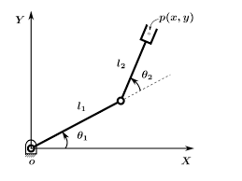
Figure 1 Schematic diagram of a 2-DOF planner serial manipulator.

 | $$x=l1\cos{θ_{1}}+l2\cos\left(θ_{1}+θ_{2}\right)$$ | (1)

 | $$y=l1\sin{θ_{1}}+l2\sin\left(θ_{1}+θ_{2}\right)$$ | (2)

In this function, input variable has a vector of two joint angles $θ_{1}$ and $θ_{2}$of joint variable. These both joint variables associated with the two joint actuators. While it has an output vector having two task parameter x and y having two DOF.
Similarly, the inverse kinematic solution is given below.
 | $$cosθ_{2}=\frac{x^{2}+y^{2}-l_{1}^{2}-l_{2}^{2}}{2l_{1}l_{2}}$$ | (3)

Use following equation to find $θ_{2}$
 | $$θ_{2}=\text{atan2}(±\sqrt{1-\cos^{2}θ_{2}},cosθ_{2})$$ | (4)
  - Positive (+) solution: Elbow-down configuration.
  - Negative (-) solution: Elbow-up configuration.
Use following equation to find $θ_{1}$
 | $$θ_{1}=\text{atan2}(y,x)-\text{atan2}(l_{2}sinθ_{2},l_{1}+l_{2}cosθ_{2})$$ | (4)
Constraints and Workspace
- Solvability: For a solution to exist, the target must be within the manipulator's workspace:
$$|l_{1}-l_{2}|≤\sqrt{x^{2}+y^{2}}≤l_{1}+l_{2}$$
- Singularity: If
$$θ_{2}=0$$
$$θ_{2}=π$$
The arm is fully extended or folded, leading to a singular configuration where the manipulator loses a degree of freedom.

MATLAB Implementation
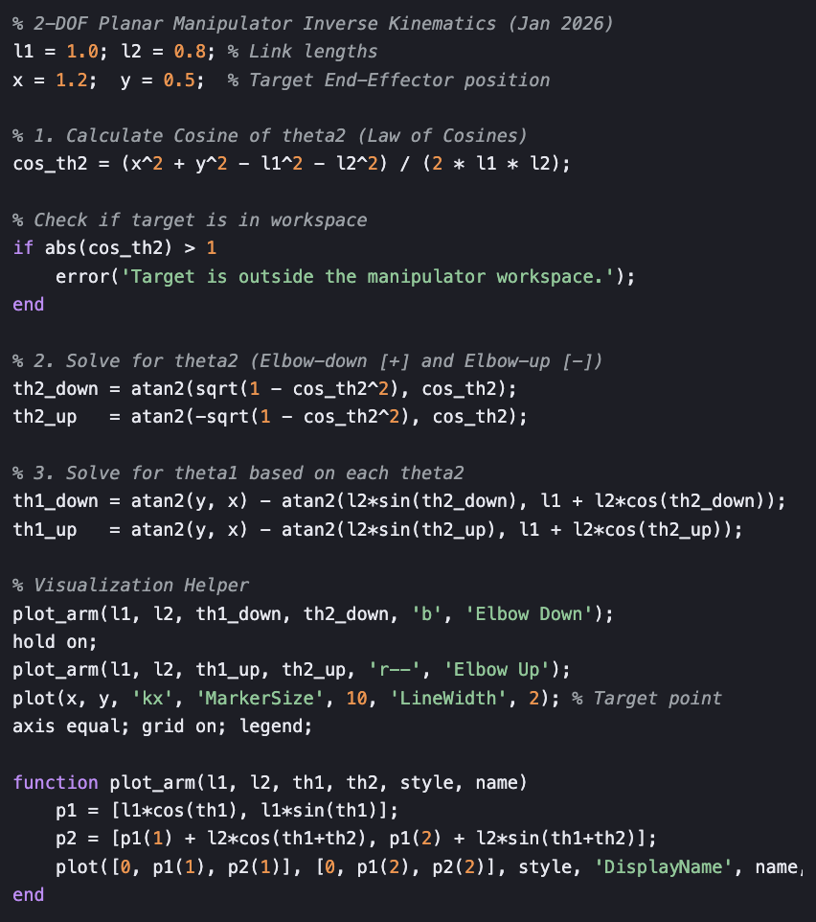
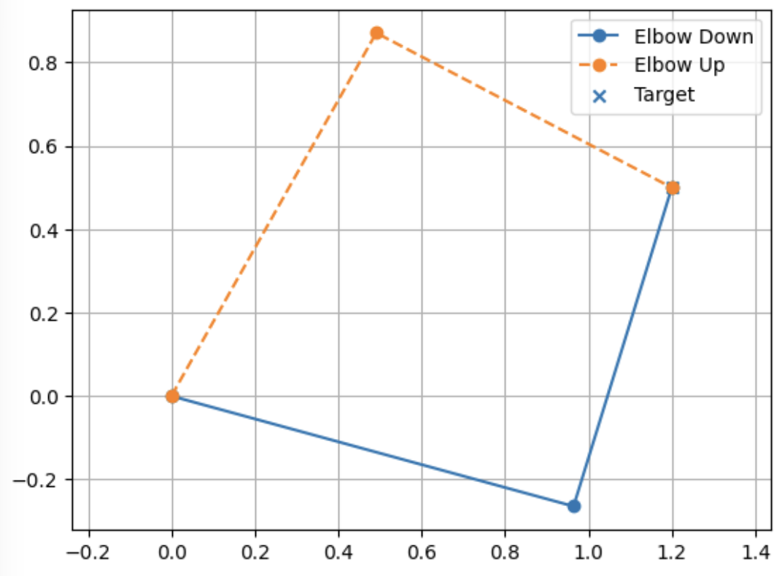ace Tra

Trajectory Planning
Trajectory planning is the process of computing a time sequence of positions, velocities, and accelerations for robot motion while satisfying physical constraints such as joint limits and actuator capabilities.

Joint Space Trajectory Planning
- Planning is done directly in joint variables (θ₁, θ₂, … θₙ).
- Smooth trajectories are generated using polynomial interpolation.
- Common trajectories: Linear, Cubic, Quintic.

Cartesian Space Trajectory Planning
- Planning is done in task space (x, y, z, orientation).
- Inverse kinematics is used to convert Cartesian points into joint variables.
- Computationally more expensive but provides better end-effector path control. (Cubic Polynomial)
A. Joint Space Trajectory Planning (Cubic Polynomial)

- Define initial and final joint angles.
- Select total motion time and time step.
- Generate joint trajectories using cubic polynomial interpolation.
- Plot joint position, velocity, and acceleration profiles.

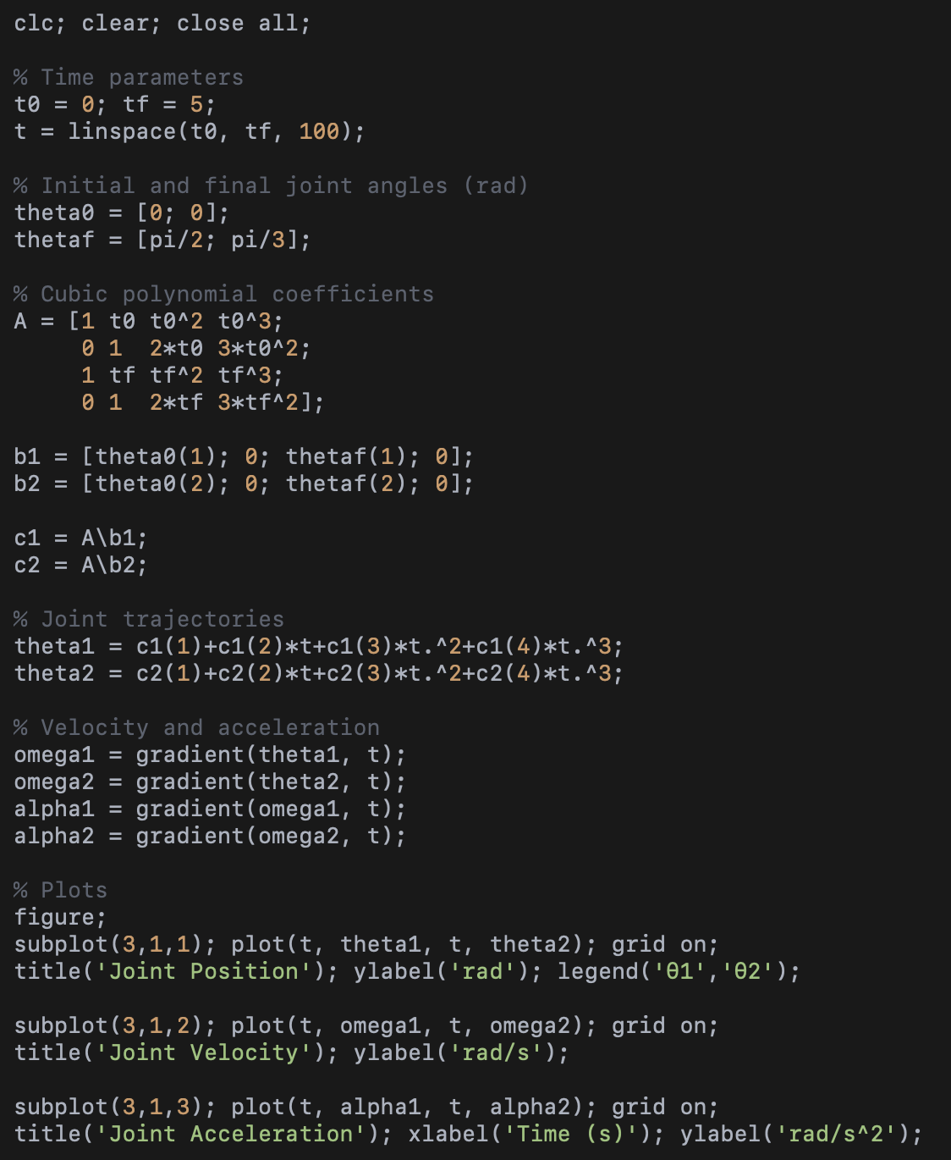

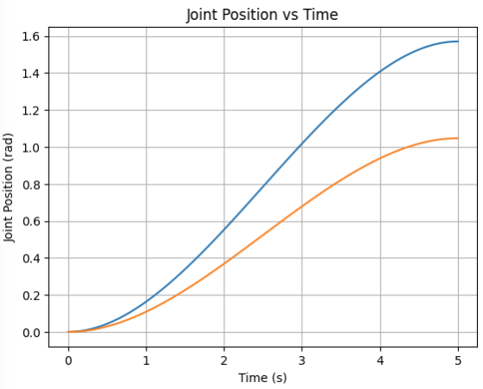

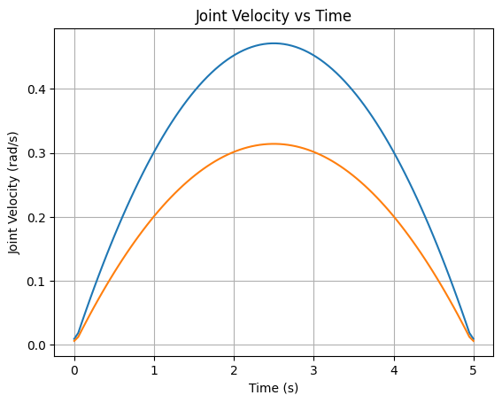
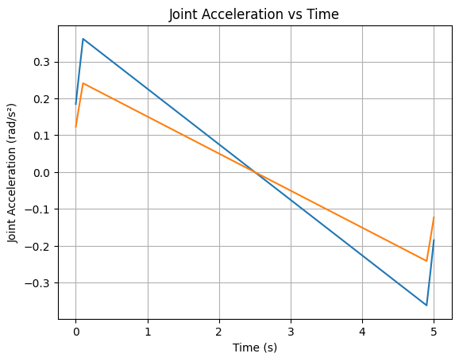

B. Cartesian Space Trajectory Planning

- Define initial and final end-effector positions.
- Generate a straight-line Cartesian path.
- Apply inverse kinematics to obtain joint trajectories.
- Plot Cartesian position and corresponding joint variables.
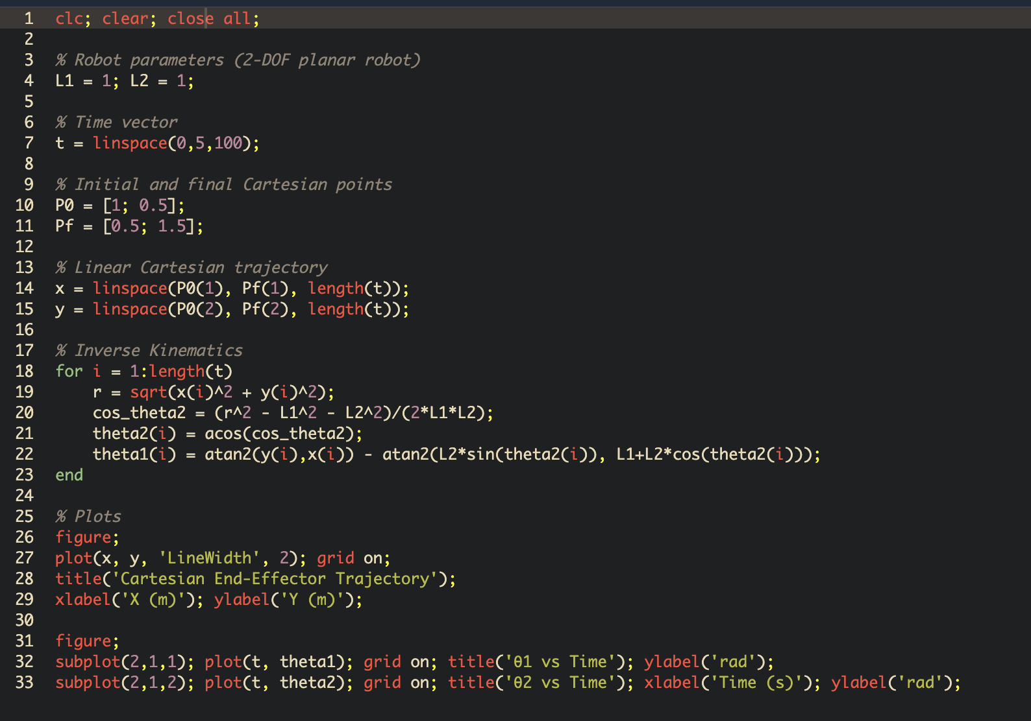

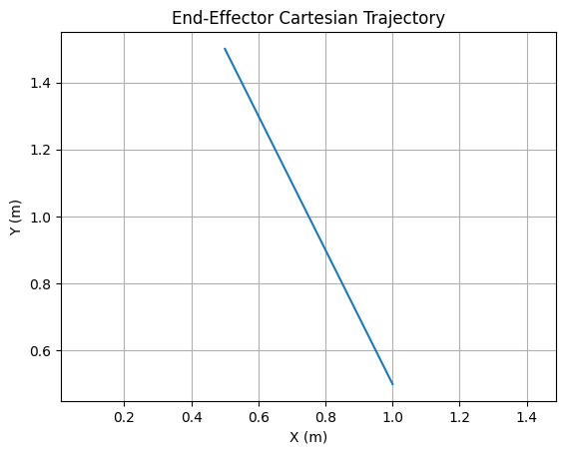
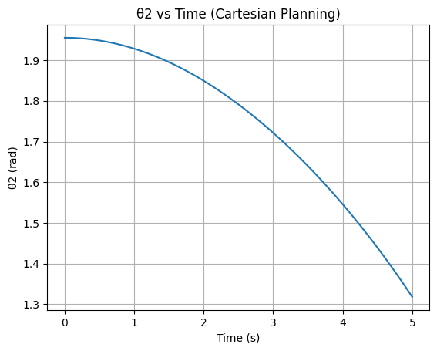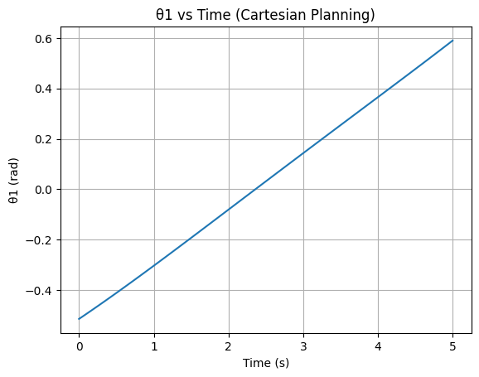

Procedure:

Joint-Space Trajectory Planning:
- Describe joint parameters (θ) and limits.
- Identify initial and final position of joints.
- Choose the type of trajectory (cubic).
- Establish joint trajectories.
- Replicate robot motion.
- Study joint angle, velocity, and acceleration profiles.
Cartesian-Space Trajectory Planning:
- Set the initial and final positions of end-effectors.
- Establish Cartesian path.
- Implement inverse kinematics to attain joint variables.
- Replicate robot motion.
- Study the steadiness of end-effectors trajectory.

Calculations:

Simulation Workspace:

Calculations:

Results:

Viva Questions:
- What is joint space trajectory planning?

- Why is Cartesian space planning computationally expensive?

- What are joint limits and why are they important?

- What is singularity in robot motion?

- Compare joint-space and Cartesian-space planning.

Regd No:

Signature: Signature of Faculty

