Meta-Learning Orchestration of Learning Modalities on Resource-Constrained Robots: A Systematic Review
Yeshwanth Guru, Department of Mechanical Engineering, Amrita Vishwa Vidyapeetham, Chennai, India (g_yeshwanth@ch.students.amrita.edu; ORCID 0009-0007-6353-4033; corresponding author)
Dev Kunwar Singh Chauhan, Department of Mechanical Engineering, Amrita Vishwa Vidyapeetham, Chennai, India (c_devsingh@ch.amrita.edu; ORCID 0000-0002-1466-4567)
Abstract
A low-cost robot that must perceive, learn from demonstration, improve through reinforcement and recover from faults on its own hardware cannot run every learned model at every step. It needs an orchestrator: a component that decides which learning modality to invoke, how much computation to spend and how far to trust the result, and that improves these decisions from experience. This systematic review asks whether the literature supports such a meta-learned orchestrator on resource-constrained hardware. Following PRISMA 2020, 180 works were included from a curated list, structured searches and a targeted search closed on 4 October 2026. Each work was graded on a six-level evidence scale, coded for the platform its inference needs and for the confidence signal it exposes, and the 161 primary studies were appraised against seven criteria. The components exist separately: calibrated or epistemic confidence signals, conformal help-seeking, budget-aware routers, adaptive computation inside policies, meta-learned adaptation and on-device fine-tuning. Their combination does not. No included work arbitrates between more than two heterogeneous learning modalities with a learned, calibrated and compute-budgeted gate; of the 65 real-robot studies, only five run inference on a Raspberry-Pi-class processor and only two of these expose a confidence signal. Most systems need a workstation GPU (68 works) or a datacenter (34). The review formalizes orchestration as confidence-driven routing in a constrained Markov decision process and treats the orchestrator as a meta-learner. An illustrative simulation shows that miscalibration lowers routing success from 0.85 to 0.81 and that a calibration prior meta-learned across tasks recovers most of the loss within the first 25 steps on a new task (0.82 against 0.77 when learning from scratch). The review closes with an evaluation protocol for real robots and five open problems.

1 Introduction

1.1 Adaptive Embodied Agents on Resource-Constrained Hardware
A household or laboratory robot faces a stream of situations that no single learned policy handles well. It must recognize objects it has not seen, refine a skill that almost works, copy a behavior a person has just demonstrated, and keep functioning when a wheel slips or a joint degrades. Robot learning has developed a separate family of methods for each of these needs. Uncertainty-aware perception [1], [2], deep reinforcement learning (RL) [3], [4], imitation learning [5], [6] and fault adaptation [7], [8] have each produced strong results. Two recent developments raise the question of how to combine them. Large language models (LLMs) can decompose tasks and call skills or tools [9], [10], [11], and generalist vision–language–action (VLA) models attempt to replace the separate modules with a single network [12], [13], [14].
Both routes are hard to realize on low-cost hardware. The LLM planners in the literature typically call cloud-hosted models, and the strongest VLAs have billions of parameters and need GPU inference (Section 6). Low-cost platforms such as the LeKiwi mobile manipulator from the open-source LeRobot ecosystem [15], [16] carry a single-board computer, two cameras and a small arm. An agent on such a platform cannot run every model all the time. It must decide which learning modality to use, when to spend computation, when to trust a module’s output, and how to improve those decisions from experience. This review calls the component that makes these decisions the orchestrator, and asks what the literature offers for building it.

1.2 Organizing Framework: Four Modalities, Their Confidence Signals and a Meta-Learned Gate
The review is organized around a design question: can an embodied agent on resource-constrained hardware adapt better if a small, local, trainable orchestrator learns to allocate computation across several learning modalities, using calibrated confidence signals that each modality emits? Four modality–signal pairs are considered: vision perception with epistemic uncertainty; RL with policy variance; imitation learning with behavioral fidelity; and fault adaptation with recovery-success rate. The orchestrator is framed as a meta-learner: it does not learn a task but learns, across a distribution of tasks, how to use the learners it has, and it adapts that knowledge to a new task or robot condition from a few outcomes. Fig. 1 shows the architecture used as the lens of the review. For each component, the review asks what the literature already provides, what is missing and what would have to be shown for the composition to work.
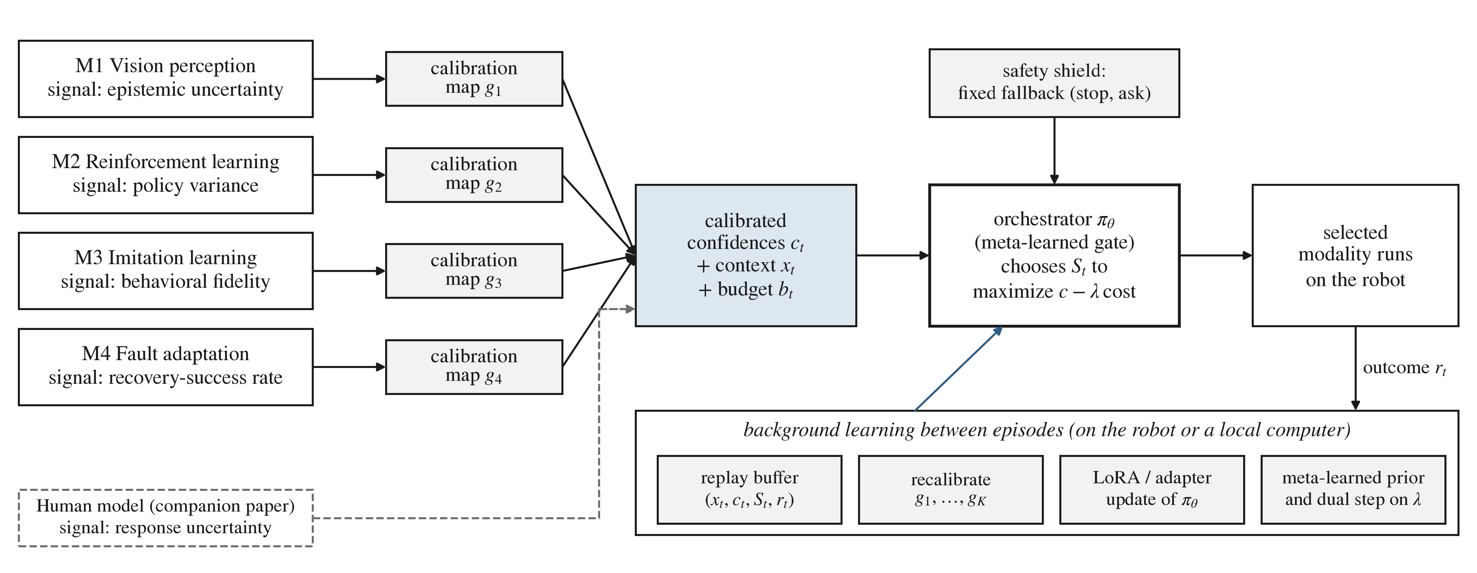
Fig. 1. Architecture used to organize the review. Each learning modality emits a confidence signal that a per-modality calibration map turns into an estimate of the probability of success. The orchestrator, a small meta-learned gate, chooses the modality to run within a compute budget, subject to a fixed safety fallback. Outcomes are stored and used between episodes to recalibrate the signals, update the gate’s adapter and refine the meta-learned prior. The dashed input is the human-model signal developed in the companion paper [17].

1.3 Scope
The review is restricted to a single robot. “On-device” covers computation on the robot and on a local computer connected to it, but never a remote cloud service. This distinction matters in practice: the standard configuration of the LeKiwi mobile manipulator runs a Raspberry Pi 5 on the robot and streams observations over ZeroMQ to a laptop, where heavier policies run [15]. Multi-robot federated learning is discussed only as a source of fusion ideas (Section 12.3). Quantum and neuromorphic hardware are outside the scope; quantum technologies for robotics and quantum-like models of decision-making are reviewed in two companion surveys by the same authors [18], [19].

1.4 Research Questions
Five research questions structure the review:
- RQ1. Which learning modalities can a resource-constrained robot draw on, and which confidence signal can each modality emit? (Sections 4, 7–10)
- RQ2. How is the choice among models, skills or modalities made in current systems, and is that choice learned, uncertainty-aware, compute-budgeted and deployable on edge hardware? (Sections 5, 6, 14)
- RQ3. Which confidence signals are cheap and calibrated enough to be compared and fused on edge hardware? (Sections 7–10, 12)
- RQ4. Can meta-learning and on-device adaptation train such an orchestrator on the robot within its memory and compute? (Sections 11, 13)
- RQ5. How far does the published evidence go toward a physical, resource-constrained robot, and what evaluation would show that orchestration outperforms its strongest single component? (Sections 3, 15)
Section 16 answers each question.

1.5 Related Surveys and Contributions
Existing surveys cover the components of the problem separately: uncertainty in deep networks [20], meta-learning [21], continual learning [22], multimodal learning [23], federated learning [24], [25], imitation learning [26], safe learning in robotics [27], [28], fault detection in robots [29], anomaly detection [30] and efficient VLA models [31]. None of them addresses how heterogeneous learners should be orchestrated on resource-constrained hardware, and none grades its corpus by how close the evidence comes to such hardware. The review makes six contributions.
- A modality-by-signal taxonomy that pairs each learning modality with a confidence signal it can emit cheaply (Table 3).
- A systematic, reproducible review of 180 works, each graded on a six-level evidence scale, coded for the platform its inference needs and the confidence signal it exposes, and appraised against seven criteria; the data and coding rules are released (Section 2).
- An evidence profile showing where the literature stops short of the target: real-robot studies rarely run on edge processors and rarely expose a confidence signal (Section 3, Fig. 4).
- A gap analysis and a formal problem statement of orchestration as budget-constrained, confidence-driven routing, with the orchestrator cast as a meta-learner (Sections 11 and 14).
- An illustrative simulation of the effect of miscalibration on routing and of a meta-learned calibration prior on adaptation to a new task (Section 14.2, Appendix B).
- An evaluation protocol for real-robot studies and five open problems (Sections 15 and 17).

1.6 Organization
Section 2 describes the review method and Section 3 the evidence profile of the corpus. Section 4 introduces the four learning modalities. Sections 5 and 6 review LLM orchestrators and VLA models. Sections 7–10 review the four modalities and their confidence signals. Sections 11–13 cover meta-learning, uncertainty fusion and on-device adaptation, and Section 14 covers adaptive computation, mixture of experts and the formal problem statement. Section 15 discusses low-cost platforms and evaluation, Section 16 answers the research questions, Section 17 lists open challenges and Section 18 concludes.

2 Review Method
The review follows the PRISMA 2020 statement [32] and the guidelines of Kitchenham and Charters for systematic reviews in computing [33]. It was registered retrospectively on the Open Science Framework [FILL: OSF registration DOI]; the protocol text, the search record and the retraction check are released with the data. Fig. 2 shows the flow of records.

2.1 Eligibility Criteria
A work was included if it (I1) proposed, evaluated or reviewed a method in one of twelve component areas of learned orchestration for embodied agents: LLM planners and orchestrators; VLA and robot foundation models; perception with epistemic uncertainty; RL and policy variance; imitation learning and behavioral fidelity; fault detection, adaptation and recovery; meta-learning; uncertainty fusion and calibration; on-device adaptation and continual learning; adaptive computation, mixture of experts and routing; low-cost platforms, benchmarks and evaluation; and safe learning; (I2) reported the method and its evaluation in enough detail to be graded, or was a review, benchmark or software release that defines a component; and (I3) was a journal article, conference paper or arXiv preprint in English published between 1991 and October 2026. A work was excluded if it (X1) concerned multi-robot or fleet learning without a single-robot component, (X2) concerned quantum or neuromorphic hardware, (X3) could not be located or verified on an arXiv or publisher page, (X4) was not a scholarly source (blog, product page, talk abstract or model card) or (X5) duplicated an included work, in which case the archival version was kept.

2.2 Information Sources and Search
The corpus was assembled in three stages. Stage 1 was a curated reading list of 108 works, assembled while the orchestration framework was designed. Every item was checked against its arXiv or publisher record, and 30 bibliographic details (year, venue, title or authors) were corrected. Stage 2, in September 2026, comprised structured searches of arXiv, the proceedings of CoRL, RSS, ICRA, IROS, NeurIPS, ICML and ICLR, and publisher sites in ten topic streams: uncertainty-aware LLM and VLA planning; efficient and edge VLAs; budget-aware model routing; RL fine-tuning of large policies; failure detection and recovery with foundation models; uncertainty fusion and calibration; continual and on-device learning; adaptive computation in robot policies; safe learning; and low-cost hardware and evaluation methodology. Backward citation chasing from the reviews in the corpus supplemented the streams, and 72 works were added. The exact strings and hit counts of stage 2 were not logged; the concept blocks that reproduce their scope are given in the supplementary material (Section S2). Stage 3 was a logged targeted search on the title topic, run on 4 October 2026. It returned seven new records: three were excluded (a talk page, a non-embodied agent and an LLM-only study) and four were recorded as candidates for full-text screening and are not counted in the corpus. The corpus was closed on 4 October 2026. All 180 references were matched against the Retraction Watch Database (72,870 records, current to 22 September 2026), and none has been retracted.
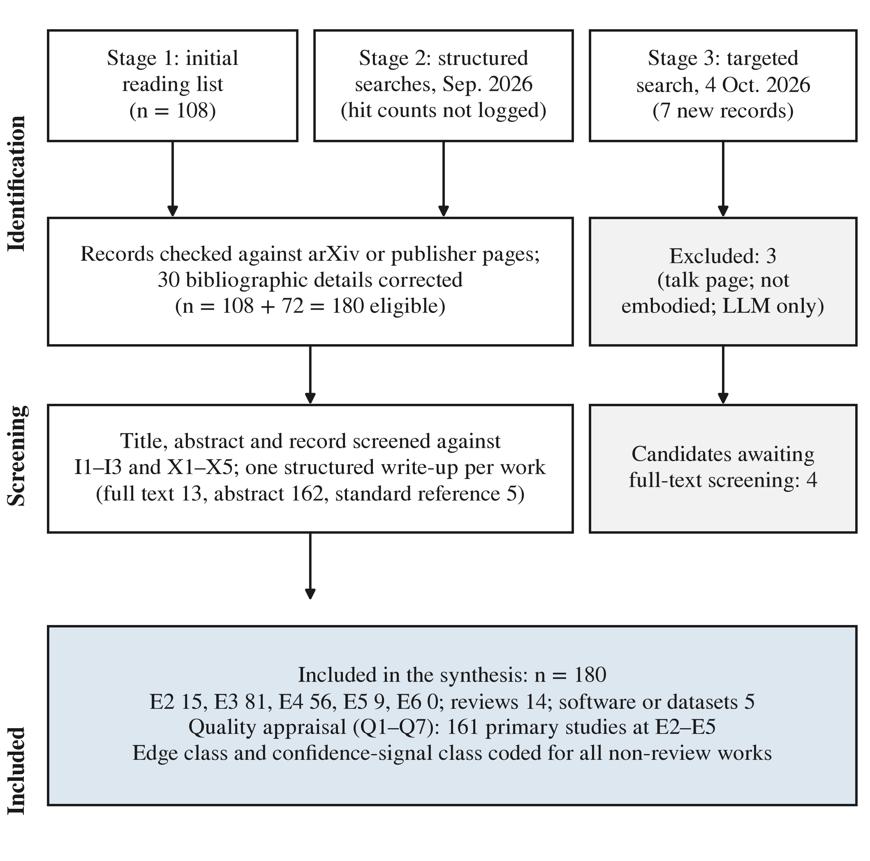
Fig. 2. Flow of records through the review (PRISMA 2020). Search hit counts were not logged for stage 2. The four stage-3 candidates await full-text screening and are not counted in the corpus.

2.3 Data Extraction and Coding
For every work, a structured write-up recorded the task, method, setup and data, key result, limitation, compute footprint relative to a Raspberry-Pi-class robot and role in the orchestration framework. Thirteen write-ups were made from the full text, 162 from the abstract and the publisher or arXiv page, and five from the standard description of well-known works; numbers not stated in the abstract are marked as such and were not inferred. Two attributes were then hand-coded for every work that is not a review. The edge class records the platform that the system’s inference needs as published: Raspberry-Pi-class or embedded CPU; embedded GPU (Jetson class); workstation GPU (a desktop, laptop or single consumer GPU); datacenter or cloud; or not stated. The confidence-signal class records the signal the work provides or uses: conformal or explicitly calibrated; epistemic uncertainty (ensembles, dropout, evidential or Bayesian posteriors); failure, anomaly or novelty score; policy variance or entropy; routing score or predicted quality; or none. The extraction table, summaries and coding files are released (Data Availability).

2.4 Evidence Levels
Every work was graded on the scale of Table 1. The levels follow the steps a component must pass before it can be relied on in an orchestrated robot: it is proposed (E1), specified as an algorithm or analysis (E2), evaluated in simulation or on a benchmark (E3), shown on a physical robot (E4), shown on several platforms or at scale (E5) and used with real users over time (E6). The scale is ordinal and was designed for this review. It grades how far the evidence goes toward a deployed robot, not the scientific quality of the work, and ambiguous cases received the lower level. A second rater re-graded a random sample [FILL: second rater; sample size; Cohen’s kappa for evidence levels and edge class].
Table 1. Evidence Levels Used to Classify the Reviewed Works, With the Number of Works at Each Level (n = 180)
Level | Label | Definition | Example | n
E1 | Conceptual | Position or proposal without an algorithm or experiments | – | 0
E2 | Algorithmic or analytic | Algorithm or theory with analytic or toy evaluation | MC dropout [1]; shielding [34] | 15
E3 | Simulation or benchmark | Evaluated in simulation or on standard datasets | LIBERO [35]; RouteLLM [36] | 81
E4 | Real robot (laboratory) | Demonstrated on physical robots in the laboratory | Sentinel [37]; MoE-Loco [38] | 56
E5 | Real robot (extensive) | Extensive real-robot evaluation or multiple platforms | OpenVLA [13]; QT-Opt [39] | 9
E6 | Deployment | Sustained deployment with real users | None found | 0
R | Review | Surveys and tutorials | Uncertainty survey [20] | 14
S | Software or dataset | Libraries, datasets and benchmark suites | LeRobot [16] | 5

2.5 Quality Appraisal
The 161 primary studies at levels E2–E5 were appraised against seven criteria chosen for the orchestration question: Q1 method specification; Q2 comparison with a named baseline; Q3 physical validation; Q4 reporting of compute, latency or memory; Q5 quantitative evaluation; Q6 release of code or models; and Q7 a confidence signal that an orchestrator could read. Each criterion was coded as met (M), partly met (P), not met (N) or not assessable without the full text (?), by explicit rules applied to the extraction fields; the rules are listed in the codebook of the data package, and ambiguous cases received the lower code. Because most codes rest on abstracts, the appraisal is a first pass, to be confirmed against the full texts. Table 2 gives the results. Most studies specify their method (Q1 met in 104) and report a result with a number (Q5 met in 68), but only 36 report compute, latency or memory as a number (Q4), and only 36 expose a calibrated, epistemic, failure or policy-variance signal (Q7). Code release (Q6) could be confirmed for only six, because abstracts rarely state it.
Table 2. Quality Appraisal of the 161 Primary Studies (E2–E5): Number of Studies per Code
Criterion | M | P | N | ?
Q1 Method specification | 104 | 57 | 0 | 0
Q2 Baseline comparison | 46 | 50 | 41 | 24
Q3 Physical validation | 63 | 2 | 96 | 0
Q4 Compute reporting | 36 | 19 | 106 | 0
Q5 Quantitative evaluation | 68 | 30 | 0 | 63
Q6 Code or model release | 6 | 0 | 0 | 155
Q7 Confidence signal | 36 | 24 | 101 | 0

2.6 Synthesis and Threats to Validity
Outcomes are too heterogeneous for meta-analysis, so the synthesis is narrative and organized by the framework of Fig. 1, supported by counts by evidence level, edge class and signal class. Several threats apply. The field moves quickly, and 25 of the included works were preprints at the time of the search. Most write-ups rest on abstracts, which can misstate the evidence level or omit compute figures; this biases Q4 and Q5 downward and is why the lower level or code was assigned in doubtful cases. Screening and extraction were done by one reviewer, with the evidence levels and coding of the core works checked by the second author. The stage-2 search strings were not logged, so that stage cannot be reproduced exactly; the concept blocks and the logged stage-3 search partly compensate. The edge class records what the published system used, not what a smaller variant might achieve, and compute figures were not measured on a common platform. Finally, the illustrative simulation uses synthetic data and makes no claim about robot performance.

3 Evidence Profile of the Corpus
Fig. 3 shows the evidence levels by topic. The corpus is dominated by simulation and benchmark studies (81 works at E3) and laboratory robot studies (56 at E4); nine works reach E5 and none reaches E6. Real-robot evidence is concentrated in VLA models, fault detection and recovery, and LLM planning. In contrast, on-device adaptation and adaptive computation, the two areas that an edge orchestrator depends on most, are evaluated almost entirely in simulation or on benchmarks (19 of 23 and 14 of 20 works at E3).
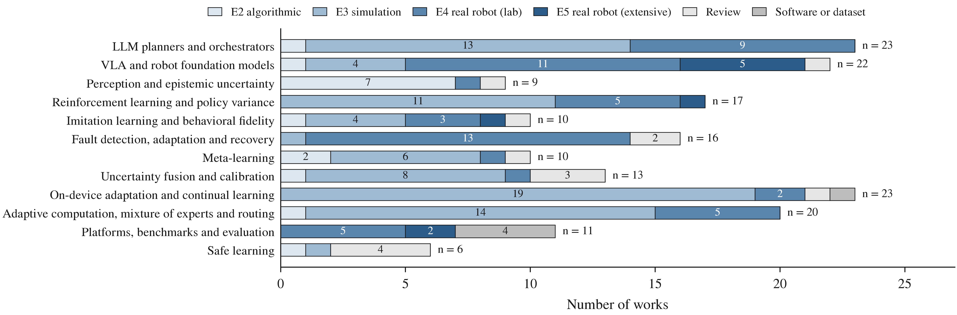
Fig. 3. Evidence levels of the 180 included works by topic. E2 algorithmic or analytic; E3 simulation or benchmark; E4 real robot (laboratory); E5 real robot (extensive or multi-platform). No work reaches E1 or E6.
Fig. 4 cross-tabulates the evidence level with the edge class and the confidence-signal class. Two patterns stand out. First, the works that run on a Raspberry-Pi-class processor are mostly algorithms and simulation studies (41 of 46 at E2 or E3); of the 65 real-robot studies (E4 and E5), 36 need a workstation GPU, 16 a datacenter or cloud service and only five run on a Pi-class processor: hindsight experience replay [40], intelligent trial and error [7], meta-learned dynamics for online adaptation [41], rapid motor adaptation [8] and ThriftyDAgger [42]. Second, 106 of the 166 non-review works expose no confidence signal at all. Among the real-robot studies, 14 expose a calibrated, epistemic, failure or policy-variance signal, and most of these are failure detectors and help-seeking planners that run on GPUs [37], [43], [44], [45], [46]. Only two works are at once on a real robot, on a Pi-class processor and equipped with such a signal: intelligent trial and error, whose Gaussian-process posterior guides recovery after damage [7], and ThriftyDAgger, whose novelty and risk estimates decide when to hand control to a human [42]. Each arbitrates between two options. No included work arbitrates between more than two heterogeneous learning modalities with a learned, calibrated and compute-budgeted gate on any hardware.
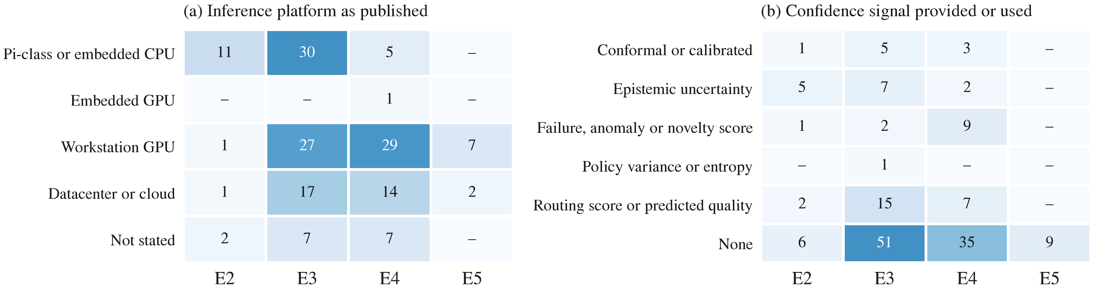
Fig. 4. Evidence level of the 166 non-review works against (a) the platform their inference needs as published and (b) the confidence signal they provide or use. Hand-coded from the structured write-ups; coding rules in the data package.

4 Learning Modalities in Robotics

4.1 Overview of the Four Modalities
Perception. Perception maps camera images and other sensor readings to object identities, poses and scene structure. Foundation vision–language encoders such as CLIP provide open-vocabulary recognition [47] and underpin language-conditioned manipulation [48]. For an orchestrator, the key property of a perception module is whether it knows when it does not know. Bayesian approximations, ensembles and evidential outputs provide this (Section 7) [1], [49], [50], and uncertainty surveys map the design space [20].
Reinforcement learning. Deep RL learns control from reward, from value-based methods with experience replay [51] to policy-gradient [4] and maximum-entropy actor–critic methods [3], [52]. Real-robot RL has reached 96% grasp success on unseen objects, but only with large-scale data collection [39]. Model-based RL improves sample efficiency across more than 150 tasks [53]. RL is the modality that can improve beyond its data, but it is the most expensive to run on hardware.
Imitation learning. Imitation learning copies expert behavior [26]. Its classical difficulty is compounding error under distribution shift, which DAgger addresses with interactive data aggregation [54]. Modern imitation, using diffusion policies [5], action-chunking transformers on low-cost hardware [6] and implicit energy-based models [55], learns dexterous skills from minutes of demonstrations. ACT reached 80–90% success on six tasks with ten minutes of demonstrations [6].
Fault adaptation and recovery. Robots that recover from damage use self-models [56], precomputed behavior repertoires searched by Bayesian optimization [7], meta-learned dynamics models that adapt online [41], or adaptation modules trained in simulation that adjust within fractions of a second [8]. Detecting that something has gone wrong is itself a learning problem [29], [30], now addressed with foundation models (Section 10).

4.2 Why Each Modality Alone Is Insufficient
Each modality has a characteristic failure. Perception is brittle out of distribution and often overconfident [57], [58]. RL is sample-hungry and unsafe to explore on hardware [27]. Imitation cannot exceed its demonstrations and degrades under distribution shift [54]. Fault adaptation methods are specialized to a platform or a class of damage [8]. Robustness baked in offline, for example by domain randomization [59], cannot anticipate every failure. No single modality covers the situations a long-lived robot will meet.

4.3 The Case for Composition
The strengths are complementary. Imitation gives fast competence, RL gives improvement [60], [61], perception grounds both, and fault adaptation keeps the robot operational. Several lines of work already combine two modalities. Residual RL refines imitation policies [60], [61], RL in the latent noise space steers diffusion policies [62], and interactive imitation switches control between robot and human under a budget [42]. What these combinations lack is a general, learned arbiter across more than two modalities that uses each modality’s own estimate of its reliability. That arbiter is the subject of Sections 11–14. Table 3 pairs each modality with the confidence signal it can emit and the cost of computing it.
Table 3. The Four Learning Modalities and Their Confidence Signals
Modality | Confidence signal | Typical estimator | Extra compute | Calibration need
M1 Vision perception | Epistemic uncertainty | MC dropout [1], ensembles [49], evidential [50] | None (evidential) to N$×$ (ensembles, MC) | Temperature scaling [57]
M2 Reinforcement learning | Policy variance | Entropy [3], critic or head ensembles [63], novelty [64] | None (entropy) to K heads | High: entropy is not a success probability
M3 Imitation | Behavioral fidelity | Action spread [37], density and OOD scores [43], [65] | Several samples or a small density model | Temperature [66]; conformal thresholds
M4 Fault adaptation | Recovery-success rate | Beta posterior over outcomes; anomaly scores | Negligible | Low (counts outcomes) but slow to accumulate

5 LLMs as Planners and Orchestrators

5.1 LLM-Driven Planning and Tool Use
LLMs were first shown to produce executable plans for embodied agents zero-shot, with a trade-off between executability and correctness [67]. SayCan grounded the choice among robot skills by multiplying LLM relevance with learned affordance values [9]. Inner Monologue closed the loop with textual feedback on success and scene state [68]. Code as Policies [69] and ProgPrompt [70] generated programs that call perception and control APIs. LM-Nav composed three frozen models for navigation [71], LLM-Planner re-planned on failure with little paired data [72], VoxPoser composed 3D value maps [73], and Language to Rewards let an LLM specify rewards for model-predictive control, solving 90% of tasks against 50% for a primitive-skill baseline [74]. Plan-Seq-Learn used an LLM for high-level plans and RL for low-level skills [75]. PaLM-E injected continuous observations into a 562-billion-parameter model [76], and Voyager built a growing skill library in Minecraft [77]. These systems establish that an LLM can decide which module to call. However, they rely on large cloud models and do not learn the calling policy from robot experience.

5.2 Agent Loops and Tool Calling
ReAct interleaves reasoning and acting, improving success by 34 and 10 percentage points on ALFWorld and WebShop over imitation and RL baselines [10]. Toolformer teaches a model, by self-supervision, when to call which tool [11]. This is the closest analog to learning when to invoke each modality, although it is offline and not embodied. Reflexion improves through verbal reflection stored in memory, without weight updates [78], and Tree of Thoughts searches over reasoning paths at much higher inference cost [79]. A second generation updates weights. FireAct fine-tuned a 7B model on agent trajectories [80], AgentTuning instruction-tuned open models on agent data [81], Retroformer trained a small reflection model by policy gradient [82], and RL fine-tuning of vision–language models as decision agents outperformed GPT-4V on several tasks [83]. These results show that small orchestrators can be improved by fine-tuning, a prerequisite for learned orchestration.

5.3 Limits of a Frozen LLM Orchestrator
A frozen LLM orchestrator has three weaknesses in the edge setting. It does not know when it is wrong. KnowNo addressed this with conformal prediction, asking for help when the prediction set over plan options contains more than one element and providing statistical guarantees on task completion [45]. Introspective planning tightened these bounds [84], and the approach extends to multi-robot planning [85] and to deciding when to stop exploring [86]. A frozen LLM also cannot adapt its calling policy to the particular robot, whose modules succeed or fail in ways no pretraining corpus describes. Finally, its cost is fixed: it cannot decide to think less when the situation is easy. Recent work learns exactly this with an RL meta-policy that decides when to invoke expensive LLM reasoning. That meta-policy cut LLM inference time by more than 60% with a small loss in success [87].

5.4 Learned Versus Hard-Coded Orchestration
Table 4 summarizes the orchestration literature along four axes. The axes are whether the orchestrator is learned, whether it uses calibrated uncertainty, whether it respects a compute budget, and whether it runs on edge hardware. Existing systems satisfy at most two. The closest are policy steering that decides whether to act, ask or request intervention [46]; fast–slow anomaly handling with small language models [88]; budget-aware reasoning [87]; and budgeted human–robot gating [42]. None of them arbitrates between heterogeneous learning modalities, and none learns the arbitration online on the robot. This is the gap that the framework of this review targets.
Table 4. Orchestration Approaches Against Four Requirements of Learned Edge Orchestration
Approach | Learned policy? | Calibrated uncertainty? | Compute budget? | Edge-deployable?
SayCan, Inner Monologue [9], [68] | No (frozen LLM) | No | No | No (cloud LLM)
Code as Policies, ProgPrompt [69], [70] | No | No | No | Generated code yes; LLM no
ReAct, Reflexion [10], [78] | In-context only | No | No | Depends on LLM
Toolformer [11] | Yes (offline) | No | No | Mid-size model
FireAct, Retroformer [80], [82] | Yes (fine-tuned) | No | No | Possibly (small models)
KnowNo, introspective planning [45], [84] | No | Yes (conformal) | No | Calibration yes; LLM no
Act, ask, or learn [46] | Partly (residual learning) | Yes (conformal) | No | No (large VLM)
Fast/slow anomaly handling [88] | Classifier trained | Partly | Implicitly (fast path) | Fast path plausibly
RouteLLM, Hybrid LLM, AutoMix [36], [89], [90] | Yes | Partly (predicted quality) | Yes | Router yes
RARRL [87] | Yes (RL) | No | Yes | Not stated
ThriftyDAgger [42] | Thresholds | Novelty and risk | Yes (human budget) | Yes
Target (unoccupied) | Yes, online on device | Yes, across four modalities | Yes | Yes

6 VLA and Robot Foundation Models

6.1 Vision–Language–Action Models
VLA models map images and language directly to actions. RT-1 trained a transformer on large real-robot datasets [91], and RT-2 co-fine-tuned a vision–language model to transfer web knowledge to control, evaluated over 6,000 trials [12]. OpenVLA, a 7B open model, outperformed the 55B RT-2-X by 16.5 percentage points in absolute success and can be fine-tuned with LoRA on consumer GPUs [13]. Octo [92], $π$0 [14], RoboCat [93], Gato [94], VIMA [95], PerAct [96] and RoboFlamingo [97] extend the generalist program, and cross-embodiment datasets support it [98].

6.2 Limitations of Generalist Policies on Edge Hardware
Generalist policies are monolithic. They offer no handle for allocating computation across sub-skills, no native uncertainty estimate, and no mechanism for on-device improvement beyond offline fine-tuning. RL fine-tuning methods address the last point, for example raising OpenVLA’s real-world success from 40% to 70% in 40 minutes [99], reaching 96.3% average success after 45–90 minutes of online training [100], and scaling RL for VLAs [101], [102]. All of these need GPUs.

6.3 Memory, Latency, and Compute
Fig. 5 compares model sizes with the memory of a 4 GB Raspberry Pi 5. Storing the weights of a 2-billion-parameter model in 16-bit precision alone would fill that memory. OpenVLA (7B) and larger models therefore require an off-board GPU. The LeRobot paper reports that ACT needs about 5 ms and 211 MB per inference on an RTX 4090, against about 209 ms and 13.3 GB for $π$0 [15]. Efficiency work narrows the gap: SmolVLA performs comparably to VLAs about ten times larger and runs on consumer GPUs or CPUs [103]; TinyVLA [104] and EdgeVLA [105] target fast inference; OpenVLA-OFT achieved 26 times higher throughput [106]; FAST compresses action tokens [107]; 1-bit and post-training quantization cut memory by up to 11 times [108], [109]; and state-space backbones reduce latency [110]. A survey maps efficient VLA design [31]. Even so, only the smallest policies are plausible on the Pi itself.
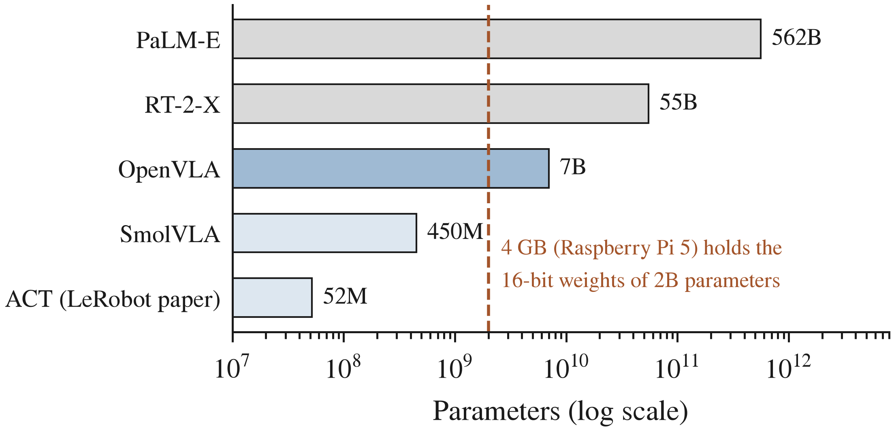
Fig. 5. Parameter counts of representative planners and policies (log scale) compared with a 4 GB Raspberry Pi 5, whose memory holds the 16-bit weights of at most about 2 billion parameters before any activations or operating system. Sizes from the cited papers; ACT’s size as reported in the LeRobot paper.

6.4 Modular Policies With a Small Local Orchestrator
The evidence favors a modular design: small specialized policies (ACT-scale imitation, compact RL policies, lightweight perception) plus a small orchestrator. Distilling planning ability into a 3B on-device model recovered over 93% of GPT-4o’s performance [111], and small routers can decide when larger models are needed (Section 14). The trade-off is that the robot loses the broad generalization of large VLAs. Whether orchestration recovers enough adaptivity to compensate is an open empirical question.

7 Vision Perception With Epistemic Uncertainty

7.1 Perception Pipeline
The perception modality turns camera images into task-relevant state such as object classes, masks and poses. On a low-cost robot with two RGB cameras and no depth sensor, 2D detection and segmentation with language-conditioned encoders [47], [48] are the realistic options. Voxel-based methods such as PerAct assume depth input [96]. Domain randomization yields detectors robust enough for 1.5 cm localization in clutter [59].

7.2 Epistemic Uncertainty Quantification
Epistemic uncertainty reflects what the model does not know and should shrink with more data, whereas aleatoric uncertainty reflects inherent noise [2]. Only epistemic uncertainty tells an orchestrator that another modality, or more data, could help.
Monte Carlo dropout. Keeping dropout active at test time and averaging several stochastic passes approximates Bayesian inference [1]. It needs no retraining, but its cost grows linearly with the number of passes, and the quality of its uncertainty is debated.
Ensembles. Deep ensembles give well-calibrated uncertainty, as good as or better than approximate Bayesian networks, and higher uncertainty on out-of-distribution inputs [49]. Their cost scales with the number of members, which is the central edge trade-off. Shared-backbone ensembles (multiple heads) reduce the cost, as bootstrapped DQN does in RL [63].
Evidential deep learning. Evidential networks output the parameters of a distribution over predictions in a single pass: a Dirichlet for classification [50] or a normal-inverse-gamma for regression [112]. This makes them the cheapest source of epistemic confidence and therefore attractive for a Raspberry Pi. Their calibration can degrade out of distribution. The simplest out-of-distribution signal, the maximum softmax probability, costs nothing extra but is often overconfident [58].

7.3 Calibration
Modern networks are systematically overconfident, and a single temperature parameter fitted on held-out data corrects much of this [57]. For VLAs, confidence predicts task success poorly without correction; prompt ensembles and Platt scaling improve it [113]. Calibration is a prerequisite for orchestration: a gate that compares confidences across modalities is only as good as their calibration (Section 12.2).

7.4 Cost Versus Uncertainty Quality on Edge Hardware
Table 5 compares the options. Temperature scaling and evidential outputs are essentially free, MC dropout and ensembles multiply inference, and conformal methods add a cheap calibration step on top of any score [45]. For a Pi-class robot, a practical design is an evidential or temperature-scaled detector, with ensembles reserved for offline calibration.
Table 5. Uncertainty Estimators: Cost and Suitability for a Raspberry-Pi-Class Robot
Method | Inference cost | Strength | Weakness
Max softmax [58] | 1 pass | Free | Overconfident
Temperature scaling [57] | 1 pass + scalar | Fixes global miscalibration | Needs held-out data; not per-input epistemic
Evidential [50], [112] | 1 pass | Epistemic signal in one pass | Can be miscalibrated out of distribution
MC dropout [1] | T passes | No retraining | Latency; quality debated
Deep ensembles [49] | M models | Strong, well calibrated | M$×$ memory and compute
Conformal prediction [45] | Negligible over base score | Distribution-free coverage | Assumes exchangeability

8 Reinforcement Learning With Policy Variance

8.1 RL Backbones
Policy-gradient methods. Proximal policy optimization (PPO) is the default on-policy algorithm, balancing sample complexity, simplicity and wall-clock time [4]. Its small policy and value networks run comfortably on a Raspberry Pi, but training is usually done in simulation on a workstation.
Value-based and off-policy methods. DQN introduced experience replay for deep RL [51]. Off-policy actor–critic methods such as SAC [3] and TD3 [52] are more sample-efficient for continuous control. Hindsight experience replay makes sparse-reward robot tasks learnable by relabeling goals, and its simulated policies transferred to a physical robot [40]. Offline RL learns from fixed buffers without new interaction; conservative Q-learning often achieved two to five times higher final return than earlier offline methods [114]. This is relevant to learning from on-device logs. Model-based RL with world models improves sample efficiency [53], but its memory cost is high for edge training.

8.2 Policy and Value Variance as Confidence Signals
An RL policy’s confidence can be read in two ways: from the spread of its action distribution, or from disagreement among value estimates.
Policy entropy. Maximum-entropy RL makes the policy stochastic by design, so its entropy is available at no extra cost [3]. Entropy, however, mixes aleatoric choice (several good actions) with epistemic ignorance (unknown state), and it is not calibrated to success probability. Calibration against observed outcomes is therefore needed before entropy is compared with other modalities’ signals (Section 12.2).
Ensembles and twin critics. Bootstrapped DQN uses multiple heads on a shared network to approximate a posterior and drive deep exploration, improving learning times across most Atari games [63]. Head disagreement is a direct epistemic signal. TD3’s twin critics reduce overestimation but do not quantify uncertainty [52]. Random network distillation provides a cheap novelty score for states the agent has not visited [64], which could also trigger the fault modality. For the orchestrator, a small ensemble of critics or a novelty score is a practical policy-variance signal.

8.3 Sample Efficiency on Edge Hardware
Training RL on the robot is limited by sample efficiency and safety. Three strategies reduce the burden. The first is refining an imitation policy with a small residual RL policy [60], [61]. The second is running RL in the latent noise space of a diffusion policy without changing its weights, which achieved sample-efficient real-world improvement [62]. The third is fine-tuning large policies with offline-to-online RL [99], [100], [101], [102], which needs a GPU. On a Pi-class robot, only the first two are realistic on board; heavier updates must run asynchronously on a local computer (Section 13.3).

9 Imitation Learning With Behavioral Fidelity

9.1 Learning From Demonstration
Behavioral cloning. Behavioral cloning (BC) regresses actions on observations. Its compounding-error problem motivated DAgger, which provides no-regret guarantees by aggregating expert labels on the learner’s own state distribution [54]. Modern BC is expressive. Diffusion policies model multimodal action distributions and improved on prior methods by 46.9% on average [5]. ACT predicts action chunks on low-cost bimanual hardware [6]. Implicit BC handles discontinuous actions with energy-based models [55]. Language-conditioned BC generalized to 24 unseen tasks with 44% average success [115], and learning from unstructured play covered about four times more interaction space than demonstrations [116]. Best practice for learning from offline human demonstrations is documented in robomimic [117].
Inverse reinforcement learning. Adversarial imitation matches the expert’s state–action occupancy rather than its actions [118]. It is more robust to distribution shift in principle, but its adversarial training is unstable and sample-hungry on real robots.
Multimodal imitation. Action multimodality, where several distinct actions are correct, is handled by diffusion [5] and energy-based models [55]. Multimodal inputs such as language and vision are handled by VLAs and multimodal prompts [95].

9.2 Behavioral Fidelity as Confidence
Behavioral fidelity is the degree to which the policy is operating within the distribution of its demonstrations, where its actions are reliable.
Action-distribution spread. For generative policies, the spread of sampled actions is a natural signal. Runtime monitors use the temporal consistency of sampled action chunks [37] and action-chunk entropy [65] to detect erratic failures. Per-task temperature scaling of language-conditioned imitation policies improved success without retraining, for example from 79.6% to 97.1% on block stacking with distractors [66]. A caveat is that the spread of a diffusion policy reflects both genuine multimodality and uncertainty, so it must be calibrated against outcomes.
Density and reconstruction scores. A second signal is how well the current observation can be reconstructed or density-estimated from demonstration data. FAIL-Detect learns such scores from successful demonstrations only and sets thresholds by conformal prediction; its flow-based density signal was the most consistently effective [43]. FIPER combines observation-space out-of-distribution scores with action entropy [65]. These are practical fidelity signals because they need no failure data.

9.3 Fast Adaptation From Few Demonstrations
One-shot imitation meta-learns to imitate from a single demonstration [119]. ACT learns from about ten minutes of demonstrations [6], and Mobile ALOHA’s co-training raised success by up to 90% with 50 demonstrations per task [120]. Meta-learned adapters improved forward transfer over LoRA and raised real-robot success from 60% to 84% with 20 demonstrations [121]. Few-shot imitation is therefore the modality through which the orchestrator can acquire new behaviors fastest.

10 Fault Adaptation and Recovery

10.1 Fault Detection
Classical fault detection and diagnosis for robots is reviewed by Khalastchi and Kalech [29], and deep anomaly detection by Pang et al. [30]. Foundation models have transformed the area. REFLECT summarizes multisensory experience for an LLM to explain failures and plan corrections [122]. AHA fine-tunes a VLM to detect and explain manipulation failures, beating GPT-4o by 10.3 percentage points [123]. RoboFAC improved failure-analysis accuracy by 34.1 points over GPT-4o [124]. SAFE reads a VLA’s internal features to predict failure across tasks [44]. Sentinel combines a cheap consistency check with a VLM progress check and detected 18% more failures than either alone [37]. Most relevant to edge deployment, Sinha et al. use a fast embedding-based anomaly classifier with small language models and fall back to slower generative reasoning only when needed [88]. This fast–slow pattern mirrors budgeted orchestration.

10.2 Online Adaptation to Damage or Malfunction
Resilient robots and meta-adaptation. Continuous self-modeling let a robot infer its damaged morphology and synthesize new gaits [56]. Intelligent trial-and-error searches a precomputed behavior map with Bayesian optimization to find compensatory behaviors within a few trials [7]. Meta-RL for dynamic environments adapts a learned dynamics model within a few steps to broken legs or new terrain [41]. This is the closest prior art to combining fault adaptation with meta-learning, but it uses a single learner. RMA adapts legged locomotion in fractions of a second with a small onboard network [8], showing that real-time adaptation modules fit on embedded hardware.
Recovery strategies and replanning. Recovery can mean re-invoking a different modality, asking a human, or replanning. Language corrections from a user improved a hierarchical policy without extra teleoperation [125], and human-in-the-loop deployment learning reweights intervention data for continual improvement [126]. For the orchestrator, recovery is an action choice, and switching modality is a recovery strategy in its own right.

10.3 Recovery-Success Rate as Confidence
The fault modality’s confidence is its empirical recovery-success rate for the current fault class, which can be maintained as a Beta posterior over successes and failures. Unlike the other signals, it is directly calibrated because it counts outcomes, but it is only available after enough attempts. Conformal thresholds give failure detectors false-alarm guarantees from successful data alone [43], [65].

11 Meta-Learning: Training the Orchestrator to Learn
Meta-learning is the part of the framework that the title refers to. The orchestrator does not learn a task; it learns, across many tasks, how to use the learners it has, and it must adapt that knowledge quickly when the robot, the environment or a fault changes. This section reviews the meta-learning methods in the corpus (ten works, mostly at E3), states the orchestrator’s meta-learning problem and asks which method fits the memory and compute of a Pi-class robot.

11.1 Foundations
MAML learns an initialization that adapts in a few gradient steps [127], Reptile does so with first-order updates that need no more memory than ordinary training [128], and prototypical networks adapt without gradients by comparing embeddings with class prototypes [129]. Learned optimizers meta-learn the update rule itself [130]. A survey organizes the field into what is meta-learned (initialization, optimizer, metric or model) and how [21].

11.2 Meta-Reinforcement Learning
RL² trains a recurrent policy whose hidden state implements a learning algorithm, so adaptation needs only forward passes [131]. PEARL infers a probabilistic task context and was 20–100 times more sample-efficient than earlier meta-RL [132], and VariBAD maintains a belief over tasks and acts under it [133]. Meta-learned dynamics models let a legged robot adapt online to a broken leg or new terrain within a few steps [41]; this is the only real-robot meta-learning study in the corpus that runs at Pi-class cost, and it adapts a single learner. Meta-World showed that algorithms struggle even with ten training tasks [134], a warning for orchestrators trained on narrow task distributions.

11.3 The Orchestrator as a Meta-Learner
Let a task $τ$ be a combination of robot, environment and fault condition, drawn from a distribution $p\left(τ\right)$. In task $τ$, the orchestrator with parameters θ routes among the modalities and collects outcomes; let $D_{τ}^{tr}$ be its first few routing decisions and outcomes, and $U_{τ}\left(θ,D_{τ}^{tr}\right)$ its parameters after adapting to them. Meta-training seeks
$$θ^{⋆}=arg\min_{θ} E_{τ∼p\left(τ\right)}\left[L_{τ}\left(U_{τ}\left(θ,D_{τ}^{tr}\right)\right)\right],$$
where $L_{τ}$ is the negative cost-penalized return of Section 14.6 on the rest of the task. The inner update $U_{τ}$ is what distinguishes the methods: a few gradient steps on the gate or its adapter (MAML, Reptile), a recurrent state update (RL²), a posterior update over a latent task variable (PEARL, VariBAD) or a running estimate shrunk toward a meta-learned prior (Section 11.5).
The orchestrator has two meta-learning roles. In routing, given fused confidences and context, it selects the modality to call. Belief-conditioned action selection [133] and context inference [132] provide the template: the unknown reliability of each modality in the current situation is a latent task variable, and routing proceeds under its posterior. In fast adaptation, when a new task or robot condition appears, the orchestrator must adapt its routing within a few episodes. Meta-learned adapters for robot policies raised real-robot success from 60% to 84% with 20 demonstrations [121], and one-shot imitation shows the analogous result for policies [119]. No included work meta-learns a gate over heterogeneous learning modalities.

11.4 Which Meta-Learner Fits an Edge Orchestrator
Table 6 compares the methods by what adaptation costs on the robot. The orchestrator itself can be small: its input is a context embedding, K confidences and a budget, and its output is one of K modalities, so a network of a few thousand parameters, or a LoRA adapter on a small language model, suffices. Meta-training can then run off-board in simulation, and only the inner update must run on the robot. On that criterion, methods whose inner update needs no gradients (RL², posterior inference, prototypes, prior shrinkage) are the cheapest, and Reptile is the cheapest gradient-based option; MAML’s second-order meta-gradient matters only for meta-training.
Table 6. Meta-Learning Methods Judged by the Cost of Adapting an Orchestrator on a Pi-Class Robot
Method | Inner update on the robot | On-robot cost of adaptation | Fit for an orchestrator
MAML [127] | Few gradient steps from a learned initialization | Ordinary backpropagation through the gate | Good for a small gate; second-order meta-training stays off-board
Reptile, FOMAML [128] | Few gradient steps | Ordinary backpropagation; no second-order terms | Cheapest gradient-based option; suits LoRA adapters
Prototypical networks [129] | New prototypes from a few examples | One embedding pass; no gradients | Routing as nearest prototype over situation embeddings
RL² [131] | Recurrent state update | Forward pass only | No on-robot gradients; bounded by the training distribution
PEARL, VariBAD [132], [133] | Posterior over a latent task variable | Encoder pass | Treats modality reliabilities as latent; gives uncertainty over the routing itself
Learned optimizers [130] | Learned update rule | Small recurrent network per parameter | Memory overhead; feasible only for small adapters
Meta-learned adapters [121] | Adapter fine-tuning from a meta-learned start | Adapter-sized backpropagation | Closest robot evidence (E4), but for a single policy
Meta-learned dynamics [41] | Online update of a model prior | Small network; Pi-class | Only Pi-class real-robot example; single learner

11.5 Meta-Learned Calibration
Calibration is the part of orchestration most exposed to change: a new robot, a worn gripper or a different room shifts how far each modality’s confidence can be trusted (Section 12.2). Learning the shift from scratch on each task costs routing errors while the estimates settle. Meta-learning offers a cheaper route. The systematic part of each modality’s miscalibration, such as the overconfidence of policy entropy or of imitation action spread, can be estimated across training tasks and used as a prior, so that only the task-specific remainder has to be learned on the robot. The second part of the illustrative simulation tests this idea (Fig. 6(b), Appendix B). On each new task, the offsets of the four modalities’ confidences are drawn around systematic values (0, 0.30, 0.25 and 0.05) with a task-to-task spread of 0.10. A gate that learns the offsets from scratch reached 0.77 success in its first 25 steps and 0.82 after 100 steps. A gate whose offsets started from a prior meta-learned on 50 training tasks reached 0.82 from the first steps, and a gate on raw confidences stayed at 0.79. The remaining gap to the oracle (0.85) is mostly the cost of the 5% exploration that keeps rarely chosen modalities calibrated (Section 14.4). The inner update is a running mean, so the on-robot cost is negligible.

11.6 Training the Orchestrator on Task Distributions
Meta-training requires a distribution of tasks in which different modalities are best. Benchmarks such as Meta-World [134], LIBERO [35], CALVIN [135] and RLBench [136] provide simulated task families, but none varies which learning modality is appropriate or injects faults. A practical approach is to build the task distribution from simulation with injected faults, perception noise and miscalibrated confidences, meta-train the gate there, and adapt it on the robot with one of the inexpensive inner updates of Table 6. Whether a distribution built this way covers the shifts met by a real robot is untested.

12 Uncertainty Fusion and Decentralized Confidence Signals

12.1 Heterogeneous Confidence Signals
The four signals differ in scale, semantics and cost (Table 3).
Vision epistemic uncertainty. Obtained by MC dropout, ensembles or evidential outputs, then temperature-scaled (Section 7).
RL policy variance. Obtained from policy entropy or critic-ensemble disagreement (Section 8.2). It is unbounded and must be mapped to a probability of success.
Imitation behavioral fidelity. Obtained from action spread, density or reconstruction scores (Section 9.2). Uncertainty for flow-based VLAs can be estimated from disagreement between velocity fields, with better calibration and at least 22% fewer samples than baselines [137].
Fault recovery-success rate. Obtained as an empirical success rate (Section 10.3); it is calibrated by construction but slow to accumulate.

12.2 Making Confidences Comparable
To be compared, all signals must be expressed as calibrated estimates of the same quantity, the probability that invoking this modality now will succeed. Temperature scaling [57], Platt scaling [113] and conformal prediction [43], [45], [138] provide the tools, but none addresses cross-modality calibration, where signals of different origin must be placed on one scale. No included work calibrates confidences from heterogeneous learners against a shared success variable on a robot; this is an open challenge (Section 17.1). The simulation of Section 14.2 illustrates the stakes: overconfident RL and imitation signals reduced routing success from 0.85 to 0.81, and a per-modality linear recalibration fitted on a separate set restored 0.85.

12.3 Federated Learning and Decentralized Confidence Fusion
Federated learning versus confidence fusion. In classic federated learning, clients train locally and a server averages weights. FedAvg reduced communication rounds by 10–100 times over synchronous SGD [139], and FedProx handles heterogeneous clients [140]. Surveys cover the field [24] and its extension to RL [25]. In the orchestration setting, “federated” is used differently: modalities stay separate and share only confidence signals, not weights or data, with the orchestrator. To avoid confusion with FL, the term “decentralized confidence fusion” is used here: each modality computes and calibrates its own signal locally, and only the scalar signals are aggregated.
Fusion methods. Three families are available. Uncertainty-weighted averaging learns weights from each head’s uncertainty, as in multitask loss weighting [141]. Evidential fusion combines per-source Dirichlet evidence with Dempster–Shafer rules, giving calibrated multi-view uncertainty [142], [143], and dynamic fusion weights modalities by their estimated informativeness per sample [144]. Learned gating and attention treat fusion as routing (Section 14). Multimodal learning surveys supply the vocabulary [23]. Evidential fusion is attractive for edge use because its combination rule is closed-form and cheap.

12.4 From Fused Confidence to Allocation
The fused confidence vector becomes the input to the gate (Section 14.2). Decisions include which modality to run, whether to run a second one for verification, and whether to ask a human. Policy steering that chooses between acting, asking and requesting intervention [46] and conformal help-seeking [45], [84] show how calibrated uncertainty can drive such discrete choices with guarantees.

13 On-Device Adaptation: LoRA, Replay, and Continual Learning

13.1 Parameter-Efficient Adaptation
Low-rank adaptation. LoRA freezes the base model and learns low-rank updates, cutting trainable parameters by 10,000 times and GPU memory by three times relative to full GPT-3 fine-tuning, with no added inference latency [145]. QLoRA fine-tuned a 65B model on one 48 GB GPU by quantizing the base to 4 bits [146]. For robot policies, LoRA gave the best post-adaptation performance with 1% of full fine-tuning parameters in continual imitation [147]. OpenVLA is designed for LoRA fine-tuning on consumer GPUs [13].
Adapter modules. Adapters insert small bottleneck layers, reaching within 0.4% of full fine-tuning with 3.6% added parameters per task [148]. Prefix-tuning trains only a continuous prompt [149], and (IA)$​^{3}$ showed that parameter-efficient fine-tuning beats in-context learning at lower cost [150]. CLARE routes between task-specific adapters inside a VLA and expands them for new tasks without replay [151]. It is an adapter-level analog of modality routing.

13.2 Continual Learning and Forgetting
Surveys organize continual learning into replay, regularization and parameter-isolation methods [22]. LIBERO benchmarks lifelong robot learning, and found that sequential fine-tuning can beat dedicated lifelong methods in forward transfer [35]. LOTUS grows a skill library by unsupervised skill discovery, outperforming baselines by over 11% [152]. Progressive networks avoid forgetting by adding capacity per task, but grow without bound [153].
Replay and prioritization. Prioritized replay outperformed uniform replay on 41 of 49 Atari games [154]. CLEAR showed that replay substantially reduces forgetting in continual RL, and that a buffer with random discarding performs nearly as well as an unbounded one [155]; this is good news for memory-limited robots. Exemplar selection [156] and gradient-constrained episodic memory [157] are alternatives. For the orchestrator, the buffer stores routing decisions, confidences and outcomes.
Elastic weight consolidation. EWC penalizes changes to parameters important for earlier tasks, using a diagonal Fisher estimate [158]. It doubles parameter memory but adds little compute. How EWC interacts with LoRA updates is not established and should be tested.

13.3 Feasibility of On-Device Training
Memory and compute budgets. Training on microcontroller-class devices within 256 KB of SRAM has been demonstrated for small vision models [159]. TinyTL showed that activation memory, not parameter count, is the bottleneck, saving up to 6.5 times memory [160]. MCUNet co-designs models and inference engines for microcontrollers [161]. PockEngine reported up to 15 times speed-up over TensorFlow on a Raspberry Pi and fine-tuned LLaMA-2–7B on a Jetson Orin at 550 tokens per second [162]. Zeroth-order fine-tuning needs only inference-level memory [163], and server-assisted side tuning offloads backpropagation [164], which would violate the no-cloud constraint unless the server is local. Together these suggest that LoRA updates of a sub-billion-parameter orchestrator on a Pi 5 are plausible but slow.
Asynchronous background learning. Because inference and learning compete for the same CPU, updates should run in the background between episodes or on the local computer, with the robot swapping in new adapters when validated. Asynchronous inference in LeRobot kept 73.3% success, against 78.3% for synchronous inference, while completing 19 rather than 9 cubes in 60 seconds [15]. This illustrates the latency–quality trade-off that background learning must also manage.

14 Adaptive Computation, Mixture of Experts, and Modality Routing
This section develops the central idea of the framework: treating the orchestrator as a learned, uncertainty-aware, compute-budgeted gate over heterogeneous learners.

14.1 Mixture of Experts as a Framework for Modality Routing
The mixture of experts originates with Jacobs et al., in which a gating network assigns inputs to specialist networks trained jointly with it [165]. Sparsely gated MoE scaled this to more than a thousandfold capacity increases with little loss of efficiency [166]. Switch Transformers simplified routing to a single expert per token with load balancing [167], V-MoE matched state-of-the-art vision models with as little as half the inference compute [168], and Soft MoE replaced hard routing with differentiable slot mixing [169]. Routing networks trained the router with RL to select modules per input, reaching cross-stitch accuracy with 85% less training time [170]. In robotics, MoE appears inside policies. Sparse Diffusion Policy activates task-specific experts and adds experts for new tasks [171]. MoDE routes by diffusion noise level with 90% lower inference cost [172]. MoE-Loco runs mixture-of-experts locomotion onboard at 50 Hz on a Jetson Orin [38], and SMP uses sticky routing to activate a small expert subset on a dual-arm robot [173]. Adaptive computation inside VLAs includes early exit under compute and memory budgets, which cut LLM computation by 5.2–6.5 times [174], and layer skipping by a router, which cut compute by up to 5.6 times [175].
These works share a limitation that defines the orchestration gap: the experts are subnetworks of one model, trained jointly and routed on internal features. In the framework considered here, the experts are separate learners of different kinds (perception, RL, imitation, fault adaptation) that expose calibrated confidences, have very different costs, and continue to learn.

14.2 The Gate Function
Gate input: fused confidence signals. The gate’s input is the context (task, observation embedding) together with the calibrated confidence vector c = (c$​_{1}$, …, c$​_{4}$) from Section 12 and the remaining compute budget. Using confidences as inputs follows LLM routing, where routers predict which of two models will answer well. RouteLLM learns such routers from preference data with cost reductions of over two times [36]. Hybrid LLM routed up to 40% of queries away from the large model with no quality drop, using a router that ran in about 0.036 s [89]. AutoMix uses the small model’s self-verification as a confidence signal [90], and FrugalGPT’s cascade matched GPT-4 with up to 98% cost reduction [176].
Gate output: routing weights or hard selection. On a robot, the gate usually makes a hard selection, because two policies cannot command the actuators at once. Soft weights remain useful for fusing perception outputs or deciding whether to run a second modality as a verifier. ThriftyDAgger’s gating between robot and human, based on novelty and risk under an intervention budget, is a two-expert instance of hard selection [42].
Compute budget and an illustrative simulation. The budget can be imposed as a penalty $λ$ on cost or as a hard constraint over a time window (Section 14.6). Fig. 6(a) shows an illustrative simulation, written for this review, of a four-modality router. Each of four situation types has one modality that succeeds 85% of the time, against 35% for the others, and the modalities cost 1, 3, 2 and 4 units per call. Routing on calibrated confidence minus $λ$ times cost reached 0.85 success at a mean cost of 2.5, equal to an oracle that knows the true success probabilities. A fixed single modality and random routing reached about 0.48. Invoking all four modalities reached 0.96, but only as an idealized upper bound, because a robot cannot execute four policies at once, and it cost 10 units. When the RL and imitation confidences were overconfident by 0.35 and 0.30, success fell to 0.81. A per-modality linear recalibration fitted on 4,000 separate calibration steps restored 0.85. Sweeping $λ$ traces the success–cost trade-off, and miscalibration shifts the whole curve down. Fig. 6(b) adds the meta-learning experiment of Section 11.5. The simulation is synthetic and makes no claim about robot performance; it shows that calibration errors translate directly into routing errors and that a meta-learned calibration prior shortens the period in which they occur (full results in Appendix B; code in the supplementary material).
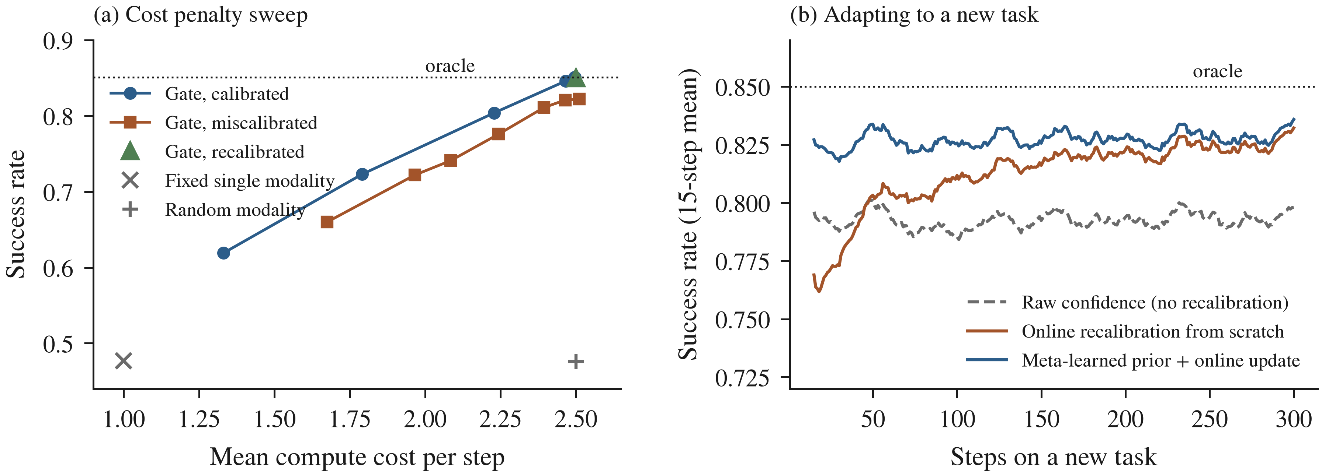
Fig. 6. Illustrative simulation (synthetic data, not robot data). (a) Success rate against mean compute cost for confidence-gated routing among four modalities as the cost penalty $λ$ varies, with calibrated and miscalibrated confidences, recalibration and two baselines; ten seeds of 20,000 steps, standard deviations below 0.005. (b) Success on a new task when the gate uses raw confidences, learns each modality’s calibration offset from scratch, or starts from a prior meta-learned on 50 training tasks; mean of 900 test tasks (three seeds of 300), 15-step moving average.

14.3 Conditional Execution and Cascading
Adaptive computation time learns how many steps to spend per input [177], and conditional computation frames unit activation as an RL policy with a cost penalty [178]. Cascades run a cheap model first and escalate only when needed [90], [176]. Fast–slow anomaly handling does the same for failures [88], and resource-aware reasoning learns when to invoke an LLM at all [87]. For edge orchestration, cascading suggests a default policy: run cheap perception and a fast imitation policy, and escalate to RL refinement or fault recovery only when their calibrated confidences fall below a threshold.

14.4 Load Balancing and Expert Utilization
MoE training suffers from collapse onto a few experts, which auxiliary load-balancing losses counteract [166], [167]. In modality routing, balance is not a goal in itself, because some modalities should be rare. But collapse is still a risk: a modality that is never invoked never generates data, so its confidence is never updated. Exploration bonuses for rarely used modalities, or optimism in the face of uncertainty, address this, following bootstrapped exploration [63].

14.5 The Orchestration Gap
Table 4 and Fig. 4 locate the gap. Uncertainty-aware planners [45], [46] are calibrated but choose between acting and asking, not between learners. Routers [36], [89] are learned and budget-aware but route between LLMs. Adaptive-compute VLAs [174], [175] and adapter routers [121], [151] route inside one model. The unoccupied position is a small orchestrator that is learned online on the device, uses calibrated confidences, respects a compute budget and routes between heterogeneous learning modalities. The novelty lies in this composition, not in any single component, so any system that claims it must show that the composition performs better than its strongest parts used alone.

14.6 Formal Problem Statement
At each decision step t, the agent observes context $x_{t}$ (task, observation embedding, robot health) and calibrated confidences $c_{t}=\left(c_{t}^{1},…,c_{t}^{K}\right)$ from K modalities, where $c_{t}^{k}$ estimates the probability that invoking modality k now succeeds. The orchestrator $π_{θ}$ selects a set $S_{t}⊆\{1,…,K\}$, typically a single modality, incurring cost CSt=k∈St​κk and receiving task reward $r_{t}$. The objective is to maximize expected return subject to an average budget B:
maxθ Et​γtrt s.t. E1Tt​CSt≤B.
This is a constrained Markov decision process. Its Lagrangian relaxation, maximizing Et​γtrt−λCSt with $λ≥0$ updated by dual ascent, gives the cost-penalized gate of Section 14.2. When a routing choice has no effect beyond its step, the problem reduces to a budgeted contextual bandit in which the confidences act as a learned prior over each arm’s success. Three results frame what can be proved. First, if the confidences are calibrated, greedy selection of $arg\max_{k}\left(c_{t}^{k}−λκ_{k}\right)$ is optimal for the one-step penalized objective. Second, if every confidence is within ε of the true success probability, the greedy choice loses at most 2ε of expected success per step relative to that optimum (Appendix A.2). Third, calibration and exploration must be maintained for modalities that are rarely chosen (Section 14.4). Meta-learning enters through θ and the calibration maps: both are trained across a task distribution by (1) and adapted online from replayed tuples $\left(x_{t},c_{t},S_{t},r_{t}\right)$.

15 Low-Cost Platforms, Benchmarks, and Evaluation

15.1 A Reference Low-Cost Platform
Hardware and compute constraints. LeKiwi is an open-source, low-cost mobile manipulator from the LeRobot ecosystem [15], [16]. According to its public documentation, it combines a three-wheel holonomic base with 4-inch omni wheels driven by Feetech servos and an SO-101 arm (SO-100 in earlier versions). A Raspberry Pi 5 is mounted onboard, and power comes from a 12 V battery or a 5 V power-bank variant. In the standard setup, the Pi streams observations to a laptop over ZeroMQ, where policies run. The compute constraint is therefore set by which components run on the Pi and which run on the local laptop.
Sensors. The documented configuration has two USB RGB cameras, one viewing the workspace and one on the wrist, plus joint-position feedback from the servos. There is no depth sensor, which excludes voxel-based policies such as PerAct without additional hardware [96].
Table 7. Documented Configuration of the LeKiwi Reference Platform
Component | Documented configuration
Onboard computer | Raspberry Pi 5 (4 GB in the reference build)
Off-board computer | Laptop receiving observations over ZeroMQ
Base | Three-wheel holonomic drive, 4-in omni wheels, Feetech servos
Arm | SO-101 (SO-100 in earlier builds), with a leader arm for teleoperation
Cameras | Two USB RGB cameras (workspace and wrist)
Power | 12-V battery or 5-V power-bank variant
Software | LeRobot [15], [16]

15.2 Benchmark Tasks and Task Distributions
Established benchmarks provide reference points but not the modality-switching structure that orchestration research needs. LIBERO [35], CALVIN [135], RLBench [136], Meta-World [134] and robomimic [117] are simulated or fixed-arm. The task distribution should therefore be designed so that each modality is the best choice in some situations: novel objects (perception), refinable skills (RL), newly demonstrated behaviors (imitation) and induced faults such as wheel slip, payload change or camera occlusion (fault adaptation).

15.3 Evaluation Protocol
Evaluation best practice for real robots recommends pre-registered protocols, blinded or randomized trial order, reporting of all trials and confidence intervals [179]. Sequential testing can reduce the number of real-robot trials needed to compare two policies by up to 32% [180]. The large-behavior-model study shows how blinded, randomized evaluation is run at scale [181]. With about 50 trials, a success rate of 0.7 has a 95% confidence interval of roughly $±$0.13, so differences between conditions smaller than about 0.2 will not be detectable. The trial plan should be sized with this in mind.
Following recommended practice for real-robot evaluation [179], [180], each experiment should specify:
- Tasks and success criteria, defined before data collection.
- Conditions (orchestrator variants and baselines) and their order, randomized across trials.
- Fault-injection procedure and timing.
- Number of trials per condition, chosen by power analysis or sequential testing.
- Reset procedure and environment variation.
- The logging needed to reproduce routing decisions (confidences, costs, selected modality, outcome).
Recommended ablations. Each component of an orchestration system should be ablated: removing calibration so that the gate uses raw signals; using a single confidence signal instead of four; freezing the orchestrator with no LoRA updates; removing replay or the forgetting penalty; removing the compute budget ($λ$ = 0); replacing the learned gate with hard-coded rules; and removing each modality in turn. Failure cases should be categorized by cause: wrong modality chosen, correct modality failed, calibration drift, or budget exhausted.

15.4 Comparable Low-Cost Mobile Manipulation Systems
Mobile ALOHA [120] and Hello Robot’s Stretch [182] are the closest low-cost mobile manipulators, both with laptop- or PC-class onboard compute. ACT [6] and SmolVLA [103] are the policies native to the LeRobot stack, and Open X-Embodiment supplies cross-embodiment pretraining data [98]. None of these systems orchestrates learning modalities.

16 Answers to the Research Questions
RQ1: modalities and their signals. Four modalities cover the situations a long-lived robot meets: perception, RL, imitation and fault adaptation (Section 4). Each can emit a confidence signal at low cost: epistemic uncertainty from evidential outputs or small ensembles (Section 7.2); policy entropy or critic disagreement (Section 8.2); action spread or density scores for imitation (Section 9.2); and an empirical recovery rate for fault adaptation (Section 10.3). The signals exist in the literature, but 106 of the 166 non-review works expose none, and policy variance is used as a confidence signal by only one (Fig. 4).
RQ2: how the choice is made today. Choice among skills, models or experts is made by frozen LLM planners [9], [68], by conformal help-seeking that chooses between acting and asking [45], [46], by learned routers between LLMs [36], [89], [90] and by gates inside one network [38], [172], [175]. Table 4 shows that no approach satisfies all four requirements of learned, calibrated, budgeted and edge-deployable orchestration, and none arbitrates between more than two heterogeneous learning modalities.
RQ3: signals cheap and calibrated enough to compare. Temperature-scaled or evidential perception, entropy or small critic ensembles for RL, density or reconstruction scores for imitation and Beta-posterior recovery rates are all cheap enough for a Pi-class robot (Table 3). None is calibrated against a shared success variable across modalities, and the simulation shows that this gap costs routing success directly (0.85 against 0.81). Cross-modality calibration is therefore the first problem to solve (Section 17.1).
RQ4: meta-learning and on-device adaptation. The pieces exist: inner updates that need no gradients (RL², posterior inference, prototypes) or only first-order gradients (Reptile), adapters and LoRA updates that fit in small memory [121], [145], memory-light on-device training [159], [160], [162] and replay with random eviction [155]. Real-robot evidence for meta-learned adaptation at Pi-class cost is limited to a single learner [41], and on-device adaptation is evaluated almost only in simulation (19 of 23 works). Meta-learning a calibration prior is a cheap first step (Section 11.5).
RQ5: distance from the target, and how to close it. The evidence stops short of a resource-constrained robot: of 65 real-robot studies, five run on a Pi-class processor and two of these expose a confidence signal; no work reaches deployment (E6); and only 36 of 161 primary studies report compute as a number (Table 2). A claim of learned orchestration should be tested by the protocol of Section 15.3, with ablations that remove calibration, meta-learning, the budget and each modality in turn, and should show that the orchestrated system outperforms its strongest single modality at equal compute.

17 Open Challenges

17.1 Online Calibration Across Modalities
The central open problem is placing four heterogeneous confidence signals on one calibrated scale, and keeping it calibrated as the modalities learn and the robot changes. Conformal prediction gives distribution-free guarantees [45], [138], but its exchangeability assumption is broken by an orchestrator that changes which data each modality sees. Online recalibration with drift detection and evidential fusion [143] are promising directions.

17.2 Training While Acting
LoRA [145] and QLoRA [146] were designed for offline fine-tuning. Updating an orchestrator while it controls a robot raises questions of when to update, how to validate an adapter before deployment, how to avoid forgetting [155], [158], and how to share the CPU with inference [15], [162].

17.3 Safety of Self-Modifying Learners
An orchestrator that retrains itself can learn unsafe routing. Safe learning in robotics [27], [28] offers several protections. Shields synthesized from temporal logic override unsafe actions [34]. The neural simplex architecture switches to a verified controller while the learner retrains [183]. Safety filters provide a unified framework [184], [185]. A practical design keeps a fixed, verified fallback (for example stop and ask) that the orchestrator cannot unlearn, and validates new adapters before swapping them in.

17.4 Generalization Beyond the Task Distribution
Meta-learned orchestrators generalize only within their training distribution [134]. Novelty detection [58], [64] and help-seeking [45], [46] are the safeguards when the robot leaves that distribution.

17.5 Human-Model Uncertainty as an Orchestration Signal
Many of the orchestrator’s decisions involve a person: whether to ask for help, which question to ask, whether to hand over control and how far the person’s answer can be trusted [42], [45], [46]. The four signals of the framework describe the robot’s learners, not the person. Human answers depend on the order and framing of questions, and trust changes with experience in ways that classical probability models capture poorly; quantum-like models of judgement represent these effects explicitly and are reviewed in the companion survey [19]. The companion paper [17] develops an order-aware human model with classical baselines and tests, in simulation, whether it predicts held-out answers and improves the robot’s choice of questions; its predictive uncertainty is the fifth, dashed input of Fig. 1. Whether such a signal improves orchestration with real people is untested.

17.6 Integration With Higher-Level Planning
The orchestrator sits below task planning. Integrating it with LLM planners [9], [68], so that the planner’s subgoals condition modality selection and routing failures inform replanning, is a natural extension. Resource-aware reasoning shows that the decision of when to plan can itself be learned [87].

18 Conclusion
This systematic review of 180 works asked whether the literature supports a meta-learned orchestrator that lets a resource-constrained robot choose among perception, reinforcement learning, imitation and fault adaptation on calibrated confidence and within a compute budget. It does so only in parts. Calibrated and epistemic confidence signals, conformal help-seeking, budget-aware routers, gates inside policies, meta-learned adaptation and memory-light on-device training all exist. Their combination does not: no included work arbitrates between more than two heterogeneous learning modalities with a learned, calibrated and budgeted gate, and the real-robot evidence rarely reaches edge processors (five of 65 studies) or exposes a confidence signal.
The review frames orchestration as a constrained Markov decision process solved by a meta-learner (Sections 11.3 and 14.6). This framing unifies mixture of experts, cascades and meta-reinforcement learning, and it identifies the parts that must run on the robot: cheap confidence signals, calibration maps and an inner update that needs few or no gradients. The illustrative simulation shows that routing inherits every calibration error and that a calibration prior meta-learned across tasks shortens the period in which those errors occur.
The final conclusion is therefore conditional. Meta-learning orchestration on a resource-constrained robot is supported in principle by the components reviewed and is plausible with small models and careful calibration, but it has not been demonstrated. The decisive test is a real-robot study, run under the protocol of Section 15.3, showing that the orchestrated system outperforms its strongest single modality at equal compute. The main risks lie in cross-modality calibration drift and in the safety of a learner that modifies itself.

Data Availability
The extraction table, quality appraisal, study summaries, codebook, hand-coding files and search strategy are available at [FILL: Zenodo DOI]. The simulation code is provided as supplementary material.

Acknowledgment
[FILL: acknowledgments and funding, or delete this section]

Appendix A. Mathematical Details

A.1 Budgeted Routing as a Constrained MDP
With state s$​_{t}$ = (x$​_{t}$, c$​_{t}$, b$​_{t}$), where b$​_{t}$ is the remaining budget, action S$​_{t}$, reward r$​_{t}$ and cost C(S$​_{t}$), the Lagrangian L($θ$, $λ$) = E[$Σ$$​_{t}$ $γ$$​^{t}$ (r$​_{t}$ $−$ $λ$ C(S$​_{t}$))] + $λ$B is maximized over $θ$ and minimized over $λ$ $≥$ 0. A practical algorithm alternates policy-gradient updates of $θ$ (for example PPO [4]) with the dual update $λ$ ← max(0, $λ$ + $η$ (Ĉ $−$ B)).

A.2 One-Step Optimality Under Calibration
If c$​^{k}$ = P(success | k, x) exactly, the expected penalized reward of choosing k is c$​^{k}$ $−$ $λ$ cost$​_{k}$, so argmax$​_{k}$ (c$​^{k}$ $−$ $λ$ cost$​_{k}$) is optimal for the one-step objective. If each reported confidence differs from the truth by at most $ε$, the chosen arm’s true value is within 2$ε$ of the optimum. This bound motivates the calibration step.

A.3 Calibration Maps
Temperature scaling divides logits by T fitted by maximum likelihood on held-out data [57]. Platt scaling fits $σ$(a$⋅$s + b) to a raw score s [113]. The simulation fits a linear map from reported confidence to observed success per modality. Split conformal prediction chooses the threshold $\hat{q}$ as the $⌈$(n+1)(1$−$$α$)$⌉$/n quantile of calibration scores, which gives coverage of at least 1$−$$α$ under exchangeability [45].

A.4 Recovery-Success Posterior
With a Beta($α$$​_{0}$, $β$$​_{0}$) prior and s successes in n recovery attempts for a fault class, the posterior mean ($α$$​_{0}$ + s)/($α$$​_{0}$ + $β$$​_{0}$ + n) is the fault modality’s confidence, and its variance measures how much that confidence can be trusted.

A.5 A Candidate Orchestrator Update Algorithm
- Observe x$​_{t}$; query the calibrated confidences c$​_{t}$ from the four modalities (cheap signals every step, expensive ones on demand).
- Select S$​_{t}$ = argmax$​_{k}$ $π_θ$(k | x$​_{t}$, c$​_{t}$, b$​_{t}$), subject to the fallback shield (Section 17.3).
- Execute; record (x$​_{t}$, c$​_{t}$, S$​_{t}$, r$​_{t}$, outcome) in the replay buffer.
- Periodically, in the background: recalibrate each modality’s confidence map on recent outcomes; update the LoRA adapter of $π_θ$ on prioritized replay [154] with a forgetting penalty [158]; validate the new adapter on held-out episodes before swapping it in; update $λ$ by dual ascent.

Appendix B. Illustrative Routing Simulation: Full Results
Table B1 reports the first part of the illustrative simulation of Section 14.2 and Table B2 the second part (Section 11.5). The data are synthetic; no robot experiments were run for this review. The simulation code is provided as supplementary material.
Table B1. Illustrative Routing Simulation: Success Rate and Mean Compute Cost ($λ$ = 0.05), Mean $±$ SD Over 10 Seeds of 20 000 Steps (Synthetic Data)
Policy | Success rate | Mean cost per step
Oracle (true success prob.) | 0.851 $±$ 0.003 | 2.5
Invoke all four | 0.959 $±$ 0.001 | 10.0
Fixed single modality | 0.477 $±$ 0.005 | 1.0
Random modality | 0.476 $±$ 0.004 | 2.5
Gate on calibrated confidence | 0.851 $±$ 0.003 | 2.5
Gate on miscalibrated confidence | 0.811 $±$ 0.004 | 2.4
Gate on recalibrated confidence | 0.850 $±$ 0.003 | 2.5
Sweep of the cost penalty $λ$ (success rate, mean cost), calibrated gate: $λ$ = 0: 0.851, 2.50; $λ$ = 0.02: 0.851, 2.50; $λ$ = 0.05: 0.851, 2.50; $λ$ = 0.1: 0.846, 2.47; $λ$ = 0.15: 0.804, 2.23; $λ$ = 0.2: 0.723, 1.79; $λ$ = 0.3: 0.619, 1.33. Miscalibrated gate: $λ$ = 0: 0.822, 2.51; $λ$ = 0.02: 0.821, 2.46; $λ$ = 0.05: 0.811, 2.39; $λ$ = 0.1: 0.776, 2.24; $λ$ = 0.15: 0.741, 2.08; $λ$ = 0.2: 0.722, 1.97; $λ$ = 0.3: 0.660, 1.68.
Meta-learned calibration. In each task, the confidence of modality k is the true success probability plus an offset $b_{k}∼N\left(μ_{k},{0.10}^{2}\right)$, with µ = (0,0.30,0.25,0.05), plus noise of standard deviation 0.08; situation frequencies vary by task. The gate selects $arg\max_{k}\left(c^{k}−{\hat{b}}_{k}−0.05 κ_{k}\right)$ with 5% random exploration and updates ${\hat{b}}_{k}$ as the running mean of $c^{k}−y$ over its own choices, shrunk toward a prior mean with n₀ pseudo-observations. From scratch, the prior mean is zero and n₀ = 1; the meta-learned prior is estimated from 50 training tasks of 400 logged steps each, by empirical Bayes ($\hat{μ}=\left(0.01,0.27,0.22,0.03\right)$, n₀ between 30 and 47). Table B2 gives the mean success over 900 new tasks of 300 steps.
Table B2. Meta-Learned Calibration: Mean Success Rate on New Tasks by Phase (Synthetic Data; 900 Tasks; Oracle 0.850)
Gate | Steps 1–25 | 26–100 | 101–300
Raw confidence | 0.793 | 0.791 | 0.793
Recalibration from scratch | 0.770 | 0.802 | 0.821
Meta-learned prior + update | 0.823 | 0.826 | 0.828

References
[Insert the Mendeley bibliography here: Mendeley Cite > Insert Bibliography]

