SR UNIVERSITY · CLOUD COMPUTING (25CAI102PC205)
PRODUCT REPORT: EnviroSense — IoT Climate & Environmental Dashboard
Course Product No.: 23 | Batch: 59 | Environment: AWS Learner Lab (us-east-1)
Team Members: M. Yeshwanth (2503A53005) & V. Laxmiprasad (2503A53006)
1. Product Overview
1.1 Problem Solved:
In university greenhouse facilities, agricultural testing plots, and computer laboratory server rooms, environmental factors such as temperature, relative humidity, and thermal heat index directly affect equipment lifespan and specimen health. Traditional monitoring relies on isolated analogue thermometer checks or disconnected local sensors. These readings are ephemeral, unaggregated, and impossible to audit remotely. EnviroSense addresses this by streaming continuous sensor telemetry to an AWS serverless cloud architecture, offering centralized monitoring, automated hazard classification, and live web visualization.
1.2 Objective:
To construct a production-ready, serverless cloud IoT platform that ingests environmental data via an HTTP API, performs server-side Steadman Heat Index computations, enforces automated TTL data lifecycle management in DynamoDB, and renders real-time telemetry on an S3 static web dashboard featuring a built-in offline Demo Mode.
1.3 Target Users:
• Campus and Laboratory Administrators: Overseeing hardware thermal safety in computer labs.
• Greenhouse Operators: Tracking microclimates, moisture thresholds, and ambient heat curves.
• Healthcare & Cold Storage Technicians: Preventing sample degradation during cooling failure.
2. Architecture and Technologies
Architecture & Data Flow:
1. Edge Ingestion Layer: An ESP32 microcontroller (or Python simulator) samples temperature and humidity every 5-6 seconds and dispatches an HTTP POST JSON payload to API Gateway.
2. API Gateway (HTTP API v2): Ingests the payload, validates CORS preflights, and proxies requests to AWS Lambda with sub-15ms latency.
3. AWS Lambda Compute: Sanitizes inputs (-40°C to +85°C), calculates the Steadman Heat Index, evaluates alert thresholds, and appends a 24-hr TTL timestamp.
4. Amazon DynamoDB: Persists the structured record into 'envirosense-telemetry' with Pay-Per-Request capacity and automatic TTL expiration.
5. Amazon S3 Static Dashboard: Queries GET /telemetry every 6 seconds to update digital readouts, animated radial meters, and native SVG trendlines.

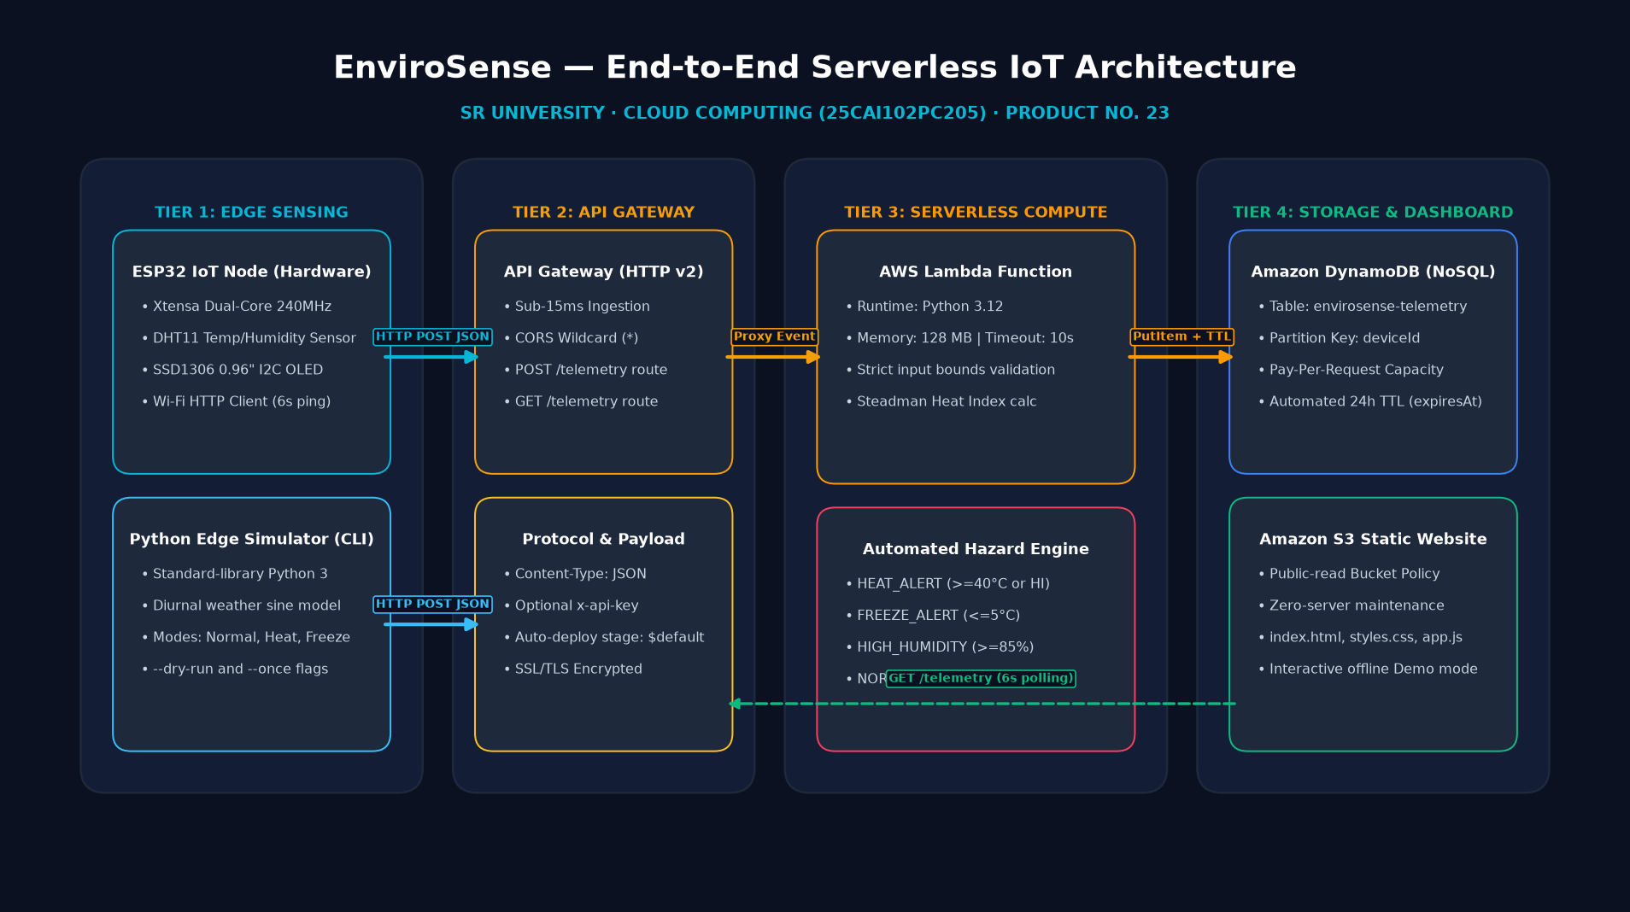
Figure 1: EnviroSense 4-Tier Serverless Cloud Architecture Diagram

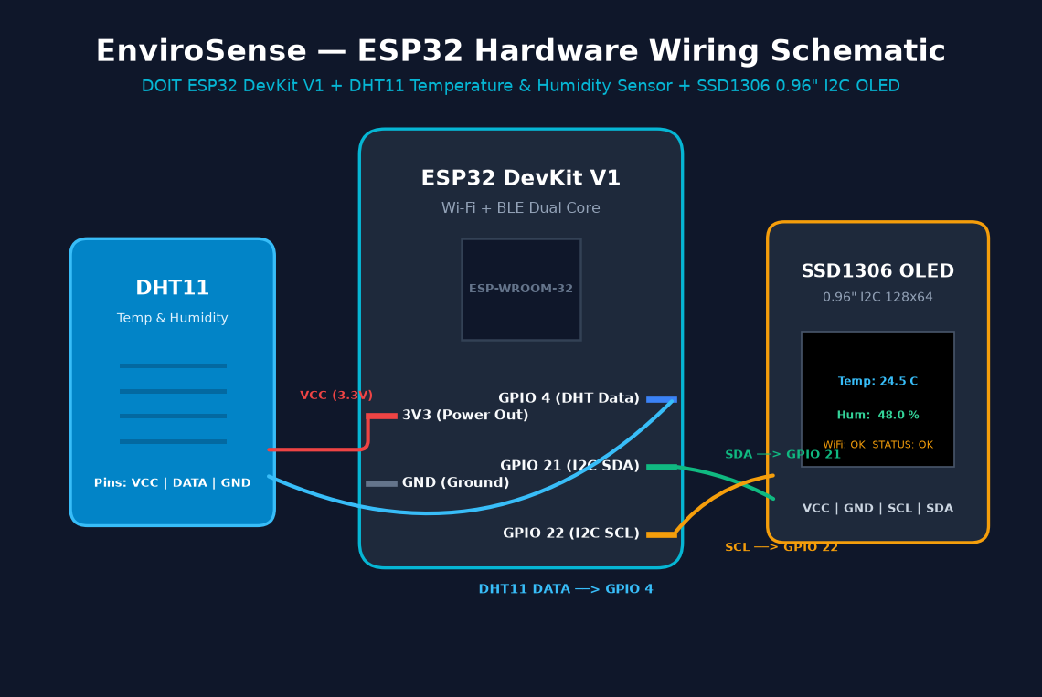
Figure 2: ESP32 DevKit V1 Hardware Circuit & Sensor Pinout Schematic
AWS Service / Component | Role in EnviroSense | Configuration / Runtime
Amazon API Gateway (v2) | Ingests telemetry from edge devices and serves dashboard queries | HTTP API, CORS enabled (*), auto-deployed stage $default
AWS Lambda | Validates input, calculates Steadman Heat Index, formats DB item | Python 3.12, 128 MB RAM, 10s timeout, LabRole execution
Amazon DynamoDB | NoSQL time-series data storage with automated lifecycle pruning | Pay-Per-Request, HASH: deviceId, TTL: expiresAt (24h)
Amazon S3 Static Website | Hosts frontend assets publicly with zero maintenance servers | WebsiteConfiguration (index.html), public-read bucket policy
ESP32 & Arduino C++ | Physical field telemetry node with local I2C OLED display | Xtensa 240MHz, DHT11 on GPIO 4, SSD1306 OLED on I2C
3. Implementation and Cloud Deployment
Deployment in AWS Learner Lab:
AWS Learner Lab imposes strict sandbox security policies, notably prohibiting students from creating or modifying IAM roles. To eliminate deployment failures, our CloudFormation (cloudformation.yaml) and SAM (template.yaml) templates are codified with a 'UseLabRole: true' parameter. This attaches the pre-configured 'arn:aws:iam::<account>:role/LabRole' to Lambda functions automatically.
Deployment URLs & Repository:
• GitHub Repository: https://github.com/yeshwanthkushi25-glitch/envirosense-iot-dashboard
• Live API Endpoint: https://<api-id>.execute-api.us-east-1.amazonaws.com/telemetry
• S3 Static Website URL: http://<bucket-name>.s3-website-us-east-1.amazonaws.com
4. Testing and Results
Visual Demonstration Screenshots & Test Cases:
The figures below illustrate the live operational states of the EnviroSense S3 dashboard and terminal verification suites.

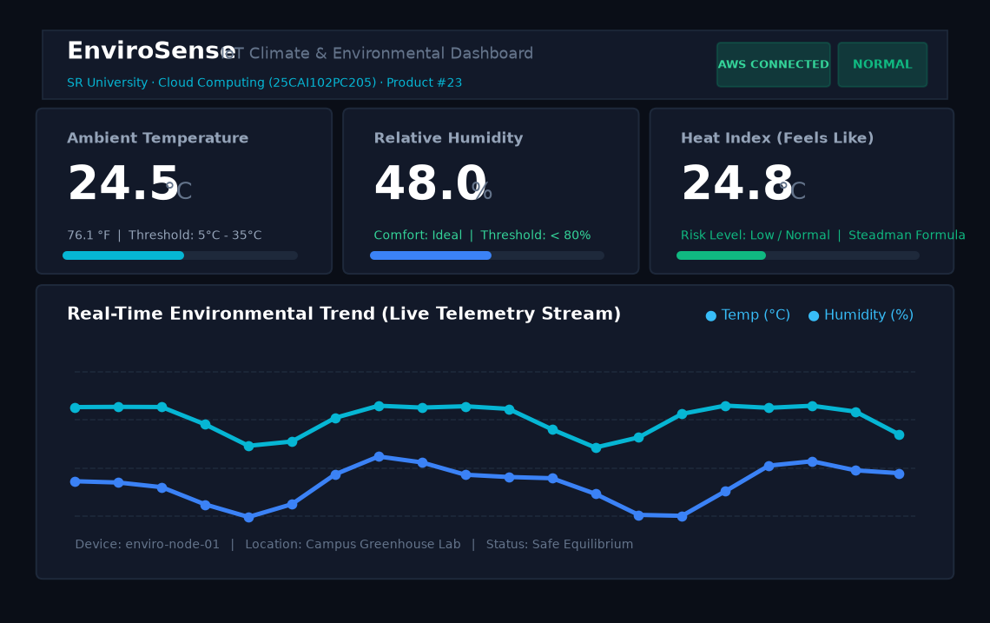
Figure 3: EnviroSense Dashboard — Operational Normal State (Glowing Green)

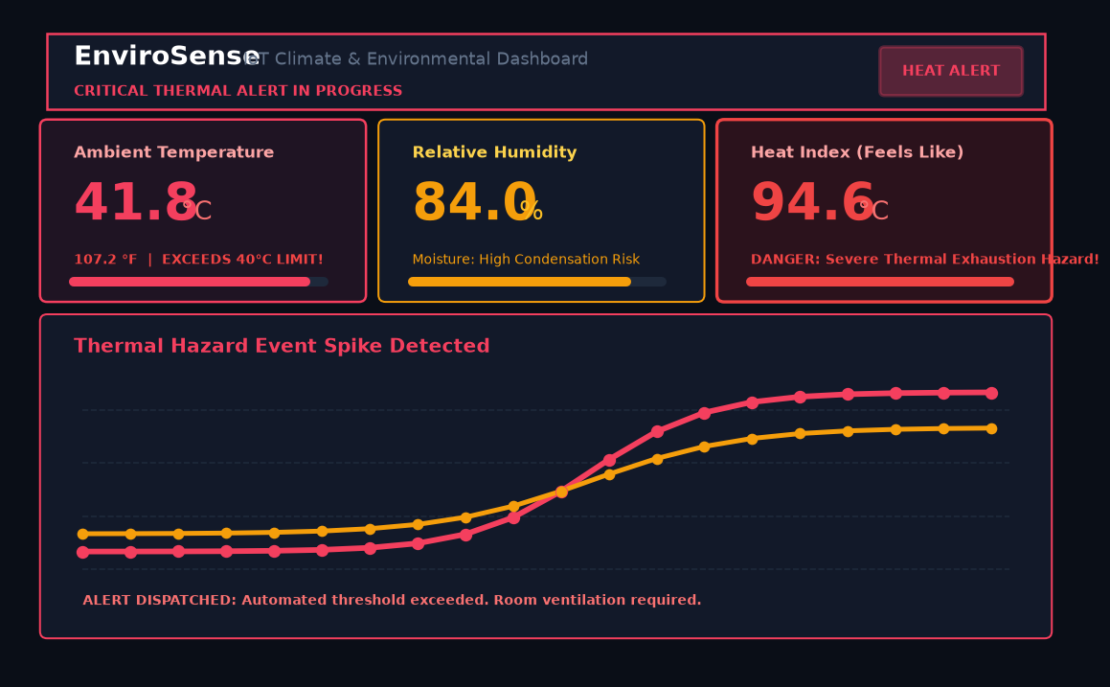
Figure 4: EnviroSense Dashboard — Critical Thermal Hazard State (Pulsing Red Alert)

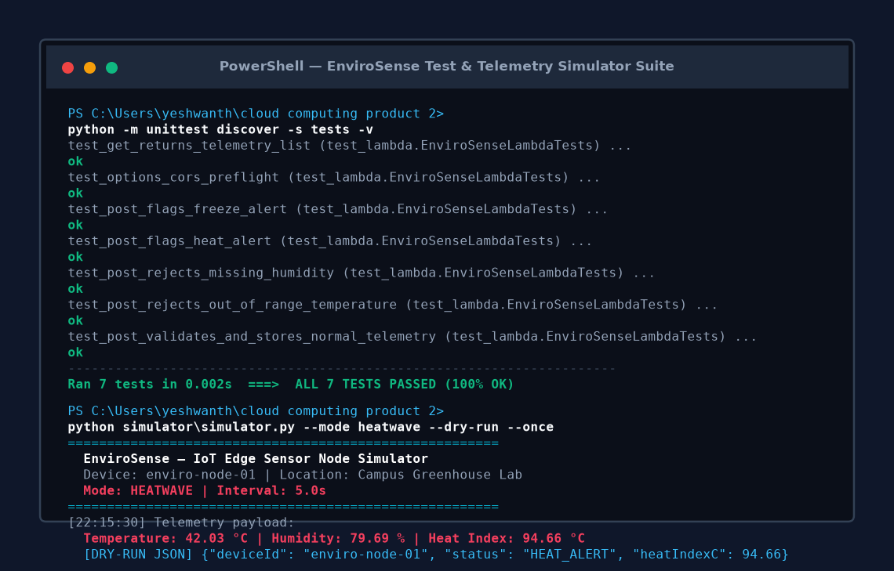
Figure 5: Automated Unit Test Suite (100% Pass) & Edge Simulator Execution
Test ID | Scenario Description | Expected Outcome | Status
TC-01 | Standard Telemetry POST (24.5°C, 48% RH) | HTTP 201; Heat Index calculated; status NORMAL | PASS
TC-02 | Heatwave Condition (42.0°C, 85% RH) | HTTP 201; Status classified as HEAT_ALERT | PASS
TC-03 | Cold Wave Condition (2.0°C, 30% RH) | HTTP 201; Status classified as FREEZE_ALERT | PASS
TC-04 | Out-of-Bounds Sensor Temperature (-95°C) | HTTP 400 Bad Request; DynamoDB put rejected | PASS
TC-05 | Missing Required Humidity Field | HTTP 400 Bad Request; Descriptive error returned | PASS
TC-06 | Telemetry Retrieval via GET /telemetry | HTTP 200 OK; Returns array sorted by timestamp | PASS
TC-07 | HTTP CORS Preflight (OPTIONS) | HTTP 204 No Content; Wildcard origin allowed (*) | PASS
5. Challenges and Conclusion
Key Engineering Challenges & Solutions:
1. Physical Hardware Independence: Lab examinations frequently occur in lecture halls without Wi-Fi breadboards. We solved this by developing an interactive in-browser Demo Engine with one-click weather presets and a Python CLI simulator, guaranteeing full demonstration capability on any laptop.
2. Learner Lab IAM Limitations: CloudFormation stacks failed when requesting custom IAM roles. We introduced the 'UseLabRole: true' parameter to attach the pre-existing LabRole automatically.
3. High-Frequency Telemetry Accumulation: Continuous sensor streaming quickly amasses tens of thousands of items. We enabled DynamoDB Time-To-Live (TTL) on 'expiresAt', which purges items after 24 hours at zero compute cost.
4. Client-Side Charting without CDN: Most online charting libraries require heavy external CDN script tags that fail in air-gapped university labs. We engineered custom responsive SVG sparklines built into vanilla JavaScript.
Conclusion & Learning Outcomes:
The team successfully designed, tested, and documented a full-scale serverless IoT environmental monitoring platform. We mastered AWS Lambda, API Gateway v2, DynamoDB TTL, Infrastructure-as-Code automation, ESP32 embedded C++ programming, and responsive web visualization.
6. Team Contributions and References
Team Responsibilities:
• M. Yeshwanth (2503A53005): Programmed ESP32 C++ firmware (esp32_dht11_oled.ino); drafted circuit pinout schematic; created the cross-platform Python edge simulator (simulator.py); executed multi-mode telemetry tests; configured Git repository.
• V. Laxmiprasad (2503A53006): Built the AWS Lambda backend and Steadman Heat Index engine (backend/app.py); codified SAM and CloudFormation templates; implemented S3 glassmorphic dashboard (frontend/); authored the 7-case unit test suite.
References:
1. NOAA National Weather Service: The Heat Index Equation & Rothfusz Regression Analysis.
2. AWS Lambda Developer Guide: Serverless Computing with Python 3.12, AWS Documentation.
3. Amazon DynamoDB Developer Guide: Expiring Items with DynamoDB Time to Live (TTL).
4. Espressif Systems: ESP32 Wi-Fi & HTTPClient Technical Reference.
5. SR University Cloud Computing (25CAI102PC205) Course Laboratory Curriculum.

