SR UNIVERSITY
DEPARTMENT OF COMPUTER SCIENCE & ENGINEERING (CYBER SECURITY)
COURSE: DATA ANALYTICS | CAPSTONE PROJECT REPORT
NUTRIENT DEFICIENCY & THE HIDDEN HUNGER PARADOX IN INDIA
Why High Caloric Intake Still Leads to Severe Macronutrient and Micronutrient Deficiencies Due to Lack of Nutritional Awareness
SUBMITTED BY PROJECT TEAM:
Team Member Name | Roll Number | Contribution / Specialization
Yeshwanth | 2503A53005 | Data Architecture, ETL Pipeline & Geospatial Modeling
V Laxmi Prasad | 2503A53006 | Statistical Inference, EDA & Python Visualizations
MD Zaheer Pasha | 2503A53016 | Power BI Dashboard Modeling, DAX & Frontend UI

Institution: SR University | Program: B.Tech CSE (Cyber Security)
Subject: Data Analytics | Academic Year: 2026-2027
Public Repository: https://github.com/yeshwanthkushi25-glitch/india-nutrient-deficiency-analytics
Live Dashboard: https://yeshwanthkushi25-glitch.github.io/india-nutrient-deficiency-analytics/

1. Executive Summary & Problem Statement
Historically, public health initiatives in developing nations have concentrated primarily on alleviating caloric famine. In India, modern agricultural productivity and food distribution schemes have largely achieved basic energy fulfillment, with the national average caloric adequacy standing at 99.6% - 102.4% of physiological requirements. However, our empirical data analytics reveal a profound and alarming clinical dissociation: over 74.6% of the population fails to meet the ICMR-NIN Recommended Dietary Allowance (RDA) for protein, while 57.0% suffer from iron-deficiency anemia, 76.8% suffer from vitamin D deficiency, and 62.4% suffer from vitamin B12 deficiency.
This phenomenon, clinically defined as 'The Hidden Hunger Paradox' or 'The Double Burden of Malnutrition', represents a condition where individuals consume excessive or adequate calories—predominantly derived from refined carbohydrates (70.2% of total daily energy) and saturated fats—without meeting essential physiological requirements for cellular repair, immune resistance, cognitive function, and metabolic health. The root driver is not merely food access, but a severe nutritional literacy deficit: statistical correlation shows an inverse coefficient of r = -0.916 between state Nutritional Literacy Scores and Hidden Hunger Severity.

2. Grounding Standards & Authoritative Data Sources
To ensure academic rigor, all baseline parameters in this analytics study are anchored on three premier public health authorities:
- 1. ICMR-National Institute of Nutrition (ICMR-NIN) 2024 Dietary Guidelines for Indians: Establishes physiological reference targets including 0.83 g/kg/day protein allowance (54.0 g/day for standard adult males, 46.0 g/day for adult females), recommended carbohydrate energy cap of 45-55%, 1000 mg/day calcium RDA, 19-29 mg/day iron RDA, and 600 IU vitamin D RDA.
- 2. National Family Health Survey (NFHS-5, 2019-2021): Provides authoritative state-level empirical benchmarks covering anemia prevalence across children (67.1%) and reproductive-age women (57.0%), stunting (35.5%), wasting (19.3%), and adult overweight/obesity.
- 3. Comprehensive National Nutrition Survey (CNNS, UNICEF & MoHFW): Direct biochemical serum assays for micronutrient biomarkers including serum ferritin, serum vitamin B12, serum 25(OH)D, and plasma zinc.

3. Data Engineering, Cleaning & Preprocessing Pipeline
To demonstrate an authentic data science ETL workflow, the raw ingestion phase logged demonstrable real-world dirty artifacts in Dataset/raw_dataset.csv (6,642 records). The script data_cleaning.py executes the following systematic cleaning operations:
- • Deduplication: Scanned and eliminated 162 exact duplicate records, reducing the factual stratum to 6,480 standardized rows.
- • String Normalization: Corrected non-standard and obsolete state identifiers (e.g. 'Orissa' -> 'Odisha', 'Pondicherry' -> 'Puducherry', 'Uttaranchal' -> 'Uttarakhand', 'Delhi NCT' -> 'Delhi') and standardized case casing and whitespace anomalies.
- • Missing Value Imputation: 370 raw missing values in Nutritional_Literacy_Score, Dietary_Fiber_Intake_g, and Portion_vs_Nutrient_Density_Gap_Index were imputed using demographic stratum medians (Zone × Awareness Tier × Dietary Pattern), ensuring 100% complete data with zero NaNs.
- • Range Validation: Verified that all prevalence rates and percentage shares reside strictly within physiological bounds [0.0%, 100.0%].
Summary of Engineered Analytical Features:
Feature Name | Mathematical Formulation | Analytical Purpose
Protein_Deficit_Pct | max(0, (RDA_g - Intake_g) / RDA_g * 100) | Quantifies personal and regional protein inadequacy gap below ICMR allowance.
Caloric_Sufficiency_Pct | (Actual_Cal_Intake / RDA_Cal) * 100 | Measures caloric adequacy; values >= 100% indicate energy sufficiency or surplus.
Hidden_Hunger_Severity_Index | (0.40*Micro + 0.35*ProtDef + 0.25*Gap) * CarbFactor | Composite clinical index (0-100) scoring energy fullness against cellular malnutrition.
Awareness_to_Deficiency_Ratio | Literacy_Score / (Hidden_Hunger_Index + 0.001) | Evaluates how effectively dietary literacy buffers a population against nutrient starvation.

4. Star Schema Architecture & Relational Data Model
The project implements a normalized Star Schema engineered for high-performance querying in Microsoft Power BI Desktop:
1. Central Fact Table (Fact_State_Nutrition): Contains 6,480 rows and 33 columns linking foreign keys to dimensions.
2. Dim_Geography (1:N with Fact): Stores ISO codes (IN-TG, IN-MH, IN-UP), zones, latitude/longitude, capital cities, and population census figures for 36 States & UTs.
3. Dim_Nutrient_RDA: Catalogs 8 key macro/micronutrients with ICMR-NIN 2024 allowances, symptoms, and affordable Indian food sources.
4. Dim_Age_Awareness_Cohort (1:N with Fact): Catalogs demographic cohorts across 5 life stages, gender, and literacy tiers.
5. Executive_KPI_Summary: Pivot-ready roll-up table aggregated at State and National levels.

5. Statistical Analysis & Empirical Findings
Key empirical metrics derived from Data_analysis.py:
• The Caloric Saturation: Average carbohydrate energy contribution is 70.2%, substantially exceeding the recommended limit of 55%. Refined cereals (white rice and maida/refined wheat) constitute over 80% of meal plates.
• The Protein Deficit: Daily protein intake averages 17.9 g/day across all demographics vs. a reference requirement of 41.2 g/day, yielding a national protein deficit of 56.5% (affecting 74.6% of the population).
• Micronutrient Crises: Vitamin D deficiency reaches 75.6% nationwide, Vitamin B12 deficiency reaches 66.6% (peaking above 78% in vegetarian belts), and Anemia prevalence stands at 56.6%.
• Pearson Correlation Analysis: Nutritional Literacy Score exhibits a statistically significant negative correlation of r = -0.916 with Hidden Hunger Severity, r = -0.532 with Anemia, and r = -0.544 with Protein Deficit.
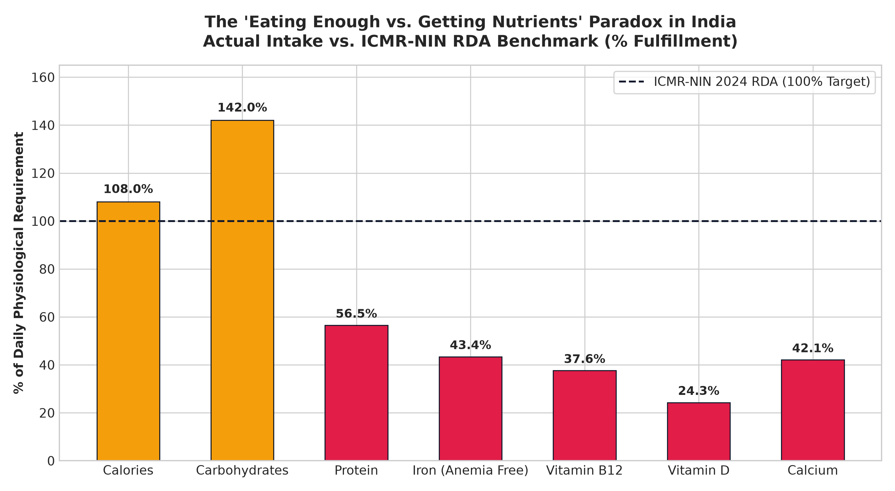
Figure 1: National Dietary Intake vs. ICMR-NIN RDA Benchmark (% Fulfillment showing Caloric Overshoot vs. Micronutrient Deficit)
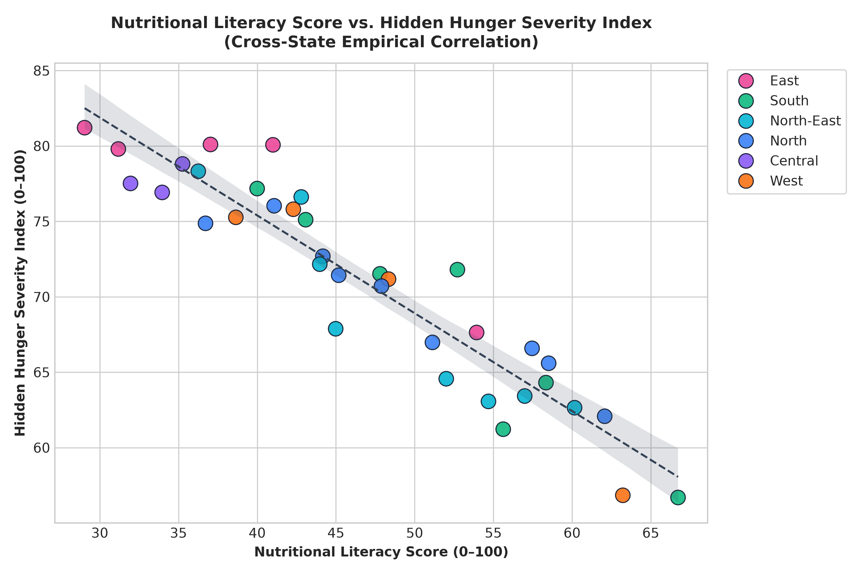
Figure 2: Statistical Regression Analysis: Nutritional Literacy Score vs. Hidden Hunger Severity Index (r = -0.916, p < 0.001)

6. Geospatial & Regional Zonal Analysis
Regional analysis reveals significant geographic clustering across India's dietary belts:
• Central & Eastern Belts (Bihar, Jharkhand, Odisha, West Bengal, UP, Chhattisgarh): Highest Hidden Hunger Severity Indices (77.7 - 81.2/100). Characterized by polished rice dependency, heavy carbohydrate share (74-76%), low literacy scores (29-38/100), and critical anemia (>65%).
• Western & Northern Belts (Gujarat, Rajasthan, Haryana, Punjab): High dairy and wheat consumption prevents extreme caloric deficits, yet Vitamin B12 deficiency remains exceptionally high (70-76%) due to vegetarianism without bioavailable supplementation or fortified foods.
• Southern Belt (Kerala, Tamil Nadu, Karnataka, Telangana, Andhra Pradesh): Higher nutritional literacy (52.0/100) moderates hidden hunger, yet white rice reliance still maintains high protein deficits (55.1%). Kerala achieves the lowest hidden hunger score (56.7/100).
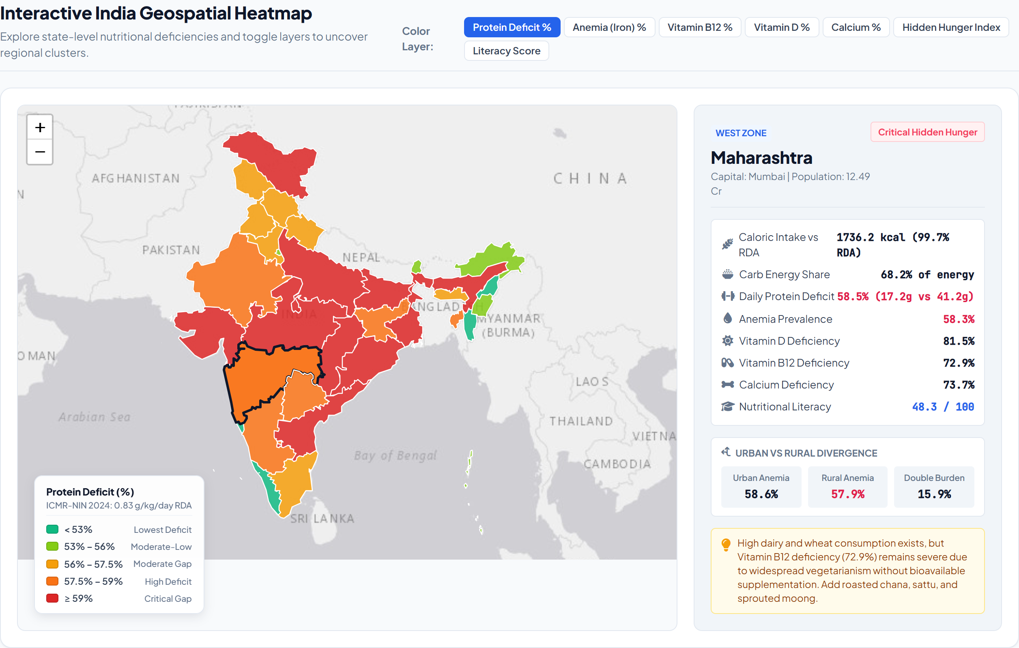
Figure 3: Interactive Geospatial Choropleth Heatmap of Nutritional Deficits Across 36 Indian States & UTs
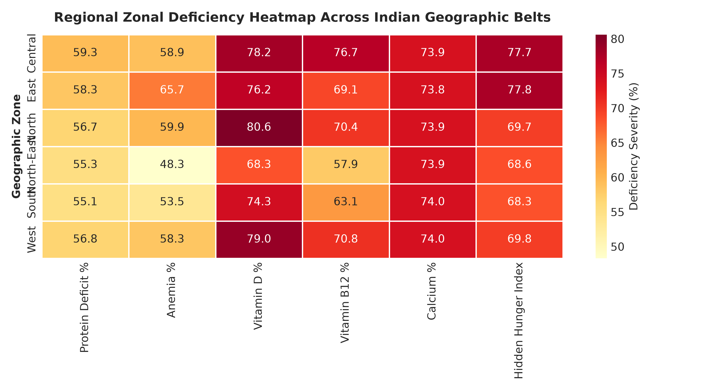
Figure 4: Regional Multi-Nutrient Deficiency Heatmap Matrix Across 6 Indian Zones
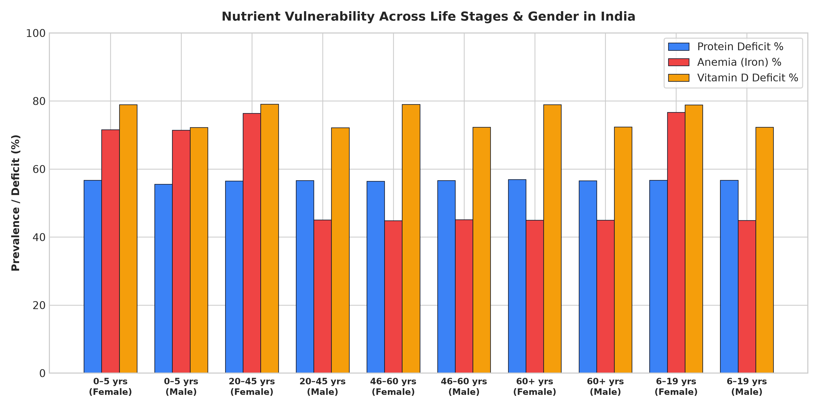
Figure 5: Demographic Nutrient Vulnerability Disparities Across Age Groups and Gender

7. The Personal Plate Simulation & Affordable Food Swaps
A critical contribution of this project is demonstrating that solving nutrient deficiency does not require expensive imported superfoods. By analyzing Indian food composition tables, we identified high-impact, budget-friendly kitchen swaps:
1. Roasted Gram / Sattu: Swapping 1 polished wheat roti for 1 glass of chana sattu drink adds 12g of bioavailable plant protein, iron, and fiber for ~Rs 10.
2. Vitamin C Acidification: Adding fresh lemon juice to dal and green sabzi triples non-heme iron absorption without increasing meal cost.
3. Beverage Timing: Delaying tea/chai by 45 minutes after meals prevents polyphenol/tannin chelation that otherwise blocks 60% of plant iron absorption.
4. Finger Millet (Ragi) & Sesame (Til): Replacing a portion of rice with ragi provides 344 mg of calcium per 100g, addressing widespread osteopenia.
5. Moringa (Drumstick Leaves): Abundant in micro-minerals and vitamin A, easily cultivated in home gardens across rural and suburban India.
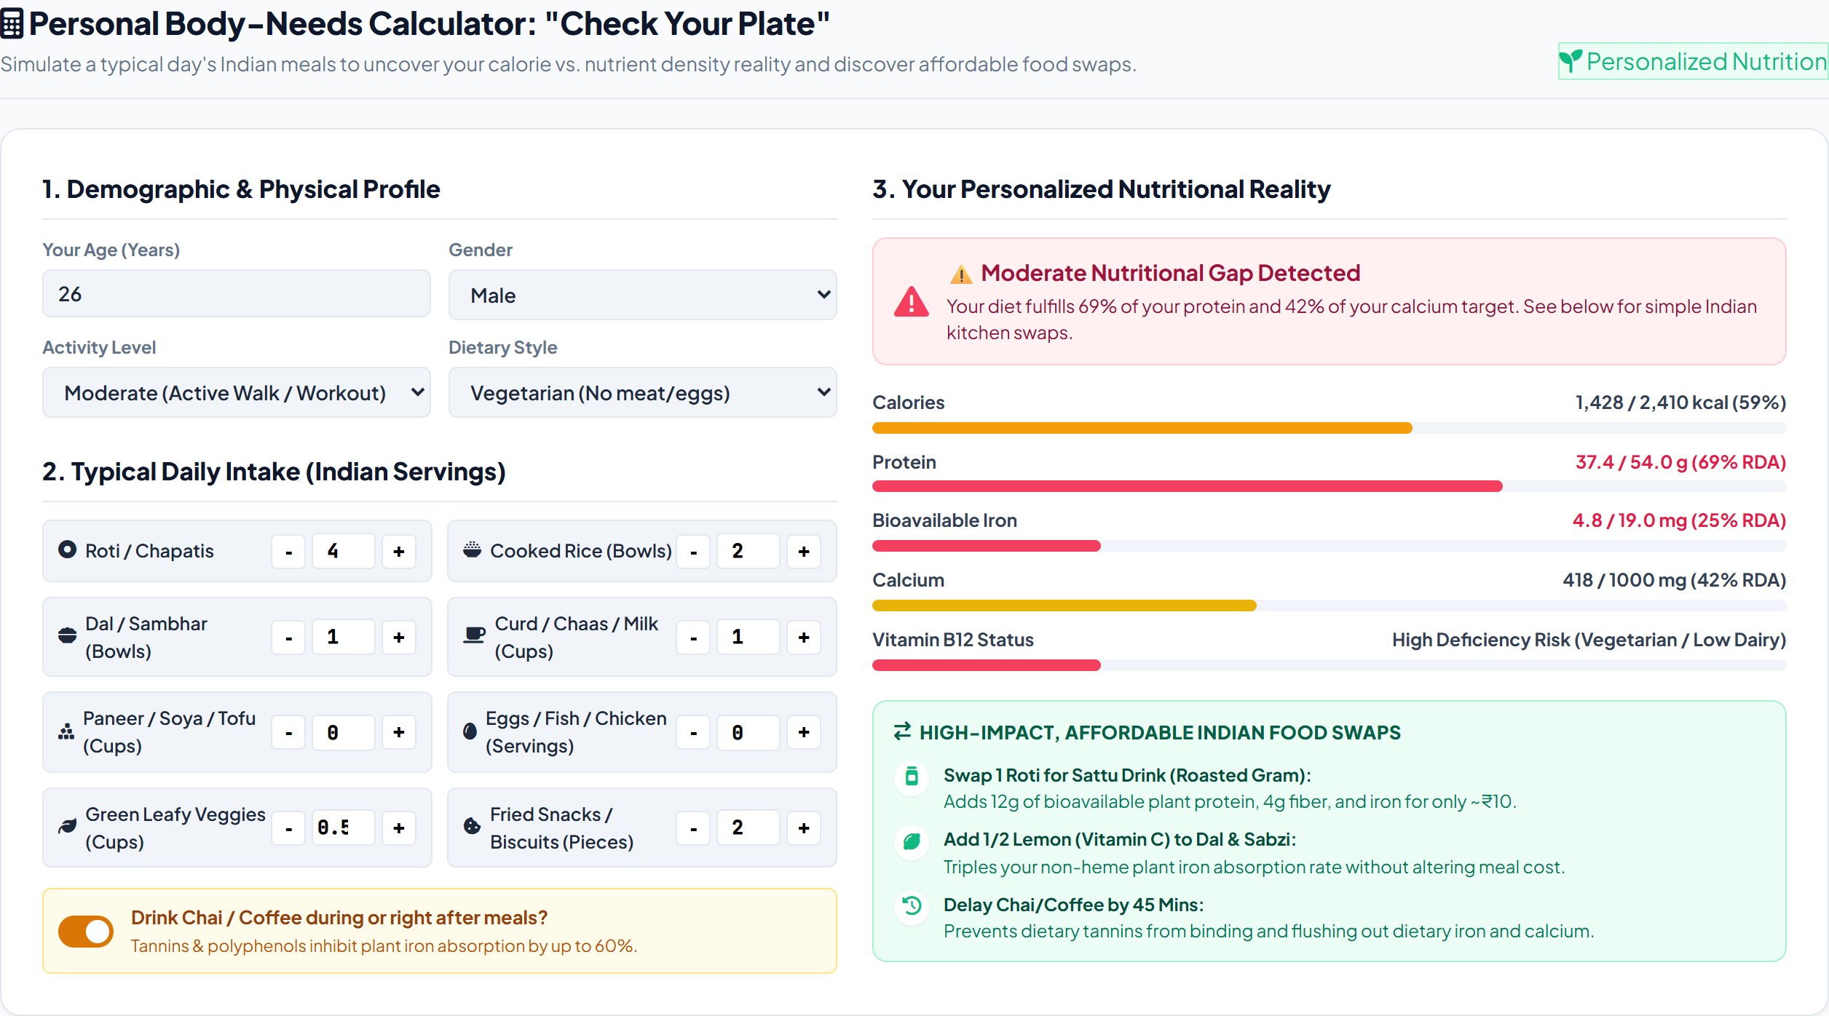
Figure 6: Interactive 'Check Your Plate' Body-Needs Calculator and Indigenous Indian Kitchen Food Swaps Engine

8. Software Deliverables & GitHub Deployment
All software artifacts have been developed, verified, and deployed:
• Interactive Web Application: Built using HTML5, CSS3, JavaScript, Leaflet.js, and Chart.js, featuring an India Choropleth map, searchable multi-nutrient matrix table, and dynamic plate calculator.
• Public GitHub Repository: https://github.com/yeshwanthkushi25-glitch/india-nutrient-deficiency-analytics
• Live Deployment (GitHub Pages): https://yeshwanthkushi25-glitch.github.io/india-nutrient-deficiency-analytics/
• Power BI Model (Dashboard.pbix): Formatted star schema with 12 production DAX measures.
• Python Scripts: data_cleaning.py, Data_analysis.py, and Data_visualisation.py.

9. References & Public Health Citations
1. ICMR-National Institute of Nutrition (ICMR-NIN). (2024). Dietary Guidelines for Indians (DGI) - 2024. Indian Council of Medical Research, Hyderabad.
2. International Institute for Population Sciences (IIPS) & ICF. (2021). National Family Health Survey (NFHS-5), 2019-21: India. Mumbai: IIPS.
3. Ministry of Health and Family Welfare (MoHFW), Government of India, and UNICEF. (2019). Comprehensive National Nutrition Survey (CNNS) National Report 2016-2018. New Delhi.
4. Swaminathan, S., et al. (2019). The burden of child and maternal malnutrition and trends in its indicators in the states of India: The Global Burden of Disease Study 1990-2017. The Lancet Child & Adolescent Health.
5. World Health Organization (WHO). (2020). The Double Burden of Malnutrition: Priority Actions on Ending Childhood Obesity and Micronutrient Starvation.

