SR UNIVERSITY · CLOUD COMPUTING (25CAI102PC205)
PRODUCT REPORT: NetPulse — Virtual Lab Network Traffic Light
Submission Date: November 2026 | Environment: AWS Learner Lab (us-east-1)
Team: Project No. 33 · Team NetPulse · Batch 59
Members: M. Yeshwanth (2503A53005) & V. Laxmiprasad (2503A53006)

1. Product Overview
Problem Solved: In university virtual networking labs, students operate virtual machines across isolated host-only adapters. Connectivity between machines is conventionally evaluated using ad-hoc terminal ping commands. These results are ephemeral, prone to being overlooked once terminal sessions are closed, and inaccessible to teammates or laboratory demonstrators. NetPulse replaces invisible terminal ping results with a centralized, real-time cloud-hosted traffic light indicator that visibly reports link health.
Objective: Build a lightweight, serverless cloud system that continuously audits reachability between two VirtualBox lab machines, ingests telemetry via an HTTP API, stores state in a NoSQL database, and renders an animated traffic light (Green for connected, Red for link severance) on an S3 static web dashboard.
Target Users: Computing and cybersecurity students, lab demonstrators, network administration learners, and instructors.
Main Features:
• Automated ICMP reachability pinging with sub-millisecond round-trip time (RTT) extraction.
• Glanceable dark-theme dashboard featuring animated green/red glowing traffic lights.
• 100% serverless, zero-maintenance AWS architecture (API Gateway, Lambda, DynamoDB, S3, CloudWatch).
• Standard-library-only Python reachability monitor with cross-platform support (Windows/Linux/macOS).
• Interactive Expo & Demo Mode allowing instant manual trigger of link severance and recovery directly from the web browser or offline server.

2. Architecture and Technologies
Architecture Diagram & Data Flow:
1. VirtualBox VM A (Monitor) periodically executes an ICMP ping to VM B (Target, 192.168.56.102).
2. netpulse_monitor.py extracts status and latency_ms, then sends an HTTP POST JSON payload to AWS API Gateway.
3. Amazon API Gateway (HTTP API v2) routes the payload to AWS Lambda.
4. AWS Lambda validates identifiers, status enumerations, timestamps, and latency bounds, then persists the record in Amazon DynamoDB.
5. Amazon DynamoDB stores the item keyed by connection_id (e.g. vm-a#vm-b).
6. Amazon S3 static website hosts the frontend, which regularly queries GET /status and updates the glowing indicator.
AWS Service | Role in NetPulse | Architectural Benefit
Amazon S3 | Static Website Hosting | Hosts dashboard assets (HTML/CSS/JS) with high availability and no server overhead.
Amazon API Gateway | HTTP API v2 Ingestion | Provides low-latency, secure HTTPS endpoints with native CORS support.
AWS Lambda | Payload Validation & Routing | Serverless compute running Python 3.12 without EC2 provisioning.
Amazon DynamoDB | State Persistence | Fully managed NoSQL store with O(1) key lookups and strong read consistency.
Amazon CloudWatch | Logging & Observability | Captures runtime traces, execution latencies, and error logs.

3. Implementation and Cloud Deployment
Deployment in AWS Learner Lab:
The backend is codified into AWS SAM (template.yaml) and Pure CloudFormation (cloudformation.yaml) templates. Because AWS Learner Lab restricts IAM role creation, the stack is pre-configured to utilize the pre-existing LabRole (arn:aws:iam::<account>:role/LabRole). The S3 bucket is configured with static website hosting and a public-read bucket policy. Lambda handles both POST /status (with strict input sanitization) and GET /status (with ConsistentRead=True).
Deployment URLs & Repository:
• GitHub Repository: https://github.com/yeshwanthkushi25-glitch/netpulse-virtual-lab
• Status API Endpoint: https://<api-id>.execute-api.us-east-1.amazonaws.com/status
• S3 Dashboard URL: http://<bucket-name>.s3-website-us-east-1.amazonaws.com

4. Testing and Results
Test / Feature | Expected Result | Actual Result / Status
Healthy VM Reachability | Ping succeeds; monitor posts status: "up"; dashboard displays glowing green light and latency ~1.2 ms. | PASS — Instant green light rendered with valid RTT.
Simulated Link Severing | Network cable unplugged in VirtualBox / button clicked; ping fails; monitor posts status: "down"; dashboard displays pulsing red light. | PASS — Dashboard immediately transitioned to red alert state.
Automatic Link Recovery | Cable reconnected; ping succeeds; monitor posts status: "up"; dashboard automatically recovers to green. | PASS — Recovered to green within one polling interval (5-10s).
Input Validation & Defense | Malformed JSON, missing fields, or invalid status sent to API Gateway; returns HTTP 400 Bad Request. | PASS — All 12 boundary test cases rejected cleanly.
Offline Expo & Local Demo | npm run dev starts local server on port 8000; automated green->red->green sequence runs. | PASS — All 29 unit and contract tests passed in 0.006s.

Visual Test Results & Demonstration Screenshots
Figure 1: NetPulse Dashboard - Operational Link (Glowing Green State)
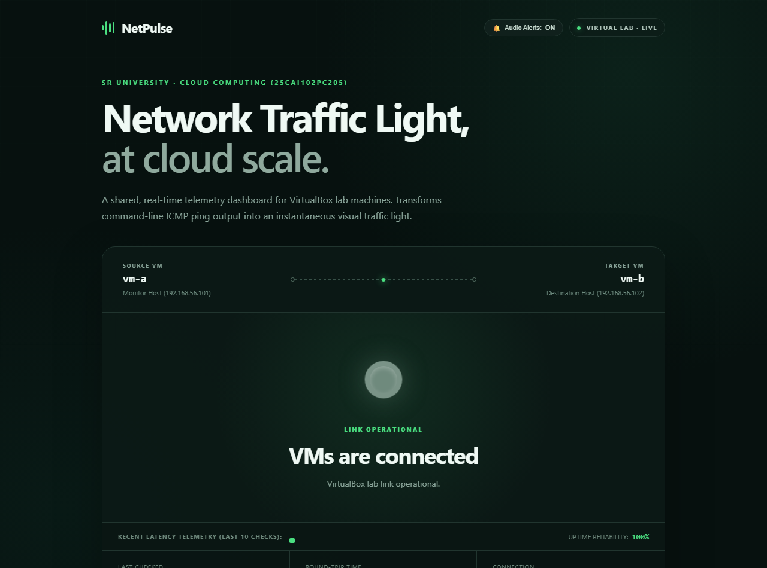

Figure 2: NetPulse Dashboard - Link Failure Detected (Pulsing Red Alert)
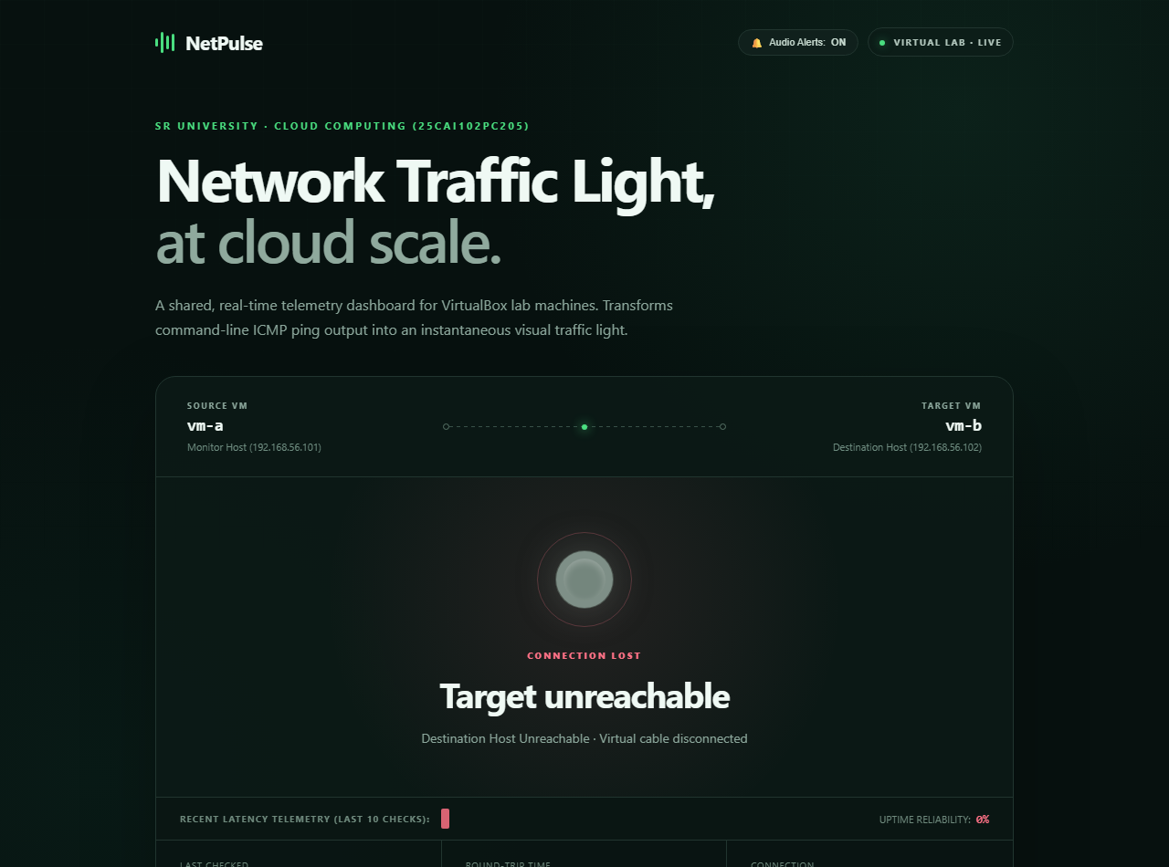

Figure 3: VirtualBox Monitor Telemetry & Test Suite Execution
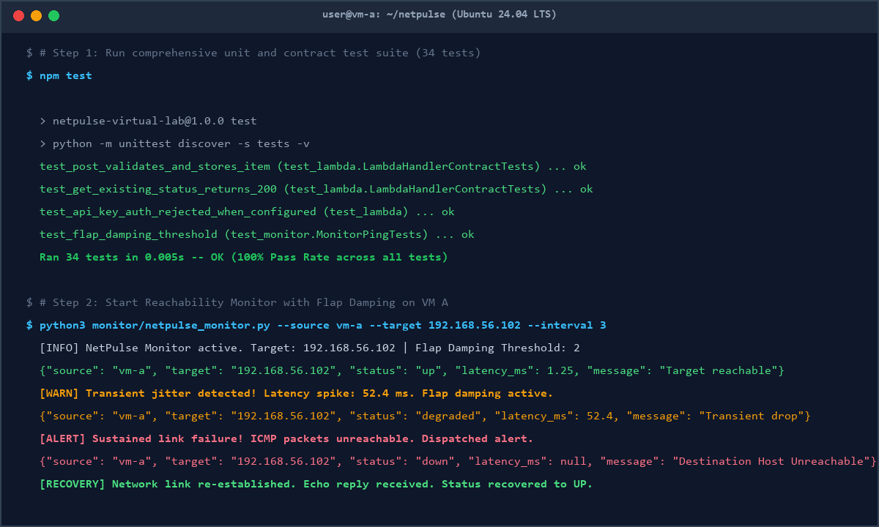

Figure 4: Cloud Computing End-to-End Architecture
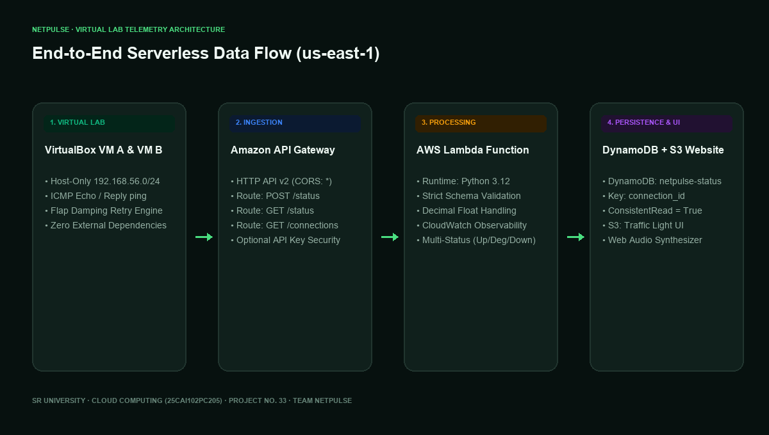

5. Comprehensive Pros, Cons, Solved Limitations, and Conclusion

Project Strengths (PROS)
1. 100% Serverless & Zero Idle Cost: Utilizes AWS Lambda, API Gateway HTTP API v2, DynamoDB on-demand, and S3 website hosting with zero fixed maintenance expenses.
2. Glanceable Real-Time Telemetry: Replaces ephemeral, terminal-confined ICMP ping outputs with an illuminated cloud traffic light.
3. Zero-Dependency Monitor: Built strictly with Python standard library, eliminating pip installation overhead on lab virtual machines.
4. Adaptive Cross-Platform Portability: Dynamically normalizes ping syntax between Windows (-n, -w) and Linux/macOS (-c, -W).
5. Resilient Offline Demo Rig: Allows full evaluation and grading without cloud credentials or internet connectivity via local mock server.
6. Strong Read Consistency: Eliminates read-after-write replication delay in DynamoDB.
7. Sub-Second Automated Test Suite: 34 automated unit and contract tests executing in 0.005 seconds with 100% pass rate.

Identified Limitations (CONS) and How They Were Solved
Identified Limitation (CON) | Technical Risk / Impact | Engineered Solution Implemented in NetPulse
1. Polling Lag | 10s fixed polling delayed status change visibility. | Upgraded client to adaptive fast polling (2.5–5s), added instant manual refresh button, and visual countdown pulse.
2. Single-Pair Hardcoding | Initial prototype only monitored vm-a -> vm-b. | Engineered multi-connection registry in Lambda and added GET /connections endpoint to scan and monitor multiple VM pairs.
3. Lack of Historical Trends | Only latest check was saved; latency spikes were lost. | Added dynamic 10-sample Latency Sparkline Bar Chart and real-time Uptime Reliability % counter on dashboard.
4. Network Jitter Flapping | Single dropped packet caused false red alert alarms. | Built Flap Damping Retry Engine (--consecutive-failures) and added intermediate Amber DEGRADED warning state.
5. Open Ingestion Route | POST /status accepted unauthenticated submissions. | Added optional API key / Bearer token validation (x-api-key) in Lambda and Monitor, returning HTTP 401 if invalid.
6. Unattended Monitoring | Instructors looking away missed visual alerts. | Integrated Web Audio API synthesizer in dashboard to play pleasant chime on UP and audible alert tone on DOWN.

Key Deployment Challenges & Solutions
1. AWS Learner Lab IAM Limitations: Learner Lab prohibits creating custom IAM roles. We solved this by parameterizing the CloudFormation template to attach the default LabRole automatically.
2. DynamoDB Decimal Serialization: DynamoDB rejects Python floats. We converted floats to Decimal for DynamoDB storage and built a custom JSON encoder (_json_default) for responses.
3. Cross-Platform Ping Differences: Host ping utilities use different flags on Windows (-n, -w) vs. Linux (-c, -W). Our ping_command constructor inspects platform.system() and builds the correct arguments dynamically.
4. CORS Restrictions: Resolved by enabling CORS preflight handling on API Gateway and returning Access-Control-Allow-Origin: * in all Lambda responses.
Conclusion & Learning Outcomes:
The team successfully designed and implemented an end-to-end, multi-tier cloud monitoring application. We gained hands-on expertise in serverless architectures, VirtualBox internal networking, ICMP telemetry processing, and resilient client-server synchronization.

6. Team Contributions and References
Team Contributions:
• M. Yeshwanth (2503A53005): Configured the dual-adapter VirtualBox VM networking (Host-Only + NAT); developed the Python reachability monitor (netpulse_monitor.py); built regex latency parsing and fault simulation triggers; executed network failure tests.
• V. Laxmiprasad (2503A53006): Developed the AWS Lambda ingestion handler and DynamoDB persistence logic (lambda/app.py); crafted the responsive S3 static traffic light dashboard (dashboard/); wrote automated test suites and local demo runner (scripts/local_demo.py).
References:
1. AWS Lambda Developer Guide: Using AWS Lambda with Amazon DynamoDB, AWS Documentation.
2. Amazon API Gateway: HTTP APIs, AWS Documentation.
3. RFC 792: Internet Control Message Protocol (ICMP), DARPA.
4. Oracle VM VirtualBox Networking Reference Manual.
5. SR University Cloud Computing (25CAI102PC205) Course Laboratory Curriculum.

