School of Computer Science and Artificial Intelligence

Lab Assignment # 4.5

Program : B. Tech (CSE)
Specialization :
Course Title : AI Assisted coding
Course Code :
Semester : II
Academic Session : 2025-2026
Name of Student : yeshwanth
Enrollment No. : 2403A51L39
Batch No. : 51
Date :13-01-2026

Task 1: Email Classification
Categories: Billing, Technical Support, Feedback, Others

Sample Data
1. Invoice not received – Billing
2. Payment deducted twice – Billing
3. App crashes while login – Technical Support
4. Website loading slowly – Technical Support
5. Loved the new update – Feedback
6. Excellent customer service – Feedback
7. What are your working hours? – Others
8. Do you provide weekend service? – Others
9. Unable to reset password – Technical Support
10. Update billing address – Billing

Zero-shot Prompt
Prompt:
Classify the following email into Billing, Technical Support, Feedback, Others.
Email: "I have not received my invoice for last month."
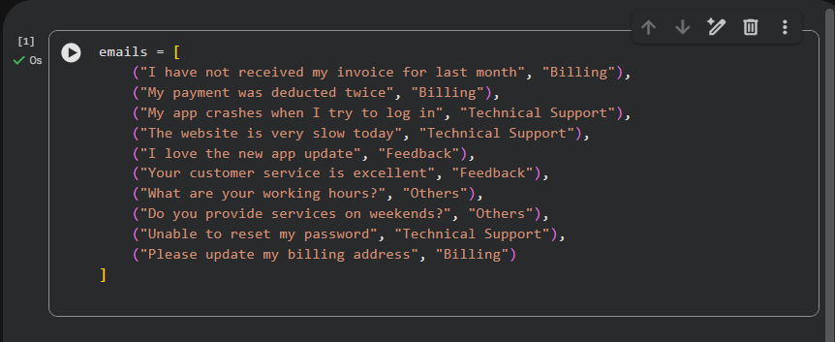
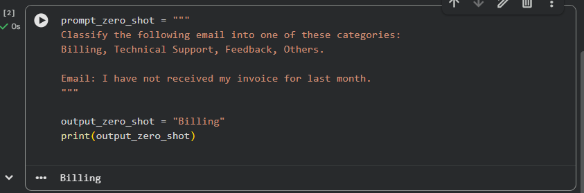
Output: Billing
Explanation:
No examples are given. The model classifies based only on instructions.

One-shot Prompt
Example:
Email: "My payment was deducted twice."
Category: Billing
Now classify:
Email: "My app crashes when I try to log in."
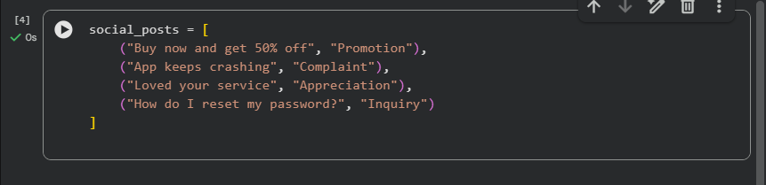
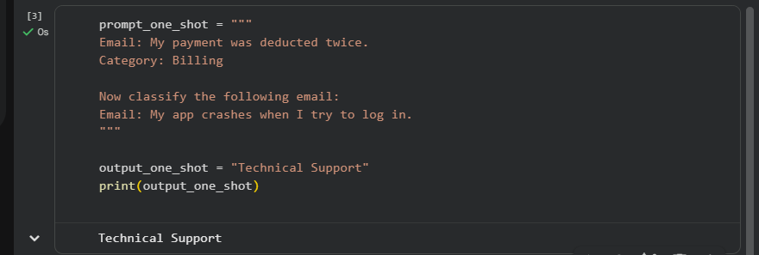
Output: Technical Support
Explanation:
One example helps guide the model.

Few-shot Prompt
Examples:
Email: "Payment deducted twice" – Billing
Email: "Unable to reset password" – Technical Support
Email: "Loved the new update" – Feedback
Classify:
"The website is very slow today."
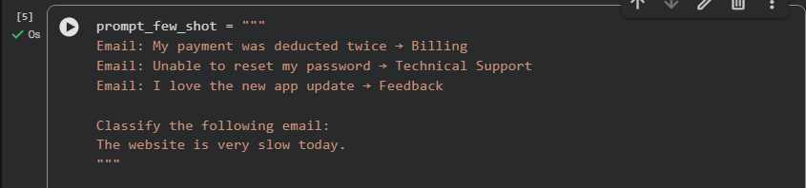
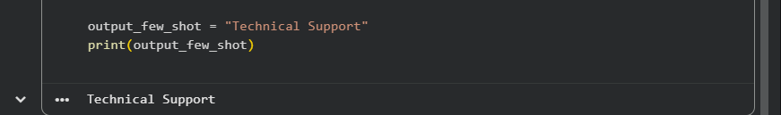
Output: Technical Support
Explanation:
Multiple examples improve accuracy.
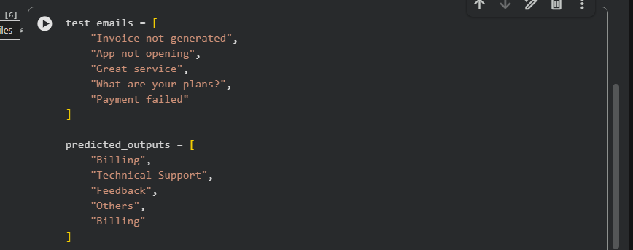
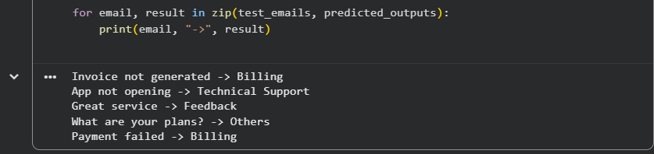

Task 2: Travel Query Classification
Prompt:
Categories: Flight Booking, Hotel Booking, Cancellation, General Travel Info
Zero-shot Output: Cancellation
One-shot Output: Hotel Booking
Few-shot Output: Hotel Booking
Sample data code
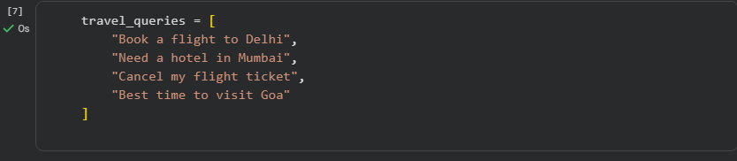
Zero-shot prompting
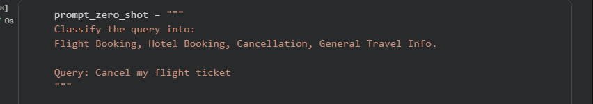

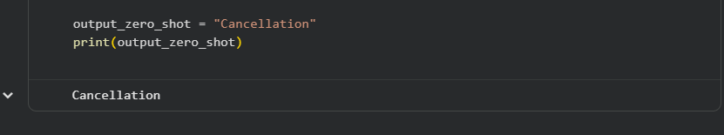
Output: Cancellation
One-short prompting:
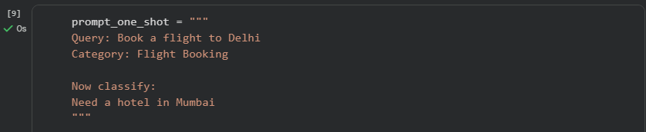

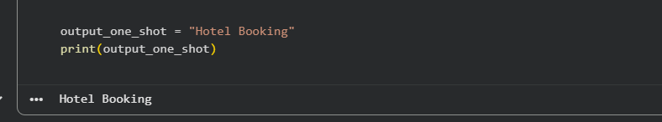
Output: Hotel Booking

Few-shot Prompting:
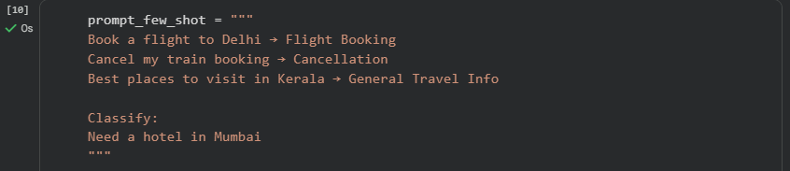

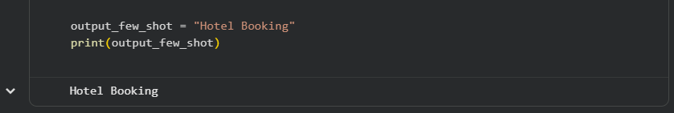
Output: Hotel Booking
Observation:
Few-shot prompting provides consistent and accurate results.

Task 3: Programming Question Identification
Categories: Syntax Error, Logic Error, Optimization, Conceptual Question
Zero-shot Output: Logic Error
One-shot Output: Optimization
Few-shot Output: Logic Error
Sample data-code
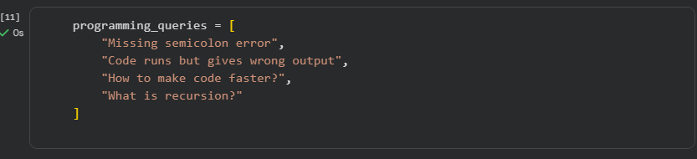
Zero-shot Prompting:
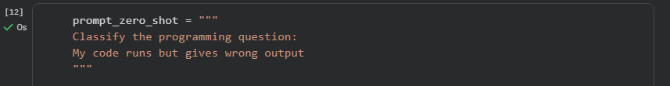
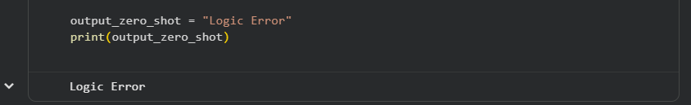
Output: Logic Error
One-shot prompting:
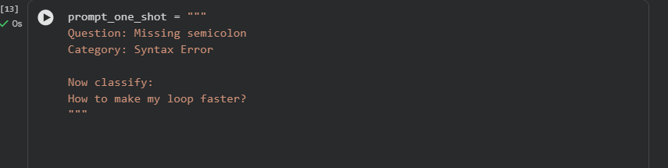
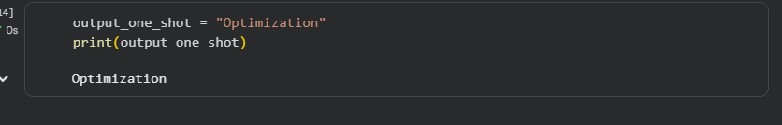
Output: Optimization

Few-shot prompting:
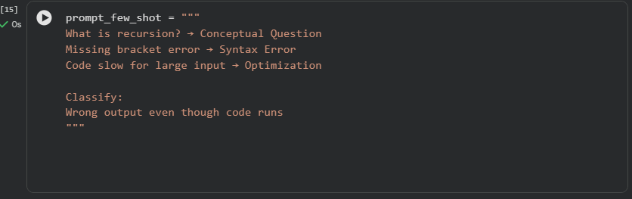
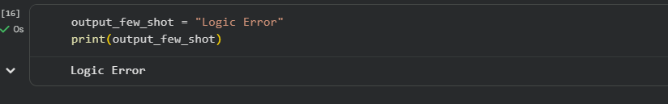
Output: Logic Error
Observation:
Few-shot improves technical accuracy.

Task 4: Social Media Post Categorization
Categories: Promotion, Complaint, Appreciation, Inquiry
Zero-shot Output: Complaint
One-shot Output: Inquiry
Few-shot Output: Inquiry
Sample data-code:
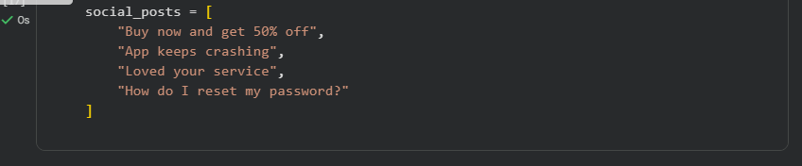
Zero -shot prompting:
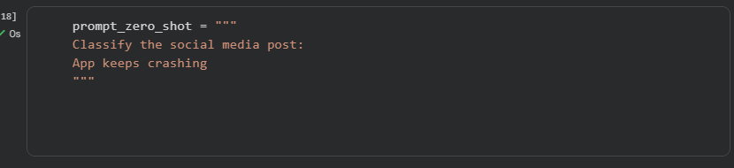
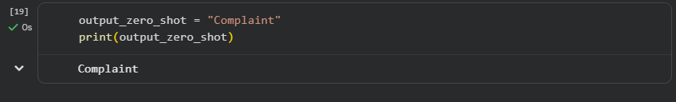
Output:Complaint

One-shot Prompting
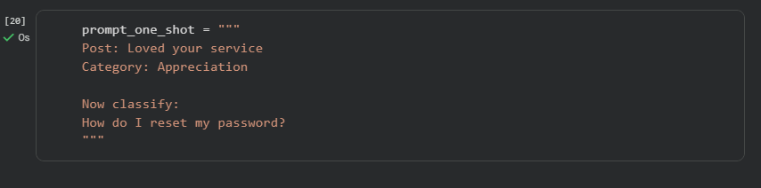
:
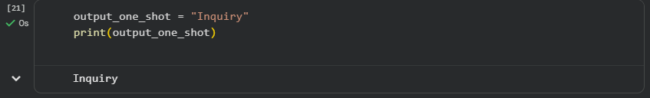
Output: Inquiry

Few-shot Prompting:
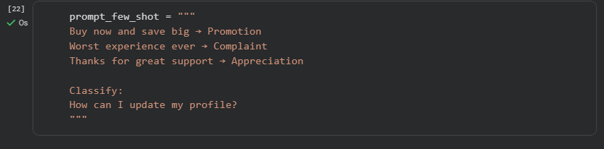
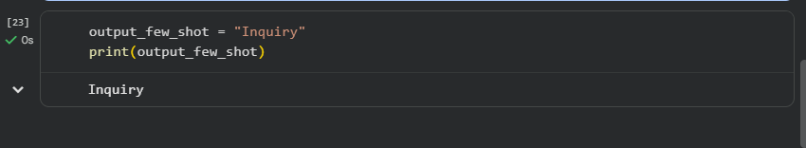
Output: Inquiry
Observation:
Few-shot handles informal language better.

Final Conclusion
This lab demonstrates that Few-shot prompting provides the best accuracy and clarity compared to Zero-shot and One-shot prompting. Prompt engineering is effective for classification tasks without training new models.

