School of Computer Science and Artificial Intelligence
Lab Assignment # 16.2

Program : B. Tech (CSE)
Specialization : -
Course Title : AI Assisted Coding
Course Code : 23CS002PC304
Semester II
Academic Session : 2025-2026
Name of Student : P.yeshwanth
Enrollment No. : 2403A51L23
Batch No : 52
Date : 17/03/26

Task 1: (Design Database Schema for Student Management System )
Input:
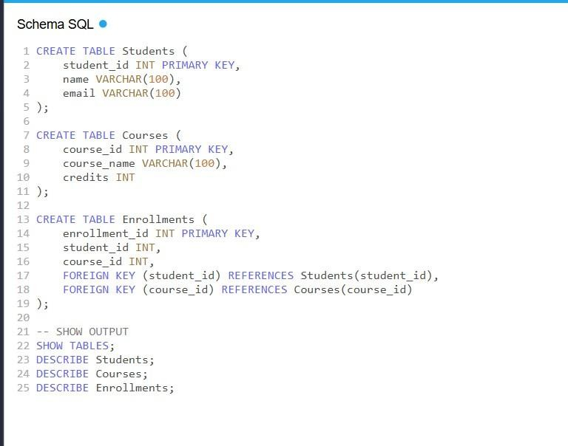

Output:
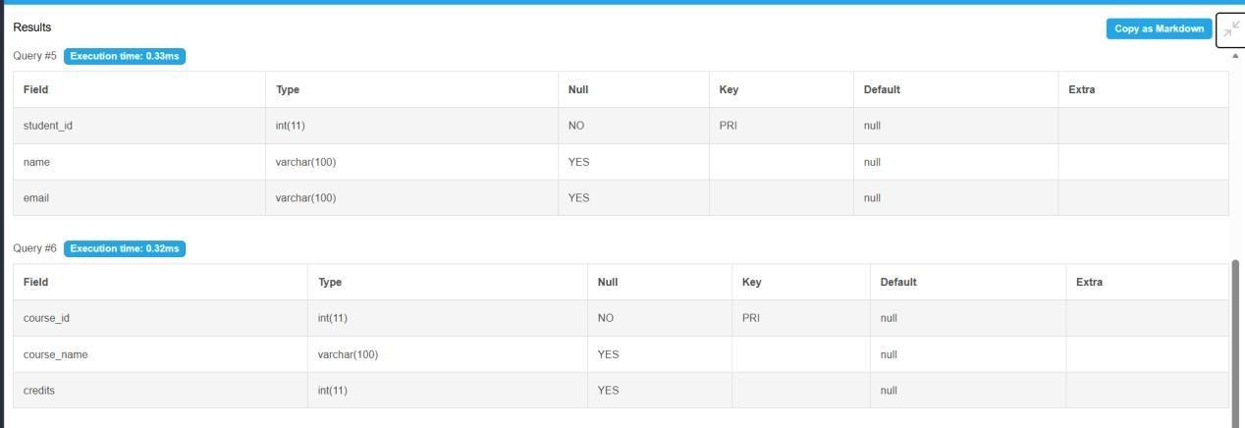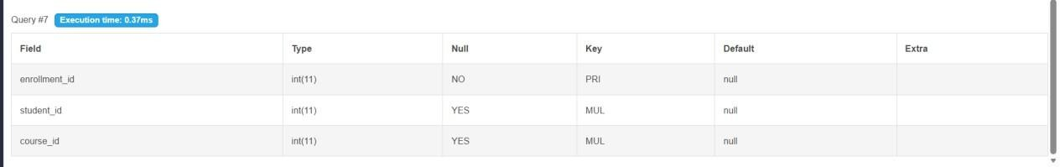

Explanation:
- Defines structure of database using tables: Students, Courses, Enrollments.
- Primary keys ensure unique identification of each record.
- Foreign keys maintain referential integrity between related tables.
- Follows normalization (1NF, 2NF, 3NF) to remove redundancy and ensure consistency.

Task 2: (Insert Sample Records)

Input:
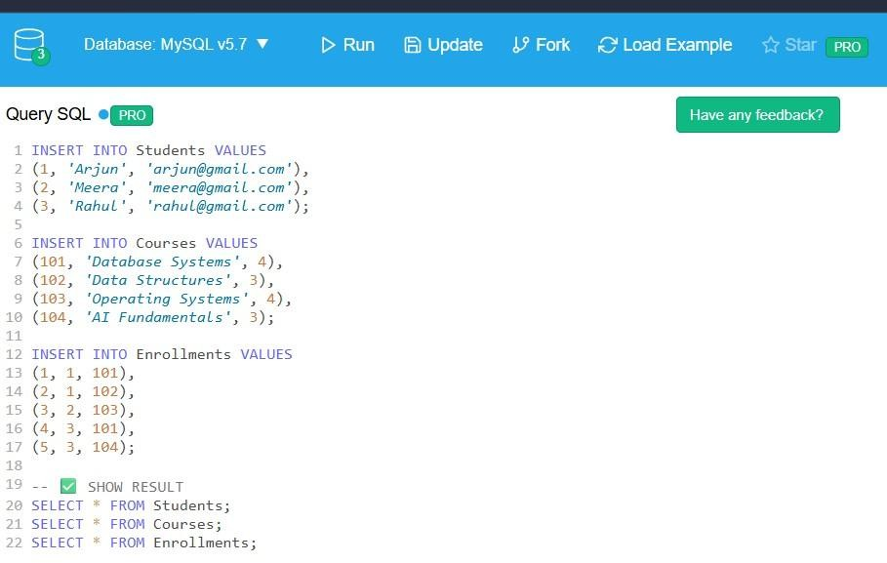

Output:
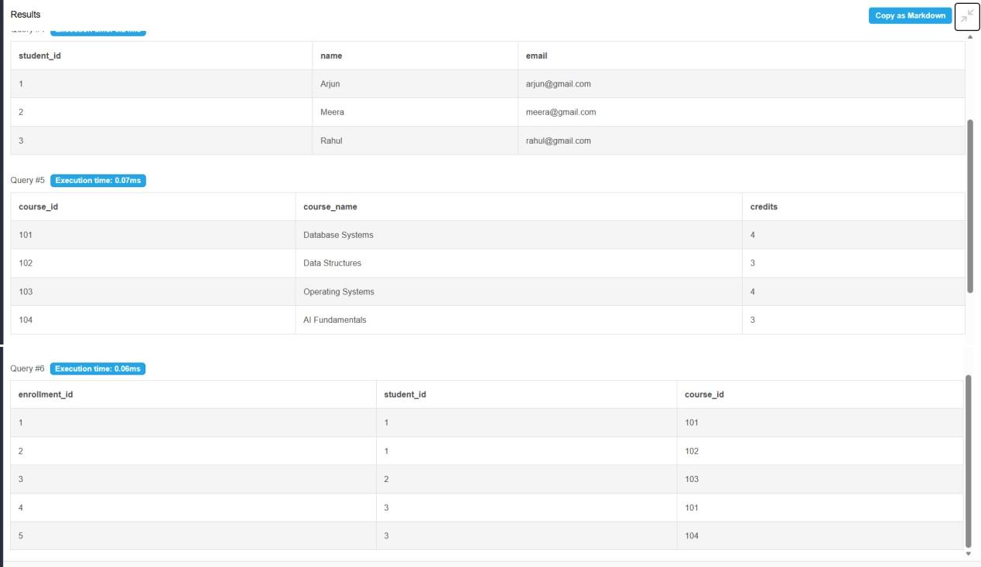

Explanation:
- Populates tables with initial data using INSERT statements.
- Ensures relational links by matching student_id and course_id.
- Helps in testing database functionality with sample dataset.
- SELECT queries verify whether data insertion is successful.

Task 3: CRUD Operations

Input:
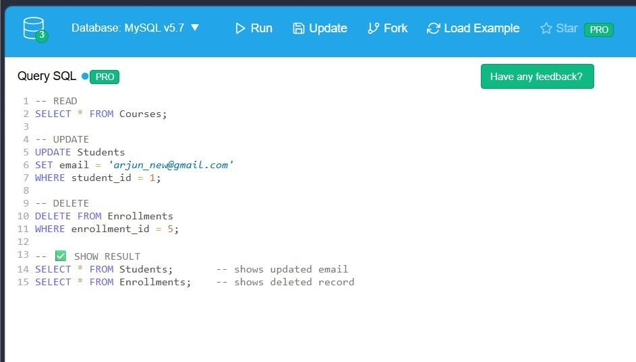
Output:
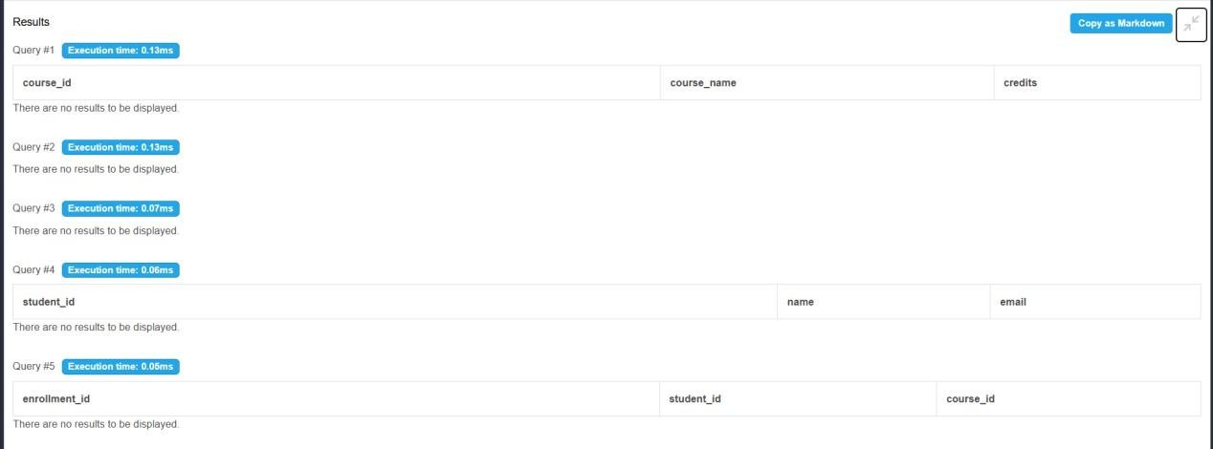
Explanation:
- SELECT retrieves data from tables for viewing records.
- UPDATE modifies existing data like student email.
- DELETE removes specific records such as enrollments.
- Validates operations using SELECT to ensure correctness.

Task 4: Aggregate Queries

Input:
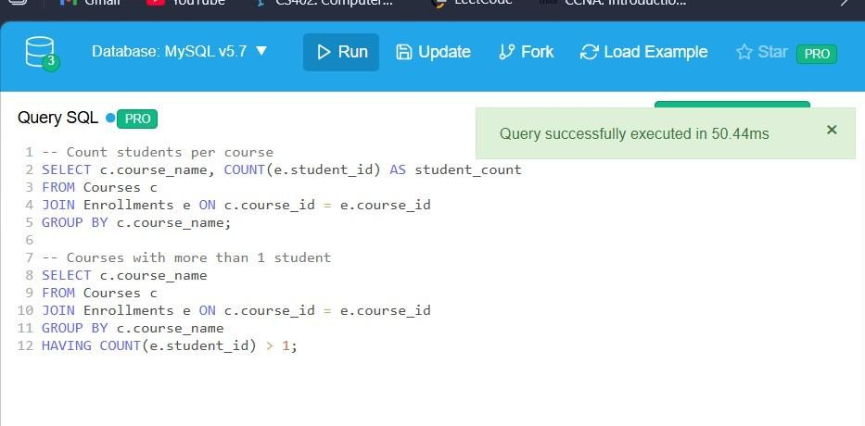
Output:

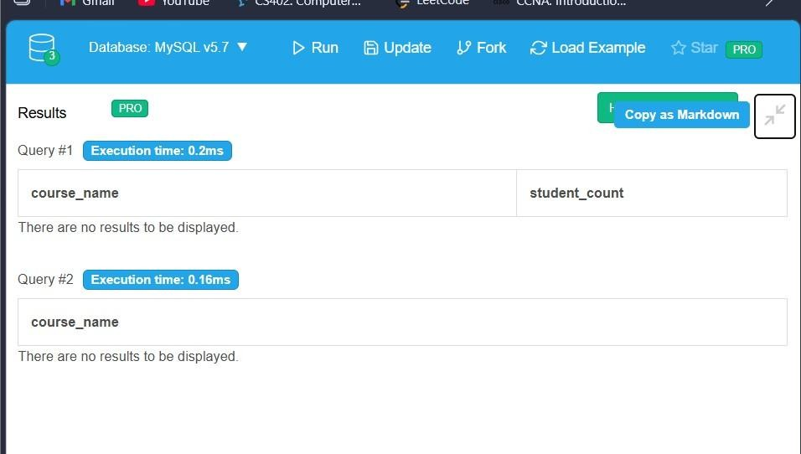
Explanation:
- Uses functions like COUNT() to summarize data.
- GROUP BY groups records based on course names.
- HAVING filters grouped data (e.g., courses with >1 student).
- Helps in analysis like enrollment trends per course.

Task 5: Query Optimization

Input:
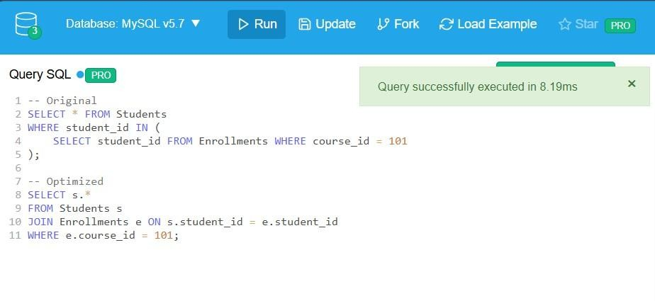
Output:
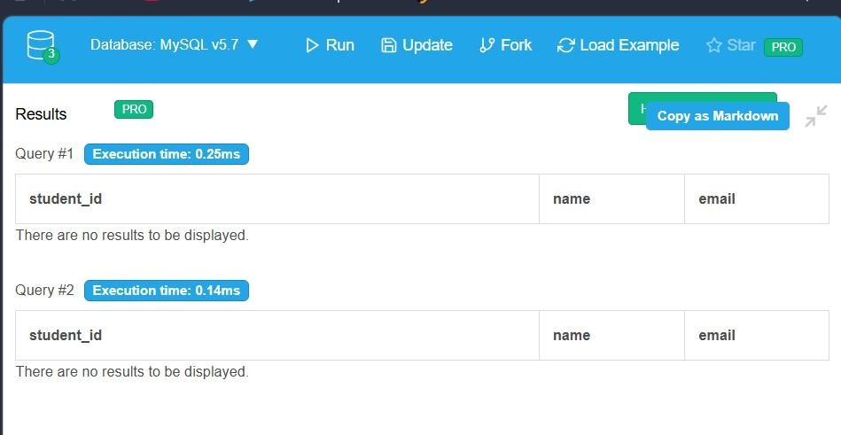
Explanation:
- Identifies inefficient queries (e.g., subqueries).
- Rewrites queries using JOINs for better performance.
- Ensures both original and optimized queries give same result.
- Improves execution speed, especially for large datasets.

