School of Computer Science and Artificial Intelligence

Lab Assignment # 11.1

Program : B. Tech (CSE)
Specialization : -
Course Title : AI Assisted Coding
Course Code : 23CS002PC304
Semester : II
Academic Session : 2025-2026
Name of Student : P.yeshwanth reddy
Enrollment No. : 2403A51L39
Batch No. : 51
Date : 17/02/26

Submission Starts here

Screenshots:
Task Description #1 – Stack Implementation
Task: Use AI to generate a Stack class with push, pop, peek, and is_empty
methods.

Sample code:

class Stack:
Pass

Prompt:
generate a Stack class with push, pop, peek, and is_empty
Methods and code.

Code:

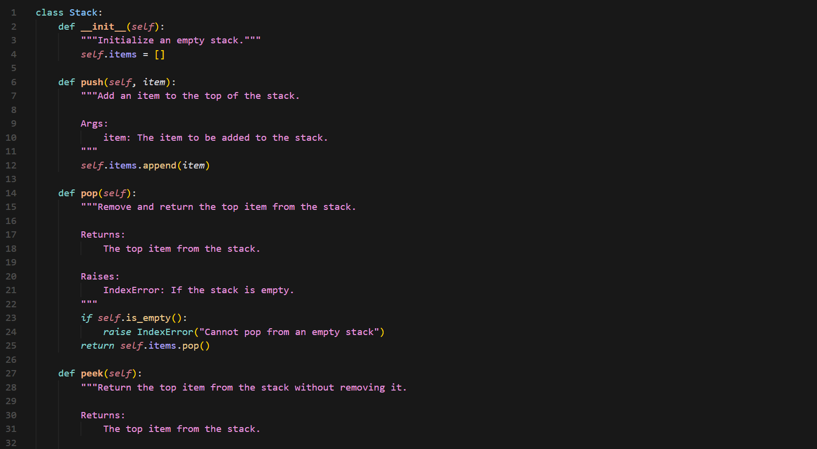
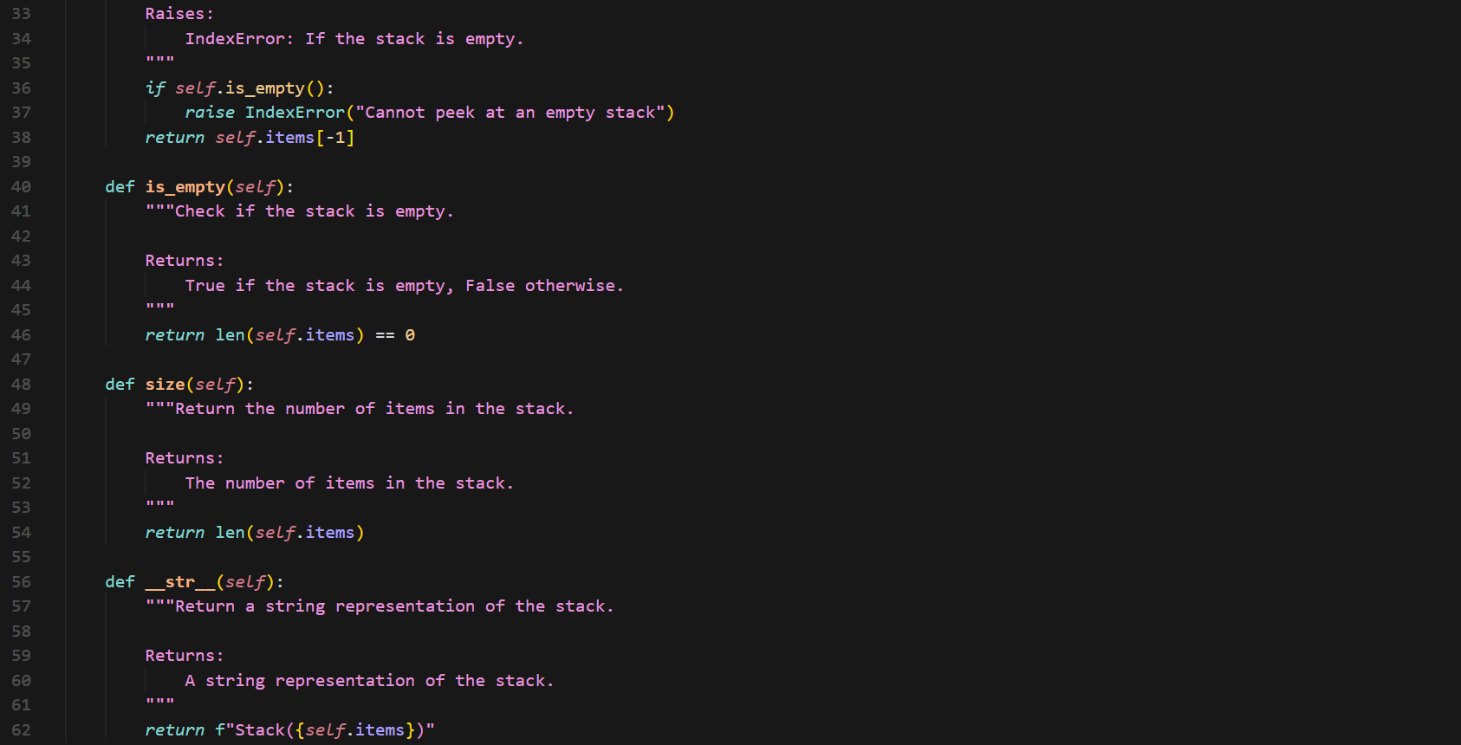

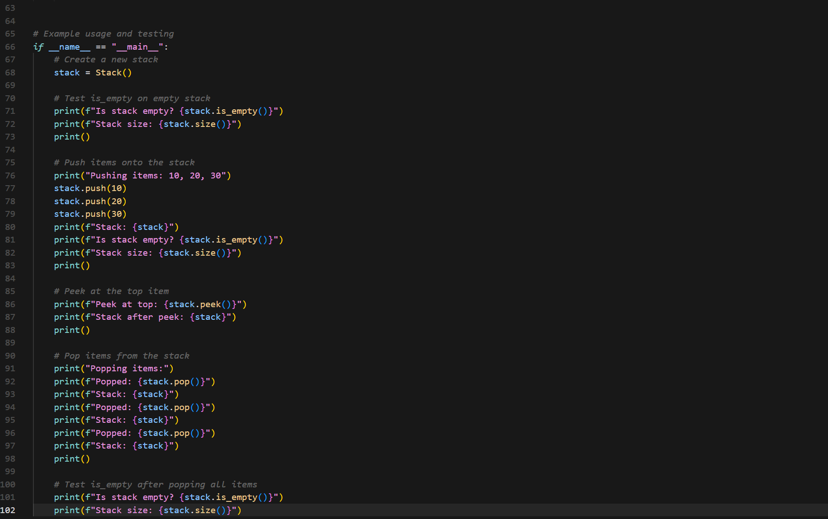

Output:
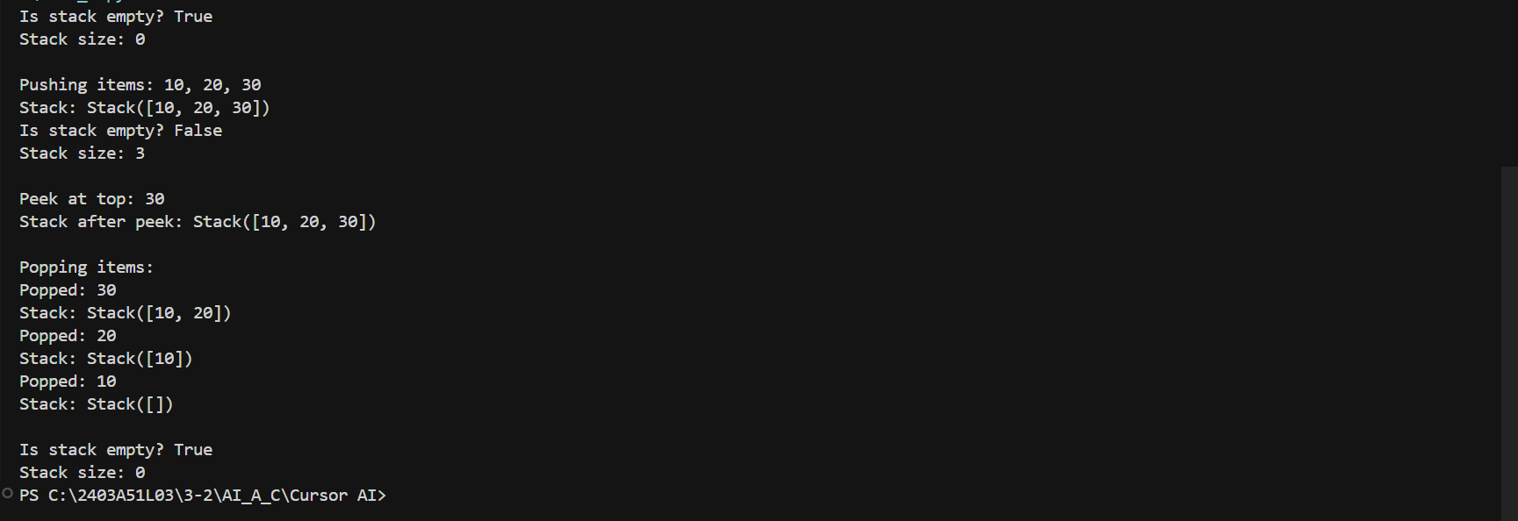

Task Description #2 – Queue Implementation
Task: Use AI to implement a Queue using Python lists.

Sample Input Code:
class Queue:
Pass

Prompt:
complete the queue class with enqueue, dequeue, peek, and size methods and code

Code:
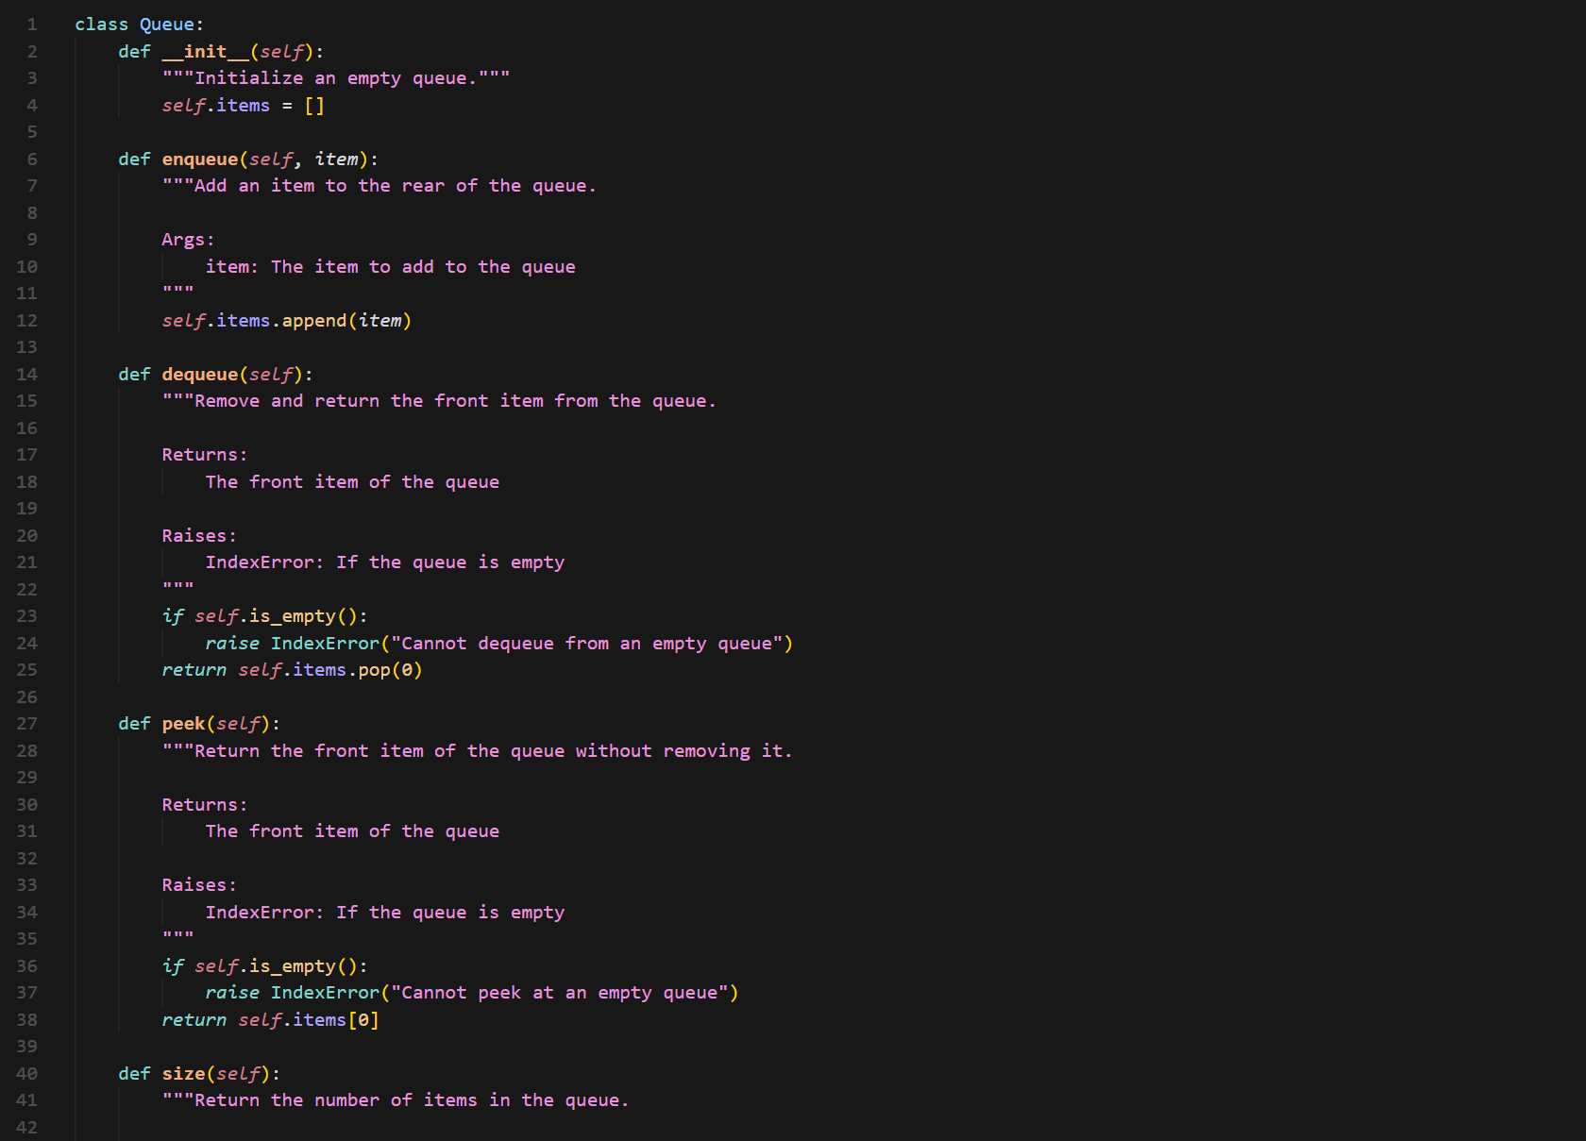
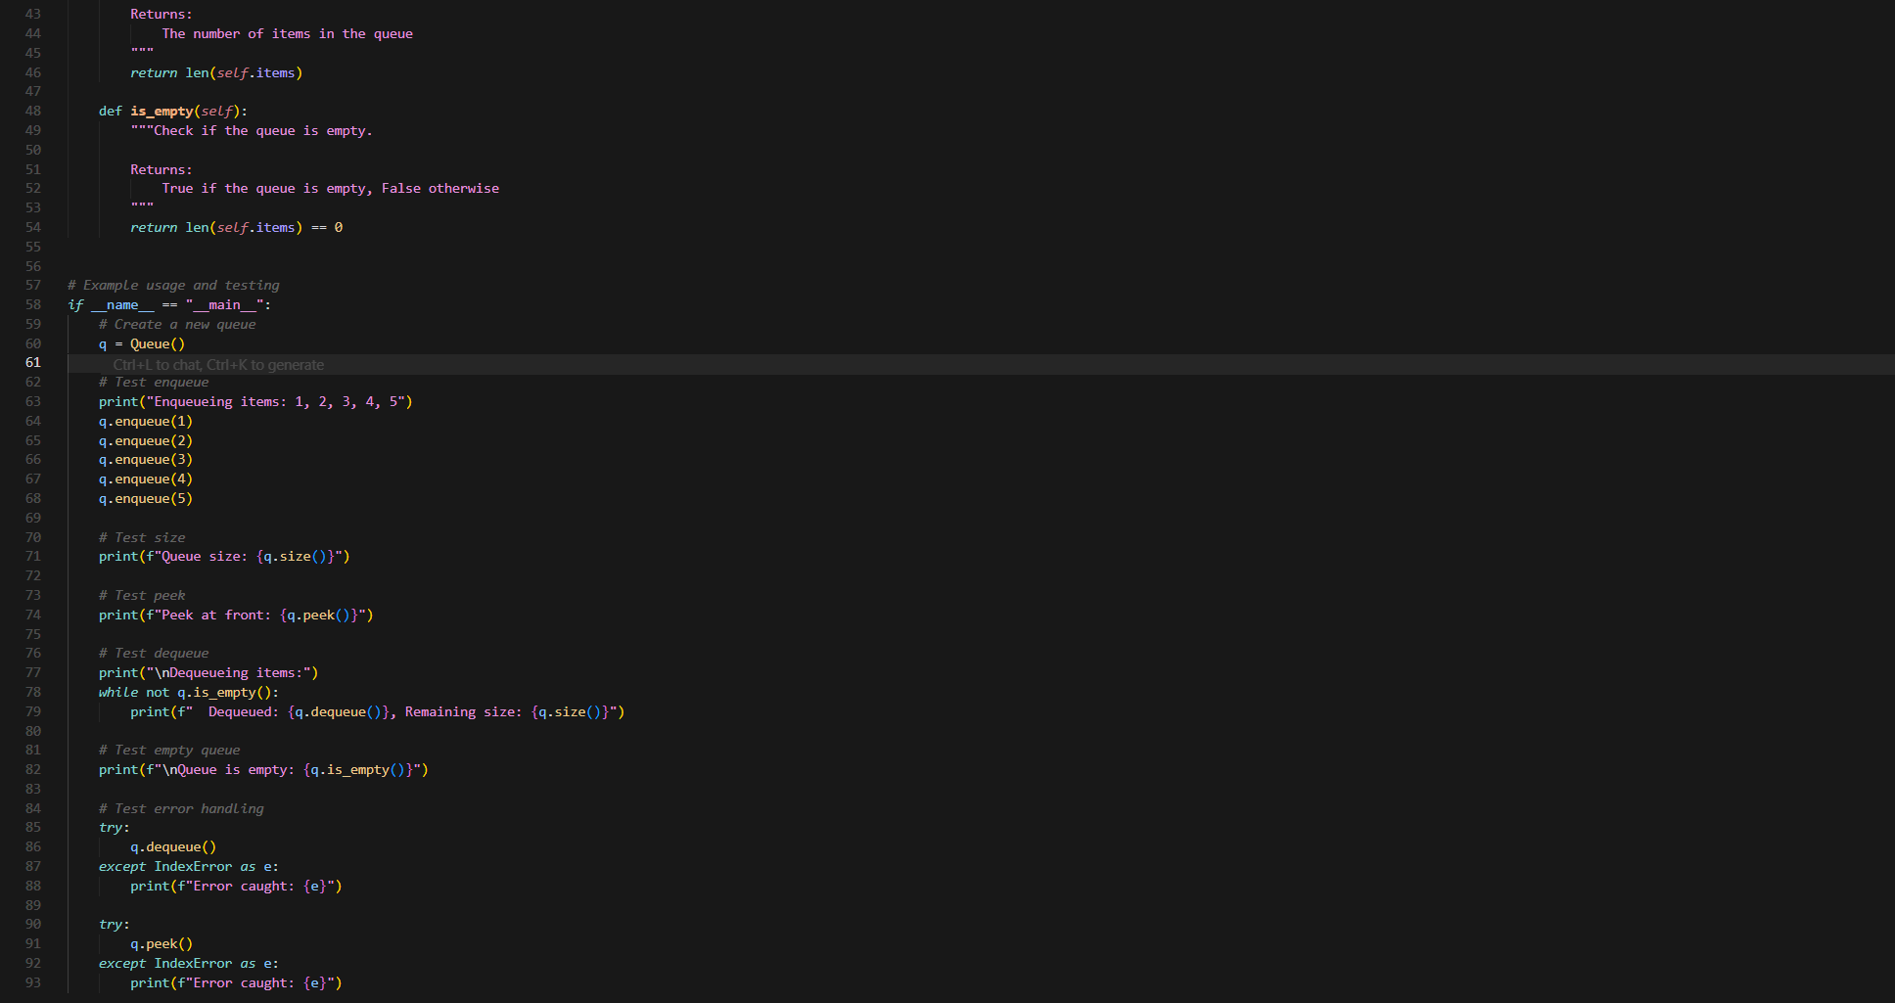

Output:
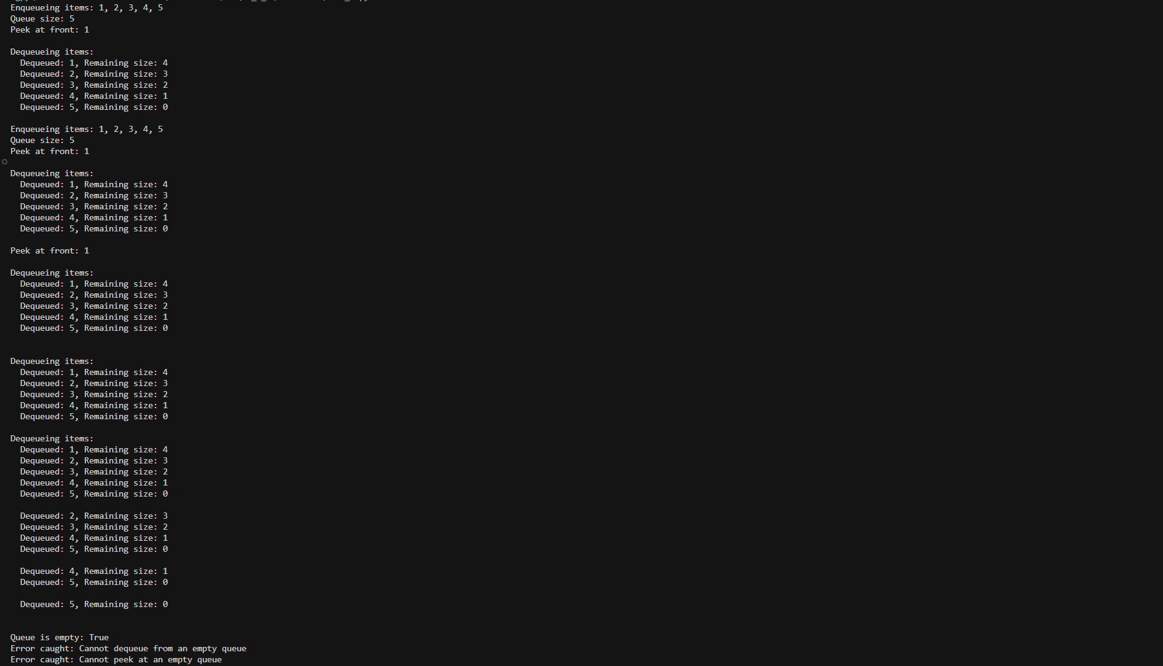

Task Description #3 – Linked List
Task: Use AI to generate a Singly Linked List with insert and display
methods.

Sample Input Code:
class Node:
Pass

Prompt:
generate a Singly Linked List with insert and display methods with code

Code:

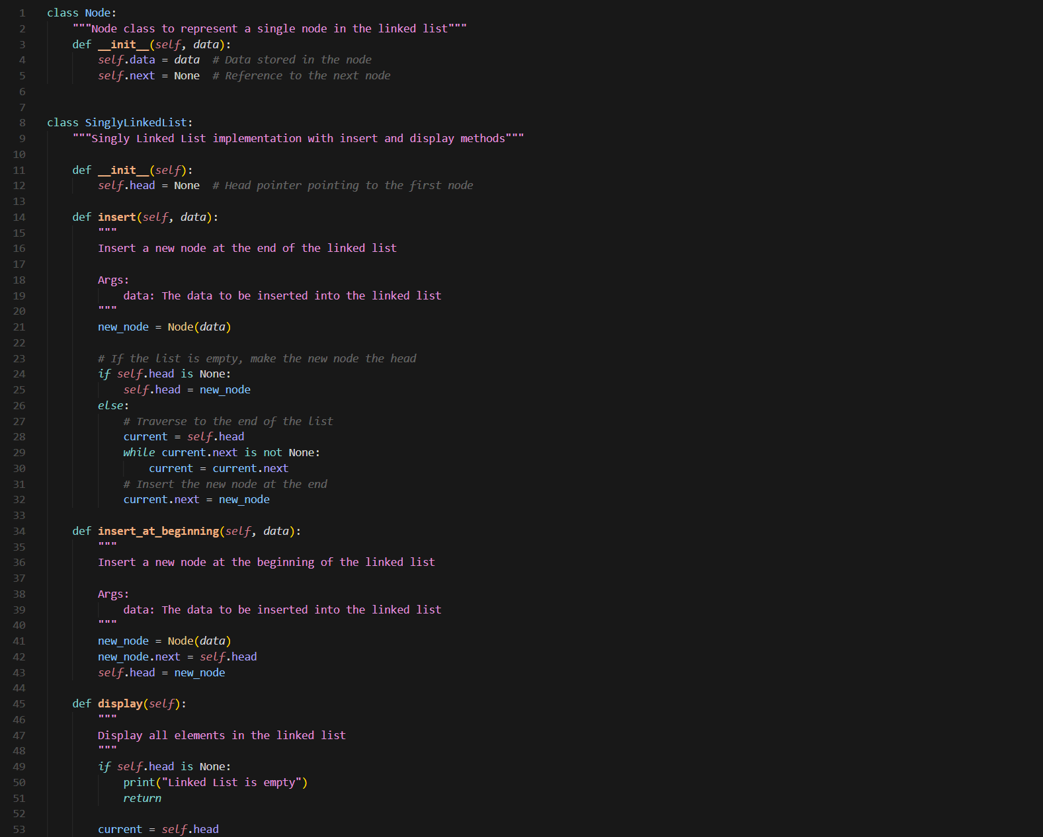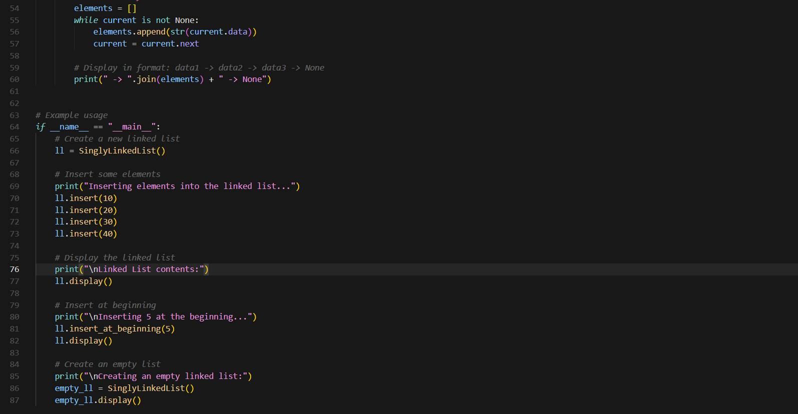

Output:
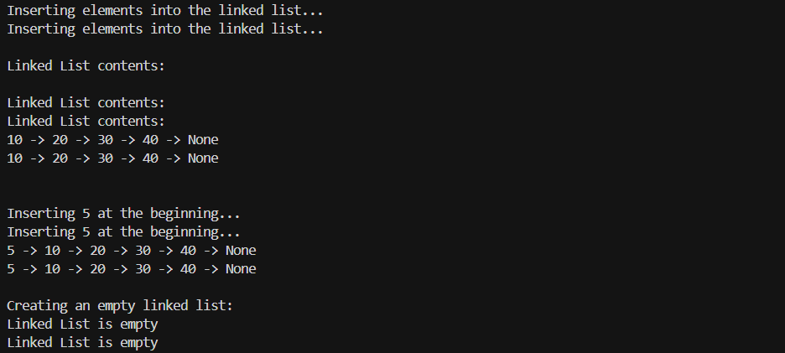

Task Description #4 – Binary Search Tree (BST)
Task: Use AI to create a BST with insert and in-order traversal methods.

Sample Input Code:
class BST:
pass

Prompt:
create a BST with insert and in-order traversal methods and code

Code:

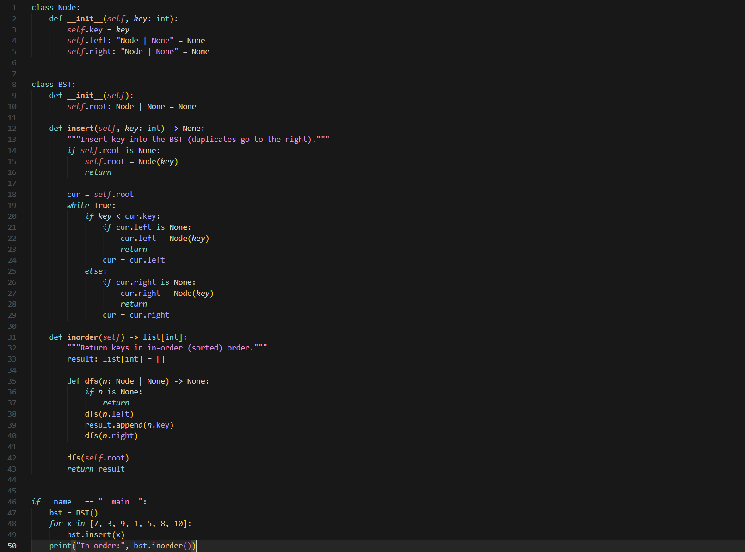

Output:

Task Description #5 – Hash Table
Task: Use AI to implement a hash table with basic insert, search, and
delete methods.

Sample Input Code:
class HashTable:
pass

Prompt:
implement a hash table with basic insert, search, and delete methods with code

Code:

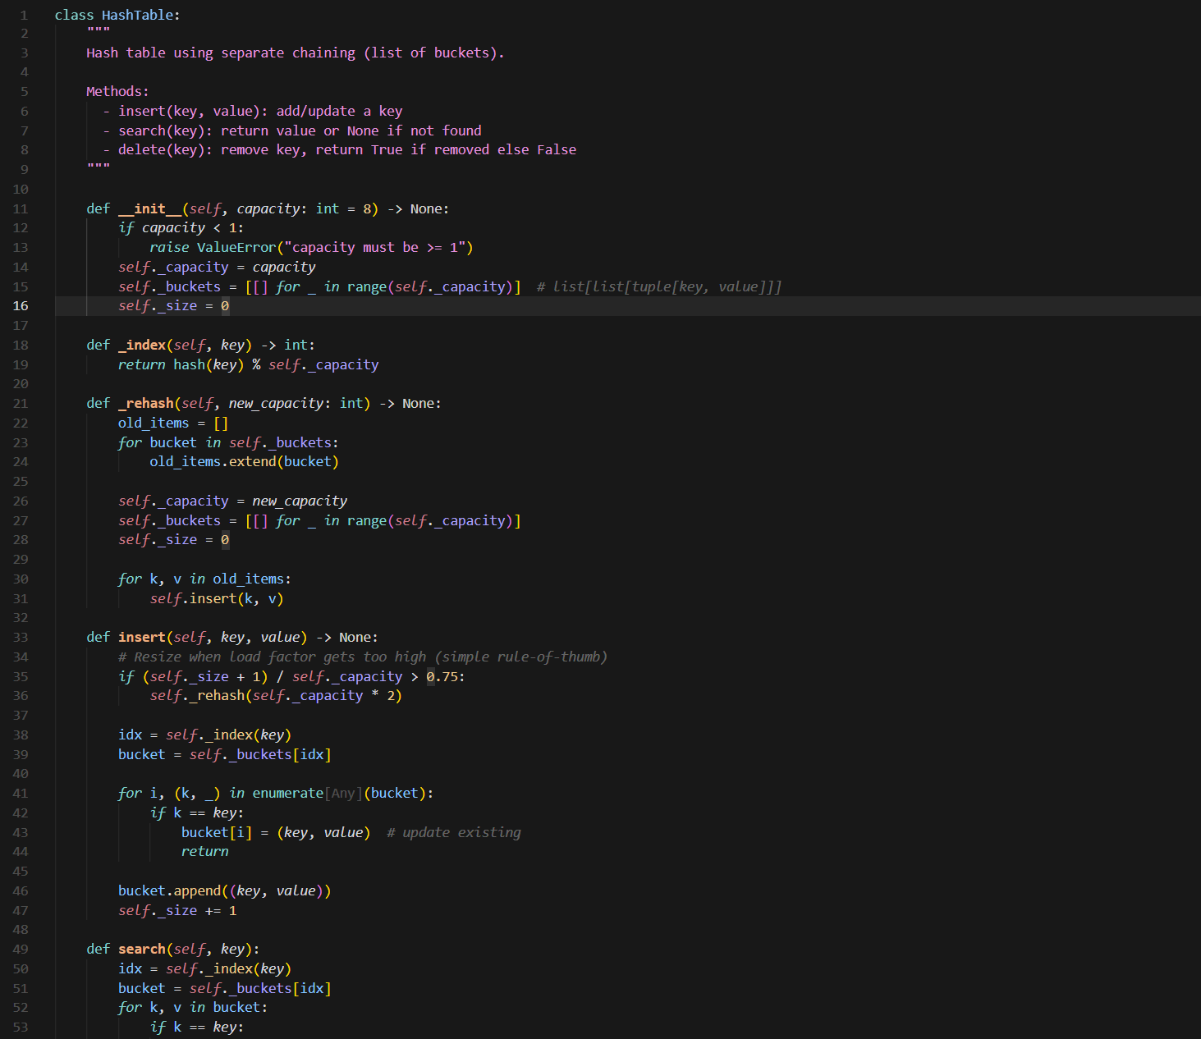
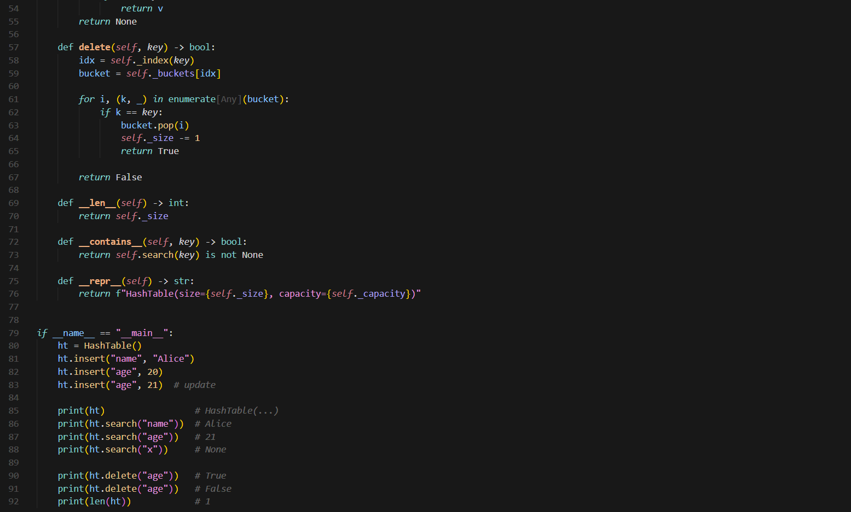

Output:
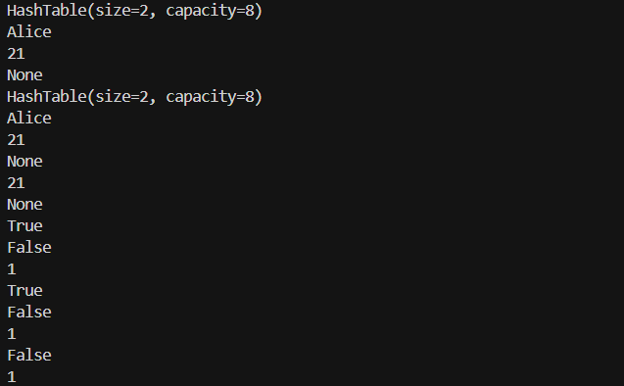

Task Description #6 – Graph Representation
Task: Use AI to implement a graph using an adjacency list.
Sample Input Code:
class Graph:
pass

Prompt:
implement a graph using an adjacency list with code

Code:

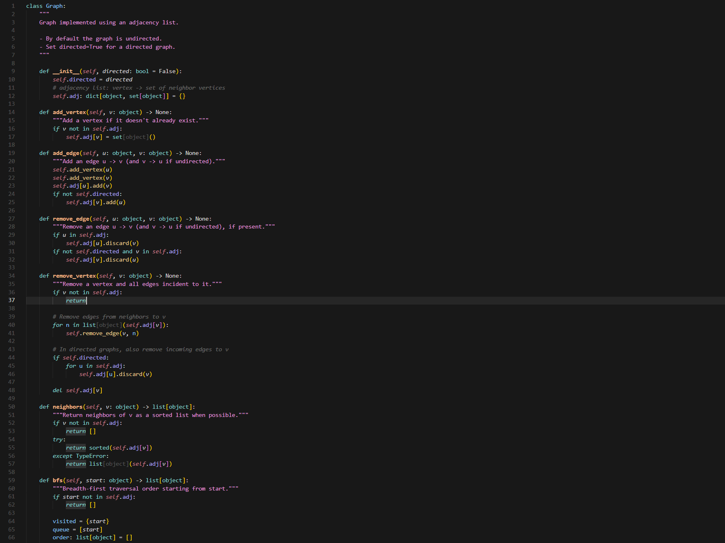
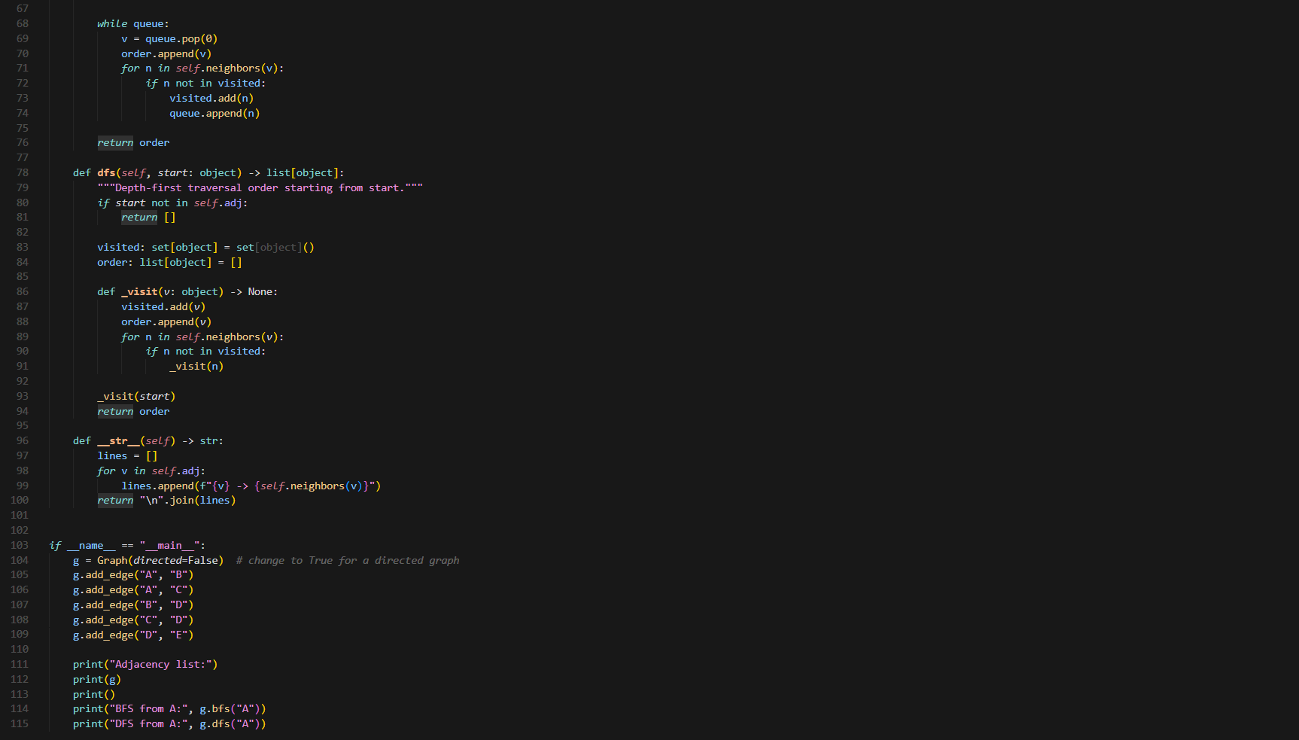

Output:
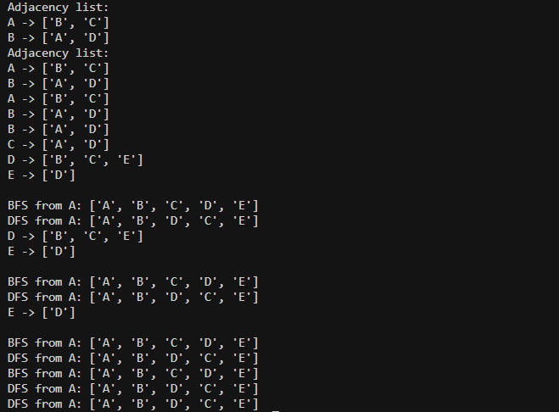

Task Description #7 – Priority Queue
Task: Use AI to implement a priority queue using Python’s heapq
module.

Sample Input Code:
class PriorityQueue:
pass

Prompt:
implement a priority queue using Python’s heapq module with code

Code:
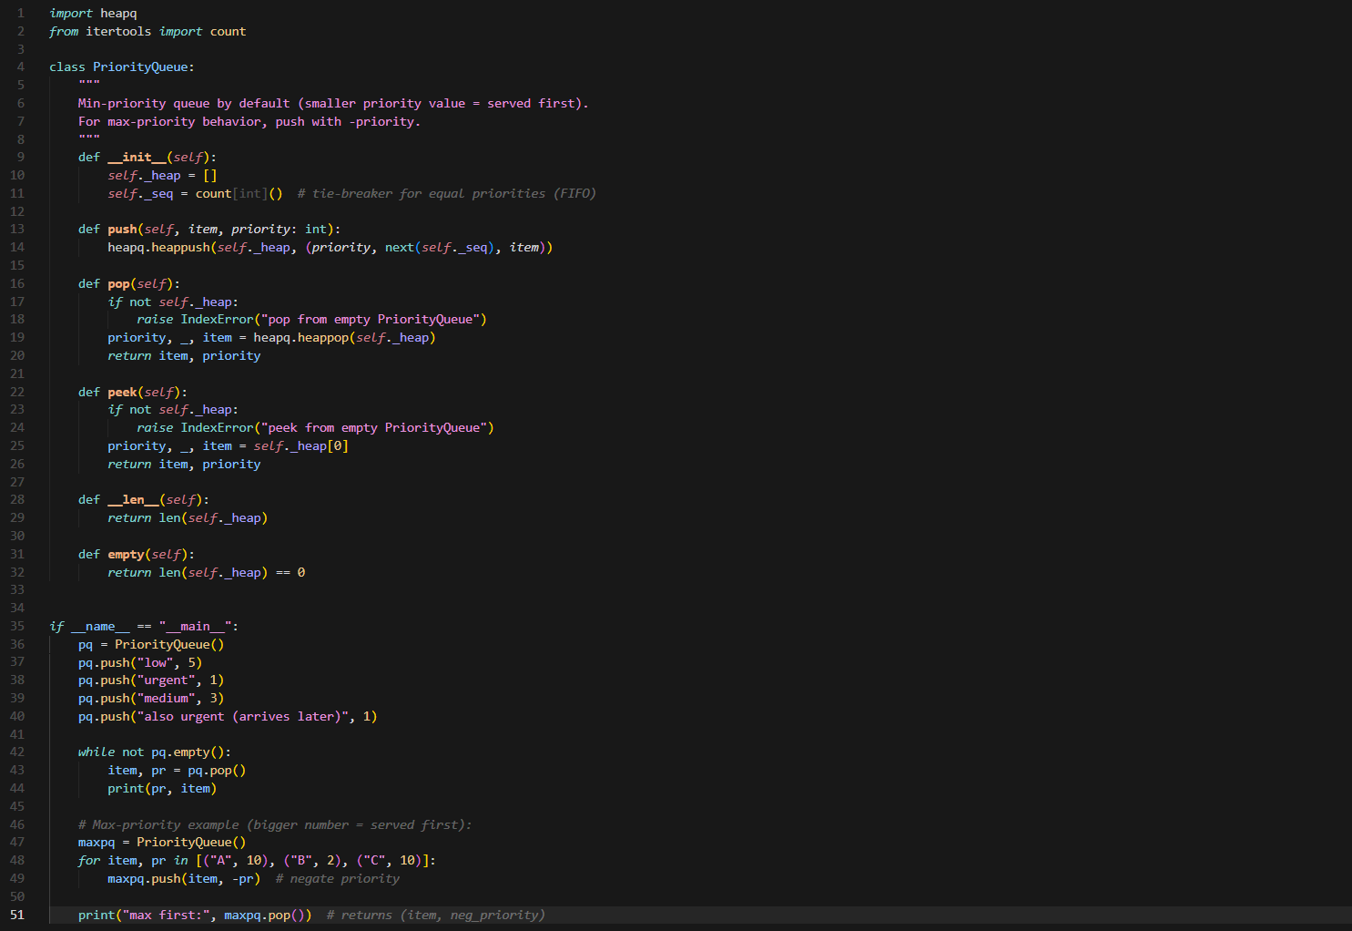

Output:
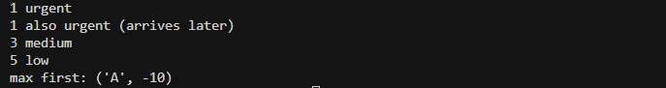

Task Description #8 – Deque
Task: Use AI to implement a double-ended queue using
collections.deque.

Sample Input Code:
class DequeDS:
pass

Prompt:
implement a double-ended queue using collections.deque with code

Code:
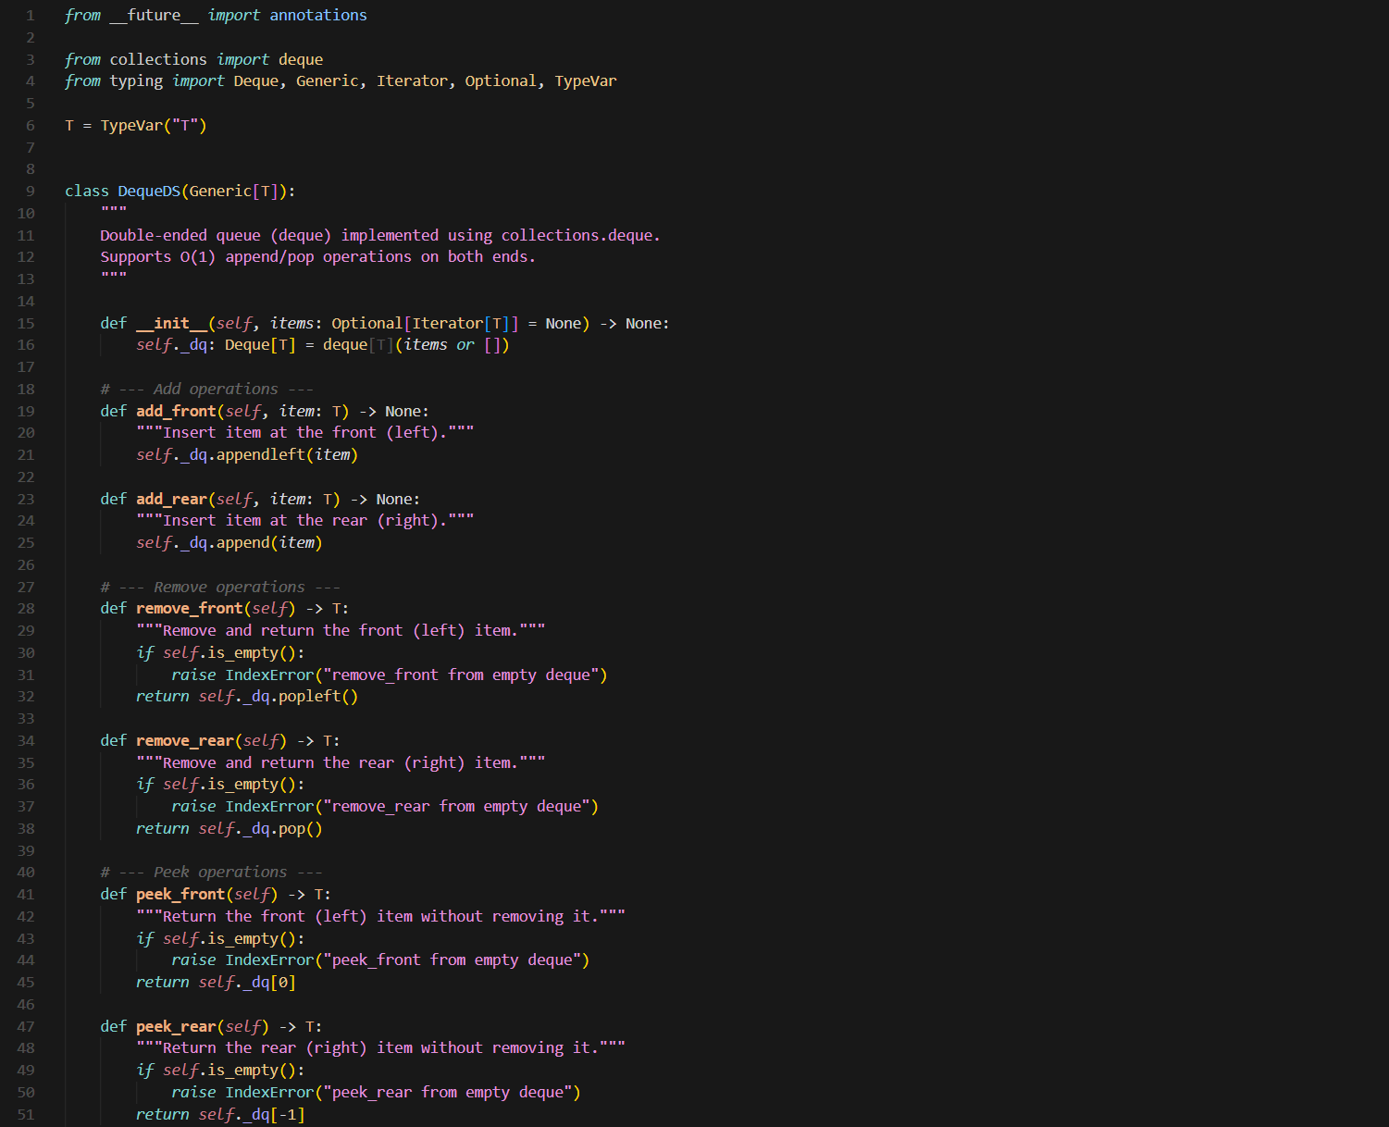
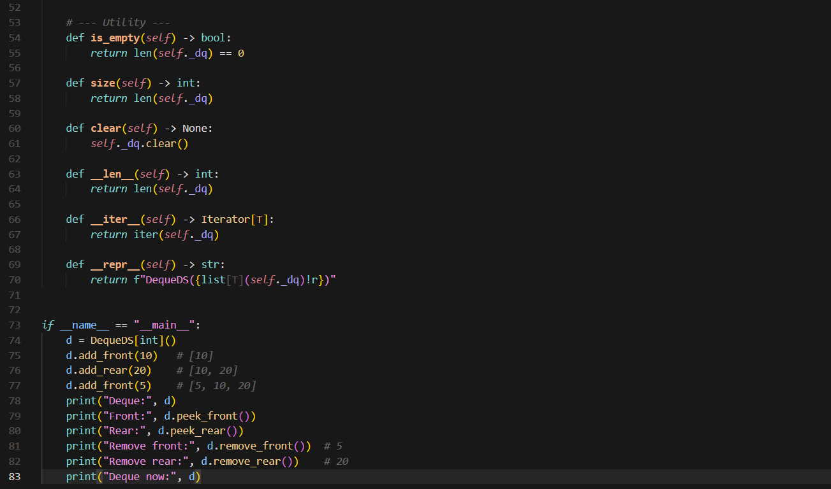

Output:
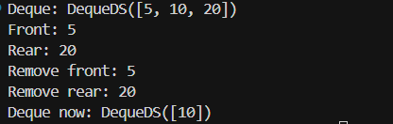

Task Description #9 Real-Time Application Challenge – Choose the
Right Data Structure

Prompt:
Solve this clearly and concisely.
Design a Campus Resource Management System code with:
- Student Attendance Tracking
- Event Registration System
- Library Book Borrowing
- Bus Scheduling System
- Cafeteria Order Queue
----
Choose the best data structure for each feature from:
Stack, Queue, Priority Queue, Linked List, BST, Graph, Hash Table, Deque

Output as a table:
Feature | Data Structure | 2–3 sentence justification

Code:

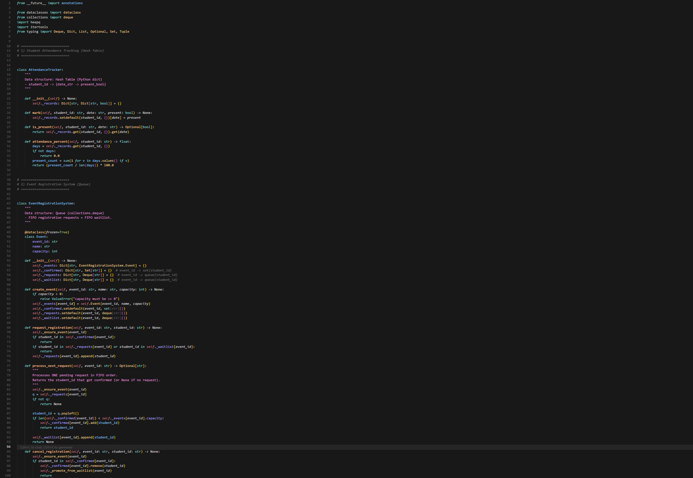
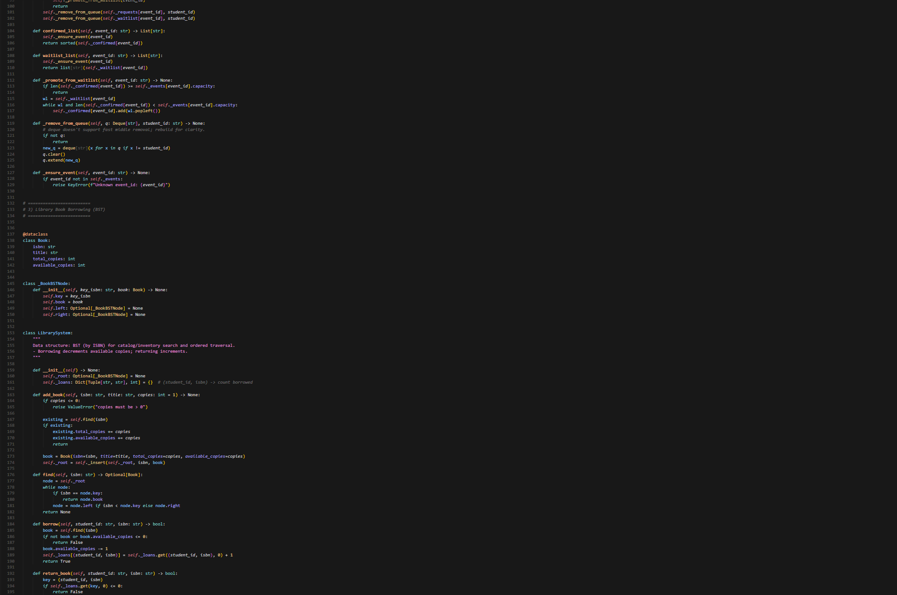

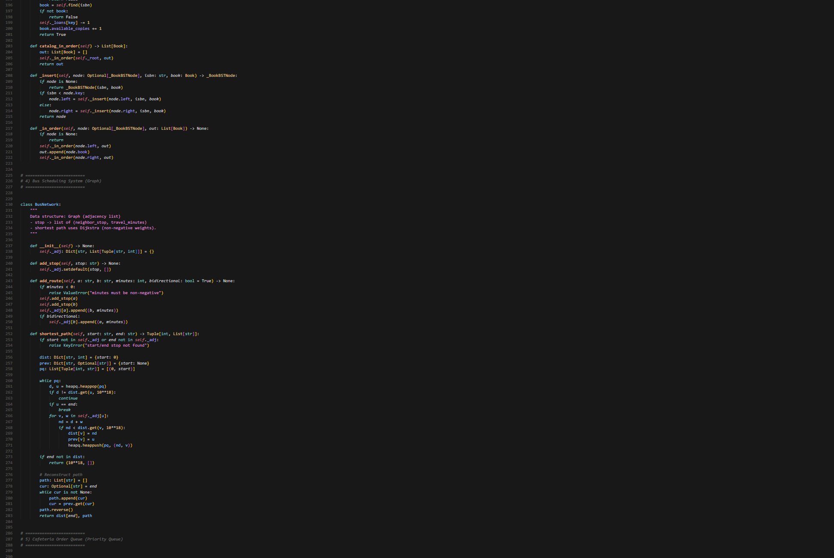
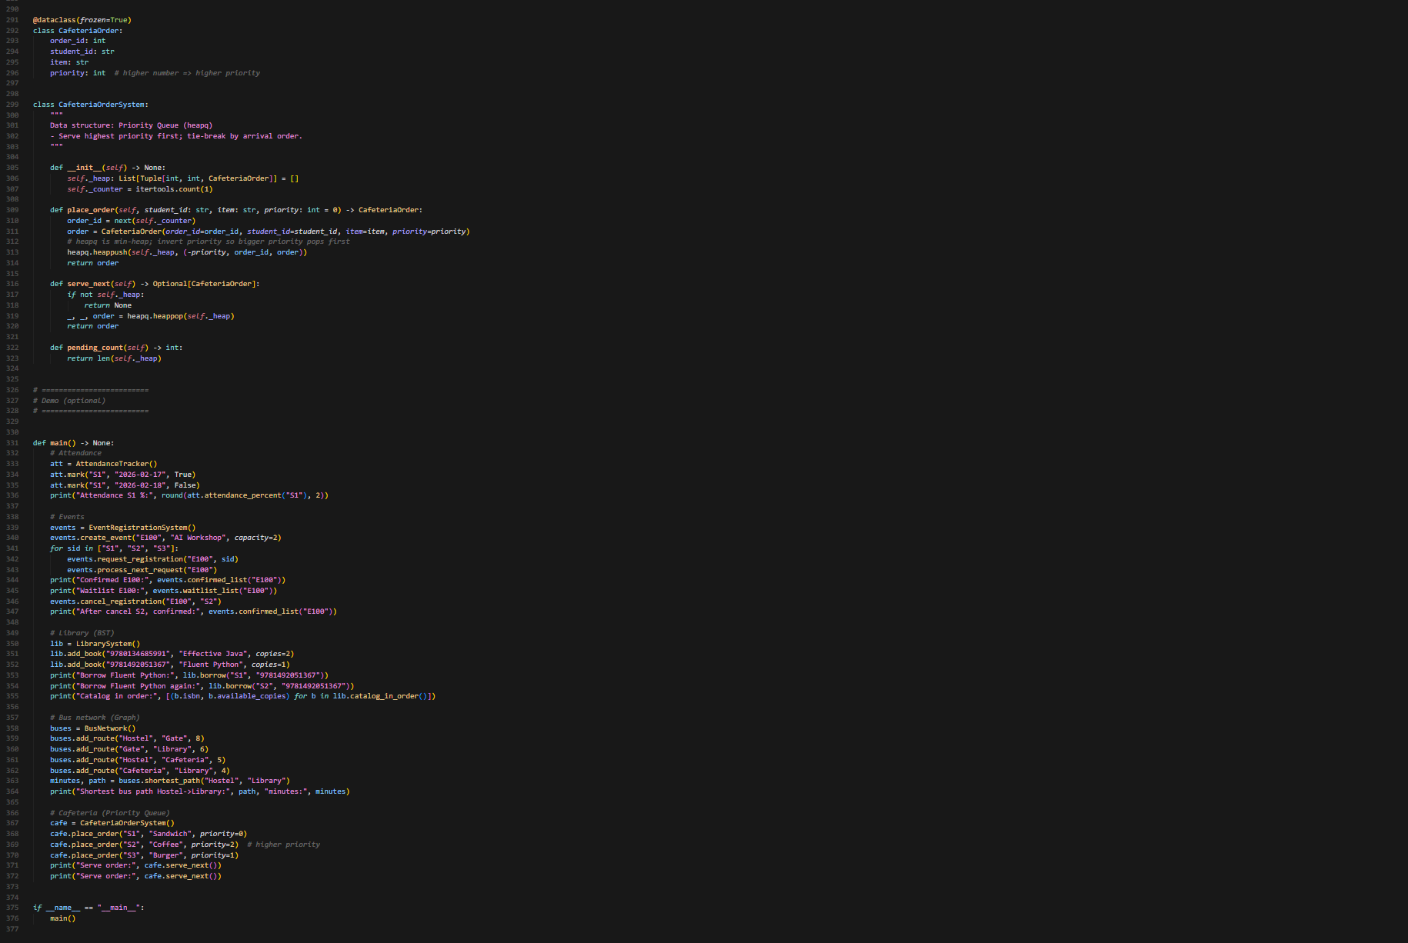

Output:
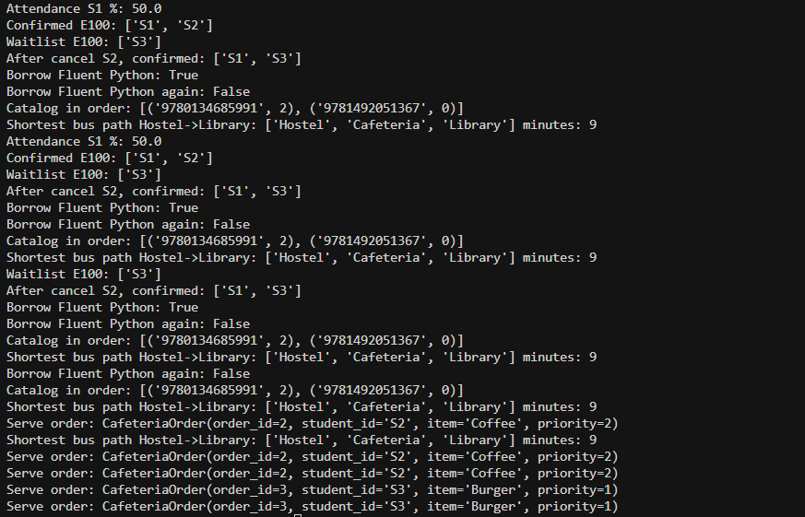

Task Description #10: Smart E-Commerce Platform – Data Structure

Prompt:

Solve this clearly and concisely.
Design a Smart E-Commerce Platform with:
Shopping Cart Management – Add/remove products dynamically
Order Processing System – Process orders in placement order
Top-Selling Products Tracker – Rank products by sales count
Product Search Engine – Fast lookup using product ID
Delivery Route Planning – Connect warehouses and delivery locations
Choose the most appropriate data structure for each feature from:
Stack, Queue, Priority Queue, Linked List, BST, Graph, Hash Table, Deque

Output as a table:
Feature | Data Structure | 2–3 sentence justification

Code:
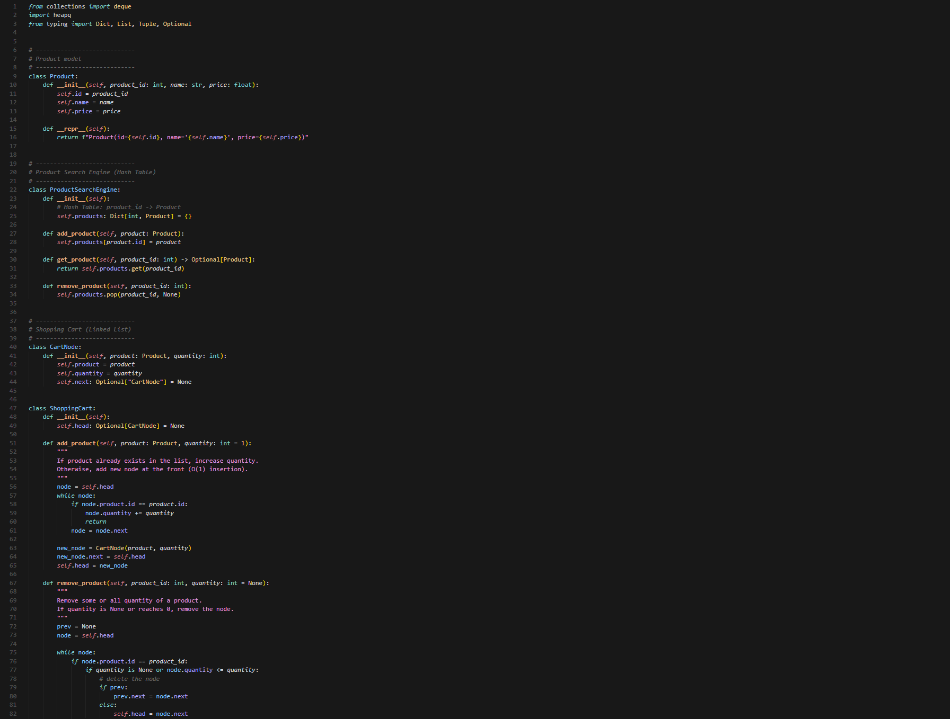
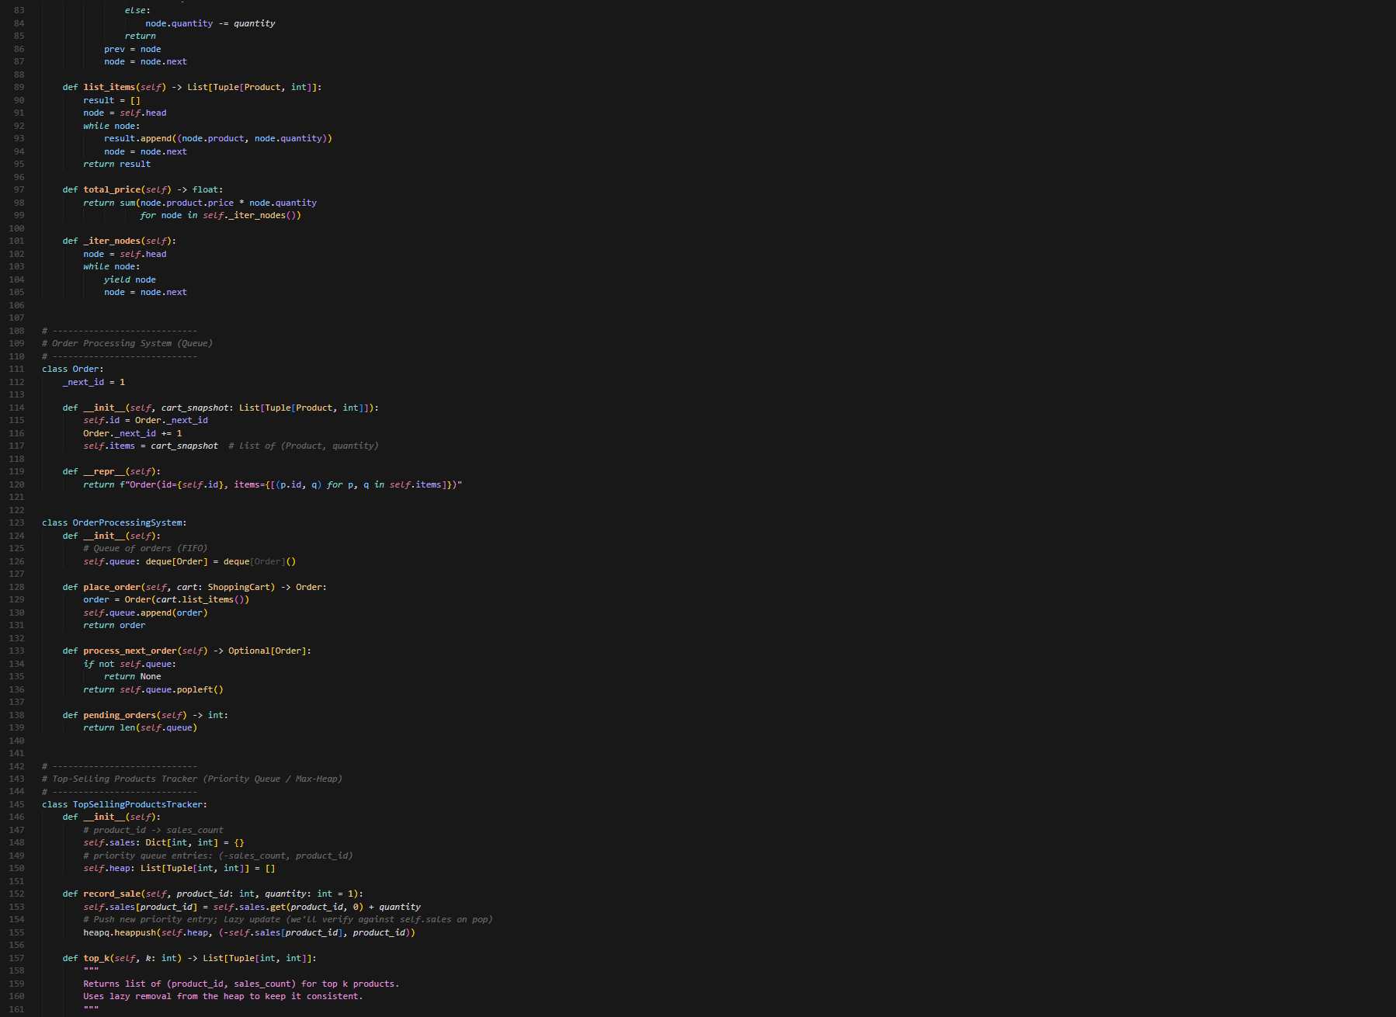

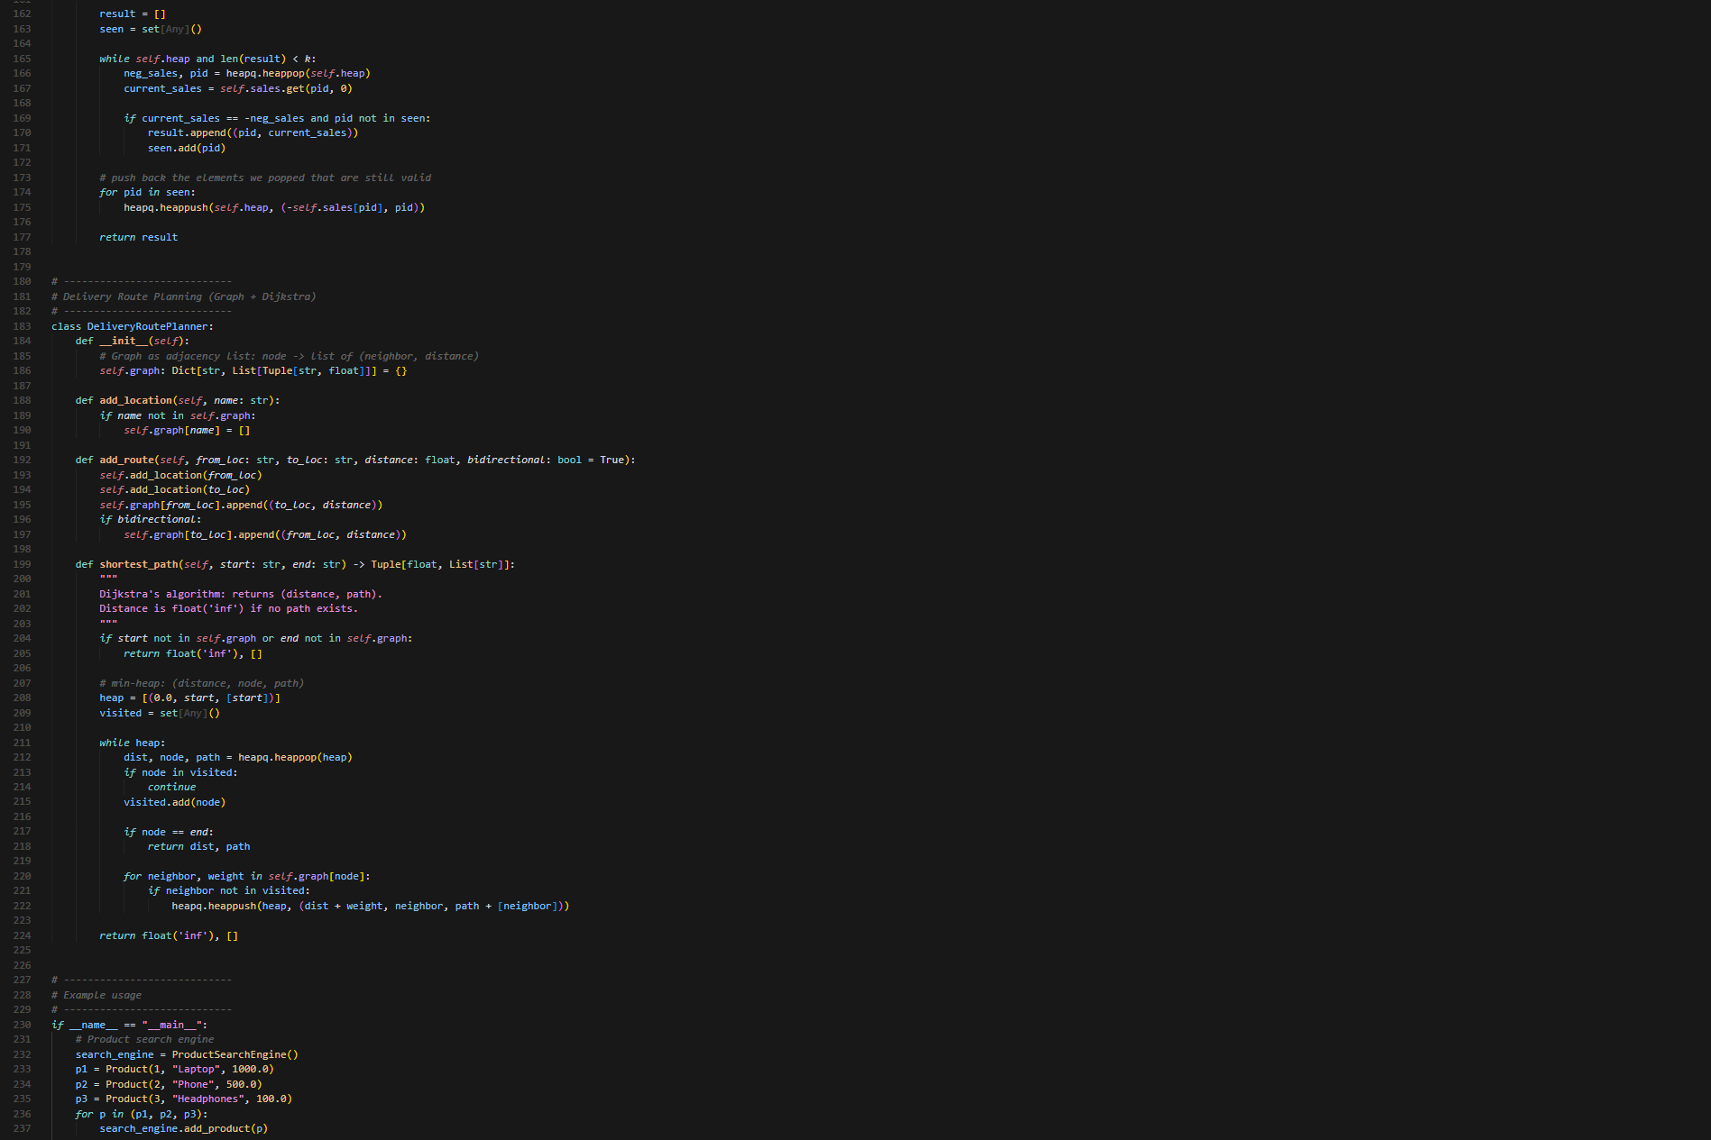
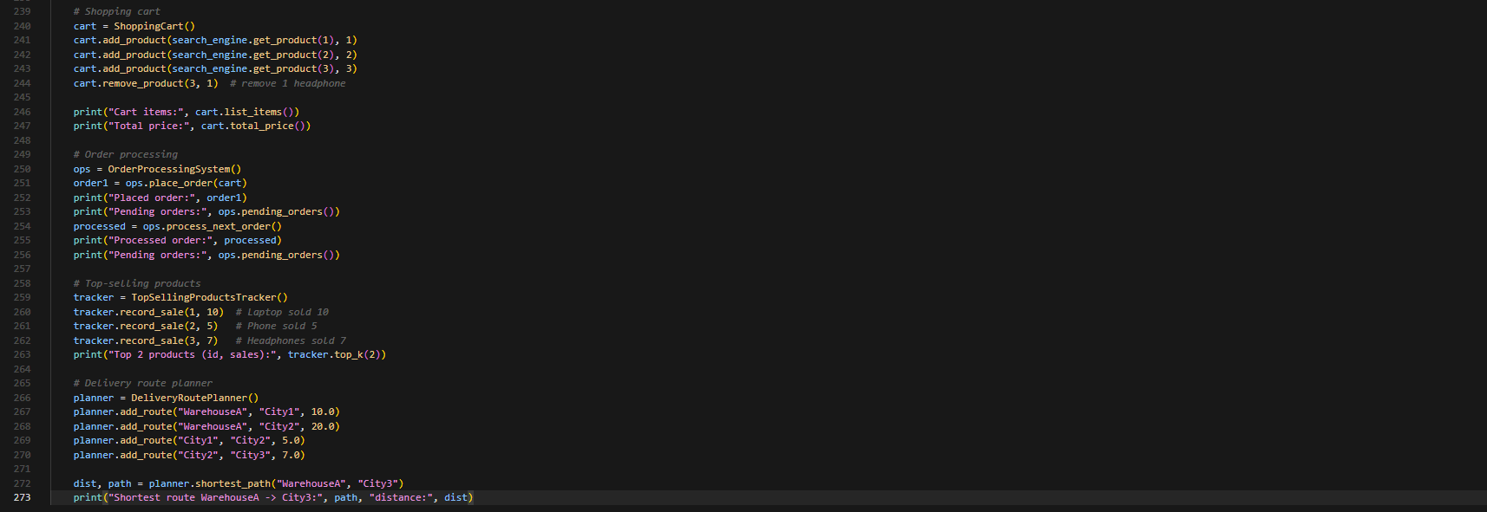

Output:
