***WEBSITE SPECIFICATION DOCUMENT***

1. ***Overview:***

Our new site will perform the following function for our business:

*"We want people to find our products by searching the web. The site will provide detailed information about the services we provide.”*

*2.* ***Goals****:*

* Attract and excite a diverse audience.
* Provide useful, timely content in a compelling, easy-to-use design.

***3. Site Architecture:***

***Navigational Structure:***

This site must allow visitors easy access to all information. As a general rule, no piece of content should ever be more than three clicks away from the visitor. This project built a site structure that emphasizes the content visitors most want to see, simplifies navigation, but still allows quick access to all content:

Home

About us

Services

Contact us

***List Of Pages:***

* **Home**
  + **Services**
  + **About us**
  + **Contact us**

### Home Page

The home page will give visitors an overview of our services.

* **Services Page**

Details about all the services our company provides.

### About Us

Details about our company and personnel.

### Contact Us

Full contact details including a map.

***5. Site Design:***

***Layout:***

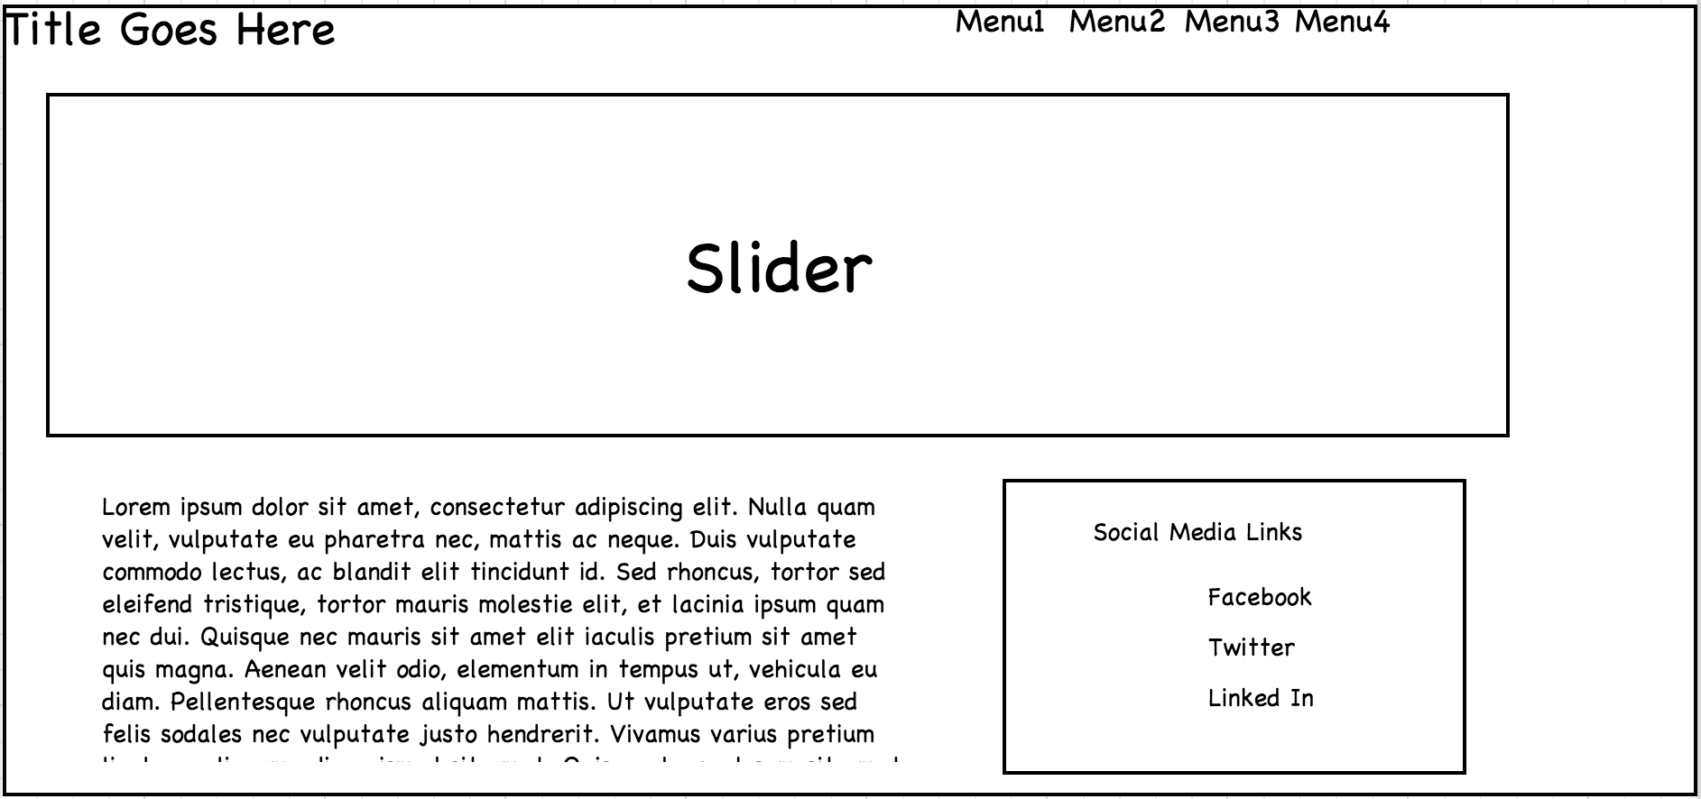

***Technologies:***

* *HTML5*
* *CSS3 (includes half-slider also)*
* *Bootstrap*
* *Angular JS (Used for routing)*
  + *Implemented Page Routing (i.e. Single Page application)*

***6. Screenshots:***

